Policing Research Project
What is the public’s perception of domestic abuse in 2024, and how does this affect criminal offences within the United Kingdom?

BMPL6015
Student Name: Christina Mikayla Davies
Student Number: 2204423

Abstract
This dissertation examines the public’s perception of domestic abuse in 2024 and how these perceptions influence criminal offences. Domestic abuse remains a significant issue in the United Kingdom. A literature review highlighted that despite increased awareness through education and campaigns, misconceptions persist, leading to underreporting due to social stigmatisation and fear. An online questionnaire was conducted on social media platforms, focusing on themes such as gender, age, and culture identified in the literature review. A total of 104 participants, primarily females from Wales, aged between twenty-five and thirty-four, took part in the study. The study concluded that, despite limitations in the demographic, the perception of domestic abuse is significantly high in the United Kingdom. However, there is a lack of insight contributing to low reporting levels. A deeper understanding of these dynamics will enhance awareness and responses to domestic abuse, pushing for changes in societal attitudes and perceptions and will improve legal protections for victims.

Acknowledgements
Firstly, I would like to thank my tutor Mike Durke and my supervisor Kelly Andrews for their guidance, feedback, and support throughout my independent research process. Mike and Kelly have both been very helpful, encouraging, and supportive throughout. Together, they have also pushed me to do my very best and achieve my goal, for which I am very grateful.
Secondly, I would like to thank all the individuals who have taken the time to participate in my research study. Their insights have helped me to successfully complete my research study, and I am very grateful for that.
Finally, I would like to thank my family, partner, and friends for their support and encouragement throughout my dissertation process and general studies throughout the course. I am very grateful for them all.
This dissertation would not have been possible without the contributions of these individuals. I am very grateful for their support.

Declaration
I declare that this work has not previously been accepted in substance for any degree and is not being concurrently submitted in candidature for any degree.
This dissertation is being submitted in partial fulfilment of the requirements for the degree of BSc (Honours) Professional Policing.
This dissertation is the result of my own independent work/investigation, except where otherwise stated. Other sources are acknowledged in the Reference Section.
I hereby give consent for my dissertation, if accepted, to be available for photocopying and for interlibrary loan, and for the title and summary to be made available to outside organisations.
I hereby give consent for my dissertation, if accepted, to be available on the university’s IT system to those who have consent to use the system.
Christina Mikayla Davies
C. M. Davies
6th May 2025

Contents
- Introduction………………..…………………………..………………………...5
1.1 The public’s perception of domestic abuse in 2024 and the impact this has on criminal offences……………………………………………………………………………5
1.2 Definition………………………………………………………………………….5,6
1.3 History……………………………………………………………………………..6,7
1.4 Perceptions……………………………………………………………………..7,8,9
- Literature Review…………………………………….………………..……...10
2.1 Gender………………………………………………………………………….11,12
2.2 Age…………………………………………………………………………………12
2.3 Culture……………………………………………………………………………..13
2.4 Underreporting…………………………………………………………….13,14,15
2.5 Limitations…………………………………………………………………………15
- Methodology……………………….………………………………..…………16
3.1 Research Strategy……………………………………………………….16, 17, 18
3.2 Data Collection…………………………………………………………..………..18
3.3 Data Analysis…………………………………………………………………...…18
3.4 Justification of Research Method……………………………………………….19
3.5 Limitations………………………………………………………………….19,20,21
3.6 Ethical Considerations…………………………………………………………...21
- Findings…………………..……….….22, 23, 24, 25, 26, 27, 28, 29, 30, 31,32
- Conclusion……..……………………..…………………………………….33,34
References………………….……..………………...35, 36, 37, 38, 39, 40, 41, 42
Appendices…….…………………………….…………………………………….43
Appendix 1 – Ethics Form…………………...………………………………43-58
Appendix 2 – Questionnaire…………..………...…………………………..59-61

Introduction
What is the public’s perception of domestic abuse in 2024, and how does this affect criminal offences within the United Kingdom?
The aim of this dissertation is to investigate the public’s perception of domestic abuse in 2024 and the impact this has on criminal offences. By exploring this topic, it can help to raise awareness of domestic abuse and highlight the importance of addressing this issue.
Domestic abuse is a worldwide issue that affects millions of people, including the United Kingdom, where it is perceived as an issue. It is generally private and usually occurs within the home (Taub, 2020). A general understanding exists, which has been achieved through education and campaigns (Sivarajasingam, et al., 2022). However, most individuals are misunderstanding domestic abuse. For example, what one person may see, another person may see something different, such as domestic abuse, public order, assault, etc, and others may not recognise the signs of domestic abuse, although they have heard of it (Fox, et al., 2014; Worrall, 2013). Despite efforts to limit it, domestic abuse continues to be a prevalent issue within society (Choi, 2009). Within the United Kingdom, there is no evidence of domestic abuse being more prevalent in rural areas compared to cities. Underreporting occurs due to people being ashamed, scared or dependent on the abuser. Therefore, there is no data on localised prevalence (Heron & Eisma, 2021).
Domestic abuse is defined as one or more incidents of controlling, coercive, threatening, degrading and violent behaviour, which can include sexual violence in most cases between those who are sixteen years old and above. Domestic abuse can be carried out by partners, ex-partners, family members and carers. Both sexes can be perpetrators and victims (Alejo, 2014). There is an increased likelihood for males to be perpetrators of domestic abuse compared to females. Therefore, women generally experience domestic abuse the most (Home Office, 2024a; Matczak, et al., 2011; Lloyd, 2018). However, consideration must be made that same-sex couples, non-binary couples, and men are also at risk of domestic abuse. This can be seen in recent years with the term of domestic abuse evolving into intimate partner violence. In this case, the term domestic abuse incorporates all individuals and types of domestic abuse within the individual's household (Denysschen & Evans, 2022).
Domestic abuse includes physical and sexual violence and can encompass emotional, financial, and psychological manipulations (Benedictus, et al., 2004). It can cause physical harm, such as minor injuries, severe disabilities and death (Worrall, 2013; Alejo, 2014). Leading to mental and emotional trauma such as depression, anxiety, post-traumatic stress disorder and a general decline in their mental well-being (Humphreys & Thiara, 2003). It can cause financial strains to develop because the abuser can control and restrict the victim from spending their money by spending it themselves (Postmus, et al., 2012). If victims need to relocate to get away from the abusers, this will result in a relocation fee (Hirst, 2003; Johnson, 2014). Victims can also lose their jobs (Anderberg & Rainer, 2011). People of all ages, genders and backgrounds can be affected by domestic abuse (Donovan & Hester, 2015; Skafida, et al., 2022), and this can have a long-lasting impact on the victims, their families, and the communities (Hill, 2020).
For centuries, domestic abuse has existed within families and households, especially against women and girls (Foyster, 2005; Delap, 2011). Historically, it was not seen as a crime because it was seen to be a private matter (Irving-Clarke & Henderson, 2020). During the 1970’s the Domestic Violence and Matrimonial Proceedings Act (1976) was introduced and became a turning point. To prevent further violence, this act offered civil protection orders for victims, but mainly for married women (Brophy, 2022). This act came into law at the same time as the beginning of the rise of the women’s liberation movement, which had brought domestic abuse into the public eye (Radford, 2023). In 1986, the Home Office made it mandatory for the police to prioritise the victim's safety in all domestic abuse situations (Walklate, et al., 2022). During the 1990’s, there was a shift, and domestic violence was declared to be a crime (Hague, 2021). Non-molestation orders were introduced, which offered some legal protection (Speed & Richardson, 2022). In 1991, further changes were made as marital rape became illegal in the United Kingdom (Banerjee & Rao, 2022). The Domestic Violence, Crime and Victims Act (2004) expanded these rights, which allowed non-married couples and same-sex couples to get protection orders and harsher penalties were introduced if they were breached (Bates & Hester, 2020). From 2010 to 2024, the focus broadened, and children are now seen as victims of domestic abuse. This is because children who witness domestic abuse can become mentally affected, and further health issues can develop. This can significantly impact children and cause them to be at risk of similar experiences in the future (Worrall, 2013; Reed, 2009). The Domestic Abuse Act (2021) was introduced and established during this time, and further support systems were offered for victims, such as counselling, Women’s Aid, etc (Chantler, et al., 2023). Throughout previous centuries, this type of violence has been mainly ignored by society and the law (Freeman, 1989). For example, for centuries, parents and family members were allowed to hit and smack children to discipline and control them (Talbot, 2009; Bunting, et al., 2010). However, The Children’s Act (2022) came into force, and under this law, it means that no parent, family member or anyone can physically abuse a child, including hitting and slapping. This law protects all children from abuse (Home Office, 2023; Gorczowska, 2022). This demonstrates that the perception of domestic abuse from 1970 to 2024 is evolving within society and will have a direct impact on the number of domestic abuse cases as thresholds decrease and more people are protected (Zorza, 1992).
Perceptions have a direct impact on domestic abuse and how it is reported to the police (Heron & Eisma, 2021). This perception changes with society and is influenced by campaigns such as Neighbourhood Watch, Woman’s Aid, ManKind Initiative and many more (Hill, 2020). The media plays a role in changing perception as it informs the public by providing accurate and sensitive representations of the crime (Burrell & Dhir, 2023). Perceptions are cultural, incorporating society, but can also be family groups. As the United Kingdom is a multicultural nation, there will be variations in the idea of domestic abuse, which will have a direct impact on the number of cases being reported (Robinson, 2020). Cultural beliefs can stem from many areas, such as family dynamics and regions. These perceptions are generally passed down through generations. However, with a change in circumstances or changes in society, domestic abuse can be better understood and reported appropriately (Hill, 2020). Perceptions can also be individual. This is directly affected by the cultural norms of the person and their family. However, even when domestic abuse is understood and is not tolerated within the family dynamics, individuals can become victims of domestic abuse. They can go into denial, even when they are aware of the signs in others (Irving & Liu, 2020). Cultural and individual understanding of domestic abuse has a direct impact on the amount of reporting done to the police and will directly affect the records of criminal offences (Hewitt, 2023).
The wider community can be impacted by domestic abuse because law enforcement, healthcare services and social services all incur a significant amount of costs when they deal with domestic abuse cases (Walby, 2004). Victims are unable to get the help and support they need due to societal stigmas and the lack of knowledge and understanding (Othman, et al., 2014). Victims and survivors should not be blamed for domestic abuse as it is not their fault, and the public needs to stop victim-blaming (McCleary-Sills, et al., 2016). They should be blaming the abuser for their actions. The public needs to be more empathetic about the situation and should understand that anyone can become a victim of domestic abuse (Rauhaus, et al., 2020).
The perception of domestic abuse can be changed through public campaigns and conversations (Bovill & White, 2022). Victims could receive more support and funding, such as shelters, helplines and counselling sessions. With these resources in place, victims can be better equipped to escape (Dudley, 2017). Victims and abusers can reduce domestic abuse by openly communicating. This communication needs to be non-abusive and offer help, support and guidance from professionals such as doctors and counsellors. Victims need to feel more open about reporting domestic abuse crimes to the police (Mackenzie, et al., 2019). To reduce further occurrences, individuals could be educated about healthy relationships and the early signs of abuse (Fox, et al., 2014). Victims could receive support through open discussions with their families, schools and communities. These discussions could encourage victims to report abuse (Sivarajasingam, et al., 2022). Training should be given to all professionals, such as law enforcement, medical personnel, social workers and teachers, to help them identify any signs of abuse so that they can provide help and support (Sohal, et al., 2020). To hold abusers accountable for their crimes, legal frameworks need to be strengthened, such as legislation and enforcement measures (Matczak, et al., 2011). Campaigns could be run to challenge the misconception of domestic abuse and highlight that any form of domestic abuse is a breach of the law and that individuals committing this crime should be brought before the justice system (Mayhew & Jahankhani, 2020).
With the increase of the public's general understanding and recognition, there is an increased response to domestic abuse situations, and the public is encouraged to not put themselves or others at risk. However, there is a need to understand that domestic abuse is everyone’s responsibility, so once witnessed, help needs to be given (Davis, 2019).

Literature Review
The literature examines statistics between the years 2021 to 2023, and the following statistics show that at the end of March 2021, the Office for National Statistics (2021) stated that the police recorded domestic abuse-related crimes, and the statistics show that it had risen by 6% to 845,743 in England and Wales. Police officers made thirty-three arrests per one hundred domestic abuse-related crimes at the end of March 2021. This is the same as the previous year 2020 (Office for National Statistics, 2021). At the end of March 2022, the Office for National Statistics (2022) stated that 5% of adults aged sixteen years and above (2.4 million) had experienced domestic abuse within the last year. The prevalence of domestic abuse did not have any significant changes by adults from the age of sixteen to fifty-nine years old who had experienced domestic abuse within the last year, compared to the end of March 2020, which was unaffected by the coronavirus and the previous time data was collected. At the end of March 2022, the police recorded 1,500,369 domestic abuse-related incidents and crimes. However, 910,980 of these were recorded as domestic abuse-related crimes in England and Wales (Office for National Statistics, 2022). At the end of March 2023, the Office for National Statistics (2023) stated an estimate of 2.1 million people aged sixteen and above (1.4 million women and 751,000 men) who experienced domestic abuse in England and Wales. Again, the prevalence of domestic abuse experienced did not have any significant changes within the last year, compared to the previous year. At the end of March 2023, the police recorded 889,918 domestic abuse-related crimes, which was similar to the previous year. However, these statistics exclude Devon and Cornwall. At the end of March 2023, there were 51,288 domestic abuse-related prosecutions, compared to 53,207 in March 2022 in England and Wales (Office for National Statistics, 2023). This indicates that domestic abuse is an ongoing issue within the United Kingdom, and as attitudes are potentially changing, there seems to be a reduction in domestic abuse cases. However, this information does not take into consideration the idea of the perception of domestic abuse. For example, is the United Kingdom becoming more tolerant of domestic abuse and is reporting it less? The impact of the COVID-19 pandemic is also worth considering, as this was an abnormal time for gathering data (Sivarajasingam, et al., 2022).
To understand domestic abuse, it is necessary to review the literature.
Domestic abuse within the literature is defined as a pattern of assaultive and coercive behaviours that include physical, sexual and psychological abuse within relationships (Moreira & Costa, 2021; Badeness-Sastre, et al., 2024). It is a severe global issue with a broad range of public health and social issues (Badeness-Sastre, et al., 2024; Moreira & Costa, 2021). According to Juarros-Bassterretxea (et al., 2024) and Taylor, (et al., 2022), there are times when victims will hesitate to report any domestic abuse to the police. If mild abuse takes place frequently, it can be normalised by the individuals, even though it is illegal. However, if any of the domestic abuse incidents taking place are severe, then the victims are more inclined to report it to the police. Juarros-Bassterretxea (et al., 2024) suggest that increasing understanding of domestic abuse and the legal framework that protects the victims would increase the amount of reporting to the police.
The literature review highlighted several key themes that are worth exploring. These themes will be examined in more detail, including gender, age, and culture. Another critical aspect that continued to arise was the issue of underreporting.
Gender was one of the main themes that was prevalent within the literature. The literature shows that men perceive domestic abuse as less severe than women, as they have lower severity levels and concerns when it comes to domestic abuse (Badeness-Sastre, et al., 2024). When women are victims of domestic abuse, they are less likely to accept and justify it if it is not severe enough. However, when domestic abuse incidents are severe, they will be more inclined to accept and justify it (Badeness-Sastre, et al., 2024; Grembi, et al., 2024). This understanding of domestic abuse was linked to ingrained perceptions within the culture, and there was a link between lower reporting of domestic abuse and traditional gender roles (Badeness-Sastre, et al., 2024), especially when the culture has a bias to normalise abuse towards women over men. In such cases, victim blaming, excusing perpetrators, sexism and rape myths all contribute to ensuring that reporting remains low and that the perception of domestic abuse remains on the individual being victimised and not the perpetrator (Badeness-Sastre, et al., 2024). Reporting is further reduced when the cultural barriers prevent the police from acting and proves a pointless exercise when domestic abuse is reported or worse, there is increased hostility towards the victim (Juarros-Basterretxea, et al., 2024). This emphasises the role of perception not only by the individual but also by the culture itself. Some cultural barriers include stigma and shame, family honour, religious beliefs, language barriers, lack of cultural competency and fear of deportation. These cultural barriers will have an effect on the amount of reporting that occurs to the police due to domestic abuse being considered differently within that culture (Heron, et al., 2022). Gender roles also have the effect of reducing the likelihood of male victims of domestic abuse understanding or feeling comfortable reporting due to the risk of being stereotyped as less masculine or weak (Margherita, et al., 2021).
Age is another theme, and is important because, according to Chandan (et al., 2020), domestic abuse is a public health issue globally, and children can be maltreated in domestic abuse situations. The literature also highlights that children in these situations can develop social, psychological and physical health issues. According to Iob, (et al., 2020), adults who are involved in domestic abuse incidents are at increased risk of self-harming themselves, being anxious and depressed and having suicidal thoughts. According to Lonbay & Southall (2024), elderly people also experience domestic abuse. However, they are usually overlooked because younger adults are generally seen as experiencing domestic abuse the most. The literature by Davidge (2022) shows that females aged sixteen to twenty-four are generally domestically abused the most, compared to those aged between twenty-five and sixty-five and above. The literature also shows that males aged fifty and above are likely to be victimised, compared to those aged sixteen to forty-nine years old. Women’s Aid carried out a survey in 2022 regarding attitudes towards domestic abuse in the United Kingdom, and the literature highlights that young people, especially young men, need to be further educated on topics related to the understanding and recognition of harmful behaviours towards women. The survey indicates that young women generally hold strong negative attitudes towards specific scenarios such as marital rape, a husband slapping his wife, controlling behaviour and a husband monitoring his wife’s clothing choices after she had cheated on him. However, they are less likely to perceive certain behaviours as incredibly wrong compared to the older age groups. Gender and age are very closely linked to the variations in attitudes. Older adults and those with higher levels of formal education are more likely to recognise harmful behaviours. The literature emphasises how complicated age is as a demographic factor. There is a need for further analysis to understand the reasons for these attitudes and perceptions (Davidge, 2022).
The perception of domestic abuse is significantly influenced by culture. This is evident when looking at the language used in victim blaming, such as they must have sent mixed messages, or they should have ended the relationship sooner. This language indicates the perception of the culture while also increasing the likelihood of the continuation of abuse. However, Badeness-Sastre (et al., 2024) argue that perception can also have the opposite effect and prevent abuse. When people are properly educated and have a good understanding, it can reduce abusive practices by changing the culture and reducing the amount of victim blaming. In their 2024 study, Juarros-Basterretxea (et al., 2024) discuss the cultural impact of reporting domestic violence to the police. The research shows that people's perception of the outcomes after reporting plays a crucial role in their decision to report abuse in the first place. Interestingly, the study reveals that this perception of reporting not only relates to the police but also includes other professionals, such as psychologists and therapists, who are bound by confidentiality. This highlights a systemic cultural issue where domestic abuse is often seen as unreportable despite legal protections for the victims. In order to address domestic abuse, policies need to be created. The media also have a role in making the public socially aware of domestic abuse (Moreira & Costa, 2021). The public’s perception of domestic abuse can influence laws and legislations that are in place to help and protect victims, as well as increasing the encouragement of reporting domestic abuse incidents (Grembi, et al., 2024). According to Grembi (et al., 2024), when dealing with domestic abuse, it is essential to understand the seriousness and consequences of the suspect's behaviours. It highlights that reporting domestic abuse is impacted by the public’s perception and gender stereotypes, and changes to perceptions need to be made for victims to take control, come forward and report domestic abuse. The literature suggests that stereotypes should be targeted through domestic abuse campaigns, and the media has an influence in shaping gender roles. It is essential to provide victims with information and available services so that they can receive help and support in relation to domestic abuse. There is a need for future research, and it should focus on understanding personal experiences more and include male perceptions and different types of relationships.
The final key theme that will be discussed is underreporting. According to Juarros-Basterretxea (et al., 2024), the literature shows that women who experience domestic abuse hesitate to report the incidents to the police. However, despite the number of domestic abuse cases against women being reported every year, it is still not being reported enough. Studies that have been carried out by Juarros-Basterretxea (et al., 2024) have also highlighted that many domestic abuse cases are unreported. The social policies that are in place to help intervene in and prevent domestic abuse are directly impacted when domestic abuse victimisation is underreported. However, there may be a lack of legal knowledge and understanding of domestic abuse, which impacts how domestic abuse is defined as indictable. This can be improved through education, which can help improve the reporting of domestic abuse. Also, future intervention and prevention programs can help women become much more aware of the indictable behaviours regarding domestic abuse, which again can help improve the reporting of domestic abuse incidents. With education and these programs in place, victims of domestic abuse can become more understanding of the law and how it protects them. The literature by Juarros-Basterretxea (et al., 2024) highlights how important it is to understand the way women perceive domestic abuse and the factors that influence their behaviour when they want help. To change the formal help-seeking processes for victims of domestic abuse, it is crucial to raise awareness of the legal system and the resources available for women and those within the communities. Their study also looked into the underreporting of domestic abuse further and the factors that influence the likelihood of women reporting it to the police. Also, women’s choices to receive help and support from the police can be impacted by formal and informal relationships.
The literature by Brennan (et al., 2024) states that police officers and staff face challenges when reporting domestic abuse, significantly when the abuser is associated with law enforcement. It highlights the conflicts and difficulties between personal and professional identities, recognising the fear of sabotaging careers and violating privacy. Therefore, calls for recognition of the vulnerabilities inherent in the police and victims overlap, and this urges researchers, policymakers, and policing institutions to respond to these challenges. According to Brennan (et al., 2024), experiences vary by occupation. Victims within the policing industry face challenges, such as competing identities, privacy concerns and inadequate support. It emphasises that there are obstacles when it comes to reporting abuse, which include the difficulty of recognising it and the anxieties of sabotaging careers. Brennan (et al., 2024) suggest that the police image of an ideal victim is influenced by their experiences, and identity can conflict in policing. In the same regard, stereotypes will have a similar effect on underreporting. For example, Grembi (et al., 2024) indicated that regional differences in underreporting in Italy were based on gender stereotypes, with stronger stereotypes reducing reporting by victims.
The literature above discussed gender. However, there are some limitations because they were limited to either males only, females only or both (Badeness-Sastre, et al., 2024; Grembi, et al., 2024; Juarros-Basterretxea, et al., 2024; Margherita, et al., 2021). The study that will be conducted will include all genders, including same-sex couples and non-binary individuals, which will provide broader perceptions regarding gender and domestic abuse. Also, Badeness-Sastre (et al., 2024) had twelve studies to review but only analysed six of them. However, the study that will be conducted will have around one hundred participants and will use its own results.
The literature above discussed age. However, there are some limitations because they either included children only, adults only, elderly individuals only or age groups between the ages of sixteen to sixty-five years and above (Chandan, et al., 2020; Iob, et al., 2020; Lonbay & Southall, 2024; Davidge, 2022). The study that will be conducted will include an age range by those completing the survey, and there will be questions regarding children, adults, and the elderly to combine the perceptions of all age groups. Also, Longbay & Southall (2024) conducted a small study. However, the study that will be conducted will have around one hundred participants, which will allow for a larger scale of perceptions regarding age and domestic abuse.
The literature above discusses culture (Badeness-Sastre, et al., 2024; Juarros-Basterretxea., et al., 2024; Moreira & Costa, 2021; Grembi, et al., 2024). However, there are some limitations because studies reviewed by Juarros-Basterretxea (et al., 2024) only had Chilean participants and studies carried out by Grembi (et al., 2024) only had Italian participants. Although the study will be conducted in the United Kingdom, it has a more diverse population. This will allow the public from all ethnicities and cultures, including the travelling community, to participate in the study and will provide a wider perception of culture and domestic abuse.

Methodology
This study is about domestic abuse in all its forms, from physical abuse to psychological abuse (Benedictus, et al., 2004). Domestic abuse is a significant issue worldwide that needs to be investigated to try to understand and reduce the number of domestic abuse cases which affect so many people (Taub, 2020).
The objective of this study is to explore the public’s perception of domestic abuse in 2024 and to determine if any significant factors contribute to the reporting of incidents to the police. The literature review highlighted key themes that have a significant impact on the reporting of domestic abuse, and these include age, gender, and culture. Consideration was also made to under-reporting to the police, which was highlighted in the literature. The researcher will design the questionnaire and, therefore, may encourage the public to disclose information that can be used to better understand the current perception of domestic abuse without the risk of stigmatisation.
The main objective of this study is a combination of utilising reduced stigmatisation and an exploration of the key themes of gender, age, and culture through a questionnaire regarding the perception of domestic abuse in 2024.
This study has been chosen because the researcher has an interest in this topic area and, therefore, wanted to explore more about the public’s perception of domestic abuse and to explore an ongoing issue within society. The literature review highlighted that other researchers have either read studies regarding perceptions of domestic abuse producing a meta-analysis or have carried out their own studies. However, limitations were evident, such as only involving males or females and only specific age groups and cultures were considered in some studies separately. However, the researcher of this study will combine all the criteria, including both males and females, as well as all age groups and cultures within this one study, to get a better understanding of the public’s perception of domestic abuse in 2024.

Research Strategy
A quantitative survey method is used to collect and analyse numerical data. This is done by using statistical methods to identify patterns, trends and relationships within a population. This is done through surveys, experiments and observations. By using this method, it allows researchers to make generalised conclusions about a topic. This research method focuses on numbers instead of words (Taherdoost, 2022). Therefore, the quantitative method has been chosen because it allows for greater participation numbers, allowing the researcher to get a larger overview of the perception of domestic abuse in 2024. The larger subject group with no restrictions other than an eighteen-year-old age limit gives a view of the population group, which can then be understood to represent the opinions of the population as a whole (Karunarathna et al., 2024). A Qualitative study was considered by the researcher but was rejected as this would narrow the number of participants and not reflect the perception of the general population (Taherdoost, 2022).
A quantitative study also allowed for a wide range of research using reliable online and physical resources, including Google, Google Scholar, library systems, journal articles, books and reports. This helped to gather all the information needed for this research and study to be carried out.
The questionnaire had fifteen questions to be answered with a combination of questions and statements, excluding questions regarding consent, gender, age, ethnicity and location. These questionnaires have been produced and distributed to the public aged eighteen and above to complete. This has been done through an online survey called Microsoft Forms, and around one hundred individuals can participate and complete this survey. The questionnaire was designed in a way that was quick and simple to complete to increase the likelihood of the public completing it. This is why only fifteen questions were utilised in this study. The format was chosen to be similar to other questionnaires, so participants felt comfortable filling in the forms. Microsoft Forms was employed to produce a user-friendly questionnaire that can be distributed quickly to a large population group with around one hundred participants to give the researcher adequate time to produce the results and conclusion.
The type of questionnaire used combines a Likert scale (Sullivan & Artino, Jr, 2013) and a multiple-choice questionnaire (Turnitin, 2025). This type of questionnaire was chosen because it is simple and easy for the public to use and understand (Robinson, 2024; Karunarathna, et al., 2024).
To gather around one hundred individuals to participate in this research study, an e-mail was sent out to students and tutors at the University of Wales Trinity Saint David’s with an explanation for this e-mail, along with the link to the survey attached. A Facebook post was also created to explain the nature of the post with the link to the survey attached for family, friends and the public to participate in the research study.
A sample size of around one hundred participants was chosen through the suggestion of the tutor and would provide a sample size that would reflect the perception of the general population. Also, the participants include the public, family, friends, students and tutors from the University of Wales Trinity Saint David’s. The participants must be aged eighteen and over to participate in the research study, which was also chosen through the tutor's suggestion and as there were more ethical considerations for participants under the age of eighteen with possible consent required. The researcher also had limited means to ensure consent was given by the appropriate adult. Therefore, there was a need to limit the age to eighteen, with younger people only considered in the questions in the questionnaire.

Data Collection
The findings were analysed using a quantitative method that involved statistical analysis. The themes explored include gender, age, ethnicity, and culture. These themes provide insights into their impact on the perception of domestic abuse and the extent to which each theme influences that perception. This perception will have an impact on the number of domestic abuse incidents reported to the police.

Data Analysis
The data analysis method used was quantitative (Goetzmann, 2023; John, 2010). This was used to examine the data in a numerical format, which was then analysed using a statistical program, such as Microsoft Forms. A quantitative analysis was necessary because the research required the measuring of differences between groups involving gender, age, ethnicity and culture to assess the relationships between variables to understand the perception of domestic abuse and criminal offences and to test the hypothesis that the perception of domestic abuse has an impact on criminal offences.

Justification of research method
The justification for this research method is that it has been used in other similar studies and gathered a wide range of perspectives from individuals in different areas regarding domestic abuse. This was discovered in the literature review. The research study that was carried out was anonymous. Therefore, anyone who participated in this research study would not be at risk of reprisals from potential domestic abusers as all information will remain private and confidential. All participants were eighteen years old and above. The researcher chose this as it ensured that more mature individuals would be completing the questionnaire, and studies indicated a higher proportion of domestic abuse among the younger individuals, increasing their vulnerability (Gama, et al., 2021). The researcher acknowledges that this would eliminate certain age groups from the study. The age limit of eighteen years or over was introduced to align the study with the World Health Organisation's definition of an adult, ensuring that there could be no classification of children within the study (Sharratt, et al., 2023). This research study does not discriminate against anyone, as it is a study in which all individuals from different backgrounds have participated in, which has allowed for the inclusion of equality (University of Wales Trinity Saint David’s, 2025; Home Office, 2015; Home Office, 2024b).
The questionnaire survey allowed for a broader research study to be carried out, as it provided more data involving gender, age, ethnicity, and location. Also, the questionnaire was designed so that many individuals could fill it out easily, such as using a scale, with questions that were asked to find out information that did not delve into potentially upsetting content.

Limitations
There were some limitations in undertaking this research study.
The first limitation includes a sampling bias. Although the survey will be published on Facebook and via the University of Wales Trinity Saint David’s Hwb e-mail for the public, family, friends, tutors and students to complete, the survey on Facebook will be restricted to family, friends and some members of the public who have access to the researcher’s profile to complete the survey. The challenges of using the internet for research include concerns about data privacy and ethical issues. Additionally, the validity and generalisability of studies may be called into question (Singh & Sagar, 2021). This limited the sample size in one area to a smaller geographical location. Another limitation of this is the age range of individuals who use social media such as Facebook. Social media use is not universal, so there will be some age groups and genders. The statistics for this show that globally, men use Facebook more than women, showing that males aged twenty-five to thirty-four use Facebook the most within this age category. However, within Europe, females use Facebook more than males (Holt, et al., 2023). There are 44.84 million Facebook users within the United Kingdom, and 44% of the population uses Facebook daily. Although Facebook has 56.6% of males using Facebook compared to 43.5% of Female users. Within the United Kingdom, statistics show that women (52%) use Facebook more than males (48%). The statistics also show that those aged between twenty-five and thirty-four (25.7%) have the highest use of Facebook, followed by those aged eighteen to twenty-four and thirty-five to forty-four (18.1%), forty-five to fifty-four (13.6%), fifty-five to sixty-four (11%), sixty-five and above (10.6%) and thirteen to seventeen (2.9%). The statistics also show that users between eighteen and twenty-four years of age have decreased from 24% in 2012 to 16% in 2020, and the number of users who are aged sixty-five and above has increased from 4% in 2019 to 9% in 2020 within the United Kingdom. This shows that Facebook will only reach a percentage of the population with different age groups and genders using Facebook more compared to others. This means that there is a general bias due to the usage of Facebook itself (Herd.Digital, 2021).
The second limitation is that the survey is more likely to be completed by individuals with an interest in this subject area involving domestic abuse. This prevented an even and well-balanced collection of data that could be generalised to the general population of the United Kingdom (Stratton, 2021).
The third limitation includes statistical bias. This would be due to the academic time constraints, limiting the time to gather as many responses as possible (Raisanen, et al., 2021). This can result in a low response rate and lead to a sample that does not accurately reflect the public’s perception of domestic abuse (Stratton, 2021).
The fourth limitation is the need for an age restriction, which was decided to ensure the safety of the participants and align with the World Health Organisation's definition of an adult. Adults over the age of eighteen are classified as a less vulnerable group than, for example, sixteen-year-olds (Sharrat, et al., 2023; Gama, et al., 2021).

Ethical Considerations
All ethical considerations have been adhered to throughout the study to reduce the risks of any harm to participants. All data collected from the participants was confidential and anonymous. All participants had to be eighteen years old and above to participate, and those who participated gave consent and could withdraw at any time. For this research study to be carried out, approval was obtained by the project tutor and supervisor. All research was done in line with the University of Wales Trinity Saint David’s guidelines. Also, any data collected will be discarded appropriately when it is no longer needed. Please see Appendix 1 for the completed ethics approval form (University of Wales Trinity Saint David’s, 2025; Home Office, 2015; Home Office, 2024b).
The next chapter will analyse and discuss the findings of the research study.

Findings
This chapter will analyse the results of the study that was carried out over two weeks in February 2025. The information from the literature review will also be used to explain the results and what the results mean exactly, leading to a conclusion.
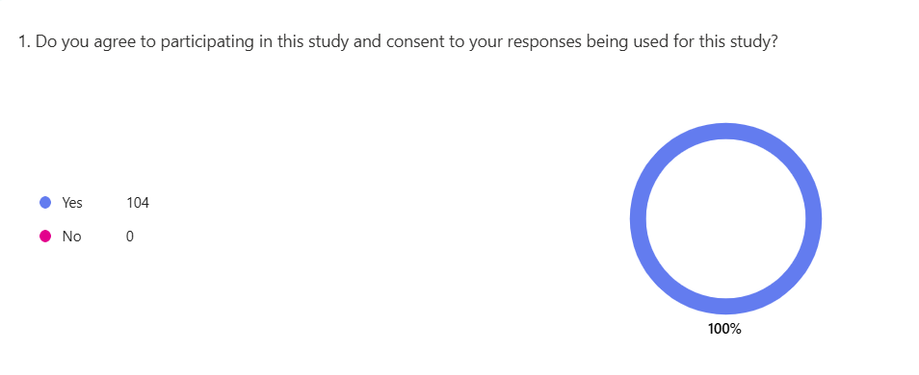

One hundred and four individuals completed the questionnaire that was distributed and consented to participate in this study. They also consented to their responses being used in this study.
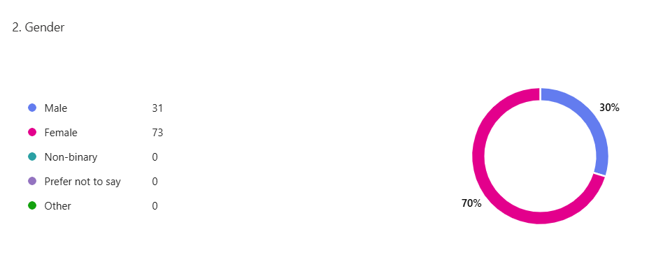

In this study, thirty-one (30%) of males participated, and seventy-three (70%) of females participated.

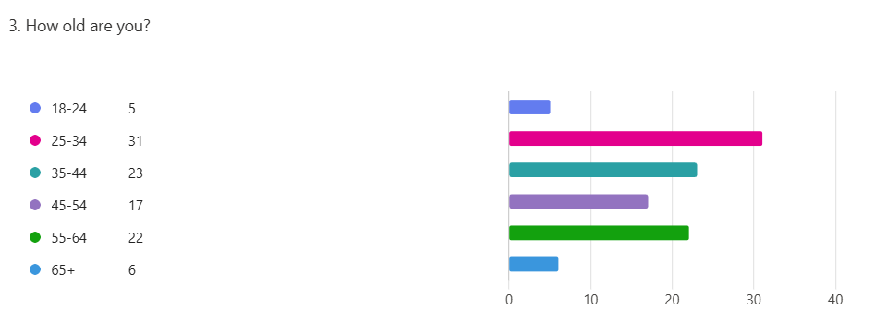

In this study, (5%) of the participants were aged between eighteen and twenty-four. (30%) of participants were aged between twenty-five and thirty-four. (22%) of participants were aged thirty-five and forty-four. (16%) of participants were aged forty-five and fifty-four. (21%) of participants were aged between fifty-five and sixty-four, and finally, (6%) of participants were aged sixty-five and above.
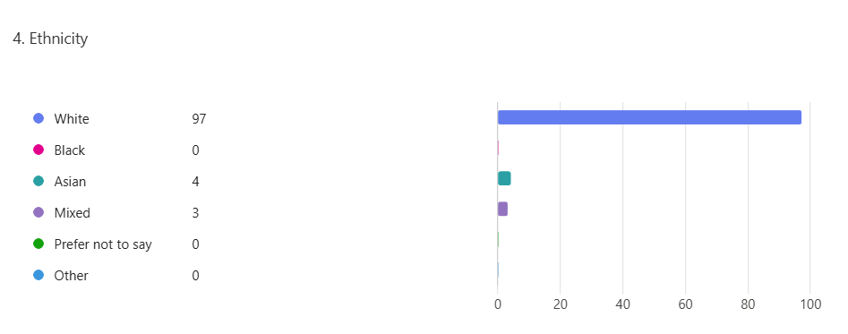

In this study, (93%) of the participants were white, (4%) were Asian, and (3%) were mixed race.
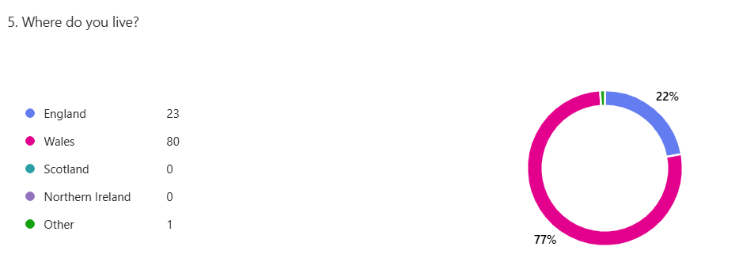

In this study, (22%) of the participants reside in England, (77%) reside in Wales, and (1%) reside in Asia.
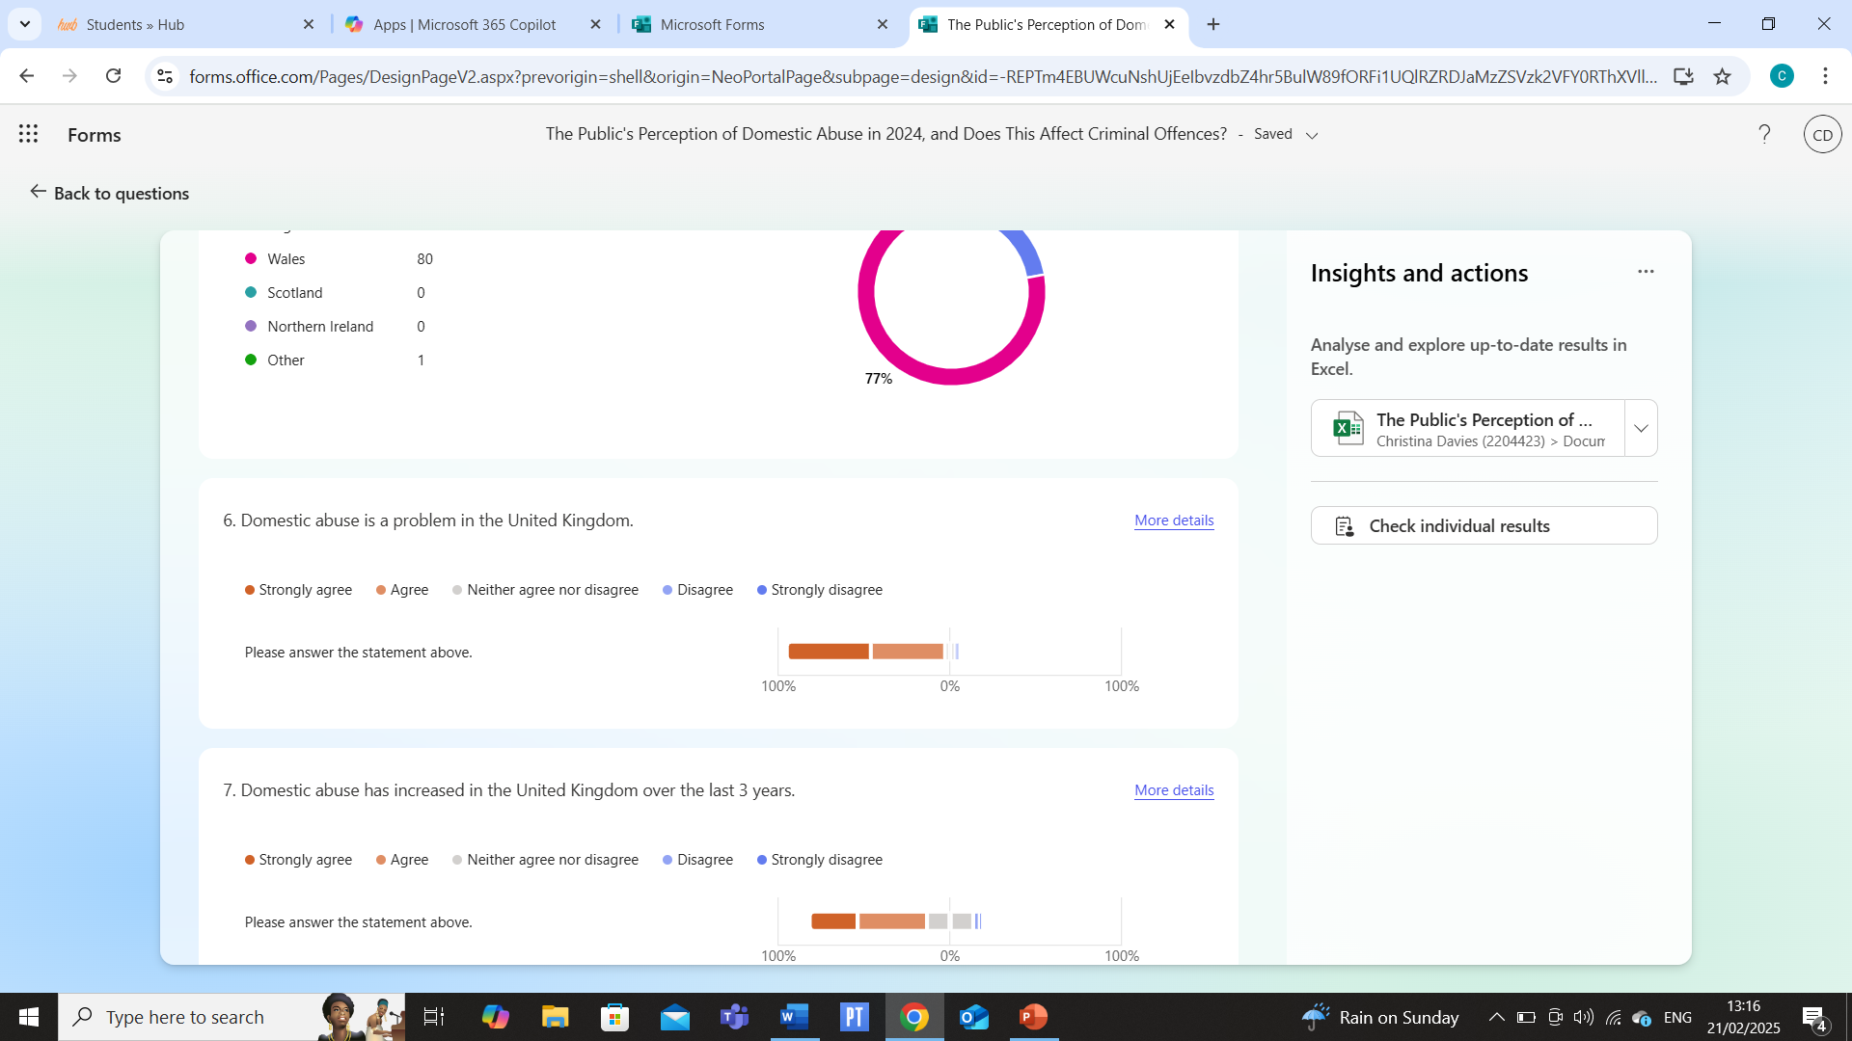
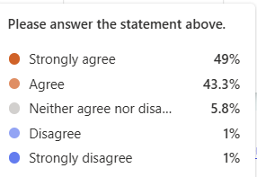

The results regarding the above question show that (49%) of the participants strongly agree that domestic abuse is a problem within the United Kingdom, followed by (43.3%) who agree, (5.8%) who neither agree nor disagree, (1%) who disagree and (1%) who strongly disagree.
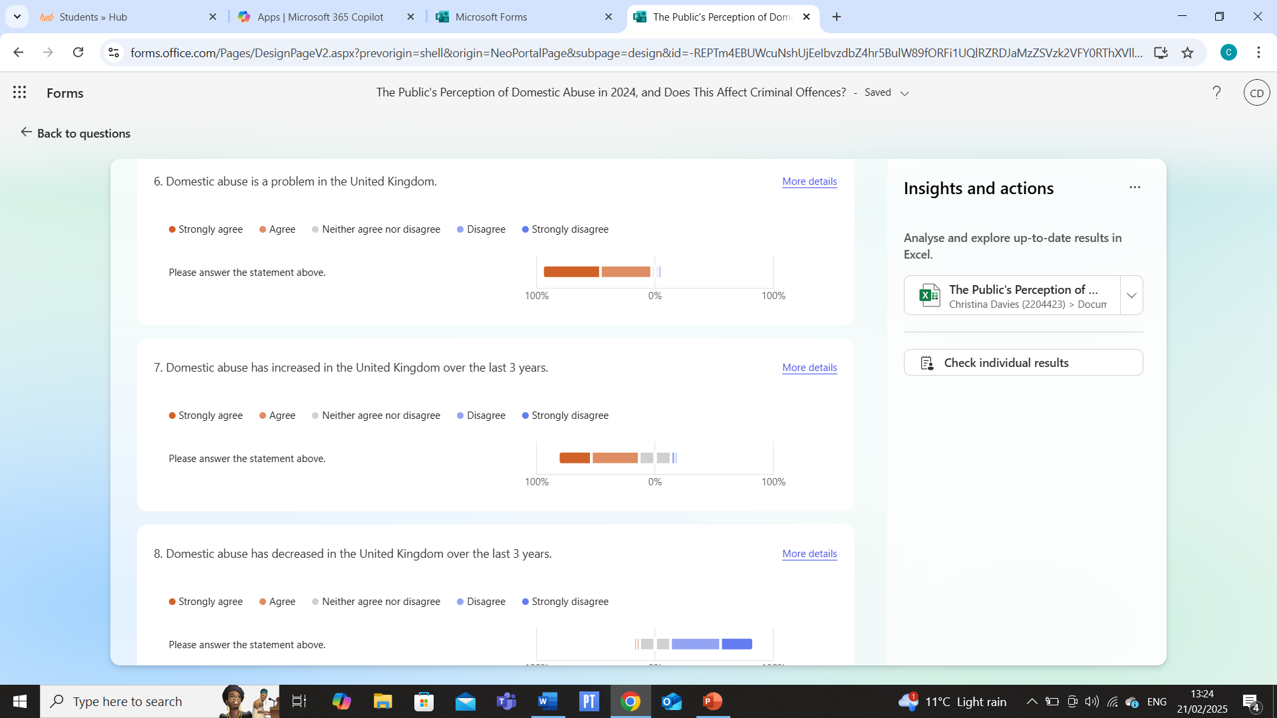

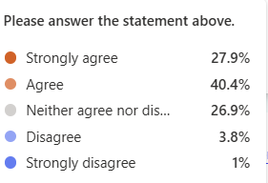

The results regarding the above question show that (40.4%) of the participants agree that domestic abuse has increased in the United Kingdom over the last three years, followed by (27.9%) who strongly agree, (26.9%) who neither agree nor disagree, (3.8%) who disagree and (1%) who strongly disagree.
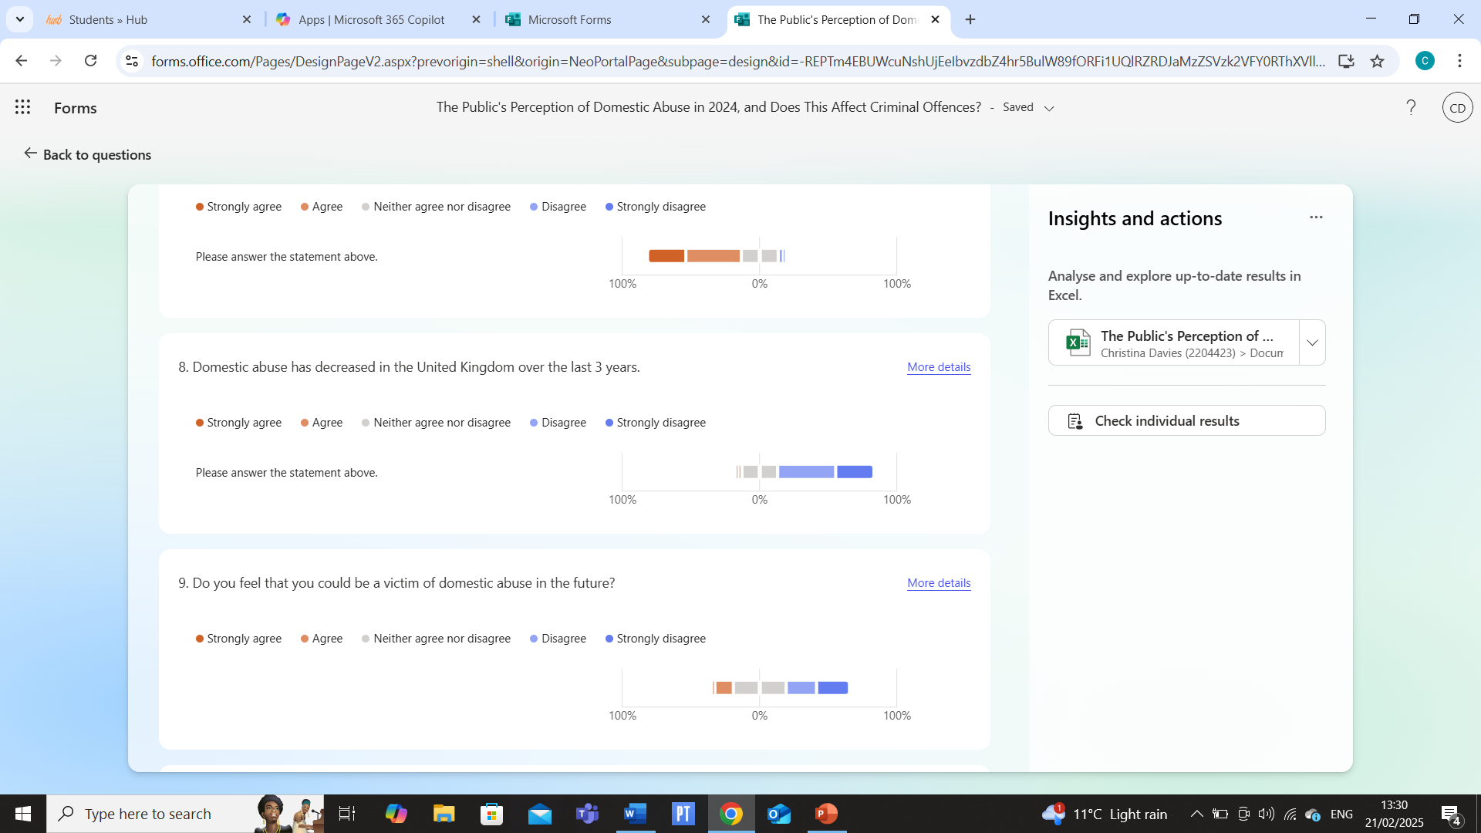
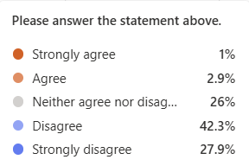

The results regarding the above question show that (42.3%) of the participants disagree that domestic abuse has decreased in the United Kingdom over the last three years, followed by (27.9%) who strongly disagree, (26%) who neither agree nor disagree, (2.9%) who agree and (1%) who strongly agree.
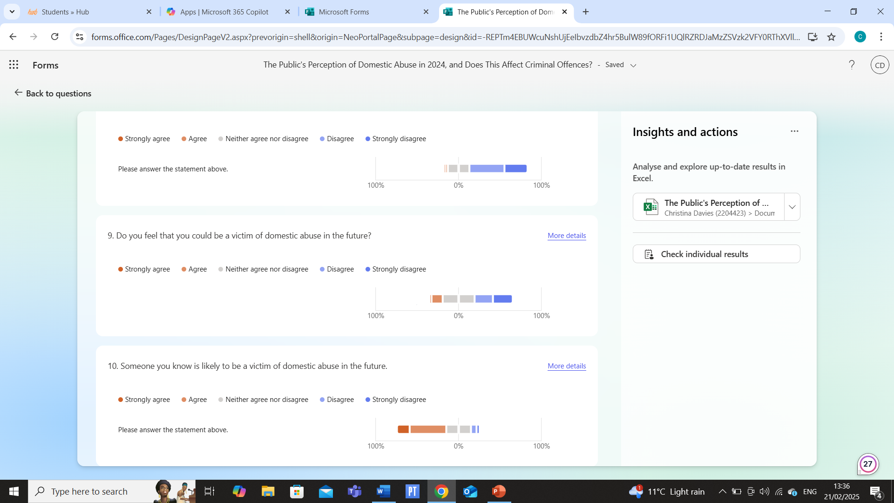
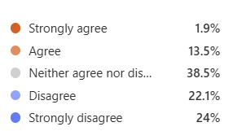

The results of this study show that (38.5%) of the participants neither agree nor disagree that they feel that they could be a victim of domestic abuse in the future, followed by (24%) who strongly disagree, (22.1%) who disagree, (13.5%) who agree and (1.9%) who strongly agree.
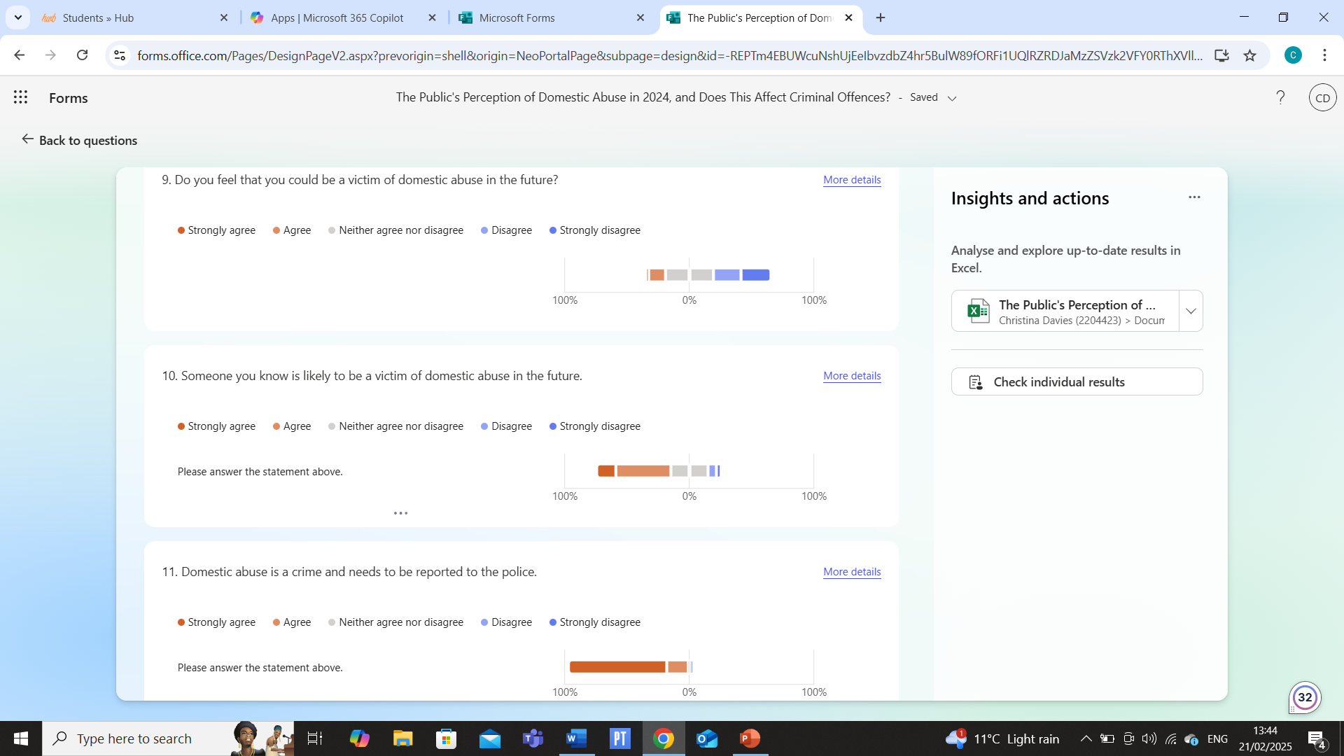
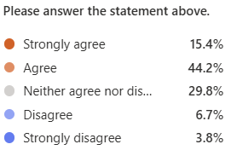

The results of this study show that (44.2%) of the participants agree that they will know someone who is likely to be a victim of domestic abuse in the future, followed by (29.8%) who neither agree nor disagree, (15.4%) who strongly agree, (6.7%) who disagree and (3.8%) who strongly disagree.
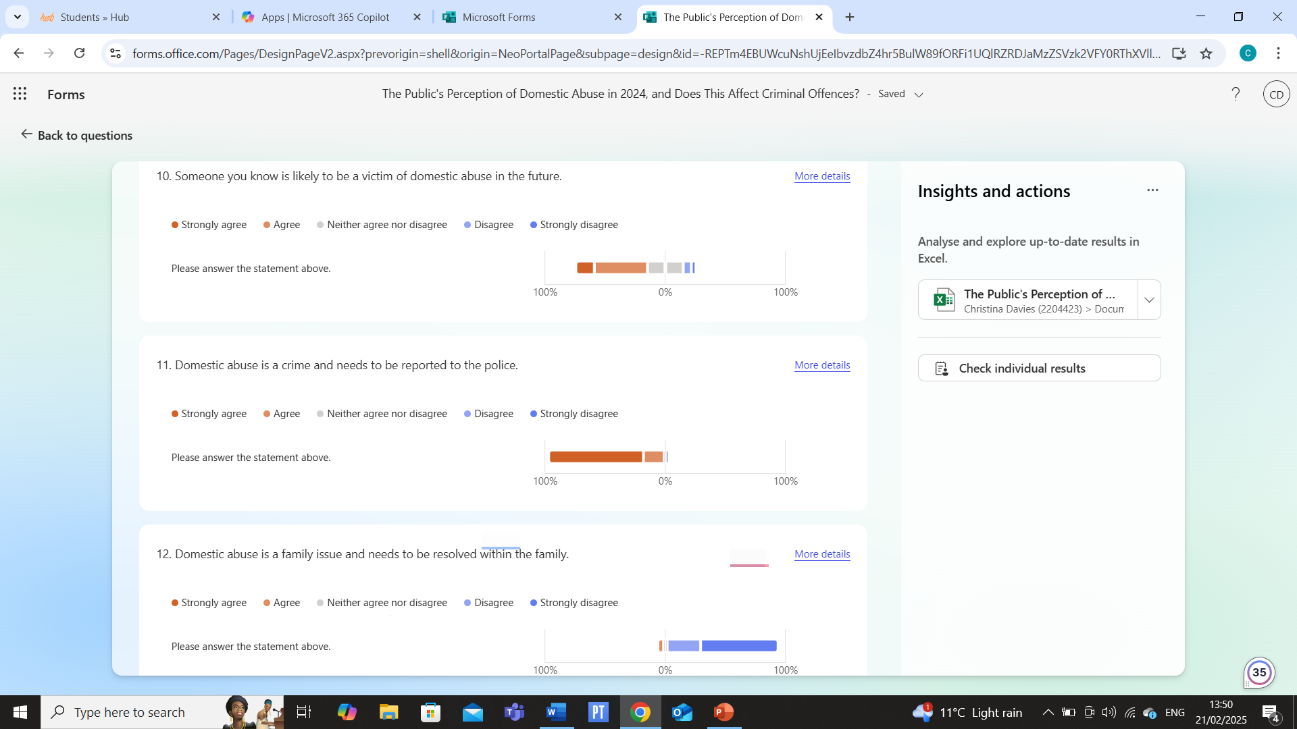
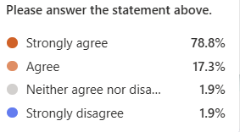

The results of this study show that (78.8%) of the participants strongly agree that domestic abuse is a crime and needs to be reported to the police, followed by (17.3%) who agree, (1.9%) who neither agree nor disagree and (1.9%) who strongly disagree.
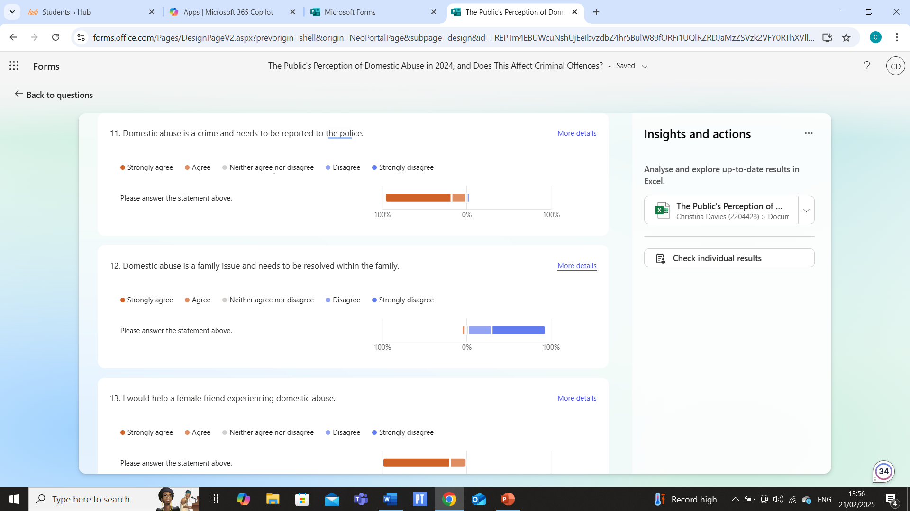
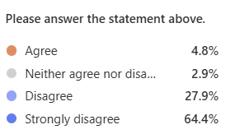

The results of this study show that (64.4%) of the participants strongly disagree that domestic abuse is a family issue and needs to be resolved within the family, followed by (27.9%) who disagree, (4.8%) who agree and (2.9%) who neither agree nor disagree.
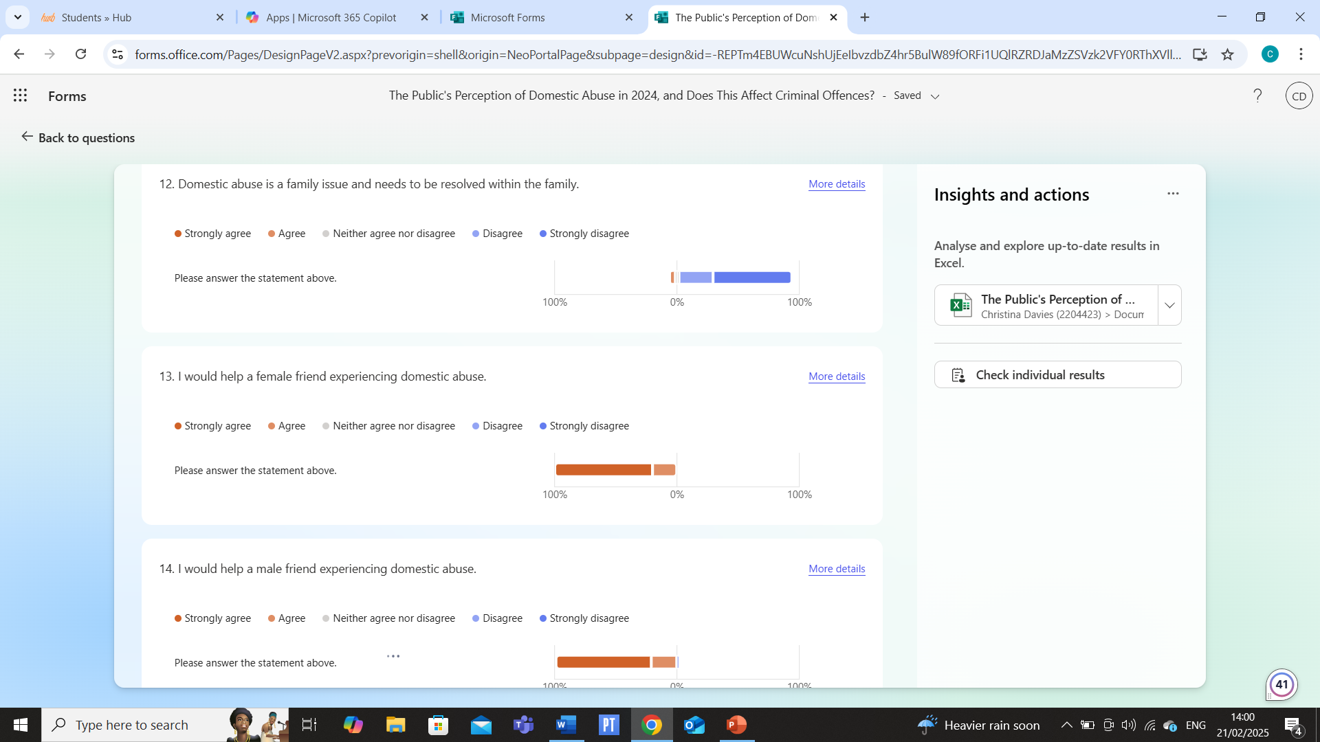

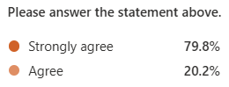

The results of this study show that (79.8%) of the participants strongly agree that they would help a female friend experiencing domestic abuse, followed by (20.2%) who agree.
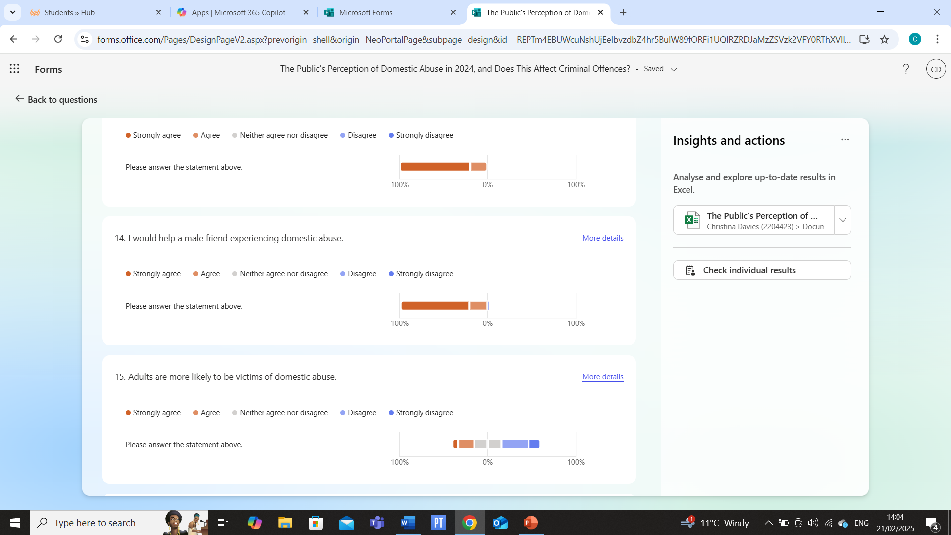
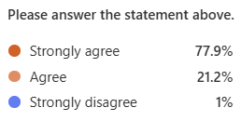

The results of this study show that (77.9%) of the participants strongly agree that they would help a male friend experiencing domestic abuse, followed by (21.2%) who agree and (1%) who strongly disagree.
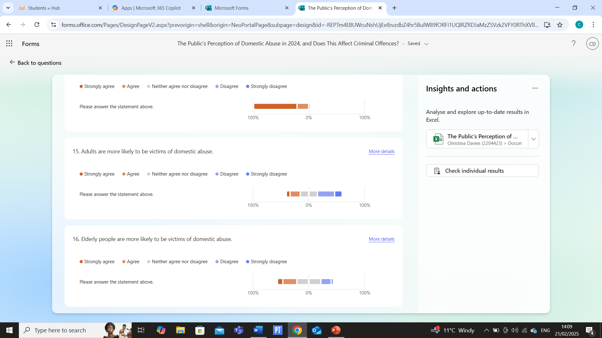
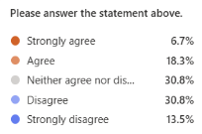

In this study, the results show that (30.8%) of the participants neither agree nor disagree that adults are more likely to be victims of domestic abuse, followed by (30.8%) who disagree, (18.3%) who agree, (13.5%) who strongly disagree and (6.7%) who strongly agree.
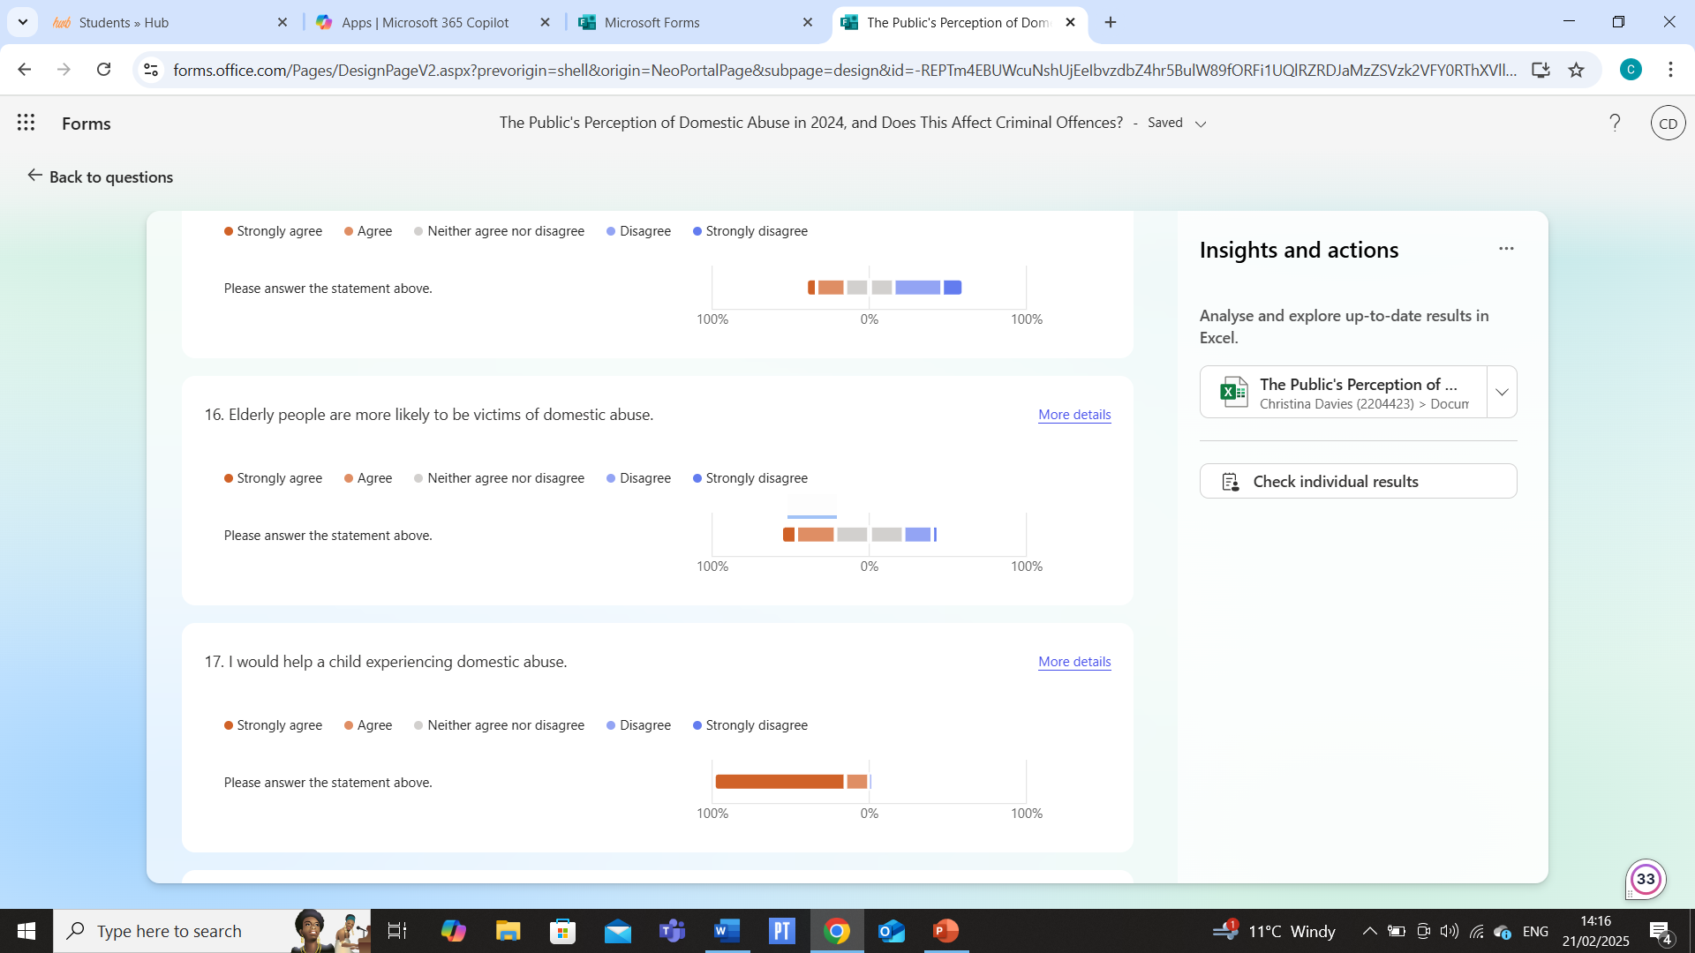
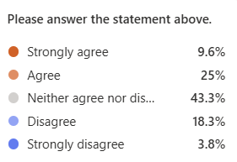

In this study, the results show that (43.3%) of the participants neither agree nor disagree that elderly people are more likely to be victims of domestic abuse, followed by (25%) who agree, (18.3%) who disagree, (9.6%) who strongly agree and (3.8%) who strongly disagree.
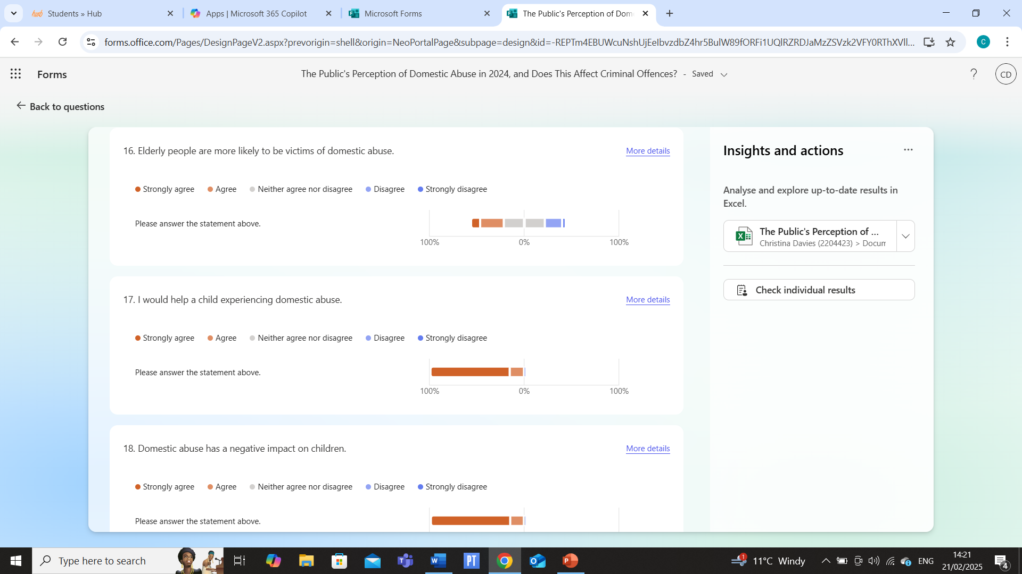
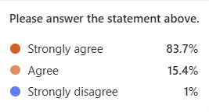

In this study, the results show that (83.7%) of the participants strongly agree that they would help a child experiencing domestic abuse, followed by (15.4%) who agree and (1%) who strongly disagree.

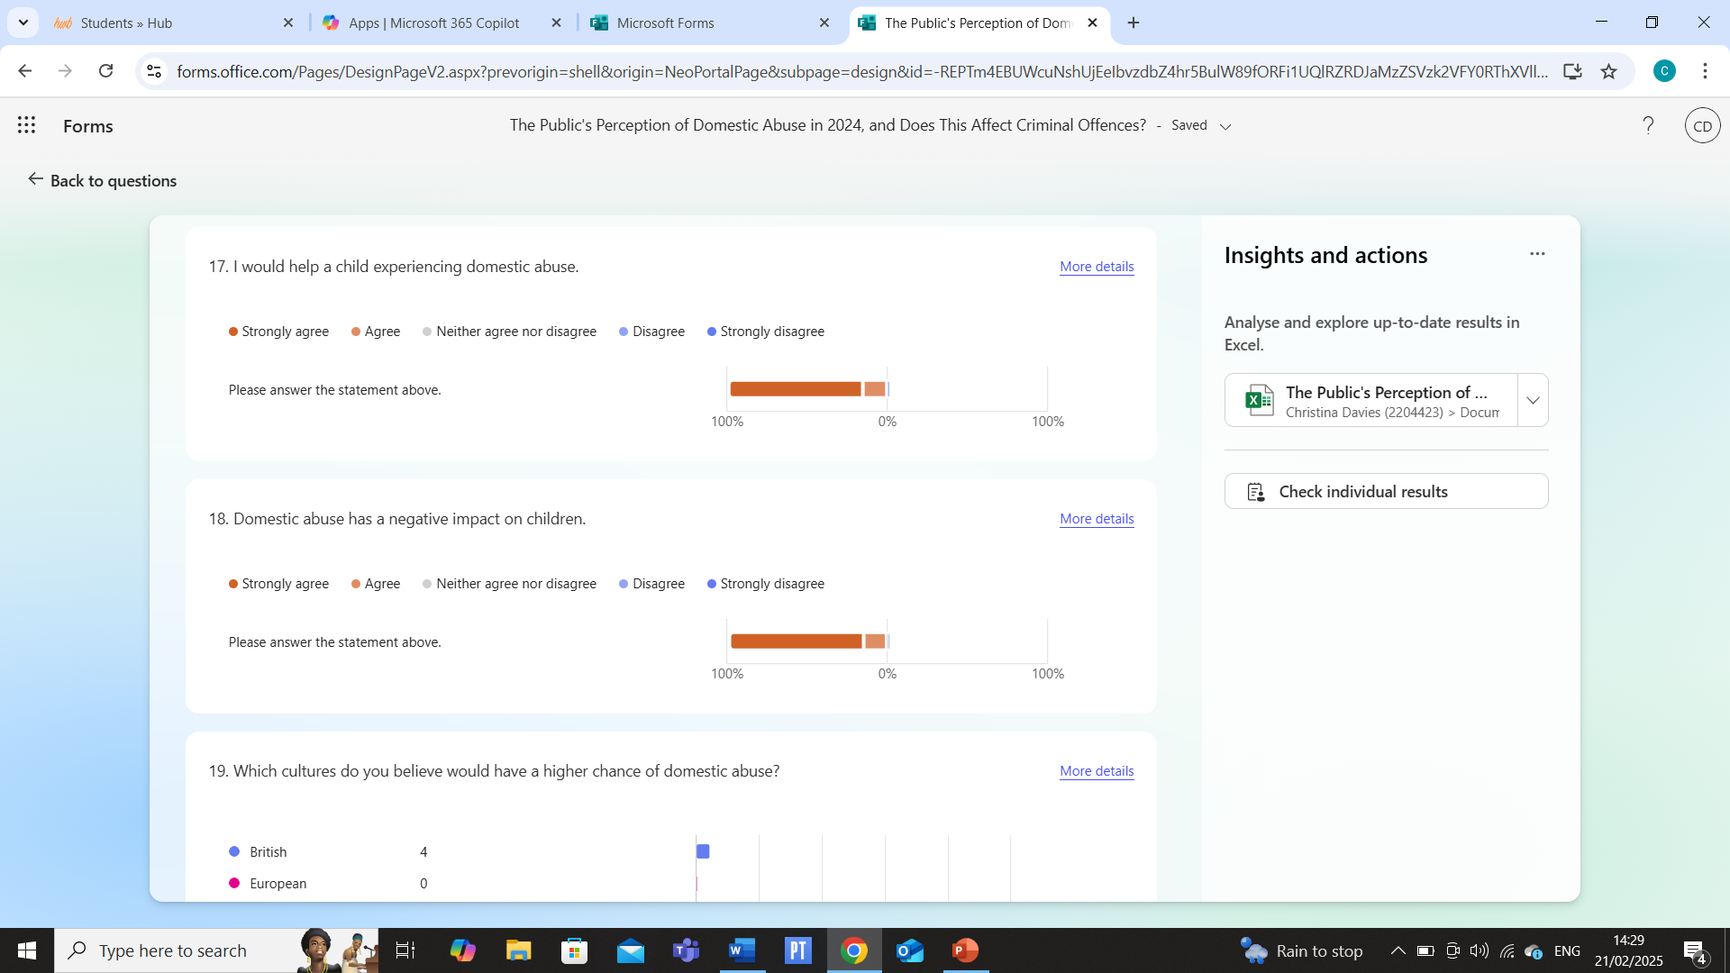
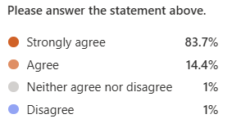

In this study, the results show that (83.7%) of the participants strongly agree that domestic abuse has a negative impact on children, followed by (14.4%) who agree, (1%) who neither agree nor disagree and (1%) who disagree.
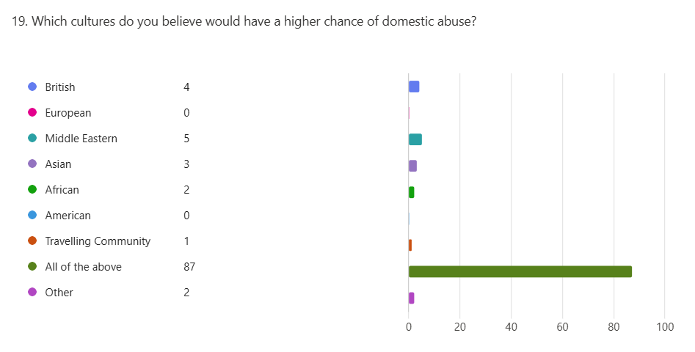

The results regarding the above question show that (84%) of the participants believe that all of the above cultures would have a higher chance of domestic abuse, followed by (5%) who believe that the Middle Eastern would have a higher chance of domestic abuse, (4%) who believe the British would have a higher chance of domestic abuse, (3%) who believe Asia would have a higher chance of domestic abuse, (2%) who believe the Africans will have a higher chance of domestic abuse, (2%) who believe maybe not dependent on culture and (1%) who believe the travelling community would have a higher chance of domestic abuse.
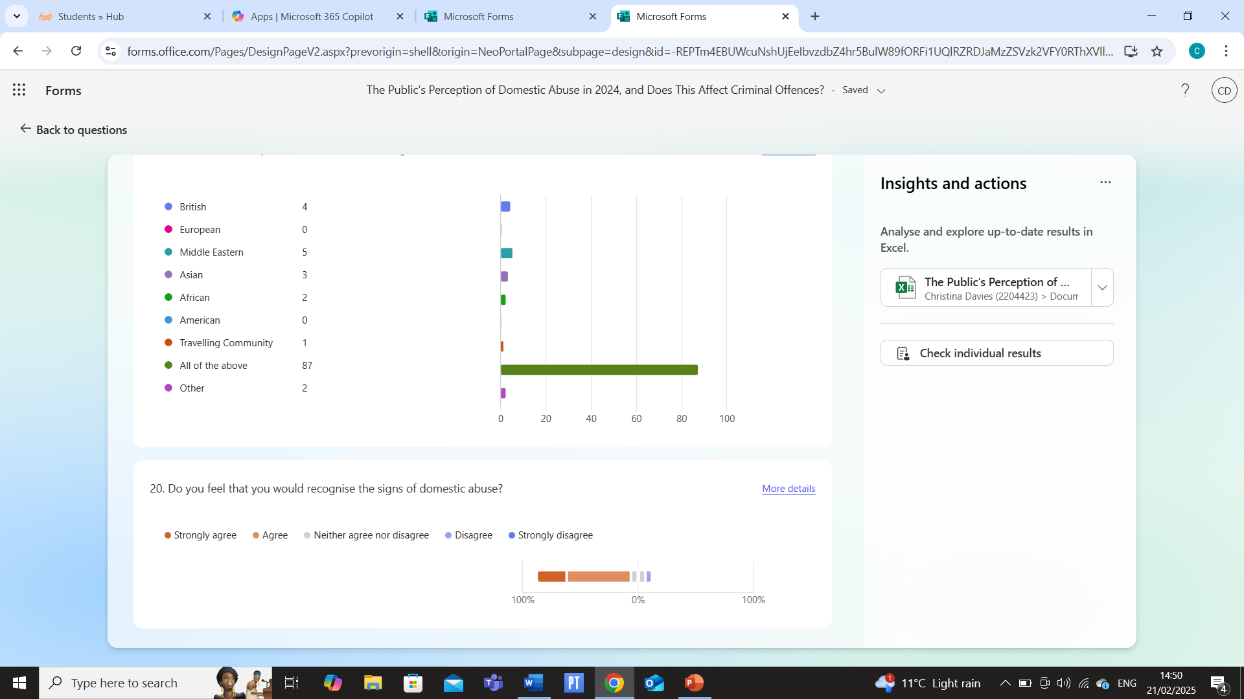
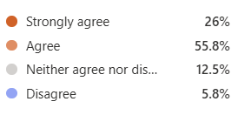

The results regarding the above question show that (55.8%) of the participants agree that they feel they would recognise the signs of domestic abuse, followed by (26%) who strongly agree, (12.5%) who neither agree nor disagree and (5.8%) who disagree.
In summary, the study involved 104 participants in total. (70%) of the participants were female, and most of the participants were aged between twenty-five to thirty-four (30%) and fifty-five to sixty-four (21%). This can be seen within the methodology, and it reflects the statistics by Herd.Digital (2021). The majority of the participants identified as white, and most of them lived in Wales (77%). The literature by Juarros-Basterretxea (et al., 2024) shows that domestic abuse is prevalent among women and highlights potential discrepancies in perceptions throughout the different ethnicities, as this study demographically focused on white participants from Wales. While this provides an insight into white individual’s views on other ethnic groups, it lacks data from those within the diverse communities.
Almost half (49%) of the participants strongly feel that domestic abuse is an issue within the United Kingdom. (40.4%) of the participants believe that domestic abuse has increased over the past three years, compared to the (42.3%) who feel that it has not decreased during that time period. (38.5%) of the participants are uncertain if they will potentially become victims of domestic abuse in the future, and (44.2%) of the participants think they may know someone who will be affected by domestic abuse. The majority (78.8%) of the participants agree that any incidents involving domestic abuse should be reported to the police, and (64.4%) of the participants do not see domestic abuse as a family matter. The majority (83.7%) of the participants acknowledge and strongly agree that domestic abuse can have an impact on children and are willing to help children who are experiencing it. This is supported by Chandan, et al., (2020). Also, the participants show that some cultures may disproportionately face domestic abuse, with (84%) of them recognising this reality. This study shows that participants and others are very aware of domestic abuse being a serious issue within society, with participants willing to help and support victims, as well as report any incidents of domestic abuse to the police.
The demographic of this study was mainly made up of females (70%), with the majority being twenty-five to sixty-four years of age. This study had the highest number of participants within the twenty-five to thirty-four age bracket and consisted of a white ethnicity group from Wales with a minority of participants (22%) from England. The researcher is aware of the limitations of geographical location and a bias in the data towards females. The literature review highlighted that there was the potential for a larger amount of female participants due to their increased exposure (Office for National Statistics, 2023; Badeness-Sastre, et al., 2024). However, the researcher did not wish to manipulate the results as that would have changed the natural perception.
The results indicate that (49%) and (43.3%) of the participants agree that domestic abuse is a problem in the United Kingdom. This demonstrates that the perception of domestic abuse is high, further highlighting that it is a global issue. This supports the views of Badeness-Sastre, et al (2024). This was further demonstrated with (40.4%) and (27.9%) of the participants who agree that domestic abuse has increased in the last three years. This shows that domestic abuse is a problem that is on the rise in the United Kingdom. This reflects the national statistics (Office for National Statistics, 2021; Office for National Statistics, 2023). This is further strengthened as (42.3%) and (27.9%) of the participants disagreed that domestic abuse had decreased in the last three years.
Interestingly, when the participants were asked if they could become a victim of domestic abuse, (38.5%) of them indicated that they neither agreed or disagreed, with only a small percentage of them agreeing (15.4%) and the remaining disagreeing. This demonstrates that the majority of participants are unsure if they could be potential victims. This reflects the literature review, as there could be two potential reasons for this. The first reason could indicate that there is a reduced understanding of domestic abuse when the abuse is mild (Juarros-Basterretxea, et al., 2024). The second reason could be the culture and stereotyping. Therefore, the participants were unsure if domestic abuse relates to them (Heron, et al., 2022; Juarros-Basterretxea, et al., 2024).
The question of whether the participants know someone who is likely to be a victim of domestic abuse in the future indicates that a more cultural influence is affecting perception. The majority of the participants in this question agreed at (44.2%) and neither agree or disagree drops to (29.8%). This demonstrates that the participants find it easier to recognise domestic abuse in others. This could be due to the normalisation of domestic abuse (Badeness-Sastre, et al., 2024) or the perception of stereotyping with the participants not stereotyping themselves (Heron, et al., 2022).
The question on the need to report to the police shows that the majority of the participants (78.8%) strongly agree. This indicates a strong understanding of a criminal act being committed. Additionally, the question about resolving domestic abuse in the family indicates that there is an awareness of domestic abuse being an issue that needs addressing through reporting to the authorities, indicating it is a social issue. These findings are similar to those of Juarros-Basterretxea, et al (2024).
The questions of whether the participants would help a female friend and a male friend demonstrates an awareness to help both males and females of domestic abuse. Interestingly, this was not reflected in the literature review with Margherita, et al., (2021), indicating that male support should be lower. This study indicates that once domestic abuse is perceived, individuals would likely want to support the person being abused.
When the participants were asked if adults are more likely to be victims of domestic abuse or the elderly, they both indicated that the perception of domestic abuse is seen less with adults (25%) than the elderly (34.6%). However, both are low, indicating that both age groups are considered low risk of domestic abuse. This supports the studies by Lonbay & Southall (2024), where domestic abuse was a young adult issue.
The questions of whether the participants would help a child experiencing domestic abuse and if domestic abuse has a negative impact on children, both indicated that children are perceived as higher risk, with both questions having over an (80%) agreement. This follows the literature review with Chandan, et al., (2020) demonstrating the perception that children need help with domestic abuse and can be impacted with psychological and physical issues.
When the participants were asked which cultures they believed would have a higher chance of domestic abuse, it demonstrated that the participants perceived that domestic abuse can occur in many cultures. This strengthens and supports the study by Badeness-Sastre, et al., (2024), indicating that improved perception can improve the understanding of domestic abuse.
When the participants were asked if they would recognise the signs of domestic abuse, it demonstrated the overall issue with perception and domestic abuse. The study has indicated that individuals will help different genders, age groups and cultures. However, recognising the signs could be the main perception issue as only (26%) of the participants strongly agreed, with the majority of the participants (55.8%) agreeing. This reduction in confidence could be a contributing factor to underreporting, as seen in the studies by Juarros-Basterretxea., et al., (2024).

Conclusion
In conclusion, this dissertation explores the public’s perception of domestic abuse in 2024 and how these perceptions affect criminal offences. Understanding how society views domestic abuse is essential for raising awareness and addressing the issue.
Domestic abuse is a worldwide issue affecting millions of people, including in the United Kingdom (Taub, 2020). While education and campaigns have contributed to the general understanding of the issue (Sivarajasingam, et al., 2022), many individuals continue to misunderstand it. To some, it may be a public disorder or a minor altercation. Some may even see it as a family issue. Additionally, many individuals may know of domestic abuse but fail to recognise its signs (Fox, et al., 2014; Worrall, 2013; Taub, 2020), leading to underreporting, especially in rural areas where data on prevalence is low or limited. Many victims feel ashamed, scared or financially dependent on their abuser, preventing them from reporting any incidents (Heron & Eisma, 2021).
Domestic abuse involves controlling, threatening, and violent behaviours, which including sexual violence in most cases between those who are aged sixteen and above. This can be carried out by partners, ex-partners, family members and carers, affecting people of all genders, and both sexes can be perpetrators and victims (Alejo, 2014). Although trends show an increased likelihood of males being perpetrators (Home Office, 2024a; Matczak, et al., 2011; Lloyd, 2018), anyone can be a victim, including men, same-sex couples and non-binary individuals. In recent years, the term domestic abuse has evolved into intimate partner violence, encompassing all forms of abuse within an individual's household (Denysschen & Evans, 2022).
This study provides significant insights into the perceptions and beliefs regarding domestic abuse based on a sample of 104 participants, mainly from Wales. The findings show a recognition of domestic abuse as a prevalent issue, with a significant percentage of participants expressing intense feelings about its impact, especially on children. The majority (83.7%) of the participants declared they would help a child experiencing domestic abuse, showing compassion and a willingness to intervene (Chandan, et al., 2024).
The demographic breakdown shows a significant representation of women (70%) within the sample, with most participants aged between twenty-five and forty-four. This demographic bias may highlight a gender bias, as previous research has suggested that women are more vulnerable to these situations (Juarros-Basterretxea, et al., 2024; Office for National Statistics, 2023; Badeness-Sastre, et al., 2024). A limitation is that it lacks a diverse ethnic representation, focussing mainly on a white Welsh demographic. The trends in perceptions of domestic abuse throughout different cultures are worth exploring further, as (84%) of the participants believe certain cultures may disproportionately face domestic abuse. This suggests a need for more inclusive research that includes various ethnic and cultural backgrounds, which could provide a broader perspective of domestic abuse patterns and perceptions (Badeness-Sastre, et al., 2024).
The study found (40.4%) of the participants believe domestic abuse has escalated in the past three years, which corresponds with the increased concerns about the societal impact of abuse, mainly in the context of recent global events (Badeness-Sastre, et al., 2024). Additionally, several participants (49%) strongly agree that domestic abuse is an issue within the United Kingdom, reflecting the findings of previous literature that identifies domestic abuse as a major public health concern (Office for National Statistics, 2021; Office for National Statistics, 2023).
The participants also expressed the importance of reporting domestic abuse, with (78.8%) agreeing that any incidents should be reported to the police. This highlights an increased awareness that domestic abuse should be viewed as a societal issue rather than a private matter, requiring intervention and support from the authorities (Juarros-Basterretxea, et al., 2024).
This study shows a high level of awareness and concern about domestic abuse among participants. Despite some limitations, including demographic limitations, the results show a commitment to recognising, addressing and supporting victims of domestic abuse. Future research should aim to include a more diverse sample and explore the differences in perceptions of domestic abuse throughout the different cultures. This may enhance the understanding of how domestic abuse is viewed in our society and improve prevention and intervention strategies for all demographic groups effectively (Badeness-Sastre, et al., 2024).

References
Alejo, K., (2014). Long-Term Physical and Mental Health Effects of Domestic Violence. Themis: Research Journal of Justice Studies and Forensic Science, 2(1), p. 5.
Anderberg, D. & Rainer, H., (2011). Domestic Abuse: Instrumental Violence and Economic Incentives.
Badeness-Sastre, M., Spencer, C.M., Alonso-Frres, M., Lorente, M. & Exposito, F., (2024). How severity of intimate partner violence is perceived and related to attitudinal variables? A systematic review and meta-analysis. Aggression and Violent Behavior, Volume 76, pp. 101-925.
Banerjee, D. & Rao, T. S. S., (2022). The Dark Shadow of Marital Rape: Need to Change The Narrative. Journal of Psychosexual Health, 4(1), pp. 11-13.
Bates, L. & Hester, M., (2020). No longer a civil matter? The design and use of protection orders for domestic violence in England and Wales. Journal of Social Welfare and Family Law, 42(2), pp. 133-153.
Benedictus, T. D., Jaffe, J. & Segal, J., (2004). Domestic Violence and Abuse: Types, Signs, Symptoms, Causes, and Effects. In: Helpguide: Mental Health Issues.
Bovill, H. & White, P., (2022). Ignorance Is Not Bliss: A UK Study of Sexual and Domestic Abuse Awareness on Campus, and Correlations With Confidence and Positive Action in A Bystander Program. Journal of Interpersonal Violence, 37(5-6), pp. 2801-2825.
Brennan, I., Couto, L. & O'Leary, N., (2023). Prevalence and patterns of domestic abuse victimisation in an English police workforce. Policing and Society, 33(6), pp. 703-716.
Brophy, J., (2022). Child care and the growth of power: The status of mothers in child custody disputes. In: Women-in-Law. 1st ed. Routledge, pp. 97-116.
Bunting, L., Webb, M. A. & Healy, J., (2010). In Two Minds? - Parental Attitudes Toward Physical Punishment in The UK. Children and Society, 24(5), pp. 359-370.
Burrell, S. R. & Dhir, A., (2023). The media and male victim-survivors of domestic abuse. In: In The Routledge Companion To Gender, Media and Violence. 1st ed. Routledge, pp. 34-43.
Chandan, J. S., Gokhale, K.M., Bradbury-Jones, C., Nirantharakumar, K., Bandyopadhyay, S. & Tylor, J., (2020). Exploration of trends in the incidence and prevalence of childhood maltreatment and domestic abuse recording in UK primary care: A retrospective cohort study using 'the health improvement network' database. BMJ Open, 10(6), pp. 036-949.
Chantler, K., Bracewell, K., Baker, V., Heyes, K., Traynor, P. & Ward, M., (2023). An analysis of minoritisation in domestic homicide reviews in England and Wales. Critical Social Policy, 43(4), pp. 602-625.
Choi, K., (2009). Tackling Domestic Violence in UK: Persistent Problems. International Area Studies Review, 12(1), pp. 17-43.
Davidge, S., (2022). Come Together To End Domestic Abuse: A Survey of UK Attitudes To Domestic Abuse 2022, Woman's Aid Federation of England.
Davis, J., (2019). Domestic Abuse. In: Cabot Police Department: School of Law Enforcement Supervision Session XVII.
Delap, L., (2011). Knowing Their Place: Domestic Service in Twentieth-Century Britain. Oxford University Press, USA.
Dennyschen, I. & Evans, R., (2022). Effects of intimate partner violence in the LGBTQ community: A systematic review. Queering Criminology in Theory and Praxis, pp. 111-128.
Donovan, C. & Hester, M., (2015). Domestic Violence and Sexuality: What's Love Got To Do With It?. Policy Press.
Dudley, R. G., (2017). Domestic abuse and woman with 'no recourse to public funds': The state's role in shaping and reinforcing coercive control. An International Journal of Research and Debate, 6(2), pp. 201-217.
Fox, C. L., Hale, R. & Gadd, D., (2014). Domestic abuse prevention education: Listening to the views of young people. Sex Education: Sexuality, Society and Learning, 14(1), pp. 28-41.
Foyster, E., (2005). Marital Violence: An English Family History, 1660-1857. Cambridge University Press.
Freeman, M. D. A., (1989). Domestic Violence: The Limits of Effective Legal Action. Cambrian L. Rev, Volume 20, p. 17.
Gama, A., Pedro, A. R., de Carvalho, M. J. L., Guerreiro, A. E., Duarte, V., Quintas, J., Matias, A., Keygnaert, I., Dias, S., (2021). Domestic Violence During The Covid-19 Pandemic in Portugal. Portuguese Journal of Public Health, 38(1), pp. 32-40.
Goetzmann, W. N., (2023). Harry Markowitz in Memoriam. Financial Analysts Journal, 79(4), pp. 5-7.
Gorczowska, J., (2022). The Child Protection System in England and Wales. In: Child Protection System - Just Think Differently?. Wydawnictwa Uniwesytetu Warszawskiego, pp. 97-122.
Grembi, V., Rosso, A. C. & Barili, E., (2024). Domestic violence perception and gender stereotypes. Journal of Population Economics, 37(1), p. 1.
Hague, J., (2021). History and memories of the domestic violence movement. In: We've come further than you think. Policy Press.
Herd.Digital, (2021). Facebook Satatistics You Need To Know in 2024.
Available at: https://herd.digital/blog/facebook-statistics-2022/
(Accessed: 16th February 2025).
Heron, R. L. & Eisma, M. C., (2021). Barriers and facilitators of disclosing domestic violence to the healthcare service: A systematic review of qualitative research. Health and Social Care in The Community, 29(3), pp. 612-630.
Heron, R. L., Eisma, M. C. & Browne, K., (2022). Barriers and Facilitators of Disclosing Domestic Violence To The UK Health Service. Journal of Family Violence, 37(3), pp. 533-543.
Hewitt, L., (2023). Male victims of domestic abuse or intimate partner violence: The causation surrounding why men have low rates of reporting - From a societal perspective. In: Doctor of Criminal Justice. Doctoral Dissertation, Saint Leo University, pp. 1-24.
Hill, J., (2020). See What You Made Me Do. In: Power, Control and Domestic Abuse. Oxford University Press.
Hirst, E., (2003). The housing crisis for victims of domestic violence: Disparate impact claims and other housing protection for victims of domestic violence. Georgetown Journal on Poverty Law and Policy, 10(1), p. 131.
Holt, A. E., Charquero-Ballester, M., Walter, J. G. & Anja, B., (2023). Misinformation Exposure on Facebook in The EU and UK.
Home Office, (2015). Equality Act 2010: Guidance.
Available at: https://www.gov.uk/guidance/equality-act-2010-guidance#:~:text=The%20Equality%20Act%202010%20legally,strengthening%20protection%20in%20some%20situations.
(Accessed: 15th March 2024).
Home Office, (2023). The Children (Abolition of Defence of Reasonable Punishment) (Wales) Act 2020: First Data Release.
Available at: https://www.gov.wales/children-abolition-defence-reasonable-punishment-wales-act-2020-first-data-release-html#:~:text=Background-,The%20Children%20(Abolition%20of%20Defence%20of%20Reasonable%20Punishment)%20(Wales,force%20on%2021%20March%202022.
(Accessed: 8th March 2024).
Home Office, (2024a). Domestic Abuse Act 2021.
Available at: https://www.legislation.gov.uk/ukpga/2021/17
(Accessed: 8th March 2024).
Home Office, (2024b). The Data Protection Act.
Available at: https://www.gov.uk/data-protection
(Accessed: 30th October 2024).
Humphreys, C. & Thiara, R., (2003). Mental Health and Domestic Violence: 'I Call it Symptoms of Abuse'. The British Journal of Social Work, 33(2), pp. 209-226.
Iob, E., Steptoe, A. & Fancourt, D., (2020). Abuse, self-harm and suicidal ideation in the UK during the Covid-19 pandemic. The British Journal of Psychiatry, 217(14), pp. 543-546.
Irving-Clarke, Y. & Henderson, K., (2020). Housing and Domestic Abuse. In: Policy into Practice. 1st ed. Routledge, p. 198.
Irving, L. & Liu, B. C.-p., (2020). Beaten into submissiveness? An investigation into the protective strategies used by survivors of domestic abuse. Journal of Interpersonal Violence, 35(1-2), pp. 294-318.
John, P., (2010). Quantitative Methods. In: D. Marsh & G. Stoker, eds. Theory and Methods in Political Science. 3rd ed. Palgrave Macmillan, pp. 216-230.
Johnson, M. E., (2014). A Home With Dignity: Domestic Violence and Property Rights. BYU L Rev, p. 1.
Juarros-Basterretxea, J., Fernandez-Alvarez, N., Torres-Vallejos, J. & Herrero, J., (2024). Perceived reportability of intimate partner violence against women to the police and help-seeking: A national survey. Psychosocial Intervention, 33(1), pp. 55-64.
Karunarathna, I., Gunasena, P., Hapuarachchi, T., Ekanayake, U., Rajapaksha, S., Gunawardana, K., Aluthge, P., Bandara, S., Jayawardana, A., De Alvis, K., Gunathilake, S., (2024). Data collection fundamentals: A guide to effective research methodologies and ethical practices.
Lloyd, M., (2018). Domestic Violence and Education: Examining The Impact of Domestic Violence on Young Children, Children, and Young People and The Potential Role of Schools. Frontiers in Psychology, Volume 9, pp. 396-402.
Lonbay, S. P. & Southall, C., (2024). Identifying and responding to domestic abuse in the older population: Key challenges and complexities. European Journal of Social Work, 27(2), pp. 374-386.
Mackenzie, M., Gannon, M., Stanley, N., Cosgrove, K. & Feder, G., (2019). 'You certainly don't go back to the doctor once you've been told, "I'll never understand women like you."' Seeking candidacy and structural competency in the dynamics of domestic abuse disclosure. Sociology of Health and Illness, 41(6), pp. 1159-1174.
Margherita, M., Franceschetti, L., Maggioni, L., Vignali, G., Kustermann, A. & Cattaneo, C., (2021). Male victims of sexual abuse and domestic violence: A steadily increasing phenomenon. Medicine, Science and The Law, 61(1), pp. 54-61.
Matczak, A., Hatzidimitriadou, E. & Lindsay, J., (2011). Review of Domestic Abuse Violence Policies in England & Wales. In: School of Social Work, Faculty of Health and Social Care Sciences. Kingston University and St George's, University of London, pp. 1-28.
Mayhew, J. & Jahankhani, H., (2020). Combating domestic abuse inflicted in smart societies. Cyber Defence in The Age of AI, Smart Societies and Augmented Humanity, pp. 347-373.
McCleary-Sills, J., Namy, S., Nyoni, J., Rweyemamu, D., Salvatory, A. & Steven, E., (2016). Stigma, shame and women's limited agency in help-seeking for intimate partner violence. Global Public Health, 11(1-2), pp. 224-235.
Moreira, D. N. & Costa, M. P. d., (2021). Should domestic violence be or not a public crime?. Journal of Public Health, 43(4), pp. 833-838.
Office for National Statistics, (2021). Domestic Abuse in England and Wales Overview: November 2021.
Available at: https://www.ons.gov.uk/peoplepopulationandcommunity/crimeandjustice/bulletins/domesticabuseinenglandandwalesoverview/november2021
(Accessed: 10th March 2024).
Office for National Statistics, (2022). Domestic Abuse Prevalence and Trends, England and Wales: Year Ending March 2022.
Available at: https://www.ons.gov.uk/peoplepopulationandcommunity/crimeandjustice/articles/domesticabuseprevalenceandtrendsenglandandwales/yearendingmarch2022
(Accessed: 10th March 2024).
Office for National Statistics, (2023). Domestic Abuse in England and Wales Overview: November 2023.
Available at: https://www.ons.gov.uk/peoplepopulationandcommunity/crimeandjustice/bulletins/domesticabuseinenglandandwalesoverview/november2023
(Accessed: 10th March 2024).
Othman, S., Goddard, C. & Piterman, L., (2014). Victims' Barriers To Discussing Domestic Violence in Clinical Consultations: A Qualitative Enquiry. Journal of Interpersonal Violence, 29(8), pp. 1497-1513.
Postmus, J. L., Plummer, S.B., McMahon, S., Murshid, N.S. & Kim, M.S., (2012). Understanding Economic Abuse in The Lives of Survivors. Journal of Interpersonal Violence, 27(3), pp. 411-430.
Radford, J., (2023). History of Women's Liberation Movements in Britain: A reflective personal history. In: Stirring It. Routledge, pp. 40-58.
Raisanen, M., Postareff, L. & Lindblom-Ylanne, S., (2021). Students' experiences of study-related exhaustion, regulation of learning, peer learning and peer support during university studies. European Journal of Psychology of Education, Volume 36, pp. 1135-1157.
Rauhaus, B. M., Sibila, D. & Johnson, A. F., (2020). Addressing the increase of domestic violence and abuse during Covid-19 pandemic: A need for empathy, care, and social equity in collaborative planning and responses. The American Review of Public Administration, 50(6-7), pp. 668-674.
Reed, E. S., (2009). The Cycle of Abuse: Personal and Political. A Journal of Economics, Culture and Society, 8(3), pp. 145-150.
Robinson, J., (2024). Likert Scale. In: Encyclopedia of Quality of Life and Well-Being Research. Cham: Springer International Publishing, pp. 3917-3918.
Robinson, K., (2020). Critical, multicultural practice: Domestic violence, and refugees and asylum seekers. In: Critical Multicultural Practice in Social Work. Routledge, pp. 149-162.
Sharratt, K., Mason, S. J., Kirkman, G., Willmott, D., McDermott, D., Timmins, S., Wager, N. M., (2023). Childhood abuse and neglect, exposure to domestic violence and sibling violence: Profiles and associations with sociodemographic variables and mental health indicators. Journal of Interpersonal Violence, 38(1-2), pp. 1141-1162.
Singh, S. & Sagar, R., (2021). A critical look at online survey or questionnaire-based research studies during Covid-19. Asian Journal of Psychiatry, Volume 65, pp. 102-850.
Sivarajasingam, V., Webber, I., Riboli-Sasco, E., Alaa, E. & El-Osta, A., (2022). Investigating public awareness, prevailing attitudes and perceptions towards domestic violence and abuse in the United Kingdom: A qualitative study. BMC Public Health, 22(1), p. 2042.
Skafida, V., Morrison, F. & Devaney, J., (2022). Prevalence and social inequality in experiences of domestic abuse among mothers of young children: A study using national survey data from Scotland. Journal of Interpersonal Violence, 37(11-12), pp. 9811-9838.
Sohal, A. H., Feder, G., Boomla, K., Dowrick, A., Hooper, R., Howell, A., Johnson, M., Lewis, N., Robinson, C., Eldridge, S. & Griffiths, C., (2020). Improving the healthcare response to domestic violence and abuse in UK primary care: Interrupted time series evaluation of a system-level training and support programme. BMC Medicine, Volume 18, pp. 1-10.
Speed, A. & Richardson, K., (2022). 'Should I Stay or Should I Go Now? If I Go There Will Be Trouble and If I Stay It Will Double': An Examination into The Present and Future of Protective Orders Regulating The Family Home in England and Wales. The Journal of Criminal Law, 86(3), pp. 179-205.
Stratton, S. J., (2021). Population Research: Convenience Sampling Strategies. Prehospital and Disaster Medicine, 36(4), pp. 373-374.
Sullivan, G. M. & Artino, Jr, A. R., (2013). Analyzing and Interpreting Data From Likert-Type Scales. Journal of Graduate Medical Education, 5(4), pp. 541-542.
Taherdoost, H., (2022). What are different research approaches? Comprehensive review of qualitative, quantatative, and mixed method research, their applications, types and limitations. Journal of Management Science and Engineering Research, 5(1), pp. 53-63.
Talbot, J. C., (2009). The Road To Positive Discipline: A Parents Guide. In: B. Talbot, ed. TNT Publishing Los Angeles, CA .
Taub, A., (2020). A New Covid-19 Crisis: Domestic Abuse Rises Worldwide. The New York Times, 6(6).
Taylor, J. C., Bates, E. A., Colosi, A. & Creer, A. J., (2022). Barriers To Men's Help Seeking for Intimate Partner Violence. Journal of Interpersonal Violence, 37(19-20), pp. NP18417-NP18444.
Turnitin, (2025). What is the history of multiple-choice exams? What is its impact on education?.
Available at: https://www.turnitin.com/blog/what-is-the-history-of-multiple-choice-exams-what-is-its-impact-on-education#:~:text=The%20origin%20of%20multiple%20choice,in%20evaluating%20student%20reading%20ability.
(Accessed: 1st February 2025).
University of Wales Trinity Saint David's, (2025). Research Integrity and Ethics.
Available at: https://www.uwtsd.ac.uk/research/research-integrity-and-ethics
(Accessed: 1st February 2025).
Walby, S., (2004). The Cost of Domestic Violence: City Research Online, City University Of London.
Walklate, S., Godfrey, B. & Richardson, J., (2022). Changes and continuities in police responses to domestic abuse in England and Wales during the Covid-19 'lockdown'. Policing and Society, 32(2), pp. 221-233.
Worrall, K., (2013). Alone, Misunderstood, Angry. An interpretative analysis of young people's experiences of witnessing domestic violence and abuse. In: Department of Educational Studies. Doctoral Dissertation, University of Sheffield, pp. 1-181.
Zorza, J., (1992). The Criminal Law of Misdemeanor Domestic Violence, 1970-1990. The Journal of Criminal Law and Criminology, 83(1), p. 46.

Legislation
Children’s Act (2022)
Domestic Abuse Act (2021)
Domestic Violence, Crime and Victims Act (2004)
Domestic Violence and Matrimonial Proceedings Act (1976)
Equality Act (2015)
General Data Protection Regulation (2018)


Appendices

Appendix 1
PG2 / E1 Form
APPLICATION FOR ETHICAL APPROVAL
In order for research to result in benefit and minimise risk of harm, it must be conducted ethically. A researcher may not be covered by the University’s insurance if ethical approval has not been obtained prior to commencement.
The University follows the OECD Frascati manual definition of research activity: “creative work undertaken on a systematic basis in order to increase the stock of knowledge, including knowledge of man, culture and society, and the use of this stock of knowledge to devise new applications”. As such this covers activities undertaken by members of staff, postgraduate research students, and both taught postgraduate and undergraduate students working on dissertations/projects.
The individual undertaking the research activity is known as the “principal researcher”.
Ethical approval is not required for routine audits, performance reviews, quality assurance studies, testing within normal educational requirements, and literary or artistic criticism.
Please read the notes for guidance before completing ALL sections of the form.
This form must be completed and approved prior to undertaking any research activity. Please see Checklist for details of process for different categories of application.

SECTION A: About You (Principal Researcher)
1 | Full Name: |  | Christina Mikayla Davies
2 | Tick all boxes that apply: |  | Member of staff: | ☐ | Honorary research fellow: | ☐
 | Undergraduate Student | ☒ | Taught Postgraduate Student | ☐ | Postgraduate Research Student | ☐

3 | Institute/Academic Discipline/Centre: | Institute Management of Health
4 | Campus: | Swansea Business Campus
5 | E-mail address: | 2204423@student.uwtsd.ac.uk
6 | Contact Telephone Number: | 07983644112
 | For students:
7 | Student Number: | 2204423
8 | Programme of Study: | BSc Professional Policing
9 | Director of Studies/Supervisor: | Mike Durke

1 | Has the research activity received approval in principle?  (please check the Guidance Notes as to the appropriate approval process for different levels of research by different categories of individual) |  | YES | ☒ | NO | ☐
 |  |  |  |  | Date
2 | If Yes, please indicate source of approval (and date where known): Approval in principle must be obtained from the relevant source prior to seeking ethical approval | Research Degrees Committee |  | ☐
2 |  | Institute Research Committee |  | ☐
2 |  | Other (write in)  Mike Durke |  | ☒ | 3rd May 2024
SECTION B: Approval for Research Activity

SECTION C: Internal and External Ethical Guidance Materials
 | Please list the core ethical guidance documents that have been referred to during the completion of this form (including any discipline-specific codes of research ethics, location-specific codes of research ethics, and also any specific ethical guidance relating to the proposed methodology). Please tick to confirm that your research proposal adheres to these codes and guidelines. You may add rows to this table if needed.
1 | UWTSD Research Ethics & Integrity Code of Practice | ☒
2 | UWTSD Research Data Management Policy | ☒
3 | [List any other relevant documents here] | ☐

SECTION D: External Collaborative Research Activity
If there are external collaborators then you should gain consent from the contact persons to share their personal data with the university. If there are no external collaborators then leave this section blank and continue to section E.
1 | Institution
2 | Contact person name
3 | Contact person e-mail address
4 | Is your research externally funded? |  | YES | ☐ | NO |  | ☐
5 | Are you in receipt of a KESS scholarship? |  | YES | ☐ | NO |  | ☐
6 | Are you specifically employed to undertake this research in either a paid or voluntary capacity? | Voluntary | YES | ☐ | NO | ☐
7 |  | Employed | YES | ☐ | NO | ☐
8 | Is the research being undertaken within an existing UWTSD Athrofa Professional Learning Partnership (APLP)? | If YES then the permission question below does not need to be answered. | YES | ☐ | NO |  | ☐
9 | Has permission to undertake the research has been provided by the partner organisation? | (If YES attach copy)  If NO the application cannot continue | YES | ☐ | NO |  | ☐

10 | Does this organisation have its own ethics approval system? | YES | ☐ | NO | ☐
 | If Yes, please attach a copy of any final approval (or interim approval) from the organisation (this may be a copy of an email if appropriate).
Where research activity is carried out in collaboration with an external organisation

SECTION E: Details of Research Activity
1 | Indicative title: | What is the perception of domestic abuse in 2024, and how does this affect criminal offences?
2 | Proposed start date: | September 2024 | Proposed end date: | May 2025
Introduction to the Research (maximum 300 words per section)
Ensure that you write for a Non-Specialist Audience when outlining your response to the points below:
- Purpose of Research Activity
- Proposed Research Question
- Aims of Research Activity
- Objectives of Research Activity
Demonstrate, briefly, how Existing Research has informed the proposed activity and explain
- What the research activity will add to the body of knowledge
- How it addresses an area of importance.
3 | Purpose of Research Activity  This topic has been chosen because it seems interesting to research the different perceptions that the members of the public have on domestic abuse. It is worthy of consideration for an undergraduate dissertation because there is a lot of information regarding this topic and the above question. In-depth research can be done on this topic, and the results will be extremely exciting to see. It also allows for a low-risk research study to be carried out by an undergraduate student. This research can be added to the current research on domestic abuse to understand further and potentially help increase understanding and awareness of the current perception of domestic abuse. The research could identify areas where perception can be changed through education to combat the crime of domestic abuse.  (this box should expand as you type)
4 | Research Question  The research question is the following: what is the perception of domestic abuse in 2024, and how does this affect criminal offences?  (this box should expand as you type)
5 | Aims of Research Activity  The aim is to gather information from members of the public about their perceptions of domestic abuse in 2024.  (this box should expand as you type)
6 | Objectives of Research Activity  The first objective is to research and gather as much information as possible about the public’s perception of domestic abuse. To gather information, reliable online and physical resources such as Google, Google Scholar, library systems, journal articles, books, and reports will be used.  The second objective is to research the history of domestic abuse and its prevalence within the United Kingdom leading up to the year 2024. Research in this area will also explore key themes that developed during the literature review, which will be explored in the survey. The key themes identified are gender, age, and culture.  The third objective is to produce an online general questionnaire survey for the public to participate in and complete on Microsoft Forms, which will gather information on gender, age, and culture as key themes to explore.  The fourth objective is to find out if any criminal offences are affected by the perceptions that the public has of domestic abuse.  The fifth objective is to collaborate all findings for the result and to produce a conclusion explaining the results and findings.
Proposed methods (maximum 600 words)
Provide a brief summary of all the methods that may be used in the research activity, making it clear what specific techniques may be used. If methods other than those listed in this section are deemed appropriate later, additional ethical approval for those methods will be needed. You do not need to justify the methods here, but should instead describe how you intend to collect the data necessary for you to complete your project.
7 | Reliable online and physical resources such as Google, Google Scholar, library systems, journal articles, books and reports will be used to gather information. In order to gather a quantitative method of research, questionnaires with seventeen questions excluding the consent, gender, age and ethnicity questions will be produced and distributed for the public to answer. This will be done through an online survey called Microsoft Forms and a maximum of one hundred people can complete the survey.  The type of questionnaire that will be used is a combination of multiple choice and a Likert scale questionnaire. Please see Task 5 for the layout of the questionnaire.  (this box should expand as you type)
Location of research activity
Identify all locations where research activity will take place.
8 | All research will be conducted digitally through Microsoft Forms and social media. There will be no physical location in use.  (this box should expand as you type)
Research activity outside of the UK
If research activity will take place overseas, you are responsible for ensuring that local ethical considerations are complied with and that the relevant permissions are sought. Specify any local guidelines (e.g. from local professional associations/learned societies/universities) that exist and whether these involve any ethical stipulations beyond those usual in the UK (provide details of any licenses or permissions required). Also specify whether there are any specific ethical issues raised by the local context in which the research activity is taking place, for example, particular cultural and/or legal sensitivities or vulnerabilities of participants. If you live in the country where you will do the research then please state this.
9 | N/A  (this box should expand as you type)

10 | Use of documentation not in the public domain: Are any documents NOT publicly available? | NO | ☒
10 |  | YES | ☐
11 | If Yes, please provide details here of how you will gain access to specific documentation that is not in the public domain and that this is in accordance with the current data protection law of the country in question and that of England and Wales.  (this box should expand as you type)
 | Does your research relate to one or more of the seven aims of the Well-being of Future Generations (Wales) Act 2015? | YES | NO
12 | A prosperous Wales | ☐ | ☒
13 | A resilient Wales | ☐ | ☒
14 | A healthier Wales | ☐ | ☒
15 | A more equal Wales | ☒ | ☐
16 | A Wales of cohesive communities | ☒ | ☐
17 | A Wales of vibrant culture and thriving Welsh language | ☒ | ☐
18 | A globally responsible Wales | ☐ | ☒
19 | If YES to any of the above, please give details:
The process of understanding domestic abuse to potentially reduce the occurrences allows for a more equal future as it is less likely that one gender in society is being dominated by another. Further, these changes would allow for a change in the culture of the specific areas, reducing the prospect of repeated cycles of abuse. In the same regard, this would benefit communities by reducing bad elements and increasing cohesiveness.
(this box should expand as you type)

SECTION F: Scope of Research Activity
 | Will the research activity include: | YES | NO
1 | Use of a questionnaire or similar research instrument? | ☒ | ☐
2 | Use of interviews? | ☐ | ☒
3 | Use of focus groups? | ☐ | ☒
4 | Use of participant diaries? | ☐ | ☒
5 | Use of video or audio recording? | ☐ | ☒
6 | Use of computer-generated log files? | ☒ | ☐
7 | Participant observation with their knowledge? | ☐ | ☒
8 | Participant observation without their knowledge? | ☐ | ☒
9 | Access to personal or confidential information without the participants’ specific consent? | ☐ | ☒
10 | Administration of any questions, test stimuli, presentation that may be experienced as physically, mentally or emotionally harmful / offensive? | ☐ | ☒
11 | Performance of any acts which may cause embarrassment or affect self-esteem? | ☐ | ☒
12 | Investigation of participants involved in illegal activities? | ☐ | ☒
13 | Use of procedures that involve deception? | ☐ | ☒
14 | Administration of any substance, agent or placebo? | ☐ | ☒
15 | Working with live vertebrate animals? | ☐ | ☒
16 | Procedures that may have a negative impact on the environment? | ☐ | ☒
17 | Other primary data collection methods. Please indicate the type of data collection method(s) below. | ☐ | ☒
 | Details of any other primary data collection method:  (this box should expand as you type) | ☐ | ☒

If NO to every question, then the research activity is (ethically) low risk and may be exempt from some of the following sections (please refer to Guidance Notes).
If YES to any question, then no research activity should be undertaken until full ethical approval has been obtained.

SECTION G: Intended Participants
If there are no participants then do not complete this section, but go directly to section H.
 | Who are the intended participants: | YES | NO
1 | Students or staff at the University? | ☒ | ☐
2 | Adults (over the age of 18 and competent to give consent)? | ☒ | ☐
3 | Vulnerable adults? | ☐ | ☒
4 | Children and Young People under the age of 18? (Consent from Parent, Carer or Guardian will be required) | ☐ | ☒
5 | Prisoners? | ☐ | ☒
6 | Young offenders? | ☐ | ☒
7 | Those who could be considered to have a particularly dependent relationship with the investigator or a gatekeeper? | ☐ | ☒
8 | People engaged in illegal activities? | ☐ | ☒
9 | Others. Please indicate the participants below, and specifically any group who may be unable to give consent. | ☐ | ☒
 | Details of any other participant groups:  (this box should expand as you type) | ☐ | ☒

Participant numbers and source
Provide an estimate of the expected number of participants. How will you identify participants and how will they be recruited?
10 | How many participants are expected? | A maximum of one hundred participants are expected to take part in the research study. A link will be put on a social media platform such as Facebook for the public to access and complete the questionnaire on Microsoft Forms.  (this box should expand as you type)
11 | Who will the participants be? | Perspectives will be gathered by the members of the public about the matters being raised in regards to domestic abuse.  (this box should expand as you type)
12 | How will you identify the participants? | Participants will be identified as family, friends and the general public. This can also include staff and students at the university.  (this box should expand as you type)

 | Information for participants: | YES | NO | N/A
13 | Will you describe the main research procedures to participants in advance, so that they are informed about what to expect? | ☒ | ☐ | ☐
14 | Will you tell participants that their participation is voluntary? | ☒ | ☐ | ☐
15 | Will you obtain written consent for participation? | ☒ | ☐ | ☐
16 | Will you explain to participants that refusal to participate in the research will not affect their treatment or education (if relevant)? | ☒ | ☐ | ☐
17 | If the research is observational, will you ask participants for their consent to being observed? | ☐ | ☐ | ☒
18 | Will you tell participants that they may withdraw from the research at any time and for any reason? | ☒ | ☐ | ☐
19 | With questionnaires, will you give participants the option of omitting questions they do not want to answer? | ☒ | ☐ | ☐
20 | Will you tell participants that their data will be treated with full confidentiality and that, if published, it will not be identifiable as theirs? | ☒ | ☐ | ☐
21 | Will you debrief participants at the end of their participation, in a way appropriate to the type of research undertaken? | ☒ | ☐ | ☐
22 | If NO to any of above questions, please give an explanation
 | (this box should expand as you type)

 | Information for participants: | YES | NO | N/A
24 | Will participants be paid? | ☐ | ☒ | ☐
25 | Is specialist electrical or other equipment to be used with participants? | ☐ | ☒ | ☐
26 | Are there any financial or other interests to the investigator or University arising from this study? | ☐ | ☒ | ☐
27 | Will the research activity involve deliberately misleading participants in any way, or the partial or full concealment of the specific study aims? | ☐ | ☒ | ☐
28 | If YES to any question, please provide full details
 | (this box should expand as you type)

SECTION H: Anticipated Risks

Outline any anticipated risks that may adversely affect any of the participants, the researchers and/or the University, and the steps that will be taken to address them.

If you have completed a full risk assessment (for example as required by a laboratory, or external research collaborator) you may append that to this form.
1 | Full risk assessment completed and appended? |  | Yes | ☐
1 |  |  | No | ☒
2 | Risks to participants  For example: sector-specific health & safety, emotional distress, financial disclosure, physical harm, transfer of personal data, sensitive organisational information
 | Risk to participants:  There is a low risk that the topic, along with the questions asked in the questionnaire, could be triggering for some individuals who have experienced domestic abuse.  (this box should expand as you type) | How you will mitigate the risk to participants:  All questions in the questionnaire will be generic and attempt not to be triggering to individuals.  Participants will be informed that they can stop at any time with no repercussions on them in any way.  Helpline information will be included at the end of the study to provide a way to access support if participants are negatively impacted by the questionnaire.  (this box should expand as you type)
3 | If research activity may include sensitive, embarrassing or upsetting topics (e.g. sexual activity, drug use) or issues likely to disclose information requiring further action (e.g. criminal activity), give details of the procedures to deal with these issues, including any support/advice (e.g. helpline numbers) to be offered to participants. Note that where applicable, consent procedures should make it clear that if something potentially or actually illegal is discovered in the course of a project, it may need to be disclosed to the proper authorities
Due to the sensitive nature of the subject, the questionnaire contains questions that could potentially upset people. Helpline information will be provided at the end of the study. All efforts will be made to ensure that questions are generic and do not trigger negative emotions. However, it is difficult to know how participants will react, so the helpline information will be available.
(this box should expand as you type)
4 | Risks to the investigator  For example: personal health & safety, physical harm, emotional distress, risk of accusation of harm/impropriety, conflict of interest
 | Risk to the investigator:  Risks to the investigator are low but include the possibility of a loss of reputation and aggression in the form of abuse through digital means.  (this box should expand as you type) | How you will mitigate the risk to the investigator:  I must ensure that I follow university rules to prevent harm to my reputation, and I will ensure that I do not share any personal data that could open up avenues for potential abuse.  (this box should expand as you type)
5 | University/institutional risks  For example: adverse publicity, financial loss, data protection
 | Risk to the University:  The risk to the university is that a bad study could affect the reputation of the university.  (this box should expand as you type) | How you will mitigate the risk to the University:  I must ensure that my study follows the university's guidelines and meets the ethical standards required for undergraduate studies.  (this box should expand as you type)
6 | Environmental risks  For example: accidental spillage of pollutants, damage to local ecosystems
 | Risk to the environment:  Environmental impact could be the increased use of technology.  (this box should expand as you type) | How you will mitigate the risk to environment:  The questionnaire will be relatively short and should not take a lot of time to complete, reducing the environmental impact.  (this box should expand as you type)

 | Disclosure and Barring Service
 | If the research activity involves children or vulnerable adults, a Disclosure and Barring Service (DBS) certificate must be obtained before any contact with such participants. | YES | NO | N/A
7 | Does your research require you to hold a current DBS Certificate? | ☐ | ☐ | ☒
8 | If YES, please give the certificate number. If the certificate number is not available please write “Pending”; in this case any ethical approval will be subject to providing the appropriate certificate number.

SECTION I: Feedback, Consent and Confidentiality

1 | Feedback  What de-briefing and feedback will be provided to participants, how will this be done and when?
Debriefing and feedback will be provided at the end of the questionnaire. This will provide information on the study, helplines, and a thank you for confirming that the participant's participation has now finished for this study.
(this box should expand as you type)
2 | Informed consent  Describe the arrangements to inform potential participants, before providing consent, of what is involved in participating. Describe the arrangements for participants to provide full consent before data collection begins. If gaining consent in this way is inappropriate, explain how consent will be obtained and recorded in accordance with prevailing data protection legislation.
Informed consent will be obtained before the completion of the questionnaire. As the questionnaire is digital, informed consent must be given before they can access the questionnaire. All information will be provided to the participant as to what, why and how the study is being run.
(this box should expand as you type)
3 | Confidentiality / Anonymity  Set out how anonymity of participants and confidentiality will be ensured in any outputs. If anonymity is not being offered, explain why this is the case.
All participants will be anonymous, as the questionnaire will be completed online, and no information will be provided that could identify the participants.
(this box should expand as you type)

SECTION J: Data Protection and Storage
 | Does the research activity involve personal data (as defined by the General Data Protection Regulation 2016 “GDPR” and the Data Protection Act 2018 “DPA”)? | YES | NO
1 | “Personal data” means any information relating to an identified or identifiable natural person (‘data subject’). An identifiable natural person is one who can be identified, directly or indirectly, in particular by reference to an identifier such as a name, an identification number, location data, an online identifier or to one or more factors specific to the physical, physiological, genetic, mental, economic, cultural or social identity of that natural person. Any video or audio recordings of participants is considered to be personal data. | ☐X | ☐
 | If YES, provide a description of the data and explain why this data needs to be collected:
2 | No names will be collected as part of the study. However, personal information such as age, gender, and ethnicity will be collected. This raises the risk of identification, however small. Therefore, all data will be stored according to the university's data policy. This will involve the use of password-protected computers, and if any data is stored, it will be stored on a password-protected USB and stored in a locked cupboard in the university. This will be done with the supervising tutor’s permission, and they will be the only other person able to access the information other than the researcher.  (this box should expand as you type)
 | Does it involve special category data (as defined by the GDPR)? | YES | NO
3 | “Special category data” means sensitive personal data consisting of information as to the data subjects’ –  (a) racial or ethnic origin,  (b) political opinions,  (c ) religious beliefs or other beliefs of a similar nature,  (d) membership of a trade union (within the meaning of the Trade Union and Labour Relations (Consolidation) Act 1992),  (e) physical or mental health or condition,  (f) sexual life,  (g) genetics,  (h) biometric data (as used for ID purposes), | ☐X | ☐
 | If YES, provide a description of the special category data and explain why this data needs to be collected:
4 | Ethnicity will be included as a data set to increase understanding of perception within the United Kingdom. It will not be used to draw conclusions against any specific ethnicity and will only look at potential differences in perception, not direct criminality.  (this box should expand as you type)

 | Will data from the research activity (collected data, drafts of the thesis, or materials for publication) be stored in any of the following ways? | YES | NO
5 | Manual files (i.e. in paper form)? | ☐ | ☒
6 | University computers? | ☐ | ☒
7 | Private company computers? | ☐ | ☒
8 | Home or other personal computers? | ☒ | ☐
9 | Laptop computers/ CDs/ Portable disk-drives/ memory sticks? | ☒ | ☐
10 | “Cloud” storage or websites? | ☒ | ☐
11 | Other – specify: | ☐ | ☒
12 | For all stored data, explain the measures in place to ensure the security of the data collected, data confidentiality, including details of backup procedures, password protection, encryption, anonymisation and pseudonymisation:
All data will be anonymous and stored according to the university's data policy. This will involve the use of password-protected computers, and if any data is stored, it will be stored on a password-protected USB and stored in a locked cupboard in the university. This will be done with the supervising tutors' permission, and they will be the only other person able to access the information other than the researcher. The university OneDrive could also be used to store information and to share information with the tutor (for a brief time). All information will be deleted once it is no longer required.

(this box should expand as you type)

 | Data Protection
 | Will the research activity involve any of the following activities: | YES | NO
13 | Electronic transfer of data in any form? | ☒ | ☐
14 | Sharing of data with others at the University outside of the immediate research team? | ☐ | ☒
15 | Sharing of data with other organisations? | ☐ | ☒
16 | Export of data outside the UK or importing of data from outside the UK? | ☐ | ☒
17 | Use of personal addresses, postcodes, faxes, emails or telephone numbers? | ☐ | ☒
18 | Publication of data that might allow identification of individuals? | ☐ | ☒
19 | Use of data management system? | ☐ | ☒
20 | Data archiving? | ☐ | ☒
21 | If YES to any question, please provide full details, explaining how this will be conducted in accordance with the GDPR and Data Protection Act (2018) (and any international equivalents, where appropriate):
All data transferred will be within the United Kingdom. To protect the data, it will only be shared through encrypted software, and all personal data that can be omitted will be omitted before the transfer. The electronic transfer of files will only happen with university personnel. In this instance, only Mike Durke will have access and will follow the university guidelines. This means that the security in place at the university will store the data temporarily if needed and will be deleted upon completion of the study.
(this box should expand as you type)
22 | List all who will have access to the data generated by the research activity:
The researchers Christina Davies and Mike Durke (Tutor).
(this box should expand as you type)
23 | List who will have control of, and act as custodian(s) for, data generated by the research activity:
The researcher, Christina Davies.
(this box should expand as you type)
24 | Give details of data storage arrangements, including security measures in place to protect the data, where data will be stored, how long for, and in what form. Will data be archived – if so how and if not why not.
Data will be stored on password-protected computers, and if any data is stored, it will be stored on a password-protected USB and stored in a locked cupboard in the university. This will be done with the supervising tutor’s permission, and they will be the only other person able to access the information other than the researcher. The university OneDrive could also be used to store information and to share information with the tutor (for a brief time). All information will be deleted once it is no longer required.

(this box should expand as you type)
25 | Please indicate if your data will be stored in the UWTSD Research Data Repository (see https://researchdata.uwtsd.ac.uk/ ). If so please explain. (Most relevant to academic staff)
No data will be stored in this way.
(this box should expand as you type)
26 | Confirm that you have read the UWTSD guidance on data management (see https://www.uwtsd.ac.uk/library/research-data-management/) | YES | ☒
27 | Confirm that you are aware that you need to keep all data until after your research has completed or the end of your funding | YES | ☒

SECTION K: Declaration
The information which I have provided is correct and complete to the best of my knowledge. I have attempted to identify any risks and issues related to the research activity and acknowledge my obligations and the rights of the participants.

In submitting this application I hereby confirm that I undertake to ensure that the above named research activity will meet the University’s Research Ethics and Integrity Code of Practice which is published on the website: https://www.uwtsd.ac.uk/research/research-ethics/
1 | Signature of applicant: | C. M. Davies | Date:  6th May 2025

For STUDENT Submissions:
2 | Director of Studies/Supervisor: |  | Date:
3 | Signature: |  | Date:

For STAFF Submissions:
4 | Academic Director/ Assistant Dean: |  | Date:
5 | Signature: |  | Date:

Checklist: Please complete the checklist below to ensure that you have completed the form according to the guidelines and attached any required documentation:
☒ | I have read the guidance notes supplied before completing the form.
☒ | I have completed ALL RELEVANT sections of the form in full.
☒ | I confirm that the research activity has received approval in principle
☒ | I have attached a copy of final/interim approval from external organisation (where appropriate)
☒ | I have attached a full risk assessment (where appropriate) ONLY TICK IF YOU HAVE ATTACHED A FULL RISK ASSESSMENT
☒ | I understand that it is my responsibility to ensure that the above named research activity will meet the University’s Research Ethics and Integrity Code of Practice.
☒ | I understand that before commencing data collection all documents aimed at respondents (including information sheets, consent forms, questionnaires, interview schedules etc.) must be confirmed by the DoS/Supervisor, module tutor or Academic Director.

RESEARCH STUDENTS AND STAFF ONLY
All communications relating to this application during its processing must be in writing and emailed to pgresearch@uwtsd.ac.uk , with the title ‘Ethical Approval’ followed by your name.
You will be informed of the outcome of your claim by email; therefore it is important that you check your University and personal email accounts regularly.
STUDENTS ON UNDERGRADUATE OR TAUGHT MASTERS PROGRAMMES should submit this form (and receive the outcome) via systems explained to you by the supervisor/module leader.

This form is available electronically from the Academic Office web pages: https://www.uwtsd.ac.uk/academic-office/appendices-and-forms/

Appendix 2
The Public’s Perception of Domestic Abuse in 2024, and Does This Affect Criminal Offences?
(What is the public’s perception of domestic abuse in 2024, and how does this affect criminal offences?)
***PLEASE READ THE INFORMATION BELOW BEFORE CONTINUING WITH THE SURVEY***
Hello, my name is Christina. I am a third year student at the University of Wales Trinity Saint David’s, studying Professional Policing BSc. To complete my dissertation, I am conducting this survey to gather the public’s perception of domestic abuse in 2024.
To take part in this survey, you must be aged 18 or over and consent to your responses being used for this study. All information and details will be kept confidential and anonymous. The gathered data will be stored safely until it is destroyed after use. You are free to withdraw from this study at any time and are under no obligation to participate. This survey will take between 5-10 minutes to complete.
Thank you for dedicating your time to completing this survey and supporting my study. If you have any questions or queries about the study, please do not hesitate to contact 2204423@student.uwtsd.ac.uk
Below explains what domestic abuse is:
Domestic abuse is defined as one or more incidents of controlling, coercive, threatening, degrading and violent behaviour, which can include sexual violence in most cases between those who are sixteen years old and above. Domestic abuse can be carried out by partners, ex-partners, family members and carers. Both sexes can be perpetrators and victims.
Do you agree to participating in this study and consent to your responses being used for this study?: Yes or No
Gender: (Prefer not to say) How old are you?: Ethnicity: (Prefer not to say)
Where do you live?: (England, Wales, Scotland, Nothern Ireland, Other)
Statement 1: Domestic abuse is a problem in the United Kingdom.
Strongly Disagree, Disagree, Neither Agree nor Disagree, Agree, Strongly Agree
Statement 2: Domestic abuse has increased in the United Kingdom over the last three years.
Strongly Disagree, Disagree, Neither Agree nor Disagree, Agree, Strongly Agree
Statement 3: Domestic abuse has decreased in the United Kingdom over the last three years.
Strongly Disagree, Disagree, Neither Agree nor Disagree, Agree, Strongly Agree
Question 1: Do you feel that you could be a victim of domestic abuse in the future?
Strongly Disagree, Disagree, Neither Agree nor Disagree, Agree, Strongly Agree
Statement 5: Someone you know is likely to be a victim of domestic abuse in the future.
Strongly Disagree, Disagree, Neither Agree nor Disagree, Agree, Strongly Agree
Statement 6: Domestic abuse is a crime and needs to be reported to the police.
Strongly Disagree, Disagree, Neither Agree nor Disagree, Agree, Strongly Agree
Statement 7: Domestic abuse is a family issue and needs to be resolved within the family.
Strongly Disagree, Disagree, Neither Agree nor Disagree, Agree, Strongly Agree
Statement 8: I would help a female friend experiencing domestic abuse.
Strongly Disagree, Disagree, Neither Agree nor Disagree, Agree, Strongly Agree
Statement 9: I would help a male friend experiencing domestic abuse.
Strongly Disagree, Disagree, Neither Agree nor Disagree, Agree, Strongly Agree
Statement 10: Adults are more likely to be victims of domestic abuse.
Strongly Disagree, Disagree, Neither Agree nor Disagree, Agree, Strongly Agree
Statement 11: Elderly people are more likely to be victims of domestic abuse.
Strongly Disagree, Disagree, Neither Agree nor Disagree, Agree, Strongly Agree
Statement 12: I would help a child experiencing domestic abuse.
Strongly Disagree, Disagree, Neither Agree nor Disagree, Agree, Strongly Agree
Statement 13: Domestic abuse has a negative impact on children.
Strongly Disagree, Disagree, Neither Agree nor Disagree, Agree, Strongly Agree
Question 2: Which cultures do you believe would have a higher chance of domestic abuse?
British, European, Middle Eastern, Asian, African, American, Other: Travelling Community
Question 3: Do you feel that you would recognise the signs of domestic abuse?
Strongly Disagree, Disagree, Neither Agree nor Disagree, Agree, Strongly Agree
Thank you for completing this survey
If this has affected you in any way and you need to talk to someone, there are some helplines available to you below:
National Domestic Abuse Helpline – 0808 2000 247 (Offers free and confidential advice 24 hours a day, 7 days a week)
Women’s Aid – 0808 2000 247 or info@womensaid.org.uk (Offers free and confidential advice 24 hours a day, 7 days a week)
The Mix – 0808 808 4994 (Offers free information and support to Under 25’s in the United Kingdom) or Text THEMIX to 85258 (To receive support through their Crisis Messenger 24 hours a day, 7 days a week)
The Men’s Advice Line – 0808 801 0327 or info@mensadviceline.org.uk (Offers free and confidential support to men who are experiencing or are survivors of domestic abuse Monday to Friday 10am to 5pm or via e-mail 9am to 5pm)
National LGBT + Domestic Abuse Helpline – 0800 999 5428 or help@galop.org.uk (Offers free and confidential advice and support Monday to Thursday 9:30am to 8pm and Friday 9:30am to 4:30pm)
Samaritans – 116 123 (Offers free and confidential support 24 hours a day, 7 days a week)
In an Emergency, Please contact the Police – 999

