Task 2: Personal Reflection on Career Development and Role Play
Name: Alexander George-Ufot
Number: 1917001
Module Leader:
Module Name: Professional and career development
Module Code: BMSW4005
Date of Submission:
Contents
Introduction 2
Kolb’s Learning Cycle 2
Stage 1: Concrete Experience 3
Stage 2: Reflective Observation 5
Stage 3: Abstract Conceptualization 7
Stage 4: Active Experimentation 8
Conclusion 8
References 10

Introduction
In this report, I will reflect on my learning and overall experience acquired through the role-play activity conducted by our instructor. To describe my career development plan, I will reflect on my knowledge and skills that can assist me in providing high-quality services in my future profession. I will also assess my readiness for employment and analyze my strengths and weaknesses to develop future plans. In addition to this, I will establish employment goals and create a personal development plan as per the analysis of the role play and the areas that are discussed in the role play.
I will use Kolb’s learning cycle to describe the experience, review the role play, highlight learnings from the experiences, and develop an action plan according to the review of the entire roleplay.

Kolb’s Learning Cycle
According to Kolb, the process of learning is associated with the attainment of abstract concepts that can be implemented flexibly in different situations. In his theory, Kolb has emphasized that learning of new concepts is associated with the acquisition of new experiences (Kolb & Kolb, 2018).
The cycle consists of four stages:
- Concrete Experience
- Reflective Observation
- Abstract Conceptualization
- Active Experimentation

Stages of Kolb’s Learning Cycle
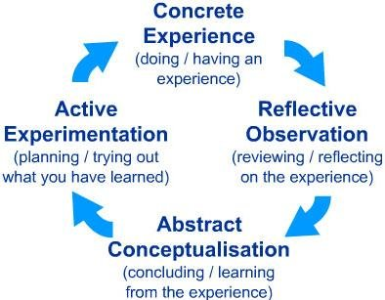

(Wu et al., 2016)

Stage 1: Concrete Experience
This stage is concerned with the encounter of a new situation or reinterpretation of a past event (Bhatti & Bart, 2013). I will use this stage to provide details about the role play. We were instructed to participate in a role-play as an interviewer and the interviewee and depict our understanding of our future goals and roles related to the desired goals. In the role play, I spoke to my partner about the work conditions at Amazon and the things that can affect our performance at the workplace including long duty hours, relationship with fellow workers, overall work environment, and the potential impact of bullying on our efficiency.
In role-play, we also discussed the significance of having a positive relationship with the team leader. We interacted with each other through five questions about the work environment, expectations of employees, and the factors that made a negative effect on the performance of workers. We tried to incorporate both internal and external factors that determine the role of workers and affect their performance in the organization. We used salary, relationship with colleagues, association with senior management, and duty hours as the internal factors and discuss their impact on the attitude of employees from the point of view of a management consultant. We also used PESTEL analysis to highlight the factors that can externally affect the organization and impact the way employees perform their jobs in the organization.
We discussed the following elements of PESTEL analysis:
- Political
The political factors are associated with political stability and the policies that are developed by the governments to secure the rights of workers. In our role play, we spoke about the importance of policies for the security of workers and the role of these policies in determining the growth of individual workers in the organization.
- Economic
Economic factors are associated with the financial performance of the country in which the organization is providing its services (Yüksel, 2012) (Huang, 2016). We discussed these factors in the context of organizations to highlight the importance of financial incentives in the improvement of the performance of employees.
- Social
Social factors are related to the equal distribution of opportunities and roles in society (Yüksel, 2012). In our role play, we highlighted the role of these factors in the promotion of a positive work environment. We discussed the negative impact of bullying and discrimination on the mental health of workers and described the role of society in the promotion of discrimination.
- Technological
Technological factors are related to the usage of advanced technologies in organizations (Yüksel, 2012). We discussed the importance of these factors in determining the efficiency of workers and improving the quality of their work.
- Environmental
Environmental factors include the weather conditions and climate of the country (Ulubeyli et al., 2019). In the role play, we described the importance of these factors by highlighting the requirement of central heating and cooling systems in the organizations.
- Legal
Legal factors are related to the laws and policies about the workplaces. We assessed the role of these factors by describing their importance in the promotion of a positive work environment that operates without any discrimination and bias towards a certain community (Kwenin et al., 2013).
PESTEL Analysis
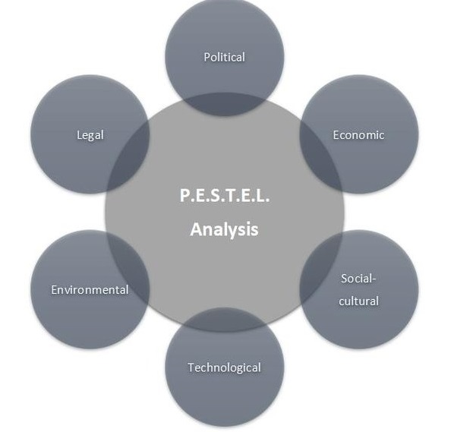

(Grab et al., 2018)

Stage 2: Reflective Observation
Initially, I was confused and nervous because I had no idea how these activities work. During the role-play, I was constantly thinking about maintaining a good impression on my teacher while reviewing the material that I had learned for the role play. The role play was centred around the factors that affect the performance of workers and how these factors can make an impact on our future services. In our role play, we decided to select the role of management consultant to assess the work conditions and other related factors.
We talked about how long working hours and poor relationships with colleagues affect the efficiency of workers. This activity was very beneficial for me because it provided me with an opportunity to review the factors and develop strategies to manage these factors in the future. Internal factors such as the attitude of senior workers, relationship with colleagues, salary, and long-shifts or inappropriate timing of shifts are the most important factors that need to be considered by the management while developing plans for the growth of their employees. Before the role play, I reviewed some articles to determine the internal factors and realized that salary is among the most important elements that act as both an incentive and a motivator for the employees. The management can use it to improve the performance of workers by offering them bonuses and increasing the salary of workers according to their role and contribution to the growth of the organization.
I am planning to acquire experience in the field of IT to open my venture in I.T engineering. To incorporate all relevant factors, I decided to include PESTEL analysis that provides a clear description of all elements that externally affect the organizations and efficiency of their employees. While searching for the content of the factors of PESTEL analysis and presenting them in the role play, I realized that I will have to pay close attention to both external and internal factors to successfully establish my own IT venture in the future.
Overall, I enjoyed this experience because it did not only allow me to present my knowledge uniquely but also helped me in understanding the role of different factors and their contribution to the improvement of the performance of employees. I believe that the inclusion of PESTEL analysis was indeed a great idea because it assisted me in analyzing external factors that can affect the performance of the organization and harm its growth.

Stage 3: Abstract Conceptualization
Abstract conceptualization is the process of developing an understanding of the situations, interpreting the events, and identifying the association between the events (Kolb & Yeganeh). I will use this stage to assess my understanding of the entire situation and identify its role in my personal growth. I am glad that our instructor provided us with an opportunity to learn about different dimensions of the processes that affect the performance of employees and allowed us to develop an understanding of the elements that can assist us in the improvement of our efficiency in our future careers.
This role play helped me in the identification of my strengths and weaknesses. I realized that my strengths are related to my ability to easily understand the situations and develop strategies to overcome the problems that are faced by the people around me. Unlike most of the students, I had the clarity of my goals and I mentioned in the role play that I would like to pursue my career in the field of IT by establishing my own venture. I think having an understanding of what I want from life and having a defined goal is my biggest strength because it will provide me with guidance and direct my actions.
However, I lack the confidence required to freely raise my points and discuss the issues. I will have to learn strategies to improve my confidence to clearly convey my points without any hesitation. My partner complained about my habit of procrastination. I realize that I need to overcome this habit to complete the given projects on time because procrastination can create problems for me in the future and negatively affect my image in the professional setting.
Other than this, the role-play helped me in the development of approaches to deal with the factors that negatively affect the performance of employees. We focused on the identification of external and internal factors that can affect the performance of employees in our role play. We did not only highlight these factors but also provide strategies to deal with the negative impact of these factors. In the role play, we mentioned that the workers should develop a positive relationship with their colleagues by spending time with them and understanding their concerns. We further added that the employees can improve their performance by conveying their complaints to the senior management and raising their voices against bullying and discrimination at the workplace. We also highlighted the role of management in improving the efficiency of workers by stating that the management should offer attractive incentives, discourage discriminatory activities and refrain from asking for unfair favours from the employees by asking them to work on holidays. I will use these approaches in my professional career both as an employee when I will work in IT firms to acquire experience and as an employer when I will open my own IT engineering venture.

Stage 4: Active Experimentation
At this stage, the learning acquired through the experience is implemented either in the current situation or for the development of future plans (ALQahtani & ALQahtani, 2014). In this stage of Kolb’s learning cycle, I will use my learning to develop a personal development plan. As mentioned in the previous sections, I want to pursue my career in the field of IT engineering and establish my own venture. I will achieve this goal by overcoming my weaknesses. I will increase my participation in the class and use different exercises to control my nervousness and confidently raise my views. I will also create a timetable and try to follow it to overcome my habit of procrastination and complete my tasks on time. Elimination of weaknesses is critical for future success because these weaknesses can add barriers and reduce the efficiency of an individual (Hameed & Waheed, 2011). I will get the feedback of my instructor and class fellows to assess the changes in my behaviour and identify the areas that need further improvement. In addition to this, I will join training programs and courses to improve my skills and get information about the addition of new tools and software systems in the IT field. After the completion of my degree, I will join internship programs in different IT firms to get field experience. I will also work in different IT companies to improve my skills and establish a strong base for the opening of my own venture.

Conclusion
In this reflective report, I provided details and reflected on my experience of participating in a role play. This role play was conducted by our instructor to increase the knowledge of students about the workplace conditions and factors that affect the performance of workers. In the role play, we talked about the role of internal factors including shift hours, salary, and interpersonal relationships, and external factors (through the PESTEL analysis) that can negatively affect the performance of workers. Kolb’s learning cycle was used in the report to reflect on the knowledge and experience acquired through this activity. Overall, I enjoyed this experience because it allowed me to get knowledge about my strengths and weaknesses and create a personal development plan.

References
ALQahtani, D.A. and Al‐Gahtani, S.M., 2014. Assessing learning styles of Saudi dental students using Kolb's Learning Style Inventory. Journal of dental education, 78(6), pp.927-933.
Bhatti, R.U. and Bart, W.M., 2013. On the effect of learning style on scholastic achievement. Current Issues in Education, 16(2).
Grab, B., Geldmacher, W. and Ionescu, R., 2018, April. Managing the risks associated with the cyber city project-case study of the NEOM Project. In 31st IBIMA Conference in Milan Proceedings (pp. 25-26).
Hameed, A. and Waheed, A., 2011. Employee development and its effect on employee performance a conceptual framework. International journal of business and social science, 2(13).
Huang, H.T.D., 2016. Exploring strategy use in L2 speaking assessment. System, 63, pp.13-27.
Kolb, A. and Kolb, D., 2018. Eight important things to know about the experiential learning cycle. Australian educational leader, 40(3), p.8.
Kolb, D.A. and Yeganeh, B., 2011. Deliberate experiential learning: Mastering the art of learning from experience. Contemp Organ Behav action.
Kwenin, D.O., Muathe, S. and Nzulwa, R., 2013. The influence of employee rewards, human resource policies and job satisfaction on the retention of employees in Vodafone Ghana Limited. European Journal of Business and Management, 5(12), pp.13-20.
Ulubeyli, S., Kazancı, O., Kazaz, A. and Arslan, V., 2019. Strategic Factors Affecting Green Building Industry: A Macro-Environmental Analysis Using PESTEL Framework. Sakarya Üniversitesi Fen Bilimleri Enstitüsü Dergisi, 23(6), pp.1042-1055.
Yüksel, I., 2012. Developing a multi-criteria decision making model for PESTEL analysis. International Journal of Business and Management, 7(24), p.52.
Wu, J., Li, M., Xu, H. and Chang, W.S., 2016. Learning by doing: A joint studio experiment on the theme of timber building design. In Proceedings of the World Conference on Timber Engineering, Aug (pp. 22-25).

