
Elena Savko (2025 3098 22)
Assessment 1 – Reading Task
Upload your photo of your A3 in-class notes here:
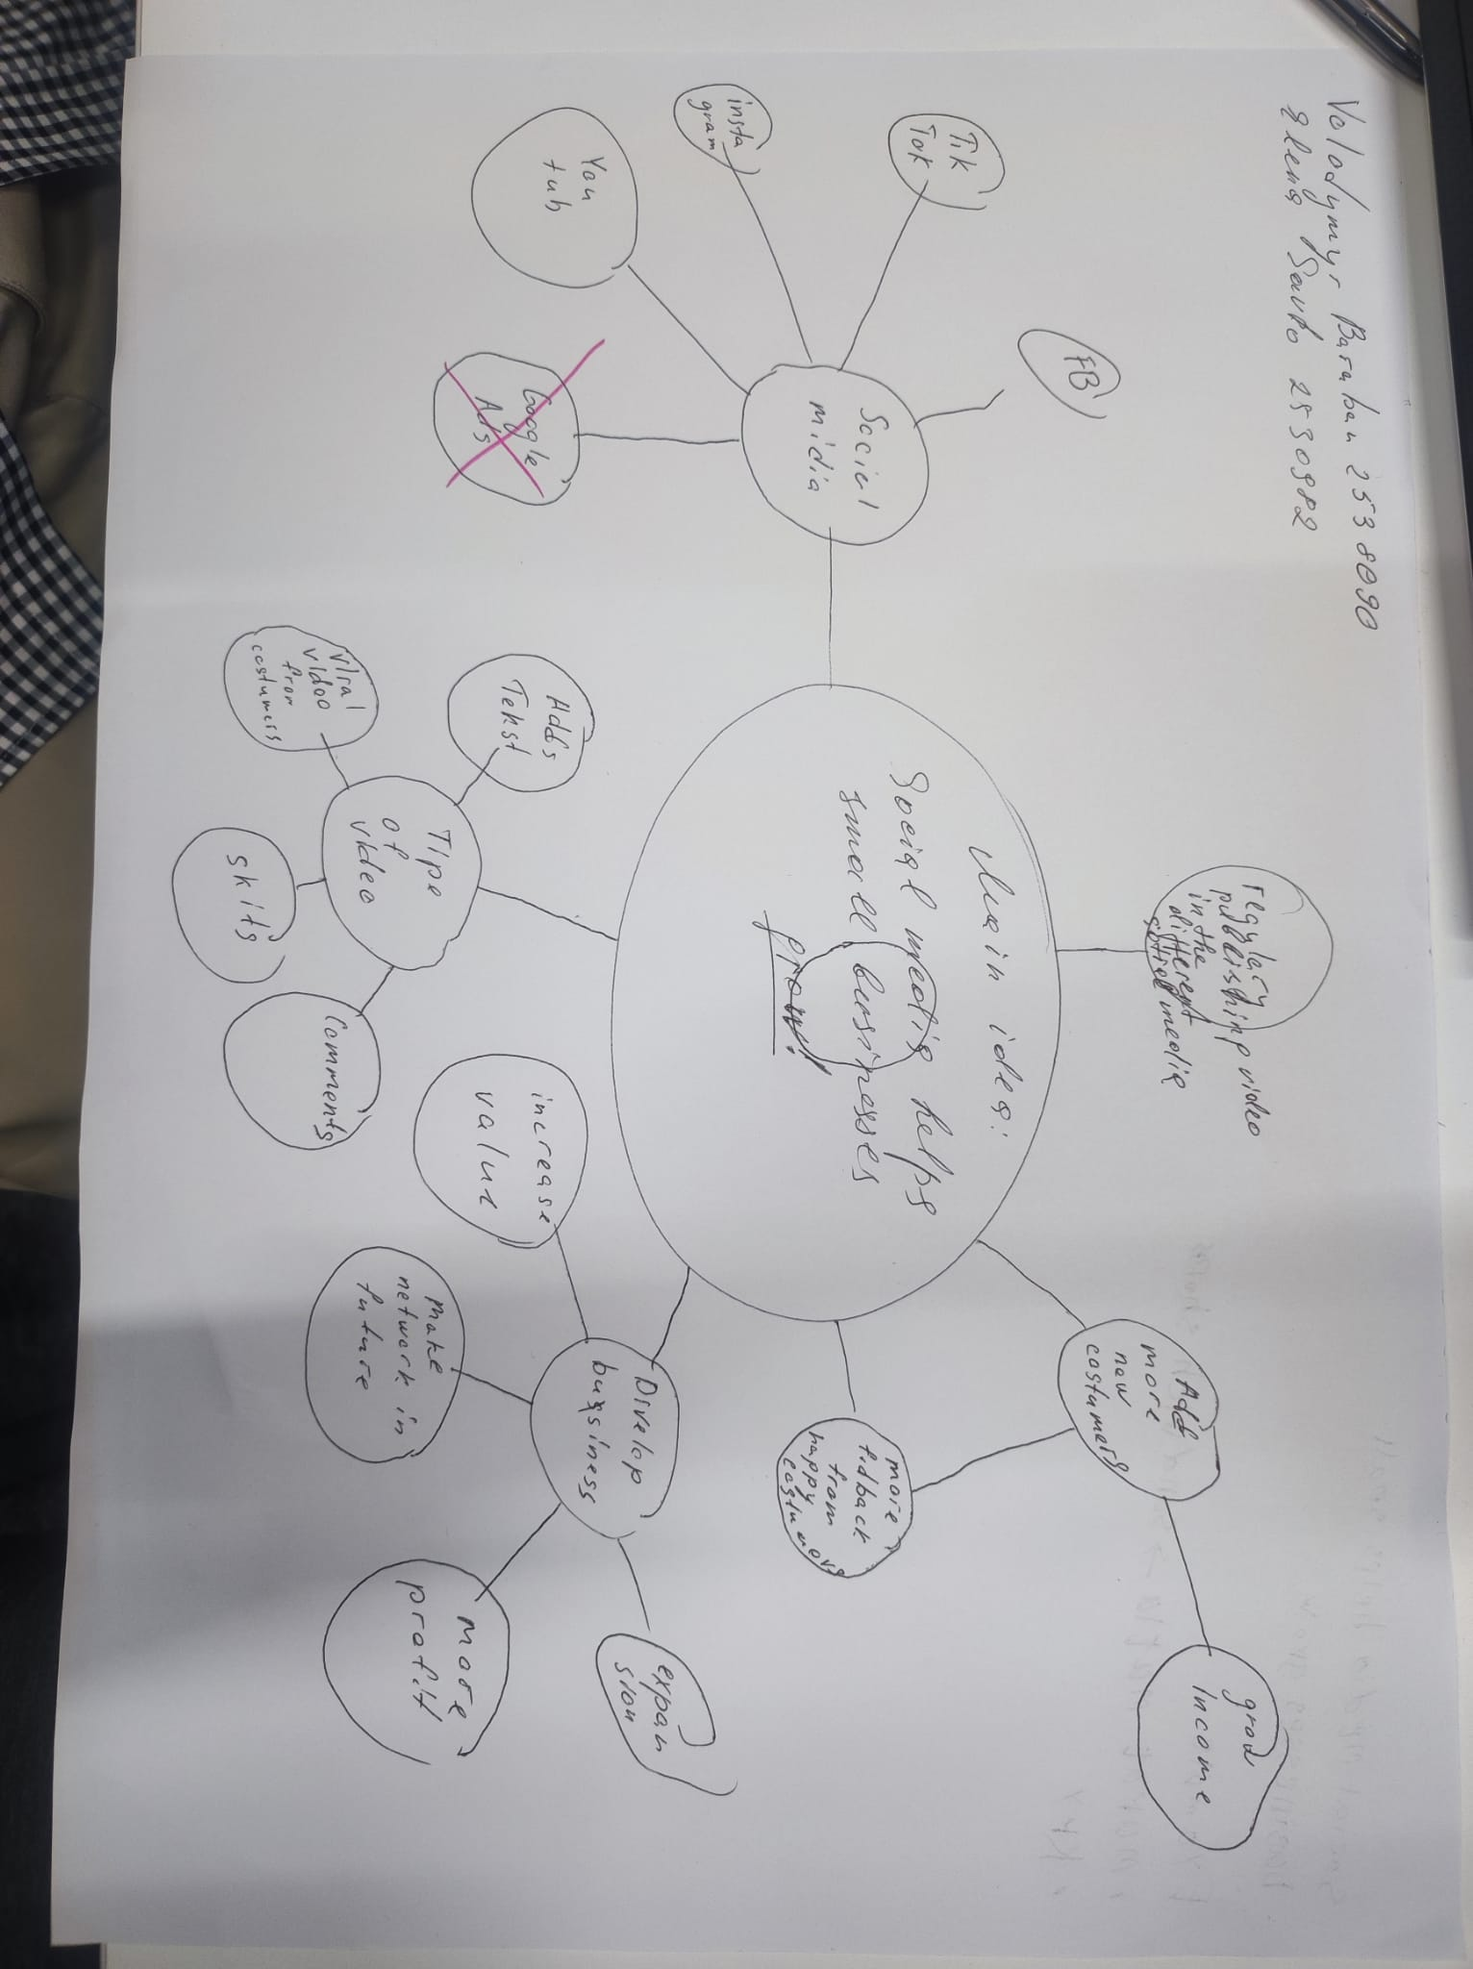

1. Answer these questions using the sentence starters below
a. What is the main idea of the text?
The main idea is that social media helps businesses attract more customers.
b. What are two key points?
One key point is that social media helps businesses become popular quickly.
Another key point is that posting on social media makes products more visible to people, even in other countries.
c. What part of the text did you find most important? Why?
The most important part is that 200 million businesses worldwide use Instagram to reach customers. This is important to me because I do not have Instagram.
d. Was anything unclear or difficult to understand?
I was not sure why people travel from far and wide just to buy food.
e. How did your group help you understand the text better?
My group helped me understand the text by discussing it together.
2. One sentence reflection
Question: What did you find challenging about this task?
The hardest part was answering question D.

