PROBLEM SOLVING AND DECISION MAKING

Module Code: BMSW 4004
Student: Elena Mihaela Radu – 2126383
Lecturer: Dr. Chijioke D Uba

Understanding and solving the problem of declining profitability at TM Lewin, UK

Abstract
Everyone working on improving technology would benefit from a heightened degree of awareness in the area of decision-making. It is hoped that this report will serve as a springboard for further research in this area. Any major choice should, in theory, be weighed using a cost-benefit analysis. When considering difficult problems, it’s important to keep in mind that the human mind is prone to a wide variety of biases and fallacies that might impede rational reasoning. The ability to solve problems and make sound decisions go hand in hand. The excellent thing is that several easy approaches may speed up the problem-solving process. The goals of the Fishbone technique, the PMI method, and similar approaches are to provide novel answers to issues whose causes are already well established.

Contents
Introduction 4
Its Scope and Impact 4
Analysis of the organisation and problem 5
Pestel analysis 5
Political considerations 6
Economic considerations 6
Social Factors 6
Technological factors 6
Environmental considerations 6
Legal considerations 6
Fishbone Diagram 7
Propose alternative solutions 7
Move business Online 7
Consider retailing a larger variety of products 8
Sell the products at more accessible prices 8
Minimising costs and securing cash flow 8
Safeguard employees’ safety 9
Use of governmental support 9
Increasing internet sales 9
Use of stock to service the local and export market 9
Innovation 9
Evaluation 10
Plan for implementing the solution, Monitoring and Review Process/System 10
Action Plan 10
Monitoring Plan 11
Evaluation Plan 12
Conclusion 13
Reference List 14

Introduction
There have been a lot of difficulties in the retail industry during the past several years. Many prominent stores have gone under in the previous two years, with the pandemic likely playing a role in the acceleration of their respective downturns. Many companies, especially merchants of luxury items, closed their doors as a result of the lockdown regulations and supply chain problems. Both consumers and businesses are concerned about the cost of living rising. While shops work hard to keep prices low, they eventually have to raise them to cover the higher expenses of things like shipping, electricity, and other supplies, as well as employee salaries. However, if customers are already feeling the effects of the cost-of-living issue on their budgets, hiking prices may only make matters worse. This report develops several obstacles and the methods to buffer those obstacles to solve the issue of the deteriorating financial performance of T M Lewin, a renowned British company (Baker, 2018).

Its Scope and Impact
As a direct consequence of the outbreak, a number of businesses that deal in clothing have seen catastrophic losses. This is because office workers have stayed away from cities and have instead been working from their kitchen tables while wearing more casual attire. In recent years, the traditional suit worn by men has been replaced in the annual basket of clothes gathered by the Office for National Statistics with only a single formal jacket or blazer. This was a substantial divergence from the practices of prior years. The crisis had a negative effect on department stores as well, as seen by the fact that retail goliaths like T M Lewin shut down sites once the lockout was implemented. The statement that eight of its sites will not be operating again was made the year before to this (Gevurtz and Gevurtz, 2015).
As more individuals worked from home and as restrictions restricted the scale of events, the T. M. Lewin Company faced challenges as a consequence of the drop-in sales of formal shirts (Goworek et al, 2020). This caused the company to struggle. Before the outbreak, the company had already established over 150 sites in different parts of the world. The pandemic had an especially negative effect on men’s clothing and formalwear since work-from-home regulations and event prohibitions led to a decrease in demand for suits and formal attire. This had a particularly negative impact on men’s clothing and formalwear. Unfortunately, the pandemic has had a significant impact on this well-known British brand, which, before the start of the epidemic, was in the process of undergoing a significant reorganisation. The company’s bottom line will suffer as a result of the problems in the supply chain, the ongoing increase in costs, and the current restrictions placed on the spending of consumers (Jia et al, 2020). The executive management of Torque Brands is well aware that the future of the firm might be at risk if the underlying causes of the company’s diminishing profitability are not recognised and corrected (Halliday and B., 2021).

Analysis of the organisation and problem

Pestel analysis
T M Lewin, a shirt manufacturing firm based in the UK, is the subject of this in-depth PESTEL investigation. The PESTEL analysis's goal is to encourage looking more closely at what's occurring in the larger economic and commercial environment. Every business is a part of the wider economy, a larger system. By performing a PESTEL study, all key factors that can affect the success or failure of an organisation could be identified. Political, economic, social, technical, legal, and environmental factors are referred to as PESTLE factors. (JOHNSON, 2013).
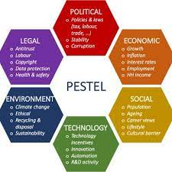
Figure: PESTEL Analysis
(Source: Desore and Narula, 2018)

Political considerations
Government COVID lockdown rule: Closing non-essential shops, prevented customers from purchasing, Work-from-home rule, and no need for the purchase of formal shirts.

Economic considerations
The cost of making clothing in the UK is rather high. As a result, many of the world’s largest retail companies get their apparel from other nations. Producing goods on board allows them to lower their overall manufacturing costs, allowing them to provide more competitive pricing (Luthans, 2012).

Social Factors
More than 50,000 individuals in the United Kingdom are employed directly by the shirt company. But there are ongoing rules such as staying at home no need to go out and a Ban on public events means none can go to any public events decreased too many sales as well as company profit.

Technological factors
There is no question that an increasing number of consumers are doing their shopping online. As T M Lewin continues to become more well-known, the majority of the world’s largest fashion companies now have their own e-commerce websites and their remote working team was great and they handle every technological factor (Paul and Cadle, 2020).

Environmental considerations
There are no environmental factors (Tseng et al, 2019).

Legal considerations
There are no legal factors about TM Lewin company (Worthington et al., 2018).

Fishbone Diagram
According to Chakraborty and Biswas (2020), ‘A fishbone diagram can be beneficial in locating potential answers for an issue that might not otherwise be taken into consideration by encouraging a team to look at the categories and investigate alternative causes. The Fishbone diagram is a graphic representation that may be utilized in any sort of work to aid in the mental organizing and processing of concepts, points of view, and conclusions when issues arise and their causes are determined.
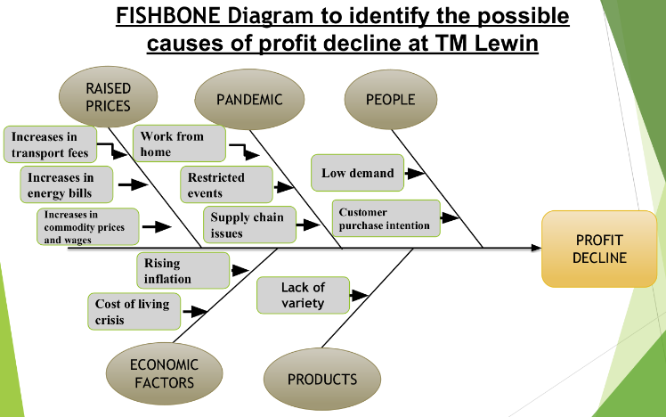
Figure: FISHBONE Diagram
(Source: Chakraborty and Biswas, 2020)

Propose alternative solutions

Move business Online
Moving business online is the most effective solution as per the grid analysis. The corporation should consider social media as a possible starting point for bringing its offline operations online. They may start executing their communication plan immediately since most of their clients are probably already utilising social media. Social media marketing also doesn't need as much effort or money as website development and upkeep. Many stores now use social media platforms like Pinterest and Instagram to showcase their wares via photographs. Social media is a great way to engage with current and future consumers, but it shouldn't be expected to directly increase revenue (Desire and Narula, 2018).
Besides updating their feed and replying to comments, users of social media sites also have the option of broadcasting live to their followers. They may provide clients exclusive access, host seminars, and reveal intimate company stories. If they have a loyal following, they may do weekly check-ins and Q&A sessions to discuss their products and services.

Consider retailing a larger variety of products
Big-scale retail commerce (also known as "large organised distribution") is a vital aspect of the retail industry as a whole. The proliferation of participants in this industry has long been seen as a barometer of a country's economic health, representing, in many respects, the ability of its people to keep the economy afloat. However, major organised distribution and the retail sector as a whole are among the first to feel the effects of an economic slowdown and a decline in consumer confidence, for whatever reason, since these events often result in a considerable reduction in spending. TM Lewin company has to consider retailing a larger variety.

Sell the products at more accessible prices
It's the discount they provide to buyers. They save costs and boost revenue by using a certain number of sales pitch points that are specific to each market. They may play a crucial part in boosting their brand's reputation by offering discounts. However, they shouldn't stop making money at that point either. By building profit into the price tag. In order to price their goods competitively while minimising potential losses, businesses must factor in the margin for discounts (Palmer and Hartley, 2012).

Minimising costs and securing cash flow
Many physical establishments have closed, and people prefer internet purchasing. T M Lewin’s management must analyse all expenditures and costs to survive the lockdown and plan for the future. Stock items, textiles, and trimmings are expensive. Many manufacturers discount their goods. Local shops are reopening as coronavirus safeguards are eased. This improves local stock value and profits when businesses reopen. Profitable local sales may be established from cloth stock.

Safeguard employees’ safety
To decrease hazards and preserve protection, they must help employees and provide a safe workplace. Throughout and after the crisis, this is crucial. The factory must be organised to safeguard employees and prevent viral transmission. A safe production environment protects employees.

Use of governmental support
Governments offer several sorts of help, such as tax cuts and bank loan interest subsidies. It’s an excellent time to continue the business.

Increasing internet sales
Due to the lockout, many shoppers can’t access shops. Some shoppers now purchase online. Structural development, particularly in nations where consumers do not purchase online frequently. The website should be in many languages to reach more nations (Guarnieri and Trojan, 2019).

Use of stock to service the local and export market
Manufacturing companies now have surplus materials due to cancelled orders. Many manufacturing facilities now have difficulties maintaining enough financial flow. The company has to start selling locally stocked items and supplies as soon as possible.

Innovation
They should innovate to stand out among global vendors. Innovations assist to identify new consumers and offer distinctive proposals. Product, sustainability, environment, service, and other innovations are highly valued by purchasers.

Evaluation
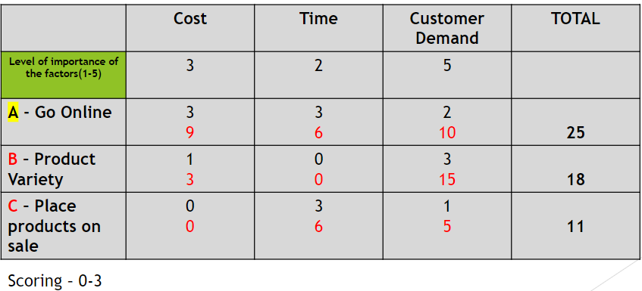

Plan for implementing the solution, Monitoring and Review Process/System

Action Plan
Action  (What) | Description of action  (How) | Timeframe  (When) | Staff responsible  (Who)
A powerful catalyst for change inside a company is consensus. | one way to foster agreement is to provide employees with a window into the perspectives of others. | In the 1st week | Employees

Monitoring Plan
Action  (What) | Description of action  (How) | Timeframe  (When) | Staff responsible  (Who)
It is crucial to the success of any business strategic plan to identify the essential activities and ensure that employees are determined to take the actions to make the adjustments necessary to effectively execute these activities (Bougie, R. and Sekaran, 2019). | The long-term sustainability of the company, plan and strategy relies on knowing what steps have been taken toward reaching the objectives. | In the 2nd Week | Security man

Evaluation Plan
Action  (What) | Description of action  (How) | Timeframe  (When) | Staff responsible  (Who)
Therefore, it is crucial to regularly monitor and evaluate the future performance drivers versus their strategy (Yazdani et al, 2018). It will be easier to spot and fix any problems early on thanks to the review process. | A particular company will remain on track to succeed, if necessary, changes are made to the plan. The success of the company depends on the contributions of every member. As a result, they must take responsibility for carrying out the strategic plan tasks that have been delegated to them. | During whole period of the project. | Manager as well as other employees.

Conclusion
The processes of problem-solving and decision-making are interconnected in several ways. Analytical thinking and problem-solving. Both decision-making and issue-solving share similar roles, goals, and systems. Essentially, one may stand in for the other. The difference between issue-solving and decision-making lies in the fact that the latter includes fixing an existing situation while the former comprises picking the best choice among multiple possibilities. The ability to think critically and find workable solutions to problems has become an absolute need for managers in today’s enterprises. They guarantee the organisation’s long-term prosperity and success. Managerial choices call for original thinking and sound judgement, and the ability to solve problems and make sound judgments is essential for coping with the challenges of any job. They are mutually supportive and may be used to address related problems. Critical thinking, issue structuring through representation, and solution searching via divergent thinking are all required for problem-solving and decision-making.

Reference List
Baker, A.J. 2018 Business decision making. London: Routledge. https://doi.org/10.4324/9781315122496
Bougie, R. and Sekaran, U., 2019. Research methods for business: A skill building approach. John Wiley & Sons, pp. 130-139.

Chakraborty, S. and Biswas, M.C., 2020. Impact of COVID-19 on the textile, apparel and fashion manufacturing industry supply chain: a case study on a ready-made garment manufacturing industry. Journal of Supply Chain Management, Logistics and Procurement, 3(2), pp.181-199.

Desore, A. and Narula, S.A., 2018. An overview of corporate response towards sustainability issues in the textile industry. Environment, Development and Sustainability, 20(4), pp.1439-1459.
Gevurtz, F. and Gevurtz, F. 2015 Business planning. St. Paul, MN: Foundation Press.
Goworek, H., Oxborrow, L., Claxton, S., McLaren, A., Cooper, T. and Hill, H., 2020. Managing sustainability in the fashion business: Challenges in product development for clothing longevity in the UK. Journal of Business Research, 117, pp.629-641.

Guarnieri, P. and Trojan, F., 2019. Decision making on supplier selection based on social, ethical, and environmental criteria: A study in the textile industry. Resources, Conservation and Recycling, 141, pp.347-361.
Halliday, T. and B., S.P.J. 2021 Communication. Oxford: Blackwell Scientific.
Jia, F., Yin, S., Chen, L. and Chen, X., 2020. The circular economy in the textile and apparel industry: A systematic literature review. Journal of Cleaner Production, 259, p.120728.
JOHNSON, R.J. 2013 Change in management: (a Jim Meade, Martian P.I. novel). S.l.: CREATESPACE INDEPENDENT P.
Luthans, F. 2012 Organization behaviour. New York: Mcgraw Hill.
Palmer, A. and Hartley, B. 2012 The Business Environment. Maidenhead, Berkshire: McGraw-Hill Higher Education.
Paul, D. and Cadle, J. 2020 Business analysis. Swindon, UK: BCS.
Tseng, M.L., Wu, K.J., Chiu, A.S., Lim, M.K. and Tan, K., 2019. Reprint of: Service innovation in sustainable product service systems: Improving performance under linguistic preferences. International Journal of Production Economics, 217, pp.159-170.
Worthington, I., Britton, C. and Thompson, E. 2018 The Business Environment: A Global Perspective. Harlow: Pearson.
Yazdani, M., Zarate, P., Zavadskas, E.K. and Turskis, Z., 2018. A Combined Compromise Solution (CoCoSo) method for multi-criteria decision-making problems. Management Decision, pp. 2501-2519.

