Portal [1]

INTENDED PLATFORMS | - Windows [2]  - Xbox 360[3]  - PS3[4]

TARGET AGE / DEMOGRAPHIC OF PLAYERS
Casual Gamers, Puzzle Enjoyers, People that delve into story, People that enjoy a challenge, people that like dystopian themes, anyone with an interest ai taking over the planet.

INTENDED PEGI / ESRB RATING
Teen (ESRB) Blood and Mild Violence [5], Pegi 12 (PEGI) Violence [6]

CONTRIBUTING TEAM MEMBER: | Mia Harries

SECTION 2: GAME OUTLINE

GAME STORY SUMMARY
You would wake up as our main character Chell [7] and follow her journey, once she receives a portal gun she goes through the science facility, solving puzzles one by one, eventually coming across a second portal gun, and then using it to continue through, with levels getting harder as they continue. You’ll have a rather humorous AI speak to you as you go along the tests. As the player is nearing the end of testing GLaDOS [8] will begin suggesting a more sinister story behind this lab, and hints death. Chamber 16 will be different to the other levels and will include a lot more danger, such as fire and turrets. During this stage, the player will be able to explore an uncovered part of the facility, hinting at past people that used to be subjects. After the final test chamber GLaDOS [8] will begin pushing the character into a furnace, once you escape, GLaDOS [8] will encourage you to come back. Chell [7] runs through rooms full of rust all the while GLaDOS [8] is in your ear, until you finally reach a control room with GLaDOS [8]. This will begin the boss fight, that when completed, will grant Chell [7] freedom.

GAME FLOW
This will be a first-person puzzle-platform game that find the protagonist Chell [7] going through tests in a laboratory using her portal gun to make her escape from the puzzles in the hands of the Ai, GLaDOS [8] that has her trapped there. [9]

CONTRIBUTING TEAM MEMBER: | Mia Harries

SECTION 3: MAIN CHARACTER(S)
& PLAYER CONTROLS

CHARACTER APPEARANCE
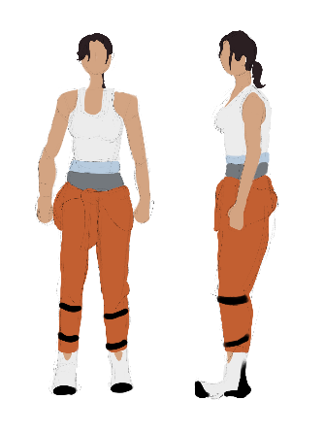

CHARACTER DOSSIER / DETAILS (Add/adjust categories as appropriate)
NAME: | Chell [7]
GENDER: | Female
SPECIES: | Human
AGE: | Undetermined
RANK: | Test Subject
KNOWN ASSOCIATES: | GLaDOS [8]
(Extra categories)
(Extra categories)

CHARACTER’S BACKSTORY
Not much is known about her backstory, we don’t know how she awoke in a pod. She will be a sort of silent protagonist meaning we won’t get to see much of her personality shine through other than through her actions [10], she is brave, and though fearful of GLaDOS [8], she is Resilient. This relates to the game because without these key factors in her personality, it wouldn’t drive her to escape the facility like the story will go. Some of her signature styles I suppose would be her ability to conquer a wide variety of puzzles with her portal gun no matter how difficult.

CHARACTER APPEARANCE
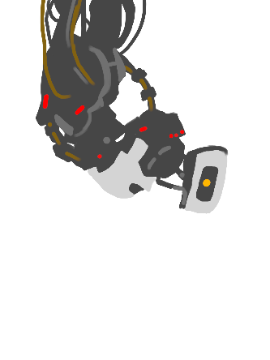

CHARACTER DOSSIER / DETAILS (Add/adjust categories as appropriate)
NAME: | GLaDOS (Genetic Lifeform and Disk Operating System) [8]
GENDER: | NA
SPECIES: | Artificial Intelligence (Failed copy of human consciousness)
AGE: | Unknown
RANK: | Responsible for “Testing and Maintenance at the Aperture Science Computer- Aided Enrichment Centre” [11]
KNOWN ASSOCIATES: | Aperture Science Computer- Aided Enrichment Centre
(Extra categories)
(Extra categories)

CHARACTER’S BACKSTORY
GLaDOS [8] is made to test subjects on various different chambers, to see their progress and development when learning a new skill with the “portal gun”. As a robot would be, GLaDOS [8] is a cold character, very uncaring, but does attempt to make jokes to lighten the player’s mood [11]. This makes the gameplay feel a lot more purposeful especially the further in you can go, since it will make the player feel a sense of urgency to escape the grasp of this AI that has put the player in this situation. Some signature elements of GLaDOS’s[8] character are Its constant changing opinion, especially at the end, when its cores drop out it will change, each core gives GLaDOS [8] elements of its personality and coding, without it, it will grow worse, almost harbouring hate and resentment.

CHARACTER CONTROLS / PLAYER CONTROLS
- Windows [2]
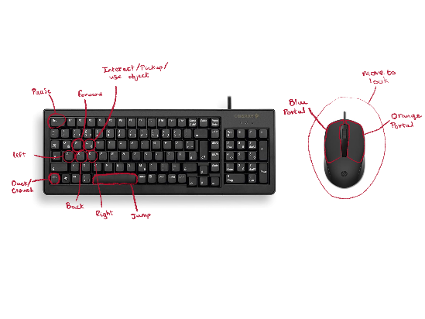

- XBOX 360 [3]
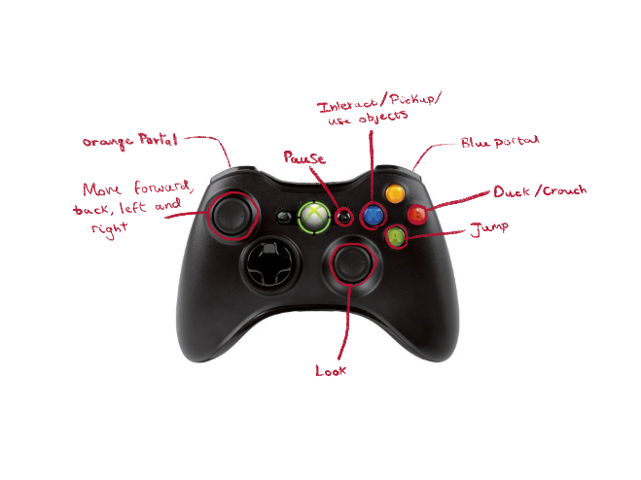

- PS3 [4]
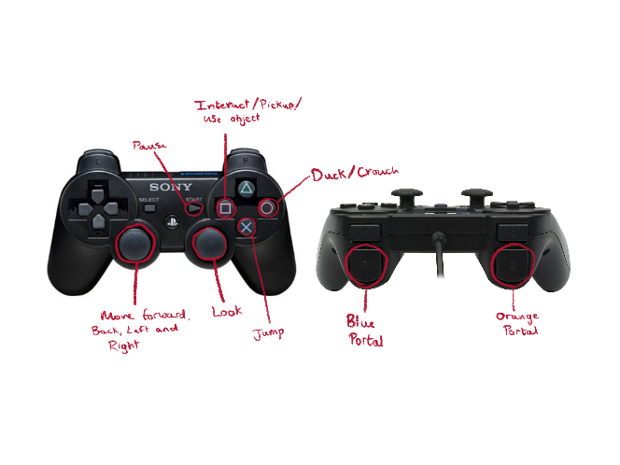

CONTRIBUTING TEAM MEMBER: | Mia Harries

SECTION 4: GAMEPLAY

SEQUENCE OF PLAY
- Woken up from the pod.
- Guides you to an elevator.
- Chamber 1-19
- Exploring out of bounds areas
- Final boss against GLaDOS [8]

The game is one continuous story, but it is cut up into multiple different test chambers, these can be considered levels, as each one progresses you further whilst getting more difficult, though players will have their portal gun to help them [9], and getting through a later chamber upgrades it to utilise two portals instead of one . This flows better than usual levels games since we will implement an elevator, once a chamber is done, the player will enter the elevator to the next level, it’ll give the player a brief break before the next level without breaking immersion.

In Portal [1] there is one main storyline, and you cannot differ from that path, you will be set on one path. The biggest set piece, the one that will have the most impact on the player as they play the game, is the section where Chell is slowly being slid down, nearing closer and closer to the incinerator all the while GLaDOS [8] talks to them sinisterly about their impending doom.

Another set piece within the game would be the boss fight near the end, the fight against GLaDOS [8] and the section leading up to it, the player is going through the restricted areas of the lab trying to escape GLaDOS [8] whilst also leading themselves straight to it.

UNIQUE SELLING POINTS (USPs)
- Dystopian Themed
Though the theme of a dystopian setting in a game is common, the idea of a puzzle game in this setting is quite unique, further it is the idea that the AI have taken control, and GLaDOS [8] controlling the entire facility in the place where a human typically would.

- Villain is an AI
What would make Portal unique is the idea of the villain being an evolved AI. Not only that but as the game proceed GLaDOS [8] is like a narrator for the player as they go through the stages, so to uncover that the person guiding you through the game the whole time, was the villain, is a unique concept.

- Transporting through portals to complete puzzles.
Altogether this GDD includes a multitude of unique selling points that can and will attract players to the game, the simple concept of just completing a series of puzzles through creating portals with a gun, is unique.

PLATFORM-SPECIFIC FEATURES
(There won’t be any platform specific feature)

CONTRIBUTING TEAM MEMBER: | Mia Harries

SECTION 5: GAME WORLD

GAME WORLD
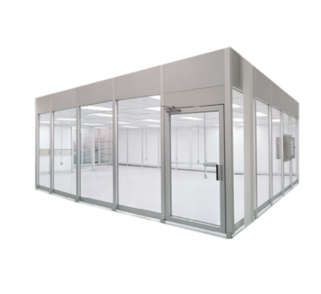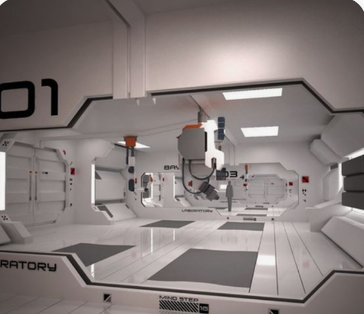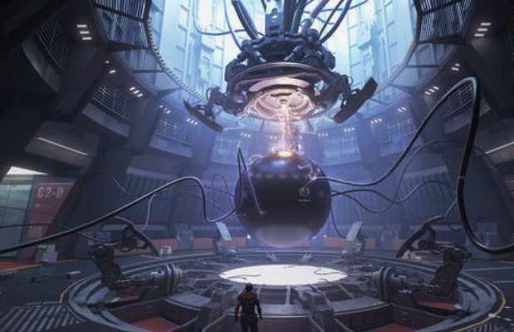
[12] [13] [14]
- Futuristic Lab
The lab is the place we first begin it’ll be very clean and though enclosed in a glass chamber at first, the open portal that will lead the player out will create a hopeful environment.

- Futuristic Test Chambers
The chambers will set a challenge for the players, each will be unique, teaching the players new skills, constantly getting their mind working. But the familiarity will come from the pristine white walls and floors, the colours coming from the portals.

- Dystopian Control Room
The control room, or the room where you must defeat GLaDOS [8] will have a slightly different feeling and look to the rest of the facility, this is to make the environment feel unfamiliar and unsafe to the character, it is darker, resulting in an ominous environment.

LOCATION DETAILS
NAME: | Futuristic Lab (Detention Vault)
WHAT DOES IT LOOK LIKE? | It’s a place covered in white, and futuristic since it includes a lot of techs we do not have in our present day. The surrounding area suggests a laboratory in the future.
WHAT MOOD IS BEING INVOKED IN THIS LOCATION? | This is a hopeful environment; area is intriguing and invokes curiosity to the player. When the robot begins to speak and the cameras on the wall follow the player, since they won’t yet be used to this, they may feel threatened.
WHAT KIND OF MUSIC WILL BE USED FOR THIS LOCATION? | The only music that will be heard at this time is a subtle tune radiating from the radio, it’ll sound almost like elevator music.
HOW ARE THE LOCATIONS CONNECTED IN THE GAME WORLD? | This will be the beginning of the building, this location is connected to the other, they will go from this starting lab to the test chambers.

LOCATION DETAILS
NAME: | Futuristic Test Chamber
WHAT DOES IT LOOK LIKE? | The test chambers all look similar, but as the player goes along, they’ll notice it getting slightly darker and complex, and instead of the use of blue and white, it’ll get closer to colours like grey, and orange.
WHAT MOOD IS BEING INVOKED IN THIS LOCATION? | Nerve-wracking feeling since the cameras will always be watching the player, and GLaDOS [8] will constantly be talking to the player as if they’re watching their every move.
WHAT KIND OF MUSIC WILL BE USED FOR THIS LOCATION? | There is no music in the chambers, it’ll have the sounds of static along to help it feel more eerie, this’ll help the player to understand the tone of the game the further they get into the story. The further into the chambers you get the more you will hear something like meditation music. Towards the final chambers the music becomes a more sombre tone.
HOW ARE THE LOCATIONS CONNECTED IN THE GAME WORLD? | The test chambers are connected by elevators.

LOCATION DETAILS
NAME: | Dystopian Control Room
WHAT DOES IT LOOK LIKE? | The room will be very dark, there’s barely any colour bringing forward that idea of the lifelessness that the room expresses, considering the occupant is an AI, making the player feel suffocated.
WHAT MOOD IS BEING INVOKED IN THIS LOCATION? | This is the sort of room that accompanied by the quickened intense music, the mood of rush, will kickstart some adrenaline fuelled fear in them.
WHAT KIND OF MUSIC WILL BE USED FOR THIS LOCATION? | Fast music with a consistent beat, like techno music. Following this music there will be a song for the credits for the game, it’ll be a slightly robotic song, as if sung by an Ai.
HOW ARE THE LOCATIONS CONNECTED IN THE GAME WORLD? | To get to this location the players go through all the chambers, and blocked off areas until they reach this room.

GAME FLOW
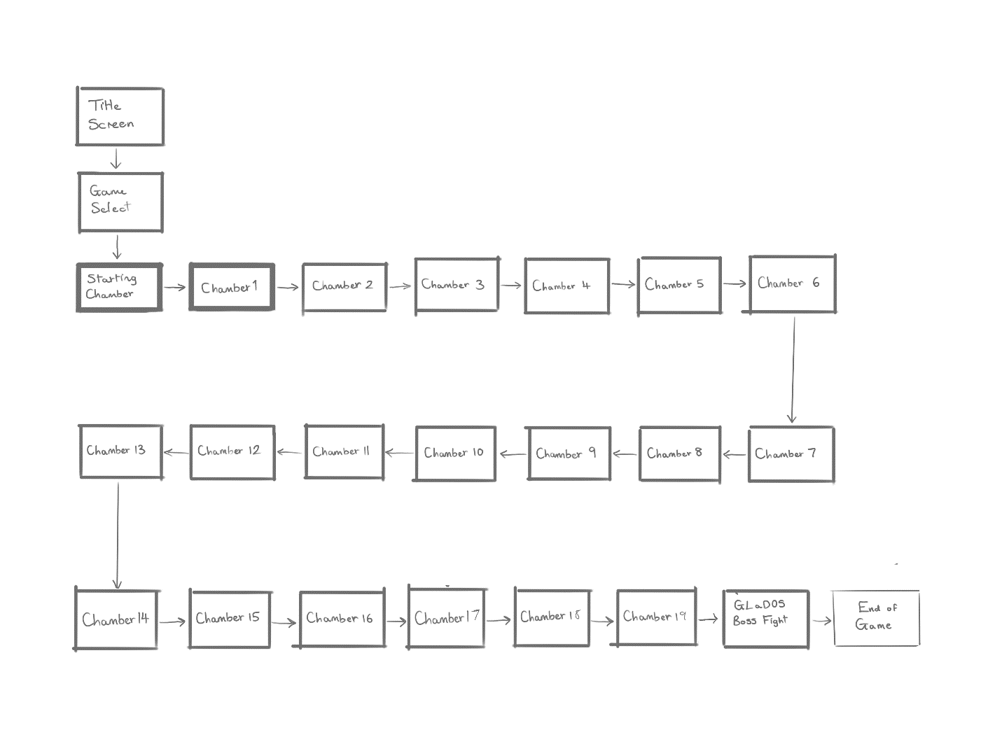

CONTRIBUTING TEAM MEMBER: | Mia Harries

SECTION 6: GAME EXPERIENCE

GAME EXPERIENCE
- Darkness
- Humorous
- Yearning
- Understanding

HOW IS THIS FEELING GOING TO BE PRESENTED TO THE PLAYER?
This theme is very subtle in the background, occasionally during the game the player will notice scraps of other humans having been in the same facility in the past, this will be unnerving considering the situation Chell [7] is in. The non-cholent nature of the robot in its terrifying statements to the player will further express this dark undertone.

I believe we should implement some humour factor into the game, taking advantage of the monotone nature of the robotic voice, adding some ridiculous topics of conversation that would make a player laugh. This humour can be sprinkled throughout to make sure the game is still light-hearted.

This yearning of freedom is going to be presented at the point where the player begins to get threatened and uncomfortable with GLaDOS’s [8] comments, when the player then realises their main goal is to escape, that they yearn for freedom.

The theme of understanding will be almost immediately recognised by the way the AI speak to Chell [7], it will react to the player completing puzzles, trying to understand how and why. Towards the end of the game this understanding comes from the player to, as they learn what GLaDOS [8] is and why.

ARE THERE ANY SPECIAL MODES OR INTERFACES FOR GAMEPLAY?
For the main story there will be no special modes, the main story is as difficult or as easy as it will be. But after completing the main storyline once, the player will be able to unlock two other special modes if they feel as if they want more of a challenge or variety in their gameplay.

WHAT DOES THE PLAYER FIRST SEE WHEN THEY START THE GAME?
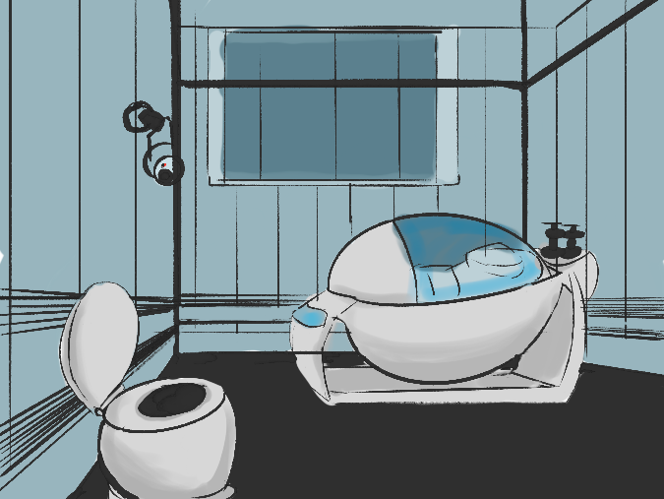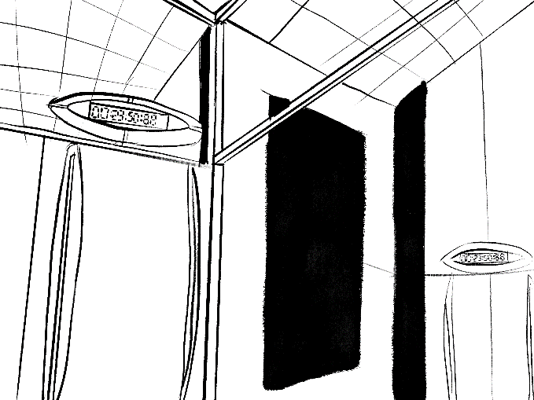

The player will be within a glass cage next to a pod and an assortment of items such as a clipboard, radio, and mug on top of a small table and a toilet. If they look beyond the glass cage, they will see things such as cameras and blue sections of walls with timers above them. Looking up the player will notice a glass window to an observation deck.

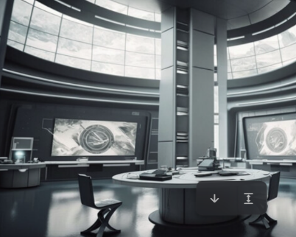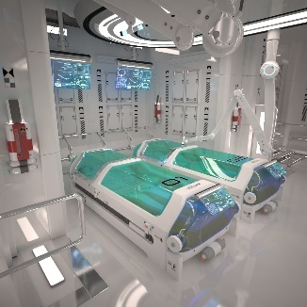
[15] [16]

WHAT EMOTIONS ARE MEANT TO BE INVOKED BY THE GAME?
We want players to feel curious about the game and excited with their progress and the development of the story and at the beginning of the game by the robotic narrator due to its calm and welcoming words. Though as they learn more, we want the players to feel as if they’re almost threatened by the oppressive presence of GLaDOS [8]. Nearing the end, we want the players to feel a sense of determination, to defeat GLaDOS [8].

HOW ARE MUSIC AND SOUND GOING TO BE USED?
At the beginning of the game, we can use examples of elevator and meditation type music to keep the player in a relaxed state, so that as the game develops, they will feel more emotion when it comes to GLaDOS’s [8] behaviour towards them. As the player goes through each test chamber, they will hear faint static and an almost windy sounds, to appear ominous. The music should increase to a techno type music, it should be intense and fill the player with adrenaline and dread, it’ll allow them to anticipate the boss fight ahead of them. When credits roll, we can use the voice of GLaDOS [8] to make a soft robotic type of song for the credits, it’ll be GLaDOS [8] addressing the player after their sour defeat. [17]

- Elevator Type Instrumental [18]
- Meditation Music [19]
- Techno [20]
- Vocaloid [17]

HOW DOES THE PLAYER NAVIGATE THE SHELL MENUS/ SCREENS OF THE GAME?
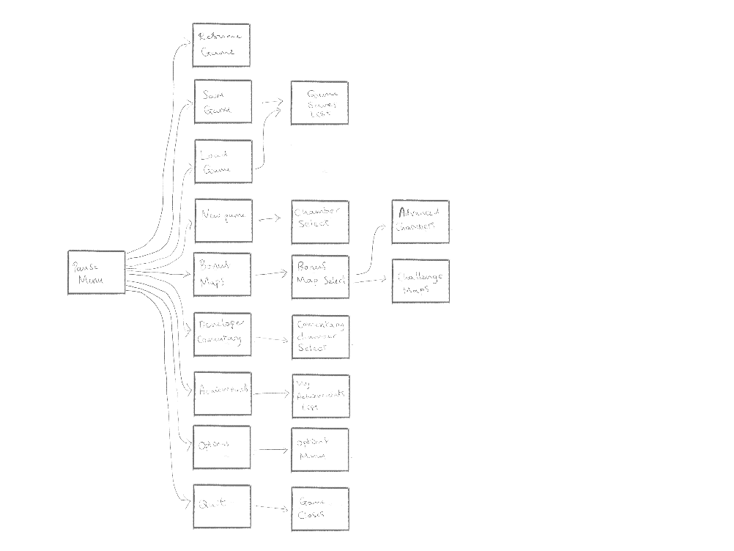
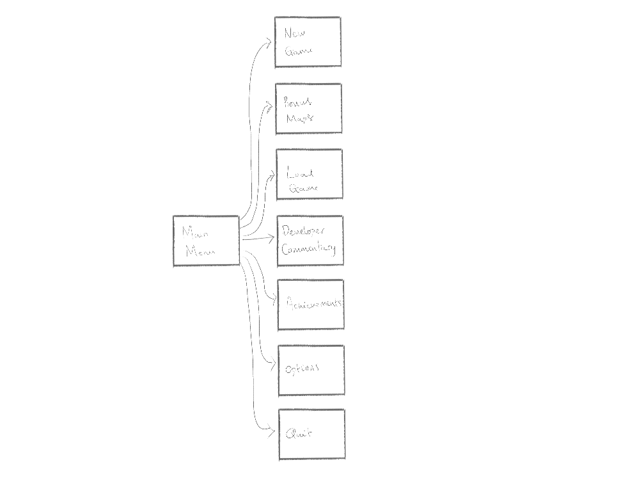

CONTRIBUTING TEAM MEMBER: | Mia Harries

SECTION 7: GAMEPLAY MECHANICS

GAMEPLAY MECHANICS
Portal Gun – Futuristic gun that shoots portals onto walls.
Moving Platform – Glass Platform that moves across a laser from one location to the next
Button – Button that open’s doors or hatches.

Energy Ball – A ball of orange and white energy that kills the player on contact.
Toxic Floor – The floor, typically underneath the moving platforms will kill the player on contact.

No Power Ups in Game [9]

MECHANIC DETAILS
NAME: | Portal Gun [21]
WHAT DOES IT LOOK LIKE? | A futuristic gun, when holding the gun, it will have a blue and gold icon in the middle, telling you if they can be shot out or not. When it shoots a blue laser it’ll create a blue portal, and when it shoots an orange laser it’ll make an orange portal.
EFFECT ON PLAYER: | Players hold gun in hands and can create blue portals with the gun that connects to the location of the orange portal. After collecting the orange portal gun, players will be able to shoot both portals from that gun, enabling them to complete future test chambers.
WHEN WILL IT FEATURE IN THE GAME? | It is a constant during the player’s journey through Portal [1]

HAZARD DETAILS
NAME: | Energy Ball [22]
WHAT DOES IT LOOK LIKE? | It’ll be a small orange ball, seemingly made of light and energy, it moves back and forth between the launcher and a wall it reaches its catcher.
EFFECT ON PLAYER: | If the player walks into it, they instantly die and go to the beginning of the test chamber.
WHEN WILL IT FEATURE IN THE GAME? | It will feature in a multitude of test chambers across the game, being one of the most frequent puzzles that show up in tests, they will get more difficult to get the energy ball to the catcher.

COLLECTIBLE ITEMS
- Hidden Radios [23]
The player can collect hidden radios, and place move them to different locations to reveal hidden achievement.

COLLECTIBLE DETAILS
NAME: | Hidden Radio [23]
WHAT DOES IT LOOK LIKE? | An Old 80s Radio
BENEFIT FOR PLAYER: | Unlockable Achievement, no in-game effect
WHEN WILL IT FEATURE IN THE GAME? | Throughout the game the song plays in a multitude of test chambers, it’ll play an instrumental version of “Still Alive”, the song that will be played during the end credits.
CAN IT BE USED AS CURRENCY? | No
WILL IT EARN PLAYERS AN ACHIEVEMENT? | Yes, the achievement “Transmission Received” [24] – The player must take all the radios and move them to certain locations for hidden signals. This achievement is only available after completing the first playthrough.[23]

GAME ECONOMY
(Portal [1] will not include an Economy System)

CONTRIBUTING TEAM MEMBER: | Mia Harries

SECTION 8: ENEMIES

LIST OF ENEMIES
- Turret: Little robots that stand on thin legs, always pointing towards an open space, when the player approaches it’ll shoot.
- Rocket Turret: This turret is circular; it spins and once it notices the player it will lock on and send a rocket in that direction.

ENEMY DETAILS
NAME: | Turret [25]
WHAT DOES IT LOOK LIKE? | Small white robot standing on three small black legs. It has 3 sections of the body and includes a bright red eye in the middle where the bullets are fired.
ATTACKS: | It fires bullets towards the player once they are in sight.
WHEN WILL IT FEATURE IN THE GAME? | It will feature later in the game towards level 16 onwards until the final boss battle. These will be obstacles to avoid and take down.
HOW DOES THE PLAYER DEFEAT IT? | The player can defeat these robots by throwing them onto the floor, it will not be able to pick itself up, and will go around in circles on the floor, firing its bullets until it runs out.
WHAT DOES THE PLAYER EARN FOR DEFEATING THEM? | By defeating them the player will have the ability to progress through the level.

LIST OF BOSS CHARACTERS
- GLaDOS [8] : At the end of the game the player will encounter the main and final boss, GLaDOS [8], it will be hanging from the ceiling and will begin with threats and disappointing remarks the player. Then it will drop one of its cores, by placing a few portals you will be able to incinerate that core which will then begin a timer as GLaDOS [8] slowly fills the room with a toxic gas. One by one the player must fetch the orbs, incinerate them, and then get the Rocket Turret underneath GLaDOS [8] to shoot back. After repeating this process GLaDOS [8] will be defeated, wires will fall, the roof will break and Chell will be freed. [8]

BOSS CHARACTER DETAILS
NAME: | GLaDOS [8]
WHAT DOES IT LOOK LIKE? | Circular chamber, stage in the middle with GLaDOS [8] hanging from the ceiling, many wires hang from it, connecting it to the building.
ATTACKS: | Rocket Turret
WHEN WILL IT FEATURE IN THE GAME? | At the end, final boss fight for freedom
HOW DOES THE PLAYER DEFEAT IT? | Defeat it by setting up portals that send the rocket turrets back to GLaDOS [8] , forcing it to drop its cores, before the player will need to burn and destroy them.
WHAT DOES THE PLAYER EARN FOR DEFEATING THEM? | After destroying GLaDOS [8] the player will earn an achievement and the story will continue, Chell being set free out of the science facility, ending the game.

CONTRIBUTING TEAM MEMBER: | Mia Harries

SECTION 9: CUTSCENES

CUTSCENES
(There will be no cutscenes within Porta [1])

CUTSCENE DETAILS
VISUAL STYLE:
BRIEF DESCRIPTION OF SCENE:

WHEN WILL IT FEATURE IN THE GAME?
PURPOSE:

CONTRIBUTING TEAM MEMBER: | Mia Harries

SECTION 10: BONUS MATERIALS

BONUS MATERIALS
Achievements
- Aperture Science – Earn gold medals on all Portal Challenges [24]
- Camera Shy – Detach security cameras from the walls [24]
These are some examples of the type of achievements we could add to the game.

Bonus Content
- Advanced chambers – Test chambers that will be made more difficult for players that would like a more difficult experience.
- Challenge Maps – These will be testing chambers with extra challenges and goal-based puzzles.
These bonus content will be here for a varied experience. [9]

REPLAY VALUE
What you’ll find in some chambers within the game, is there will be multiple different solutions to the same problems, so the replay value that comes from this is that players could play the same levels repeatedly, trying out different ways of completing them.

At the end of the game there will be unlockable content such as advanced chambers that will allow players to replay the game at an increased difficulty and bigger variety of gameplay.

CONTRIBUTING TEAM MEMBER: | Mia Harries

Bibliography
[1] Portal. [Software], Washinton Bellevue, Valve, 2007
[2] Microsoft Windows, Windows 11, [Software], Washington Redmond, Microsoft Corp. 2021
[3] Xbox 360, 2.0.17559.0, [Software], Washington Redmond, Microsoft Corp, 2016
[4] PlayStation3, 4.90 [Software], Tokyo Japan, Sony Interactive Entertainment, 2023
[5] Entertainment Software Rating Board, “Search ESRB Game Ratings”, ESRB Ratings, 2008 [Online] Available: https://www.esrb.org/. [Accessed Dec.11, 2023]
[6] Pan European Game Information, “PEGI helps parents to make informed decisions when buying video games” PEGI, 2003 [Online] Available: https://pegi.info/ . [Accessed Dec.11,2023]
[7] “Chell Portal”, Wikipedia, 2023(Updated), [Online], Available: https://en.wikipedia.org/wiki/Chell_(Portal) . [Accessed Dec.11, 2023]
[8] “GLaDOS”, Wikipedia, 2023(Updated), [Online], Available: https://en.wikipedia.org/wiki/GLaDOS . [Accessed Dec.11, 2023]
[9] Valve, “Portal”, Valve Developer Community, 2023(Updated), [Online], Available: https://developer.valvesoftware.com/wiki/Portal . [Accessed Dec.11,2023]
[10] Valve, “Chell”, The Half-Life & Portal Encyclopedia, 2023(Updated), [Online], Available: https://half-life.fandom.com/wiki/Chell . [Accessed Dec.11, 2023]
[11] Valve, “GLaDOS”, The Half-Life & Portal Encyclopedia, 2023(Updated), [Online], Available: https://half-life.fandom.com/wiki/GLaDOS . [Accessed Dec.11, 2023]
[12] Micro Kleanz Clean Room Device “ 12 Feet Portable Clean Room”, 2006, [Image] Available: https://www.indiamart.com/proddetail/portable-clean-room-11642052755.html . [Accessed: Dec.11, 2023]
[13] Anton Cermak “Sci fi Corridor Hallway Interior 3D Model Free”, Feb.16, 2017 [Image]. Available: https://www.deviantart.com/a-cermak/art/Sci-fi-Corridor-Hallway-Interior-3D-model-free-663900028 . [Accessed: Dec.11, 2023]
[14] Frank Chen “科幻练习”, 2020 [Image]. Available: https://www.artstation.com/artwork/QzbQBx. [Accessed: Dec.11, 2023]
[15] Marcin Rubinkowski “White Lab”, Feb, 2023 [Image]. Available: https://www.artstation.com/artwork/04YbdV. [Accessed: Dec.11, 2023]
[16] Anton Cermak “Scifi Laboratory 3D Model”, Feb.13, 2017 [Image]. Available: https://www.behance.net/gallery/48758355/Scifi-Laboratory-3D-model . [Accessed: Dec.11, 2023]
[17] OverTheGun “Portal – ‘Still Alive’”, YouTube, Oct.10, 2007 [Video File]. Available: https://www.youtube.com/watch?v=Y6ljFaKRTrI . [Accessed: Dec.11, 2023]
[18] death space “Elevator music (sped up)” YouTube, Feb.11, 2023 [Video File]. Available: https://www.youtube.com/watch?v=0HCvm_By2Hg . [Accessed Dec.11, 2023]
[19] SpaceWave – Cosmic Relaxation “SciFI Sleep Music [Cyber Dream] Epic Sleep Journey” YouTube, Jun.7, 2021 [Video File]. Available https://www.youtube.com/watch?v=DGtDad8z8_o . [Accessed Dec.11, 2023]
[20] Aim to Head Official “Dark Techno/Cyberpunk/Industrial Type Beat ‘FACTORY’ Background Music” YouTube, Feb17. 2021 [Video File]. Available https://www.youtube.com/watch?v=piNLbvl50fI . [Accessed Dec.11, 2023]
[21] Valve, “Aperture Science Handheld Portal Device”, The Half-Life & Portal Encyclopedia, 2023(Updated) [Online], Available: https://half-life.fandom.com/wiki/Aperture_Science_Handheld_Portal_Device . [Accessed Dec.11, 2023]
[22] Valve, “Aperture Science High Energy Pellet”, The Half-Life & Portal Encyclopedia, 2023(Updated), [Online], Available: https://half-life.fandom.com/wiki/Aperture_Science_High_Energy_Pellet. [Accessed Dec.11, 2023]
[23] SW, “Portal/Transmission Received”, Strategy Wiki, 2022(Updated), [Online], Available: https://strategywiki.org/wiki/Portal/Transmission_Received . [Accessed Dec.11, 2023]
[24] Steam “Global Gameplay Stats Portal – Achievements”, Steam Community, 2008, [Online], Available: https://steamcommunity.com/stats/Portal/achievements . [Accessed Dec.11, 2023]
[25] Valve, “Aperture Science Sentry Turret”, The Half-Life & Portal Encyclopedia, 2023(Updated), [Online], Available: https://half-life.fandom.com/wiki/Aperture_Science_Sentry_Turret . [Accessed Dec.11, 2023]

2900 written words.

