University of Wales, Trinity St. David
Icarus Sales Service
BEng Computer Systems and Electronics
Thorbjørn R. Kristiansen (P151226 / 1651093)
March 2018

Contents
Introduction 2
User Manual 3
Features 3
Running the Program 3
Administrator Portal 5
Technical Documentation 7
UML Diagrams 7
Code Examples 12
Overloading 12
Inheritance 12
Object Usage 12

Introduction
This is the technical documentation and user manual for the Icarus Sales System (ISS) software. This software is designed for medium-large businesses who wish to enter the component sales market at a simple level.

User Manual

Features
This software features shopping baskets, user lists, inventory control, an administrator portal and discount control. These will be further explained in the document in either the user manual or with included diagrams.

Running the Program
When launching the profile, a prompt with either creating a new user, logging in to the customer portal or logging in to the administrator portal appears (fig. 1).
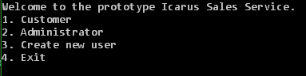
Note: Entering a category number which doesn’t exist prompts the user to try again until a valid number is inputted. This recurs through the program UI.
Figure 1 - Initial menu
In the customer menu, the user is given a choice between purchasing components or exiting the program (fig. 2). Exiting the program will give the option of clearing the shopping basket before closing. Choosing option 1 will prompt the user to log in.
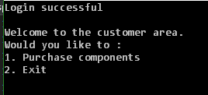
If option 1 is chosen, the user is presented with the various components available for purchase and their prices. The current component stock is also shown. The user can now choose to either buy components, view shopping basket, reverting to the customer portal, empty the shopping basket or exiting the program (fig. 3).
Figure 2 - Customer portal
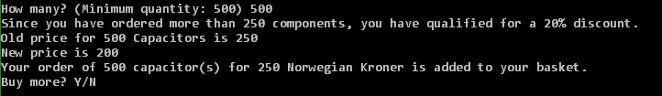
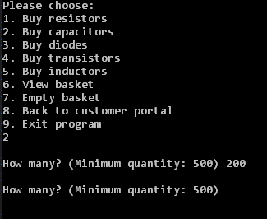
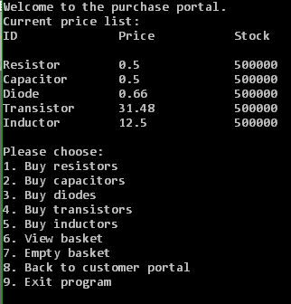
If alternatives 1-5 is chosen, a standardised prompt appears asking the user for the desired purchase quantity. Some components are restricted to a minimum purchase amount, which will prompt the user to correct the original requested quantity (fig. 4). After inputting a valid quantity, the component is added to the shopping basket and the price is calculated with any applicable discounts (fig. 5).
Figure 3 - Discount applied
Figure 4 - Minimum purchase quantity not satisfied
Figure 5 - Customer purchase menu (note that the prices are to be treated as examples)
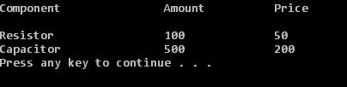
Viewing the basket will list the components purchased within the current session (fig. 6).
Figure 6 - View basket
The last feature accessible by the end-user is creating a new username and password for new customers. When choosing option 3 from the initial menu, the user is prompted with entering a new username and a new password. Because of software limitations, these cannot contain spaces.

Administrator Portal
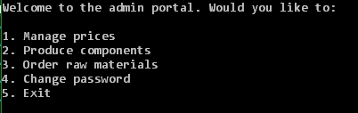
The administrator portal allows for stock control both on the component level and the subcomponent level. It also allows any administrator to change the prices of components sold by the company and makes password management possible. The administrator menu (fig. 7) is shown after the user enters the correct password (default: “2”).
Figure 7 - Administrator menu
In the “Manage prices” option, the administrator can change the price of individual components (fig. 8). A confirmation is printed to screen when the price change is successful (fig. 9).

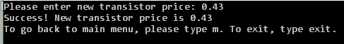
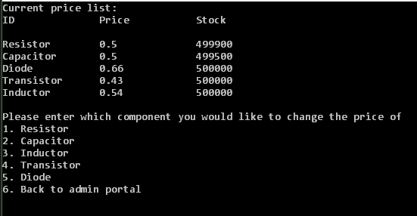
Figure 8 - Price change complete
Figure 9 - Price change menu
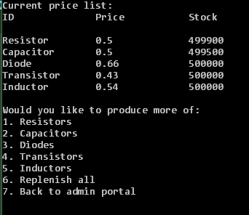
The “Produce components” option allows for the administrator to produce individual components or replenish the entire component stock (fig 10). This decrements the subcomponents stock file automatically with the right amounts.
Figure 10 - Production menu
Safeguards are in place, so the stock list cannot be overfilled. If subcomponents are lacking, the administrator will be prompted to reorder subcomponents first.
The “Order raw materials” option fills the subcomponent stock to default max.

Technical Documentation

UML Diagrams
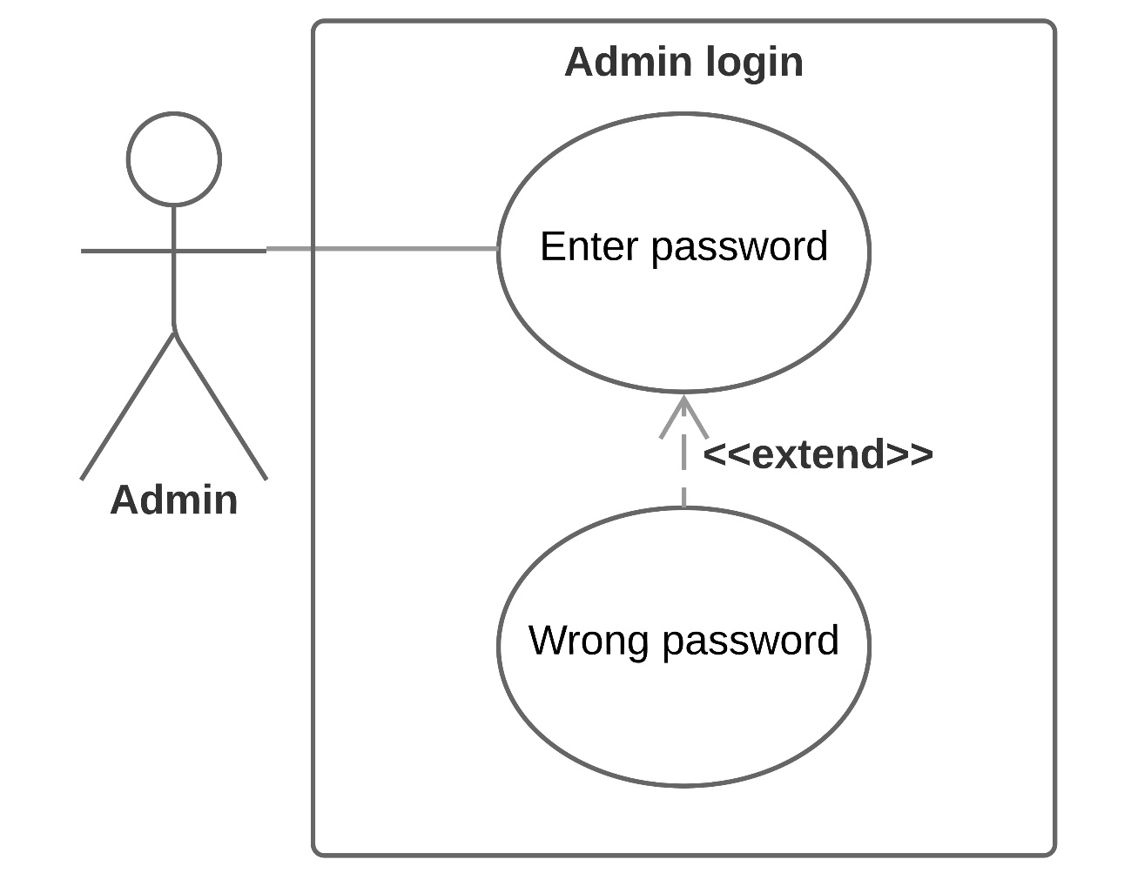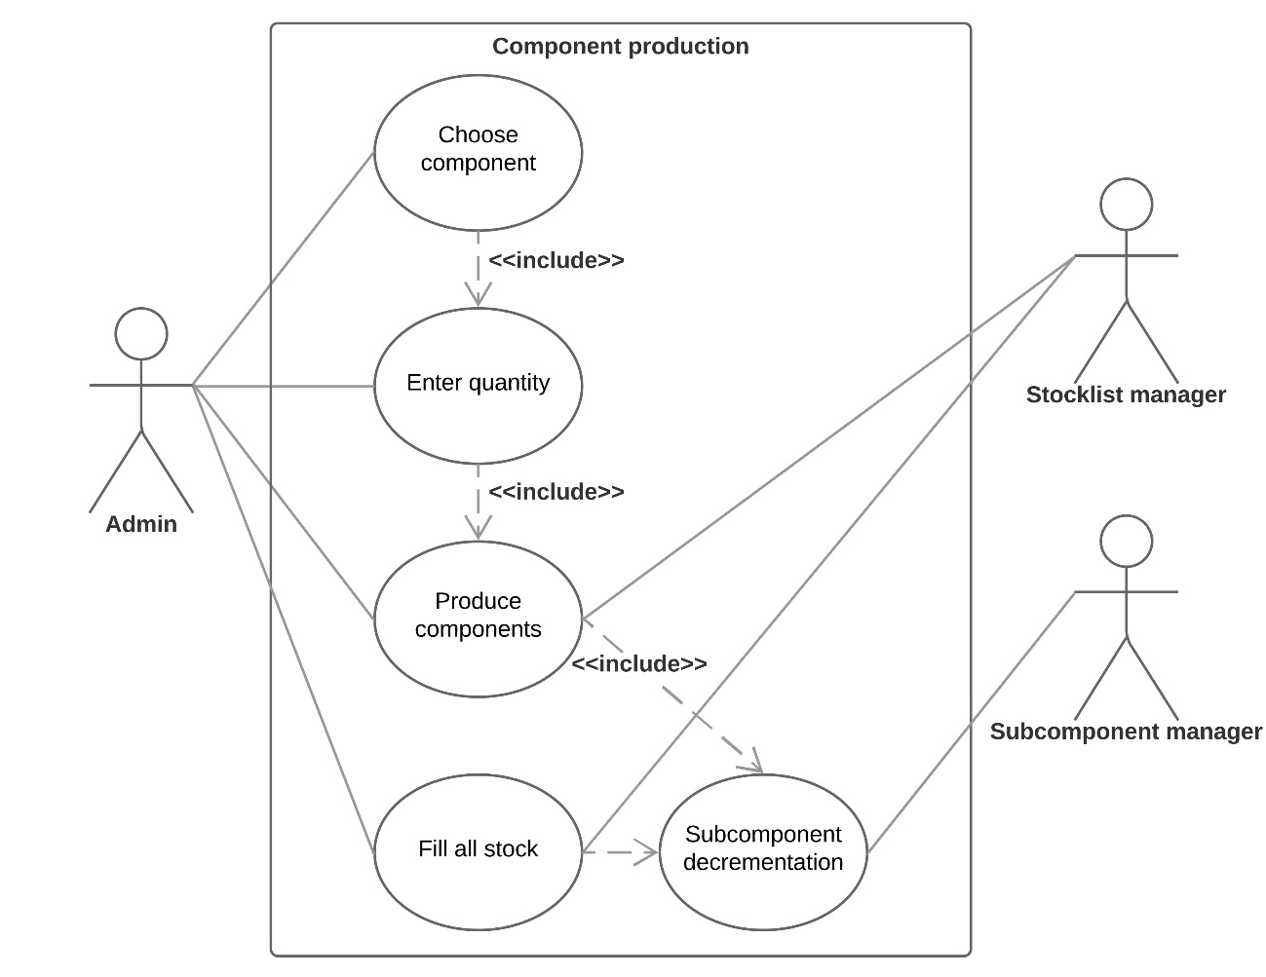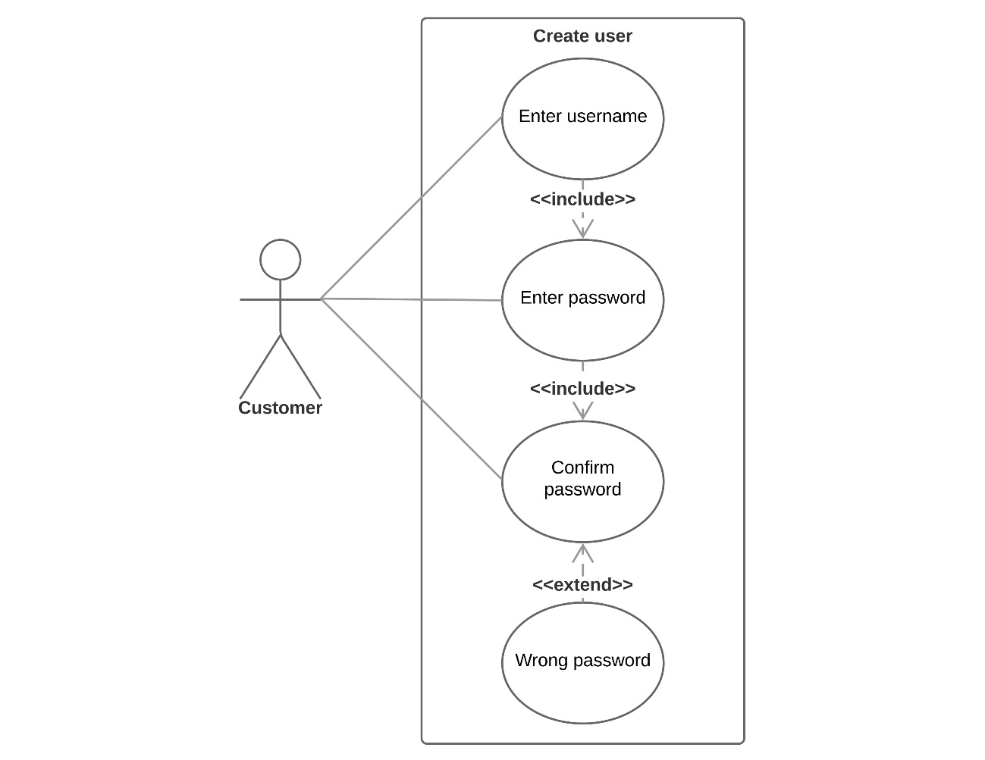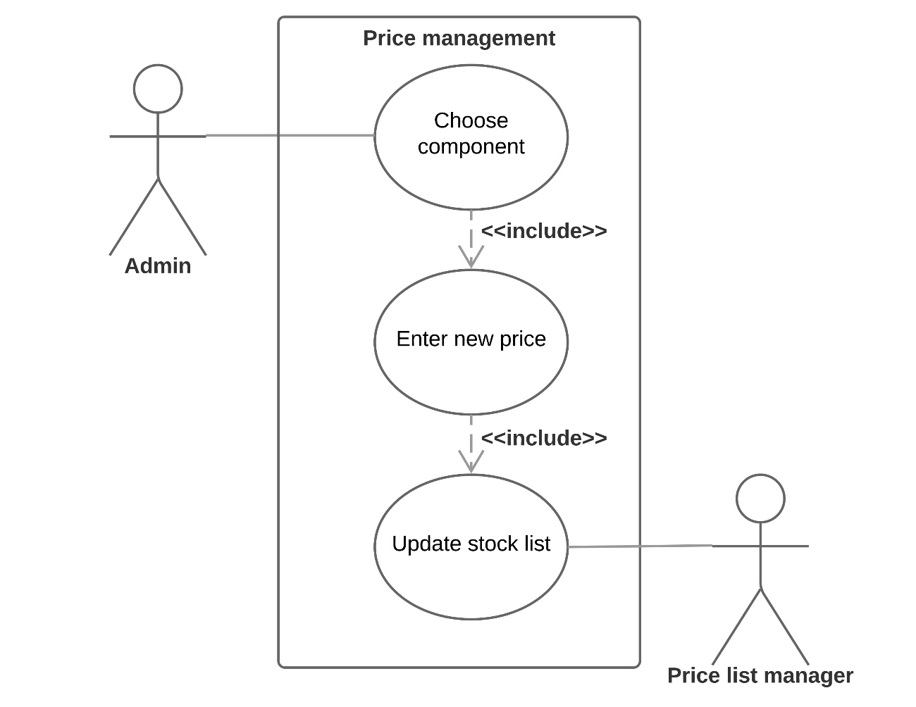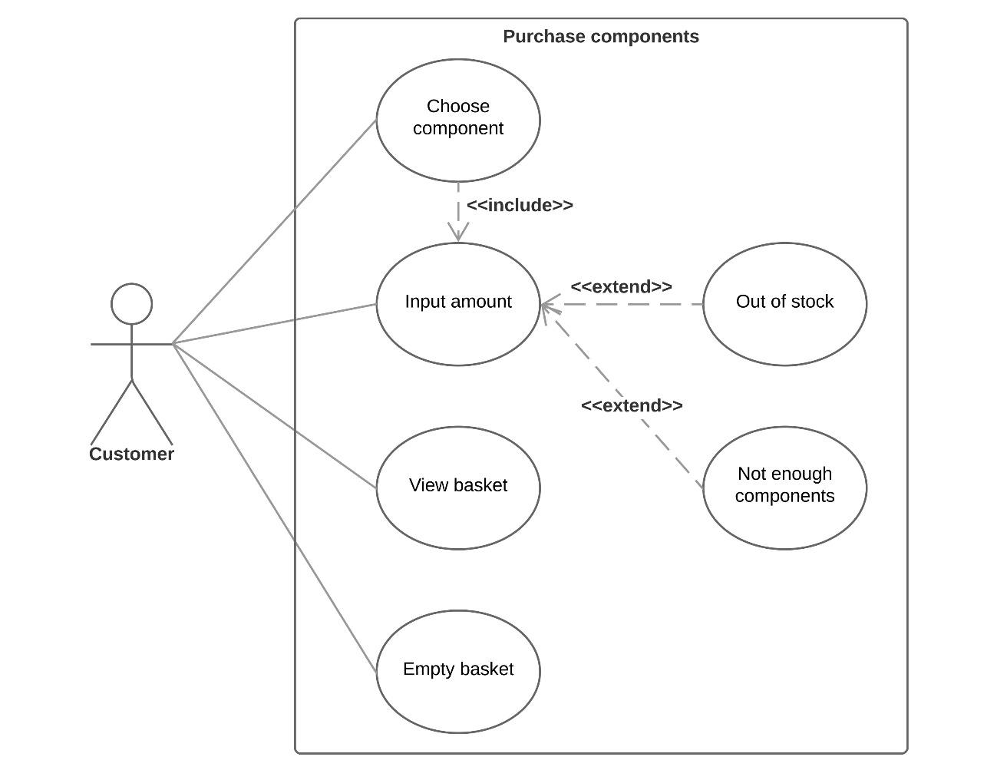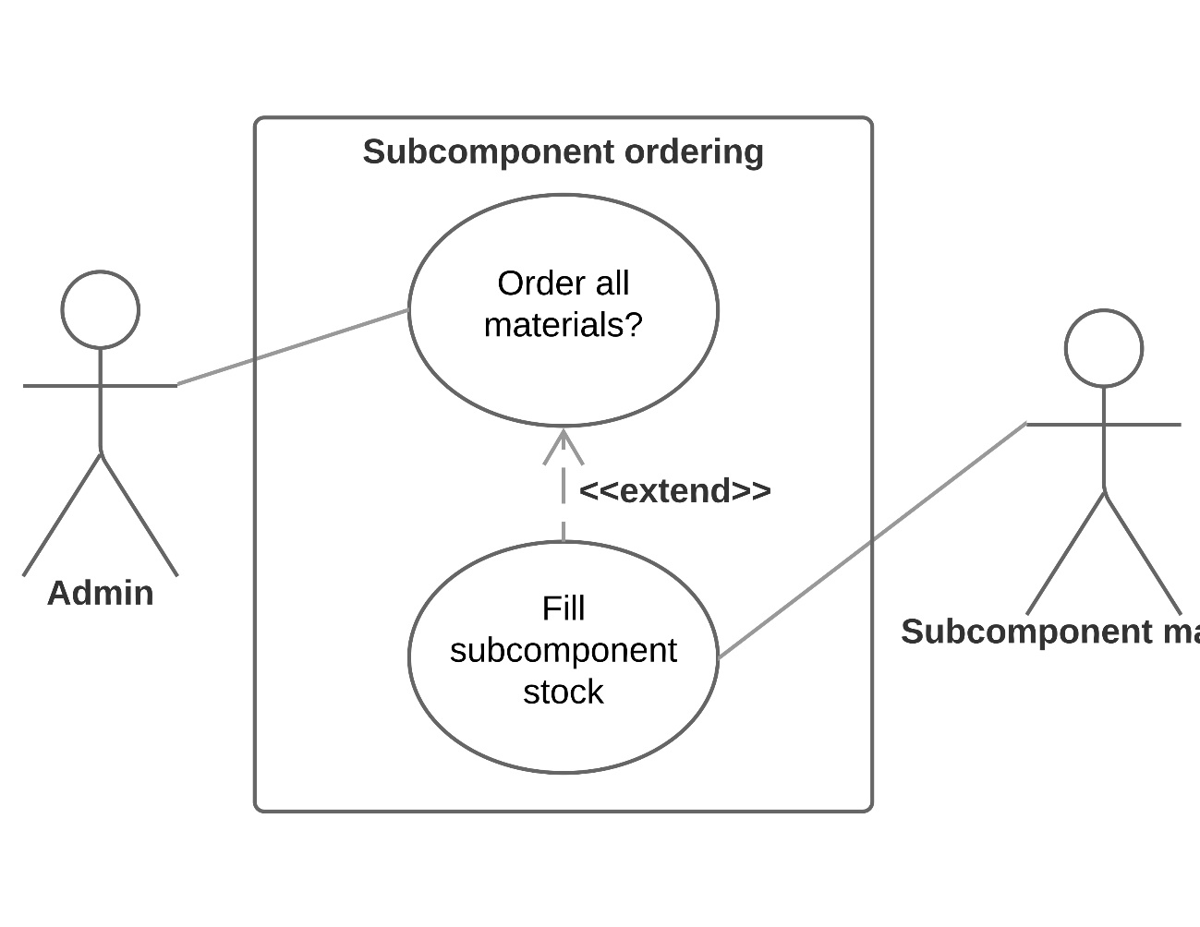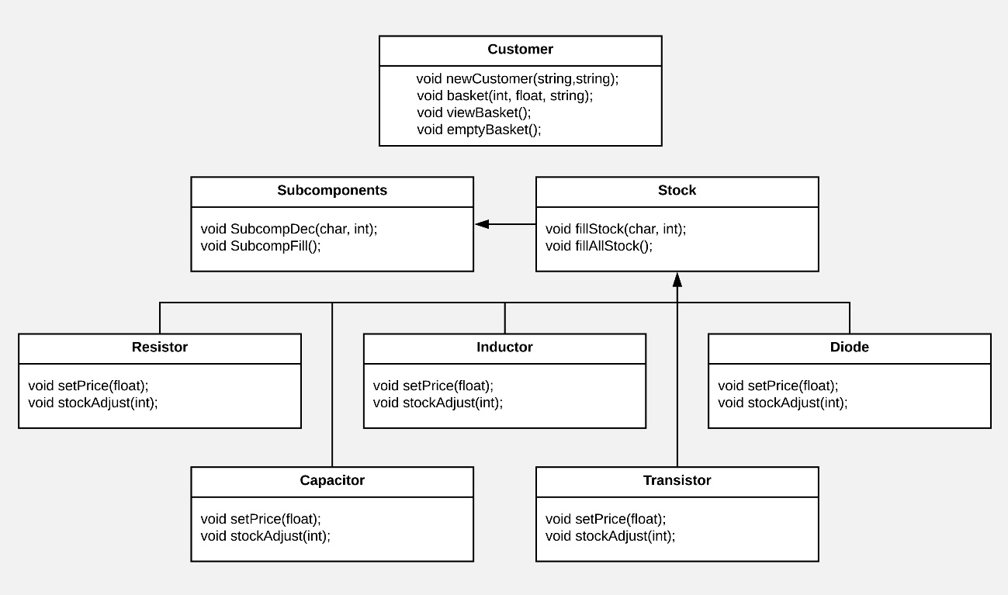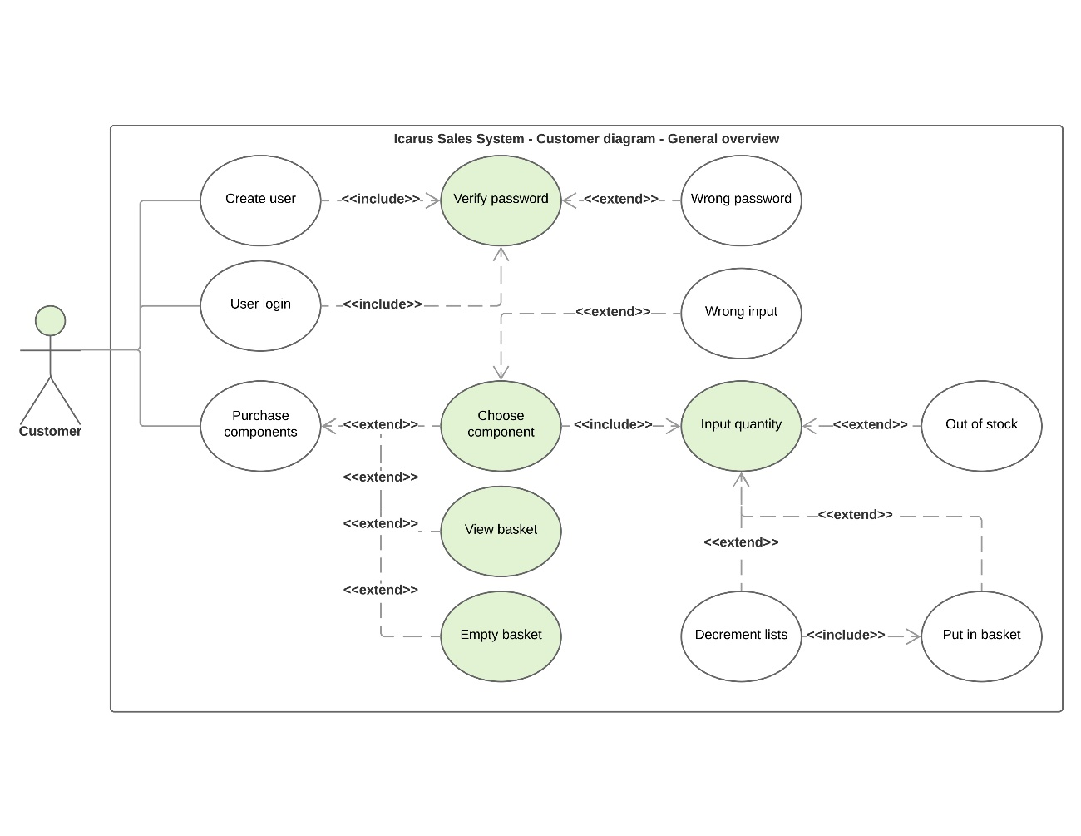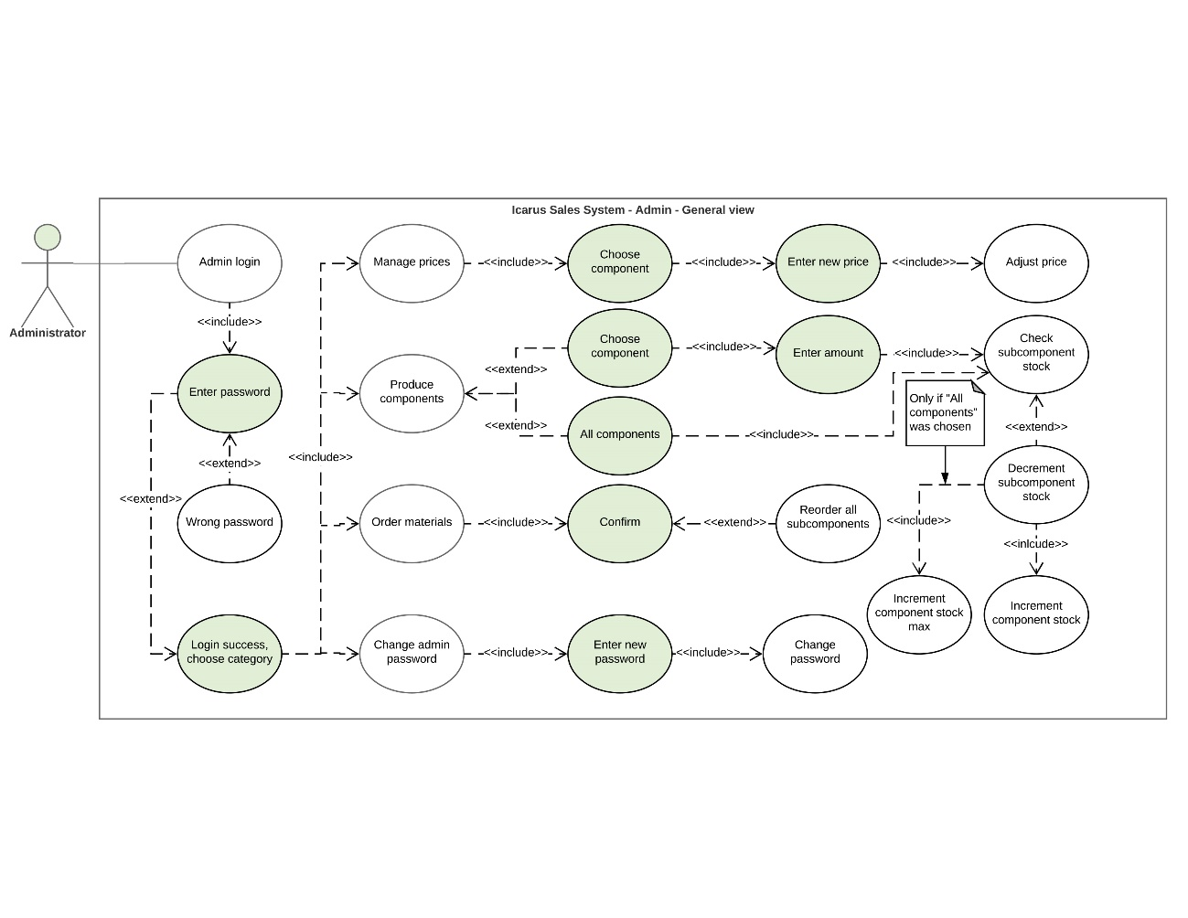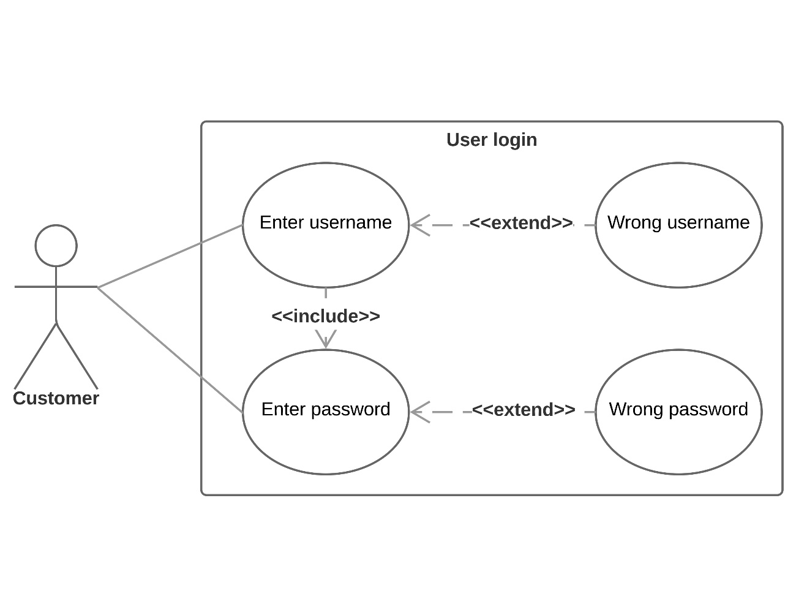
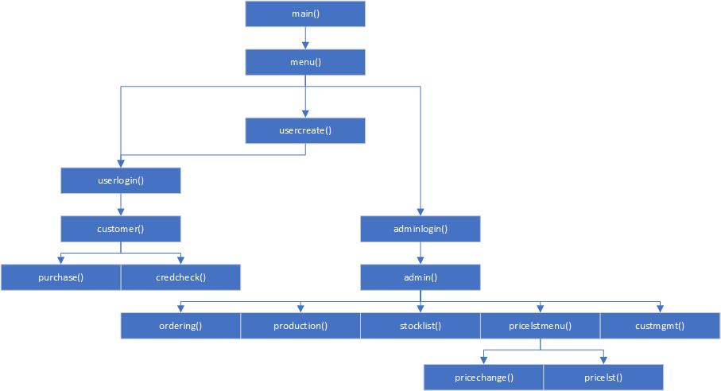

Code Examples
These are some examples of the different techniques utilised in object-oriented programming. The following images are excerpts from the program code.

Overloading

Inheritance
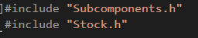

Object Usage


