Connor Thomas (2503035)
2503035@student.uwtsd.ac.uk
Abstract
This assessment designs a custom desktop workstation for engineering design, simulation, and remote collaboration, and evaluates cybersecurity risks in a manufacturing organisation. It prioritizes key vulnerabilities and proposes a comprehensive mitigation and incident response strategy to improve system security and operational continuity.
Cyber Risk and Computer System Design
LEVEL 4 ASSESSMENT



Contents
Task 1 – Custom Desktop Computer System Design 2
System Specification and Justification 2
CPU Selection 3
Motherboard Selection 4
Cooling Solution 5
Graphics Card (GPU) Selection 6
Memory (RAM) Selection 7
Storage Selection 8
Power Supply (PSU) Selection 9
Case Selection 10
Monitor Selection 11
Peripheral Input 12
Webcam Selection 13
Software and Security Tools 14
Cybersecurity Risk Assessment and Mitigation Strategy Introduction 15
In conclusion 17
References 17

Task 1 – Custom Desktop Computer System Design

System Specification and Justification
Table 1 PC PARTS
Component Type | Component Name | Price of component (£)
Central processing unit (CPU) | AMD Ryzen 7 7700 | 230
Motherboard | ASUS TUF Gaming B850-PLUS Wi-Fi | 240
CPU Cooler | Arctic Liquid Freezer III 240mm AIO | 70
Graphic processing unit (GPU) | Gigabyte GAMING OC Rev 2.0 RTX 3060 12GB | 260
Random access memory (RAM) | Corsair Vengeance 32GB (2×16GB) DDR5-6000 CL30 | 120
Storage 1 | Samsung 980 500GB NVMe SSD | 40
Storage 2 | Seagate Barracuda 2TB 7200RPM HDD | 45
Power supply (PSU) | Corsair RM750e (2025), 750W | 80
Case | Montech XR ATX Mid-Tower | 50
Monitor | ASUS TUF VG249QE5A, 24" IPS | 72
Keyboard | Corsair 4-in-1 Gaming Bundle (2025) | 90
Mouse | Corsair 4-in-1 Gaming Bundle (2025) | N/A
webcam | Logitech C920 | 42
Operating system (OS) | Windows 11 Pro | 20
TOTAL COST (£)= |  | 1359

CPU Selection
1 AMD CPU R7 7700
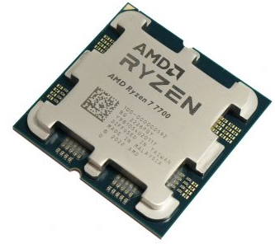
https://www.custompc.com/amd-ryzen-7-7700-review
The AMD Ryzen 7 7700 was picked for this workstation because it has great single-core speed and a good balance of multi-core performance. This is very important for electrical engineering work. PSpice and LabVIEW both benefit from multi-threading when simulating and processing data. On the other hand, SolidWorks Electrical needs great single-thread performance to make navigation and drawing activities smooth. The Ryzen 7 7700 has 8 cores and 16 threads, which means it can handle multitasking without getting too hot. The AM5 platform also has a strong upgrade path for the next CPUs.

Motherboard Selection
2 ASUS TUF GAMING B850-PLUS WIFI
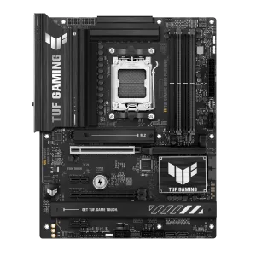
Why this motherboard was chosen
It offers excellent connectivity, strong power delivery, and long-term AM5 upgrade support, making it ideal for an engineering workstation that must remain reliable and future-proof.
Feature | Specification
Chipset | AMD B850
Form Factor | ATX
Socket | AM5
Memory Support | DDR5, up to 192GB
Expansion | PCIe 5.0 ×16 slot, PCIe 4.0 slots
Storage | Multiple M.2 NVMe slots (PCIe 4.0/5.0)
Networking | WiFi 6E + 2.5Gb Ethernet
Rear I/O | USB-C, USB 3.2 ports, HDMI/DP (for APUs)

Cooling Solution
3 Arctic Liquid Freezer III High Performance All In One CPU Cooler
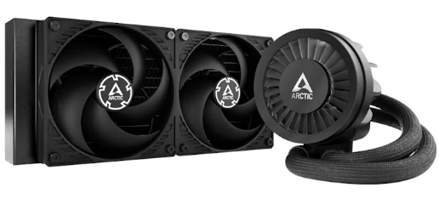
https://www.overclockers.co.uk/arctic-liquid-freezer-iii-high-performance-all-in-one-cpu-cooler-240mm-coo-arc-01985.html
Why this cooler was chosen
It delivers excellent cooling performance with low noise, ensuring stable CPU temperatures during long simulation or engineering workloads while providing future upgrade headroom.
Feature | Specification
Cooler Type | All-in-One Liquid Cooler
Radiator Size | 240mm
Fan Configuration | Dual 120mm fans
Compatibility | AM5
Pump Design | Efficient, low-noise pump
Thermal Performance | High cooling capacity for sustained workloads
Installation | Supports top or front radiator mounting

Graphics Card (GPU) Selection
4 GeForce RTX™ 3060 GAMING OC 12G
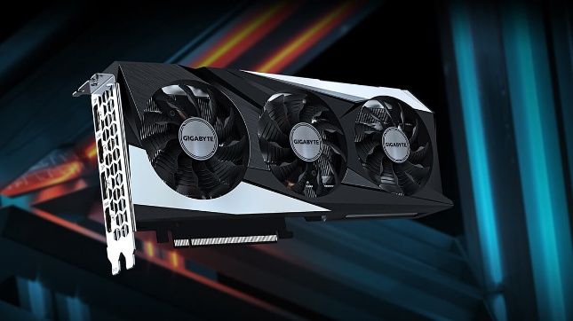
https://www.gigabyte.com/uk/Graphics-Card/GV-N3060GAMING-OC-12GD-rev-20
Why this GPU was chosen
It provides excellent value, stable performance for CAD and engineering tasks, and enough VRAM for large drawings and multitasking, without the higher cost or power demands of higher-end GPUs.
Feature | Specification
Model | Gigabyte GeForce RTX 3060 GAMING OC Rev 2.0
VRAM | 12GB GDDR6
Core Clock | Factory overclocked (OC edition)
Cooling | Triple-fan WINDFORCE cooling system
Power Requirement | ~170W (recommended PSU: 550W+)
Ports | HDMI, DisplayPort
Use Case | CAD acceleration, multi-monitor support, light 3D workloads

Memory (RAM) Selection
5 Corsair Vengeance DDR5
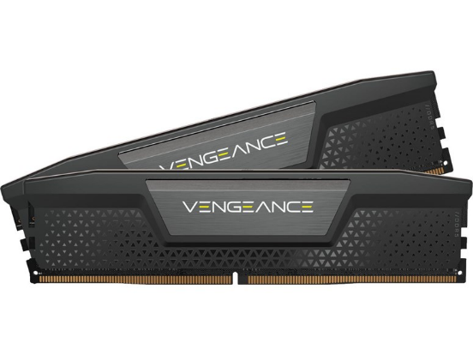
Why this RAM was chosen
It offers fast DDR5 performance, low latency, and sufficient capacity for running multiple engineering applications simultaneously without slowdowns.
Feature | Specification
Model | Corsair Vengeance DDR5
Capacity | 32GB (2 × 16GB)
Speed | 6000 MHz
Latency | CL30
Type | DDR5, Dual-Channel
Compatibility | AMD EXPO support (ideal for AM5 systems)
Use Case | Multitasking, simulations, CAD workloads

Storage Selection
6 Seagate BarraCuda 2TB, Internal Hard Drive, 3.5 Inch

7 Samsung 980 NVMe SSD
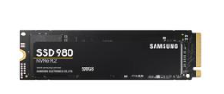
https://www.seagate.com/gb/en/products/hard-drives/barracuda-2-5-hard-drive/
https://www.samsung.com/uk/memory-storage/nvme-ssd/980-1tb-nvme-pcie-gen-3-mz-v8v1t0bw/

Why this storage setup was chosen
It combines fast SSD performance for daily tasks with large, affordable HDD capacity for engineering files, simulations, and backups.
Feature | Primary Drive | Secondary Drive
Model | Samsung 980 NVMe SSD | Seagate Barracuda Compute HDD
Capacity | 500GB | 2TB
Type | NVMe SSD (PCIe 3.0) | 7200RPM HDD
Speed | Up to 3,500 MB/s read | Mechanical, suitable for bulk storage
Use Case | OS + applications | Project files, backups, large data
Reliability | High durability SSD | Long-term archival storage

Power Supply (PSU) Selection

8 CORSAIR RMe Series Fully Modular Low-Noise Power Supply
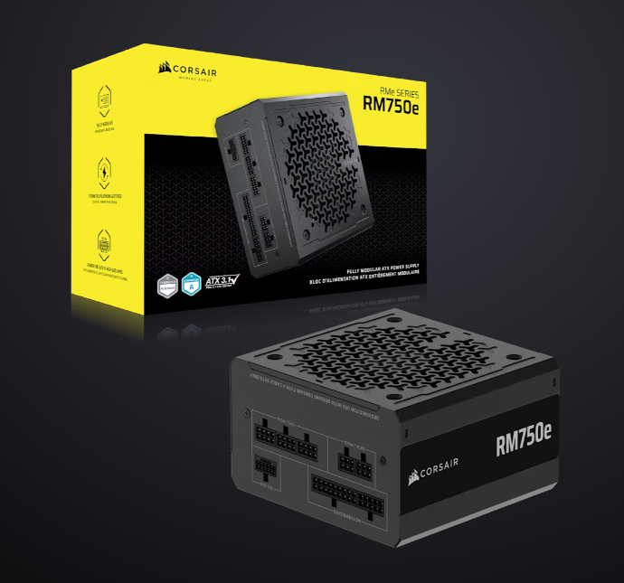
https://www.corsair.com/uk/en/p/psu/cp-9020295-uk/rme-series-rm750e-fully-modular-low-noise-atx-power-supply-uk-cp-9020295-uk

Advantages
- Fully modular design improves airflow and cable management.
- 750W capacity provides strong headroom for future GPU upgrades.
- ATX 3.1 and PCIe 5.1 support ensure long-term compatibility.
Disadvantages
- More expensive than non-modular PSUs.
- Higher wattage than strictly necessary for current components.
Why this component was chosen
This PSU was selected for its reliability, efficiency, and future-proof power delivery for potential upgrades.

Case Selection
9 montech XR CASE
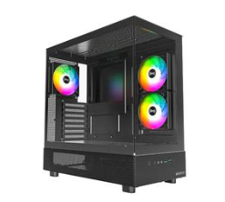
https://www.montechpc.com/xr

Advantages
- Good airflow and cooling support.
- Fits ATX boards and 240mm AIO.
- Clean internal layout.
Disadvantages
- Limited premium features.
- Cable management can be tighter than higher-end cases.
Why this component was chosen
This case was selected due to its strong airflow and compatibility at a reasonable price.

Monitor Selection
10 ASUS TUF VG249QE5A Full HD 24" IPS LCD Gaming Monitor
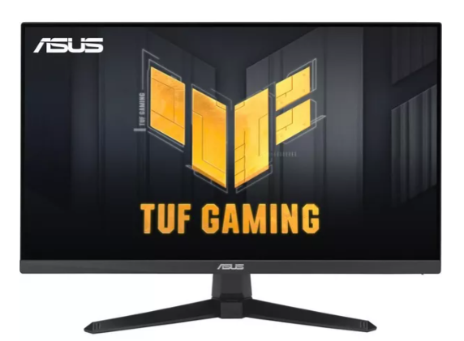
https://www.currys.co.uk/products/asus-tuf-vg249qe5a-full-hd-24-ips-lcd-gaming-monitor-black-10289500.html?srcid=198&cmpid=ppc~gg~2053+(Shopping+Ads)+PC+Gaming+HW+-+SBRE+-+Pmax~~Exact~21275899394~&mctag=gg_goog_7904&kwid=GOOGLE&device=c&ds_kids=&tgtid=2053+(Shopping+Ads)+PC+Gaming+HW+-+SBRE+-+Pmax&gclsrc=aw.ds&&gad_source=1&gad_campaignid=21279918217&gbraid=0AAAAAD7JKSIEsoAkdoVEQjEVeaSZW_Psz&gclid=CjwKCAiA86_JBhAIEiwA4i9Ju1GkkTLqLcRSEwFVqazryaQn-uOF3pLawNACyYTvvhFMwaEytQBdkBoCOdEQAvD_BwE

Why this monitor was chosen
It offers clear IPS image quality, a smooth viewing experience, and reliable everyday performance at an affordable price ideal for engineering work and general productivity.
Feature | Specification
Model | ASUS TUF VG249QE5A
Screen Size | 24 inches
Resolution | 1920 × 1080 (Full HD)
Panel Type | IPS
Refresh Rate | 165Hz
Response Time | 1ms
Ports | HDMI, DisplayPort
Adaptive Sync | FreeSync

Peripheral Input
11 CORSAIR 4 in 1 Gaming Bundle - 2025 Edition
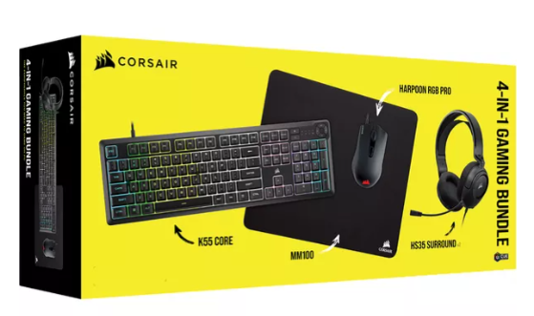
https://www.currys.co.uk/products/corsair-4-in-1-gaming-bundle-2025-edition-10266645.html?srcid=198&cmpid=ppc~gg~1016+(Shopping+Ads)+Gaming+Accessories+-+PMAX~~Exact~20655757123~&mctag=gg_goog_7904&kwid=GOOGLE&device=c&ds_kids=&tgtid=1016+(Shopping+Ads)+Gaming+Accessories+-+PMAX&gclsrc=aw.ds&&gad_source=1&gad_campaignid=20646252135&gbraid=0AAAAAD7JKSKLxd9WtW-lip9slodmj579p&gclid=CjwKCAiA86_JBhAIEiwA4i9JuxXgcGaEJ_727h1vHIT6MEekiCKMsRqMuqaNwFjEEjMaBCIekKsKtxoC4FsQAvD_BwE
Why this bundle was chosen
It provides all essential input devices in one affordable package, offering reliable everyday performance and good ergonomics suitable for engineering work and general productivity.
Item | Specification
Keyboard | Full-size membrane keyboard with RGB lighting
Mouse | Optical gaming mouse with adjustable DPI
Headset | Stereo headset with microphone
Mousepad | Standard desk-sized cloth pad
Connectivity | USB (wired)
Brand/Series | Corsair 4-in-1 Gaming Bundle (2025)

Webcam Selection

12 C920 HD Pro Webcam
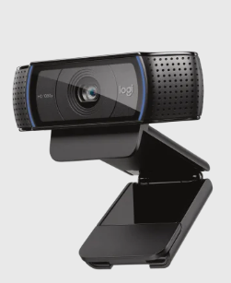
https://www.logitech.com/en-gb/shop/p/c920-pro-hd-webcam

Why this webcam was chosen
It delivers clear 1080p video, reliable autofocus, and high-quality audio, making it ideal for remote meetings and engineering collaboration
Feature | Specification
Model | Logitech C920
Resolution | Full HD 1080p
FPS | 30 frames per second
Microphone | Dual stereo mics
Field of View | 78°
Connection | USB 2.0
Mounting | Universal monitor/laptop clip

Software and Security Tools
13 microsoft windows 11 pro
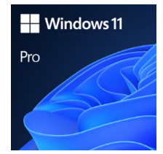
Why this OS was chosen
It offers strong built-in security, excellent stability, and full compatibility with engineering applications, making it ideal for a professional work-from-home workstation.
Feature | Specification
Edition | Windows 11 Pro
Security Features | BitLocker, Secure Boot, Windows Defender
Compatibility | Supports all required engineering software
Updates | Automatic security & feature updates
User Management | Enhanced admin tools and access control
Licensing | Single-device digital license

Cybersecurity Risk Assessment and Mitigation Strategy
Task 2.1: Find and Rate Cybersecurity Risks
Using outdated firewall rules and failing to separate corporate IT systems from operational technology (OT) systems on the network are two major cybersecurity risks [1]. This makes it easier for attackers to gain unauthorised access to networks and move throughout them, potentially causing production systems to fail and compromising their integrity and availability.
Another major risk is embedded devices with outdated firmware and default passwords [2]. These flaws make it easy for malware and password attacks to gain access to devices, giving hackers unauthorised control, the ability to change how the system works, or the ability to stop operations, which directly affects integrity and availability.
The company’s global supply chain increases risk because some suppliers do not use secure development or validation methods. Systems may be compromised by introducing vulnerable or malicious components, putting the confidentiality of intellectual property and the security of critical systems at risk.
In addition, some engineering workstations run outdated operating systems that no longer receive security updates [3]. These systems are easy targets for malware, ransomware, and zero-day exploits, increasing the likelihood of data breaches and operational downtime.
Finally, employees who do not receive sufficient cybersecurity training are vulnerable to phishing attacks, increasing the risk of credential theft and malware spreading across systems.
Task 2.2: Prioritising Risks and Giving Reasons
Outdated operating systems and insecure embedded devices pose the greatest risk because they are easy to exploit and directly affect critical engineering and operational systems [4]. Poor network segmentation is also a significant risk, as it allows attackers to move between IT and OT environments. Medium-priority risks include insufficient employee training and supply chain vulnerabilities. Phishing attacks are common but usually have indirect impacts, while supply chain attacks are less likely but potentially severe. Risks are prioritised based on their likelihood and potential impact on operations and sensitive data.

Task 2.3: A Complete Cybersecurity Plan
A complete cybersecurity plan should include both technical and management controls. The company should use network segmentation to keep corporate and OT systems separate, and change firewall rules to block unauthorised traffic. Operating systems and embedded devices must support patch and firmware management, remove default passwords, and use strong authentication methods such as multi-factor authentication.
To reduce the risks of phishing and social engineering, managers should provide employees with training to help them recognise cybersecurity issues. Regular audits and risk assessments should be conducted to identify weaknesses early. The company should also put in place supply chain security policies that make sure suppliers meet at least the minimum cybersecurity standards. These steps together deal with weaknesses in technology, people, and organisations.
Task 2.4: Plan for Responding to Incidents
The incident response plan follows a defined lifecycle. Setting up an incident response team, defining roles, and training staff are all parts of preparation. Identification means finding suspicious activity and grouping incidents by severity. During containment, affected systems are kept separate from each other, and malicious traffic is blocked to prevent further spread. Getting rid of malware, fixing security holes, and installing patches are all part of eradication. During the recovery phase, systems are restored from backups and monitored to prevent re-infection. Finally, lessons learnt are documented so that policies can be improved and similar events avoided in the future.
Task 2.5—Best Practices and Standards for Cybersecurity
The proposed cybersecurity strategy aligns with ISO/IEC 27001, which focuses on risk-based information security management [6]. The identify, protect, detect, respond, and recover lifecycle follows the NIST Cybersecurity Framework [5]. IEC 62443 provides guidance for securing industrial automation and control systems and supports network segmentation in operational environments [7]. Aligning with these standards ensures the organisation follows recognised cybersecurity best practices.
In conclusion
The manufacturing company is at significant risk of cyberattacks because its systems are outdated, its embedded devices are insecure, its network design is weak, its supply chain is weak, and its employees are not well-trained. The organisation can protect its intellectual property, keep operations running smoothly, and safeguard customer data by focusing on the most serious risks and implementing a comprehensive cybersecurity strategy that includes a robust incident response plan and recognised standards.

References
[1] U.S. Department of Homeland Security, Cybersecurity and Infrastructure Security Agency (CISA), Common Cybersecurity Vulnerabilities in Industrial Control Systems, 2023. [Online]. Available: https://www.cisa.gov/sites/default/files/recommended_practices/DHS_Common_Cybersecurity_Vulnerabilities_ICS_2010.pdf
[2] Cybersecurity and Infrastructure Security Agency (CISA), Critical Manufacturing Sector Landscape, May 2024. [Online]. Available: https://www.cisa.gov/sites/default/files/2024-05/Critical_Manufacturing_Sector_Landscape_updated_CP_5_2024_.pdf
[3] Microsoft, Are You Leaving the Door Open for Hackers? The Hidden Dangers of Unsupported Systems, 2025. [Online]. Available: https://www.microsoft.com/en-us/windows/business/knowledge-center/unsupported-systems-security-risks
[4] M. Wetzels, J. d. Santos, D. Ghafari, and A. Mohammad, “Insecure by Design in the Backbone of Critical Infrastructure,” arXiv preprint, 2023. [Online]. Available: https://arxiv.org/abs/2303.12340
[5] N. Mahn and A. Amy, “Identify, Protect, Detect, Respond and Recover: The NIST Cybersecurity Framework,” National Institute of Standards and Technology (NIST) Blog, 2018. [Online]. Available: https://www.nist.gov/blogs/taking-measure/identify-protect-detect-respond-and-recover-nist-cybersecurity-framework
[6] International Organization for Standardization, ISO/IEC 27001:2022 — Information Security Management Systems, 2022. [Online]. Available: https://www.iso.org/standard/27001
[7] International Electrotechnical Commission, IEC 62443: Cybersecurity Standards for Industrial Automation and Control Systems, n.d. [Online]. Available: https://amdt.com/en/resources/glossary/iec-62443

