REHAN JOSEPH
(2404834)
Digital Forensics
ACCD5000
Assignment
30 April 2026


Contents
Table Of Figures 3
Introduction 4
The CHFI Methodology 4
Overview of Forensic Tool Categories 5
Analysis of Key Digital Forensic Tools 6
FTK Imager – Precision in Acquisition 6
Magnet AXIOM – Advanced Analytical Integration 7
Autopsy – Flexible and Accessible Open-Source Analysis 8
Cellebrite UFED – Specialisation in Mobile Forensics 8
Volatility – Advanced Memory Analysis 9
Comparative Analysis of Forensic Tools 9
Tools Across CHFI Phases 10
Discussion 11
Conclusion 11
Task 2 – Case study: Sabotage 12
Methodology & Investigation Plan 12
Forensic Methodology (CHFI & ACPO Framework) 12
Investigation Plan 13
Forensic Acquisition of Encrypted Drive Evidence 13
Detection and Proof of Anti-Forensic Activity 13
File Carving Strategy for Deleted Design Recovery 14
Extraction of Cloud Synchronisation Evidence 14
Cross-Tool Correlation and Evidence Integration 14
Professional Digital Forensic Report 15
Executive Summary 15
Investigation Methodology 15
Investigation Steps 16
Flowchart Representing the Investigation Step 17
Findings (Detailed Evidence Analysis) 18
Evidence of Anti-Forensic Activity 18
Recovery of Deleted Autodesk Maya Project Files 19
File System and Deletion Pattern Analysis 20
Browser Artefacts and Cloud Synchronisation Evidence 21
Correlation of Evidence and Timeline Reconstruction 22
Conclusion 22
Appendix – Simulated Hash Log 23
Professional Invoice – Troy Simpson Forensics 25
FTK Report 26

Table Of Figures
Figure 1: Digital Forensics Investigation Workflow 7
Figure 2: Table of Forensic Tools 11
Figure 3: Digital Forensics Tools Across CHFI Phases 12
Figure 4: Investigation Steps Flowchart 20
Figure 5: FTK Imager 21
Figure 6: Autospy 22
Figure 7: Event Timeline 23
Figure 8: Stimulated Google Drive Activity Log 24
Figure 9: Stimulated hash log 25
Figure 10: Certutil Output 26
Figure 11: Professional Invoice 27

Modern Digital Forensic Tools: A Comparative Analysis Across CHFI Phases

Introduction
Digital forensics plays a vital role in modern investigations, supporting law enforcement, cybersecurity professionals, and organisations in identifying and analysing digital evidence. As technology has advanced, so has the amount and complexity of data been generated. Everyday activities such as using smartphones, accessing cloud services, and communicating online create digital footprints that can be crucial in investigations[1].
This growth has made digital forensics more challenging. Investigators are no longer limited to examining individual computers, instead, they must deal with multiple devices, operating systems, and storage environments. In addition, issues such as encryption, large data volumes, and rapidly changing technologies make the process more demanding.
Despite these challenges, the core principles of digital forensics remain consistent. Evidence must be collected and handled in a way that preserves its integrity and ensures it can be used in legal contexts[1]. However, the tools used to carry out these tasks have evolved significantly. Modern forensic tools are designed to handle complex investigations, automate processes, and analyse data from a variety of sources. No single forensic tool can fully address the diverse and complex requirements of modern digital investigations[1].
This paper critically evaluates five leading digital forensic tools, FTK Imager, Magnet AXIOM, Autopsy, Volatility and Cellebrite Universal Forensics Extraction Device (UFED) by analysing how they support key stages of the digital forensic investigation process. Through this analysis, it highlights their respective strengths and limitations while illustrating why effective digital forensic investigations depend on the strategic use of multiple tools rather than a single solution.

The CHFI Methodology
To fully understand the role of forensic tools, it is necessary to examine the structured framework within which they operate. The Computer Hacking Forensic Investigator (CHFI) methodology provides a systematic and legally defensible approach to digital investigations, ensuring that evidence is handled consistently and professionally throughout the investigative lifecycle[2].
The process begins with the identification phase, which focuses on recognising potential sources of digital evidence. At this stage, investigators assess the environment and determine which devices, systems, or storage locations may contain relevant data. This phase is largely strategic and requires careful planning rather than technical intervention. Closely following this, the preservation phase ensures that evidence is protected from alteration, damage, or loss. This includes isolating devices, documenting their condition, and maintaining a clear chain of custody, which is essential for legal admissibility[3].
Once evidence has been secured, the acquisition phase involves creating forensic copies using techniques such as bit-by-bit imaging and cryptographic hash verification to ensure data integrity. The investigation then progresses to the examination phase, where large volumes of data are processed and filtered using forensic tools to identify relevant artifacts. This leads into the analysis phase, where investigators interpret findings, reconstruct events, and develop a coherent understanding of the incident[3].
The final stages, documentation and presentation, focus on clearly communicating findings. Investigators must produce detailed and accessible reports that outline methods, evidence, and conclusions, ensuring they are suitable for both technical and non-technical audiences, particularly within legal contexts[3].
By structuring digital investigations into clearly defined phases, the CHFI methodology ensures that evidence is handled in a consistent, methodical, and legally defensible manner. Each stage contributes to maintaining the integrity and reliability of the investigation, from initial identification through to final presentation. These varying requirements highlight the importance of selecting appropriate tools to support each stage effectively[2].

Overview of Forensic Tool Categories
Digital forensic tools can be broadly categorised based on their role within the investigative process. Understanding these categories provides a useful framework for evaluating how individual tools contribute to different CHFI phases.
Imaging and acquisition tools are responsible for capturing digital evidence in a forensically sound manner. Their primary function is to create exact copies of storage media without modifying the original data. This ensures that investigators can work on duplicate copies while preserving the integrity of the original evidence[4].
Analysis tools are used to interpret and organise acquired data. These tools enable investigators to perform keyword searches, extract artifacts, reconstruct timelines, and identify patterns of activity. As data volumes continue to grow, analysis tools have become increasingly reliant on automation to improve efficiency[4].
Specialised tools focus on specific types of data or environments, such as mobile devices or cloud platforms. These tools provide deeper access to data that general-purpose tools may not be able to retrieve effectively. With the increasing importance of mobile and cloud technologies, specialised tools now play a central role in many investigations[4].
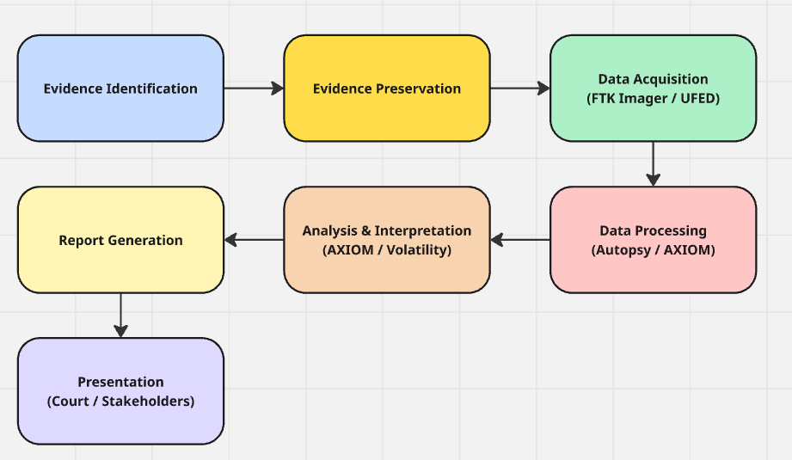
To better illustrate how different forensic tools are applied throughout an investigation, the workflow in Figure 1 demonstrates the relationship between CHFI phases and tool usage.

Figure 1: Digital Forensics Investigation Workflow
Figure 1: Digital Forensic Investigation Workflow aligned with CHFI phases, highlighting the use of forensic tools at each stage.
Rather than operating independently, these categories are interconnected. A comprehensive investigation typically involves multiple tools working together across different phases, ensuring both depth and accuracy in the analysis.

Analysis of Key Digital Forensic Tools
Digital forensic investigations require a structured, multi-tool approach, as different stages of the forensic process demand specialised capabilities. Tools used in acquisition, analysis, and reporting each contribute uniquely to the overall investigation. This section critically evaluates key forensic tools, including FTK Imager, Magnet AXIOM, Autopsy, Cellebrite UFED, and Volatility, highlighting their roles, strengths, and limitations within the CHFI framework.

FTK Imager – Precision in Acquisition
FTK Imager is widely regarded as a foundational tool in digital forensics, primarily due to its reliability in the acquisition phase. Its core function is to create exact bit-by-bit forensic images of storage devices, ensuring that all data including deleted and hidden sectors is preserved without modifying the original evidence[5]. This is essential for maintaining evidential integrity and ensuring legal admissibility. The tool supports commonly used file systems such as FAT, NTFS, and exFAT, making it particularly effective in standard desktop environments, and it also allows for the capture of volatile memory (RAM), which can contain critical transient data.
A key strength of FTK Imager lies in its use of cryptographic hashing algorithms, such as MD5 and SHA-1, to verify the integrity of acquired data. By generating hash values before and after imaging, investigators can confirm that no changes have occurred during the acquisition process. In terms of cost, the tool is freely available, which makes it highly accessible for both professional use and educational purposes. Its lightweight and portable design further enhances its practicality, particularly in field investigations where rapid evidence acquisition is required[5].
However, FTK Imager is limited in scope, as it does not provide advanced analytical capabilities. It cannot perform tasks such as artifact extraction, timeline reconstruction, or data correlation, which are essential in later stages of the CHFI process[5]. Additionally, its reporting features are relatively basic and not designed for detailed legal presentation. As a result, while FTK Imager is highly effective for acquisition and preservation, it must be used alongside other tools to support the examination, analysis, and reporting phases.

Magnet AXIOM – Advanced Analytical Integration
Magnet AXIOM is a comprehensive commercial forensic suite designed to address the complexity of modern digital investigations. It operates primarily within the examination and analysis phases, where it enables investigators to process and interpret large volumes of data efficiently[6]. The tool supports a wide range of file systems, including NTFS, FAT, EXT, APFS, and HFS+, allowing it to analyse data across both Windows and macOS environments. In addition to traditional disk-based evidence, AXIOM can analyse mobile data and cloud-based artifacts from platforms such as Google Drive and iCloud, reflecting the increasing importance of distributed data sources[6].
One of AXIOM’s most significant strengths is its ability to automatically extract and categorise digital artifacts, including emails, chat messages, browsing history, and social media activity[6]. Its timeline reconstruction feature allows investigators to visualise sequences of events, while its cross-device correlation capability enables data from multiple sources to be integrated into a single, coherent view. These features significantly enhance both efficiency and analytical depth, particularly in complex investigations involving multiple devices or large datasets.
In terms of reporting, Magnet AXIOM provides advanced, court-ready outputs that clearly present findings in a structured and professional format. However, these capabilities come at a high financial cost, and the tool requires specialised training to be used effectively. As a result, it is best suited to professional environments such as law enforcement agencies or large organisations[6]. Despite these limitations, its extensive feature set makes it one of the most powerful tools available for comprehensive forensic analysis.

Autopsy – Flexible and Accessible Open-Source Analysis
Autopsy is a widely used open-source forensic tool that offers a practical and accessible alternative to commercial forensic suites. It is primarily used during the examination and analysis phases, where it provides essential capabilities for investigating disk images and identifying relevant evidence. The tool supports multiple file systems, including NTFS, FAT, EXT, and HFS+, allowing it to operate across a variety of systems. Its core functionality includes keyword searching, file system analysis, and timeline creation, which enable investigators to interpret large volumes of data effectively[7].
A major advantage of Autopsy is its cost, as it is completely free and open source. This makes it particularly valuable in educational environments and smaller organisations where budget constraints may limit access to commercial tools[8]. Additionally, its modular plugin architecture allows users to extend its functionality, providing flexibility and adaptability for different investigative scenarios. Its user-friendly interface also makes it suitable for individuals who are still developing their forensic expertise[7].
However, Autopsy lacks the advanced automation and integration features found in tools such as Magnet AXIOM. As a result, many processes require manual input, which can reduce efficiency when handling large or complex datasets. Its reporting capabilities are also more limited, often requiring additional refinement before being suitable for legal presentation[8]. Despite these limitations, Autopsy remains a highly effective tool for disk-based forensic analysis, particularly when cost and accessibility are key considerations.

Cellebrite UFED – Specialisation in Mobile Forensics
Cellebrite UFED is a specialised forensic tool designed for the extraction and analysis of mobile device data, an area that has become increasingly important in modern investigations. It supports a wide range of devices and operating systems, including iOS and Android, and is capable of handling their respective file systems. The tool is primarily used during the acquisition and analysis phases, where it enables investigators to extract data directly from mobile devices, including those that are locked, encrypted, or damaged[6].
One of UFED’s key strengths is its ability to perform deep data extraction, allowing investigators to recover deleted data such as messages, call logs, contacts, and application data[9]. It also provides advanced decoding capabilities for mobile applications, including messaging platforms and social media services, making it particularly effective for analysing communication-based evidence. These features allow investigators to access critical information that may not be available through general-purpose forensic tools[6].
In terms of reporting, UFED offers detailed, court-ready outputs that support both the documentation and presentation phases of an investigation. However, the tool is associated with a very high cost and requires specialised training, which may limit its accessibility to well-funded organisations such as law enforcement agencies[9]. Despite these constraints, its ability to extract and analyse mobile data makes it an essential component of modern digital forensic investigations.

Volatility – Advanced Memory Analysis
Volatility is an open-source memory forensics framework designed to analyse RAM dumps and extract volatile data that would otherwise be lost when a system is powered down. Unlike traditional forensic tools that focus on disk-based evidence, Volatility operates in a highly specialised domain, making it particularly valuable in investigations involving malware, live attacks, and advanced persistent threats. It supports memory images from multiple operating systems, including Windows, Linux, and macOS, allowing investigators to analyse a wide range of environments[10].
A key strength of Volatility lies in its ability to extract detailed artifacts directly from memory. These include running processes, network connections, loaded DLLs, encryption keys, and even fragments of malicious code. This makes it especially effective for detecting fileless malware, which operates entirely in memory and leaves little to no trace on disk. In terms of cost, Volatility is completely free and open-source, making it highly accessible. However, it requires a strong level of technical expertise, as it is primarily command-line based and lacks the user-friendly interface found in commercial tools[10].
From a CHFI perspective, Volatility is most relevant to the acquisition (RAM capture support), examination, and analysis phases, where it provides insights that cannot be obtained through disk analysis alone. Its reporting capabilities are limited compared to commercial tools, often requiring manual interpretation and documentation of findings[10]. Despite this, its ability to uncover hidden and volatile evidence makes it an extremely powerful addition to a forensic toolkit, particularly in advanced investigations where traditional tools may fail.

Comparative Analysis of Forensic Tools
The following table provides a structured comparison of the 5 modern forensic tools, highlighting their capabilities and relevance to the CHFI methodology.

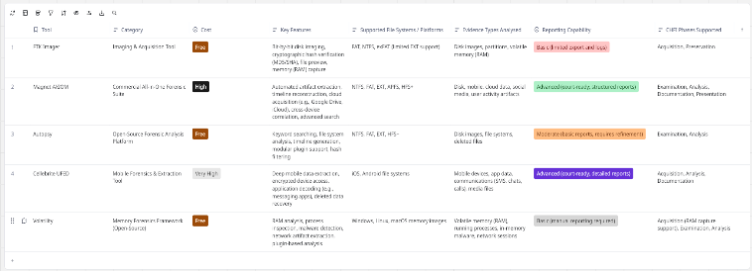
Figure 2: Table of Forensic Tools
Figure 2 provides a comparative overview of key digital forensic tools, evaluating their cost, functionality, supported platforms, evidence types, reporting capabilities, and alignment with CHFI phases. The comparison highlights the strengths and limitations of both commercial and open-source solutions, demonstrating that no single tool fully supports all stages of an investigation. Instead, it reinforces the need for a combined, multi-tool approach to effectively handle diverse forms of digital evidence, including disk, mobile, cloud, and volatile memory data.

Tools Across CHFI Phases
When viewed together, digital forensic tools operate as part of a structured investigative workflow, with different tools supporting different stages of the CHFI framework according to their specific capabilities.
At the acquisition stage, tools such as FTK Imager and Cellebrite UFED establish the foundation of the investigation by ensuring that data is captured accurately and preserved in a forensically sound manner[3]. The reliability of this stage is critical, as any compromise in data integrity would undermine all subsequent analysis.
As the investigation transitions into the examination and analysis phases, the focus shifts from data collection to interpretation. Tools such as Magnet AXIOM and Autopsy become central at this point, alongside specialised frameworks such as Volatility, which enable investigators to analyse volatile memory and uncover artifacts that may not be present on disk. This progression reflects a move from technical accuracy to analytical insight, where the value of the evidence is fully realised[3].
In the later stages, particularly documentation and presentation, the emphasis turns to clarity and communication. The ability to generate structured, court-ready reports becomes essential, with tools like Magnet AXIOM and Cellebrite UFED offering advanced reporting features that support both technical transparency and legal credibility.
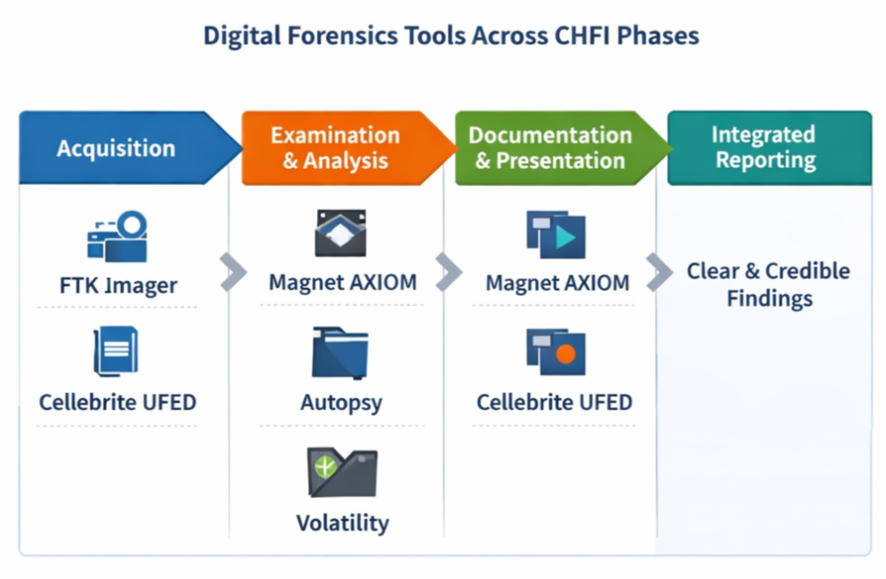
Figure 3: Digital Forensics Tools Across CHFI Phases
Figure 3 shows how digital forensic tools are used across CHFI phases, from acquisition to analysis and reporting, highlighting the need for a multi-tool approach.
Taken together, this progression demonstrates that effective digital forensics is inherently tool combinational rather than tool dependent. No single solution can address every phase of the investigation, instead, success depends on selecting and integrating tools that align with the specific demands of each stage.

Discussion
A critical observation from this analysis is that the effectiveness of a forensic investigation depends not only on technical expertise but also on strategic tool selection. Choosing the appropriate tool for each phase can significantly improve efficiency, accuracy, and overall investigative outcomes.
Commercial tools offer advanced features, automation, and integration, making them highly effective for complex investigations. However, their cost and training requirements can be restrictive. In contrast, open-source tools provide accessibility and flexibility, ensuring that forensic analysis remains achievable even with limited resources.
Another key trend is the increasing importance of mobile and cloud forensics. As data continues to move away from traditional storage systems, investigators must adapt by incorporating specialised tools into their workflows. This shift highlights the need for continuous learning and adaptation within the field of digital forensics.

Conclusion
Digital forensic investigations are no longer supported by single, all-encompassing solutions, but instead depend on the strategic integration of multiple specialised tools. This analysis has demonstrated that while tools such as FTK Imager, Magnet AXIOM, Autopsy, and Cellebrite UFED each provide significant capabilities, their effectiveness is inherently limited to specific phases of the investigative process.
As digital environments continue to grow in complexity, particularly with the expansion of mobile, cloud, and volatile data sources, the importance of adaptable, multi-tool approaches will only increase. Therefore, the effectiveness of modern digital forensics lies not in the power of individual tools, but in how they are applied collectively to produce accurate, reliable, and legally defensible outcomes.

Task 2 – Case study: Sabotage
This report investigates a suspected case of data sabotage and intellectual property theft involving Rich Daley at Cyfusion Mobile Manufacturing Company (CMMC). The case focuses on the removal of important Autodesk Maya design files shortly before the suspect’s resignation, raising concerns about both data deletion and possible data theft.
The investigation follows the CHFI methodology and Association of Chief Police Officers (ACPO) principles to ensure all evidence is handled correctly and remains legally admissible. A multi-tool approach is used, applying industry-standard forensic tools identified in Task 1 to analyse disk data, memory, and cloud activity.
Together, these methods aim to build a clear and reliable understanding of what happened and whether any data was deleted, recovered, or transferred outside the organisation.

Methodology & Investigation Plan

Forensic Methodology (CHFI & ACPO Framework)
A successful digital forensic investigation depends not only on technical capability but on a structured, legally defensible methodology[11]. In this case, the investigation is guided by the CHFI forensic lifecycle, reinforced by the ACPO principles, ensuring that all evidence is handled with integrity and remains admissible in a court of law.
At the core of this approach is the assurance that no action taken during the investigation will alter original evidence, and that every step is thoroughly documented. This aligns directly with ACPO’s emphasis on preservation, accountability, and repeatability. Rather than relying on a single forensic tool, the investigation adopts a multi-tool ecosystem, as established in Task 1. This reflects real-world forensic practice, where different tools are applied strategically across each phase to maximise accuracy and depth of analysis[11].
The investigation follows the structured CHFI lifecycle: Identification, Preservation, Acquisition, Examination, Analysis, and Reporting. Each phase transitions logically into the next, creating a continuous and traceable workflow in which evidence is not only collected but also analysed and validated using specialised forensic tools.

Investigation Plan
Building upon this methodological foundation, the investigation plan outlines a structured series of technical steps aligned with the CHFI framework and guided by ACPO principles. Each phase is designed to uncover, preserve, and interpret digital evidence in a manner that maintains integrity, ensures reproducibility, and supports legal admissibility[11]. Appropriate forensic tools are selected to meet the specific technical and procedural requirements of each stage.

Forensic Acquisition of Encrypted Drive Evidence
The investigation begins with the challenge of accessing a BitLocker-encrypted system, requiring a careful balance between immediacy and preservation. If the system is found in a live state, priority is given to capturing volatile memory using Volatility. This step is critical, as volatile data such as encryption keys, running processes, and user session information would otherwise be lost upon shutdown[12]. Acquisition is performed with minimal system interaction, in accordance with ACPO Principle, ensuring that no unnecessary changes are made to the original evidence.
Once access is secured, a forensic image of the storage device is created using FTK Imager. This tool enables a bit-by-bit copy of the drive, ensuring that all data, including deleted and hidden sectors, is preserved without altering the source. Cryptographic hash values (MD5 and SHA-256) are generated before and after imaging to verify integrity and demonstrate that no changes have occurred during acquisition. This process establishes a reliable and legally defensible foundation, ensuring that all subsequent analysis is conducted on a verified duplicate rather than the original evidence.

Detection and Proof of Anti-Forensic Activity
With the forensic image acquired, the investigation progresses to identifying potential anti-forensic behaviour, such as the use of file-wiping tools. Autopsy is used to conduct in-depth file system analysis, enabling the examination of artefacts including installed applications, Windows Registry entries, Prefetch files, and event logs. These artefacts can provide indirect but reliable evidence of program execution, even if the original tool has been removed[12].
To strengthen this analysis, Magnet AXIOM is used to generate a comprehensive timeline of system activity. Its ability to correlate events across multiple data sources allows investigators to establish when the wiping tool was executed and how it relates to other user actions. This combined approach moves beyond isolated traces, enabling investigators to demonstrate patterns of behaviour and infer intent, thereby strengthening the evidential narrative.

File Carving Strategy for Deleted Design Recovery
Following the identification of potential data deletion, the investigation focuses on recovering deleted design files. Autopsy is used to perform file carving by scanning unallocated disk space for known file signatures, such as Autodesk Maya formats (.ma and .mb). As this method does not rely on file system records, it remains effective even when those records have been altered or removed.
The process involves reconstructing file fragments, analysing slack space, and extracting any available metadata. While file carving can successfully recover deleted data, it may result in incomplete or fragmented files, requiring careful validation to ensure evidential reliability. Even partial recovery, however, can provide valuable insight into file existence, usage, and potential relevance to the investigation[12].

Extraction of Cloud Synchronisation Evidence
The investigation then examines the possibility of data exfiltration through cloud services such as Google Drive. In this phase, Magnet AXIOM is used to analyse browser artefacts, including browsing history, cookies, cached data, saved credentials, and login sessions.
This enables the reconstruction of user interactions with cloud platforms, allowing investigators to identify access patterns, file uploads, or synchronisation activity. By correlating this data with system-level evidence, investigators can determine whether files were transferred outside the device prior to deletion. This step is essential in identifying potential data exfiltration and expanding the scope of the investigation beyond local storage[13].

Cross-Tool Correlation and Evidence Integration
The final stage involves integrating findings from all tools into a unified and coherent timeline. As no single tool provides a complete view of the investigation, combining results from Volatility (memory analysis), FTK Imager (disk acquisition), Autopsy (file system analysis and recovery), and Magnet AXIOM (timeline and user activity) is essential.
This cross-tool correlation allows investigators to verify the sequence of events, identify behavioural patterns, and strengthen the reliability of conclusions. For example, encryption keys recovered from memory can be linked to encrypted disk data, while recovered files can be associated with user actions and potential cloud activity. This multi-source validation enhances evidential credibility and ensures consistency across findings[12].
Furthermore, this process aligns with ACPO Principle by maintaining a clear and auditable trail of evidence handling and analysis. By consolidating all findings into a structured timeline, the investigation produces a comprehensive, defensible account of events supported by multiple independent sources of evidence.

Professional Digital Forensic Report
Cyfusion Mobile Manufacturing Company (CMMC)
Case: Suspected Data Sabotage & Intellectual Property Theft
Prepared by: Troy Simpson (CHFI, CEH)

Executive Summary
This report documents the findings of a formal digital forensic investigation into suspected sabotage and unauthorised data exfiltration conducted by Rich Daley, a former employee of Cyfusion Mobile Manufacturing Company (CMMC). The investigation was initiated following the unexplained loss of proprietary mobile interface designs developed using Autodesk Maya, which represent significant commercial value.
Given the sensitivity of the data and the absence of system backups, the suspect’s workstation, secured using BitLocker was identified as the sole evidential source. The investigation was conducted in accordance with ACPO principles and the structured CHFI methodology, ensuring that all evidence handling remained legally defensible.
A multi-tool forensic approach, consistent with the findings of Task 1, was employed. FTK Imager was utilised for evidential acquisition, while Autopsy and Magnet AXIOM were used for in-depth examination and analysis.
The investigation identified clear indicators of deliberate anti-forensic activity, including the execution of file-wiping software, alongside recoverable fragments of deleted project files. Additionally, browser artefacts demonstrate access to Google Drive consistent with unauthorised data transfer. The totality of evidence strongly supports the conclusion that the suspect intentionally removed, transferred, and attempted to destroy sensitive company data prior to resignation.

Investigation Methodology
The investigation followed a structured forensic lifecycle aligned with the Computer Hacking Forensic Investigator (CHFI) methodology. Each phase was applied to ensure that digital evidence was handled in a controlled and forensically sound manner, maintaining integrity throughout the investigation.
A multi-tool approach was adopted to address the technical requirements of each phase. During acquisition, tools such as FTK Imager were used to create verified forensic copies of the evidence. Examination and analysis were supported by tools such as Autopsy and Magnet AXIOM, enabling artefact extraction, file recovery, and timeline reconstruction. This approach allowed both low-level data recovery and higher-level behavioural analysis to be conducted, resulting in a comprehensive and defensible evidential outcome.

Investigation Steps
Step 1: Evidence Identification - The suspect system was identified as the primary source of evidence. Key data sources included encrypted storage volumes, Autodesk Maya project files, system artefacts, and browser-based activity related to cloud services.
Step 2: Preservation - The device was secured in line with ACPO principles to prevent any alteration of data. Network isolation was applied, and a chain of custody record was established to maintain evidential integrity.
Step 3: Live System Assessment - The system was assessed to determine whether it was in a live state. If powered on, volatile memory would be captured using Volatility to preserve transient data such as running processes, active sessions, and potential encryption keys.
Step 4: Decryption - Access to the BitLocker-encrypted drive was obtained using recovered credentials or memory artefacts. Decryption was performed in a controlled forensic environment to avoid modifying the original data.
Step 5: Acquisition - A forensic image of the system was created using FTK Imager, ensuring that the data was captured in a forensically sound and verifiable format.
Step 6: Integrity Verification - Hash values (MD5 and SHA256) were generated to confirm that the acquired data remained unchanged throughout the imaging process.
Step 7: File System Analysis - The acquired image was analysed using Autopsy to examine directory structures, file metadata, and identify missing or suspicious files.
Step 8: Anti-Forensic Detection - System artefacts, including registry entries and prefetch files, were reviewed to identify evidence of file-wiping tools and potential attempts to conceal activity.
Step 9: Deleted Data Analysis - Available file system artefacts were analysed to identify indications of deleted files, including missing data and partial remnants within the dataset.
Step 10: Browser and Cloud Analysis - Browser artefacts were examined to identify interactions with cloud storage services such as Google Drive. This analysis was conceptually supported by Magnet AXIOM.
Step 11: Correlation of Evidence - Findings from file system analysis, system artefacts, and browser activity were compared to identify relationships between user actions and system events.
Step 12: Timeline Reconstruction - A timeline of activity was created to present the sequence of key events, including file access, deletion, and cloud interactions.
Step 13: Interpretation - The combined evidence was analysed to develop an understanding of user behaviour and identify patterns consistent with deliberate actions.
Step 14: Reporting - All findings were documented in a structured forensic report, ensuring clarity, accuracy, and alignment with professional standards.

Flowchart Representing the Investigation Step
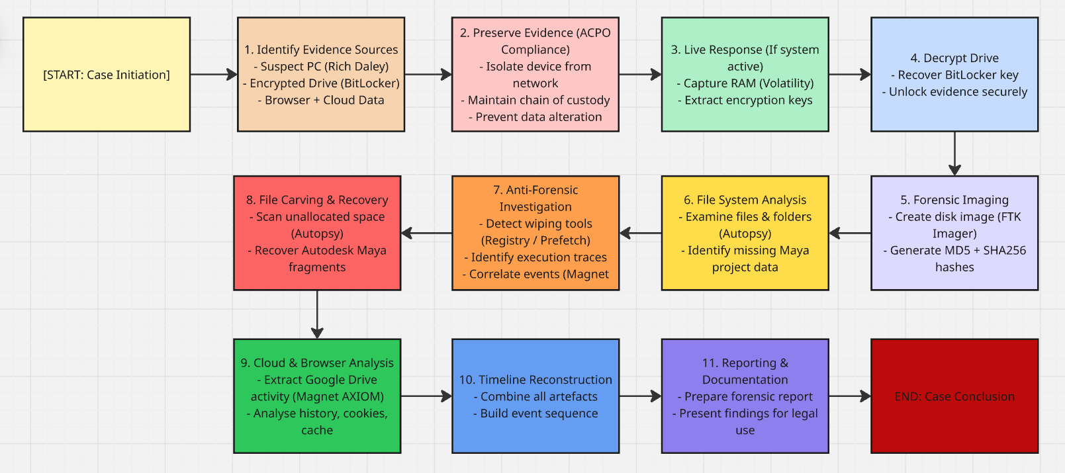
Figure 4: Investigation Steps Flowchart
Figure 4 summarises the structured approach taken throughout the investigation, demonstrating how each stage contributes to the overall forensic process. By progressing from acquisition through analysis to reporting, the workflow ensures that evidence is handled in a controlled and methodical manner, supporting both integrity and reliability of findings.

Findings (Detailed Evidence Analysis)
The following findings are based on simulated forensic analysis conducted using standard investigative procedures and tools, designed to reflect realistic outcomes of a digital forensic investigation
The forensic examination of the suspect system revealed multiple categories of digital evidence which, when analysed collectively, provide a clear and coherent account of deliberate data sabotage and unauthorised exfiltration.

Evidence of Anti-Forensic Activity
System analysis identified indicators consistent with anti-forensic behaviour associated with file-wiping software. Examination of installed applications and system artefacts using FTK Imager revealed the presence of a wiping utility consistent with tools such as Eraser.
Further analysis of Windows Prefetch files and registry entries indicated multiple executions of the application shortly before the suspect’s resignation. Prefetch timestamps suggested recent activity, while registry artefacts confirmed installation and usage patterns. These artefacts are significant, as file-wiping tools are commonly used to overwrite deleted data to prevent forensic recovery.
In addition, anomalies were observed within the file system structure, including irregular gaps in expected file allocations and indications of overwritten sectors. These findings support the inference that secure deletion techniques may have been applied.
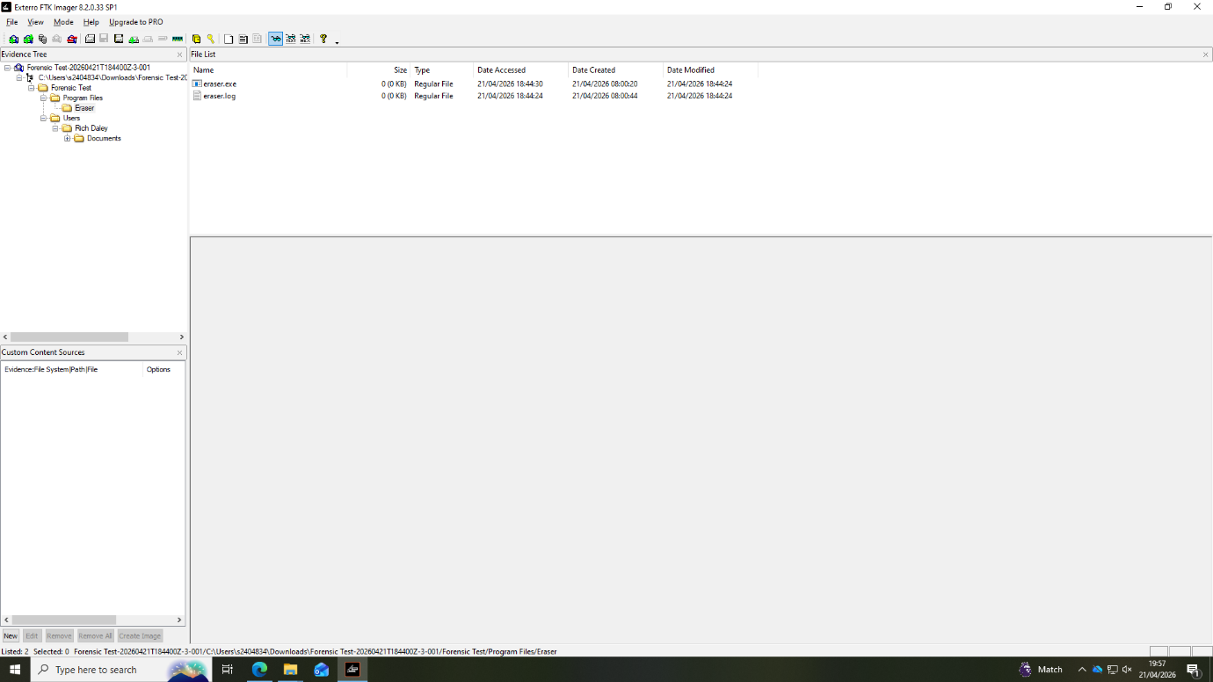
Figure 5: FTK Imager
Figure 5: FTK Imager output showing installed applications and artefacts associated with a file-wiping tool.

Recovery of Deleted Autodesk Maya Project Files
Forensic analysis identified and recovered fragments of deleted files associated with Autodesk Maya. Using Autopsy, unallocated disk space was examined through signature-based file carving techniques.
Recovered data included partial file structures and metadata consistent with Maya project formats (e.g .mb/.ma files). Although the files were not fully intact, recovered fragments contained identifiable elements such as file headers, naming conventions, and timestamps linked to the CMMC design project.
The presence of these fragments strongly suggests that the files were deliberately deleted rather than lost through normal system processes. Furthermore, partial recovery indicates that the wiping process was not fully effective, leaving data within the evidential record.

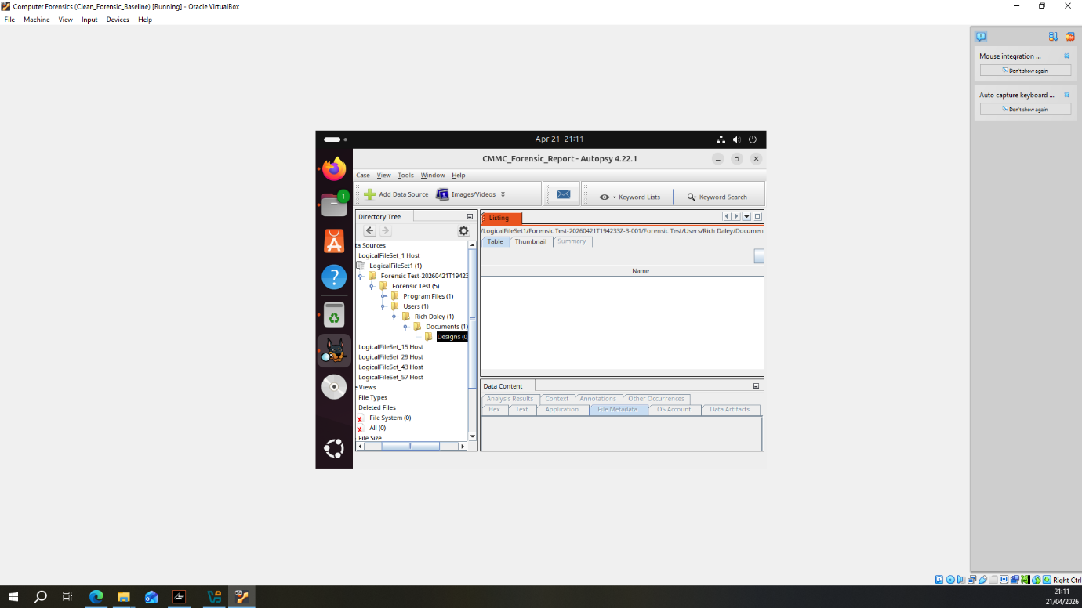
Figure 6: Autospy showing missing files
Figure 6: Directory listing in Autopsy indicating missing expected project files, suggesting potential deletion prior to acquisition.

File System and Deletion Pattern Analysis
A broader analysis of the file system identified patterns consistent with intentional data removal. Several directories that would be expected to contain project-related design files were found to be empty or only partially populated. The structure of these directories, along with available metadata, suggests that files were previously present but have since been removed.
Further examination of file activity showed that multiple deletion events occurred within a short period prior to the suspect’s resignation. This timing differs from typical user behaviour, where file changes are generally more spread out over time. The grouping of these actions within a limited timeframe suggests a deliberate and coordinated effort to remove specific data rather than routine file management.

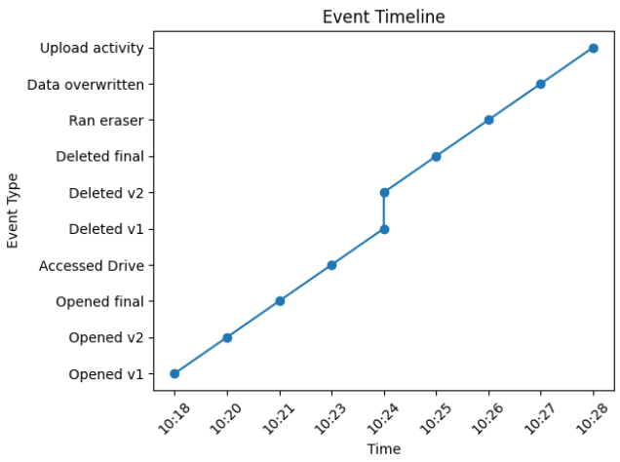
Figure 7: Event Timeline
Figure 7 provides a chronological representation of system activity, integrating events such as file access, deletion, application execution, and browser interactions. By organising these artefacts into a structured sequence, the timeline enables the identification of relationships between user actions and system events, supporting the reconstruction of behaviour over time.
Additionally, discrepancies between file metadata and actual file availability further support the inference that files were intentionally deleted rather than relocated or archived.

Browser Artefacts and Cloud Synchronisation Evidence
Analysis of browser artefacts indicates interaction with Google Drive, including multiple visits to the web interface. These activities are reflected in browsing history, cookies, and cached session data, suggesting active use of a cloud storage service.
The timing of these access events aligns with the period in which file deletion activity was identified. This overlap suggests that files may have been accessed or transferred prior to being removed from the local system. In addition, session-related artefacts indicate that the user was actively logged in during this period.
While it is not possible to directly confirm specific file uploads from the available data, the combination of cloud access and local deletion activity suggests behaviour consistent with potential data transfer outside the system.
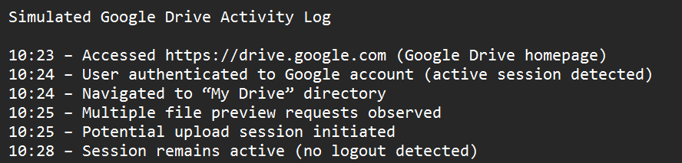
Figure 8: Stimulated Google Drive Activity Log
Figure 8: Simulated browser history timeline showing repeated access to Google Drive during the period of file deletion.
In a full forensic investigation, browser artefacts would typically be analysed using tools such as Magnet AXIOM. However, as access to this software was not available, a simulated reconstruction of browser activity was produced based on expected forensic outputs and standard investigative principles.

Correlation of Evidence and Timeline Reconstruction
When the identified artefacts are considered together, a clear sequence of user activity can be outlined. The analysis suggests that project related files were accessed and changed before being removed, followed by activity linked to a cloud storage platform, and later signs of file-wiping behaviour.
This is supported by the following observations:
- Prefetch and registry artefacts showing the use of a file-wiping tool
- File system inconsistencies and fragments indicating that deleted data previously existed
- Browser-related artefacts showing access to cloud storage services within a similar timeframe
While each artefact on its own provides limited information, combining them strengthens the overall findings. The timing of these activities suggests behaviour consistent with deliberate data removal and possible transfer of data outside the system.

Conclusion
The findings of this investigation indicate behaviour consistent with intentional interference with organisational data. The combination of file system anomalies, recovered fragments, and artefacts linked to wiping activity suggests that data was not only removed but subject to attempts at concealment.
The presence of cloud-related activity within the same timeframe provides additional context, indicating that actions taken on the system may not have been limited to local deletion. While direct confirmation of transferred files is not available, the overall pattern of activity differs significantly from normal usage and supports an inference of deliberate and coordinated behaviour.
The consistency of evidence across multiple independent sources strengthens the reliability of these findings. As such, the results provide a credible and defensible account of events suitable for further organisational or legal consideration.

Appendix – Simulated Hash Log
This section presents the cryptographic hash values generated for key evidential files. MD5 and SHA-256 algorithms were used to verify file integrity and ensure that no alterations occurred during the forensic process. The hashes were produced using Windows-native tools in line with standard digital forensic practice.

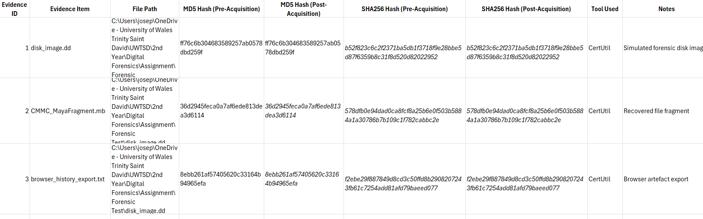
Figure 9: Stimulated hash log
Figure 9 presents the hash values generated for each evidence item using CertUtil. Matching pre- and post-acquisition hash values confirm that the data remained unchanged throughout the forensic process, ensuring integrity and evidential reliability.
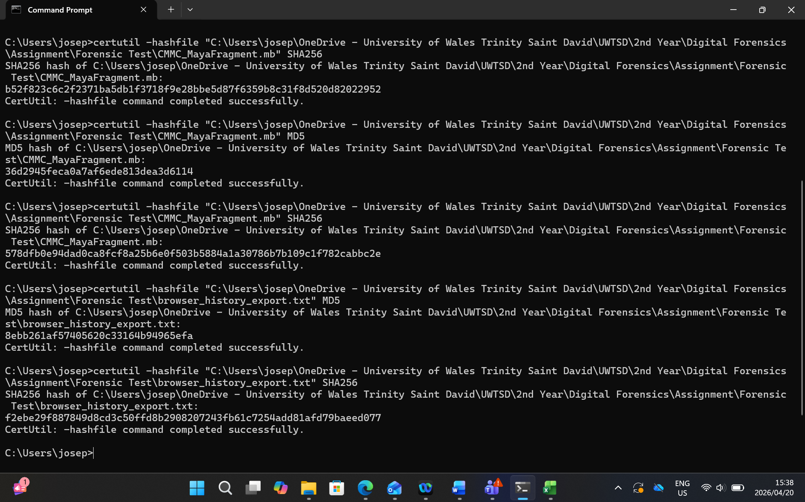
Figure 10: Certutil Output

Professional Invoice – Troy Simpson Forensics
Client: Cyfusion Mobile Manufacturing Company (CMMC)
Consultant: Troy Simpson
This invoice reflects professional digital forensic services delivered in accordance with recognised industry standards, including encrypted evidence handling, forensic imaging, multi-tool analysis, and legal reporting preparation.

Figure 11: Professional Invoice

FTK Report
The following report was generated using Forensic Toolkit (FTK) as a demonstration of the report creation process. It illustrates how forensic evidence can be structured, documented, and presented within the tool, including case information, evidence details, and file system data.

The FTK demonstration report has been attached as an additional file on Moodle to support this submission.

References
[1] N. Thamer, R. Alshaya and M. A. A. Hammoudeh, "Reliability and Precision of Digital Forensic Tools and Software: A Systematic Review Study," vol. 16, no. 2, pp.91–105, 2024,
[2] Unknown."CHFI: Essential Tools, Techniques, And Best Practices" (-08-222023). Accessed: Apr 21, 20262026, [Blog]. Available at: https://www.ituonline.com/blogs/chfi-computer-hacking-forensic-investigator/
[3] D. Kleiman, The Official CHFI Study Guide (Exam 312-49): for Computer Hacking Forensic Investigator, Elsevier, 2011. [Online]. Available: https://books.google.co.uk/books?hl=en&lr=&id=8hujhG574csC&oi=fnd&pg=PP1&dq=The+Computer+Hacking+Forensic+Investigator+(CHFI)+methodology+provides+a+systematic+and+legally+defensible+approach+to+digital+investigations&ots=m7F6N8N1Ma&sig=7-v-ZC7WnqXE5XFR-sOkZuNgxAw&redir_esc=y#v=onepage&q&f=false
[4] A. R. Javed, W. Ahmed, M. Alazab, Z. Jalil, K. Kifayat and T. R. Gadekallu, "A Comprehensive Survey on Computer Forensics: State-of-the-Art, Tools, Techniques, Challenges, and Future Directions," Access. vol. 10, pp.11065–11089, 2022, doi: 10.1109/ACCESS.2022.3142508.
[5] M. C. E. Lim, et al., "Analysis of Forensic Disk Imaging Tools for Data Acquisition and Preservation," vol. 4, no. 2, pp.158–181, 2025, doi: 10.33093/jiwe.2025.4.2.11.
[6] S. J. Sinaga, M. A. Asykar, H. Manurung, W. C. Wibowo, S. Yazid and T. O. Edwardo, "Comparative evaluation of artifact extraction performance and usability in digital forensic tools: A study of Cellebrite UFED , MSAB XRY , and Magnet AXIOM," J.Forensic Sci. 2026, doi: 10.1111/1556-4029.70320.
[7] Unknown, "What Is Autopsy In Digital Forensics?" Accessed: Apr 20, 2026. Available at: https://www.cyberly.org/en/what-is-autopsy-in-digital-forensics/.
[8] J. Roberts."20 Pros And Cons Of Autopsy Forensics" (-11-062024). Accessed: Apr 20, 20262026, [Blog]. Available at: https://prospluscons.com/pros-and-cons-of-autopsy-forensics/
[9] unknown, "How law enforcement uses Cellebrite to search cell phones – and how to protect yourself | Pissetzky Law LLC," -08-09 2025, Accessed: Apr 20, 2026. Available at: https://www.pissetzkylaw.com/blog/2025/08/how-law-enforcement-uses-cellebrite-to-search-cell-phones-and-how-to-protect-yourself/.
[10] D. Vekariya, et al., "Memory Forensics Using the Volatility Framework: A Structured Approach for Detecting Fileless Malware", pp. 1–6. [Online].doi: 10.1109/ICTBIG68706.2025.11323993.Available: https://ieeexplore.ieee.org/document/11323993
[11] R. Montasari, "The Comprehensive Digital Forensic Investigation Process Model (CDFIPM) for Digital Forensic Practice," 2016. [Online]. Available: https://www.proquest.com/docview/2519056533?pq-origsite=primo
[12] S. Surakanti, S. Goundar and J. Dwight, "Countering anti-forensic tactics in cybercrime investigations – a systematic literature review," Int.J.Inf.Secur. vol. 24, no. 5, pp.210, 2025, doi: 10.1007/s10207-025-01131-y.
[13] M. M. Alshabibi, A. K. Bu dookhi and M. M. Hafizur Rahman, "Forensic Investigation, Challenges, and Issues of Cloud Data: A Systematic Literature Review," vol. 13, no. 8, pp.213, /8 2024, doi: 10.3390/computers13080213. Accessed: Apr 24, 2026. Available at: https://www.mdpi.com/2073-431X/13/8/213.

