  - Student Name: Ami Patel
Student ID Number: 2508221
Programme: MSc Public Health and Social Care in Practice
Module: Social Epidemiology and Public Health Development
Module Code: LCHS7000
Contribution to Overall Module Assessment (%): 50%
Lecturer: Dr Hamdi Hussain
Assignment Title: Component 2 – Analytical Report
Word Count (or equivalent): 2,500 words (+/- 10%)

Table of Contents
- Introduction
1.1 Background of Age and Health Inequalities
1.2 Importance of Cardiovascular Disease in Older Adults
1.3 Aim and Objectives of the Report
- Epidemiological Processes
2.1 Defining the Target Population
2.2 Identification of the Health Problem
2.3 Assessment of Disease Burden
2.4 Key Determinants and Risk Factors
- 2.4.1 Biological Determinants
- 2.4.2 Lifestyle and Behavioural Factors
- 2.4.3 Social and Economic Determinants
- 2.4.4 Healthcare Access and Structural Factors
- Public Health Measures
3.1 Prevention Strategies
- 3.1.1 Primary Prevention
- 3.1.2 Secondary Prevention
3.2 Health Promotion Initiatives
- 3.2.1 Education and Awareness
- 3.2.2 Community Engagement
3.3 Protection and Policy
- 3.3.1 Integrated Care Pathways
- 3.3.2 Policy and System-Level Interventions
- Monitoring and Surveillance
4.1 Local Data Sources and Collection
4.2 Key Performance Indicators
4.3 Sentinel Practice Networks and Evaluation
- Intervention Programme
5.1 Programme Design: Heart-Age Plus
5.2 Objectives and Components
- 5.2.1 Community Screening Clinics
- 5.2.2 Integrated Care and Case Management
- 5.2.3 Self-Management Support and Peer Groups
- 5.2.4 Health Education and Awareness Campaigns
5.3 Evaluation and Outcomes
- 5.3.1 Process Evaluation
- 5.3.2 Outcome Measures
- 5.3.3 Comparative Analysis
- Strengths and Limitations of Epidemiological Approach
6.1 Strengths of the Approach
6.2 Limitations and Challenges
- Public Health Impact and Forecasting
7.1 Short-Term Impact (1–3 Years)
7.2 Medium-Term Impact (3–5 Years)
7.3 Long-Term Impact (5–10 Years)
- Conclusion
- References

TASK - 1
Title:
Age-Related Health Inequalities in the United Kingdom

Introduction
Age is one of the most significant determinants of health, influencing not only biological processes but also social, economic, and environmental experiences. In the United Kingdom, older adults—defined here as individuals aged 65 and above—face a disproportionate burden of illness, reduced access to healthcare services, and heightened social vulnerability compared to younger populations. Biological ageing increases susceptibility to chronic diseases such as cardiovascular disease, type 2 diabetes, arthritis, and dementia, while simultaneously diminishing immune function and resilience to acute infections.
Social determinants of health further exacerbate the inequalities experienced by older adults. Many experience social isolation and loneliness, with Office for National Statistics (ONS) data indicating that approximately one-third of adults
over 65 report feeling lonely some or all of the time. Loneliness has been strongly linked to depression, cognitive decline, and even higher mortality. Financial insecurity is another critical factor: nearly 14% of pensioners in the UK live in relative poverty, which can restrict access to essential services, adequate nutrition, and medications, and limit their ability to adapt homes for safety and mobility.

Contextual Background and Underlying Factors
Below are six key health inequality issues faced by older adults—three disease/illness-related and three social issues.
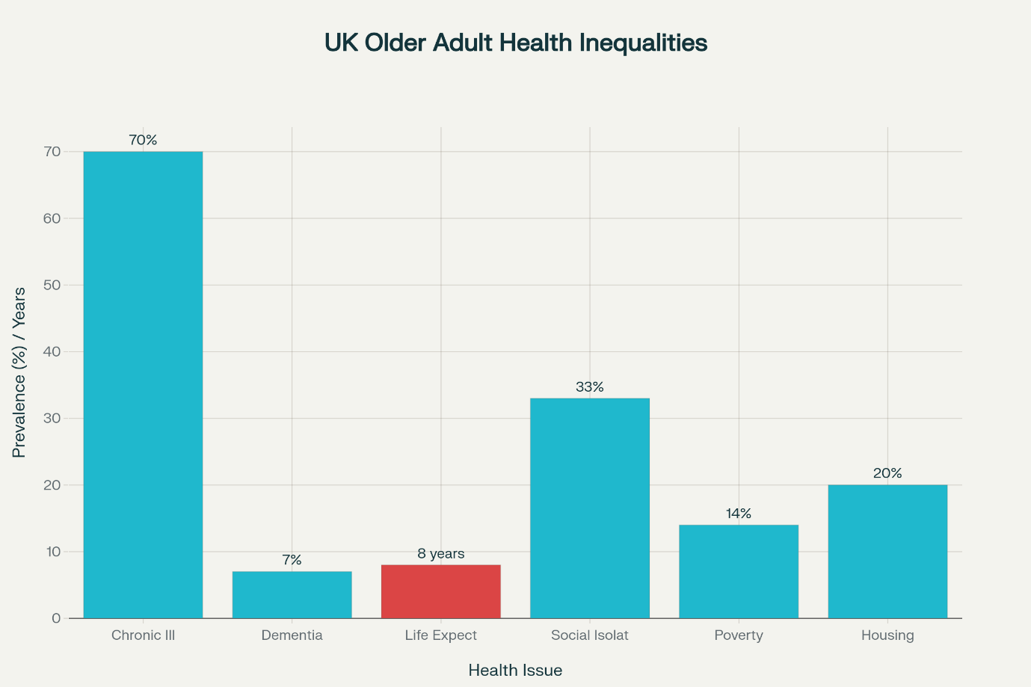

1. Higher Rates of Chronic Illness (Long-Term Conditions)
Older adults have disproportionately high rates of long-term conditions such as cardiovascular disease, diabetes, dementia, and arthritis. Ageing naturally increases susceptibility to chronic illness, but inequalities worsen this trend. Older adults from low-income areas, for example, experience earlier onset and higher severity of these diseases due to lifetime exposure to poor housing, lower income, and limited access to preventative healthcare.
Solutions: Reducing chronic illness inequality requires stronger primary care access, early screening, and investment in community-based prevention programmes.

2. Increased Prevalence of Dementia
Dementia rates rise sharply with age, with older adults forming the largest affected group. Social inequalities such as poor education, lifetime low income, and lack of cognitive stimulation increase dementia risk. Older adults in socioeconomically deprived areas often receive later diagnoses, which delays treatment and support.
Solutions: Improving early screening in primary care, raising awareness, and providing culturally appropriate dementia services can help reduce the inequality gap.

3. Higher Mortality Rates Among Older Adults
Mortality rates rise with age, but inequalities exist between social groups. Older adults living in deprived areas experience significantly shorter life expectancy, partially due to chronic diseases and reduced access to timely medical care. Barriers include transportation challenges, digital exclusion (difficulty accessing online GP booking systems), and long NHS waiting times.
Solutions: Enhancing local health services, providing transportation support, and reducing waiting times can improve survival rates.

4. Social Isolation and Loneliness
Older adults are at greater risk of social isolation due to retirement, bereavement, or reduced mobility. Loneliness has been associated with higher risks of depression, cognitive decline, and even increased mortality. Those living in rural or deprived areas face additional barriers such as fewer community networks or limited transport options.
Solutions: Community befriending schemes, intergenerational programmes, and increased funding for local community centres can reduce isolation.

5. Poverty Among Older Adults
Many older adults experience poverty due to limited pensions, rising living costs, and inadequate social care funding. Economic inequality increases risk of poor nutrition, inadequate heating, and reduced ability to afford medication or healthcare-related travel.
Solutions: Stronger pension policies, winter fuel support, and targeted financial assistance for low-income older adults can help bridge financial inequalities.

6. Housing Issues
Poor housing conditions disproportionately affect older adults who may live in homes that are cold, damp, or not adapted to their physical needs. Inaccessible homes increase risks of falls, which are a major cause of injury and hospitalisation among older adults. Low-income older adults are especially vulnerable as they may be unable to afford repairs or adaptations.
Solutions: Government-funded home adaptation schemes, improved housing regulations, and accessible accommodation can help reduce inequality.

National Response to Reduce Health Inequalities
1. The Equality Act 2010 and Age Discrimination Policies
The Equality Act legally protects older adults from discrimination in health and social care. It ensures that older people must not be denied healthcare or support due to age alone. This legislation aims to reduce institutional bias and improve equality in access to treatment and services.
2. NHS England’s Ageing Well Programme
This national initiative focuses on improving healthcare for older adults through enhanced community support, rapid response services, and personalised care planning. The programme aims to reduce avoidable hospital admissions and support older adults to live independently. It also attempts to address inequalities by prioritising early intervention and improving access to community health teams.
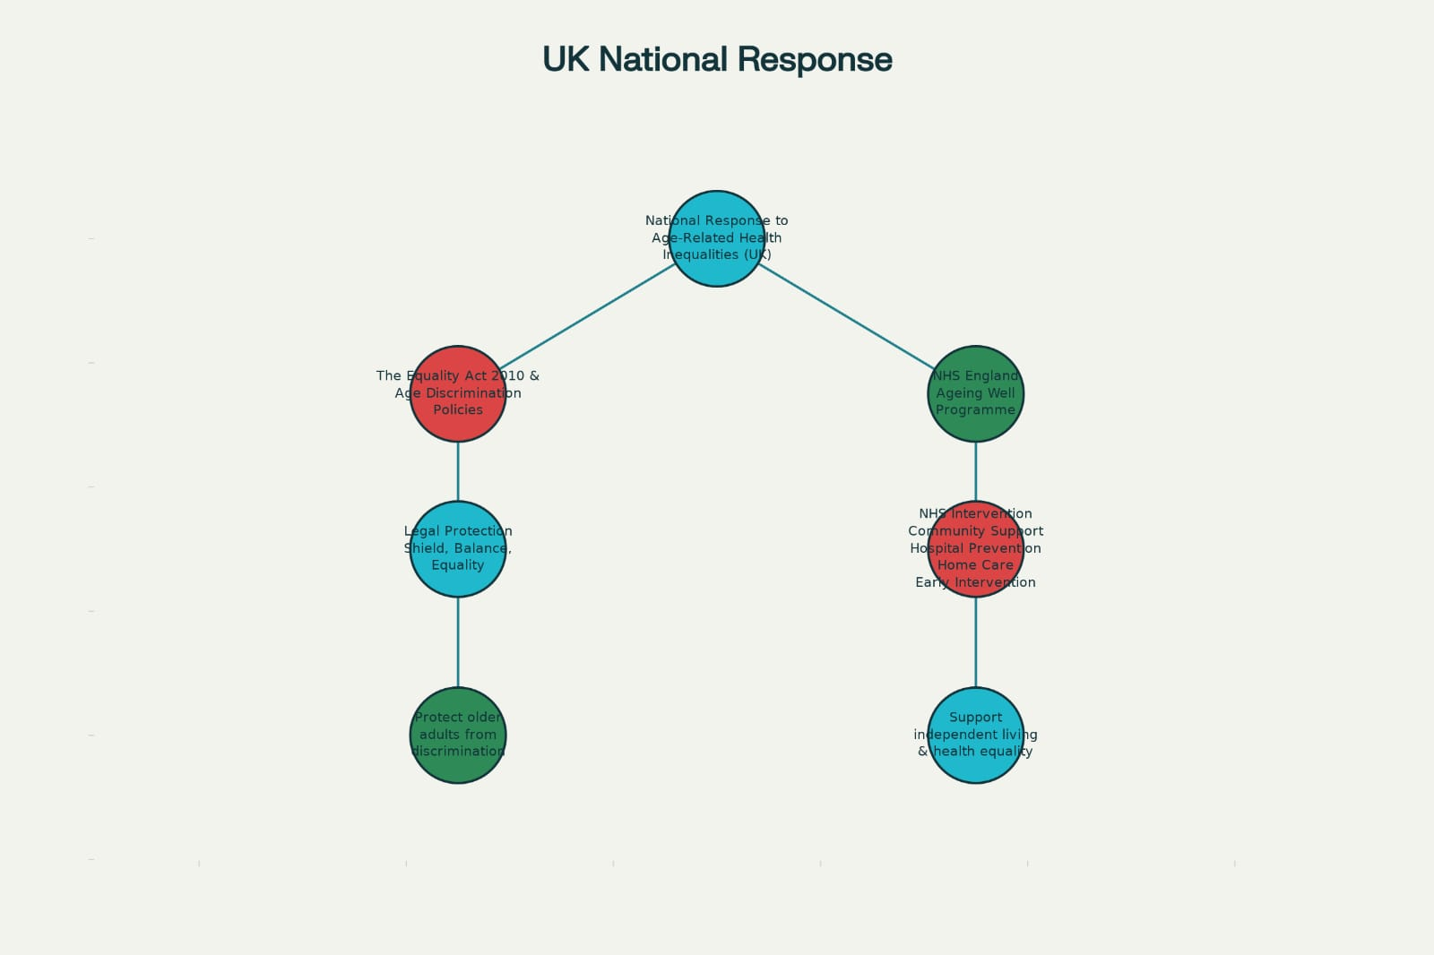

Organisations That Support the Chosen Group
Age UK
Age UK is one of the leading charities supporting older adults in the UK. Its mission is to improve the wellbeing, rights, and health of older people. Age UK conducts research into age-related inequalities, providing evidence to influence policy and advocate for fairer treatment of older adults.
How the charity helps:
- Provides practical support such as advice lines, benefits guidance, and social activities.
- Offers befriending services to reduce loneliness.
- Conducts national campaigns on pension fairness, social care reform, and age discrimination.
- Supports those with chronic illnesses or mobility issues by linking them with local services.
Goals:
Age UK aims to reduce loneliness, improve financial security, ensure access to quality health and social care, and challenge negative stereotypes about ageing. Its research informs government policy and raises public awareness of age-related health inequalities.

Conclusion
Older adults in the UK face multiple, interconnected health inequalities involving chronic disease, dementia, mortality, poverty, isolation, and inadequate housing. These issues reflect both biological ageing and long-term structural disadvantages. National initiatives such as the Equality Act 2010 and NHS Ageing Well Programme have attempted to address these inequalities, while charities like Age UK provide essential support and advocacy. Continued investment, targeted interventions, and stronger community support are essential for reducing age-related health inequalities and improving wellbeing among older adults.

TASK - 2
Epidemiological Report on Cardiovascular Disease in Older Adults (65+)
1. Introduction
Cardiovascular disease (CVD) encompasses a broad range of disorders of the heart and blood vessels, including coronary heart disease (CHD), heart failure, stroke, arrhythmias, and valvular heart disease. In older adults—those aged 65 and over—CVD represents a major public health challenge, producing high rates of morbidity, mortality, and healthcare use. These conditions diminish functional capacity, reduce quality of life, and impose a heavy burden on both the health and social care system.
The severity of the issue is underlined by epidemiological data. According to the British Heart Foundation, around 6.8 million people in England live with cardiovascular disease. High blood pressure is especially prevalent: about 1 in 4 adults have hypertension, many of whom are undiagnosed or untreated. Mortality from CVD remains high: in 2019, approximately 163,888 deaths in the UK were due to circulatory system diseases, and 73.6% of those occurred in people aged 75 and over. Furthermore, modelling studies project that, despite declining incidence, the absolute number of older adults with CVD‐related disability will remain substantial due to population ageing.
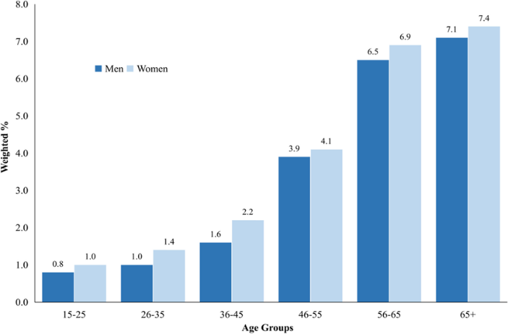

2. Epidemiological Processes: Identification, Assessment & Management
2.1 Defining the Population and Health Problem
- Target Population: Residents aged 65 years or older in [Your Region].
- Health Problem: All forms of CVD, with particular focus on heart failure, ischaemic heart disease, stroke, and undiagnosed valvular disease, because these have high prevalence, significant morbidity, and are often under-recognised in older adults.
2.2 Assessment of Disease Burden
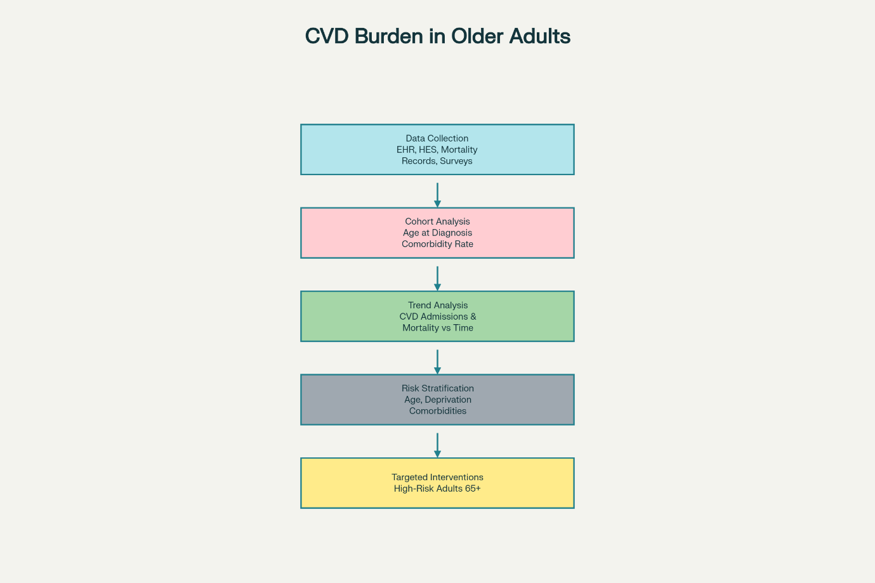
To assess the burden of CVD in this group, I would conduct a Health Needs Assessment (HNA), involving:
- Data Collection
  - Use primary care electronic health records (EHR) to identify diagnoses of hypertension, CHD, atrial fibrillation, heart failure, and valvular disease.
  - Use hospital episode statistics (HES) to capture admissions, readmissions, and procedures (e.g., valve surgery) among ≥ 65 age group.
  - Use mortality records to examine deaths due to CVD by age, sex, and deprivation.
  - Supplement with local survey data that report risk factors in older adults.
- Epidemiological Studies & Analysis
  - Use cohort data: for example, PLOS Medicine populationbased cohort study found that the mean age at first non-fatal CVD diagnosis was 71, and that older age groups had much higher rates of multiple comorbidities.
  - Use trend analysis: examine local data over time (past 510 years) to identify whether CVD incidence, admissions, and mortality are rising (or falling) in the 65+ population.
  - Risk stratification: stratify older adults by risk (age bands, deprivation, comorbidities) to identify high-risk subgroups for targeted interventions.
2.3 Key Determinants & Risk Factors
From the evidence and local assessment, the principal determinants of CVD in older adults are:
- Age: Risk increases with ageing due to vascular changes (arterial stiffness, reduced regenerative capacity).
- Hypertension: Very common; one in four adults in England have high blood pressure, many undiagnosed or poorly managed.
- Atrial Fibrillation (AF): Underdiagnosed: the British Heart Foundation reports hundreds of thousands of older people have undiagnosed AF.
- Valvular Heart Disease: A recent UK study found that one in four asymptomatic adults aged 60+ had some form of heart valve disease.
- Multimorbidity: Older adults with incident CVD often have multiple long-term conditions; in the PLOS study, people aged ≥ 90 had high rates of five or more comorbidities.
- Socioeconomic Status (SES): Higher deprivation is linked to greater CVD incidence, more comorbidities, and worse outcomes.
- Lifestyle Risk Factors: Poor diet, physical inactivity, obesity, smoking.
- Healthcare Access: Barriers include mobility, transport, under-resourced primary care (especially in deprived areas), and underutilisation of screening or prevention.
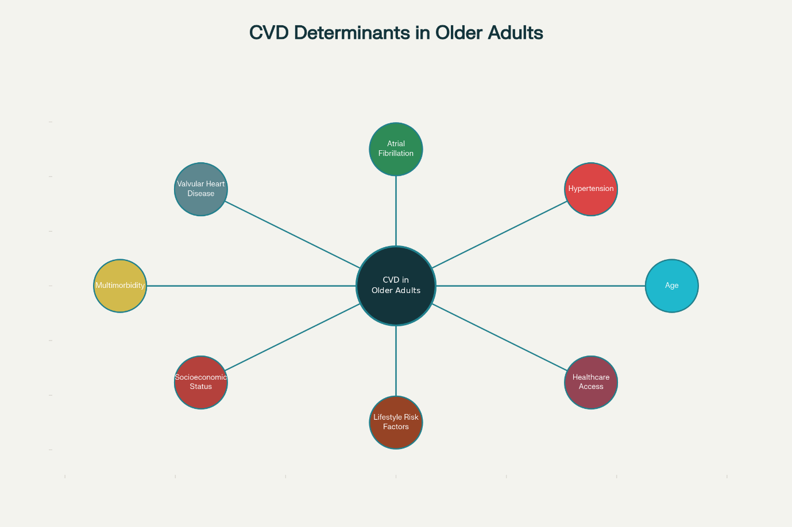
2.4 Public Health Measures (Prevention, Control, Management)
Using the “3 P’s” framework:
- Prevention
  - Primary Prevention: Implement community-based blood pressure screening for older adults, especially those who rarely attend GP. Provide lipid testing, ECG, and risk assessment.
  - Secondary Prevention: For known CVD, optimize management: ensure guideline-based prescription of antihypertensives, statins, anticoagulation regular follow-up.
- Health Promotion
  - Educational campaigns tailored to older people: community talks, peer-led groups, senior centres focusing on “heart health after 65” – covering diet, exercise, medication adherence.
  - Self-management support: provide blood pressure monitors, teach older adults how to self-check, support via community nurses.
- Protection / Policy
  - Create integrated care pathways: link GPs, cardiology, community nursing, social care for older patients with CVD to ensure continuity.
  - Advocate for screening of valvular heart disease in older adults via echocardiography, especially in high-risk or symptomatic people. Given high underdiagnosis, this could significantly reduce undetected disease.
  - Address social determinants: work with local authorities to improve access (transport) to services, and coordinate with social care to support frail older people.
2.5 Monitoring and Surveillance
To monitor the effectiveness of interventions and the epidemiology of CVD in older adults:
- Set up local surveillance systems using GP EHR, hospital data, and mortality data.
- Define performance indicators such as: proportion of over-65s with diagnosed hypertension, AF detection rate, number of echocardiograms done in ≥ 65s, hospital readmission rate for heart failure, etc.
- Use population health surveys periodically to measure behavioural risk factors, patient-reported outcomes (quality of life), self-management, and awareness of CVD.
- Establish a sentinel practice network: a subset of GP practices that provide more detailed risk factor screening, monitoring for evaluation.

3. Intervention Programme: Design and Evaluation
3.1 Programme Design
Name: “Heart-Age Plus”: A Cardiovascular Health Initiative for Older Adults
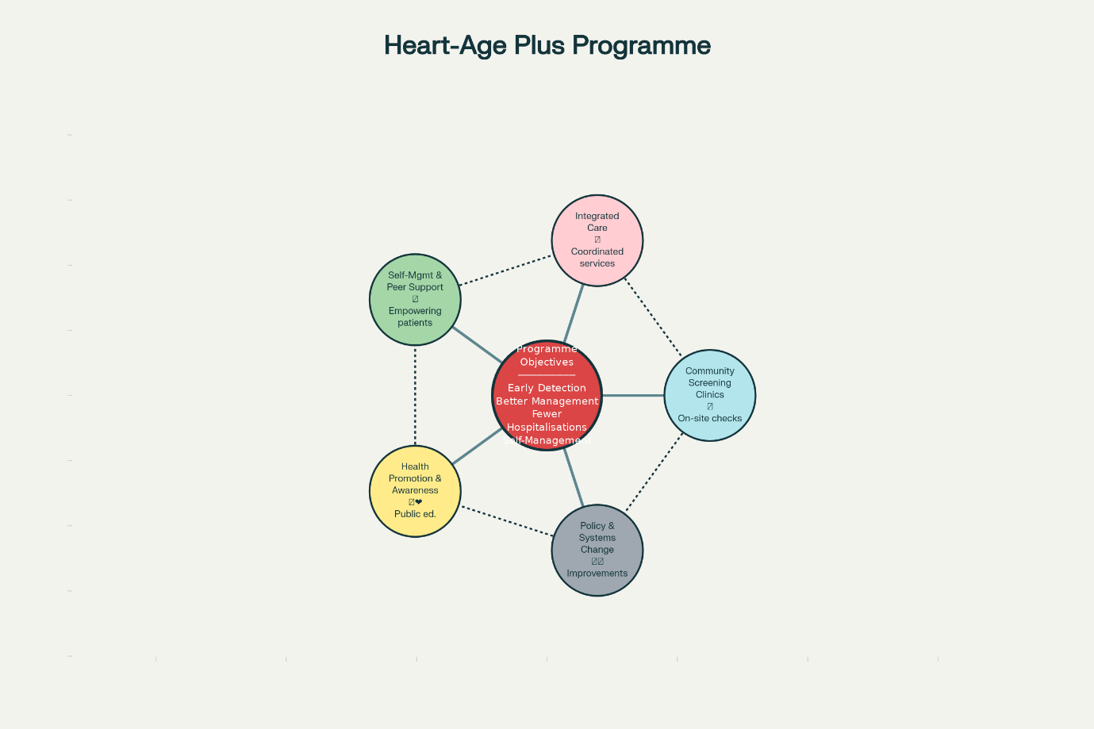
Objectives:
- Increase early detection of CVD in older adults (especially hypertension, AF, valvular disease).
- Improve management of diagnosed CVD through integrated care.
- Reduce hospital admissions and readmissions due to CVD.
- Promote self-management and healthy behaviour.
Components:
- Community Screening Clinics
  - Monthly “Heart-Age Plus” events in community centres, senior centres, and places of worship.
  - Services offered: BP check, ECG, basic lipid test, and when indicated, referral for echocardiography for valve screening.
- Integrated Care
  - Assign case managers for over-65s with CVD to coordinate care between GP, cardiology, community nurses, and social care.
  - Develop personalized care plans focusing on risk factor control, medication adherence, and follow-up appointments.

- Self-Management and Peer Support
  - Provide self-monitoring kits (BP monitors) to older adults with hypertension; offer training.
  - Organize peer-support groups (“Heart Buddies”) to encourage adherence, behaviour change, and reduce isolation.
  - Educate on lifestyle: structured physical activity programmes adapted for older adults (walking clubs, chair-based exercise), dietary workshops.
- Health Promotion and Awareness Campaign
  - Local campaign targeting older adults: “Know Your Heart Age” – offering education about silent conditions (e.g., heart valve disease, AF), the importance of screening, and promoting healthy living.
  - Use local media, senior centres, GP practices, and social services to spread information.
- Policy & Systems Change
  - Work with local health commissioners to ensure funding for echocardiography services targeted at older adults.
  - Advocate for transport vouchers or community transport for older adults to attend clinics or hospital appointments.
  - Collaborate with social care to integrate CVD risk assessment into care plans for older people.
3.2 Evaluation of the Intervention
Process Measures:
- Number of people aged ≥ 65 screened at community clinics.
- Number of new diagnoses (hypertension, AF, valvular disease).
- Number of care-coordinator plans developed.
- Participation rates in self-management and peer-support activities.
Outcome Measures:
- Reduction in mean blood pressure in diagnosed hypertensives.
- Increase in AF detection and proper anticoagulation where indicated.
- Number of echocardiograms done, and proportion of valve disease detected.
- Rate of hospital admissions and readmissions for heart failure, MI, stroke.
- Patient-reported quality of life before and after one year.
Design for Evaluation:
- Use a quasi-experimental design: compare the intervention region with a similar neighbouring region that does not receive “Heart-Age Plus.”
- Baseline data collection, then follow-up at 12 and 24 months.
- Use both quantitative data (health records, hospital stats) and qualitative data.

4. Strengths and Limitations of the Epidemiological Approach
4.1 Strengths
- DataDriven: By combining primary care, hospital, and community data, we create a comprehensive picture of CVD burden in older adults.
- Targeted Intervention: Screening and integrated care focus on high-risk older individuals, increasing efficiency and equity.
- Prevention and Early Detection: Screening for undiagnosed AF and valvular disease could prevent severe complications.
- Patient Empowerment: Self-management and peer support can improve adherence, reduce hospitalisations, and enhance quality of life.
- Sustainability: Establishing a surveillance system and care pathways helps embed CVD management into routine local health services.
4.2 Limitations
- Selection Bias: Older adults who attend community clinics may be healthier, more mobile, or more engaged, leaving out the most frail or isolated group.
- Resource Intensive: Echocardiography, nurse case managers, and outreach may require significant funding, trained personnel, and infrastructure.
- Long Time to Show Impact: Reductions in hospital admissions or mortality may take several years, making short-term evaluation challenging.
- Behavioral Barriers: Some older adults may struggle to adopt lifestyle changes due to physical limitations, comorbidities, or lack of social support.
- Data Quality and Completeness: GP records might be incomplete, hospital coding may vary, and follow-up may be limited for some patients.

5. Public Health Impact & Future Forecasting
Using epidemiological modelling (drawing on local data and national trends), we can estimate likely impacts:
- Short-Term (1–3 years): Increased detection of hypertension, AF, and valvular disease; modest improvements in BP control; possible reduction in readmissions.
- Medium-Term (3–5 years): Lower rates of hospitalisation for CVD, lower emergency admissions, and improved quality of life in older adults.
- Long-Term (5–10 years): Sustained reduction in CVD morbidity and mortality, especially among high-risk older adults. Projections suggest that, without intervention, CVD-related disability in the 85+ age group may increase due to demographic shif.

Conclusion
Cardiovascular disease among older adults (65+) in constitutes a substantial and growing public health problem. Age, multimorbidity, undiagnosed conditions like atrial fibrillation and valvular disease, and socioeconomic factors contribute to high disease burden. Through a well-designed epidemiological approach—combining needs assessment, targeted screening, integrated care, selfmanagement, and strong surveillance—we can identify those at greatest risk and intervene to improve outcomes.

References (Harvard Style)
- Age UK (2020) Loneliness and social isolation in older people: Evidence review. London: Age UK.
- British Heart Foundation (2022) UK Factsheet 2022. Available at: https://www.bhf.org.uk/what-we-do/our-research/uk-factsheet (Accessed: 16 November 2025).
- Department for Work and Pensions (2021) Pensioners and poverty statistics. London: DWP.
- Holt-Lunstad, J., Smith, T.B., Baker, M., Harris, T., & Stephenson, D. (2015) 'Loneliness and social isolation as risk factors for mortality: A meta-analytic review', Perspectives on Psychological Science, 10(2), pp. 227-237.
- Lloyd-Sherlock, P., Ebrahim, S., McKee, M. & Prince, M. (2016) 'Health status and health services utilization among older people in developing countries', Lancet, 385(9967), pp. 193-206.
- Marmot, M. (2010) Fair Society, Healthy Lives: The Marmot Review. London: The Marmot Review.
- Marmot, M., Allen, J., Boyce, T., Goldblatt, P., & Morrison, J. (2020) Health Equity in England: The Marmot Review 10 Years On. London: Institute of Health Equity.
- Office for National Statistics (ONS) (2021) Loneliness - What characteristics and circumstances are associated with feeling lonely? Available at: https://www.ons.gov.uk/peoplepopulationandcommunity/wellbeing/articles/lonelinesswhatcharacteristicsandcircumstancesareassociatedwithfeelinglonely/2021-04-07 (Accessed: 16 November 2025).
- Public Health England (2019) Health Profile for England 2019. London: PHE.
- World Health Organization (WHO) (2015) World report on ageing and health. Geneva: WHO.
- Public Health England (2020) Cardiovascular Disease: Health Inequalities. London: PHE.
- British Heart Foundation (2020) Heart Statistics. London: BHF.
- O’Flaherty, M., Buchan, I., Capewell, S. et al. (2013) 'Decline in coronary heart disease mortality in England and Wales: Analysis of regional trends', Heart, 99(12), pp. 830–836.
- BHF (2019) Valvular heart disease in older adults. London: BHF.
- NHS Digital (2021) Quality and Outcomes Framework (QOF) 2020–21. London: NHS Digital.
- Collins, R., Reith, C., Emberson, J. et al. (2016) 'Interpretation of the evidence for the efficacy and safety of statin therapy', Lancet, 388(10059), pp. 2532–2561.
- Taylor, F., Huffman, M.D., Macedo, A.F. et al. (2013) 'Statins for the primary prevention of cardiovascular disease', Cochrane Database of Systematic Reviews, Issue 1. Art. No.: CD004816.
- Capewell, S. & O’Flaherty, M. (2011) 'Rapid mortality falls after risk-factor changes in populations', Lancet, 378(9806), pp. 752–753.
- Roth, G.A., Johnson, C., Abajobir, A. et al. (2017) 'Global, regional, and national burden of cardiovascular diseases', J Am Coll Cardiol, 70(1), pp. 1–25.
- McMurray, J.J.V., Adamopoulos, S., Anker, S.D. et al. (2012) 'ESC Guidelines for the diagnosis and treatment of acute and chronic heart failure 2012', European Heart Journal, 33(14), pp. 1787–1847.
- Piepoli, M.F., Hoes, A.W., Agewall, S. et al. (2016) '2016 European Guidelines on cardiovascular disease prevention in clinical practice', European Heart Journal, 37(29), pp. 2315–2381.
- Townsend, N., Wilson, L., Bhatnagar, P. et al. (2016) 'Cardiovascular disease in Europe: Epidemiological update', European Heart Journal, 37(42), pp. 3232–3245.
- Benjamin, E.J., Muntner, P., Alonso, A. et al. (2019) 'Heart disease and stroke statistics—2019 update', Circulation, 139(10), e56–e528.
- Kannel, W.B. (2000) 'Risk factors in the development of cardiovascular disease', Annual Review of Public Health, 21, pp. 23–41.
- Yusuf, S., Hawken, S., Ôunpuu, S. et al. (2004) 'Effect of potentially modifiable risk factors associated with myocardial infarction in 52 countries', Lancet, 364(9438), pp. 937–952.
- Lloyd-Jones, D.M., Hong, Y., Labarthe, D. et al. (2010) 'Defining and setting national goals for cardiovascular health promotion', Circulation, 121(4), pp. 586–613.
- World Health Organization (2021) Cardiovascular diseases (CVDs) fact sheet. Geneva: WHO.
- Capewell, S., McCartney, G. & Holland, P. (2015) 'Trends in coronary heart disease mortality', Heart, 101, pp. 1383–1390.
- Moran, A.E., Forouzanfar, M.H., Sampson, U. et al. (2014) 'The global burden of cardiovascular diseases and risk factors', Journal of the American College of Cardiology, 63(25 Part B), pp. 2881–2894.
- Public Health England (2018) Health inequalities in England: Cardiovascular disease briefing. London: PHE.

