MY ESSAY ON ACADEMIC EMPLOYABILTY SKILLS

Teletha Duberry
Student I.D - 1917189
Academic Employability Skills
Assignment Term 1
Lecturer: Akinseye Aluko

TABLE OF CONTENTS

- Introduction
  - Introducing Purpose of Essay
- My Academic Employability Skills
  - My SWOT Analysis
  - Appendix A – SWOT Analysis
  - My Employability Skills
  - Appendix B – Employability Skills Student Worksheet
  - Appendix C – Employability Skills Student Worksheet Continued.
  - Testing My Skills
  - Appendix D – Questionnaire Results
  - How to Identify your Transferable Skills When Changing Career
- Personal Development Plan
  - My Personal Development Plan
  - Appendix E – PDP
  - Appendix F – PDP Continued.
- Time Management
  - Time Management
  - Appendix G – My Weekly Calendar
  - The Eisenhower Method
  - Appendix H – My Eisenhower Method
- The ’80 – 20 Rule’
  - ‘The Pareto Principle’
  - Appendix I – Diagram of ‘The Pareto Principle’
  - Brian Tracy’s ‘Eat That Frog’
- Conclusion
- Bibliography
- Appendixes (A-I)
INTRODUCTION
In Term 1 of this module I took the opportunity of analysing my strengths, weakness, time management and also looking at my short term and long term goals in alignment with my studies.
In this essay I will evaluate and demonstrate how I applied the knowledge I gained in this module and transformed it into wisdom. This will consist of looking at some well – established individuals, organisations, articles published by popular newspapers in the U.K and personal analysis’ from myself.

MY ACADEMIC EMPLOYABILITY SKILLS

MY SWOT ANALYSIS

On the first week of this module, I was encouraged to focus on a personal SWOT analysis based my skills for academic and employment purposes. This analysis helped me to put my life into perspective, and I can honestly say since the beginning of this module I have definitely strengthened some of my weaknesses, allowing me to achieve some of my personal goals, such as Interpersonal Skills, Availability and & Flexibility.

Appendix A

MY EMPLOYABILITY SKILLS
In this module I looked at five Top skills employers look for in potential employees and how I can build and improve these skills academically whilst studying.
Appendix B Appendix C
TESTING MY SKILLS
I completed a few questionnaires to test my academic skills in employment, on ( www.mindtools.com,) I will now go on to show my results whilst identifying my academic abilities in the workplace.

Appendix D

Questionnaire Results: I scored a total of 55. Here is a more detailed insight of my results:

Leadership and Management = 11 out of 15

I have identified that whether in a formal or informal setting, my understanding of the different skill sets between leadership and management are clear. This enables me to develop further skills in these areas, so that I can use them effectively. To support this, I took a Leadership Skill Test which focused on the various areas of leadership and results that highlight my strengths and areas for improvement.

Leadership Skills Test Results = 73

- Self Confidence (9 out of 10) - Awareness of my skills and knowing the value I add to the work that I do.
- Positive Attitude & Outlook (9 out of 10) - I am an optimist, I often look for realistic solutions to problems that have a long - term effect, to avoid repeated failed procedures which were possibly the cause initially.
- Emotional Intelligence (7 out of 10) - I am emotionally intelligent, with the ability to be empathetic towards others around me. I treat everyone as individuals by considering their personal circumstances and feelings, as this widens communication between them and myself, and helps to build strong relationships. This has its advantages and disadvantages.

Transformation Leadership

- Providing a Compelling Vision of the Future (13 out of 10) – I can take my knowledge of the field I am in and envisage strategic development techniques, along with detailed planning, to make the vision come to life. Understanding the actions required, I can take into consideration the needs of all those involved, meet their needs, so that they are equally motivated and enthusiastic to jump on board.
- Motivating People to Deliver the Vision (9 out of 10) - I can use my leadership skills to create and initiate ideas that I can share with others. Motivating a team of people to bring my vison to life can be done effectively using MBO & KPIs.
- Being a Good Role Model (9 out of 10) -
- Providing Support and Stimulation (17 out of 20) - I enjoy being consistently motivated at work, challenges and setting targets help me to develop my skills in the workplace. I always aim to reach set targets and expect to be acknowledged and valued for my enthusiasm.

Problem Solving and Decision Making = 8 out of 15

I am able to identify problems, assess the possible cause and decide on the actions required to move forward. However, this isn’t always as easy as it seems depending on the environment and job position. Therefore, I have found that I need to learn to work on finding better ways to share my findings and solutions with those in the appropriate positions to do so.

Communication Skills = 13 out of 15
I have great communication skills. This is essential as this will make you successful in any job role whilst essentially demonstrating the 7 C’s in communication.

Time Management = 16 out of 20

Overtime I have learnt how to manage my time by developing my organisation skills and planning ahead, this has helped me to become more effective in my work and more relaxed. Time management is a great skill to possess, as most employers value these qualities’ in their employees as It also shows reliability, as well as the pride you take in your job role.

Personal Mastery = 7 out of 10

I often set personal life goals for myself, which include short-term and long-term goals ensuring I demonstrate ‘SMART’ principles. These principles help me to achieve things realistically as I evaluate my strengths and identify my values, to support my circumstances. It also allows me to review where I have made mistakes, look for new methods to apply when amendments are required and most of all, this strengthens my skills to lead.

HOW TO IDENTIFY YOUR TRANSFERABLE SKILLS WHEN CHANGING CAREER

According to an article I read written by (Bacchus E. 2020) it is necessary that you learn how to identify your transferable skills when looking for a change in career.

She explained in this article that Specific sectors are being strategic in how they recruit candidates from industry sectors negatively affected by the recession.

Elizabeth discussed a time where a client came to her for career coaching after working in a competitive and highly pressured job role for 25 years. Additionally, the client was about to face redundancy, and now interested in changing their job role and focus on a new career which entailed her giving something back.

To guide the client on her desired career path, Elizabeth assessed them so that they can review their own skills. Elizabeth’s start guide for anyone who wanted to change careers, was to start off by listing items in key areas:

1 – The things you love to do
2 – The aspects your good at
3 – your personal qualities
4 – Your specific work experience
5 – The dream organisations you would want to work for

Then analyse how 1 – 4 are transferable to the organisations listed in 5. This method will help you to identify what key values you can offer the organisations you are targeting. A good way of completing this guide is identifying the success you have achieved in previous employment. How did you achieved it, what steps were taken to reach your targets and how did you apply these steps?
Did you have to apply any of your personal qualities to reach these achievements, and if so, what were these qualities?

This helped the client to focus on the charities she desired working for the most, to help them focus they planned a step by step route to change, which entailed specific goals and a time plan.

PERSONAL DEVELOPMENT PLAN

According to (Hutchins M. 2020) Once you have gone through the process you will probably find that the PDP benefits you in more ways than you may expect both in your professional life and your personal life such as having clearer ideas about the kind of life and work you want, greater confidence and a more positive attitude in the skills, qualities and attributes you bring to your position and the choices you make and be in a better position to compete for jobs.
I focused on my own PDP highlighting my current goals, including the things I would like to achieve academically and career wise over the next few years.

Appendix E Appendix F

TIME MANAGEMENT
I filled in a weekly calendar to help me realise how much I have to do in a day, and how dedicated I have to be, especially being a single parent. Now that I am studying I will have to re- condition a few things in my day to day lifestyle and environment to ensure that I achieve my short term and long term goals as I have documented in my Personal Development Plan.

Appendix G

Einseinhower Method

In an article John Heap enlightened his readers on how Eisenhower recognized that great time management means being effective as well as efficient. In other words, we must spend our time on things that are important and not just the ones that are urgent. He devised a system for managing his time and deciding his priorities which has become known as the Eisenhower Method which basically allowed him to distinguish between what was urgent and what were important tasks. He is quoted as saying:
“What is important is seldom urgent and what is urgent is seldom important.”?—?Dwight D. Eisenhower (Heap J. 2020).

I used the Eisenhower method to see how I usually mange my time on a day – to – day basis. I found it difficult sorting my ‘urgent’ tasks, as I see everything urgent as important, however there are days where I can’t always get everything done.
Appendix H

THE 80 - 20 RULE
‘The Pareto Principle’
Vilfredo Pareto was an Italian economist-sociologist, who discovered a well-established concept for time management in personal lives, as well as organisations, businesses and most areas of work.
Appendix I
When I have a lot of tasks to complete in one day it can sometimes cause me to overthink, worried about whether I have enough time or not and what to prioritise, which then causes procrastination – This wastes a lot of time when in fact I could of either started on one of the task, or even completed it.
So now that I am aware of how I waste time and how much time I waste, I now need to attempt resolving this problem effectively. I can simply change this by being more productive and getting on with the tasks at hand, instead of procrastinating. This way my various tasks throughout the day are more likely to get done, I will feel less pressured and more motivated as the day goes on.
The Pareto Principle suggests that by finding the right solution to your problems, you should become 80 percent more productive in your day – to – day tasks.

‘Eat that Frog’

I took the time to read Brian Tracy’s ‘Eat that Frog,’ via E-Book. Brian explains that the 80/20 rule simply encouraged prioritising your biggest task of the day first, followed by the other tasks which are normally just as important but easier or smaller.
(Tracy B. 2004) It has been said that if the first thing you do each morning is to eat a live frog, you can go through the day with the satisfaction of knowing that that is probably the worst thing that is going to happen to you all day long.
Your “frog” is your biggest, most important task, the one you are most likely to procrastinate on if you don’t do something about it. It is also the one task that can have the greatest positive impact on your life and results at the moment.

The first rule of frog eating is this:
If you have to eat two frogs, eat the ugliest one first.

This is another way of saying that if you have two important tasks before you, start with the biggest, hardest, and most important task first. Discipline yourself to begin immediately and then to persist until the task is complete before you go on to something else.

After studying both theories, I can agree that both rules are sensible and can definitely help me to manage my time more effectively. If I practice Pareto’s principle first, at the point of identifying the cause of my time wasting, I will then be able apply Brian Tracy’s ‘Eat That Frog’ concept as a solution to my worries in regards to prioritising tasks. Overall I should then be successful in using my time productively.

281
CONCLUSION

I have carefully identified my various types of skills both academically and career wise. Building a Personal Development Plan has inspired me to stay focused on my goals and all that is required of me to achieve them.
I will definitely continue to apply both Pareto’s Principle and Brian Tracy’s ‘Eat That Frog’ concept to my time management, as they have proven to be beneficial to my lifestyle since discovering them both.
I am positive that Term 1 of this module has fuelled and inspired me to continue with this course and I am ready to approach Term 2 even more career driven and ready to further evolve.

Bibliography

Bacchus, E. (2020) Changing Your Career: How To Identify Your Transferable Skills. [online] the Guardian. Available at: <https://www.theguardian.com/careers/careers-blog/changing-your-career-how-to-identify-your-transferable-skills> [Accessed 13 April 2020].

Chaffey, D. (2016) The Pareto Principle In Marketing - Definition And Examples. [online] Smart Insights. Available at: <https://www.smartinsights.com/marketing-planning/marketing-models/paretos-8020-rule-marketing/> [Accessed 13 April 2020].

Heap, J. (2020) Time Management – The Eisenhower Method. [online] Ims-productivity.com. Available at: <https://www.ims-productivity.com/page.cfm/content/Time-Management-The-Eisenhower-Method/> [Accessed 26 April 2020].

Hutchins, M. (2020) Advice On Creating An Effective Personal Development Plan (PDP). [online] Professionalacademy.com. Available at: <https://www.professionalacademy.com/blogs-and-advice/-advice-on-creating-an-effective-personal-development-plan--free-template-> [Accessed 26 April 2020].

Mindtools.com. (2020) Test Your Skills: Find The Resources That Will Help You Most. [online] Available at: <https://www.mindtools.com/pages/article/get-started.htm> [Accessed 29 April 2020].

Tracy, B. (2017) Eat That Frog! London: Yellow Kite [Kindle Edition]

Appendices

Appendix A

SWOT Analysis

I was given the opportunity to create my own personal SWOT Analysis as an in-class exercise to help me identify my transferable skills and skills I need to improve:
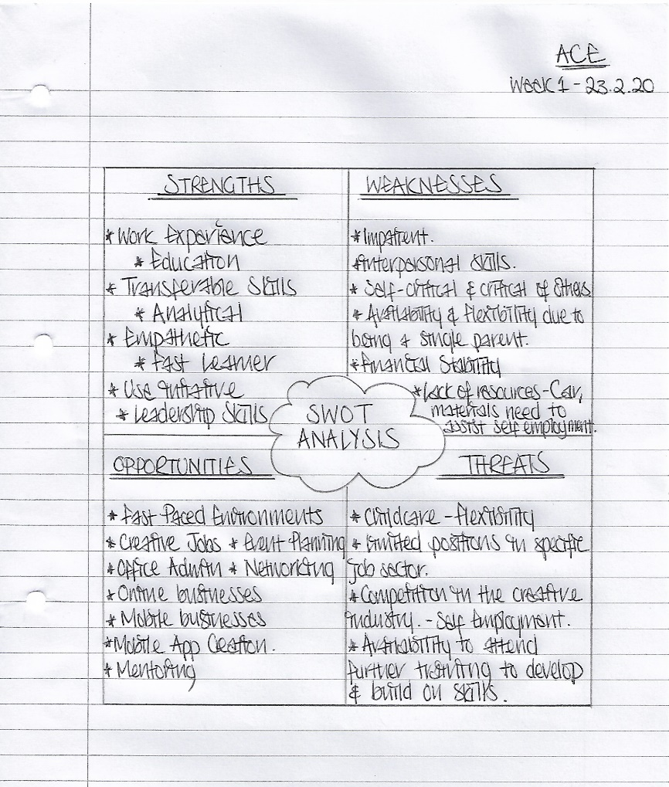
Appendix B

Employability Skills Student Worksheet

This image is a worksheet completed by myself, which was a set task as a part of this module:

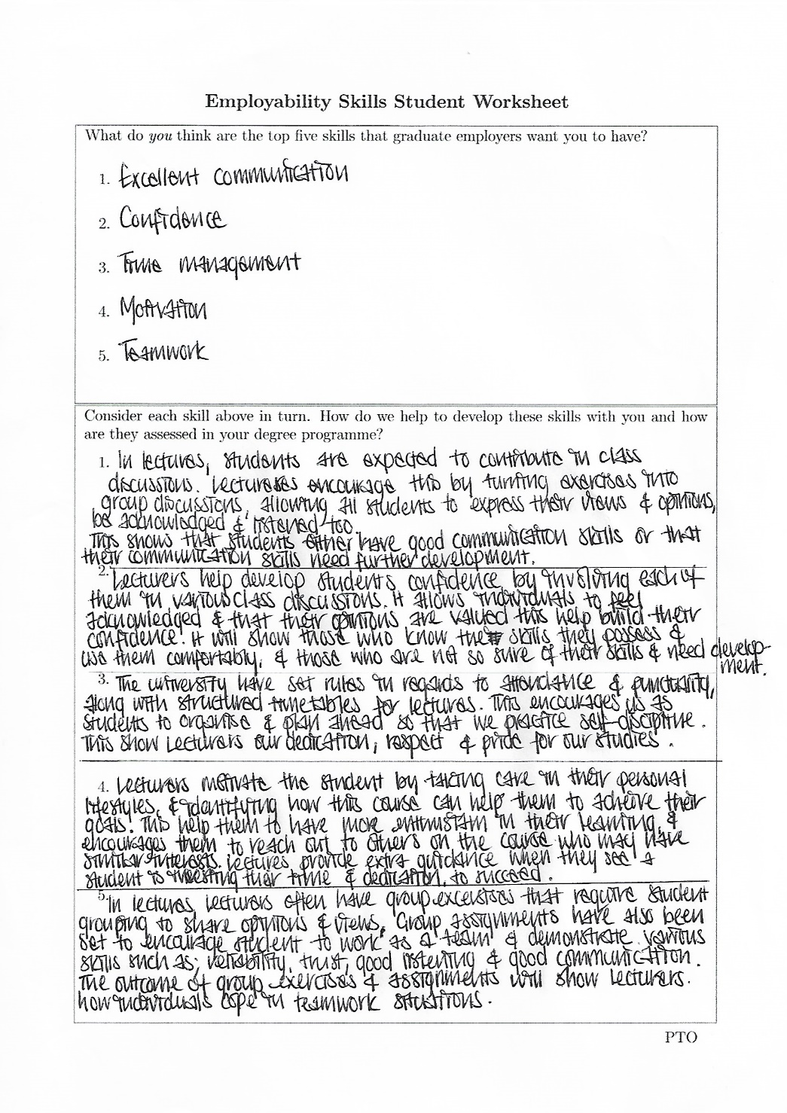

Appendix C

Employability Skills Student Worksheet Continued.

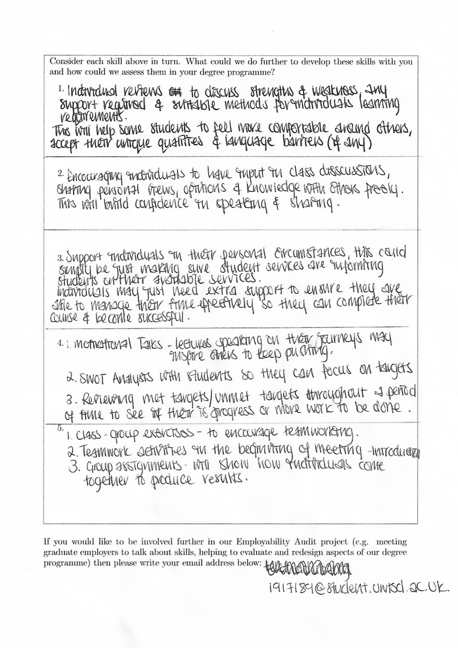

Appendix D

Questionnaire Results

This image shows the results from the ‘Testing My Skills’ questionnaire I completed focusing on my Academic Employability Skills:

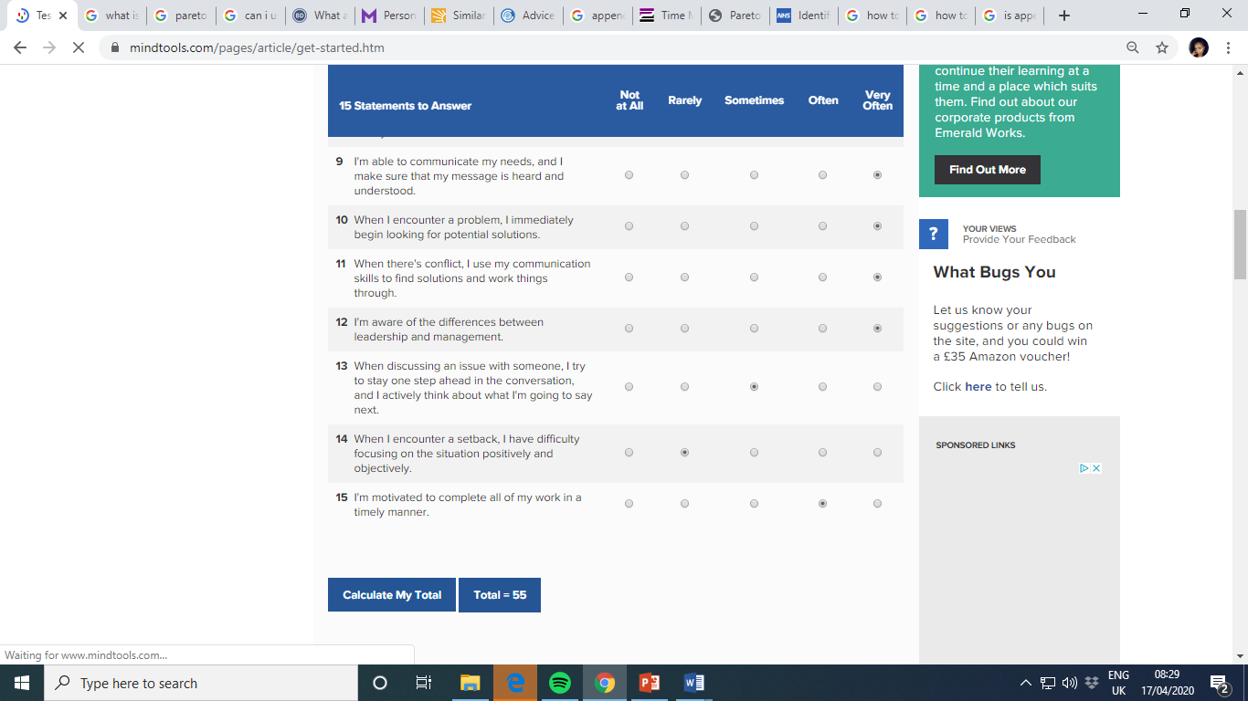
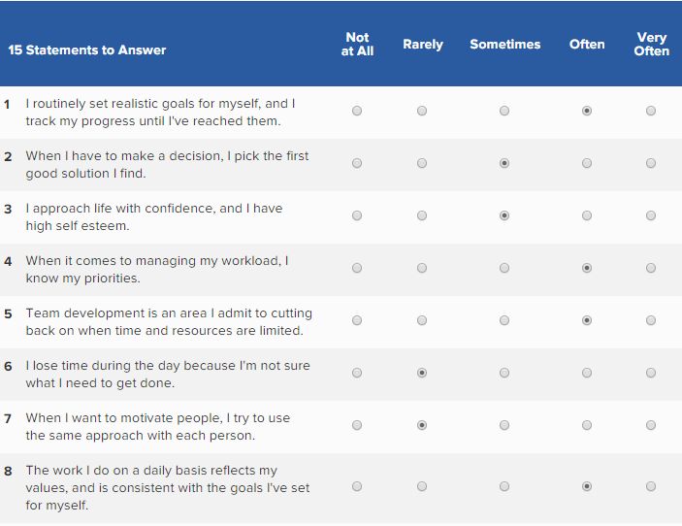

Appendix E

Personal Development Plan

This is an image of my ‘PDP’ which I completed since starting my studies:

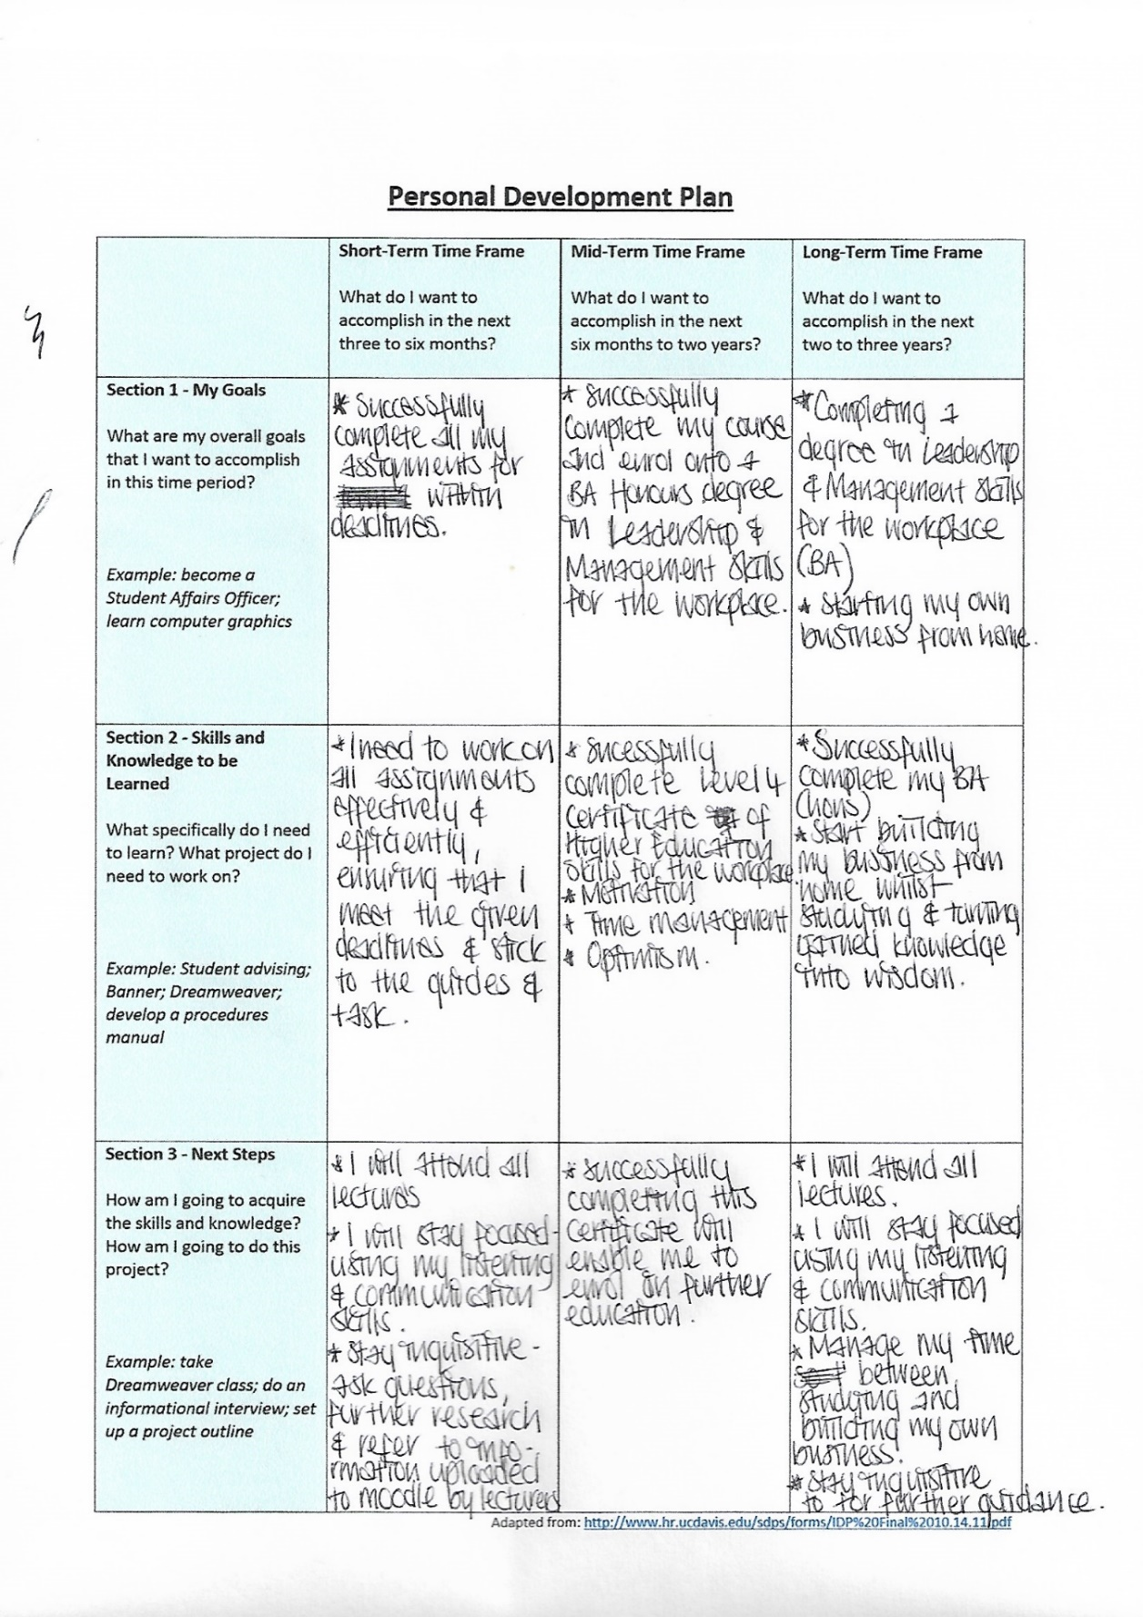
Appendix F
Personal Development Plan Continued.
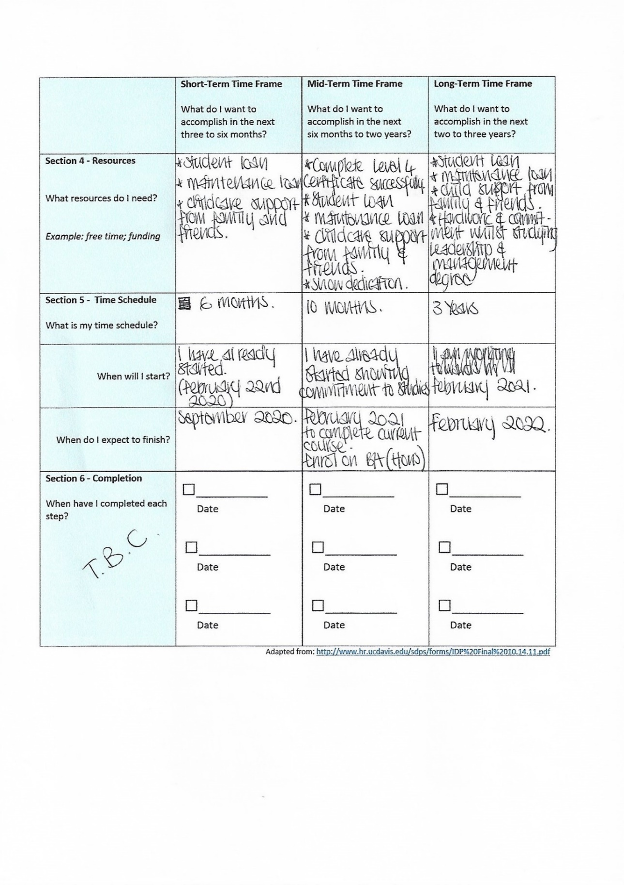

Appendix G
My Weekly Calendar
This is an image of my weekly calendar showing my usual day – to - day routine and how I try to manage my time:
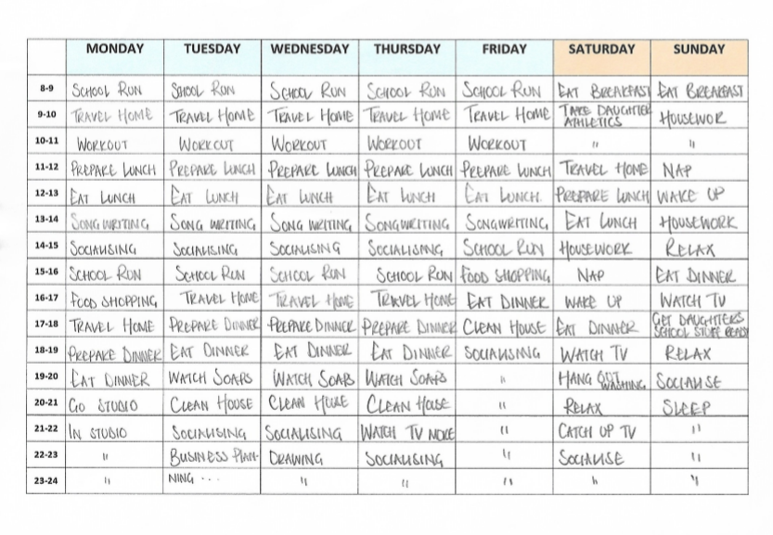

Appendix H
My Eisenhower Method
I took the opportunity of applying the Eisenhower Method to my everyday tasks:
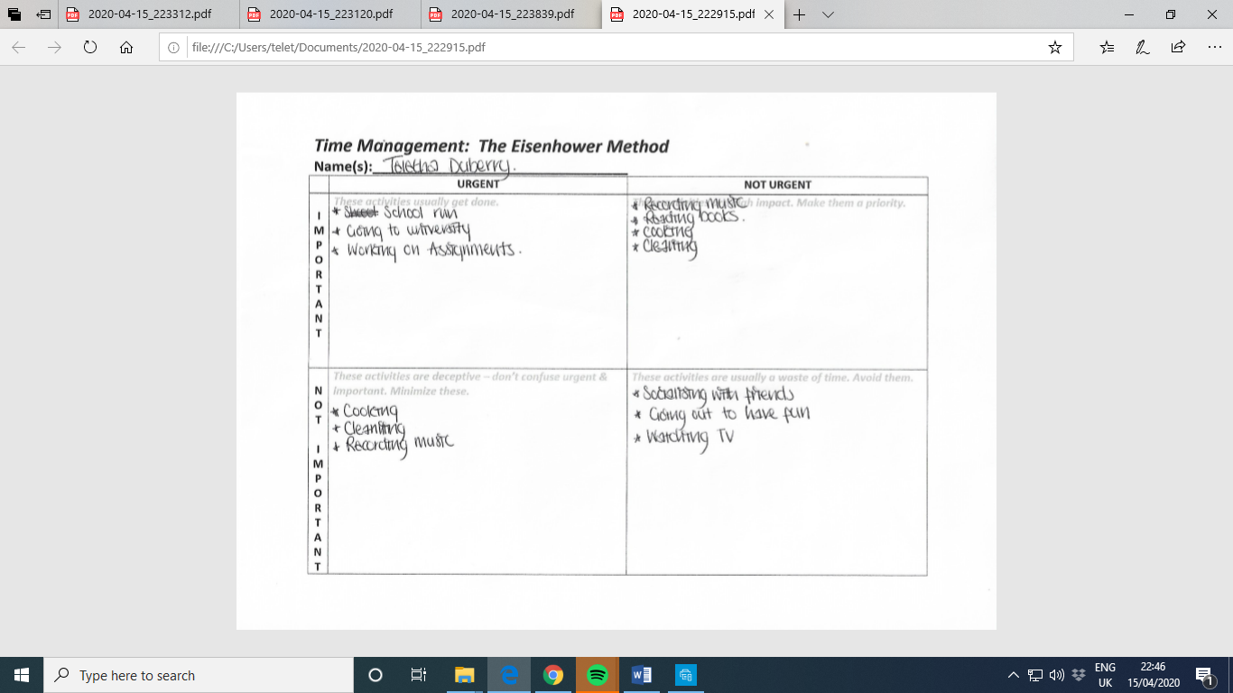
Appendix I

‘The 80 – 20 Rule’

This is a diagram demonstrating how the 80 – 20 rule works in Time Management:

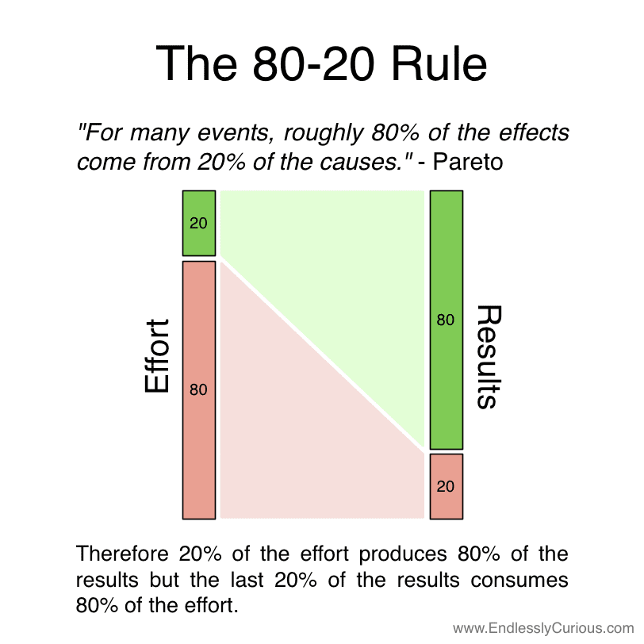

Image: Chaffey D. (2016) https://www.smartinsights.com/marketing-planning/marketing-models/paretos-8020-rule-marketing/

