A Qualitative Exploration into Social Media ‘Influencers’ and their Impact on Decision-Making Among 18–25-Year-Olds Consuming Fast Fashion.



Name: Glesni Olivia Loveridge

Student ID: 1804647

University: UWTSD Swansea

Degree: Business Management

Due Date: 12th May 2021

Impact of Covid-19

In light of the continuing impact of the global pandemic, it is important to include a statement at the start of my dissertation which outlines the effects that COVID-19 has had on the research that I have undertaken towards my undergraduate degree.

The University of Wales Trinity Saint David recognises that the COVID-19 pandemic, and consequent closures of our campus (18th March 2020) and national and international lockdowns, has directly or indirectly impacted the work of many of our undergraduate researchers. Although the campus had periods of re-opening in 2020 and 2021, some research will have been disrupted and some personal circumstances difficult to manage. Teaching was arranged via suitable meeting software and documents shared electronically. All research data collection was designed to utilise digital data collection.

The inclusion of this statement is to facilitate the reader’s awareness, both now and in the future, that the pandemic may have had an effect on the scope, direction and presentation of the research.

The academic standards and quality threshold for the award remains unchanged. I wish to reassure readers that this statement is not evidencing a lack of original research or quality.

Declaration

Statement 1

I, Glesni Olivia Loveridge, declare that this work has not previously been accepted in substance for any degree and is not being concurrently submitted in candidature for any degree


Signed: Date: 24.04.21

Statement 2

This dissertation is being submitted in partial fulfilment of the requirements of the degree of BA.
Signed: Date: 24.04.21

Statement 3

This dissertation is the result of my own independent work/investigation, except where otherwise stated. Other sources are acknowledged by footnotes giving explicit references. A bibliography is appended.
Signed: Date: 24.04.21

Statement 4

I hereby give consent for my dissertation, if accepted, to be available for photocopying and interlibrary loan, and for the title and summary to be made available to outside organisations.
Signed: Date: 24.04.21

Acknowledgements

I would like to thank dissertation tutor, Caroline Jawad for their support throughout this uncertain time. I would also like to thank my family and partner for their encouragement, patience and support not just at this current time but throughout the three years spent at University, it has made me want to achieve as best as I can. I am a very lucky woman to have such a supportive family.

Abstract

The overall aim of this dissertation was to gain an insight into the fast fashion industry and the impact social media influencers have on consumer behaviour. Using Instagram as a social media platform will establish how social media influencers engage with 18–25-year-olds, to be more inclined to purchase fast fashion.

I conducted a literature review to gain an understanding of the fast fashion industry and the social media influencer side towards marketing using social media. Also, identifying consumer behaviour by using a model and theory. The findings which were found enabled the researcher to underpin questions within the interviews held.

Online interviews were carried out using emails. The researcher would send an interview sheet for the interviewee to respond and send back completed, the responses linked to the findings within chapter one and two. Which then allowed conducting themes within research found:
  - Theme one, fast fashion knowledge consumer behaviour.
  - Theme two social media influencer knowledge.
From all findings, recommendations were then proposed.

Table of Contents
Chapter One: Introduction 1
1.1 Introduction 1
1.2 Background and Rationale 1
1.2.1 Fast fashion Industry and Marketing 1
1.2.2 Klarna 3
1.2.3 Instagram 3
1.3 Aims and Objectives 4
1.3.1 Aim: 4
1.3.2 Objectives: 4
1.4 Research Structure 5
1.5 Conclusion 6
Chapter Two – Literature Review 7
2.1 Introduction 7
2.2 Fast fashion and Social Media 7
2.2.1 Traditional Marketing vs Digital Marketing 8
2.3 Social Media Influencers 9
2.3.1 Social Media Influencers 9
2.3.2 Influencer Ambassadors 10
2.3.3 Authenticity & Intimacy 11
2.4 Consumer Behaviour Theory: Approaches and Models 12
2.4.1 Consumer Behaviour and Consumer Decision Making 12
2.4.2 Theoretical approaches to the study of consumer behaviour 13
2.4.3 Decision-making model 13
2.5 conclusion 17
Chapter Three – Research Methodology 19
3.1 Introduction 19
3.2 The Research Onion 20
3.2.1 Research Philosophy and Approach 21
3.2.3 Research Strategy and Choice 22
3.2.5 Time Horizon 23
3.3. Techniques for Data collection and analysis 24
3.3.1 Data collection 24
3.3.2 Questionnaire Design with Literature Review Matrix 24
3.4 Sampling 28
3.5 Reliability and Validity 28
3.6 Limitations 29
3.7 Ethical Considerations 29
3.8 Conclusion 29
Chapter Four: Data Analysis 30
4.1 Introduction 31
4.2 Data Analysis 31
4.3 Methods 31
4.4 Demographics 32
4.5 Theme One: Fast Fashion Knowledge and consumer behaviour 33
4.6 Theme Two: Social media influencer knowledge 39
Chapter Five – Conclusion and Recommendations 42
5.1 Introduction 42
5.2 Main Findings 42
5.3 Recommendations 43
5.4 Limitations 44
5.5 The achievement of objectives 45
5.6 Self Reflection 46
5.7 Conclusion 47
References 49
Appendices 54

Chapter One - Introduction

1.1 Introduction

The aim of this chapter is to provide context and justification for the analysis that follows. Moreover, clarify the researcher’s purpose by including aims and objectives as well as its definition and structure.

The research aims to understand and examine the way in which social media influencers impact decision making among 18–25-year-olds with particular focus on fast fashion. Considering this, sampling will concentrate on 18–25-year-olds as a group and will not focus outside this chosen demographic. Research states that young adults develop consumer behaviour patterns when purchasing fast fashion, mostly being female but also male or those in which idenitfy as non-binary (Workman & Lee, 2011; as cited in Simpson, 2019).

1.2 Background and Rationale

1.2.1 Fast fashion Industry and Marketing

The term fast fashion is used to describe the readily available, inexpensive made fashion available today. The word “fast” describes how quickly retailers can move and produce designs (Brick, Hasley & Ekenga, 2018). The fast fashion industry has been criticised for its lack of attention to social and environmental issues. The fashion industry has extensive and significant environmental consequences (Peters et al, 2020). Influencer engagement is seen to encourage fast fashion by using social media as a platform to advertise (Claude, Malek & Runnvall, 2018). Influencers can also be described as SMIs (Social Media Influencers), this can be described as “people who possess greater than average potential to influence others due to such attributes as the frequency of communication, person persuasiveness from a social network” (Audrezet et al, 2017, P.509).

According to Pemberton (2016), 84% of the younger generation admitted that when they purchase fast fashion it is due to being influenced by user-generated content from influencers or SMIs (Revlon-Chion, Bolat & Liang, 2020). This stage occurs between the ages of 18-25, when young people are preoccupied with themselves before marriage and careers (Arnett, 2015; as cited in Simpson, 2019). Within today's world the majority of young individuals spend an excessive amount of time online scrolling through social media (Asano, 2018; Claude, Malek & Runnvall,2018).

Today, fast fashion businesses must follow the 'Business model' which provides a swift response to new fashion trends, otherwise, they will be left behind as well as production times being quick to ensure rapid supply to the retailers and consumers (Gordon & Swinney, 2011). Appendix A shows an example of ASOS business model. ASOS is a popular fast-fashion retailer which sells inexpensive clothing, often poor-quality clothing made from polyester or other synthetic fabrics, nevertheless, it is seen to be the highest shopped website (Ibid.). the quicker a fast industry responds to changing trends, the faster the sales. For example, new fashion trends should be introduced within weeks, which keeps a continuous cycle of customer visits online. The fast-fashion model is proven to be inexpensive prices and manufactured short term to keep with seasonal clothing, ASOS is an example of a successful approach to fast fashion (Ibid.).

1.2.2 Klarna

Due to technological changes, Klarna is the leading global payments method, providing a smarter and more flexible shopping experience. Klarna offers a pay later option or pay in three instalments, offering customers more time to pay or try before buy (Klarna, 2021). This can encourage impulse buying due to not having to pay straight away.

1.2.3 Instagram

Instagram is a smartphone application that allows users to upload photos and videos to social networking site. Every individual who opens an Instagram account, similar to Facebook, has a profile and a news feed (Moreau, 2018). According to Sheldon and Bryant (2016) and Recode (2018), Instagram is the fastest growing social networking platform in contemporary times. In 2017, Instagram had almost 800 million monthly profiles, making it the third most popular social networking site (millions, 2018; Dreagrow.com, 2018).

Instagram uses hashtags as a significant marketing tool, which means it may be used more as a discovery social media tool than a visual social media tool by individuals looking for material they want to view, ensuring a beneficial relationship between Instagram and businesses (Costill, 2020; as cited in Wally & Swapna, 2014). There are approximately 30.36 million users in the United Kingdom. According to statistics Instagram has the highest proportion of users ages between 25–34-year-olds, this was then accompanied by respondents within the ranges of 18 to–24-year-olds. Individuals over the age of 65 are unlikely to use Instagram (Tankovska, 2021). Users that have a greater network of followers are considered to be more creditable and famous (Jin & Phua, 2014).

1.3 Aims and Objectives

1.3.1 Aim:
To explore the impact social media influencers, have on consumer behaviour; a case study of the views of 18-25-year-olds of the fast fashion industry.

1.3.2 Objectives:

- “To explore and analyse academic literature on the influence of social media within the fast fashion industry on consumer behaviour”.
- “To select a suitable research approach and explore 18–25-year-old views on fast fashion and to see if social media engagement encourages purchase decision making within this sample”.

- “To analyse the data collected to explore 18-25-year old’s views on how they think fast fashion is becoming, by also using them as a way to identify how popular the industry is, with particular focus on how social media influencers, influence individuals purchase fast fashion by using social media as a tool for marketing”.
- “To understand the researcher’s practical consequences and generating practice suggestions”.
- “To look at prospective future research areas while keeping in mind the limitations of the current study”.

1.4 Research Structure

The research will be divided into five Chapters in order to achieve its goals. The introduction is in Chapter One, followed by a literature review in Chapter Two, methods and methodology in chapter three, data collection and analysis in Chapter Four, lastly ending with a conclusion and recommendations in Chapter Five.

Chapter One has provided a background of the research, rational for conducting the research, and aims and objectives. The research utilise use both primary data and secondary data in the form of a participant interview sheets and literature review.

Chapter Two literature review involved reviewing topics on fast fashion and consumer behaviour. Chapter Two will provide a better understanding of this research.

Chapter Three identifies the methods and methodology, selecting appropriate primary research techniques and the procedure for this research, allowing the following data to be analysed.

Chapter Four will analyse primary data, which was collected through interview sheets as stated in Chapter Three. Statistical analyses will be used to develop findings and review.

Chapter Five will determine whether this research has acieved its aims and objectives, followed by a discussion of the main findings, recommendations and limitations of the research conducted.

1.5 Conclusion

This chapter has given an overview of the study, including the purpose and goals, as well as why its importance. The next chapter will present a literature review, bringing more depth to the growing industry of fast fashion and social media influencers.

Chapter Two – Literature Review

2.1 Introduction

The purpose of Chapter Two is to explore the fast fashion industry and the impact the term 'influencer' has on decision making among 18-25-year-olds when deciding to purchase fast fashion. The following chapter will complete the first objective of this dissertation:

“To explore and analyse academic literature on social media influence within the fast fashion industry on consumer behaviour”

The following literature review will contain a wide range of sources gathered from Google Scholar and the University of Wales Trinity Saint David's (UWTSD) online library. All sources include academic journals and prior primary research in the topic area. Search terms include: 'influencers', 'decision making, 'fast fashion' and 'customer behaviour'.

2.2 Fast fashion and Social Media

Fast fashion is defined as something which is quickly produced, inexpensive clothing which gets manufactured every day by inexpensive retail companies. By dividing the term "fast fashion" into two will give a better understanding of the term. "Fast" describes the rapid approach in which retailers shift designs to their stores or websites taken from high-end catwalks (Brick, Hasley and Ekenga, 2018). According to Fletcher, fast fashion can be considered as quick and on time, while comparing slow fashion is based on quality and consistency (Fletcher, 2008). The production of inexpensive as clothing is continuously in demand and costs are kept low by exporting to low- and middle-income countries.

Since 2016, the fast-fashion business has grown at a rate of 9.7% per year (Michaela & Orna, 2015), owing to the rising demand for fashion and a luxury lifestyle. Social media is a new type of media that can consist of online sources created, investigated, and shared by online users with the goal of educating others about an organisation, services, events and other topics of interests (Ibid). Today, social media is an important tool for marketers by providing several opportunities to build brand recognition among customers (Bashar, Ahmad & Wasiq, 2012). Social media is one of the most accessible and engaging methods of public relations due to the ubiquity of the smartphone (Ahmad, Salman and Ashiq, 2015).

2.2.1 Traditional Marketing vs Digital Marketing

Traditional marketing can still be found in magazine or newspaper advertisements, as well as billboards but it primarily targets a local audience rather than a national one (Tudor, 2016). Due to different factors such as inflation, economic recessions, and quick technical advancement, the function of marketing has evolved considerably over time and continues to do so, with the internet being the most significant change (Bala & Verma, 2018). According to studies, digital marketing has displaced traditional marketing due to the continuous advancement of technology (Hanlon, 2020).
Digital marketing is a sort of marketing that uses digital platforms such as social media to promote items and reach out to customers. Which social media influencers use, Instagram as the digital platform to promote and advertise (Yasmin, Tasneem & Fatema, 2015). Social media marketing, according to Chaffey (2011), entails "encouraging customer communications on the company's website or through its social presence". Companies may utilise social media to communicate their ideas to their target audience without having to pay for publishers or distributors, which is typical of traditional marketing (Yasmin, Tasneem & Fatema, 2015).

2.3 Social Media Influencers

2.3.1 Social Media Influencers

An influencer is defined as a popular individual who provides the advertisement to their audience to maintain a high following, helping them to make a purchase solely on what they see (Dizon, 2015). Research states social media influencers contribute to consumers purchasing behaviours and actions (Balakrishnan et al, 2014 as cited in Vandenbosch and Orpha, 2017). Customers who use fast fashion websites, direct themselves to social media channels first such as Instagram to gather more information about a particular product to see if it has been influenced and reviewed (Awe and Labrecque, 2020).

An influencer posts to Instagram in exchange for compensation, organisations reward influencers with money or free items, programmes, services or experiences (Campbell and Farrell, 2020). In return for payments or endorsed goods and services, influencers now create advertising on blogs as well as social media sites. As a result, many bloggers have direct financial and contractual relationships and contacts with product marketers or indirectly through different agencies and content networks. Influencers are not always looked upon as a fashion trend, the success of the influencer industry has been shown in several other contexts, including multinational corporations, politics, and education they have all drawn widespread interest from the influencer industry. Following on the above sectors invite influencers to attend appearances to bring publicity to the organisation or project. As special guests and VIPs, influencers are often welcomed to events in appreciation of their distinctive status and the social prestige they have gained by followers (Abidin and Ots, 2016).

2.3.2 Influencer Ambassadors

Fashion organisations state that celebrity ambassadors can improve advertisement credibility, brand image and even purchase behaviour. Celebrities have built-in images and followers, both of which can have a significant impact on potential customers (Ford, 2018). An example being Pretty Little Thing a popular online fast-fashion company that has a social media influencer ambassador Molly-Mae Hauge who become famous by being on Love Island in 2019 (Pretty Little Thing, 2021).
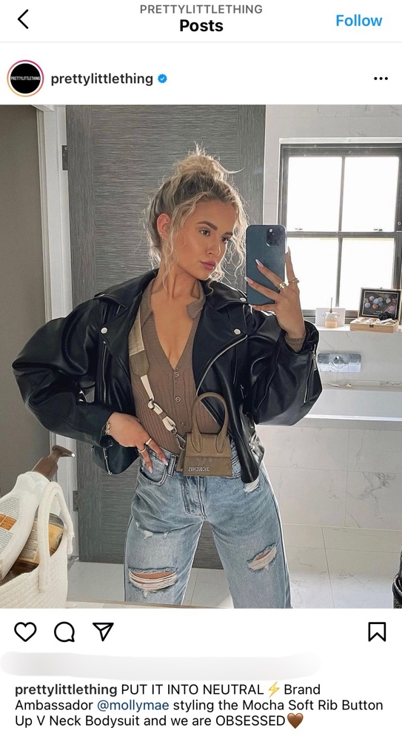

Figure 2.1 Screenshot of Brand Ambassador (Source: Pretty Little Thing, 2021).

Following two successful launches with the company Pretty Little Thing, Molly-Mae Hauge has realised her own clothing line which served to increase sales (Brandy, 2021). Following Molly-Mae’s first launch, Pretty Little Thing’s website had seemingly crashed after a successful sell out ( Bayley, 2019).

2.3.3 Authenticity & Intimacy

Business’ who collaborate with social influencers to promote products need to remember the importance of authenticity. Influencers are deemed more trustworthy than celebrities according to Marwick (2013). Today influencers focus on building awareness and growing their audience (Marlow, 2006). Although Abidin Thompson (2012) cited in (Lea, Malek and Runnvall, 2018) argues that influencers focus on establishing an intimate relationship between the brand and its followers which can create important factors such as personal relevance, inspiration and trust which can all impact behaviour.

It is important to view the influencers with credibility and intimacy, both because of the popularity of the endorsed product. If this is not done properly, both influencers' image and the brand itself may have a negative outcome (Ibid.).

2.4 Consumer Behaviour Theory: Approaches and Models

2.4.1 Consumer Behaviour and Consumer Decision Making

Consumer behaviour is the process involved within an individual's or group selection, purchase, resource, and experience which meets the desired need (Solomon et al, 2006 as cited in Bray, 2008). This behaviour includes information search, purchase decision, selection and post-purchase feelings of the consumer, these actions result in the individuals feeling satisfied or unsatisfied (Evans et all, 2009 as cited in Lea, Malek and Runnvall, 2018). This thesis explores consumer behaviour with 18–25-year-olds post-purchasing to explore the consumer behaviour process.

Consumer behaviour is also viewed as; buyer behaviour’ both looking at the relationship between consumers and producers at the time of purchase to identify what has drawn them to purchase. Consumer behaviour is now seen as a continuous process to marketers, by exploring options of marketing tools such as influencers and social media. Buyer behaviour is defined as the decision-making process and behaviours of individuals involved in the purchasing and use of consumer goods from a social viewpoint, meaning social media has an impact on this (Michaela, 2015).

2.4.2 Theoretical approaches to the study of consumer behaviour

In the study of decision making, research suggests that numerous methods have been implemented to identify each variable for each approach. The five strategies include: economic, psychodynamic, behaviourist, cognitive and humanistic (Foxall, 1990 as cited in Bray, 2008).

Focusing on a particular method ‘behaviourist’ will identify how this theoretical approach to this study of exploring trends within decision making among the young when purchasing fast fashion. According to research, behavioural theorists have established unreasonable choices in which consumers make when decision making. The role of business is understanding this approach as consumer behaviour has been proven to be important and it can be vital to understand the meaning of decision making (Stankevich, 2017)

2.4.3 Decision-making model

Research has shown that many models have been developed by different authors, trying to understand customer behaviour during the decision-making process when purchasing. Understanding what draws customers to their final thoughts on why they make a purchase, will be beneficial to this research. The Engel-Kollat-Blackwell (EKB) model was developed by John Dewey in 1910. The EKB model (Figure 1), states the five components of the consumer decision-making process. The model focuses on five core stages of the decision-making process and can be applied to consumer behaviour (Stankevich, 2017).
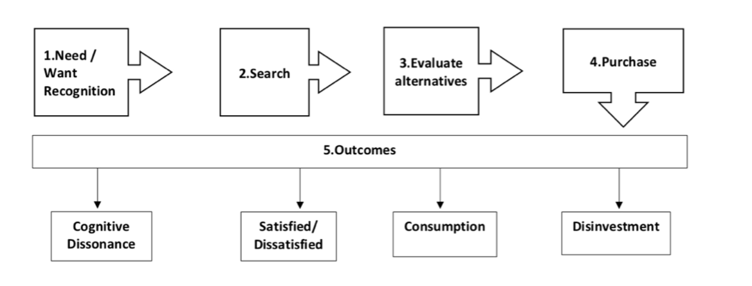
Figure 2.2. Model of the consumer decision-making process (Source: Engle, Kollat, and Blackwell, 1978).

Although this model is forty-three years old the above model is still a process that is used within a shopping environment when purchasing fast fashion, due to the advancement of technology and today's cultural engagement which is used in the shopping environment (Ashman, Solomon and Wolney, 2015).

- Problem recognition
The EKB models’ initial step is to identify the problem. Consumers are more likely to identify a need or desire during this period, which can be triggered by both internal and external stimuli and can be also triggered by a variety of elements including human, social and economic considerations. When a consumer recognises a need, they must seek facts to determine how that might meet problem (Darley, Blankson and Luethge, 2010). Influencer’s engagement to purchase fast fashion can be identified as a problem, seeing something advertised gives consumers a need to purchase, not seeing that advertisement does not give a reason to purchase.

- Search
Both internal and external searches are part of this step. In order to make a final decision, the consumer compares the benefits and drawbacks of prior experiences this can be done by using social media as a tool for knowledge. Informative research is the main research process within this model stage. Here, the consumer beings the hunt for various alternatives that could fulfil the need (Ibid).

- Evaluating alternatives
Evaluating alternatives means the consumer has already developed standards for what they desire, this could be because they have seen exactly what they want advertised. Now, by analysing and contrasting them against each other, they actively assess the alternatives they looked for in the previous process (Ibid).

- Purchase
A customer will eventually make the purchase decision, after evaluating the alternatives and collecting all required information from feedback (Ibid).

- Cognitive dissonance
Cognitive dissonance is the first result that would result from making a decision. This buying situation is where the emotions and opinions of a person contradict the individual's behaviour. An example of cognitive dissonance is when a person has decided to stop consumption due to a bad economic condition but contradicts themselves by buying an expensive purse maybe they have seen on social media or an influencer (Evans, Jamal and Foxhall, 2009).

- Satisfactory and unsatisfactory
After consumers make a purchase decision, satisfaction or dissatisfaction is a feeling which will most likely stem from that purchase. Satisfaction and dissatisfaction can depend on many factors some including value and experience (Evans, Foxall and Jamal, 2009). Dissatisfaction can mostly happen when online shopping as it is either a hit or miss. However, satisfaction is most definitely always in favour as it leaves consumers happy and most likely to share their experience with others on social media (Fu et al., 2020).

- Consumption
Depending on the feedback, consumption is either positively or negatively influenced. The requirement for a complete field provides useful input. It usually leads to unfavourable evaluations as a result of the consumer unrealistic expectations or any defects in the goods. Consumption is determined by whether the customer is satisfied or not, based on the level of satisfaction obtained through the process (Phillips, Olson and Baumgartner, 1995).
- Disinvestment
Disinvestment is defined as the consumer demand for a particular product will not always be in demand or remain the same, availability of identical or close substituted commodity may be reflected in the reduction of the level of consumer demand (Sewing, 2010).

2.5 Conclusion

The following objective has been achieved within this chapter:

“To explore and analyse academic literature on social media influence within the fast fashion industry and consumer behaviour”
The literature review has outlined that the fast fashion industry is a continuously growing sector (Michaela & Orna, 2015), due to how popular social media is today and how easy the platform is to use as a marketing tool (Ahmad, Salman and Ashiq, 2015). A positive is that since digital marketing is timely social media advertisement is the way forward (Marlow, 2006). In addition, since digital marketing is timely, social media advertisement is the way forward in today’s world of smartphones (Hanlon, 2020) Digital marketing is frequently used to advertise and is seen as a competitive advantage on fast fashion websites, according to marketing experts (Hanlon, 2020), (Yasmin, Tasneem & Fatema, 2015). It is clear that social media marketing encourages fast fashion as well as social media influencers engagement in consumer decision making and actions (Balakrishnan et al, 2014 as cited in Vandenbosch and Orpha, 2017). This can also be seen as a positive by influencers having an impact on consumer behaviour, it keeps the economy alive. It is seen that influencers improve the overall performance of a business (Ford, 2018).

The follow Chapter aims to identify the research method and methodology in which the researcher has decided to take addressing the issues mentioned within this chapter.

Chapter Three – Research Methodology

3.1 Introduction

The first goal was met in chapter two, with a critical review of academic literature on social media impact in the fast fashion industry and an examination of customer behaviour.
There was a wide range of research and literature relating to this subject of fashion influence and customer behaviour.

The Third Chapter attempts to achieve the second objective:

"To select a suitable research approach and explore 18–25-year-old views on fast fashion and to see if social media engagement encourages purchase decision making with this sample”

The ‘Research Onion’, crafted by Saunders et al, (2016), will direct the decision-making process to achieve this objective. Figure 3.1 shows the ‘Research Onion’ and the chosen pathways in each layer this research will be conducted for this thesis.

3.2 The Research Onion

The concept of research is defined as 'disciplined inquiry' which for the rational claim to be carefully tested, it must be conducted and reported; it does not rely on surface plausibility or its author's eloquence, status, or authority; errors is avoided; proof checking and clarification are valued; philosophy is valued over the dispassionate quest for reality (Morgan, Gliner and Harmon, 1999).
This chapter explaining the chosen research method will be influenced by the ‘Research Onion’ from Saunders et al, (2016), which offers an understanding of the value of research and how it should be conducted.
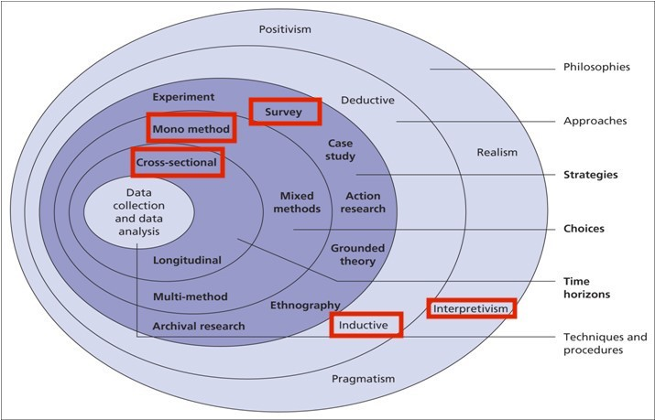
Figure 3.1: The Research Onion (Saunders et al., 2016)
The ‘Research Onion’, as shown in Figure 3.1 depicts ‘layers’ of research that reflect different aspects of research in which the researcher must follow in order to get a successful study (Saunders, et al 2016). To prepare a technique, this dissertation considered various stages of the model which have been shown above.

3.2.1 Research Philosophy and Approach

The interpretation of facts, fact, and knowledge can be described as a researcher’s research philosophy. With philosophical ideas as a guide, it outlines the beliefs and values that govern the design of a research study as well as the collecting and interpretation of data (Ryan, 2018). According to many scholars, all scientific study should be focused on a set of basic conceptual principles that take into account the essence of the research, the evidence available to support it, and the research process (Myers, 1997; Neuman, 2011; Orlikoqski & Baroudi, 1991 as cited in Alharasheh & Pius, 2020).

Interpretivism as a research philosophy is based on the idea that a researcher has a particular role to play in analysing the social world. According to Packard (2017) research focuses on the researcher’s interests in which this study will be doing. The interpretive paradigm is concerned with understanding the world as it is from the subjective experiences of individuals.

Within this study, a mono method has been chosen. In order to advance information, an inductive analysis method is needed after the data has been evaluated (Harriman, 2010 as cited in Woiceshyn & Daellenbach, 2018). The researcher has adopted an inductive approach which begins with unanswered questions rather than a theory (Woiceshyn & Daellenbach, 2018) in regard to interest, this is why this approach is suitable for the researcher.

3.2.3 Research Strategy and Choice

According to Saunders, et al (2016), research strategy refers to how the researcher wants to perform the analysis and what tools and techniques will be used. The primary qualitative data in this study will be gathered through a series of online interviews due to the Covid-19 pandemic and participants will be between 18-25 and both male and female. There are various interview formats that can be used by both individuals and groups. Qualitative interviews enable the researcher to look deeper into topics that are unique to the interviewees' perspectives, revealing how various facts of interest are interpreted and perceived. This would be relevant because fast fashion can be viewed and perceived in a variety of ways such as affordable but unsustainable (McGrathm, Palmgren & Lijedahl, 2019).

It is important to ensure participants get involved and express their views, not only is this important but essential to this study in order for the researcher to achieve the inductive approach; the viewpoints of the interviewees will be used to develop this study’s theory. The chosen pathway of online interviews was specifically due to COVID-19. The set of interview questions were derived from the literature review performed in Chapter Two. The literature review matric would include an in-depth understanding of the subject area from various perspectives.

3.2.5 Time Horizon

Due to the research onion indicating the time taken to perform research and data collection, cross-sectional research is the most appropriate time horizon for this review due to it being a short-term analysis (a couple of months).

3.3. Techniques for Data collection and analysis

3.3.1 Data collection

According to Hox & Boeije (2005), primary research entails gathering data directly on a specific research question. The researcher's primary research will obtain data by holding interviews with a sample of 18-25-year-olds. The researcher will use WhatsApp messenger as the platform to host the interviews. In a qualitative study, interviews are an important part of data collection (Fritz & Vandermause, 2018). Interviews identify opinions and perceptions to gather more in-depth information (Showkat & Parveen, 2017).

3.3.2 Questionnaire Design with Literature Review Matrix

Semi-structured interviews were chosen by the researcher. Within a social aspect, semi-structured interviews are the most common and widely used methods of data collection (Evans & Lewis, 2018). Considering the guidelines set by COVID-19 regulations, a sample of ten participants were interviewed through social media. See below:

Questions in Interview | Relevance and Relation to Chapter 2
Q1 What Gender are you?  Q2 How old are you? | Questions 1+2 are demographic, gathering basic information on participants. Q2 also relates to research question between 18-25-year-old participating only
Q3 How would you describe the fast fashion industry today? | (Su and Chnag, 2018), (Brick, Hasley and Ekenga, 2018)
Q4 What do you know about the fast fashion industry? | (Ahmad, Salman and Ashiq, 2015)  (DIzon, 2015), (Vandenbosch and Orpha, 2017).
Q5 Do you have Instagram?  If yes, do you follow any fast fashion companies such as Asos? (Please name one or more) | It is vital that participants use Instagram, to then find out popular fast-fashion websites
Q6 Are you familiar with the term social media influencer?  Q7 How would you describe a 'social media influencer as? | Participant’s idea of a social media influencer is necessary due to wanting to gain knowledge on what they might describe an influencer as.  (Khoja & Stita, 2020 & (Statista, 2019)
Q8 What social media sites do you see most advertisement for fast fashion? | (Khoja & Stita, 2020, (Klarna, 2021) & (Statista, 2019)
Q9 Have you ever shopped online before?  Q10 What makes you want to spend money on fast fashion sites such as ASOS or Pretty Little Thing? | This question is also a vital part, it was important to gather information on participants who have had experience shopping online.
Q11 What factors do you feel are important when you make a clothing purchase?  Q12 If price, do you use Klarna? | (Brick, Hasley and Ekenga, 2018)  Klarna is used as the leading global payments method, if the price is a factor then why is Klarna is used?  (Klarna, 2020)
Q13 If you do not use Klarna, are there any other methods of ‘pay later’ you use instead.  Q14 If Klarna or others, why do you use this method? Do you feel it's safe? Do you feel it encourages unnecessary buying? | Marwick, 2013)  (Lea, Malek and Runnvall, 2018), (Bray, 2008), (Michaela, 2015) & (Stankevich, 2017).
Q15 Does influencer engagement make you more inclined to purchase fast fashion? If yes or no, please express your opinion on influencer engagement.  Q16 If yes or no, have you ever bought an item or items promoted by an influencer? | Since social media influencers are known to increase sales, asking participants if they feel inclined to purchase when they see something, they like advertised will be interesting.
Q17 Please name you to go to fast fashion site e.g., ASOS, Pretty Little Thing.  Following with a reason why you shop there.  Q18 Please also name a fashion influencer you follow or heard of on social media such as Instagram  This question purpose is to see if there is a theme with a popular influencer. | This question’s purpose is to recognise if there is a theme of websites and a theme to price or quality on why they chose a site such as ASOS.
Q19 Would you describe your buying behaviour as complex, variety, dissonance or habitual buying fast fashion? Please give a reason for your answer. | Understanding why participants purchase is interesting, whether they buy because they are bored or actually in need.

3.4 Sampling

The participants selected for interviewing for this research were chosen by the researcher due to judgement on who might be interested within the fast fashion industry and who have social media. The researcher interviewed people from different backgrounds and levels of involvement but made sure that all participants had access to social media, in order for the researcher’s results to be as reflective as possible of the fast fashion industry and their feelings about influencer marketing.

3.5 Reliability and Validity

Reliability is defined as a concept in which the overall goal is to assess the degree to which knowledge is consistent. Whereas validity is defined as a methodology that tests exactly what is supposed to be tested (Middleton, 2020). Using both reliability and validity within this research is essential the findings obtained must be relevant and accurate. This can be restricted by ensuring that the analysis is carried out in a consistent way to affect variable. The analysis must be conducted fairly and transparently which is consistent with all respondents.

3.6 Limitations

Within this area of study, the primary limitation is time and limited resources available due to research having to be all based online. Additionally, research was limited due to the ongoing Covid-19 pandemic, which will affect how interviews are carried out as well as the manner. Interviews have some risks due to participants having their own opinions and thoughts.

3.7 Ethical Considerations

The research conducted will be with persons over 18 years old only and voluntary. The research being from marketing and advertisement it is unlikely to cause any psychological harm. Furthermore, the UWTSD’s ethical guidelines are followed in this study. Anonymity, confidentiality, and data protection were used to meet ethical considerations. Data was collected and maintained on a single device with password protection, preventing misuse.

3.8 Conclusion

This chapter successfully met the second objective:
"To select a suitable research approach to explore public views on the influence of the fast fashion industry by social media."
The required research methods for this analysis were described in chapter three. It supported the researcher’s decision to use an interpretivism qualitative method with the public in the form of interviews.

Chapter Four - Data Analysis

4.1 Introduction

The previous chapter identified the researcher’s methods and methodology of the research. This chapter aims to achieve the third objective:

“To analyse the data collected to explore 18–25-year-olds views on how they think fast fashion is becoming, by also using them as a way to identify how popular the industry is, with particular focus on how social media influencers, influence individuals to purchase fast fashion by using social media as a tool for marketing”

The following chapter will compare and contrast the data gathered by the researcher in Chapter 3 with the literature study conducted in Chapter 2.

4.2 Data Analysis

Data was collected from one sample; this was online interviews and consisting of ten participants. Huberman & Saldana described qualitative data as "a little bit of this and a little bit of that" and used on an "as-needed basis". This identifies the breakdown of the analysis, taking key information from each interview and deciding what is relevant to tell others.

4.3 Methods

In Chapter Four two software's have been utilised to analyse findings within the online interviews held. The software includes NVivo to utilise and explore qualitative data to open-ended questions which were allowed (NVivo, 2020). As well as Microsoft Excel for questions that did not provide in-depth numerical data such as demographics. Within the interviews, a small number of participants did not provide in-depth information. All interview sheets are kept anonymous and can be found in the appendices of this dissertation. All of the participants gave their consent to participate in the interview, and confidentiality and anonymity have consented to prior interview.

4.4 Demographics

In total there were two demographic questions that provided limited information because it was the intention of the purposive sample of fast fashion shoppers. Gender cross-tabulation was conducted to see if it had any effect on responses whether one gender is typically more inclined to purchase more.

The second question asked for participants ages, within this research there was a set category of 18–25-year-olds. All ten were between 18-25 with the most common age being 22. Since the phenomenon of fast fashion is especially common among young women, there were more female than male participants (Cohen, n.d; Simpson, 2019).

4.5 Theme One: Fast Fashion Knowledge and Consumer Behaviour

The purposeful sample is to analyse the data collected to explore public views on how popular fast fashion is becoming, whether it is down to social media influencer engagement or is just popular within the younger generation and becoming a habit.

Figure 4.2 Interviewees fast fashion knowledge.
Figure 4.2 highlights one problem that participants are not fully aware of in the fast fashion industry. Chapter 2 identifies what the fast fashion industry is, (Brick, Hasley and Ekenga, 2018), identifies quickly produced which reflects on participants knowledge. Participants have outlined that the fast fashion industry is a "dominating market" (Michaela & Orna, 2015) states that fast fashion has grown since 2016 by an average of 9.7% per year. This speed of growth is a concern due to participants mostly stating they do not know a lot about fast fashion, a dominating market should be understood.

Figure 4.3 Go to fast fashion websites.
Question 17 aims to identify popular fast-fashion websites most shopped at, participants were asked to name one or more. Nearly all mentioned ASOS for their variety and inexpensive clothing (Gordon & Swinney, 2011). ASOS keeps up to date with new trends which have been proven to create sales (Ibid).

Figure 4.4 Popular fast fashion influencers
Question 17 asked participants to name their go-to fast-fashion websites with options such as ASOS and Pretty Little Thing. Nearly all participants stated they shop on both websites. In addition to this, question 18 sought to dig deeper to understand what draws them to these websites if it is down to social media influencer engagement. Dizon (2015), highlights that an influencer provides the advertisement to create sales. The outcome of this question identifies that the use of “celebrity brand ambassadors” (Ford, 2018) such as Molly-Mae has a significant impact on protentional customers.

Figure 4.4 Why spend on fast fashion websites?
Question 10 aimed to understand why participants choose websites such as ASOS and Pretty Little Thing, Figure 4.4 displays participants responses. Brick, Hasley & Ekenga (2018), describes fast fashion as inexpensive which links to the majority of responses within this question. Inexpensive and variety were key points which ASOS provides (Gordon & Swinney, 2011). However, participants state that it is "cheap" but further into this analysis Klarna will be mentioned. Klarna, pay later contradicts this finding, why do participants shop on "cheap" websites, but use the pay later scheme (Klarna, 2020).

Figure 4.6 Klarna usage
Following on from above, question 12 was seeking to achieve that if the price was an important factor of purchase, why is Klarna used and if Klarna encourages in-pulse buying. Small (2021), states that Klarna does encourage unnecessary purchases. 80% of participants use Klarna, ASOS is one company that allows Klarna (ASOS, 2021) and 50% say they shop there because it is cheap, this is confusing why do individuals shop cheaply using Klarna if they can't afford to pay right away? Another way to see this is, it gives participants a "try before buying" method. If shoppers order "variety" then they can pick first before making the final purchase.

Figure 4.5 Consumer buying behaviour

Question 19 asked participants if they could describe their buying behaviour as either complex, variety, dissonance or habitual and a reason why. Solomon et al, (2006) describe the stages of consumer behaviour that required a desired need not want. However, this result explains habitual behaviour due to purchasing out of boredom and not a necessary purchase, customers are neither satisfied nor unsatisfied when purchasing fast fashion (Evans et al, 2009 as cited in Lea, Malek & Runnvall, 2019).

4.6 Theme Two: Social media influencer knowledge

Figure 4.1 Participant's knowledge of fast fashion impacts.
Figure 4.1 was created using NVivo, which allowed to input interviewee answers and find matches, displaying a word cloud of relevant words related to what participants see fast fashion as shown in Appendix B. Question 6, was intended to gain knowledge on what participants think a social media influencer can be described as. Campbell & Farrell (2020) state influencers get paid by promoting this can be seen as “untrustworthy” as stated by interviewees.

Figure 4.7 Popularity of a social media influencer

Marlow (2006), states that influencers focus on building awareness and growth of their audience. This question shows, influencers are succeeding in building these two key points by 100% of interviewees said they are familiar with the term influencer. Traditional marketing today isn't as popular as digital marketing, organisations embrace social media by getting influencers to promote (Bala & Verma, 2018).

Figure 4.8 Bought due to influencer engagement
Question 15 and 16 seeks to achieve if influencer engagement successfully encourages participants to be more inclined to purchase fast fashion. Social media influencers do contribute to consumer behaviour and actions as shown in the research question (Balakrishnan et al, 2014; as cited in Vandembosch & Orpha, 2014). Customers are also likely to direct themselves to social media to look at products that have been promoted by an influencer since it is only influenced on social media (Awe & Labrecque, 2020).

Chapter Five – Conclusion and Recommendations

5.1 Introduction

The preceding chapter examined the data from this investigation, highlighting the most important conclusions and attaining this goal. The remaining two objectives will be met in this chapter:

“To understanding the researcher’s practical consequences and generating practise suggestions.”
and,
“To look at prospective future areas while keeping in mind the limitations of the current study”.

5.2 Main Findings

The main findings of this study were gathered from primary research and the literature review within Chapter Two. Within Chapter Four, the findings have been organised into two themes. The researcher's central question was: if social media influencers have a habitual impact on the younger generations purchasing of fast fashion. Although the answer to this question is decided on research, the researcher believes that social media influencers do influence boredom shopping and an increase of unnecessary purchases within fast fashion.
Moreover, the study found that 18–25-year-olds believe that social media influencers do increase sales from interviews held showed in appendix B. Whereas, since this study is based solely on digital platforms the research could be different if focusing on the older generation since they are more familiar with traditional marketing (Hanlon, 2020) & (Yasmin, Taneem & Fatema, 2015).

Recommendations

The following recommendations have been constructed taking into account the themes derived from Chapter Four. Firstly, social media influencers are focused on growing their audience (Marlow, 2006). It should be vital that when promoting and engaging with followers through social media platforms, to always say it is a paid advert it is important to remember the importance of authenticity (Marwick, 2013). If this step is not done correctly then ‘personal image’ and the brand may have a negative outcome for not remembering authenticity (Abidin Thompson (2012) cited in (Lea, Malek and Runnvall, 2018).

Secondly, within the fast fashion industry sustainability seems to be an issue (Brick, Hasley & Ekenga, 2018). The researcher would look at the impacts fast fashion has on the environment if this research was done again.

Lastly, to gain a greater understanding of not just the younger generations attitudes towards fast fashion and social media influencers the researcher would take a quantitative approach by using surveys to gain a deeper understanding within the general public. Although surveys do not collect in-depth information (Morgan, 2018), more participants and more demographics would participate, it would be interesting to see different opinions. Surveys are good for collecting information that can be generalised.

Limitations

The general drawback of this study was the lack of resources accessible to the researcher, which limited the quantity of research that could be completed. After multiple lockdowns since March 2020 due to the Covid-19 pandemic, both primary and secondary research for this study was limited.

The sample base is on limitation that has arisen within this research. The purposive sample of 18-25-year-olds could be viewed as an unrepresentative sample of social media users and fast fashion purchasers in general. This limitation was predicted, however, because the younger generation was picked in part because of the digital environment in which we now live.

Another limitation was based on trying to get a fair sample of both males, female and non-binary. It was expected that research gathered would be mostly female participants, however, it was important to get a mixture to avoid an unfair sample.

Lastly, when a social media influencer is promoting, they must make it clear that it is an advert promotion for a particular business. However, it may be helpful to provide experiences they've had when buying the same product that was influenced. This would raise social awareness among the younger generation on trustworthiness.

The achievement of objectives

The study’s objectives have been met:
- To explore and analyse academic literature on social media influence within the fast fashion industry and consumer behaviour.
This was completed in chapter 2 the literature review, focusing on previous research relating to fast fashion and social media influencer engagement. The study aimed to explore research surrounding what fuels the fashion industry.
- To select a suitable research approach to explore public views on the influence of the fast fashion industry by social media.
This was completed by using (Saunders et al, 2016) the research onion. Due to Covid-19, the study used a qualitative research method to collect data. An interview question sheet was created to explore 18-to 25-year-olds opinions on fast fashion and social media influencer.
- To analyse the data collected to explore public views on how popular fast fashion is becoming, with particular focus on how social media influencers, influence individuals to purchase fast fashion by using social media as a tool for marketing.
NVivo and Microsoft Excel helped complete this process. Using both of these software's enabled us to identify patterns and key findings. The results showed how popular social media influencers are and how they impact consumer behaviour when purchasing fast fashion.

- To understand the researcher’s practical consequences and generating practice suggestions.
This was achieved by taking into account the practical concerns raised by the current study. The study identified that research has been conducted within this area already, suggesting that the younger generation is more inclined to be influenced into buying fast fashion.

- To look at prospective future research areas while keeping in mind the limitations of the current study.
This stage was followed by an examination of the research's limitations and considerations of how future research could address them. The use of a research sample restricted by Covid-19 were all limitations towards this study.

Self-Reflection

The researcher aimed to explore social media influencers and their impact on decision making, focusing on the younger generation when purchasing fast fashion. The researcher was interested in this area to understand the strong influence these influencers have on young people since they sometimes influence the researcher. The study has been successfully meeting the researcher's aim and objections and keeping within the focus on 18-25-year-olds.

The research has an interest in how social media can help a business grow and develop and how it is used as a digital marketing tool. Within this study, the researcher has developed many skills including using NVivo and further knowledge on the fast fashion industry. Overall, this study has been a challenge and took longer than expected due to interruptions such as Covid-19 and having no face-to-face contact with participants. The researcher is particularly interested to see how social media grows over time and to see if social media influencers must follow stricter laws and influence ethics when being paid to promote. The researcher feels hopeful that, with increased understanding and continued focus in this area, improvements will be made.

Conclusion

The fourth and fifth objectives were met within this chapter:

“To understand the researcher’s practical consequences and generating practice suggestions”. As well as “To look at prospective future research areas while keeping in mind the limitations of the current study”.

From this research, it can be concluded that there is a strong relationship between the younger generation, fast fashion and social media. Social media influencers do have an impact on consumer behaviour and fast fashion is widely popular among 18–25-year-olds. It is also clear that a social media influencer has become a full-time job to some individuals which suggests that this occupation is only just developing and will continue.

References

Abidin, C. and Ots, M., (2016). Influencers tell all. Unravelling Authenticity and Credibility in a Brand Scandal, pp.153-161.

Abidin, C. and Thompson, E.C., (2012), November. Buymylife. com: Cyber-femininities and commercial intimacy in blogshops. In Women's Studies International Forum (Vol. 35, No. 6, pp. 467-477). Pergamon.

Ahmad, N., Salman, A. and Ashiq, R., (2015). The impact of social media on fashion industry: Empirical investigation from Karachiites. Journal of resources development and management, 7.
Asano, E. (2018). How Much Time Do People Spend on Social Media? [Infographic]. [online] Social Media Today. Available at: https://www.socialmediatoday.com/marketing/how-much- time-do-people-spend-social-media-infographic [Accessed 15 Mar. 2018].
Ashman, R., Solomon, M.R. and Wolny, J., (2015). An old model for a new age: Consumer decision making in participatory digital culture. Journal of Customer Behaviour, 14(2), pp.127-146.

Bala, M. and Verma, D., (2018). A critical review of digital marketing. M. Bala, D. Verma (2018). A Critical Review of Digital Marketing. International Journal of Management, IT & Engineering, 8(10), pp.321-339.

Bashar, A., Ahmad, I. and Wasiq, M., (2012). Effectiveness of social media as a marketing tool: An empirical study. International Journal of Marketing, Financial Services & Management Research, 1(11), pp.88-99.

Bayley, L., (2019). Love Island star Molly-Mae causes the PLT website to sell out after launching her FIRST collaboration. HELLO!. Available at: <https://www.hellomagazine.com/fashion/news/2019090277211/molly-mae-prettylittlething-collection-smash-hit/> [Accessed 29 May 2021].

Bick, R., Halsey, E. and Ekenga, C.C., (2018). The global environmental injustice of fast fashion. Environmental Health, 17(1), pp.1-4.

Bourlakis, M., Papagiannidis, S. and Fox, H., (2008). E-consumer behaviour: Past, present and
Brady, S., (2021) Instagram Influencer Marketing.

Bray, J.P., (2008). Consumer behaviour theory: approaches and models.

Cachon, G.P. and Swinney, R., (2011). The value of fast fashion: Quick response, enhanced design, and strategic consumer behavior. Management science, 57(4), pp.778-795.

Campbell, C. and Farrell, J.R., (2020). More than meets the eye: The functional components underlying influencer marketing. Business Horizons, 63(4), pp.469-479.

Claude, L., Malek, P. and Runnvall, L., (2018). Influencers impact on the decision-making among generation Y & Z Swedish females when purchasing fast fashion.
Darley, W.K., Blankson, C. and Luethge, D.J., (2010). Toward an integrated framework for online consumer behavior and decision making process: A review. Psychology & marketing, 27(2), pp.94-116.

Dennis, C., Merrilees, B., Jayawardhena, C. and Wright, L.T., (2009). E‐consumer behaviour. European journal of Marketing.
Dizon, M.F., (2015), Jul 26. What is an influencer? Business Mirror. ISSN 19081189
Evans, C. and Lewis, J., (2018). Analysing semi-structured interviews using thematic analysis: exploring voluntary civic participation among adults. SAGE Publications Limited.
Evans, M., Jamal, A. and Foxall, G. (2009). Consumer behaviour. 2nd ed. Chichester: Wiley.
Fletcher, K., (2008). Sustainable fashion and textiles: Design journeys. Environmental Science and Technology, 45(21), pp.9175-9179.

Ford, J.B., (2018). What do we know about celebrity endorsement in advertising?.
FOXALL, G., (1990). Consumer Psychology in Behavioural Perspective. London: Routledge.
Fritz, R.L. and Vandermause, R., (2018). Data collection via in-depth email interviewing: Lessons from the field. Qualitative Health Research, 28(10), pp.1640-1649.

Fu, X., Liu, S., Fang, B., Luo, X.R. and Cai, S., (2020). How do expectations shape consumer satisfaction? An empirical study on knowledge products. Journal of Electronic Commerce Research, 21(1), pp.1-20.

Future Trajectories of an evolving retail revolution. International Journal of E-Business Research (IJEBR), 4(3), pp.64-76. Buying Intention, and Social Identification with Celebrities. Journal of Advertising, 43(2), pp.181-195.

Hanlon, A., (2020). Ethics in Digital Marketing and social media. The SAGE Handbook of Marketing Ethics, p.424.

Heinonen, K., (2011). Consumer activity in social media: Managerial approaches to consumers' social media behaviour. Journal of Consumer Behaviour, 10(6), pp.356-364.

Hox, J.J. and Boeije, H.R., (2005). Data collection, primary versus secondary.
INSTAGRAM, P.O., (2016). Instagram.
Jin, S. and Phua, J. (2014). Following Celebrities’ Tweets About Brands: The Impact of Twitter-Based Electronic Word-of-Mouth on Consumers’ Source Credibility Perception.
Kim, A.J. and Ko, E., (2012). Do social media marketing activities enhance customer equity? An empirical study of luxury fashion brand. Journal of Business research, 65(10), pp.1480-1486.
Kotler, P. (1997). Marketing Management: Analysis, Planning, Implementation and Control (9th ed.). India: Prentice Hall.
Marlow, C.A., (2006). Investment and Attention in the Weblog Community. In AAAI Spring Symposium: Computational Approaches to Analyzing Weblogs (pp. 128-135).

Marwick, A.E., (2013). Status update: Celebrity, publicity, and branding in the social media age. Yale University Press.

McGrath, C., Palmgren, P.J. and Liljedahl, M., (2019). Twelve tips for conducting qualitative research interviews. Medical teacher, 41(9), pp.1002-1006.

Michaela, E., (2015). Fashion conscious consumers, fast fashion and the impact of social media on purchase intention. Academic Journal of Interdisciplinary Studies, 4(3 S1), p.173.

Miles, M.B., Huberman, A.M. and Saldaña, J., (2018). Qualitative data analysis: A methods sourcebook. Sage publications.
Millions, N. (2018). Instagram: active users 2017 | Statista. Statista. Available at: https://www.statista.com/statistics/253577/number-of-monthly-active-instagram-users/ [Accessed 20 Feb. 2018].
Moreau, E., (2018). What is Instagram, anyway. Here's what Instagram is all about and how people are using it.

Morgan, D. L., (2018). Living within blurry boundaries: The value of Distinguishing between qualitative and quantitative research. Journal of Mixed Methods Research, 12(3), pp. 268-279.

MORGAN, G., GLINER, J. and HARMON, R., (1999). Definition, Purposes, and Dimensions of Research. Journal of the American Academy of Child & Adolescent Psychiatry, 38(2), pp.217-219.

Niinimäki, K., Peters, G., Dahlbo, H., Perry, P., Rissanen, T. and Gwilt, A., (2020). The environmental price of fast fashion. Nature Reviews Earth & Environment, 1(4), pp.189-200.

NVivo (2020). ‘Unlock insights in your data with powerful analysis’. Available from: https://www.qsrinternational.com/nvivo-qualitative-data-analysis-software/home

Packard, M.D., (2017). Where did interpretivism go in the theory of entrepreneurship?. Journal of Business Venturing, 32(5), pp.536-549.

Phillips, D.M., Olson, J.C. and Baumgartner, H., (1995). Consumption visions in consumer decision making. ACR North American Advances.
Recode. (2018). Instagram Is the Fastest Growing Major Social Network. [online] Available at:https://www.recode.net/2015/1/9/11557626/instagram-is-the-fastest-growing-major-social- network [Accessed 2 Feb. 2021].
Revlon-Chion, E., Bolat, E. and Liang, Y., (2020). Instant Buying of Fast Fashion: Are Influencers to Blame?.

Rickman, T.A. and Cosenza, R.M., (2007). The changing digital dynamics of multichannel marketing: The feasibility of the weblog: text mining approach for fast fashion trending. Journal of Fashion Marketing and Management: An International Journal.

Ryan, G., (2018). Introduction to positivism, interpretivism and critical theory. Nurse researcher, 25(4), pp.41-49.
Seno, D. and Lukas, B.A. (2007), “The equity effect of product endorsement by celebrities. A conceptual framework from a co-branding perspective”, European Journal of Marketing, Vol. 41 Nos 1/2, pp. 121-34.
Sewing, J.H., (2010). Foundations for understanding the divestiture phenomenon under analysis. In Corporate Divestiture Management (pp. 29-51). Gabler.
Sheldon, P. and Bryant, K. (2016). Instagram: Motives for its use and relationship to narcissism and contextual age. Computers in Human Behaviour, 58, pp.89-97.
Showkat, N. and Parveen, H., (2017). In-depth interview. Quadrant-I (e-Text).
Simpson, L.H., 2019. Exploration of the perpetuating fast fashion consumption cycle: Young women's experiences in pursuit of an ideal self-image.

Simpson, L.H., 2019. Exploration of the perpetuating fast fashion consumption cycle: Young women's experiences in pursuit of an ideal self-image.
SOLOMON, M., et al., (2006). Consumer Behaviour: A European Perspective. 3rd ed. Harlow: Prentice Hall.
Solomon, M., Russell-Bennett, R. and Previte, J., (2012). Consumer behaviour. Pearson Higher Education AU.

Tankovska, H., (2021). UK: Instagram users by age group 2021 | Statista. [online] Statista. Available at: <https://www.statista.com/statistics/1018012/instagram-users-united-kingdom/> [Accessed 1 February 2021].

Todor, R.D., (2016). Blending traditional and digital marketing. Bulletin of the Transilvania University of Brasov. Economic Sciences. Series V, 9(1), p.51.

Wally, E. and Koshy, S., 2014. The use of Instagram as a marketing tool by Emirati female entrepreneurs: an exploratory study.

Woiceshyn, J. and Daellenbach, U., (2018). Evaluating inductive vs deductive research in management studies: Implications for authors, editors, and reviewers. Qualitative Research in Organizations and Management: An International Journal.

Xu, X. and Pratt, S., (2018). Social media influencers as endorsers to promote travel destinations: an application of self-congruence theory to the Chinese Generation Y. Journal of travel & tourism marketing, 35(7), pp.958-972.

Yasmin, A., Tasneem, S. and Fatema, K., (2015). Effectiveness of digital marketing in the challenging age: An empirical study. International Journal of Management Science and Business Administration, 1(5), pp.69-80.

Appendices

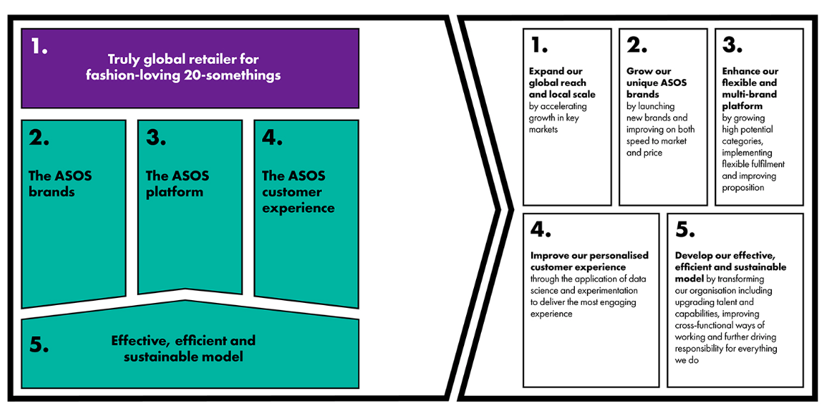
Appendix A - ASOS business model

Appendix B- Interview sheets

Participant 1

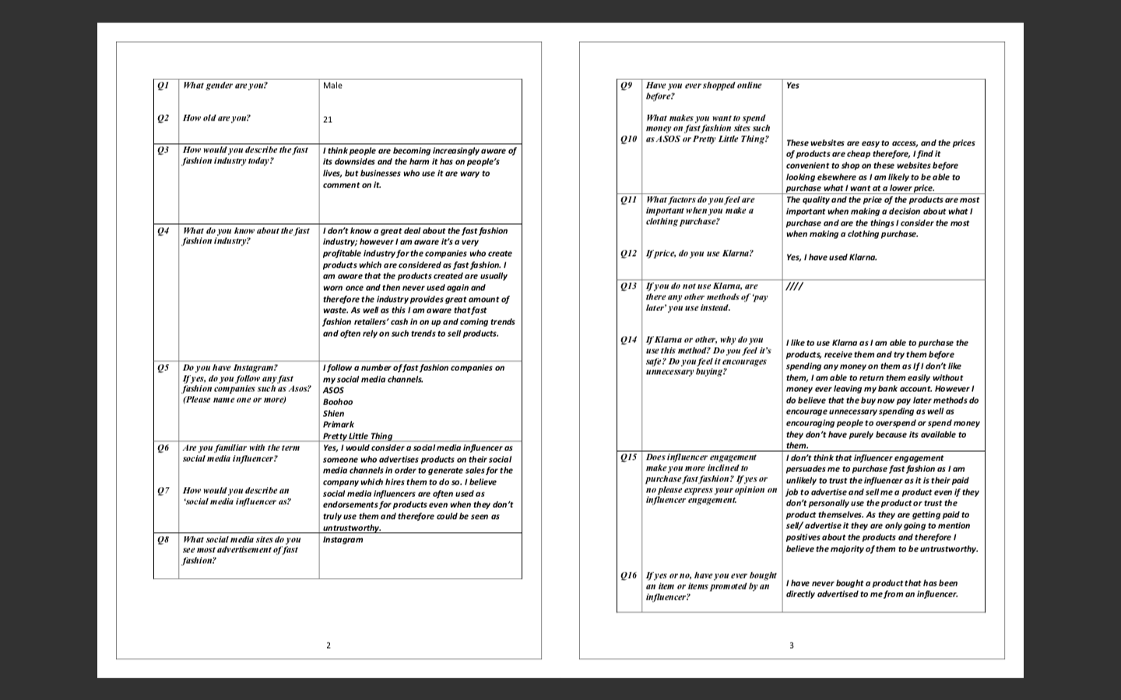
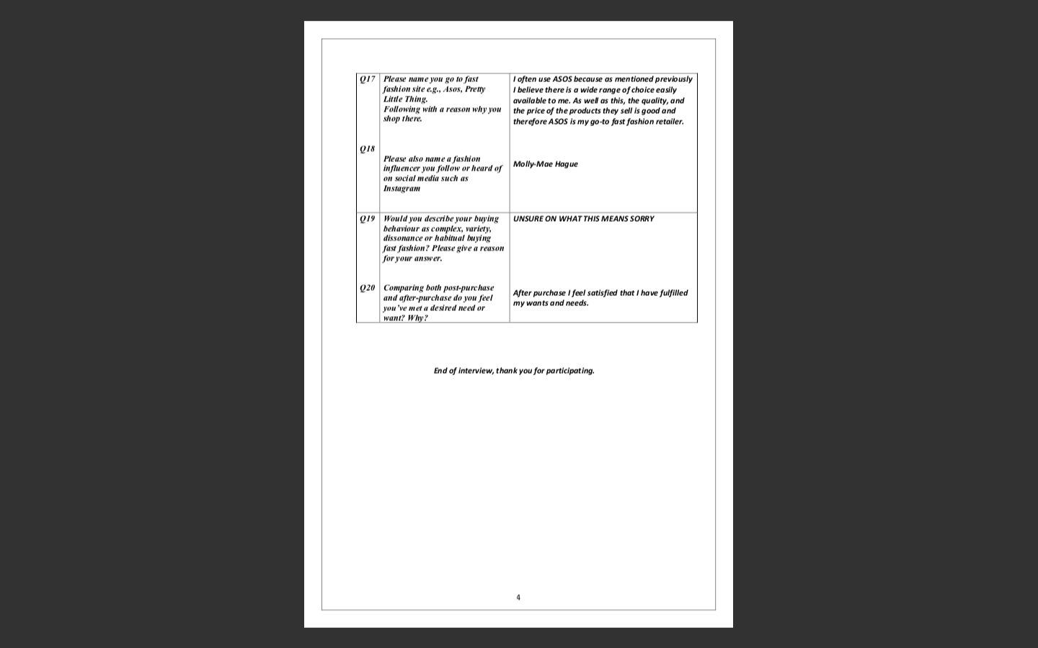

Participant 2 -

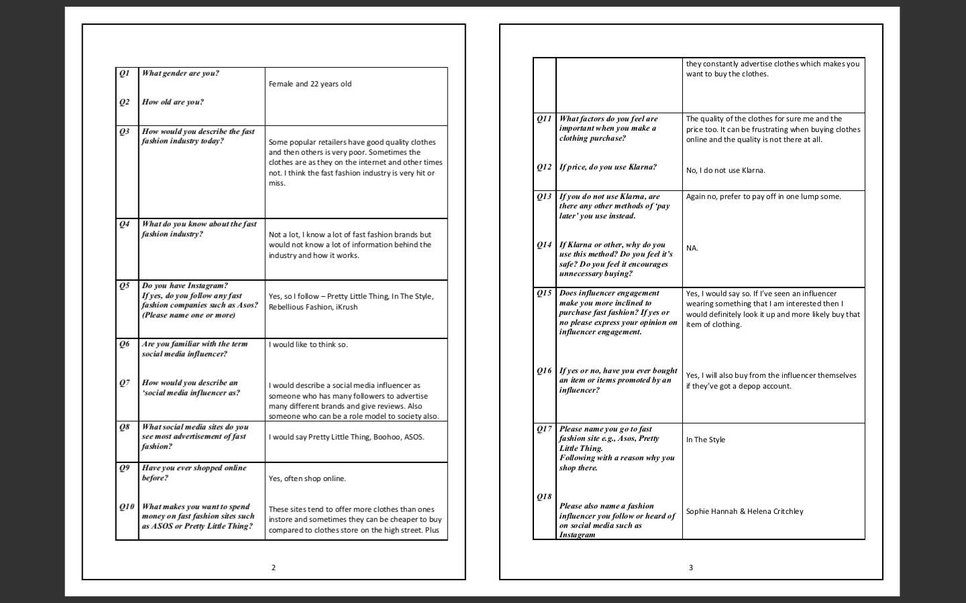
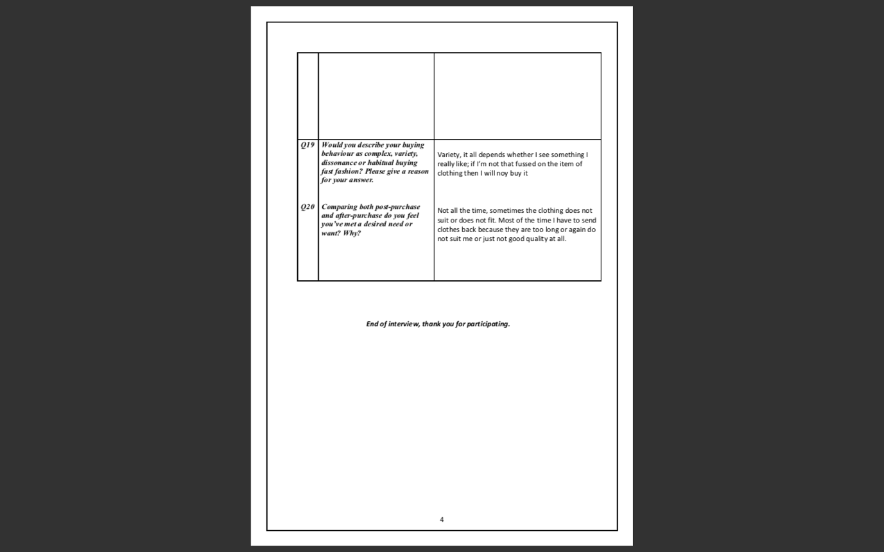

Participant 3 -

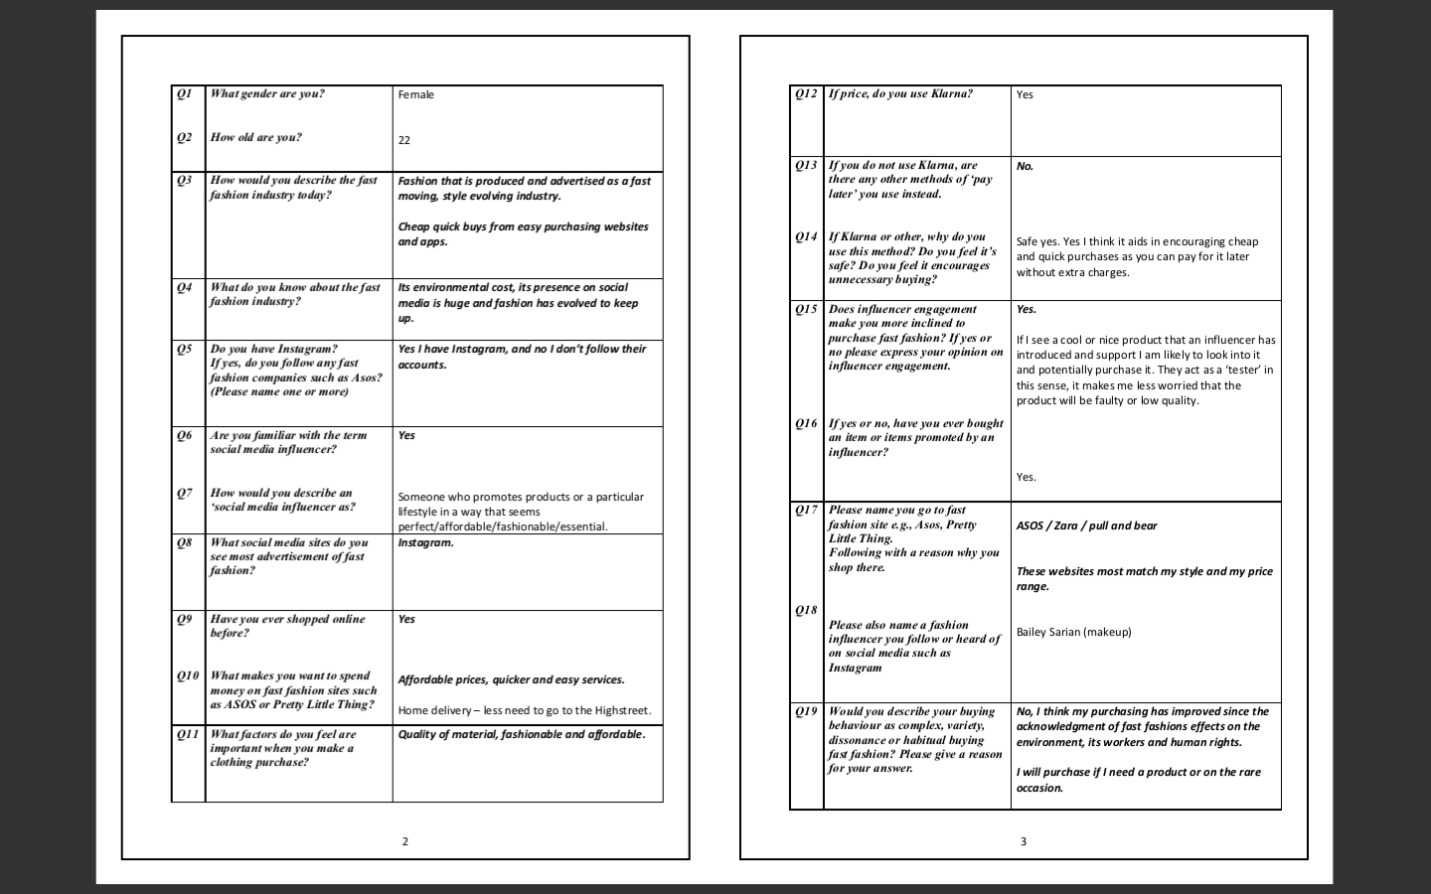
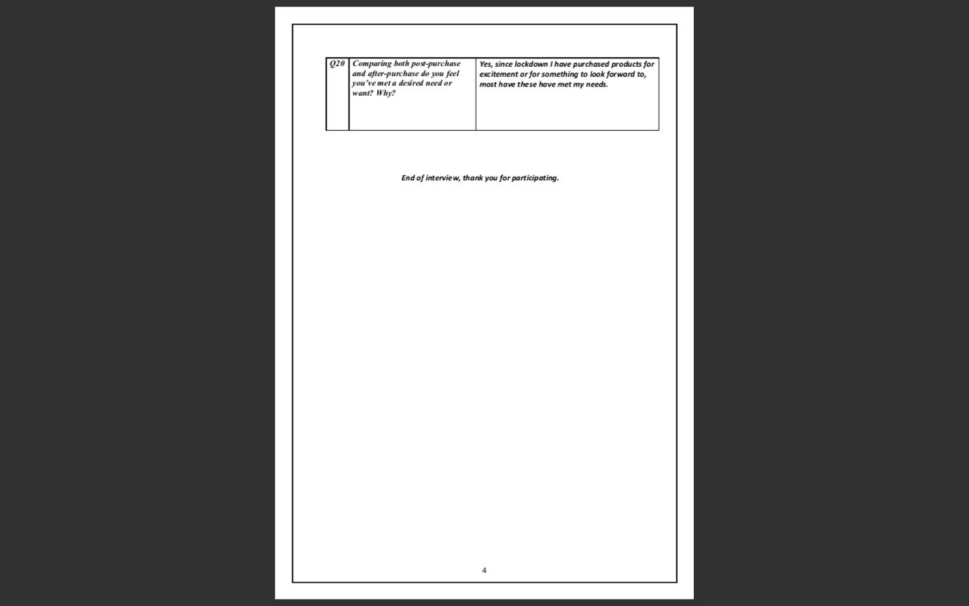

Participant 4 -

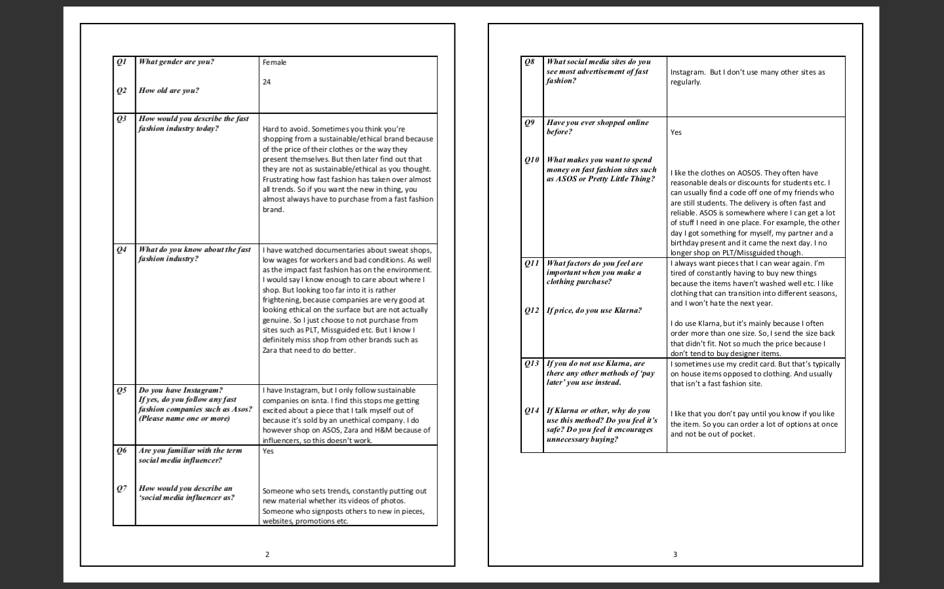
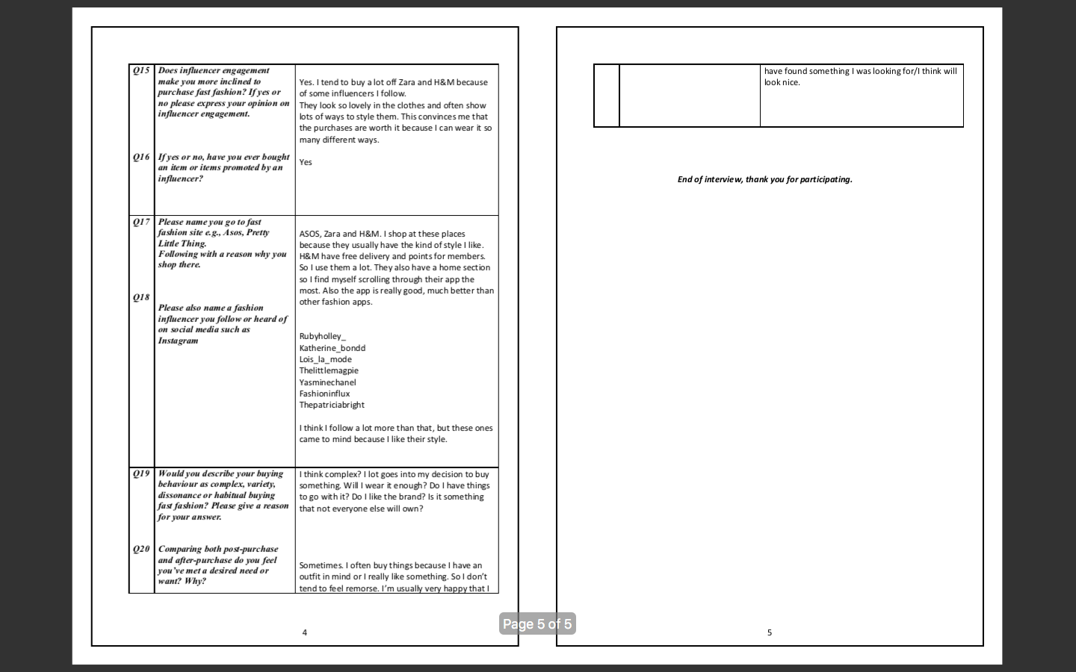

Participant 5 -

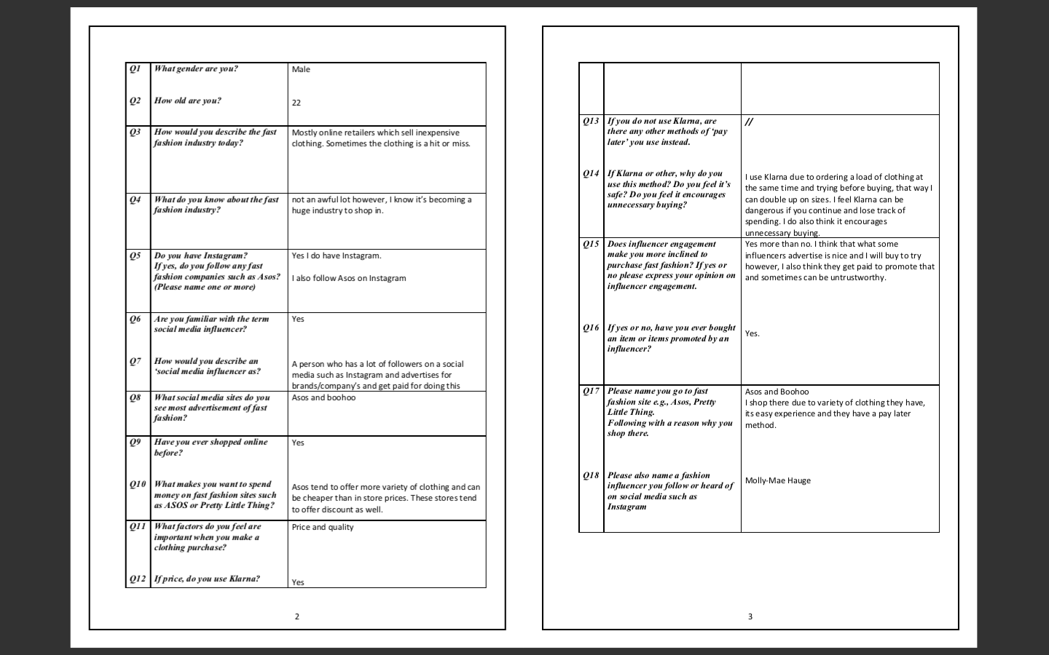
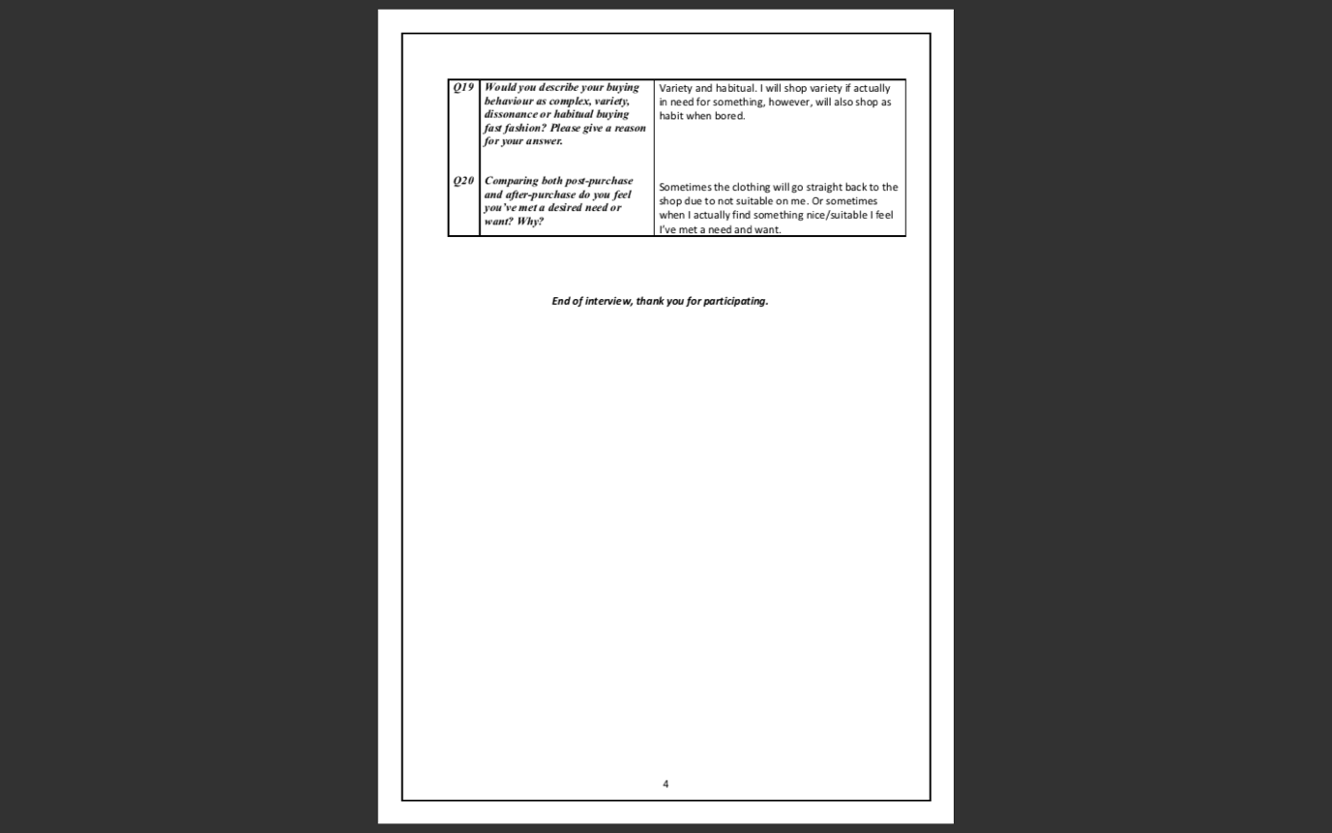

Participant 6 -

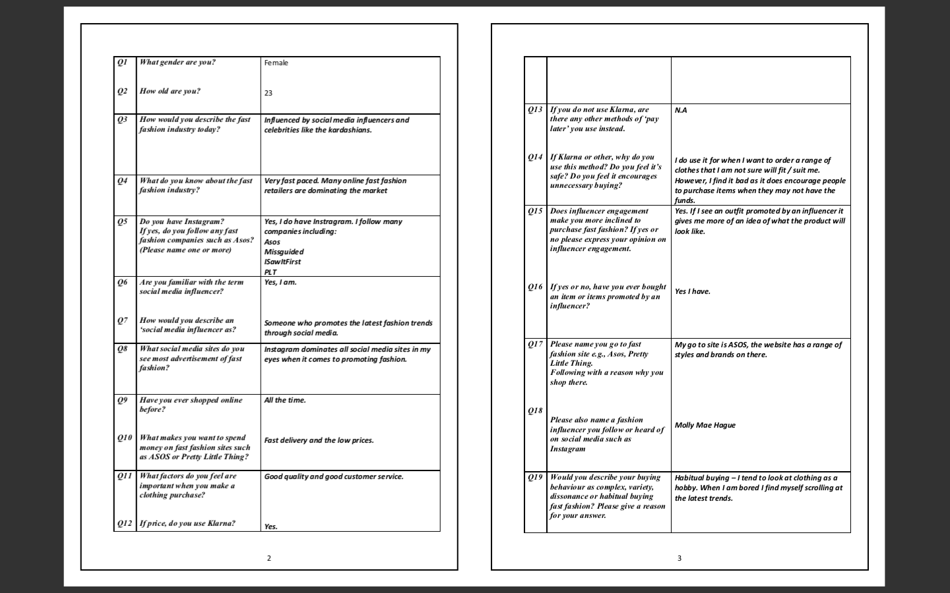
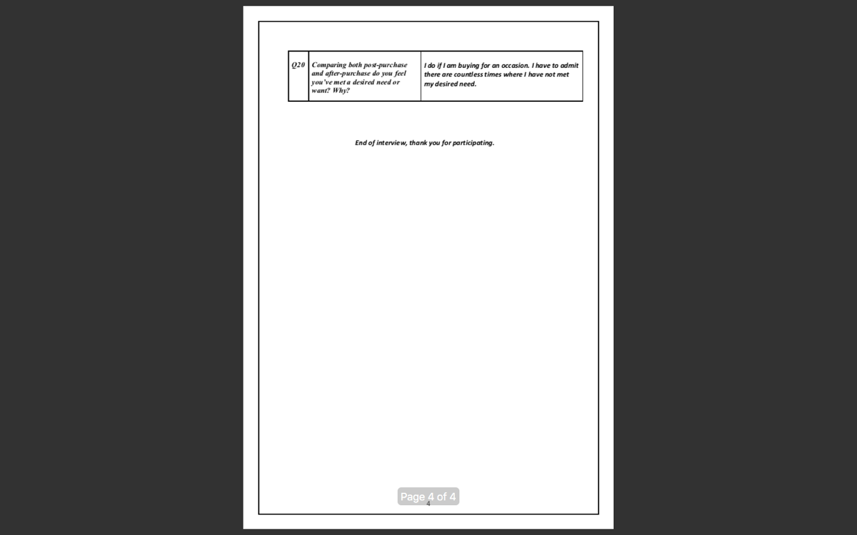

Participant 7 –

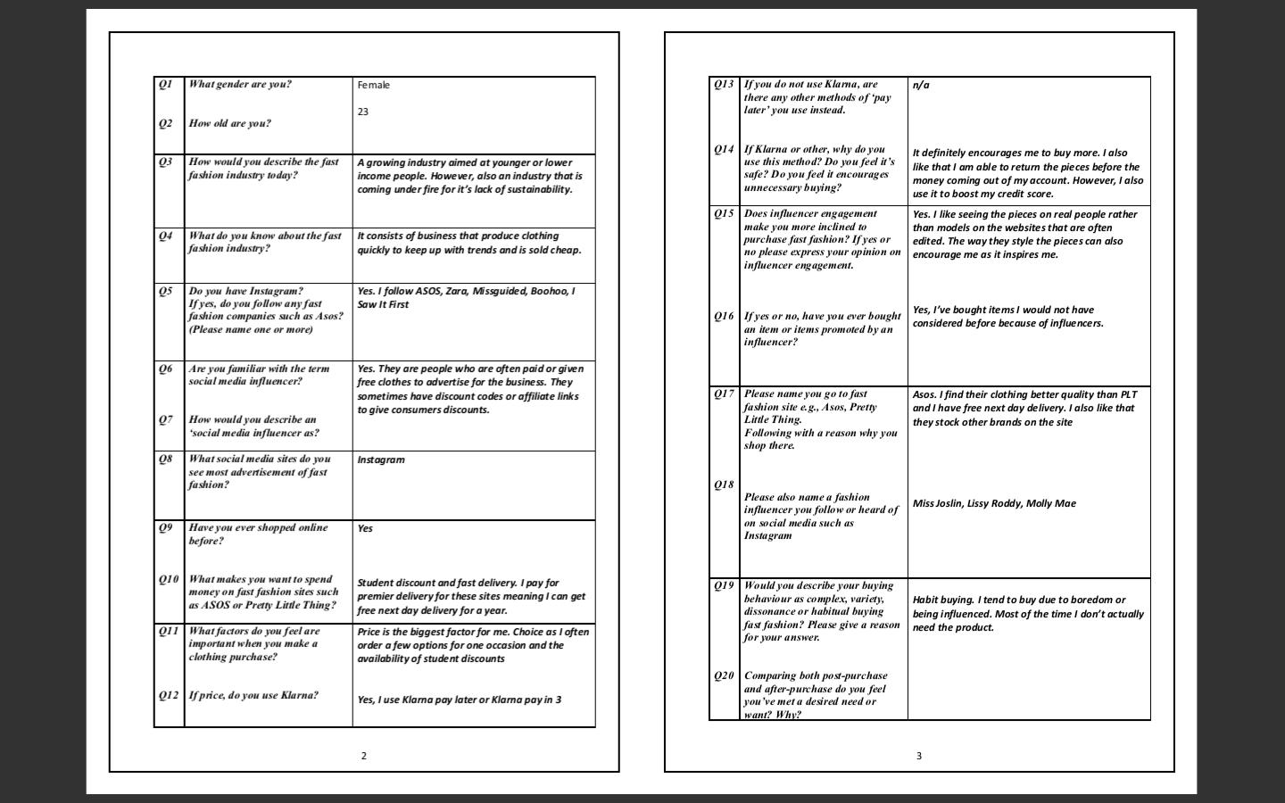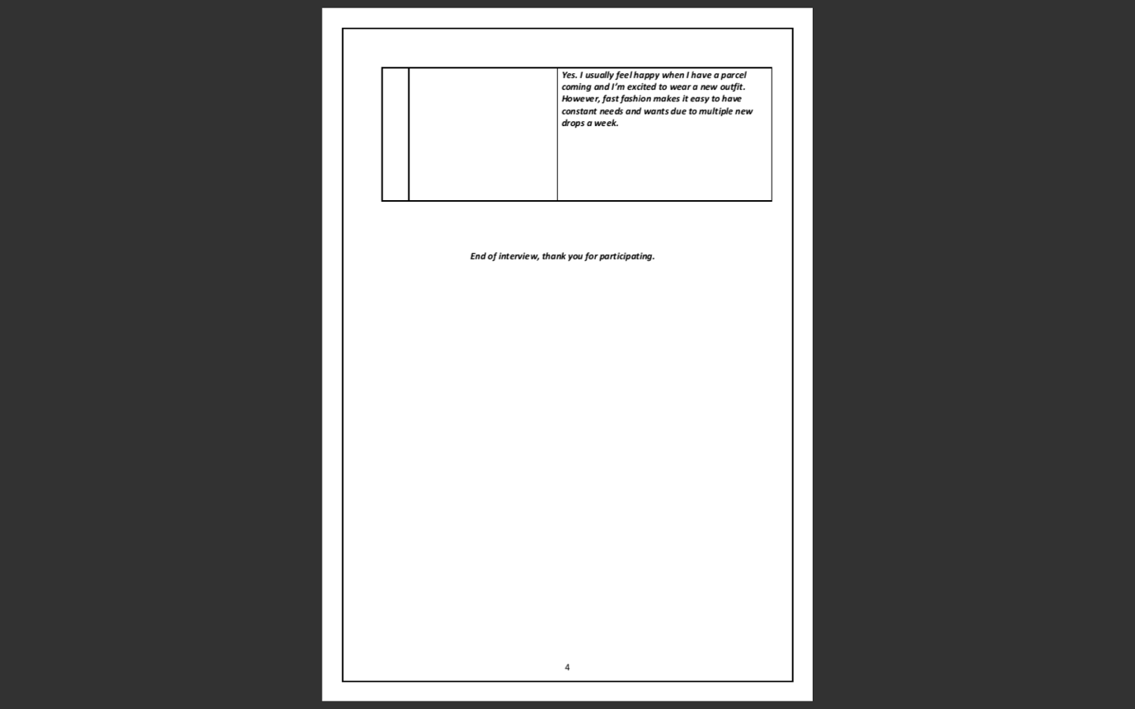

Participant 8 –

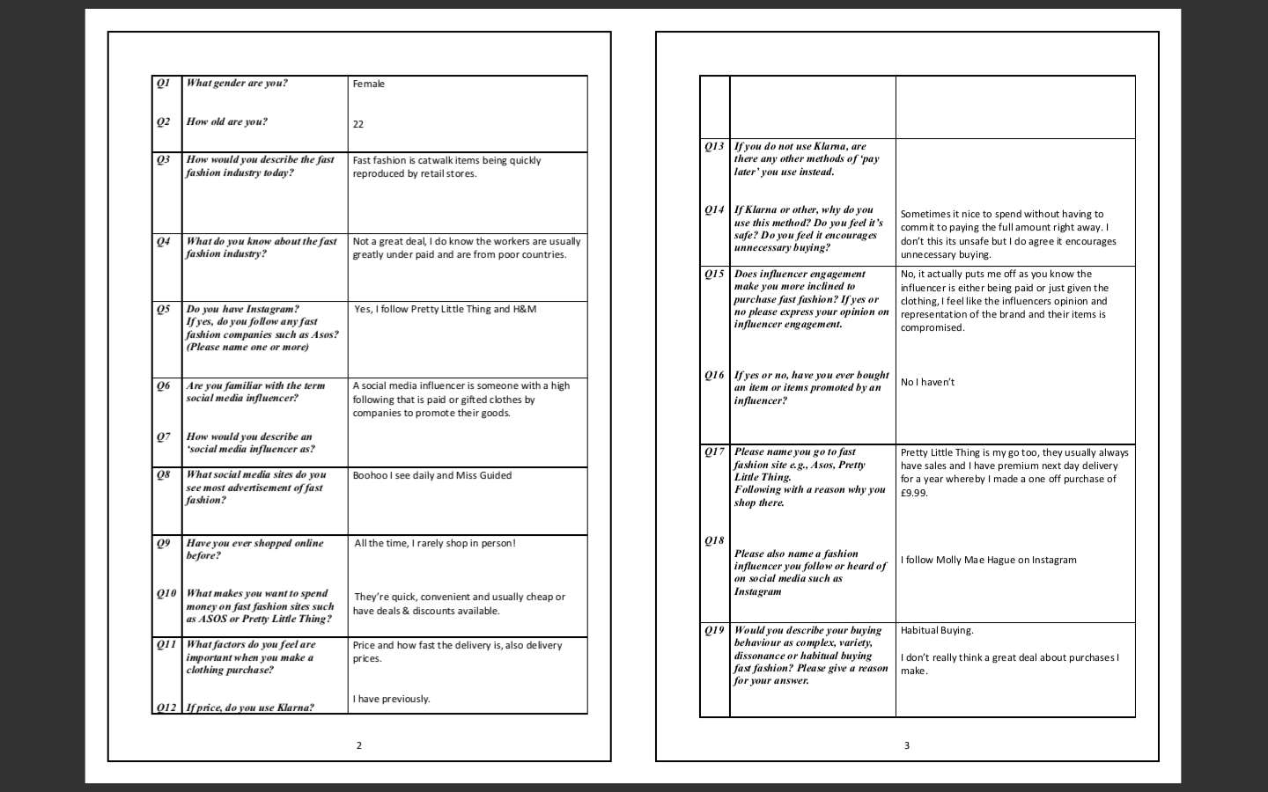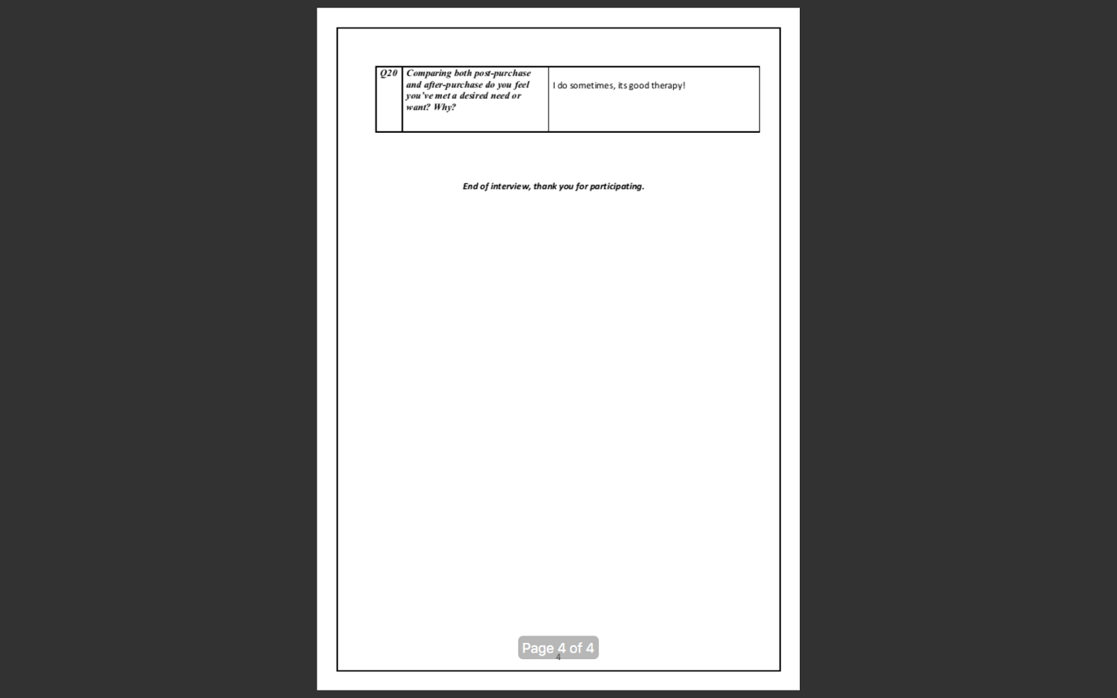

Participant 9 -

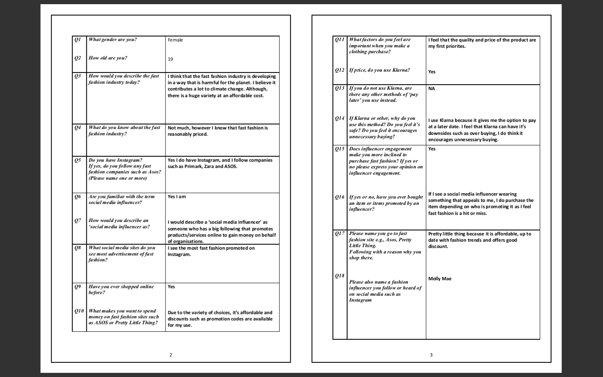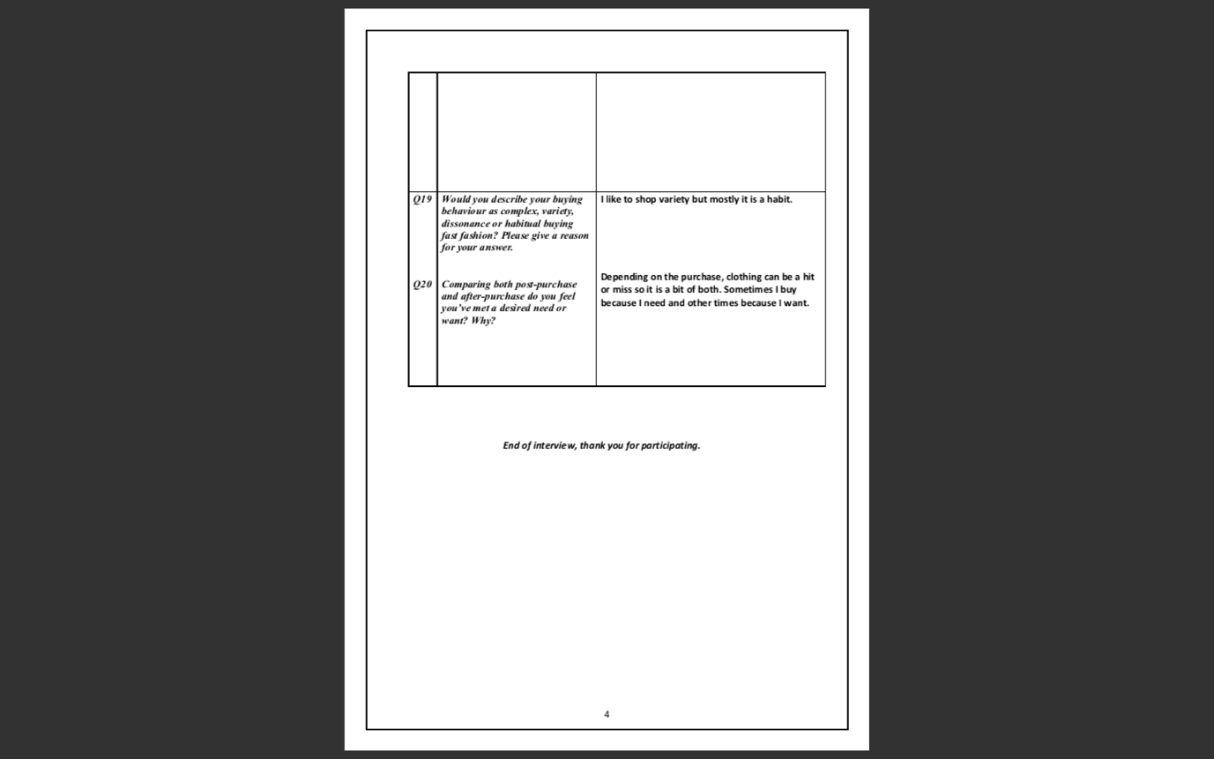

Participant 10 –



