
Student Name: Petar Stanchev
Student ID: 2505752
Lecturer’s Name: Fouziya Farheen
Module Code: LCLM 4006
Module Name: Enterprise & Entrepreneurship
Component 1: Individual Written Business Plan

Executive Summary
- Business Name: Black Sea Studio Ltd
- Ownership: 100% solo-owned and operated by Petar Stanchev.
- Core Product: High-depth, premium Turn-Based Strategy RPGs (TB-RPGs) featuring rich systems, tactical combat, and high replayability.
- Primary Platform: Exclusive digital distribution on Steam (PC).
- Target Audience: Core PC gamers aged 25–45 in North America and Europe with a background in tabletop gaming or classic PC strategy titles.
- Funding Strategy: 100% boot-strapped through personal finances, avoiding debt or publisher equity dilution.

Table of Contents
4……………………………………….……..Business Idea.
5………………………………………………Legal Format.
7………………………………………………PESTEL Analysis.
10…………………………………………….Market Analysis, Model, Strategy.
13…………………………………………….SWOT Analysis.
15…………………………………………….Financial Projection.
16…………………………………………….References List.

Business Idea:
The idea for Black Sea Studio is independent video game development studio based in the United Kingdom. Founded and operated as a LTD enterprise, the studio is 100% self-funded through personal capital. This lean financial structure eliminates external debt, retains total intellectual property ownership, and allows for complete creative control. The studio focuses on creating high-quality, mechanically deep, and immersive digital experiences for PC gamers globally.
- The Genre Focus: Blending deep tactical positioning, complex resource management, and rich narrative character progression.
- Development Philosophy: Priority is placed on systemic design, high replayability, and polished gameplay loops over expansive graphical overhead.
- Revenue Model: Games will be sold via a traditional premium upfront pricing model (Buy-to-Play). The studio will avoid predatory microtransactions, aligning with the consumer preferences of the target demographics.
Strategic Objectives

- Launch Plan: Develop and launch one flagship commercial TB-Strategy RPG title within 24 months of development cycle.
- Financial Goal: Achieve profitability on the first game to entirely fund a second, more ambitious project.
- Competitive Edge: Solo development eliminates high payroll overhead, allowing the studio to spend extra time polishing complex gameplay mechanics that larger studios overlook due to high burn rates.

Legal Format:

The studio will register as a Private Limited Company (Ltd). A corporate structure protects personal assets through limited liability and enables the business to claim specialized UK tax reliefs (Claiming video games tax relief for corporation tax, 2026b).
Key Advantages:
- Limited liability: Avoiding the risk of a sole trader, where your personal and business finances are legally identical. For example, in solo trader’s case if copyrighted assets are used by accident your personal finances, property and savings will be at risk (Government Digital Service, 2025).
- Tax Efficiency and Profit Extraction: While sole trader pays personal income tax on all business profits, a Limited Company pays corporate tax (which ranges between 19% to 25% depending on company profits). You can also draw low base salary and take the rest of your profits as dividends, which carry lower tax rate and National Insurance Liabilities. The lower tax rates leave more retained earnings within the company to fund future expansions, marketing, or external contractors.
- IP Protection and Licensing: A limited company allows you to clearly own, house and transfer IP (Intellectual Property). If there is need of license game engines, sign distribution agreements, or eventually sell the studio, having clean corporate IP history makes legal negotiation and paperwork much easier (Licensing intellectual property, 2026).
- Access to UK Games Industry Incentives: The UK Government offers VGTR (Video Games Tax Relief), allowing qualifying British-made games to claim back up to 20% of core development cost.
- Platform Publishing and Contractual Ease: While Steamworks allows solo proprietors, operating under registered company name provides stronger brand recognition. Should the products gain traction

PESTEL Analysis:
Political & Economic
- Tax Reliefs: As a UK-based developer, the studio can utilize the Video Games Expenditure credit (VGEC). By passing the BFI cultural test, this government scheme allows you to claim back a highly valuable percentage of core development costs (Bfi, 2020).
- Currency Fluctuations: Selling globally on Steam means the revenue comes primarily in USD, while the development costs are in GBP. A strong dollar can significantly boost the income when revenue is repatriated.
- Capital Risk: Because the studio is completely self-funded, cash flow is the greatest vulnerability. Solo development requires extreme budgeting to survive multi-year production cycles without running out of personal capital. Poor budget management or investment in the wrong resources can drain limited funds (Mifsud, 2024).

Social & Technological
- Target Audience Demographics: The target (adults 25–45) represents a highly lucrative demographic with disposable income. This group grew up with tabletop role-playing games and classic turn-based PC titles, meaning they heavily prioritize deep mechanics, strategy, and narrative over flashy graphics or quick-twitch gameplay.
- Accessibility and Unity: Building the game in an accessible engine like Unity or Unreal Engine gives robust, out-of-the-box tools for turn-based combat and complex RPG systems, allowing you to punch well above your weight as a solo developer.
- Community Engagement: The Audience thrives on community-driven platforms. Engaging directly with players during development trough Steam Community forums and Reddit helps build a loyal, vocal player base that can drive organic sales and pre-orders.

Legal & Environmental
- IP Protection: Turn-based strategy games rely entirely on their unique systems and settings. It must be ensured that core mechanics and art assets are strictly your own to avoid intellectual property disputes on digital storefronts.
- Consumer Regulations: The digital landscape in major markets is maturing, such as the EU's Digital Fairness Act (Digital Fairness Act (DFA) | Updates, no date) and related consumer policies. As a sole trader, the studio must carefully navigate digital storefront Steam policies regarding refunds and user support.

Market Analysis
Target Market Profile
- Demographics: Adults aged 25–45, predominantly male but increasingly diverse. They possess high disposable income but limited free time.
- Geographics: Concentrated heavily in North America and Europe where PC strategy and tabletop gaming cultures are mature.
- Psychographics: Players value deep systemic design, strategic agency, theory-crafting, and respectful treatment of their time (e.g., no microtransactions, offline play capability).
Market Trends
- Steam Dominance: Steam reminds the premier storefront for indie games, capturing roughly 74-75% of the global PC digital distribution market (Jaimes, 2025).
- Genre Resurgence: Tuen-based mechanics are experiencing massive commercial renaissance on PC (Higham, 2026). Adult gamers favour turn-based titles because the gameplay can be paused instantly to accommodate work or family life.

Monetization Model
Premium Pricing: Sold at flat premium price point of $19 to $25 USD.
Zero Microtransactions: No pay-to-win elements, aligning perfectly with community expectations for the genre.
Steam Matrix Pricing: Pricing will utilize Valve’s (Steam’s owners) local purchasing power parity (PPP) matrix to optimize sales across different global currencies.

Marketing Strategy
Because a solo studio lacks massive marketing budged, the strategy relies on community building and platform visibility milestones.

Steam Store Optimization:
- Wishlist Aggregation: The Steam Store page will launch 6 to 12 months before the release date. No game launch will occur until the game accumulates a minimum target of 10,000 organic Wish-lists.
- Localization Focus: High-fidelity English text at launch, with localized storefront description targeting key European regions based on early Wishlist.

Grassroots Community Marketing:
- Target PR: Distribute playable alpha builds directly to mid-tier “Let’s Play” YouTube creators and Twitch streamers who specialize specifically in tactical RPGs and strategy games.
- Community Hubs: Establish presence on Reddit and launch dedicated Discord to gather feedback from enthusiasts.
- Steam Next Feast: Participating in at least one Steam Next Feast with highly polished, repayable 30-minute tactical demo is mandatory for organic visibility.

SWOT Analysis:
- Strengths: Zero payroll cost; Total creative freedom; Rapid decision-making; Exceptionally low business overhead; Unconstrained by corporate red tape, you can quickly pivot, take narrative risks, and introduce fresh gameplay mechanics; Close-knit teams can foster highly engaged, loyal player bases through direct communication on platforms like Discord; Smaller, more nimble workforces allow for cheaper production costs compared to massive AAA studios.
- Weaknesses: Limited production capacity; Potential bottlenecking in non-core disciplines (e.g., Music, Art); Virtually no initial funding compared to larger companies limits your capacity for massive scope, high-end polish, or extensive post-launch support; Starting from scratch means you lack the prestige or pre-existing resume to easily attract widespread media attention; Developers frequently handle dual roles (e.g., coding and marketing), which can delay production and lead to creator burnout.
- Opportunities: Leveraging Steam’s build-in organic traffic features; UK’s Video Game Expenditure Credit (VGEC) for tax offsets; Tools like Kickstarter allow you to secure initial funding and validate your game concept before full release; Platforms like Steam give you immediate, global distribution to millions of players, removing traditional retail gatekeepers; Gamers actively seek out smaller, novel indie games over massive, expensive franchise fatigue titles.
- Threats: High market saturation on Steam; Risk of solo developer burnout; With thousands of games released annually, standing out in digital storefronts requires significant marketing efforts; Larger, predatory publishers or "clone" operations may quickly copy your unique mechanics and undercut your price; Reliance on third-party game engines or storefront policy changes (e.g., algorithm updates or monetization shifts) can disrupt your release plans.

Financial Projection:
Development Phase Budged:
Since the studio is self-funding, the largest cost saver is the own equity (unpaid personal labour). The cash layout goes exclusively to operational overhead and production assets.
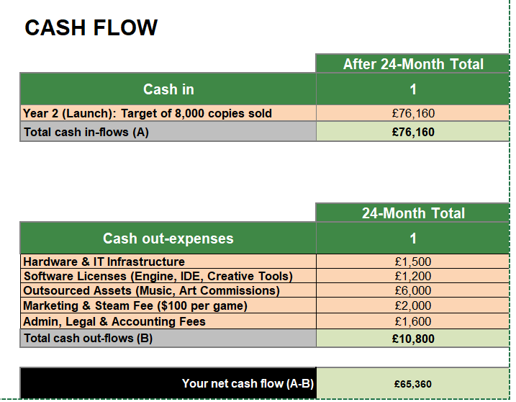

References:
Claiming video games tax relief for corporation tax (2026b). Available at: https://www.gov.uk/guidance/claiming-video-games-tax-relief-for-corporation-tax.

Government Digital Service (2025) Set up a private limited company. Available at: https://www.gov.uk/limited-company-formation.

Licensing intellectual property (2026). Available at: https://www.gov.uk/guidance/licensing-intellectual-property

Mifsud, C. (2024) Calculated Risks for Indie game Studios: Navigating challenges for maximum innovation. Available at: https://pressstartleadership.com/calculated-risks-for-indie-game-studios-navigating-challenges-for-maximum-innovation/

Jaimes, R. (2025) Steam Game Statistics.
Available at: https://www.quantumrun.com/consulting/steam-game-statistics/

Higham, M. (2026) 'Why Turn-Based RPGs are resurging, according to Final Fantasy Resonance Devs,' IGN, 16 June. Available at: https://www.ign.com/articles/why-turn-based-rpgs-are-resurging-according-to-final-fantasy-resonance-devs.

Bfi (2020) About UK creative industry tax reliefs. Available at: https://www.bfi.org.uk/apply-british-certification-expenditure-credits/about-uk-creative-industry-expenditure-credits.

Digital Fairness Act (DFA) | Updates (no date). Available at: https://www.digital-fairness-act.com/.

