Marketing Essentials
Student Name: Vasilica Crenganis
Student ID number: 2221600
Module title: Marketing Essentials BMIH4005
Lecturer’s name: Dale Clark
Word Count: 1402

Table of Contents
Introduction 3
Situation Analysis 4
Company: SWOT analysis 4
Customers: Segmentation and Targeting 4
Competitors: Perceptual positioning map, Bowman’s strategy clock 4
Collaborators: Demonstrate an awareness of your organisations B2B Relationships, Partnerships, Franchises 5
Climate: PESTLE 6
Marketing Mix 6
Objectives 7
Strategy 7
Tactics 8
Action 9
Control 10
Conclusion 10
References 11
Appendix 13
Presentation 13

Introduction
In this report, there will be a discussion of the famous international hotel which is Hotel Holiday Inn. It is known to everybody that this hotel is very famous as the hotel gives one of the best customer services and thus customers from all over the world love to spend their vacation in this hotel. The report will include the marketing plan of the hotel as there should be frequent changes in the marketing plan so that the business strategies will also be changed and the hotel can improve their services in a better way.

Situation Analysis

Company: SWOT analysis
Strength- The good customer service of Holiday Inn can be said as the strength of the company.
Weakness- The other hotels in the market can be weakness of Holiday Inn as they are the competitors (Bagrii, 2022).
Opportunity- With the best services the hotel can be known in the international market also.
Threat- The pandemic like covid -19 can be the threat as the hotel has faced a large amount of loss at that time (Birru, et. al., 2022).

Customers: Segmentation and Targeting
Segmentation- The hotel has segmented the customers present in the geographically and demographically segmented markets.
Targeting- Mainly the tourists and the business travellers are the targeted people of the hotel who will love to stay in their hotel (Jiang, 2023).

Competitors: Perceptual positioning map, Bowman’s strategy clock
Perceptual Positioning Map
- The Resident Liverpool
- Tune Hotel
- South Lawn Hotel
High Price
- The Midland
- The Ritz London
- Six Senses
- Marriott International
Low Price
Low Quality
High Quality
Bowman’s strategy clock
- The Grand Hotel Scarborough
Position 1: Low Price & Low Value Added
To make the services with very low price.
Position 2: Low Price
The price should be low so that it can help in cost reduction (Kim, et. al., 2019)
Position 3: Hybrid
This position helps in the competitive market.
Position 4: Differentiation
Here the company can innovate new product and services.
Position 5: Focused Differentiation
The new product should have high value.
Position 6: Risky High Margins
The new products sometimes have a risk factor in the market (Weston and Nnadi 2021).
Position 7: Monopoly Pricing
The monopoly nature controls the price of the services in the market.
Position 8: Loss of Market Share
If the business strategy did not work then the company may face loss.

Collaborators: Demonstrate an awareness of your organisations B2B Relationships, Partnerships, Franchises
Holiday Inn should collaborate with other organisation also so that they can expand their business easily in the market (Liu and Filimonau 2020).

Climate: PESTLE
Political- Brexit can increase the wages of labours of the hotel.
Economic- The Ukraine-Russia war have increases the tax rate thus the price of the hotel have increased.
Social- The tourist are always in search of the new hotel.
Technological- Holiday Inn uses the most advanced technology in their payments method (Bertozzi, et. al., 2020).
Legal- The Company abide by all the government rules.
Environmental- The Company also take care of the environmental measures.

Marketing Mix
Price- The prices of the hotel rooms are affordable.
Place- The hotel is located in the prime area of London.
Product- The hotel gives extremely good services (Leroi-Werelds, et. al., 2021).
Promotion- Uses websites and social media for the promotion for the product.

Objectives
SMART objectives-
- Accomplish a consumer loyalty rating of 90% or above in view of post-stay reviews inside the following year.
- Increment of client rate by 15% inside the following a half year through customized offers and unwaveringness programs.
- Lessen client protests connected with administration quality by 20% inside the following quarter through staff preparing and process upgrades.
- Further develop online audit evaluations to a normal of 4.5 stars or higher across different stages inside the following a half year.
- Increment the quantity of positive client tributes and suggestions by 25% inside the following year through designated promoting efforts (Koc and Ayyildiz 2021).

Strategy
In the report Ansoff matrix will be used to elaborate about the change in the marketing plan.
Market Penetration- Holiday Inn will try to promote their existing product in the existing market so that they attract more new customers from the market.
Market Development- Holiday Inn will try to make their new branch in the UK so that they can come across new customers and it is also analysed that the UK have a large scale of tourist in their country (Reidhead, 2020).
Product Development- Holiday Inn will add new facilities to their services so that the customer can feel more relaxed while staying in the hotel.
Diversification- Holiday Inn will also try to launch their new products in the new market so that more people can come across their products (Clarissia, 2020).
As per analysis of the strategies, the product development strategy is the most suitable strategy for the marketing plan of Holiday Inn.

Tactics
This tool helps the company to communicate with potential customers so that the organisation can know the need of the customer. After knowing they can implement it in their company so that they can give more satisfaction to their loyal customers (Kurniawan, et. al., 2020). There are various types of communication tools which are used in the market and they are advertisements, social media, product packaging, websites, exhibitions and many more. Good and successful campaigns are also very good options for the communication mix. With the help of the communication mix Holiday Inn can attract more customers.
With the help of the new communication tactics, Holiday Inn can easily know about the issues faced by their customers when they stay in their hotel. If the company did not know their poor sides then it will become difficult for them to change the process and to give better services to their customers. The communication tools will also allow them to share each detail of their new business plan with the customers. With market research, they can also have knowledge about their competitors which will help them to know about the market also. Thus it can be said that with the communication tools Holiday Inn can easily overcome their challenges.
As per analysis, it was found that Holiday Inn uses the most advanced technological method to communicate with their customers. But it is also observed that there are some options which they are still lacking behind (Klymovych, et. al., 2020). They indeed have a good website and a very good social page in the social media but they did not update regularly their innovation over there for which it becomes difficult for them to promote their new inventions to their customers. The company can also launch their new applications which will be easily available free of cost and which will also help them to get connected with the customers more easily. It will be also easier for them to share their new ideas over there so that the customer can know their new plan instantly.

Action
Milestone | Activities | W1 | W3  2 | W4 | W7 | W8 | W11 | W12 | W16 | W17 | W20 | W21 | W23 | W24
M1 | Advertising
M2 | Market Research
M3 | Methodology
M4 | Cold calling
M5 | Competitor Analysis
M6 | Brand Loyalty
M7 | Social media marketing

With the help of these marketing activities, the company Holiday Inn can give an introduction to their new products which they have started to implement in their hotel (Chen and Lin 2019).

Control
It is very true that if the company will change their marketing plan then it is for sure that they will have a huge increase in the percentage of their profits. Such like that the marketing plan of the Holiday Inn has implemented some new KPIs which will help the company to increase its yearly revenue (Desai and Vidyapeeth 2019). The employees have been trained more with new tactics of customer service so that they can help their customers to the fullest. This positive attitude towards the brand will help the company to grow more in the market.

Conclusion
It can be concluded that if Holiday Inn uses this marketing plan in their company then it is for sure that they would be able to face all the challenges which will come their way during the business. The marketing plan will help to attract more new customers and also retain the old customers and due to this the company will also increase their profit percentage. Frequent change in the business plan is very much needed to grow the company in a better way.

References
Bagrii, K.L., 2022. SWOT Analysis as a Basis for Strategies Designed for the Management of Tourism Development in Ukraine. In Tourism and Rural Space. TARS Journal (pp. 21-36). Academia Română, Filiala Iași Institutul de Cercetări Economice și Sociale „Gheorghe Zane”.
Bertozzi, F., Ali, C.M. and Gul, F.A., 2020. RESOURCE BASED VIEW OF AN ORGANIZATION AND PEASTEL ANALYTICAL TOOL; AN ANALYSIS OF HOTEL CORALLO, RIMINI. EPH-International Journal of Science and Engineering, 6(1), pp.30-39.
Birru, A.C., Sudarmiatin, S. and Hermawan, A., 2022. Competitive strategies in the lodging service sector: Five porter analyses and case study SWOT analysis. Journal of Business and Management Review, 3(1), pp.001-017.
Chen, S.C. and Lin, C.P., 2019. Understanding the effect of social media marketing activities: The mediation of social identification, perceived value, and satisfaction. Technological Forecasting and Social Change, 140, pp.22-32.
Clarissia, S.M.S., 2020. A study on Ansoff Matrix Technique: As a growth strategy and an adaptive learning technique adopted in the leading brand of products. BIMS Journal of Management, p.18.
Desai, V. and Vidyapeeth, B., 2019. Digital marketing: A review. International Journal of Trend in Scientific Research and Development, 5(5), pp.196-200.
Jiang, L., 2023. J Hotel Marketing Strategy Study. Frontiers in Business, Economics and Management, 9(1), pp.350-354.
Kim, J.J., Lee, Y. and Han, H., 2019. Exploring competitive hotel selection attributes among guests: An importance-performance analysis. Journal of Travel & Tourism Marketing, 36(9), pp.998-1011.
Klymovych, O., Hrabchak, V.I., Lavrut, O., Lavrut, T., Lytvyn, V. and Vysotska, V., 2020. The Diagnostics Methods for Modern Communication Tools in the Armed Forces of Ukraine Based on Neural Network Approach. In MoMLeT+ DS (pp. 198-208).
Koc, E. and Ayyildiz, A.Y., 2021. Culture’s influence on the design and delivery of the marketing mix elements in tourism and hospitality. Sustainability, 13(21), p.11630.
Kurniawan, D., Iswahyudin, M.D. and Suciati, T.R., 2020. SWOT Analysis and Ansoff Matrix in Creative Food Industry Business Development: A Study on Creative Food Business “Komala”. Open Access Indonesia Journal of Social Sciences, 3(2), pp.128-136.
Leroi-Werelds, S., Verleye, K., Line, N. and Bove, L., 2021. Value proposition dynamics in response to external event triggers. Journal of Business Research, 136, pp.274-283.
Liu, J. and Filimonau, V., 2020. Exploring the business feasibility of childcare provision in hotels. International Journal of Hospitality Management, 88, p.102394.
Reidhead, C., 2020. Impact of organizational culture on employee satisfaction: A case of Hilton hotel, United Kingdom. Journal of Economics and Business, 3(1).
Weston, P. and Nnadi, M., 2021. Evaluation of strategic and financial variables of corporate sustainability and ESG policies on corporate finance performance. Journal of Sustainable Finance & Investment, pp.1-17.

Appendix

Presentation
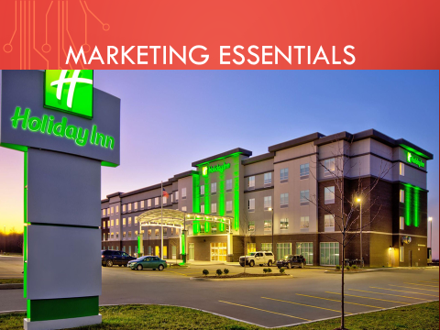
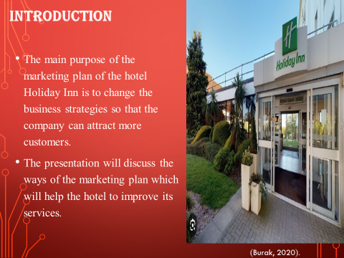
Notes-
The main purpose of the marketing plan of the hotel Holiday Inn is to change the business strategies so that the company can attract more customers and can serve them with different new facilities. The presentation will discuss the ways of the marketing plan which will help the hotel to improve its services.
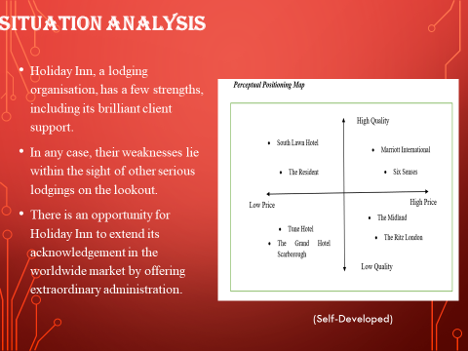
Notes-
Situation Analysis
Holiday Inn, a lodging organisation, has a few strengths, including its brilliant client support. In any case, their weaknesses lie within the sight of other serious lodgings on the lookout. There is an opportunity for Holiday Inn to extend its acknowledgement in the worldwide market by offering extraordinary administration. The threats of occasions like the Coronavirus pandemic represent a gamble, as it brought about huge misfortunes for the organisation. Holiday Inn sectioning their market cautiously because of the inn's greater expense. Contenders can be dissected utilizing a perceptual situating guide and Bowman's strategy clock, which frame different situating choices going from low-cost to centred separation. Collaboration efforts with different associations can assist Holiday Inn extend its business. As far as the environment, political elements like Brexit might affect work compensation, while financial variables like the Ukraine-Russia war can impact charges and costs. Socially, sightseers are continuously looking for new lodging encounters. Mechanically, Holiday Inn uses settlement ahead-of-time strategies, agrees with legitimate guidelines, and goes to ecological lengths. Their marketing mix includes offering reasonable costs, an ideal spot in London, excellent administrations, and using sites and web-based entertainment for advancement (Burak, 2020).

Notes-
Objectives-
The main aim of making the marketing plan of the Holiday Inn is to improve the services of the hotel in every way. This will help to attract new customers, reduce client complaints, and also help to increase the profit percentage of the company by providing them better services and keeping an evaluation of the services to maintain their quality.
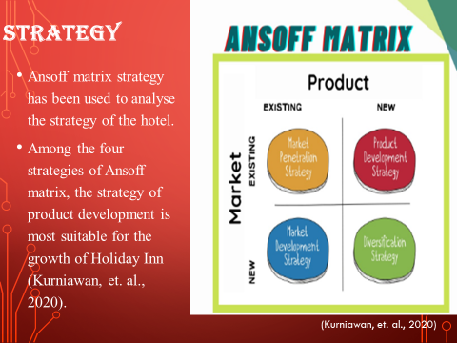
Notes-
Strategy
Ansoff matrix strategy has been used to analyse the strategy of the hotel. There are four types of Ansoff matrix and they are market development, market penetration, product development and diversification. Among these, the strategy of product development is most suitable for the growth of Holiday Inn (Kurniawan, et. al., 2020).
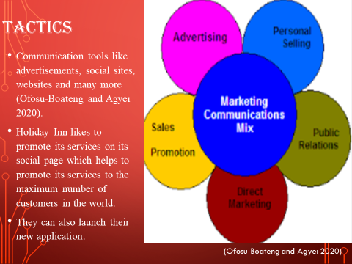
Notes-
Tactics
The communication mix tactics are used by Holiday Inn to communicate with the customers. There are various types of communication tools and they are advertisements, social sites, websites and many more (Ofosu-Boateng and Agyei 2020). Holiday Inn likes to promote its services on its social page which helps to promote its services to the maximum number of customers in the world. They can also launch their new application.
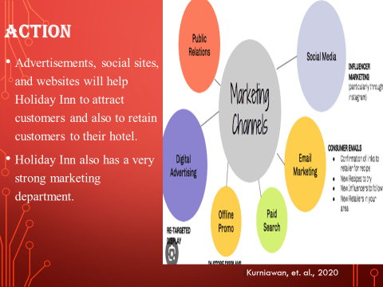
Notes-
Action
Advertisements, social sites, and websites will help Holiday Inn to attract customers and also to retain customers to their hotel. Holiday Inn also has a very strong marketing department.
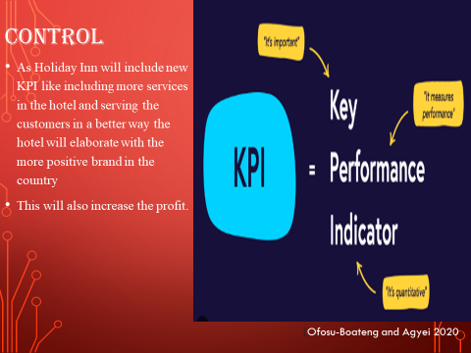
Notes-
Control
As Holiday Inn will include new KPI like including more services in the hotel and serving the customers in a better way the hotel will elaborate with the more positive brand in the country. This will also increase the profit.
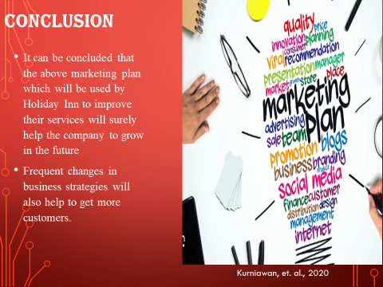
Notes-
It can be concluded that the above marketing plan which will be used by Holiday Inn to improve their services will surely help the company to grow in the future. Frequent changes in business strategies will also help to get more customers. .
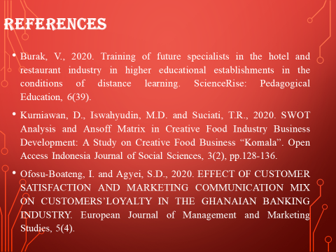
References
Burak, V., 2020. Training of future specialists in the hotel and restaurant industry in higher educational establishments in the conditions of distance learning. ScienceRise: Pedagogical Education, 6(39).
Kurniawan, D., Iswahyudin, M.D. and Suciati, T.R., 2020. SWOT Analysis and Ansoff Matrix in Creative Food Industry Business Development: A Study on Creative Food Business “Komala”. Open Access Indonesia Journal of Social Sciences, 3(2), pp.128-136.
Ofosu-Boateng, I. and Agyei, S.D., 2020. EFFECT OF CUSTOMER SATISFACTION AND MARKETING COMMUNICATION MIX ON CUSTOMERS’LOYALTY IN THE GHANAIAN BANKING INDUSTRY. European Journal of Management and Marketing Studies, 5(4).

