A Practitioners Guide to inclusive practice and support for children who are deaf in a mainstream school setting:

In this guide you will find information and guidance on how to support your students who have a hearing impairment. The guide will discuss and guide you by suggesting various strategies based on best practice, your duty as a practitioner, the guidance and policy from the Welsh Government and Educational bodies that will facilitate an inclusive classroom and environment for your hearing-impaired student.
There are more one billion people loving with a disability and around 300 million of those are deaf (Shade of Noir, ND, Healthy Hearing, 2022). And of these there are 52,798 deaf children. As practitioners in mainstream school, you need to be aware that 77% of deaf children in the Uk attend mainstream school. Article 23 of the United Nations Convention on the Rights of the Child states that every child with a disability deserves to lead the best possible life in society and to be an active member of the community. Every child has a right to an education; Article 28 tells us. The right to an education is also supported by Article 2 of the Human Rights Act, 1998 to ensure uniformity of all Educational Rights. All children should have access to an education to at least a secondary level and encouraged to attend education to the highest level (UNICEF, ND). Under the New Curriculum for Wales, all teachers are now considered an Additional Learning Need teacher, (HWB, ND). Estyn (2023) recommends that staff in education should have adequate training and resources to ensure an inclusive environment for all.

What is Deafness/ hearing impairment?

According to the National Deaf Children’s Society, (ND), deafness occurs when ‘one or more parts of the ear aren’t working effectively’. The World health Organisations defines deaf as ‘a profound hearing impairment with complete loss of the ability to hear from one or both ears, (WHO, ND)
There are three main types of hearing loss: As you can see in the picture below:
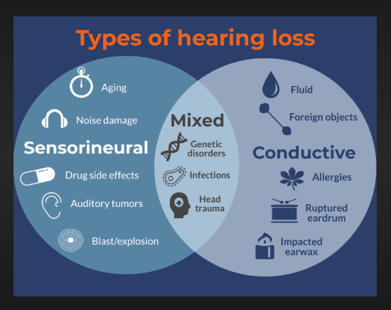
Types of hearing loss, (Healthy Hearing, 2022)

There are three types of hearing loss also hearing loss is described in grades of severity, mild, moderate, moderately severe, severe and profound hearing loss.
They are categorised and linked as following:

Types of Hearing Loss | Symptoms | Grade of Deafness
- Sensorineural – this type of hearing loss is permanent. Meaning it could be a defect from birth or an environmental factor such as noise damage, aging and auditory tumours. Unfortunately, medical professionals are unable to repair this type of hearing loss and all that can be done is to manage the hearing with aids or cochlear implants | - Difficulty in differentiating speech when multiple people are talking  - Unable to hear certain sounds like “s” or “th”  - Some noises may be too loud or too quiet | - This type can vary in severity from mild – finding it difficult to hear clearly in a noisy environment to profoundly deaf and unable to hear at all
- Conducive – this type of hearing loss is temporary, it is caused by external factors such as fluid in the ear (sometimes referred to as glue ear), a ruptured ear drum, allergies and foreign objects. This type affects both middle and outer ear. | - Can cause pain in one or both ears  - A feeling of pressure in one or both ears  - Can cause a horrible smell emulating from the ear | - Like Sensorineural however usually causes up to a moderate deafness which means the deaf person can hear a loud speech directly in their ear but no less
- Mixed – This type of hearing loss is a mixture of both and reasons for this type includes head trauma, genetics and infections | - The symptoms of this type are a combination of the sensorineural and conductive hearing loss | - Like the severities of both types of the above deafness

It is important to ensure inclusivity in your classroom, the Welsh Government (2016), has provided essential principles that practitioners should consider whilst planning and creating and inclusive curriculum and learning environments. Some of these principles include:
- That all children should be protected and that individual needs of children should be met on the classroom floor
- Inclusive education should include all the people involved in the child’s life such as parents, grandparents, school staff, and external workers, whether it is social services or a therapist
- All staff should have adequate training around inclusive practice, particularly in relation to the Additional Learning Need that staff members are working with such as ADHD, ASD, Deafness, blindness

Successful inclusive practice should implement the following:
- School development plans to support any pupils with an additional learning need which may include strategies to develop staff knowledge and training when needed
- Designated staff to ensure consistency for staff and guidance for all pupils and staff alike, this would usually be the Additional Learning Need Co-Ordinator also known as an ALNCo
- Uniformity in each classroom and consistency from each member of staff, from catering staff to head teachers

‘Disability is one of the most serious barriers to education across the globe’
(UNICEF, ND)

Challenges faced by deaf pupils in a mainstream school vary from pupil to pupil, schools and classrooms, however there are a few common challenges faced by deaf students. Some of the common challenges impacting deaf and hearing-impaired learners are problems with literacy skills such as oracy skills and comprehension, a longer processing tie which could lead to the student not being able to keep up with a task, self-esteem, this could impact their attitude towards learning if they feel they are failing. Some of the factors that learners encounter that are responsibility of the professionals. including lack of awareness for those who teach them and are responsible for their education, social attitudes, ignorance and the stigma attached to someone who is different and lack of access to language and/or assistive devices. (Department of Education, 2015).
Hearing Health Foundation (2017) stresses the importance of early intervention for hearing loss. There are around 3 children in every 1000 children in America who are born deaf, similarly, statistics in the UK where 1 to 2 in 1000 are born deaf, (NHS, Wales). The foundation states that screening newborns gives children and their loved ones an opportunity to acknowledge and prepare for a life with deafness. NHS Wales offers newborn hearing screening; they offer a hearing test within the first four weeks of birth which is key to identifying deafness that children are born with. The screening does not prevent or aid hearing loss that develops with age.

Theories of Educational Practices and Inclusion:

Learning and Educational Theories underpin many styles of teaching and learning. One widely used approach is the Montessori Method which emphasises on child-centred learning. ensuring an environment that is structured and prepared to encourage independent learning and exploration. With advantages including the development of executive function, responsible for problem solving and adaptability, which would be beneficial to deaf learners as they will learn how to adapt through experience. However, bearing in mind this approach could encourage too much freedom, which could be conflicting for them as they continue through school. Particularly as the constraints of education further on in the school and secondary schools may not allow the same exposure to the freedoms of a Montessori approach. Hauser, Lukomski and Hillman (2008) state that the development of executive function (EF) is greatly beneficial to deaf people. With the development of EF deaf pupil can learn that facial expression is a way to communicate, thus developing their ability to express their emotions through body language and facial expressions. Leading to an inclusive environment on a deeper level for the deaf. Theory of Mind is regarded as a great importance to deaf pupils. It allows practitioners to use, understand and appreciate that all pupils learn at a different pace and by various ways. Remmel, Bettger and Weinberg (2001) Deaf children are sometimes delayed in their learning, this has been suggested it is due to the pupil’s inability to pick up on incidental learning, overheard from others. However, Hall, Eigsti, Bortfield and Lillo-Martin (2018) discussed the correlation of incidental learning of deaf children and those born hearing. During the small study they discovered that there was a marginal difference in incidental language gains of both deaf and hearing children however, the correlation between incidental language gain and lack of access to language seems significant. The study showed that lack of access to language has a significant effect on those who haven’t been exposed to language from an early age. This would apply potentially to children born to hearing parents.
A primary principle of the Additional Learning Needs Code 2021 ensures inclusivity for all pupils within an educational setting, Core Learning Wales (2024) and HWB (2024) states that parental participation is a key part of the Montessori Theory and a method of inclusivity that is a focus with the New Curriculum in Wales. Practitioners’ awareness of a student’s home life as well as their school life is a beneficial advantage to any deaf pupil and others with an ALN. It will ensure consistency and inclusivity for the pupil. Research from Deakin University (2012) tells us that while a practitioner’s role in transition from school to school is crucial, additionally involving a wider scope of people in that pupil’s life will enhance their transition.

Case Study:

Pupil A is an 11-year-old boy who attends a Welsh medium Comprehensive. Pupil A has been partially deaf in one ear for his whole life. He started comprehensive using a Phonak Roger Touchscreen hearing aid. The earpiece is connected via Bluetooth to a device worn on a lanyard around the neck of the primary speaker such as a teacher. The device is connected to the earpiece and filters out all background noise. Humphries, Mander and Jones (2024) found that this specific device was the most used in their research in North East England. Pupil A has a Classroom support guidance, which helps the pupil feel more included and have better experience and access to the curriculum:
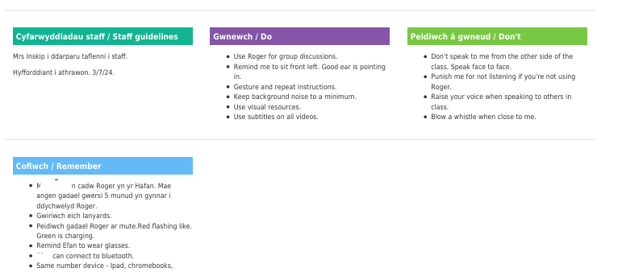
However, use of assistive technologies such as hearing aids not always sufficient. Several factors can affect the concentration and education of a pupil with hearing impairement. Some of these factors have been identified as follows:
- Classroom noise
- Experience of teacher/ staff involved
- Training of staff
- Perception of deaf pupils – limiting their education due to teacher incorrect perception of their disability as opposed to seeing their ability (Masoud, 2025)
- Social, Emotional and |M|ental Health of pupils

Education Scotland (2024), found that the high ratio of hearing to hearing-impaired students was low and caused anxiety for these students. The lack of awareness from pupils and lack of training and inclusivity from staff members. It also found that communication between staff and hearing impaired pupils was inadequate as staff were only trained in basic British Sign Language or not all, this led to some pupils feeling isolated. During the research conducted, pupils specified that they had no access to other languages, other than English, taught at their respective school. Which means they did not have access to the whole curriculum. Prior (2023), discovered a pupil in her research did not chose a language at GCSE for this reason. The pupil coud not grasp the language and had difficulty speaking the language and although the pupil chose other subjects, they considered chosing the subject. The pupil speaks highly of the student support within the school in the support of her decision not to take the subject.
Moffatt-Feldman (2013), Nimante and Eksa (2020) have all concluded that sitting a pupil near the front of the class is beneficial to hearing the teacher better and to help the pupil lip read the instruction. Using hearing aids during the school day helped the pupil feel more included in the class. The research carried out by Nimante and Eksa was in Latvia, however the methods of inclusivity and giving full access to the curriculum is similar to that of the United Kingdom and Wales (Welsh Government, ND). Maslow’s Hierarchy of Needs is critisised by Moffat-Feldman (2013) as he highlights the Hierarchy does not take cultural discrepencies into consideration when discussing inclusivity in education. He concludes that language barries have an effect on inclusivity. A language barrier would include their native spoken language and their native signing language. Saudi Arabian Education has an approach called Total Communication Philosophy which is a mixture of both spoken and signed Arabic, to allow total inclusion (Alanazi, 2021). The benefits of using this method is that includes both hearing impaired and completely deaf pupils.
Mpofu and Chimhenga ( 2013), found that pupils found it tiring to hear and isolate the teacher whilst speak and reported that a teacher shoud face the class and pupil whilst talking.

Good practice:
Polvanov, (2023) states that visual aids are an effective method of teaching for hearing impaired pupils, assistive technology such as hearing aids, subtitles on videos, sign language if the pupil uses sign. A pupil is likely to thrive and improve communication if they can work in small groups with other pupils and staff. Ensure that you enunciate and not mumble to ensure that the pupil can lip read. Ensure that staff repeat or rephrase information they convey to the class, ensuring that the pupil can understand and have access to all the information. McPheson, (2024) expressed that visual aids must be purposeful and used appropriately. Students who are hearing impaired rely on their sight to negotiate situations they encounter. They use their eyes to read lips, facial expression, situations and their work, to add to this load can be tiring and cause an avoidable strain for them. A purposeful visual is to use subtitles whilst showing a video to the class. Hand gestures are another form of visual communication; a wave for hello, describing height and width when teaching science. The Curriculum for Wales now allows for British Sign Language to be integrated into the curriculum (Education Wales, 2022). The UK Government are consulting on a new type of GCSE in Comprehensive schools which will allow pupils to gain a GCSE in BSL, (UK Government, 2023). Incorporating BSL into the curriculum it will allow hearing impaired and deaf students to feel more included and allow them and their peers better access to communicating with each and engaging in the curriculum. Swansea Council have provided funded videos and training materials for their staff which includes schools. The teaching will differ from school to school as the schools may provide external BSL interpreters to teach staff and pupils or they may train their staff to provide this resource, (Swansea Deaf Education Team, ND). Learning BSL is a cross-curricular skill, according to the Education Wales (2021), it crosses, Literacy, Numeracy and Digital Competence. As BSL is a language it allows pupils to learn another language, numeracy advantage is learning how to count in BSL and through digital competence, pupils can access more BSL online and develop their skills further than available in the curriculum. Scientifically visual aids are beneficial for pupils and their cognitive load Visual aids can assist with recall of previously learned concepts and work (Tabatabaee, Jambarsang and Keshmiri, 2024). The Natinal Deaf Children’s Society (2018) specified that the use of Whiteboards and Interactive screens can be viewed as an asset to hearing impaired pupils and staff due to being able to write information on the board. Additionally it allows staff to emphasise importance of information by replaying videos or highlighting key words. The pupils can be provided with a copy toperuse at their own pace and convenience following the lesson.
As previously mentioned, a classroom with a low noise volume is commonly considered beneficial to hearing impaired pupils. Classroom control ensures a classroom that is low volume and allow the teacher to control the narrative, allowing the teacher to have a one to one discussion as opposed to pupils shouting out and no order. Hearing impairment pupils may have difficulty in speaking themselves and trying to shout or control their voice over a loud class can be physically and mentally tiring for them. Mpofu and Chimhenga (2013) reported that some pupils lost interest in some subjects as their teacher did not facilitate an inclusive environment for them. Teachers should provide as much physically information for pupils as possible regarding their subject, being mindful not to overload the pupil. By rewording sentences and information that is not understood by the pupil would be benficial to the pupil. Thus allowing futher access to the curriculum. Welsh Government (2019) found that interventions such as the use of visual aids, seating plan, reduction of unnecessary visual and audio distractions were successful.

Support for children and young people with hearing impairment in educational settings
ARC_JIAR_Article_1730607755674_Oct_2024-libre.pdf (UDL)
International Journal of Education Humanities and Social Science

SEM Inclusive education for deaf students: Pass or fail
The association between childhood hearing loss and self-reported peer victimisation, depressive symptoms, and self-harm: longitudinal analyses of a prospective, nationally representative cohort study | BMC Public Health

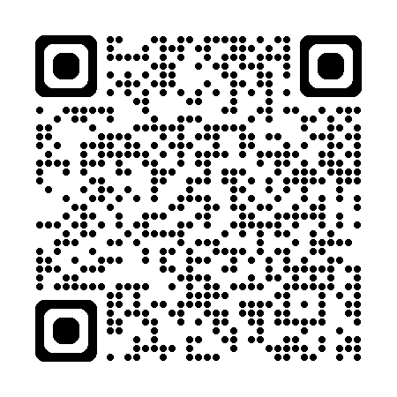  https://www.unicef.org/education | - ^{UNICEF – Education}
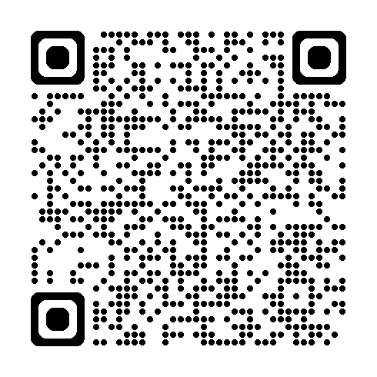  https://www.childcomwales.org.uk/resources/the-right-way-a-childrens-rights-approach/ | - Children’s Commissioner for Wales - A Children’s Rights Approach

References:
- Alanazi, M. (2021) Communicating with Deaf Students in Inclusive Schools: Insights from Saudi University Faculty* available at EJ1321894.pdf (accessed on 09/05/2025)
- British Deaf Education Team (ND) Swansea Deaf Education Team - BSL Curriculum
- Education Scotland (2024), Case Study with Deaf Young People in Scotland, available at report-for-yag-case-study-june-2024.pdf (accessed on 22/04/2025)
- Education Wales (2021), Curriculum for Wales British Sign Languare (BSL) Guidance available at 210126-curriculum-for-wales-british-sign-language-v1.pdf accessed on 09/05/2025)
- Education Wales (2019), Support for children and young people with hearing impairment in educational settings available at Support for children and young people with hearing impairment in educational settings accessed on 02/05/2025)
- Education Wales (2022) A sign of things to come – British Sign Language and the Curriculum for Wales available at A sign of things to come – British Sign Language and the Curriculum for Wales | Education Wales (accessed on 23/04/2025)
- Humphries, C., Mander, J., Jones, L. (2024), An overview of assistive hearing technology used by services for deaf children. What is being used and what influences purchasing decisions? Available at An overview of assistive hearing tchnology used by services for deaf children. What is being used and what influences purchasing decisions? (accessed on 09/2025)
- Jullu, G. T., Amos, O. (2024) TEACHERS’ PERCEPTION OF INCLUSIVE EDUCATION FOR STUDENTS WITH HEARING IMPAIRMENT IN PUBLIC SECONDARY SCHOOLS IN MOROGORO MUNICIPAL, TANZANIA available at International Journal of Education Humanities and Social Science accessed on 09/05/2025)
- Masoud, S. (2025), Investigating Teachers’ attitudes towards Using Assistive Technology in Teaching Students with Hearing Impairments available at Investigating Teachers’ Attitudes toward Using Assistive Technology in Teaching Students with Hearing Impairments (accessed 02/05/2025)
- McPherson (2024), TEACHER OBSERVATIONS ON THE SUCCESS OF HARD-OF-HEARING STUDENTS IN THE MIDDLE SCHOOL MATHEMATICS CLASSROOM: A CASE STUD, available at Proposal, (accessed on 02/2025)
- Mpofu, J. and Chimhenga, S. ( 2013), Challenges faced by Hearing Impaired pupils in learning: A case study of King George VI Memorial School available at Challenges faced by Hearing Impaired pupils in learning: A case study of King George VI Memorial School (accessed on 09/05/2025)
- Moffat-Feldman, M. (2013) The Inclusion Of Deaf Pupils Who Use Sign Language In Mainstream available at Deaf Children in Mainstream Classrooms (accessed 09/05/2025)
- NCDS (2018) Mainstream tech in the Classroom, available at Mainstream tech in the classroom | Technology articles (accessed on 02/05/2025|)
- Nimante, D., Eksa, L. (2020) Inclusion Of A Child With A Hearing Impairment In A Mainstream School, Single Case Study available at Inclusion_of_a_Child_With_a_Hearing_Impa.pdf (accessed on 23/04/2025)
- Rapp, A.C., Corral – Granados, A. (2024). Understanding inclusive education– a theoretical contribution from system theory and the constructionist perspective available atUnderstanding inclusive education a theoretical contribution from system theory and the constructionist perspective.pdf |(accessed 23/04/2025)
- Tabatabaee, S.S., Jambarsang, S. and Keshmiri, F. (2024) Cognitive load theory in workplace-based learning from the viewpoint of nursing students: application of a path analysis, available at Cognitive load theory in workplace-based learning from the viewpoint of nursing students: application of a path analysis | BMC Medical Education | Full Text (accessed on 02/05/2025)
- UK Government (2023) British Sign Language GCSE moves one step closer to the classroom
- Available at British Sign Language GCSE moves one step closer to the classroom - GOV.UK (accessed on 02/05/09)
- Vukovic, B.Z., Ristic, I.D., Calasan, S. V., (2024), Inclusion in Education and Hearing Impairment Naslovna strana za rukopis Inkluzija u obrazovanju i oštećenje sluha (accessed on 02/05/2025)

I confirm that I have used AI namely Co-pilot to assist with research and finding documents related to my Essay.

