Essential Skills for Study and Employment
In the current competitive academic landscape students are required to posses a mix of soft skills to succeed. The main skills include communication, teamwork, problem solving and much more [1]. Strong and effective communication is very important in a team. It allows for ideas to be clearly understood. This also builds trust and helps teams’ function well. Strong teamwork skills are a must for group projects in an academic and workplace setting [3].
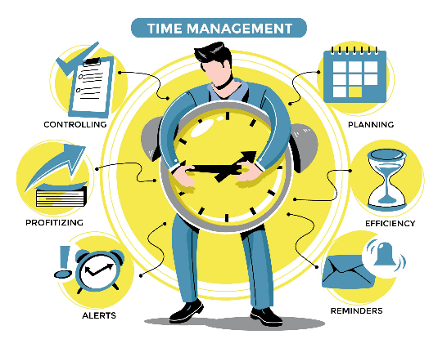
Problem solving and critical thinking help people effectively assess situations. Things like implementing good solutions are very important in stressful situations. Having good skills on how to use software tools, online platforms, online security and adaptability show potential employers your strong digital literacy skills. Staying aware of digital safety, is increasingly important as technology becomes central to most careers [2][4]. Great time management increases work and reduces stress levels. Having things planned and prioritised correctly is a result of effective time management.
For a future career in IT, more specifically cyber security the skill above would be very valuable. Communication could help me in clearly explaining security risks and other issues that may not be obvious to others without the knowledge in cyber security. Teamwork would be needed as cyber security work needs to be often done in a team with many other people to solve problems and secure systems. Identifying weaknesses and analysing threats would require problem solving. Due to the ever-changing digital world, digital literacy would allow for a smooth transition between software’s, devices, threats etc. Time management would allow me to effectively plan out activities based on their severity and difficulty. If done correctly, it would allow for me to respond to any urgent situations and other distractions allowing me to still get all work done on time and up to the highest possible standard. These skills would help me become more confident with my work and therefore I would be able to challenge myself with more difficult tasks.
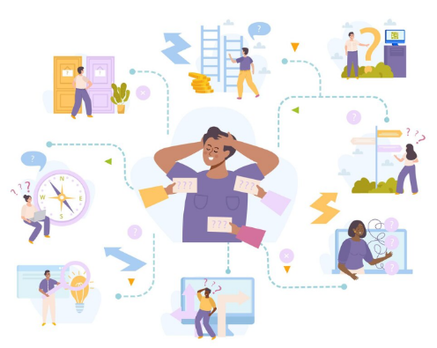
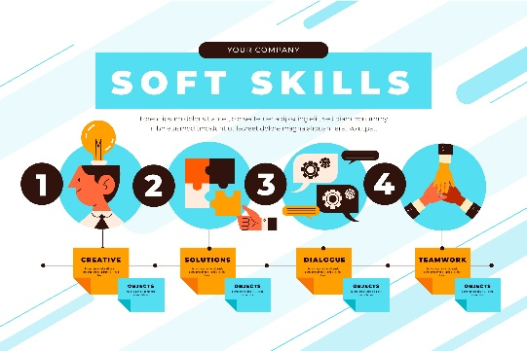
References:
[1] J. Seely, Oxford Guide to Effective Writing and Speaking, Oxford, UK: Oxford University Press, 2013.
Type: Book
[2] A. Redecker, “European Framework for the Digital Competence of Educators (DigCompEdu),” Publications Office of the European Union, vol. 1, no. 1, pp. 1–67, 2017.
Type: Academic Article / Report
[3] N. B. Govaerts and S. Baert, “Employability Skills and Labour Market Outcomes,” International Labour Organization, 2022. Available: https://www.ilo.org
Type: Website / Online Report
[4] UNESCO, “ICT Competency Framework for Teachers,” UNESCO, 2018. Available: https://unesdoc.unesco.org
Type: Website / Online Report
Images - License:Free
www.freepik.com

