Integrated group Project
ACBA: 6003
Student: 1910146

Table of contents
- Construction site plans ………………………………………………………………………………….. 3
  - Constraints ……………………………………………………………………………………………... 4
  - Hospitals …………………………………………………………………………………………………. 4
  - Delivery routes …………………………………………………………………………….………….. 5
  - Site layout plans …………………………………………………………………………………… 5-8

References …………………………………………………………………………………………………………… 9

1 Construction Site Plans

Site layout planning is a vital action that leads to project success (Muhammad et al, 2019). In order to ensure safety, effectiveness and the efficiency of all tasks it is vital to have a well-planned and good site layout (Sanad et al, 2008). The author goes on to suggest that the planning of the site layout has a substantial impact on costs, productivity and time the project takes to complete. Sadeghpour, (2015) echoes this by believing the efficient use of space on a site can have an important bearing on the safety, productivity as well as site security which can impact on the cost and duration of the project. It is critical that facilities are placed in the correct locations and in order to increase the level of safety on a construction site (Ning et al, 2018).
Considerations to factor in when designing a site layout plan as suggested by RazaviAlavi et al (2021), are:
- Construction resources ( Material, equipment, Workers)
- Site Constraints
- Logistics, deliveries (Off loading and storage)
- Facilities, (Site offices, welfare)
- Hoarding and security
- Entrance and exits
As well as these considerations there are also other key components that will need to be addressed, such as:
- Temporary utilities
- Vehicle washing facilities
- Pedestrian access
- Locations of cranes
- Site security
For some construction sites, the size of the site and constraints can play a significant role and impact the project (Farmakis, 2018), such as location of storage facilities especially if the site is congested (RazaviAlavi et al 2021). Therefore if storage facilities are not able to be on the projects site it would be necessary to have them as close as possible to reduce the loss of productivity due to interruptions. Also if a separate location is required for facilities this could incur extra costs which will need to be factored in to the budget of the project. Planning the site layout in line with logistics and even allocating resources all need to be considered for an efficient project (Skjelbred et al, 2015).
To put it simply a construction site layout plan is prepared as part of mobilisation activities before work begins. It identifies the sizing and positioning of temporary and permanent facilities within the sites boundary.

1.2 Constraints
The first task considered as part of the site layout plan was to identify the constraints and any challenges that may be encountered during the project, these are not solely associated with the actual site but the surrounding areas and buildings that may affect transport such as deliveries.
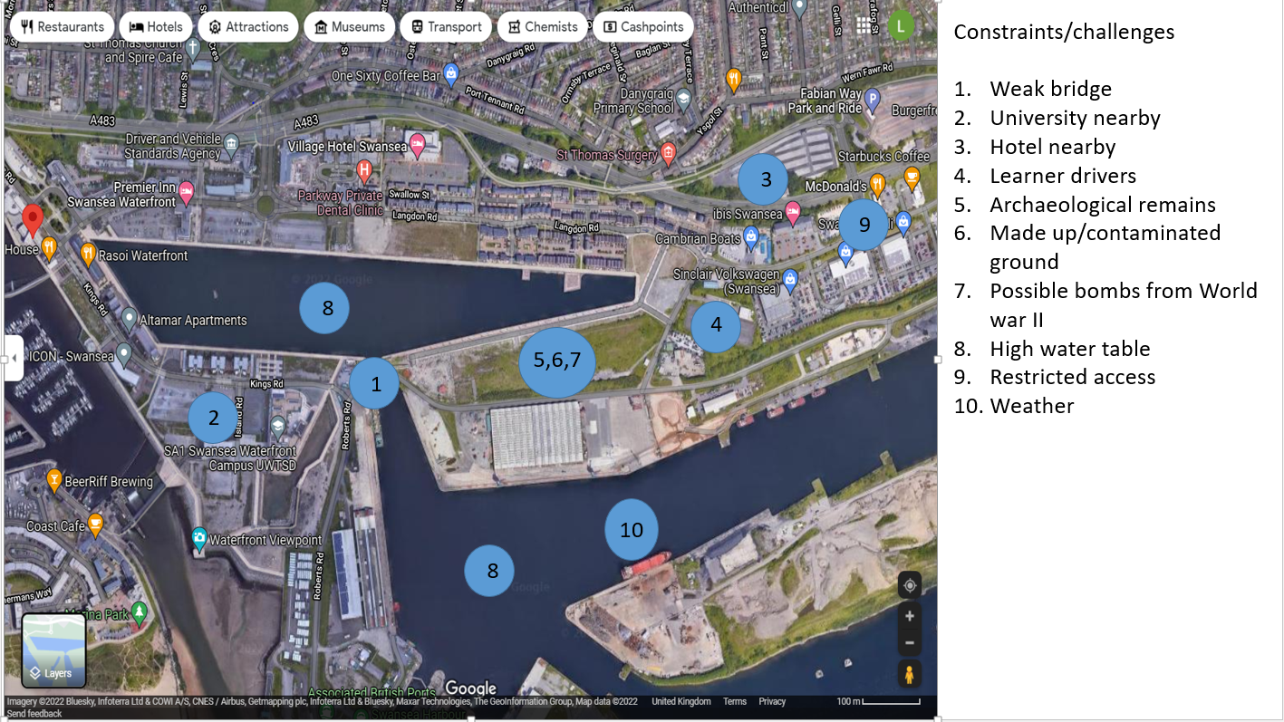
Fig 1 below shows the restraints and challenges identified
Fig 1, constraints and challenges. (Jones, 2022)

1.3 Hospitals
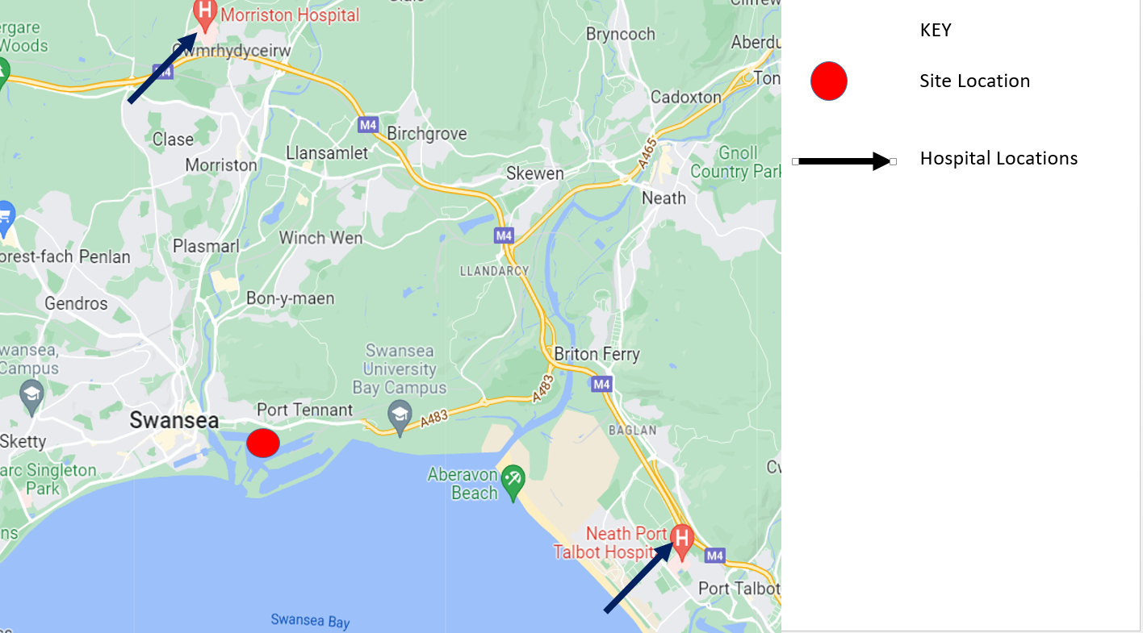
Below (fig 2) identifies the nearby hospital to the proposed site location. From the site to Morriston Hospital is 7.2miles and site to Neath Port Talbot Hospital is 7.7miles. However the quickest route would be to Neath Port Talbot as it is more direct.
Fig 2, Hospitals located nearby. (Jones, 2022)

1.4 Delivery Routes
Following on from the restraints the next task carried out as part of the site management plan was to look at the delivery routes for materials. The location of the site allows good access from the M4, and the avoidance of using a route that comes through the city centre will be favoured at all times if possible.
Fig 3 below shows the delivery route identified
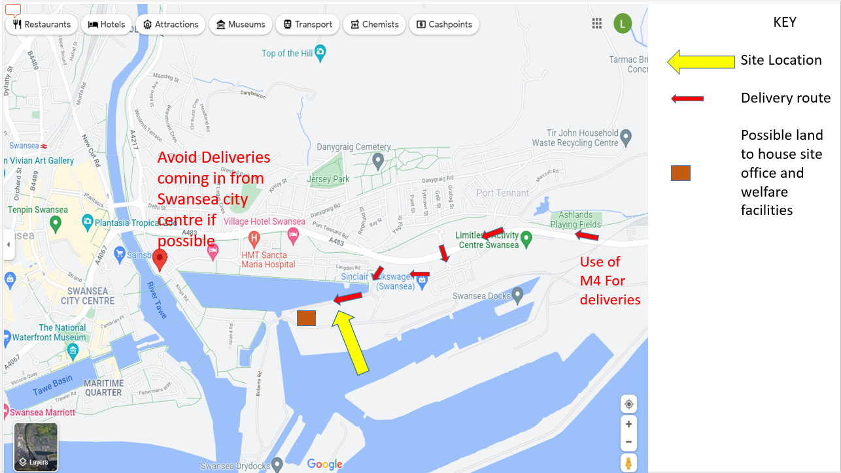
Fig 3, Delivery route. (Jones, 2022)

1.5 Site layout plans
Once the constraints, challenges and delivery routes were identified and decided upon, the site layout plans at different stages were then designed.
Due to the proposed design of the project and the intention to use as much of the space available to maximise capacity (see fig 4), the ability to house the facilities such as the site offices and welfare facilities on the project site would be difficult, therefore these facilities will be placed at the patch of waste land just down from the proposed site having agreed terms with the owner of the site in question.
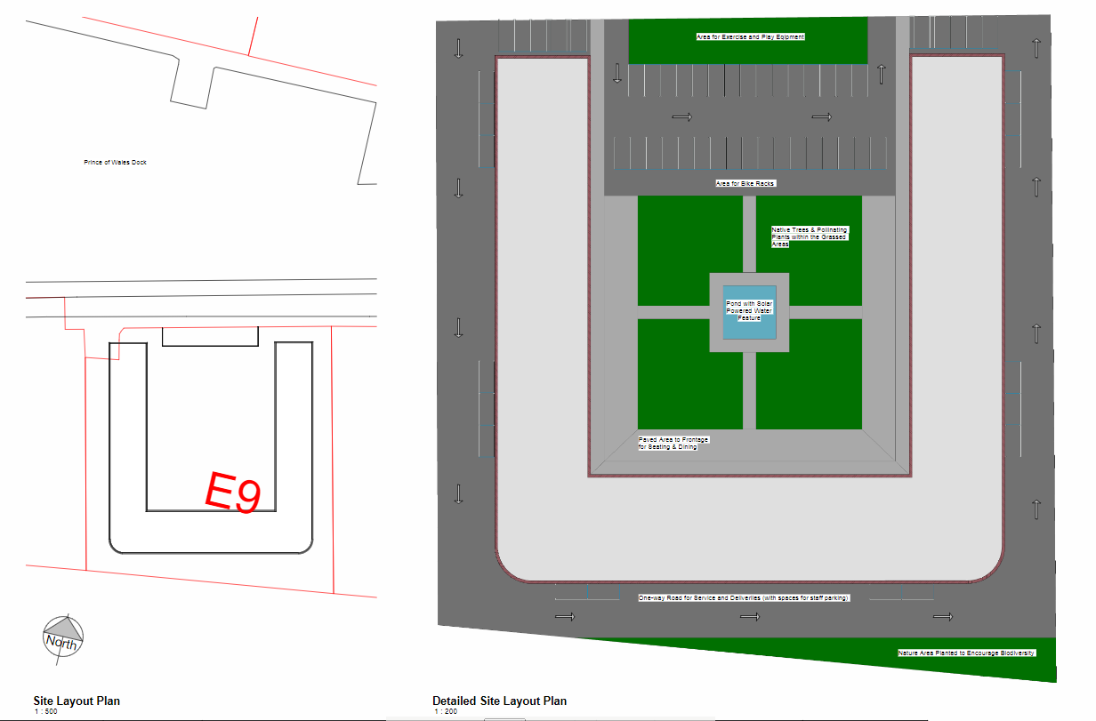
Fig 4. Propose site plan. (Owen Brown: 1901187, 2022)

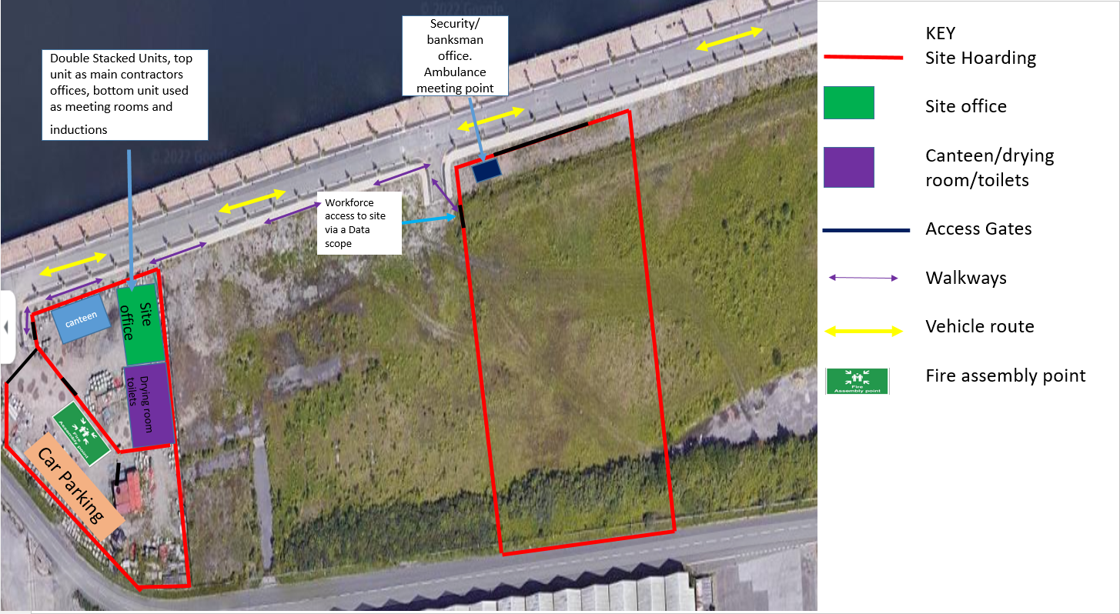
The first Site plan shown below (fig 5), is the initial set up ready for the site clearance and site preparation to begin. The site hoarding, security/banksman, offices and welfare cabins have been set up as well as an area for parking. Also marked is a fire assembly point. Fire escape routes will be updated throughout the duration of the project as it develops and changes.
Fig 5. Initial set up. (Jones, 2022)

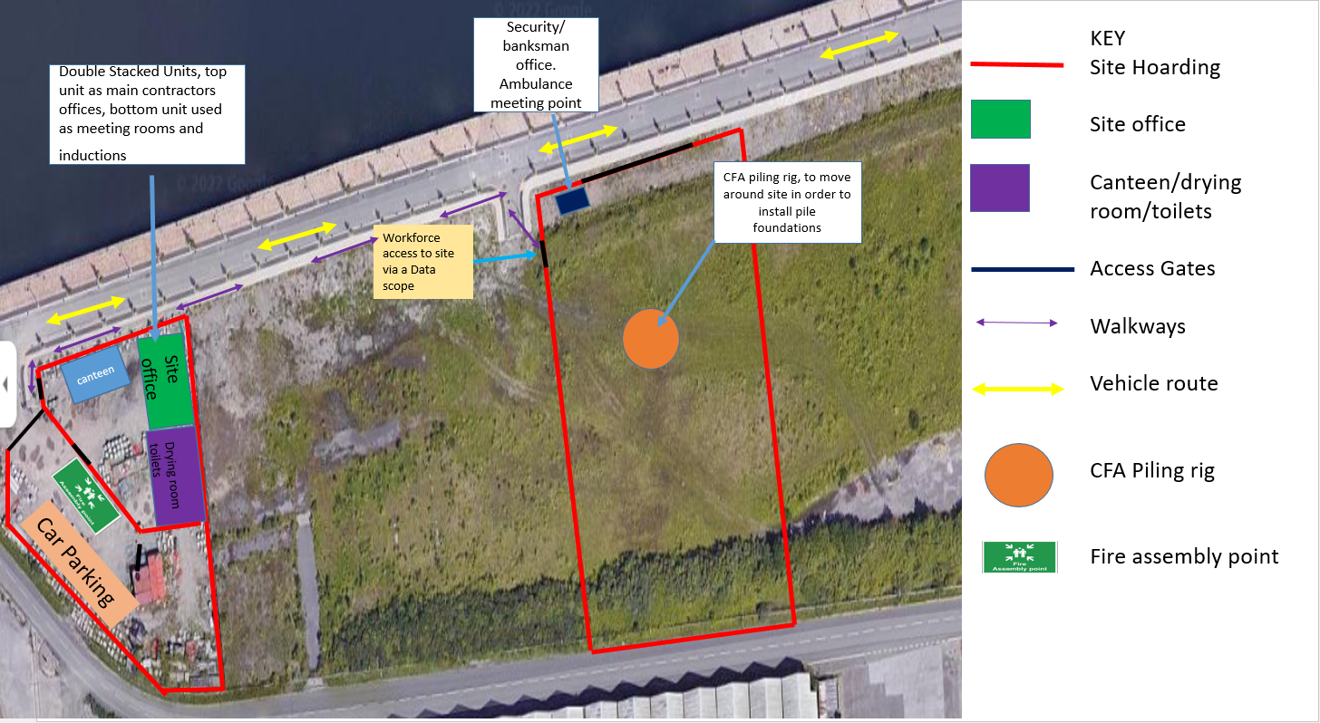
The second site plan shown below in (fig 6) is similar to the first site plan, just with the added CFA piling rig during foundations on the completion of site preparation.
Fig 6. Site layout plan 2 (Jones, 2022)

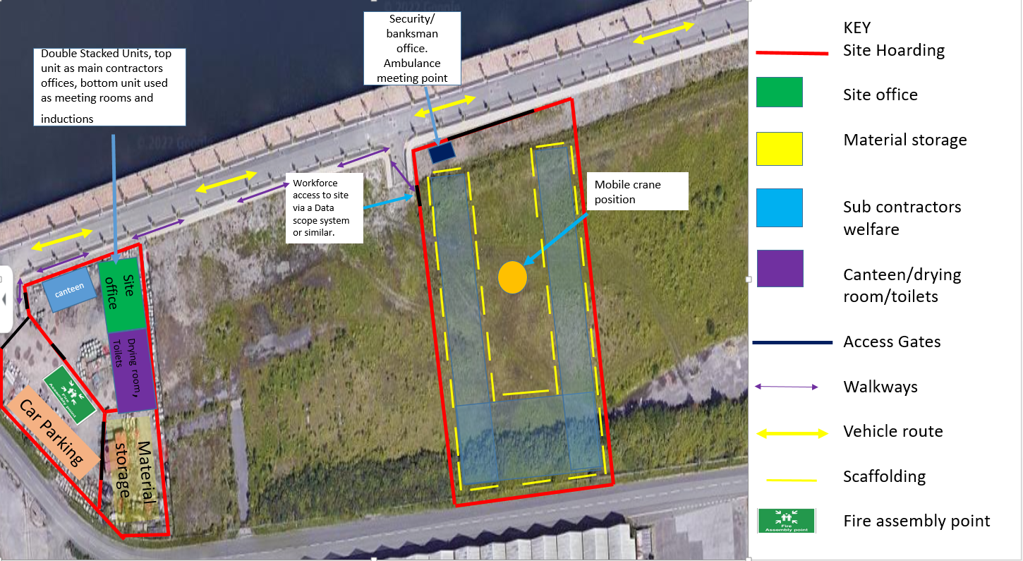
Site layout plan three shown below (Fig 7), has developed following the foundations, material storage has been added to the site facilities compound, the visual layout of the proposed building is shown, with scaffolding and the position of the tower crane for the large/heavy prefabricated items.
(Fig 7. Site layout plan 3)
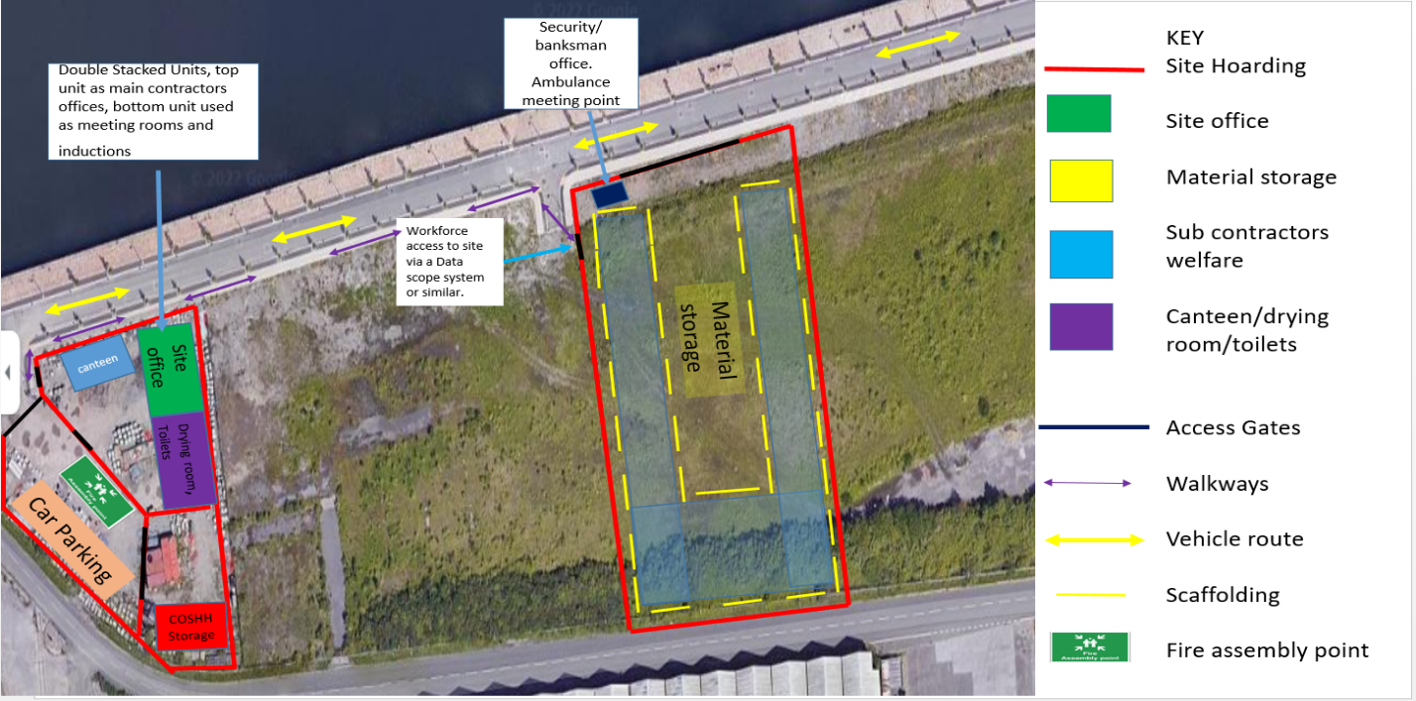
Site layout plan four shown below (fig 8), is showing the material storage has now been moved on to site following on the completion of the larger works. Having the materials on site will minimise the interruption of having to go to the compound to collect them. Also the addition of storage for Control of substance hazardous to health (COSHH) at the site facilities compound.
Fig 8. Site layout plan 4. (Jones, 2022)

The final site layout plan as shown below (fig, 9), the building is near completion, and scaffolding has been removed with the material storage being moved back to the site facilities compound in order for the landscaping of the grounds to be completed.
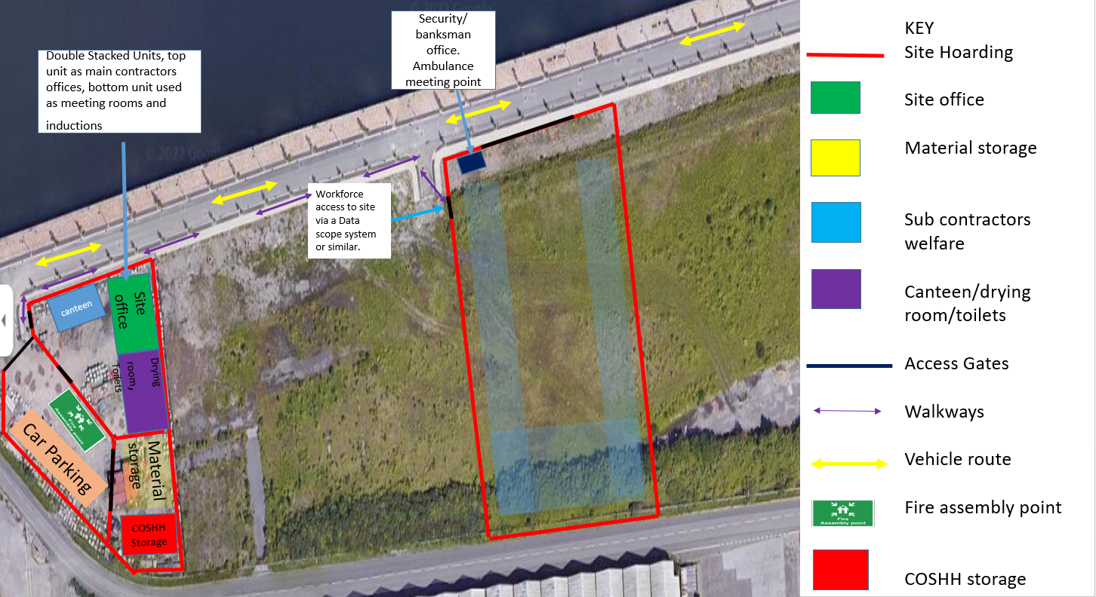
Fig 9. Site layout plan 5. (Jones, 2022)
References
Farmakis, P.M., (2018). Genetic algorithm optimization for dynamic construction site layout planning. Organization, technology & management in construction: an international journal, 10(1), pp.1655-1664.

Muhammad, A.A., Yitmen, I., Alizadehsalehi, S. and Celik, T., (2019). Adoption of Virtual Reality (VR) for site layout optimization of construction projects. Teknik Dergi, 31(2), pp.9833-9850.

Ning, X., Qi, J. and Wu, C., (2018). A quantitative safety risk assessment model for construction site layout planning. Safety science, 104, pp.246-259.

RazaviAlavi, S. and AbouRizk, S., (2021). Construction site layout planning using a Simulation-Based decision support tool. Logistics, 5(4), p.65.

Sadeghpour, F. and Andayesh, M., (2015). The constructs of site layout modeling: an overview. Canadian journal of civil engineering, 42(3), pp.199-212.

Sanad, H.M., Ammar, M.A. and Ibrahim, M.E., (2008). Optimal construction site layout considering safety and environmental aspects. Journal of construction engineering and management, 134(7), pp.536-544.

Skjelbred, S., Fossheim, M.E. and Drevland, F., (2015). Comparing site organization and logistics in the construction industry and the oil industry: A case study. In Proceedings of the 23rd Annual Conference of the International Group for Lean Construction, Perth, Australia (pp. 29-31).

