GLOBAL BUSINESS SECTOR ON NUFFIELD HEALTH COMPANY

Student ID Name | Florin Baituc
Student ID Number | 2114268
Module Title | Global Business Management
Module Code | LCBB4005
Assignment Title | Individual project report
Word Count | 2000 |  |  | Date Submitted |  | 14.07.2022

Table of Contents
Introduction 3
Overview of the business 3
Pestle analysis 3
Porter's five forces 6
Conclusion 8
Reference list 9
Appendix 10

Introduction
Nuffield health Company is one most impotent sector within the Healthcare and service-based service industry. This company mainly focus on Consumer Healthcare and service which is the most impotently and essential sector in today's life. Nuffield health is the biggest private business within the Healthcare and service sector. This company has an important place to lead the "OTC and oral care medicines, service and providers through the world. The overview of the companies is effective to measure the implication of the PESTLE and Porter’s five forces analysis to understand the factors and prime aspects in order to measure the growth and developments of the company within the large global business aspect throughout the world.

Overview of the business
Nuffield health is one of the most impotent "British multinational pharmaceutical companies and service-based company" with global business effects. The overview of the Nuffield health company is based on the growth and development of the service industries in order to analyse the global business aspect (Munyalo, 2020). Based on the effective guidelines from the governments of different countries, differences have a massive effect on a multinational corporation for this the Nuffield health companies need to focus on the different Healthcare and service aspects to measure the global business possibilities. The Nuffield health Company is also affected by the covid-19 pandemic situation by providing vaccines and permitted pharmaceutical service. The governments of the United Kingdom and other countries have provided find to this company to take medicine and injection and also deliver a good amount of motivation and support for medicine, "health insurance and Mediclaim", surcharges on essential "medical equipment and price ceiling on stents" and others (Rono, 2020). The implication of the global business aspects affects the business directly and indirectly to analyses the customer service and customer satisfaction within the medical and service-based industry. Within the service-based industry, Nuffield health Company has an important role to take an option and increase its interaction with the helped government of the United Kingdom.

PESTEL Analysis
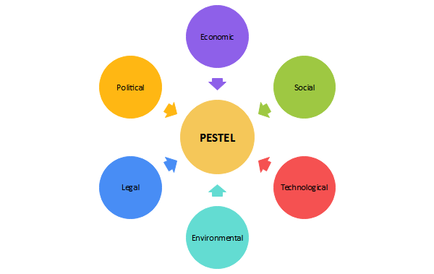
Figure 1: PESTEL Analysis
(Source: https://www.edrawmax.com/pestel-analysis/)
Political
Nuffield health is one most impotent sector within the Healthcare and service-based industry. This company mainly focus on Consumer Healthcare and service which is the most impotently and essential sector in today's life. Nuffield health is the biggest private business within the Healthcare and service sector. This company has an important place to lead the "OTC and oral care medicines, manufacturers and providers through the world. The stability and the positivity of the political condition are effective in making the easy business process for a Nuffield health company to conduct its global business firm (Abdullah et al. 2019). For example, governments of different countries have different rules and regulation over the drug and medicine business for this reason this company need to analyse the study of the different Healthcare and service rules and regulation to measure the global business aspects. a huge number of impotent and contemporary initiatives has been taken by the governments within the health sector which is been effective to measures the global business aspect of the Nuffield health Economical
The implication of the economic factors of the Nuffield health company is based on the "inflation rate, recession, income, foreign exchange rate can impact the sale of necessary OTC medicines, vaccines" and other factors to analyse the growth and developments of the company. The "inelastic nature of the demand curve" affects the service process of essential medicines within the Nuffield health company to promote the deals for win terms of the global business firm (Pan et al. 2020). At the time of COVID-19, people are giving priority to health and hygiene for this reason the sales values increased to a considerable degree. The analyses on the Nuffield health Consumer Healthcare and service provide the opportunity to create the customer requirements in the state of "vaccines and required medicines". The international financial circumstances have a significant influence on Nuffield health firm as the purpose of the "export tariffs, trade restrictions on medicines, exchange rate and risks" and other factors which are impactful to process the global business criteria.
Social
The implication of the social factors within the global business market of the Nuffield health companies affects the "Society's culture and the set norms" which can influence the “Nuffield health Healthcare and service revenue". The social factors are based on demographic factors including "age, gender, income, geographical location, education level" and others to analyse the social involvement within the business aspects. The implication of the social factors has an essential role to recreate in adjusting processes, therefore. The social factors of the Nuffield health companies’ effects on the customer sales margin in different countries to analyse the developments of the society and social factors. The "consumer lifestyle and the class structure in the society" are also significant to analysing the social factors which must be regarded to understand the growth and stability of the Nuffield health company for this reason the applicability of the social structure is related to the business growth and developments.
Technological
Technological effects are one of the major factors in the growth and development of the company. The implication of the technological impacts within the Nuffield health companies is effective to measures the betterment of productivity and operational activity. Technological supports within Nuffield health the "Consumer Healthcare and service" towards the competitive advantage to develop the Healthcare and service sector. The involvement of the new “technological innovations" within the industry affects the sales margin of the Nuffield health. It constantly expands on the technological modification of "Healthcare and service with AI and machine learning" in recent times (de Sousa et al. 2019). The implication of the technological support and efforts has been interested in developing "medical research and development”. The applicability of IoT is supporting this Nuffield health company to reach and explore the advantages of "interconnectivity and the rich patient data" based on the technologies that can supply. This Nuffield health company is even marketing its "medicines and drugs on E-commerce platforms". It is even strengthening its analysis and growth channel with developed technologies to support and deliver "transformational new medicines and vaccines for patients".
Legal
The "legal factors" of regional and transnational needs are very essential for Nuffield health Consumer Healthcare and service". All regulations connected to customer safety, fitness and protection regulations, secure working conditions, "IPR and patents etc" are necessary for its company procedures in other countries based on the government's rules and regulation. All the corresponding "laws and regulations" should be brought the consideration of while working within a country. Any criminal medicine selling activity affects the entire business process of the Nuffield health firm and put in legal problems. The government of different countries set some important "legal guidelines" for the medicine companies to measure the people's health and well-being to permit selling "medicine or drug" within the country. The implication of the legal factors within the global business market of the Nuffield health companies is very important to achieve success without facing any kind of legal difficulties to measure the answers to sidestep the deals being hindered. Legal factors recreate a very significant position as this can hardly influence the Nuffield health Company.
Environmental
The implication of the environmental factors within the business aspect of Nuffield health Consumer Healthcare and service is concentrated on the conditions in reserve to develop income and develop the sales ratio. It is operating towards lowering "carbon footprint and pollution through various measures" within the business and service aspects. It is "using 100% renewable energy for electricity supply and E-vehicles for transportation" to measure environmental sustainability. The implication of the environmental factors is effective to measure the “processes efficient through the use of digitalization and reducing emissions". This company has a "competitive advantage over many other firms in the industry with its positive environmental impact" which is one of the most impotent and key factors to measure the growth and development of the company. The environmental suitability measures the applicability of the resource utilisation within the Nuffield health company in order to develop the global business aspects.

Porter's five forces
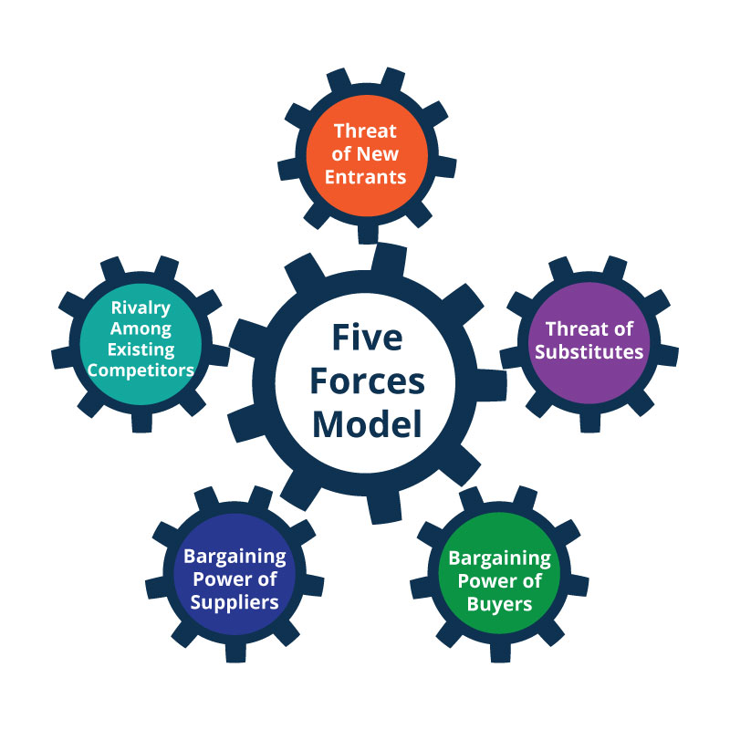
Figure 2: Porter’s five forces
(Source: https://www.planiumpro.com/blog/porters-five-forces-analysis-assessing-the-competitive-environment/)
Competition in the industry
Nuffield Health Company is mostly found in the "Allegations of Healthcare and service fraud impact the brand image". The implication of the weak points within the Nuffield health has been conveyed to the applicability of "illegally marketed prescription medications, misleading sales charges, and failure to disclose safety information in certain countries". The implication of the difference is "Charges of endorsing antidepressants that have not been approved by the FDA in the US".
Potential of new entrants into the industry
Nuffield health company is mostly found in the "Strategic growth through Acquisitions and Collaboration" to measure the implication of the global business possibilities in recent times. Nuffield health has "inorganically grown its portfolio through Acquisitions and Collaborations. Acquisitions and partnerships help Nuffield health to expand its portfolio and boost its market share" (Vlados, 2019). A New Product Launch is one of the most impatient parts or the opportunity of the company which affects the new customer analysis and increases the sales ratio of the company. Nuffield health has "recently introduced new service, especially in the metabolic and respiratory business". The announcement of "Nucala as a medication for refractory eosinophilic asthma in adults” is one of the most essential opportunities for the company.
Power of suppliers
Nuffield health companies have to face issues to measure the "such cases impact the company's brand image”. The analysis of the "Generic competition and maturity of Flagship drugs" is one of the major issues of the Nuffield health which affects the company's business possibilities and stability to measure the applicability of the global business acceptance. Several times Nuffield health and vaccines are now subject to competition from generic medicines and some of the flagship services are now reaching maturity" which affects the sales ratio of the Nuffield health and can affect deals.
Power of customers
Strong Research and Development: is one of the most strengths of the Nuffield health company to measure the business growth and development in order to develop the potentiality of the global business respect Nuffield health has created concentrating actions on the study and evolution of new results. The Nuffield health is accomplishing analysis in "HIV, respiratory, and cardiovascular drugs (Benzaghta et al. 2019). The Nuffield health company has a great network system in different countries to measure the capabilities of the business potential. This company has a strong presence in the marketing concept which affects the market value and recent customer analysis. "Nuffield health and Novartis Joint Venture '' takes position in 2015 for customer "Healthcare and service and vaccines", which permits both parties to improve "presentation, new creation on the action, penetration, and increase market share".
The threat of substitute service
"Price controls for drugs" is one of the major threats of the Nuffield health company. This company has faced huge issues to allow the "drug prices are controlled by law" in order to obey the rules and regulations of the drug and medicine business within the organisation. The intense contest is treated as the major issue of the company to measure the implications of the medicine and service industry in order to analyse the global business aspects. “Nuffield health is based on consumer care service, as well as pharmaceuticals, are subject to intense competition in the industry that not only limits market share but also leads to price wars". The threats of the Nuffield health company are based on the "Generic competition" to "launch of generic drugs has impacted pharmaceutical firms' sales as sales and supply of generic medications have improved".

Conclusion
The implication of the global business aspects within Nuffield Health Company is effective to measure the process of decision-making to increase the selling expense for customers in additional markets. This "Healthcare and service firm" must adjust its marketing and global business system in order to analyse the implication of the "macro and micro economic factors" which is impactful to measure the profitable business aspects. On the other hand, the "rising attitude among consumers" toward good Healthcare and service reduces the deals for medicines and affects the business within the Nuffield health company. The implication of the global business factors within the Nuffield health can discover untapped possibilities within the large market of medicine and pharmaceuticals

Reference list
Website
Nuffield Health Company, 2022 Homepage. [Available from: https://wwwNuffield Health Company/en-gb/home/] [Available on: 16.06.2022]
Journals\
Abdullah, M.F., Zainol, Z., Thian, S.Y., Ab Ghani, N.H., Mat Jusoh, A., Mat Amin, M.Z. and Mohamad, N.A., 2022. Big Data in Criteria Selection and Identification in Managing Flood Disaster Events Based on Macro Domain PESTEL Analysis: Case Study of Malaysia Adaptation Index. Big Data and Cognitive Computing, 6(1), p.25.
Benzaghta, M.A., Elwalda, A., Mousa, M.M., Erkan, I. and Rahman, M., 2021. SWOT analysis applications: An integrative literature review. Journal of Global Business Insights, 6(1), pp.55-73.
de Sousa, G.C. and Castañeda-Ayarza, J.A., 2022. PESTEL analysis and the macro-environmental factors that influence the development of the electric and hybrid vehicles industry in Brazil. Case Studies on Transport Policy, 10(1), pp.686-699.
Munyalo, E., 2020. Quality management system implementation and continuous improvement in Glaxosmithkline Kenya Limited (Doctoral dissertation, University of Nairobi).
Pan, W., Chen, L. and Zhan, W., 2019. PESTEL analysis of construction productivity enhancement strategies: A case study of three economies. Journal of Management in Engineering, 35(1), p.05018013.
Rono, A., 2020. Effects of Strategic Outsourcing of Non-Core Business Units on Business Performance: A Case of GlaxoSmithKline Limited in Kenya (Doctoral dissertation, United States International University-Africa).
Vlados, C., 2019. On a correlative and evolutionary SWOT analysis. Journal of Strategy and Management.

Appendix
PESTEL Analysis
(Source: https://www.edrawmax.com/pestel-analysis/)
Porter’s five forces
(Source: https://www.planiumpro.com/blog/porters-five-forces-analysis-assessing-the-competitive-environment/)

