Module code: BMSW4005
Module title:
Student Name: Liliana Tofan
Student ID: 2008331
Lecturer’s Name: Anita Nan

Table of Contents
Introduction 3
Career Needs in Role play 3
Personal reflection 4
Personal strength 7
Teamwork skill 7
Research skill 7
Employment goals 7
Personal development goal 9
Conclusion 11
References 12
Appendix: Interview Questions in Role Play 13

Introduction
Professional career development is a process by which student assess their current skills and learn new skills that will have a great impact on their professional life (Adam, 2021). Roleplay activities allow individuals to step into the role of a particular position, person, or scenario. this can be performed individually or in groups. The report is aimed at describing role play and making a personal reflection based on it. For that, I conducted the report by describing role play in the first part and reflection writing, personal strength, and PDP in the second part.

Career Needs in Role play
Roleplay activities allow individuals to step into the role of a particular position, person, or scenario. this can be performed individually or in groups. Participants engaged in role-plays in which they are immersed in real-life events or scenarios (Cavil, 2021). The objective of this play is to motivate someone to obtain a new skill or ability. Getting what you want in a virtual world makes you more professional and comfortable in real life. It allows a person to acquire a plethora of skills, for example, such as improving problem-solving skills, receiving honest opinions, and changing their behaviour of the most important aspects of role-playing is that the student inserts himself in the position that he desires to be in the future.
During the interview, I was asked five questions by the interviewer for the customer service manager position at B&M. The question was designed to evaluate my skills and ability whether I am suitable for this position or not. All the question was mostly on the leadership skills. the first question was if I had played any leadership role in my life. I have experience in leadership. In my school, I was the leader of a case competition group. There I made strategies and demonstrate our activities to my fellow teammates. In my previous position, I was accountable for supervising a team, which included coordinating their timetables, learning, and counselling. I love leading and am happy to report that two of these five individuals were elevated as a result of my mentorship.
The second question was about the strengths that I have that would benefit me for this position. As I have said about my leadership skills. In my academic and job life, I have performed leadership roles with fruitful results. Besides, I have competency in problem-solving which helps me take challenges and explore new things. My motivation skill will help me to stimulate employees which will increase efficiency and productivity at the workplace.
The next question was how I would resolve the conflict between the members. The first thing that I always keep in mind is that conflict is a common phenomenon that can take place at anytime and anywhere. The first step to resolve conflict is listening to the source of conflict. Listen to both sides and let them say. Then I will run a proper investigation and based on that I will find a way to keep their common interest and will determine the responsibility each person has. Finally, I will take preventive strategy to stop the incident from repetition.
The fourth question was what would be my key strategies to motivate employees. I answered this question by stated that, I will ensure employee safety and right in the first place. I will maintain direct communication with them so that they can feel important and become motivated to work hard. I will listen to the employees, encourage them so that they can come up with new ideas and strategies. I will reward performance and give them incentives based on their performance. Lastly, I will ensure the implementation of the employability act which will help them feel safe and free at the workplace.
Lastly, the final question was what will be my key-value addition to the company. The first important thing, I will put importance on is good customer service. I will make a new strategy to improve the existing product to add more value to the product so that the company would be able to attract new customers. Besides, I will improve the efficiency of procedures and protocols such as client representation, monthly reports, and innovation.

Personal reflection
Reflection is an important part of effective and experiential learning because it allows learners to understand the connection between what they experience and what they acquired (Redfern, 2010). It is a kind of learning that enables us to memoir every nuance of an academic or work event. It allows the learner to evaluate the experience they had and find their strength, weaknesses, skills. improvement and happiness. It helps learners with things that need to be changed or progressed. To reflect learning, people use various reflection models such as Kolb or Gibbs’s model of reflection (Shoshana, 2013). To conduct the role play, I will use Gibbs’ model of reflection which is composed of mainly six stages. Each of the stages contains some specific questions, by answering them I will complete my reflection on role play.

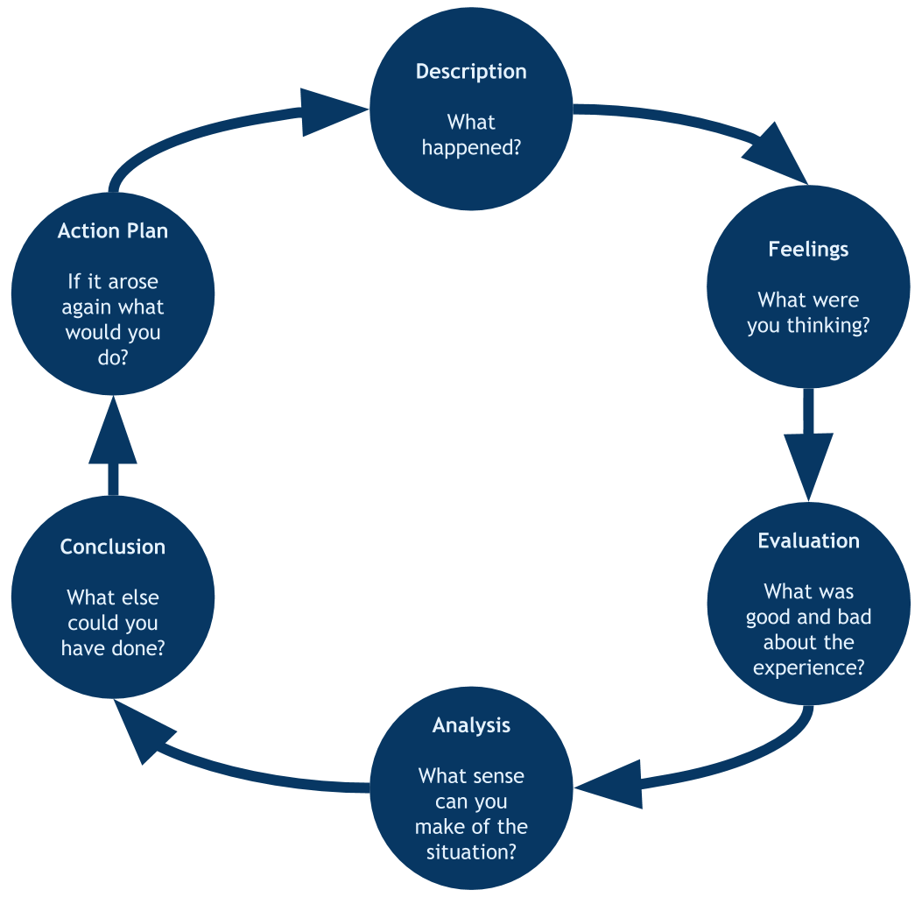
Figure 1 1 Gibbs' model of reflection / Source: (Adam, 2021)

Description
In this stage, the learner describes the whole event leaving details without leaping to the conclusion immediately (Koski and Launonen, 2012). It helps to understand what happened and when did it happen and the role of the learner. I performed the interview for the position of Customer Service Manager at B&M. I was able to accomplish the interview keeping composed behaviour. I made myself presentable without having a major problem. I felt comfortable throughout the interview. I provided acceptable responses since I have prior leadership experience as well as previous expertise in a variety of fields. My partner's performance was also excellent. We completed the role-playing session in the allotted time.
Feelings
Learner portrays the exact feeling that the experienced triggered during the event without making any judgment (Segal et al., 2002). The stage explains the emotion of the learner and associates’ people throughout the event. During the interview, when I perform as an interviewer, I was excited because this was the first time, I was taking an interview with a friend. It went well because it is easy to ask a question then answering them. But before the time when I played as an interviewee, I was quite nervous. But after hearing the calm and familiar voice of my partner, I felt confident.
Evaluation
In this stage, the learner evaluates whether the event was good or not. The learner finds out the approach or method that was effective during the event. There were a lot of good aspects to the role play (Rimmer, 2019). We rehearsed several times well before the session and discussed many aspects that helped us performed well. Communication between us was outstanding because we were friends. I liked my partner's helpfulness and calmness during the role play. Both of our performance was remarkable. But during the act, I was distracted by technological devices.
Analysis
The learner learns from the experience in this stage by analysing the good and bad aspects of the event (Rimmer, 2019). This helps learners to improve in the future. I have learned about how to give answers precisely during an interview. Further, how to act during an interview. The role-play helped me become more concerned about my time management skills. besides, I learned how important it is to acquire proper nonverbal communication.
Conclusion
Learners take a step back and think about what they could have done to improve the experience. It is a universal fact that there are always things left to improve (Helms and Van Esch, 2017). I could be more concerned about answering by making pertinent examples from my experience. it could add weight to my answers. Besides, I could be calm and act mature during the interview. Moreover, overall performance was good due to the understanding between me and my partner.
Action plan
In this final stage, the learner demonstrates the things that need to be improved in the future. I will perform the role-play again in the future. I will increase my confidence by being able to communicate precisely. Besides, I will work on problem-solving skills, teamwork skills, and time management skills. For that, I will make a personal development plan on the skills.

Personal strength
Personal strengths are the qualities and characteristics that an individual has, such as, ambition, consistency, effective communication, and innovation, that build personal growth (Helms and Van Esch, 2017). According to studies, those who develop with their skills have a greater sense of pleasure and development. The most practical route to enhanced efficiency and fulfilment is to recognize one's true talents including using personal strength in both personal and professional endeavours.
Some areas that I need to develop is given below:

Teamwork skill
Employees utilize their problem-solving abilities collectively to achieve a shared objective, which is why teamwork is important to a successful company (Adam, 2021). collaboration, empathy, communication, active listening, and cooperation are all-important teamwork abilities. Employers see teamwork as one of the most valued soft skills since it is a necessary component of most jobs. It's a thrilling possibility to be able to create via cooperation. All the companies look for an employee who has good teamwork skills. Teamwork skills can be improved by doing group work, and volunteer work. The skill can be acquired from academic level

Research skill
It is one of the important and valuable skills a person could have. This is the world of information and resourcefulness. In academic life or work life, a person faces many unprecedented problems, which can be solved by research (Redfern, 2010). People can become innovative by research new things. Research makes it possible to come up with new things and idea, that adds value to product and companies. In today's world, companies now invest millions of dollars in their R&D department to do progress in the competitive business environment.

Employment goals
Some of the employment goals are given below:
- Improve ability and skills as a professional. This is a usual aim, whether a person is in his academic level or work life. It may be beneficial whether you are seeking for job or already have one.
- Boost your income. Being undervalued may hurt effort and commitment. Making adjustments to gain more stimulates job seekers and boosts their passion for most professions.
- Optimize underperforming work processes or interpersonal connections. This objective area has the potential to improve the everyday job experience and make it more enjoyable.
- Achieve target within the targeted time and go for the next one
- Always go the extra mile. It will help anyone to reach his/her ultimate goal before others.
- Explore new opportunities. If there is a better opportunity, always go for it. By exploring a new job, new workplace, a person will be able to choose which will be the better option (Koski and Launonen, 2012).

Personal development goal
Skills | Actions Required | Resources Required | Start Date | End Date | Further Comments
Time management skills and teamwork skills | Adopting methods and techniques, practicing continuously, creating a to-do list,  Always keeping a preference list,  Dedication towards work, being smart about time, participation in volunteer work | Books, journal articles, online articles,  other secondary resources,  practice materials, watch, sticky notes, other sources |  |  | Improving time management skills will help me accomplish the task effectively and within the time limit. Teamwork skills will help create bonding and trust with my colleagues

Skills | Actions Required | Resources Required | Start Date | End Date | Further Comments
Analytical skill | Assess critical issues, evaluate things with information and data, reading the newspaper, | Primary and secondary sources,  Newspaper, Internation journal, peer-reviewed research paper, books |  |  | It will improve my analytical skills which will help me assess things scientifically and with fruitful result
Problem-solving skill | Identify the problem,  Find alternatives, assess opportunities, consider meticulous things,  Take action, effective research | Books, journal articles,  online articles,  research paper,  secondary sources |  |  | It will help me to take on challenges. Solve new things. Which will I help me to become competitive in the competition

Conclusion
Upon completing the report, it can be said that role play is an effective and fruitful medium that helps learners experience real-life events (Shoshana, 2013). I have performed the role play part very well. Personal strengths are the qualities and characteristics that an individual has, such as, ambition, consistency, effective communication, and innovation, that build personal growth. I made a personal development goal where I have drawn the framework to improve certain skills within a short time.

References
WAGNER, P., LENTZ, L. and HESLOP, S., 2011. Teaching Communication Skills. Academic Medicine, 77(11), p.1164.
Koski, K. and Launonen, K., (2012). Assessing the communication skills of carers working with multiple learning disabilities: a case study. International Journal of Language & Communication Disorders, 47(6), pp.685-695.
Rimmer, A., 2019. How do I improve my time management skills?. BMJ, p.l5322.
Helms, L. and Van Esch, F., 2017. Turning Structural Weakness into Personal Strength. The Leadership Capital Index: A New Perspective on Political Leadership, p.27.
Segal, G., Borgia, D. and Schoenfeld, J., 2002. Using social cognitive career theory to predict self-employment goals. New England Journal of Entrepreneurship.
Fryer, N. and Boot, M., 2017. Beyond you and I: role play and reflection-in-action in communication training. Reflective practice, 18(1), pp.112-122.
Hayes, C., Jackson, D., Davidson, P.M., Daly, J. and Power, T., 2018. Pondering practice: Enhancing the art of reflection. Journal of clinical nursing, 27(1-2), pp.e345-e353.
Brockbank, A. and McGill, I., 2007. Facilitating reflective learning in higher education. Buckingham: Society for Research into Higher Education & Open University Press.
Burns, T. and Sinfield, S., 2015. Essential study skills. Sage Publication.
Adam, v., 2021. Role play exercises | Career Development Service | University of Leicester. [online] Le.ac.uk. Available at: <https://le.ac.uk/career-development-service/interviews-and-assessments/assessment-centres/role-play-exercises> [Accessed 4 August 2021].
Shoshana, A., 2013. Role-Play and “As If” Self in Everyday Life. Ethos, 41(2), pp.150-173.

Appendix: Interview Questions in Role Play
Job Position: Customer Service Manager, B&M
- Did you play any leadership role in your life and career? Where and how you demonstrated your leadership skills?
- What are your major strengths that will make you a perfect fit for a managerial position?
- How would you resolve a conflict between the members in your team?
- What would be your key strategies to motivate employees in B&M?
- What will be your key value addition in the company as a manager?

