NAME: Nunzia Lomonaco
STUDENT NUMBER: 2123363
MODULE: LCMB7000
LECTURER: Gladius David Kulothungan
COURSE: Master’s in business administration
SUBMISSION DATE: 03/05/2022
Title: HRM Assessment 2

TABLE OF CONTENTS

- INTRODUCTION 3

- RECRUITMENT AND AVAILABILITY OF SKILLED LOCAL LABOUR 4

- REALISTIC JOB PREVIEW 5
- EMPLOYER BRANDING 5
- POOL TALENT 6

- LEARNING AND DEVELOPMENT 6

- MOTIVATION THEORY 7
- TRENDS IN GLOBAL TRAINING AND DEVELOPMENT 7

- COMPENSATION 8

- PAY EQUITY 8
- TYPES OF EQUITY COMPENSATION 9

- CONCLUSION 10

- REFERENCES 11

INTRODUCTION
In times when globalization is a well-established reality, where markets are global, partnerships are international, and foreign investment is constantly growing, human resource management is also called to be global. Human Resources Management (HRM) must be aware of how to manage the company’s international dynamics, how to support companies in developing global operations and new management strategy ideas. In this report, we will analyse the good practices of an HR manager of an international technology company (Vodafone Group), aimed at taking care of staff and making them feel apprehensive. Also, some models and concepts of current HRM and International HRM theories will be analysed to improve the company’s Hr practices, like Qualified labour (Talent) recruitment, Compensation, Learning and development.

COMPANY BACKGROUND
Vodafone Group is a global leader in communication technology, connecting individuals and businesses of all sizes to the digital world: small and medium enterprises (SME), large and global corporations and carrier services are all covered (Forbes Media, 2022).
The company provides mobile telecommunication services: Voice services, such as mobile voice communications and voice roaming, messaging services, data services, mobile connectivity, Mobile internet, data roaming services, fixed broadband services, fixed voice and data solutions, mobile advertising, and services operated by businesses. Business and personal solutions, as well as branded phones and devices, are all available (Vodafone group, 2022). Communications, cloud and hosting, Internet of things (IoT), security, and fixed connections are all areas where the company plans to invest.
The company was created on July 17, 1984, in Newbury, United Kingdom, and is headquartered there. Germany, Italy, the United Kingdom, Spain, and the rest of Europe are the geographical segments through which it operates (Forbes Media, 2022). The Company has 315 million Mobile customers, 28 million broadband customers, and 105,000 employees that are essential for the success of the Company and with which the company is committed to respecting the company’s values (Vodafone group, 2022). The total annual revenue is 43.80 billion pounds in 2021. The company is attentive to sustainability with programs aimed at ensuring the environmental impact of its infrastructure, making services accessible to all (inclusion), limiting the emission of toxic gases, and respecting the integrity and the work ethic of employees (Vodafone Group, 2022).

Source: (Vodafone group, 2020)
RECRUITMENT AND AVAILABILITY OF SKILLED LOCAL LABOUR
Advanced education, the possession of knowledge and abilities to do complex tasks, the ability to adapt effectively to technological changes, and the innovative application of knowledge and skills, obtained through training in their work, are all characteristics of highly skilled labour (Armstrong & Taylor, 2020).
So that a business run efficiently, skilled labour or talented workers are vital. The talented worker must be identified (recruited), nurtured (through training), and managed. Human resources must ensure hiring the appropriate talent to pursue the company's goals, being able to train, and knowing how to manage that specific talent (Armstrong & Taylor, 2020).
In the current international environment, when markets are dealing with the effects of wars, pandemic-related emergencies, travel restrictions, with related issues, it is crucial to enhance local skilled labour.
A strategic people management plan is vital for a company that wants to achieve success and be different from competitors (Schuler, 2009).
The term "recruitment" refers to the process of filling vacancies in a corporation. The process consists of identification, attraction, interview, selection, hiring and training of employees. Human resources management is responsible for managing the company’s human capital to maximize its profits. The first stage in developing an organization's human capital is recruitment ( Torrington, et al., 2020). It is segmented into two categories: external recruitment and internal recruitment. Both methods of recruitment have advantages and disadvantages; for example, external recruitment is expensive, in terms of direct costs (e.g., adverts-agency service) and friction costs (finding the right candidate requires doesn’t guarantee the candidate has all the skills related to the vacant role, and training can take a considerable amount of time). Under this point of view, it would be a great benefit for the company to resort to the Internal Recruitment, instead, by developing a home growth of talented workers or, however, workers with great growth potential. This way allows the company to choose the right candidate, develop his skills by matching the company’s needs, and fill the vacancies at an affordable cost, either in terms of time or money (Keller, 2017). On the other side, External recruitment is a good way to fill the vacancies up, by looking at the largest work market, recruiting less time. On top of that, an external candidate may bring his own experience, gained in a different sector, or environment, and a fresh breath of air in terms of new ideas.
This focuses on making the hiring process more efficient and diversified fits, particularly on the recruiting of qualified or soft skilled personnel.
Below are some strategies that Vodafone group could adopt to make the recruitment of qualified personnel effective.
REALISTIC JOB PREVIEWS
This is a recruitment method that involves presenting the good and bad aspects of the job to the candidate, allowing him to better understand the job requirements as well as the company's culture and values. This technique aids in reducing the gap between a candidate's expectations and the reality of the company, minimizing the number of employees who leave after a short amount of time (Beardwell & Thompson, 2014). Candidates who received a realistic preview of work for expatriate assignments in a multinational organisation (Caliguiri, 2003) reported a stronger perceived capacity to make an informed decision on whether or not to take a global job than those who did not.
EMPLOYER BRANDING
Many studies have demonstrated that the reputation of a company's name is one of the elements that determine a candidate's decision to work for or leave a company. So, as it happens in corporate marketing, which focuses on the brand's value to maximise sales, any company should also focus on employer branding. Employer branding is a set of intangible characteristics and qualities that defines an organisation. The process aims to create a positive, challenging, and flexible work environment so that employees feel proud of the company’s values and philosophy and can advocate for it (Green, 2021). A positive employer brand may increase the organization's attractiveness to potential employees, whilst reducing recruitment costs (Beardwell & Thompson, 2014). This would be an excellent strategy and an added value for a company that already gained a strong brand value.

POOL TALENT
This is an internal recruitment approach that requires developing a talent pool to ensure that key position vacancies are quickly filled (Armstrong & Taylor, 2020). HRM should specify the criteria for inclusion in the talent pool in the form of general abilities and competencies, such as ambition, engagement, motivation, curiosity, commitment, and determination. This method of recruitment is less expensive and assures the retention of talented employees. The company's employees will be trained on a regular and targeted basis under this strategy. (Armstrong & Taylor, 2020). This will be discussed thoroughly in the following paragraph.

LEARNING AND DEVELOPMENT
Human resource learning & development serves to help employees to develop their personal and organizational skills, knowledge, and abilities. Learning and development include employee training, career development, management and performance development, coaching, mentoring, succession planning, key employee identification, and classroom assistance organization development. Learning and development in HRM mean also training an individual after he has been hired for the first time, providing him with opportunities to learn new skills, distributing useful resources for the employee’s tasks, and any other development activity (Torrington, et al., 2020). Having a strong learning and development strategy can help the company to engage employees, attract top talent, and build the company's reputation. In the figure below, are the elements of Learning and Development.
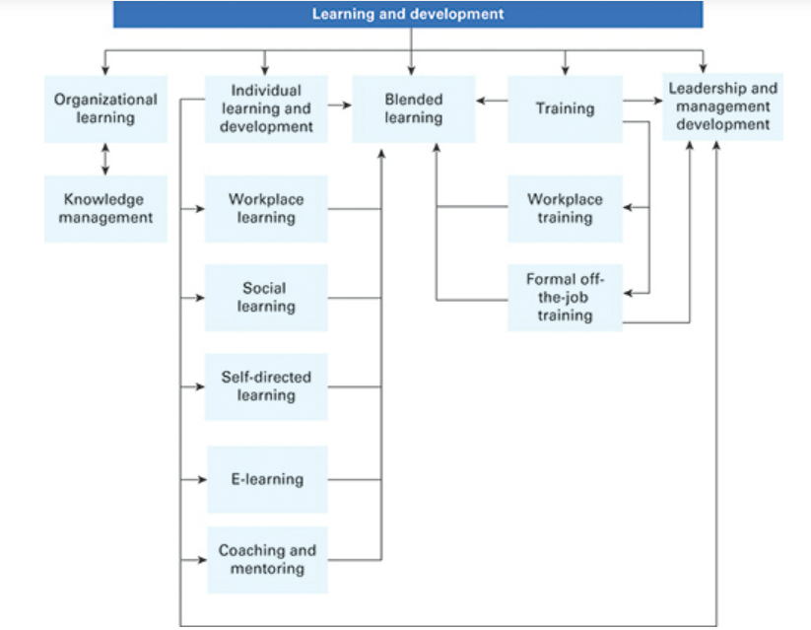
Source: (Armstrong & Taylor, 2020)

HRM should consider the fact that each employee has a different cognitive learning approach and therefore can provide a variety of training options. Learning theories, such as Motivation Theory, are equally important and should be considered.
MOTIVATION THEORY
People that are motivated will learn more effectively. There are two crucial theories to support that idea: the Expectancy theory and the Goal theory.
- The Expectancy theory states that when someone desires something strongly, the expectation of being able to have it will lead to actions. Furthermore, if an individual believes that the goal of learning is advantageous to him, he will be more willing to work to achieve it (Armstrong & Taylor, 2020). When he realises that expectations have been met, his belief that learning is beneficial will be reinforced.
- The Goal theory asserts that individuals are more motivated when they are working toward clear goals, even if the goals are difficult, they will be achievable, and when there is feedback on performance (Armstrong & Taylor, 2020). When people are motivated by clear goals and appropriate feedback, they are more efficient. A person's performance and perseverance in meeting a goal are influenced by how challenging, specific, and realistic the objective is. Employee productivity and self-confidence rise when targets are clear and measurable (Locke, 1990).
The fundamental principle of human resource development is to have a planned and systematic process in which:
- A performance management system should define skills or competencies.
- These will be integrated with the human resources strategy's requirements.
- The development programme will fill in the gaps (Price, 2011).
Training should be viewed as an activity connected to the organization's goals as part of an HRD programme.

TRENDS IN GLOBAL TRAINING AND DEVELOPMENT
For a company like Vodafone, which operates in different regions, it is essential to consider global HR development and training.
Global HRD is influenced by global competitiveness, technology advancements, and an international workforce (Lazarova & Thomas, 2014). There are four current trends in HR theory to consider:
- In-Country Training
- Cross-Cultural and Diversity Training
- Training in Cross-Cultural Teams
- Media-Based and Web-Based Training
The new trend in training is the availability and integration of electronic media. This type of training is cost-effective for the organisation and especially helpful for personnel who are on short-term or non-standard assignments, especially if the training is customized. Very often, these online training tools are especially useful for expatriates and their families (Lazarova & Thomas, 2014).
The challenge for a global company like Vodafone group is to develop individuals at all levels and in a variety of locations with different cultures. Global HRM has mostly focused on preparing expatriates for abroad assignments and producing global leaders. It must, however, cater to the training and development needs of its personnel in all its regions. Working with people of many cultures and countries, while performing activities on a global scale, is what international training and development entail. As a result, employees must develop global thinking that has no boundaries (Schuler, 2009).
COMPENSATION
In human resource management, payment is an important feature. It is the main reason people work. The reward or compensation that people receive for their contribution to an organization includes monetary and non-monetary components. Remuneration also has an impact on the recruitment and retention of talented people. The term 'reward management' includes the strategy and practice of pay systems, the financial aspect and the management of staff (Price, 2011). The compensation that employees receive for their work has an impact on how they work, their attitude toward customers, their desire to improve and learn, and the quality of their performance. As a result, this will have consequences for the company's success. So, human resource management must plan compensation strategies (Milkovich, 2013). The factors influencing the compensation of the employees are external and internal to the company; below will analyse some internal factors.
PAY EQUITY
Behavioural psychologist Adams in the 1960s theorized equity theory, according to which employees to feel valued and motivated, must believe that their efforts (inputs) are balanced with rewards (outputs). Rewards such as assignments with more 'responsibility', recognition and appreciation, and career progression. Moreover, it is very important for the perception of employees to be treated fairly about colleagues, this makes a job environment positive or negative ( Torrington, et al., 2020).
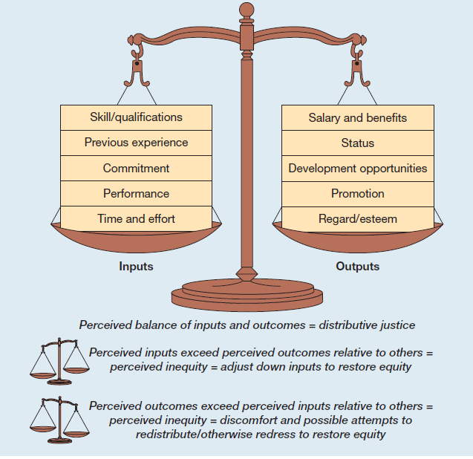
Source: (Beardwell & Thompson, 2014)
Employee efforts are numerous and varied, as seen in the illustration above.
Employees, according to Adams, will compare the rewards they receive with their effort, skills, competencies, time, and other contributions; as a result, if they feel they are being treated unequally, they will be demotivated to work, whereas if they are being rewarded for their efforts, they will be motivated.
HRD of Vodafone could implement the following strategies for the appreciation and retention of employees based on the principles of Adams' theory:
- Monitor salary and benefits regularly to identify any inefficiencies.
- Support a working environment in which employees are free to express their opinions and communicate their moods to their superiors
- Balance any inequity when there is evidence
- During the recruitment phase, inquire about the employee’s expectations on salary, career, etc. (Belton, 2018)

TYPES OF EQUITY COMPENSATION
For a technology company operating globally, there are several ways to ensure adequate compensation, below are some suggestions:
- Employee stock ownership plans, or ESOP, provide employees with stock ownership in the company. ESOP is qualifying programmes because they provide numerous tax benefits to the sponsoring company, the seller shareholder, and the participants. ESOPs are frequently used by employers as a corporate finance approach to matching the interests of their employees and shareholders (Schuler, 2009).
- ESSP. Employee Stock Purchase Plans: These plans allow employees to buy company stock at a discounted price through payroll
- PHANTOM STOCK allows employees to have stock ownership without really owning the shares. The value of phantom stock increases and decreases in perfect sync with the underlying firm shares, just like any other real stock. On occasions, employees are reimbursed with earnings resulting from any corporate stock appreciation. This type of compensation is usually used for senior employees (Schuler, 2009)

CONCLUSION
This report highlighted some of the components that make a worker satisfied with a job in the workplace. How an HR manager could develop a sense of belonging to the company of employees, how to make them feel valued and appreciated, and how to retain the staff. Below are some considerations.
- In the report some of these factors have been identified in 3 elements:
- an adequate and fair compensation.
- Recognition of employees and the work done.
- Positive work environment.
These three factors must all be present at the same time for the employee to be engaged with the organisation. Reasonable pay without recognition or a healthy work environment will cause frustration. Inequality will result from a positive environment without proper compensation and recognition, while hypocrisy will result from recognition without compensation and a positive environment.
Frustration, inequity, and hypocrisy are all three factors that may contribute massively to Employees leaving the job. All of those negative factors generate higher employee dissatisfaction, comparatively more than the impact of a low salary (Lipman, 2017).
- Vodafone case: typically, since 2007, according to Matthew Brearley Vodafone’s HR director, the approach and consideration of retention strategies have nothing to do with HR policies and procedures; and the company focused exclusively to develop and create great managers (Personell today, 2007). This vision proved to be effective in terms of not only employee retention but also in terms of expansion when Vodafone faced an increased number of employees from around 85.000 worldwide to 105.000 in 2016. Since the pandemic changed those figures and made the Vodafone group face a drop of around 12.000 employees, it seems that new strategies are now being reconsidered. On the 1st of April 2019, the new chief HR officer Leanne Wood joined the Vodafone group, and she start up the new Vodafone’s people and organizational strategies which include developing strong talent and leadership, engaging culture and a working environment (Vodafone Group, 2022).
- Managing human capital is one of the most difficult and complex jobs, requiring remarkable interpersonal skills such as great communication, negotiation, flexibility, and the ability to solve problems both individually and in teams. In addition, many aspects relating to people must be considered: the sensibility of an employee, visible and invisible disabilities, family needs of each, the risk of discrimination of particular categories, and the well-being of everyone. On the other hand, there are the business needs: fierce competitiveness, a dynamic and challenging environment, the new post-pandemic ways of working, and the need for a good understanding of the global market’s needs. As a result, the challenge for a successful HRM is both complex and difficult. However, in this report, it was highlighted that the theories and models of HRM and IHRM are in continuous development, those available are constantly evolving, and the options are numerous and engaging. After that, it's time to put the theory into practice. Bring the theory and the practice together.

References
Torrington, D., Hall, L., Taylor , S. & Atkinson, C., 2020. Human Resource Management. 11 ed. s.l.:Pearson.
Armstrong, M. & Taylor, S., 2020. Armstrong's Handbook of Human Resource Management Practice. London: Kogan Page.
Beardwell, J. & Thompson, A., 2014. Human resource management. 7 ed. Harlow: Pearson.
Belton, V., 2018. What is equity theory and why should I be applying it?. [Online]
Available at: https://www.perkbox.com/uk/resources/blog/what-is-equity-theory-and-why-should-i-be-applying-it
[Accessed 18 04 2022].
Caliguiri, P. P. J., 2003. An application of selfassessment realistic job previews to expatriate assignments’,. International Journal of Human Resource Management, 14, 7:, 14(7), pp. 1102-16.
Forbes Media, 2022. Vodafone. [Online]
Available at: https://www.forbes.com/companies/vodafone/?sh=65d246bb7dfb
[Accessed 27 04 2022].
Green , M., 2021. Employer brand. [Online]
Available at: https://www.cipd.co.uk/knowledge/fundamentals/people/recruitment/brand-factsheet#gref
[Accessed 28 04 2022].
Keller, S., 2017. Attracting and retaining the right talent. [Online]
Available at: https://www.mckinsey.com/business-functions/people-and-organizational-performance/our-insights/attracting-and-retaining-the-right-talent
[Accessed 24 04 2022].
Lazarova, M. B. & Thomas, D. C., 2014. Essentials of international human resource management : managing people globally. s.l.:Sage.
Lipman, V., 2017. 66% Of Employees Would Quit If They Feel Unappreciated. [Online]
Available at: https://www.forbes.com/sites/victorlipman/2017/04/15/66-of-employees-would-quit-if-they-feel-unappreciated/?sh=c1b702a68979
[Accessed 25 04 2022].
Locke, E. A. &. L. G. P., 1990. A theory of goal setting & task performance. 18 ed. Englewood Cliffs, N.J.: Prentice Hall.
Milkovich, G. N. J. &. G. B., 2013. Compensation. 11 ed. New York: McGraw-Hill/Irwin.
Personell today, 2007. Vodafone does not regard staff retention as an HR policy issue. [Online]
Available at: https://www.personneltoday.com/hr/vodafone-does-not-regard-staff-retention-as-an-hr-policy-issue/#:~:text=The%20most%20effective%20retention%20strategies,an%20HR%20policy%20or%20process.
[Accessed 25 04 2022].
Price, A., 2011. Human resource management. 4 ed. s.l.:Brendan George.
Schuler, D. R. S., 2009. International human resource management.. 3 ed. s.l.:Global HRM.
Vodafone group, 2020. Vodafone Group Plc Annual Report 2020. [Online]
Available at: https://pdf.dfcfw.com/pdf/H2_AN202006181385716575_1.pdf?1593398150511.pdf
[Accessed 29 04 2022].
Vodafone Group, 2022. Sustainability. [Online]
Available at: https://www.vodafone.com/business/sustainability
[Accessed 26 04 2022].
Vodafone group, 2022. Vodafone Group Plc annual report 2021. [Online]
Available at: https://investors.vodafone.com/sites/vodafone-ir/files/2021-05/vodafone-annual-report-2021.pdf
[Accessed 27 04 2022].

