Student Name: Aida Lamer
Student Number: 1706552
Module Code: ACDA5005
Module: Smart and Connected Devices

Table of Contents
Task 1 3
History of IoT 3
Internet of Things and Smart Home Concepts 3
Advantages and disadvantages 4
Security issues associated with smart home concepts 4
Task 2 5
References 7

Task 1
The following section is conducting research on Internet of Things since 1980s and the growth it made in recent times. Further research is carried out on current technologies on the market and the security issues associated with them are also discussed.

History of IoT
The following section is disgusting the history of IoT Since the 1980s.
A historic step in IOT was when members of the Carnegie-Mellon Computer Science Department installed microswitches in Coke vending machines to monitor number of bottles in the machine. The employees would be able to go on the Internet to check if the bottles have recently been refilled to give information if the bottles were cold. “One of the first examples of an Internet of Things is from the early 1980s, and was a Coca Cola machine, located at the Carnegie Melon University. Local programmers would connect by Internet to the refrigerated appliance, and check to see if there was a drink available, and if it was cold, before making the trip.” [1] This research shows one of the first examples of IoT. Even though IoT has been around for some time, it did not get officially named until 1999.

Internet of Things and Smart Home Concepts
IoT is used to connect devices to the existing Internet infrastructure. Any electronic device(things) with a sensor that is connected to the Internet are IoT. One of the main advantages of IoT is connecting the physical world and computer-based systems by thus improving efficiency and benefits. “As of 2015, a total of 15.41 billion devices were connected to the internet. Thanks to new wireless technologies and other IoT-related advancements that number will balloon to 75 billion devices by 2025.” [2] This research shows the estimated growth IoT as expected to have and the Foreseeable future. Existing devices will require to be linked to IoT, IoT devices will become cheaper, widely available and more advanced hence the expected growth. Some of the common practical applications that use IoT are smart homes, environment monitoring, medical and health care, smart cities and energy management.
The following section is focused on smart home concepts. Smart homes use IOT devices to enable remote management and monitoring of the appliances and the systems. Some of these appliances and systems would include lighting, heating, security alarm and access control. On average it would cost $1000 per room to automate a home. Singular software platforms allow users to remotely control their home through voice commands, app, or device. hubs are not as widely used anymore, have a certain system and setups still required them. Most smart home devices are now using integrated controllers which use IFTTT to control individual devices with each other. Some of the most popular types of home automation devices are lights, security system, locks, blinds, switches and bedroom alarms. A top manufacturer for security systems is “SimpliCam” [3] which offers home security using a camera that is connected to an app on the user’s device. This device also offers intruder and motion alerts. A locks top manufacturer for home automated devices is “August” [4]. August is a smart lock that is using an application to control the door to unlock/lock, grant access and monitor who entered/exited. Professional home automation systems are also available for those who won professional installation. Some research found that “prices start at around $500 for basic set-ups, and go as high as $10,000 for fully automated homes with monitoring.” [5] This shows how prices can vary from low to high based on the amount of insulations requires. Security, communication and full automation can cost between $10,000 to $150,000 which shows how expensive professional home automation systems can be. A company that offers these features is “Elan”, [6] which gives users easy control over their connected smart home and entertainment system. Some other features Elan enables users are monitor what door is open, closed, locked or unlocked. Another feature is enabling the user access to all the functions from security keypad. Elan also allows switching between the systems. Using Elan, instant view of single and multiple cameras can be monitored, giving the user maximum security. A company that offer security systems, lighting and thermostat control is “ADT” [7]. This company costs $30-$50 monthly to monitor existing devices that would cost $1000. ADT includes alarm monitoring, video security monitoring, smart home controls and many more features.

Advantages and disadvantages
The following section is discussing the advantages and disadvantages of various techniques currently available on the market. Advantage for using home automation systems would be that they are energy efficient. Automated devices pre-program based on time, environment or even adapting to the user’s behaviour. Some research found that on average “systems can help consumers save anywhere from 10 to 15 percent off of heating and cooling bills” [8] which shows one of the advantage automated devices provide. Another advantage would be the convenience of using whole motivated devices. The devices can be instructed to complete tasks using applications on smart devices such as phones, smart watches and computers. Another advantage is the security as the security cameras can be monitored and the user is immediately alerted. By being able to remotely control blinds and lights, it provides security against intruders.
A disadvantage for home automated systems would be installation. Depending on the complexity of the system, it can be time consuming to set up and expensive to hire someone to do it. Another disadvantage would be the technology being complex. In some cases, the physical option is easier to perform rather than using a smart phone to conduct the same simple task in real life. Another disadvantage would be system compatibility. This is a disadvantage as not all systems are compatible with each other and this could lead to the user needing to use different platforms for different devices. In order to avoid this, a centralized platform technology that controls all the systems and devices from one location could be purchased. Another disadvantage is that using home automated systems are expensive.
In conclusion, home automated systems offer convenience for the users and aid to cut down on energy usage. There are some disadvantages that comes with automated systems, however the benefits they offer outweigh the negatives.

Security issues associated with smart home concepts
The following section is discussing the security issues that are associated with smart home concepts.
Smart homes could potentially give hackers an opportunity to access sensitive information. Attackers could also gain access to appliance such as a washing machine and proceed to use other devices in the household or unlock doors and change locks which is a potential device hijacking threat. Cameras could also be a target for hijack threat which would enable the attacker to monitor when the home is empty and the owner’s daily activities. Another attack that smart homes could be a victim of is distributed denial of service attacks which occurs when the targeted system gets flooded with traffic causing the service or network to be overwhelmed. In worst case scenarios, permanent denial of service attacks could take place which damages the device to the point where it must be replaced or reinstalled. An attack that could take place is “fake data fed to thermostats in an attempt to cause irreparable damage via extreme overheating” [9] which shows the extent of damage that can be caused though such an attack. This attack could also be used in man-in-the-middle attacks, where the attacker interrupts the communication between the two systems. There are security solutions that can be used to protect smart home devices one of these solutions is security monitoring and analysis. This captures data of the overall state of the system allowing monitoring of the traffic between the devices. The data is also analysed to detect security violations and system threats. When such threat is detected, the suspected device should be isolated. Another way to secure smart homes is to use secure boot which works by ensuring the device only executes code from a trusted party.
In conclusion, there are many threats when it comes to smart home security that would be a potential problem. The additional methods that aid smart home devices to be more secure from attackers. These methods require additional cost and knowledge or someone to set them up. The threats would remain if the user did not want to invest in further security solutions such as security monitoring and analysis or a secure boot.

Task 2
In the following section, using the knowledge and understanding gained from the research, a design of a real-life smart home scenario is created.
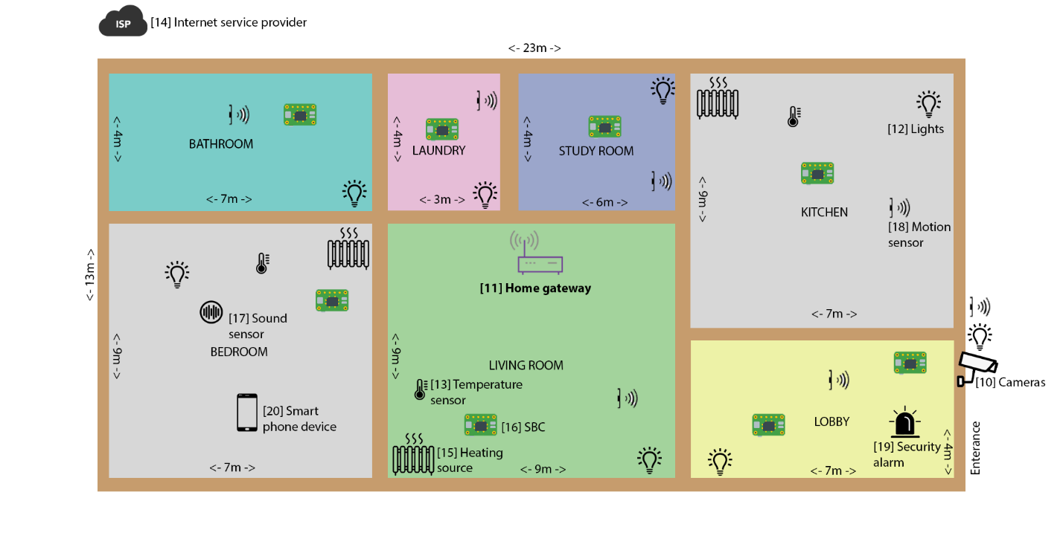The above image demonstrated the design created for a real-life scenario. The smart house includes a camera [10], home gateway [11], lights [12], temperature sensors [13], ISP [14], heaters [15], SBC [16], sound sensor [17], motion sensors [18], security alarm [19] and a smartphone device [20]. The camera is located at the entrance of the house and is connected to an SBC. This SBC also connects to an outdoor light and motion sensor. All SBCs are connected to the home gateway. SBC allows connection to be made between sensors and devices. If an intruder were attempting to access the property, the camera would film them. Lights automatically turn on if motion this being sensed. In the lobby another SBC is connected to the light and to a motion sensor. This motion sensor activates the light to turn on or turn off depending on motion. This is also used in all the other rooms of the house except for the bedroom. In the living room and SBC is connected to a temperature sensor, heating source, motion sensor and a light. The temperature sensor provides information which then can be used to set the heating source device according to the information provided. The light in the living room also activates using motion sensors. In the kitchen another SBC is connected so he thinks source, a temperature sensor, emotion sensor and a light to provide the same effect as in the living room. Other features that could have been used in the kitchen would have been a fire alarm and a smoke detector to warn resident of danger. In the study room an SBC is connected to a motion sensor and a light. In the laundry room an SBC is connected to a light and a motion sensor just like in the study room. In the bathroom an SBC is connected to a motion sensor and a light. In the bedroom an SBC is connected to a heating source, temperature sensor, sound sensor and a light. In the bedroom a different sensor is used to avoid the light being switched on unnecessarily triggered by movement. Motion sensors and noise sensors should be used accordingly to benefit the chosen room that the device is based in. A smart phone device is also connected to the home gateway to allow access to any of the appliances in the home using an application.
In conclusion, there are improvements that could be made to provide more security and more appliances. All the sensors have been chosen to benefit the room they are in, by this allowing more energy efficiency, security and accessibility.

References
[1] "A Brief History of the Internet of Things - DATAVERSITY", DATAVERSITY, 2020. [Online]. Available: https://www.dataversity.net/brief-history-internet-things/#. [Accessed: 12- May- 2020].
[2] J. Weber, "2019 Edition: 15 Fascinating Facts About the Internet of Things", Sagiss.com, 2020. [Online]. Available: https://www.sagiss.com/small_business_technology_blog/2019-edition-20-fascinating-facts-about-the-internet-of-things. [Accessed: 12- May- 2020].
[3] "SimpliSafe: Home Security Systems", Simplisafe.com, 2020. [Online]. Available: https://simplisafe.com/simplicam-security-camera. [Accessed: 12- May- 2020].
[4] A. Connect, "August Smart Lock | Control and Monitor Your Door From Anywhere", August.com, 2020. [Online]. Available: https://august.com/products/august-smart-lock-connect. [Accessed: 12- May- 2020].
[5] "Cost to Install Home Automation - Estimates and Prices at Fixr", Fixr.com, 2020. [Online]. Available: https://www.fixr.com/costs/home-automation. [Accessed: 12- May- 2020].
[6] "Smart Home Automation Systems and Smart Home Controls | ELAN Home Systems", Elanhomesystems.com, 2020. [Online]. Available: https://www.elanhomesystems.com/. [Accessed: 12- May- 2020].
[7] "ADT® Security | Alarm Systems for Home and Business", Adt.com, 2020. [Online]. Available: https://www.adt.com/. [Accessed: 12- May- 2020].
[8] "Think Energy - Pros and Cons of Home Automation Systems", Mythinkenergy.com, 2020. [Online]. Available: https://www.mythinkenergy.com/pros-cons-home-automation. [Accessed: 12- May- 2020].
[9] "Smart Home: Threats and Countermeasures - Rambus", Rambus, 2020. [Online]. Available: https://www.rambus.com/iot/smart-home/. [Accessed: 12- May- 2020].
[10] Netclipart.com, 2020. [Online]. Available: https://www.netclipart.com/pp/m/324-3242000_security-camera-camera-icon-png.png. [Accessed: 12- May- 2020].
[11] Digi.com, 2020. [Online]. Available: https://www.digi.com/digi/media/home/icon-cellular-solutions.png. [Accessed: 12- May- 2020].
[12] Lh3.googleusercontent.com, 2020. [Online]. Available: https://lh3.googleusercontent.com/proxy/aJqCmc8yqg6mOC1pBExnKGj6hVR6upSisOsAvVt3uGt0UZtTxgPg9TXxduGTTBND1l_ySwX84tKwHdsLtHz-1E53JRlcG5wwlVnivjLCgvr1MgqYZvyzFw. [Accessed: 12- May- 2020].
[13] Clipartmax.com, 2020. [Online]. Available: https://www.clipartmax.com/png/middle/60-605263_computer-icons-laboratory-thermometer-temperature-measurement-temperature-sensor-icon.png. [Accessed: 12- May- 2020].
[14] 2020. [Online]. Available: https://lh3.googleusercontent.com/proxy/FmM3PAL6aZQ74X-1449Guv5gmzJugIK0IIKNDE6aNLIzkC5svsiVjWE2G1QP446KrMLJv4Cf8aEYmBOoc4vbN-sZMenh. [Accessed: 12- May- 2020].
[15] Cdn.onlinewebfonts.com, 2020. [Online]. Available: https://cdn.onlinewebfonts.com/svg/img_554318.png. [Accessed: 12- May- 2020].
[16] W0.pngwave.com, 2020. [Online]. Available: https://w0.pngwave.com/png/442/56/computer-icons-raspberry-pi-font-pi-png-clip-art.png. [Accessed: 12- May- 2020].
[17] Static.thenounproject.com, 2020. [Online]. Available: https://static.thenounproject.com/png/614179-200.png. [Accessed: 12- May- 2020].
[18] I.pinimg.com, 2020. [Online]. Available: https://i.pinimg.com/originals/34/07/e2/3407e299661c6f1c866e6363eca47300.png. [Accessed: 12- May- 2020].
[19] Netclipart.com, 2020. [Online]. Available: https://www.netclipart.com/pp/m/223-2238922_solar-panel-icon-png-security-alarm-alarm-icon.png. [Accessed: 12- May- 2020].
[20] Image.flaticon.com, 2020. [Online]. Available: https://image.flaticon.com/icons/png/512/65/65680.png. [Accessed: 12- May- 2020].

