
Skills for the Workplace
Module Assignment Submission
Student Name: | Louise Ricketts
Student Number: | 1910919
Module No: | BMSK5006
Module Title: | Knowledge and Information Management Skills for the Workplace.

Statement of Confirmation of Authenticity
By the act of making this submission, the student declares that this is the work of the student named above. The work has not, in whole or in part, been knowingly presented elsewhere for assessment, or where assessment has been built on a previous assessment, this has been identified. Where materials have been used from other sources it has been properly acknowledged. If this statement is untrue, the student acknowledges that an assessment offence has been committed.
Attention is drawn to the plagiarism and unfair practice policies of both the University and of ILM.

Table of Contents
Introduction 3
Management Synopsis 3
1.0 The importance of knowledge management in context of the organisation’s Knowledge assets. 4
1.1 The relationship between data, information, and knowledge. 4
1.2 Individual knowledge and organisational knowledge. 5
1.3 Knowledge Assets 6
1.4 Actual and potential knowledge assets 6
2 knowledge management processes. 8
2.1 GDPR 8
2.2 Intellectual Property Rights 9
3 knowledge management culture 9
3.1 knowledge asset contribution 9
3.2 Knowledge requirements 10
3.3 Organisation’s knowledge platform 10
3.4 How the organisation should improve their knowledge sharing platform. 12
Conclusion 13
References 13
Bibliography 15
Appendix A 18
Example of raw Data. 18
Data transformed into Information. 19
How data is turned to knowledge in Author’s workplace. 20
Appendix B 20
Shannon Weaver Model. 20
Appendix C 21
Organisation SWOT 21
Appendix D 21
British Gas Logo 21
Appendix E 22
SECI Model 22
Appendix F 22
Flow chart 22
Appendix G 26
Employee Questionnaire Graph 26
Appendix H 27
How the knowledge hub process should work 27

Introduction
The author is a level 5 student trying to discover the art of management and leadership. She has a long way to go before she has the answers but is enjoying learning one step at a time. She is discovering and learning new information every day.
Life throws challenges at you every day, if you are ready to accept those challenges you could change the path you intended to take. The author has accepted her challenge to change the path she was on, to learn new things everyday that could eventually lead to her finding what she has been looking for.

Management Synopsis
The author has researched the relationship between data information and knowledge and was surprised how much literature there is to read, but a lot of this literature is not current. There is a lot of information dated between 1990s to early 2000s and the information is very similar as no one has discovered anything different.
Researching Knowledge was an interesting task, listening and reading how researchers try to explain tacit knowledge. The author likes polyani (1966) saying about tacit knowledge, which she has stated in the report in section 1.2.
The author looked deeply into her organisation’s knowledge hub which she normally avoids and discovered how poor it was. After discussing with colleagues how they felt it worked, she spoke with her manager and advised of the issues and requested some changes. On the back of this research the author created some flow charts to show how the process should work to make life easier for the employees.
Not really knowing much about tacit and explicit knowledge before conducting her research the author is also looking to send feed back to her organisation to arrange workshops, where experienced employees can share their tacit knowledge and possibly an A&Q session.
Along the way the author has improved her knowledge on how to accurately research using the university library, learnt about flow charts and the SECI model which can be used for future assignments.
During this report, the author has researched so many different resources and used the CRAAP analysis to determine if the information she was reading was reliable (Benedictine University, ND).
Much of the work she has used has been sourced from the university library and has been peer reviewed so is classed as reliable. Quite a lot of the information is over 5 years old.
One resource for example is the student year-book supplied by the university, it is Current as it was published in the last 4 years so is up to date, relevant to the authors work as the information is about business and employability, Authority, it was published by sage, which is a reputable publisher, reliable as the information comes from reputable university lecturers, and the purpose of the book is to teach students.
Another book which was CRAAP tested was Polanyi (2009) The tacit dimension, which was available in the university library and peer reviewed, but as library was closed the author accessed it on google books.

The importance of knowledge management in context of the organisation’s Knowledge assets.

1.1 The relationship between data, information, and knowledge.
Data, Information and Knowledge has a defined relationship as many believe you cannot have one without the other. To gain knowledge, you require information and to produce information you need data.
According to Kettinger and Li (2010), during their research, they discovered there have been many models to show the relationship between the three. Most popular models look at it as Data, Information, and knowledge, but according to Tuomi (1999), there has been other models that suggest a different relationship, i.e., the reversed knowledge Information data hierarchy, as some researchers believe there must be knowledge to create the data, but none have been proven to help in the understanding of the process. The author tends to agree with the theorists who suggested the reversed model, as in her work place the data provided has come from a source of knowledge which is then transferred into information and relayed to the workforce to do their job correctly.
Data are facts with no context, can be organised numbers or words, known as raw data, which are meaningless until analysed and put into context to give it meaning. Information is created once this happens (Lewis 2007, p.74). After reading the student yearbook (Maund, Schriek & Tinkler, p. 169, 2017), the author has created an example of how raw data looks before it is transformed into information (Appendix A, Fig.1 & Fig. 2). The author has also included a diagram of how data and information is turned to knowledge in her workplace (Appendix A, Fig.3).
Data can be quantitative or qualitive, and a combination of Data and information is then turned into knowledge when an individual analysis and stores the data and information in their brain by reading or listening. This information can then be communicated by email, telephone, verbal etc, this is classed as the noise on the Shannon Weaver Model (1949), to pass on the knowledge. An example of the process is shown by using the Shannon Weaver model (1949), (Appendix B). But this way of communication is not agreed by everyone, i.e., If an email is not opened or phone line crackling then the information is not passed on, so cannot be turned into knowledge.
Information can be tangible and seen as an object, whereas knowledge is invisible and not known until the host speaks or writes. (Stenmark, 2001).
Researchers often advise data, information and knowledge are not the same, yet Kogut and Zander (1992) have suggested information is a form of knowledge. This can be disputed because information needs to be accepted and retained to become knowledge. Without factual knowledge there is no understanding (Brock, 2015).
It has been a quest of philosophy to discover what knowledge is, dating back to the Antient Greek times. (Stenmark, 2001).

1.2 Individual knowledge and organisational knowledge.
An organisation will have many staff with various knowledgeability, some will be long standing loyal employees who have been through so much training, and in return they have a wealth of knowledge on how processes are done, problem solving and fixing issues that are not working, this is individual knowledge.
Individual Knowledge, or tacit knowledge as it is known, is when an individual has knowledge through experience and learning but cannot be expressed fully in words. (Polanyi, 1966, p.4). One of Polanyi’s (1966) beliefs was “You can know more than we can tell” (Polanyi, 1966, p.10).
As with all companies there is a turnover process, the average is approximately 15%, and a company could lose valuable knowledge if long term employees leave the business (Denny 2019). Turnover costs the company money, i.e., recruitment and training. The organisation needs to make sure their expert employees’ knowledge is shared and accessible to everyone to continue to succeed. Experienced people are the best guarantee to success (Ribeiro, 2012). When the employees share their knowledge, by either training or writing step by step guides they are turning their tacit knowledge into Explicit knowledge.
If the organisation’s employees refuse to share their tacit knowledge this is frowned upon as unethical as it can slow the growth of the company and there would be a lack of trust (Lin, 2007, p 411).
According to Wang and Wang (2012), when researching knowledge management literature, they found tacit knowledge and explicit knowledge sharing has positive relationships with the organisations financial and operational performance improvements, but (Choi and Lee, 2003, Davenport and Prusak, 1998, Hsu, 2008, Law and Ngai, 2008, Liebowitz and Chen, 2001), found some researchers argue that these practices do not lead to improvements of performance, as stated in Wang & Wang (2012) Article.
Knowledge is critical to an organisation if they are to be competitive and sustain a successful business. It is how they manage, share, and store that knowledge that will help them succeed, and to do this they need to have in place a competent knowledge sharing system (Bollinger & Smith, 2001).

1.3 Knowledge Assets
An organisations knowledge asset is the driving force to a company’s success. Assets are important as they help the company gain revenue, increase business value and to make the business succeed. Company assets help determine the business worth.
All receivables are assets, from knowledge assets, employees with tacit knowledge, and codified explicit knowledge to how much money the company have. Some assets you cannot put a value on but others like the amount of cash the business have you can. Other company assets are liabilities, these are the company payables or financial obligations, i.e., bills, etc (MacMillan, 2015)
Fixed or tangible assets are buildings, equipment, land, or machinery, and intangible, invisible assets would be patent, copyright, intellectual property. Operating assets such as money, equipment, and stock, generally maintain operation. (Ministry of Business, 2021)
To keep track of the business assets, to know what and where assets are the company must have structured balance sheets and organisation.
In the author’s workplace they have a team of ‘Fixers’, who are experienced office staff with technical skills and know the company systems and processes better than most. They are an asset to the company as they are the key players in the organisation as it is their valuable knowledge that helps the organisation grow. Newer employees who are less knowledgeable, therefore rely on this team to fix certain issues or just help with general questions.
As Tacit knowledge is hard to communicate this is a competitive advantage to the organisation and they need to hold onto their experienced employees. Even though the organisation has an important asset such as the knowledge hub, without expert teams continuously updating this hub with their knowledge the company would not be able to move forward.
Ofgem and the FCA, Financial Conduct Authority, are also an asset to the author’s organisation as they regulate the company to advise what they need to do to stay compliant and within the regulations.

1.4 Actual and potential knowledge assets
Within the authors organisation there is room for improvement to make sure the company can move forward in a very competitive industry. They already possess knowledge assets but need to continue to add to these assets.
The author has investigated 2 opportunities of potential knowledge, the first one is to do with electric cars:
The organisation could approach companies such as Tesla and other car manufacturers who deal in electric cars to discuss options to work together so when they sell an electric vehicle the energy company could install electric car charging ports and supply the electricity to these ports for the customers. That way the car manufacturers and the energy company both grow their business with each customer.
The second opportunity is heating customers households in the future:
In the news over the last few days there has been talk of getting rid of gas boilers in households and replacing them with more eco-friendly systems. This is just talk for now, but this is an opportunity for the organisation to start looking into alternative heating solutions and getting ready for any changes that could be in the future.
The organisation could start to train apprentices, new engineers, and younger engineers on installing and fixing heat pumps so if this does become a reality, the company will be one step ahead. As it is suggested these measures may not come into force until the 2040s, meaning there is no value in training the older long-term engineers, as by the time the work is required to take place, they will possibly have retired from the company or due to retire.
The alternative which are being suggested are heat pumps, boilers run on hydrogen, or heat batteries. Whilst these appliances may change the way we heat our home, they are not all as reliable as natural gas. Hydrogen is sourced from surplus electricity and water and will not always work, as it has been said we would only have enough hydrogen to heat 11% of homes in the UK. Heat pumps are a more favourable idea, but are a lot more expensive, ranging from £6000-£18000 (Harribin, 2021).
There are so many other ways the company can gain potential knowledge, from knowledge magazines, books, or the internet to talking to similar organisations and retrieving customer feedback.
By working with outside organisations, this gives the company opportunities. the company is expanding its knowledge assets and moving forward into the future with the opportunity to branch out further. Once the organisation has a solid relationship with another, such as Tesla, other brands will be interested in seeing what your company can offer and potentially strike up future deals.
As for the heating in homes, this can also be branched out to commercial properties as they are also going to need new heating systems, and if businesses can see an organisation has already trained engineers to install and repair the new kind of heating systems, they are likely to approach this company first.
The organisation has opportunities within other organisations to branch out with other companies. Its strengths are competitive prices, being one of the leading energy companies on the market and knowledge. Its threats are the economy crashing, a pandemic, competitors under cutting and employee turnover.
The author has done a SWOT analysis on her organisation to show its strengths, weaknesses, threats, and opportunities (CMI, ND) (Appendix C).

2 knowledge management processes.

2.1 GDPR
Every living person is protected by the data protection act, which was updated in May 2018 and is now called GDPR, General Data Protection Regulation.
The European Convention on Human Rights, states “Everyone has the right to respect for his private and family life, his home and his correspondence.” They have made sure this right is protected through legislation (Wolford, 2020).
The right to privacy dates back to the 1950s and was updated to the Data Protection Act in 1995 due to the increase in technology. The GDPR was introduced in 2016 and all organisations had to be compliant by 25 May 2018.
Under the GDPR, a company must only gather data for legitimate purposes, data must be kept in secure places or on secure devices using encryption and must be kept accurate and up to date. All staff in the organisation that deal with customer data, must have GDPR training to make sure they are compliant, and a regular refresh brief is required.
People need to know that they can trust a company to use their data fairly and in a responsible manner. If you call a company who are likely to take your personal data, they will advise you of the GDPR regulations and advise you to look on their website under the privacy policy for more information.
If there is a breach of GDPR this should be reported to the Information Commissioner’s office, no later than 72 hours from the time the breach was discovered. There are hefty fines for breaches (ICO, ND).
The author works in a large office block with over a thousand employees who deal with customer data every day. The customers trust the company to use their data in a professional manner and rely on the company to report any data breach as soon as possible. All employees are trained on the GDPR regulations, so they can reassure customers if they have questions about how we use their data. The company have a department who do regular checks to make sure employees are compliant on every call whether it be inbound or outbound calling. All calls are recorded and can be referred to if required by the company or the regulatory bodies.
The building the author works in has 5 floors, on each floor there are pod sections for each team, and within these pods are filing cupboards with the files of everyone on the team. These files contain personal details to identify the employee as well as records on sickness and performance. These cupboards should always be kept locked and only the manager should have access to them. On a few occasions the author has walked past the pods to see a filling cabinet left open and individuals accessing these cupboards to retrieve stationary as they keep the teams stationary in the same cupboard.
The author reported this to the individual managers who would lock the cupboards but a few days later it would happen again, so it was reported to the business manager by email as a formal complaint and all managers were called into a meeting and given a warning, this also resulted in a GDPR briefing to go out to all managers and employees to read. They were also advised stationary must be kept in a separate cupboard.
It is scenarios like the one in the authors office that make people feel uncomfortable about companies holding personal data.
According to Layton (2019), there are problems with GDPR which she discussed before the Senate Judiciary Committee in 2019.
The issues she advised were, for a large business to trade in the EU it will cost them in the region of just over £2 million pound to comply with GDPR. She also advised the risk of identity theft and online fraud, due to cybersecurity fails is on the increase, and larger firms have an upper hand over smaller businesses due to not being able to afford the cost to comply with GDPR and shutting their businesses down (Layton 2019).
The author agrees with the issues with putting your data online, but no one is forced to use online, it is a choice and as in everything there are risks, we must trust the online platforms we use to have good security and should research them thoroughly before entering any details.

2.2 Intellectual Property Rights
When a business is set up, the creator of that business will give it a name and a logo. This name and logo need to be protected so it cannot be stolen or copied. It cannot be proved easily without evidence, that a name or logo is your idea as it is in the mind. This is where Copyright, Patent and trademark come in.
Copyright is an automatic right which gives the owner of the creation the right to use and earn from their work. The creator should sign and date their work and use the copyright symbol. Under the copyright laws, the copyright protects the creator’s expression of ideas, meaning another person can create something similar, but must not copy the original creation (Copyrightuser.org, ND).
Patent is a registered right, which gives the owner exclusive rights on their invention. As soon as someone has created an idea or an invention it is advised to get it patented before it is made public knowledge to reduce the risk of it being copied.
Trademark is a right which protects logos and signs, for example the author’s company is called British Gas and have a flame as its logo (Appendix D), and this is trademarked so no one else can use the same logo.

3 knowledge management culture

3.1 knowledge asset contribution
An organisations knowledge management boosts the efficiency of the decision making within the organisation. All employees should accept knowledge sharing is the right behaviour and encourage the knowledge culture within the organisation. The organisations capabilities and competencies are represented by the company’s knowledge assets, as well as human skill, tacit knowledge, and expertise all contribute to the organisation’s growth.
As mentioned earlier, by reaching out to other organisations to develop new business, this will add new knowledge and contribute to the organisation’s assets.

3.2 Knowledge requirements
Knowledge requirements within an organisation are needed to meet the operational goals to make the organisation a success.
The organisation must have regular training and briefings with all employees to make sure they are up to date with the business needs, i.e., Ofgem and FCA regulations, industry networking, changes to company policies, changes to products and services etc. This is also a way of sharing knowledge between each other.
The SECI model (Nonaka, 1994), is widely acknowledged as a framework for knowledge management cultures. It is a practical tool for assessing the creation of knowledge in the organisation, but according to Farnese et al. (2019), the SECI Model is criticized by others as not necessarily reliable due to lack of facts. The SECI Model shows it is a continuous process creating knowledge between tacit and explicit (Andre 2018) (Appendix E). Knowledge conversations consist of four modes,
- Socialisation, where tacit knowledge is shared between people by talking to each other.
- Externalisation, embedding tacit knowledge so it can be communicated further.
- Combination, Reviewing, updating, and connecting knowledge.
- internalisation, learning and practicing, taking in the knowledge to become an experienced member of the organisation, which in return will lead to being an asset to the company.

3.3 Organisation’s knowledge platform
Within the author’s organisation they use a knowledge sharing platform called the “knowledge Hub”. This platform is supposed to help employees to find the answer to a question or help with a situation or process they are unsure about.
If you need help you can approach the fixers, but first the employees are directed to the company’s knowledge hub to try to find the answers themselves. As an experienced employee the author will tell you, this is a daunting task due to the inefficient system they use.
The authors organisation feels the knowledge hub they have in place is efficient and holds the knowledge required to do the job. Whilst the author agreed it held the knowledge required to do their job, she disagreed the platform was efficient and told them why.
To search for a certain issue, you need to type in the search bar what you are looking for, i.e., ‘energy account wont bill’, but instead of bringing up the answer it will bring up everything relating to the words you have typed. You then need to search each folder for what you are looking for, but there is no guarantee you will find the help you need, and if you have a customer on the phone this can be frustrating.
The author created a flow chart (Appendix F, Fig.1) to show the process and took a screen shot from her organisation site to give an idea of what she come across whilst searching a question about Energy.
Before you get onto the knowledge hub you will find a list (Appendix F, Fig.2) which shows a lot of other links to click on for information which should all be on the knowledge hub rather than all over the place. Once the Author opened the knowledge hub, on the front page (Appendix F, Fig. 3) she entered ‘how to create energy bill’ in search bar, this brought up the second page (Appendix F, Fig. 4), which is not structured to a good standard, it shows 111 items for UK Energy. Once you have clicked on UK energy you then have to search through 108 items (Appendix F, Fig.5) to find what you are looking for.
The author used the platform to look at different scenarios to issues that could come up. It is no wonder so many employees prefer to go to the “fixers” for help rather than search the knowledge hub as it is time consuming and frustrating.
The knowledge hub is a new system as it was updated about 2 years ago when the company had a platform called the “How Guide”. The knowledge hub replaced the How Guide, as it was supposed to be a platform with every bit of information required to do your job in one place, according to the author, this clearly is not the case.
The company also has a social platform called Yammer, where employees can ask questions, post information, or use best practice and share the answers to common issues that come up. Because time is tight, and you can only use yammer in your own time, people do not bother posting answers, it is always used to ask questions.
The author sent out a questionnaire to some employees from different departments, and with different knowledge to see what was thought of the current system and to find out what they thought of the knowledge hub. The answers were analysed, and a graph produced (Appendix G). The information was then looked at and there was no surprise when asked if the knowledge page could be better, 100% agreed.
On question seven the author asked if they could give a suggestion on how the organization can make their knowledge guide better by sending her the answer by email, three of the suggestions were:
- Make it simple and use tiles on the front page to click on what department you require. Within that tile there should be separate tiles to click on for all the common issues.
- Use word recognition. When you input a word, it will bring up all the information, such as ‘Bill’, it will bring up all scenarios for billing and then have a list which you can click on. If your scenario does not populate, then a suggestion tab would be useful where employees can ask the question so the answer can be found and put on the platform.
- Have an employee question webchat on the platform so if your issue cannot be found you can send a message. An expert team could man this and if an employee needs help, they will get the answer straight away.
The author thought the web chat idea was very good. The only issue with this is it would have to be manned all day giving the experts more work on top of their workload. But if the expert team worked it on a rota basis this may be the best idea yet.
As for word recognition this may be a bit like the issues they have today, you put a word in and it could bring up hundreds of scenarios and you need to go through them all to find your answer, so this would not be an improvement. Again, with tiles, this could have the same effect, click on one tile and this may bring up hundreds of scenarios.
Overall, looking at all the questions on the questionnaire, by adding the answers together and dividing them by 7, as there were 7 questions, the employee mean for yes, was 60.7% and of those who answered no, the mean was 39.3%. The organisation now needs to evaluate the knowledge hub.

3.4 How the organisation should improve their knowledge sharing platform.
The organisation needs to talk to the employees via meetings or sending out questionnaires to see what is right and what is wrong with the knowledge hub, as they are the ones using it on a day-to-day basis. They then need to evaluate the current system take on board employees’ feedback and make changes.
The organisation must ask themselves and employees some questions when considering changes to the platform:
- Audience – who will be using the platform.
- Reliability – is the current information helpful.
- Changes – what can we do to make it easier.
There are various departments within the organisation that require different processes and requirements. This should be reflected on the knowledge hub so you can easily search for answers to do with each department individually, i.e., if you have an energy query it should be simple to find the answer to your question and not have to search 108 documents for the answer, and each department should have their own knowledge hub, one for energy, one for hive, one for home care and one for insurance. This way you know the information your searching is relevant to your department only. This can still all be on one platform but segregated into individual hubs.
the author has created a flow chart to give an example of how easy the process should be (Appendix H, Fig.1 & Fig. 2).
By having a simple knowledge platform, this will save time and money as the agents will not have to spend a long time searching for answers keeping customers on hold, resulting in call handling times shortened, reduction in complaints and increased productivity as agent will be free to take more calls which they promote products on every call.

Conclusion
The author concludes her organisation consists of a huge amount of knowledge. She has learned during the last 6 weeks about tacit and explicit knowledge which has made her look at her company’s worth in a different way, it is not just all about money. When you are asked to look at a company’s assets, you automatically look at the material items, this has taught the author there is more to a company than material items. If she were asked to write a list of assets before her research, knowledge would not have been on the list, now it is top of the list.
Looking into the company knowledge hub thoroughly, has brought to her attention just how inefficient the current hub is and how it can be improved. Gathering information and talking to colleagues has shown the organisation this has been an issue since it was introduced 2 years ago. Changes are in the process of been implemented due to the author bringing the issues to the attention of her organisation.
If all the organisations looked after their knowledgeable employees, they have less chance of losing them.

References
Andre, D. (2018) Knowledge management-The SECI Model (Nonaka & Takeuchi 1996) Tacit and explicit knowledge. Available at: https://www.youtube.com/watch?v=Rr02SdqmY2A [Accessed: 09 May 2021]
(2020) CRAAP test to evaluate sources. Available at: https://www.youtube.com/watch?v=3B2UCdmzZpM [Accessed: 13 May 2021]
Benedictine University. (ND) Evaluating Sources: The CRAAP Test. Available at: https://researchguides.ben.edu/source-evaluation [Accessed: 13 May 2021]
BOLLINGER, A.S. and SMITH, R.D., (2001) Managing organizational knowledge as a strategic asset. Journal of Knowledge Management, 5(1), pp. 8-18. Available at: https://search-proquest-com.ezproxy.uwtsd.ac.uk/docview/230316214/CC069AA665624F10PQ/2?accountid=130472 [Accessed: 09 May 2021]
Brock, R. (2015) Importance in tacit knowledge in education. Available at: https://www.youtube.com/watch?v=Hkd-1zc_Gn4 Available at: youtube.com [Accessed: 22 April 2021]
CMI (ND) Performing a SWOT analysis checklist. Available at https://www.managers.org.uk/wp-content/uploads/2020/03/Performing-SWOT-analysis.pdf [Accessed:15/05/2021]
Copyrightuser. (ND) What is the difference between copyright and other rights such as trademark and patent? Available at: https://www.copyrightuser.org/faqs/question-20/ [Accessed: 20 May 2021]
Farnese, M, L. et al. (2019) Managing Knowledge in Organisations: A Nonaka's SECI Model Operationalization. [Online] Available at: https://www.frontiersin.org/articles/10.3389/fpsyg.2019.02730/full [Accessed: 20 May 2021]
Harrabin, R. (2021) Gas Boilers: What are heat pumps and how much do they cost? Available at: https://www.bbc.co.uk/news/science-environment-57159056?at_custom2=facebook_page&at_custom3=bbc_wales_news&at_custom1=%5Bpost+type%5D&at_custom4=0BB7FE60-B879-11EB-899D-FB0B3A982C1E&at_campaign=64&at_medium=custom7 [Accessed: 20 May 2021]
ICO. (ND) Personal data breaches. Available at: https://ico.org.uk/for-organisations/guide-to-data-protection/guide-to-the-general-data-protection-regulation-gdpr/personal-data-breaches/ [Accessed: 20 May 2021]
KETTINGER, W.J. and LI, Y. (2010) The infological equation extended: towards conceptual clarity in the relationship between data, information and knowledge. European Journal of Information Systems, 19(4), pp. 409-421. Available at: https://www-proquest-com.ezproxy.uwtsd.ac.uk/docview/742649696/fulltextPDF/A896B16B5B50425FPQ/1?accountid=130472 [Accessed: 05 May 2021]
KIMMERLE, J., CRESS, U. and HELD, C., (2010) The interplay between individual and collective knowledge: technologies for organisational learning and knowledge building. null, 8(1), pp. 33-44. Available at: https://orsociety.tandfonline.com/doi/full/10.1057/kmrp.2009.36?needAccess=true#.YJabXrVKhPZ [Accessed: 08 May 2021]
KOGUT, B. and ZANDER, U., (1992) Knowledge of the Firm, Combinative Capabilities, and the Replication of Technology. Organization Science, 3(3), pp. 383-397. Available at: https://www.jstor.org/stable/2635279?seq=1 [Accessed on 06 May 2021]
Layton, R. (2019) The 10 Problems of the GDPR. Available at: https://www.judiciary.senate.gov/download/03/12/2019/layton-testimony [Accessed: 23 May 2021]
Liew, A. (2007) Understanding Data, Information, knowledge and their inter-relationships. Journal of Knowledge Management Practice, Vol, 7, (2). Available at: https://www.researchgate.net/publication/224937037_Understanding_Data_Information_Knowledge_And_Their_Inter-Relationships#fullTextFileContent [Accessed on 05 May 2021]

LIN, C., (2007) To Share or Not to Share: Modeling Tacit Knowledge Sharing, Its Mediators and Antecedents. Journal of Business Ethics, 70(4), pp. 411-428. Available at: https://www-jstor-org.ezproxy.uwtsd.ac.uk/stable/pdf/25075304.pdf?refreqid=excelsior%3A1979260ea704d2aa0ac84a7fbfcf2f7a [Accessed: 15 May 2021]
MacMillian, I. (2015) Do you understand your companys knowledge assets. Available at: https://www.weforum.org/agenda/2015/04/do-you-understand-your-companys-knowledge-assets/ [Accessed: 15 May 2021]
Maund, A., Schriek, M. & Tinkler, P, K., (2017) Certificate in Higher Education: Skills for the Workplace. London: Sage. pp.156-169. [Accessed: 07 May 2021]
Ministry of Business. (2021) Common business asset checklist. Available at: https://www.business.govt.nz/risks-and-operations/equipment-premises-and-assets/common-business-assets-checklists/ [Accessed: 15 May 2021]
POLANYI, M. (2009) The tacit dimension. Chicago, Ill.; London: Chicago, Ill; London: University of Chicago Press. [online] Available at: https://www.google.co.uk/books/edition/The_Tacit_Dimension/zfsb-eZHPy0C?hl=en&gbpv=1&printsec=frontcover. also available at: The tacit dimension - University of Wales Trinity Saint David (exlibrisgroup.com) [Accessed: 03 May 2021]
RIBEIRO, R. and RIBEIRO, R., (2013) Tacit knowledge management. Phenomenology and the cognitive sciences, 12(2), pp. 337-366. Available at: https://link-springer-com.ezproxy.uwtsd.ac.uk/article/10.1007/s11097-011-9251-x [Accessed: 08 May 2021]
Stenmark, D. (2001) The Relationship between Information and Knowledge. Available at: https://citeseerx.ist.psu.edu/viewdoc/download?doi=10.1.1.21.965&rep=rep1&type=pdf [Accessed on 05 May 2021]
TUOMI, I., (2000) Data is more than knowledge: Implications of the reversed knowledge hierarchy for knowledge management and organizational memory: JMIS. Journal of Management Information Systems, 16(3), pp. 103-117. Available at: https://www-proquest-com.ezproxy.uwtsd.ac.uk/docview/218916214?accountid=130472&pq-origsite=primo [Accessed: 08 May 2021]
WANG, Z. and WANG, N., (2012) Knowledge sharing, innovation and firm performance. Expert Systems with Applications, 39(10), pp. 8899-8908. Available at: https://www-sciencedirect-com.ezproxy.uwtsd.ac.uk/science/article/pii/S0957417412002618 [Accessed on 14 May 2021]
Wolford, B. (2020) What is GDPR, the EU's new data protection law? Available at: https://gdpr.eu/what-is-gdpr/ [Accessed: 20 May 2021]

Bibliography

Bellinger, G., Castro, D. & Mills, A. (2011) Data, Information, Knowledge, and Wisdom. Available at: https://www.systems-thinking.org/dikw/dikw.htm [Accessed: 06 May 2021]
CHEN, C. and HUANG, J., (2007) How organizational climate and structure affect knowledge management—The social interaction perspective. International Journal of Information Management, 27(2), pp. 104-118. Available at: www.sciencedirect.com.ezproxy.uwtsd.ac.uk/science/article/pii/S0268401206001381 [Accessed:30 April 2021]
Collison, C. (2004) Knowledge Management – the next generation? [online] Available at: BMSK5006: Journal Articles (uwtsd.ac.uk) [Accessed on 30 April 2021]
Denny, J. (2019) How to create a knowledge sharing culture. Growth Engineering. Available at: https://www.youtube.com/watch?v=lmlEXRmhTjQ&t=36s [Accessed: 22 April 2021]
DU PLESSIS, M., (2008) What bars organisations from managing knowledge successfully? International Journal of Information Management, 28(4), pp. 285-292. Available at: https://www-sciencedirect-com.ezproxy.uwtsd.ac.uk/science/article/pii/S026840120800042X [Accessed: 23 April 2021]
Greenbank, L. (2018) Intellectual property in the age of open source. Available at: https://www.ted.com/talks/liam_greenbank_intellectual_property_in_the_age_of_open_source. [Accessed: 06 May 2021]
Griffiths, D. (2012) Why and what is knowledge management. Why should you be interested in knowledge management today? Available at: https://www.youtube.com/watch?v=5iTPg5SrD2M [Accessed: 25 April 2021]
Hamilton, S. (2018) Organizational Knowledge sharing practices https://www.youtube.com/watch?v=v3VCFuxz0l8&t=3s. Available at: youtube.com [Accessed: 23 April 2021]
HAN, J., PEI, J. and KAMBER, M., (2006) Data Mining, Southeast Asia Edition. Amsterdam: Morgan Kaufmann. Available at: Data Mining, Southeast Asia Edition (uwtsd.ac.uk) [Accessed: 03 May 2021]
Intoto Knowledge. (2013) Knowledge management in 87 seconds. https://www.youtube.com/watch?v=JUZxaHj0FEI. [Accessed: 23 April 2021]
IT Governance. (2018) What is GDPR? A summary of the EU GDPR. Available at: https://www.youtube.com/watch?v=Assdm6fIHlE [Accessed: 09 May 2021]
JOHN, S.B. and DUGUID, P., (1998) Organizing Knowledge. California management review, 40(3), pp. 90-111. Available at: https://search-proquest-com.ezproxy.uwtsd.ac.uk/docview/1474199301?accountid=130472&pq-origsite=primo [Accessed: 09 May 2021]
Knowledge Management -5 minutes or less. Available at: https://www.youtube.com/watch?v=k3jo7oWzUUc&t=51s [Accessed: 25 April 2021]
KnowledgeMT. (2017) Data-Information-Knowledge in 3 minutes or less. Available at: https://www.youtube.com/watch?v=sIjSY05JE9Q [Accessed: 22 April 2021]
Koenig, E, D, M. (2018) What is KM? Knowledge Management Explained. Available at: https://www.kmworld.com/About/What_is_Knowledge_Management [Accessed: 30 April 2021]
Krishtel, P. (2019) Why are drugs prices so high? Investigating the outdated US patent system. Available at: https://www.ted.com/talks/priti_krishtel_why_are_drug_prices_so_high_investigating_the_outdated_us_patent_system/footnotes?language=en#t-16123 [Accessed: 06 May 2021]
LEASK, M., LEE, C., MILNER, T., NORTON, M. and RATHOD, D. (2008) Knowledge management tools and equipment. Available at: BMSK5006: Journal Articles (uwtsd.ac.uk) [Accessed on 30 April 2021]
Lliadis, A.& Russo, F. (2016) Critical data studies: An introduction. Available at: https://journals.sagepub.com/doi/pdf/10.1177/2053951716674238 [Accessed: 07 May 2021]
McGrath, J. & Bates, B. (2017) The Little Book of BIG Management Theories and how to use them. 2nd ed. Harlow: Pearson. [Accessed: 23 April 2021]
Mushir, T. (2020) Tacit and Explicit knowledge. Available at: https://www.youtube.com/watch?v=DVVJW5poypA (Accessed: 25 April 2021)
NONAKA, I. and TAKEUCHI, H., (1996) The knowledge-creating company: How Japanese companies create the dynamics of innovation. Long range planning, 29(4), pp. 592. Available at: https://www-sciencedirect-com.ezproxy.uwtsd.ac.uk/science/article/pii/0024630196815093 [Accessed: 14 May 2021]
Organisational assets Available at: BMSK5006: Journal Articles (uwtsd.ac.uk) [Accessed: 30 April 2021]
Pauleen, J, D. (2017) Davenport and Prusak on KM and big data/analytics: interview with David J. Pauleen. Vol 21(1), pp. 7-11. Available at: BMSK5006: Journal Articles (uwtsd.ac.uk) [Accessed: 30 April 2021]
SANCHEZ, R., (2001) Knowledge management an organizational competence. New York: oxford university press. [Accessed: 23 April 2021]
Stewart, M. (2010) How YouTube thinks about copyright. Available at: https://www.ted.com/talks/margaret_gould_stewart_how_youtube_thinks_about_copyright?language=en [Accessed: 06 May 2021]
VON KROGH, G., ICHIJO, K. and NONAKA, I., (2000) enabling knowledge creation. New York: oxford university press. [Accessed: 23 April 2021]

Appendix A

Example of raw Data.

(Fig.1
85000000000 |  | 20500 | 13372 | 53489
85111111111 |  | 3900 | 23765 | 95060
9100001111 |  | ------------------ | 10895 | 43582

Data transformed into Information.

(Fig.2)
Account number | Product | KWH used | Quarterly bill | Annual Bill
85000000000 | Gas | 20,500 | £133.72 | £534.89
85111111111 | Electric | 3,900 | £237.65 | £950.60
9100001111 | Home care | -------------------- | £108.95 | £435.82

How data is turned to knowledge in Author’s workplace.
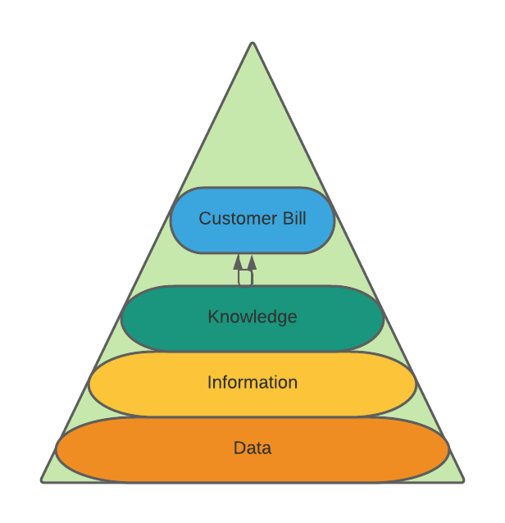
(Fig.3)
Knowledge is then transferred onto a bill for the customer to read and understand.
Information is passed on to agent to read and understand this is a customer’s bill.
Data is put into context and transformed into a bill.
Data is input on a computer with no context.

Appendix B

Shannon Weaver Model.

(Fig.1)

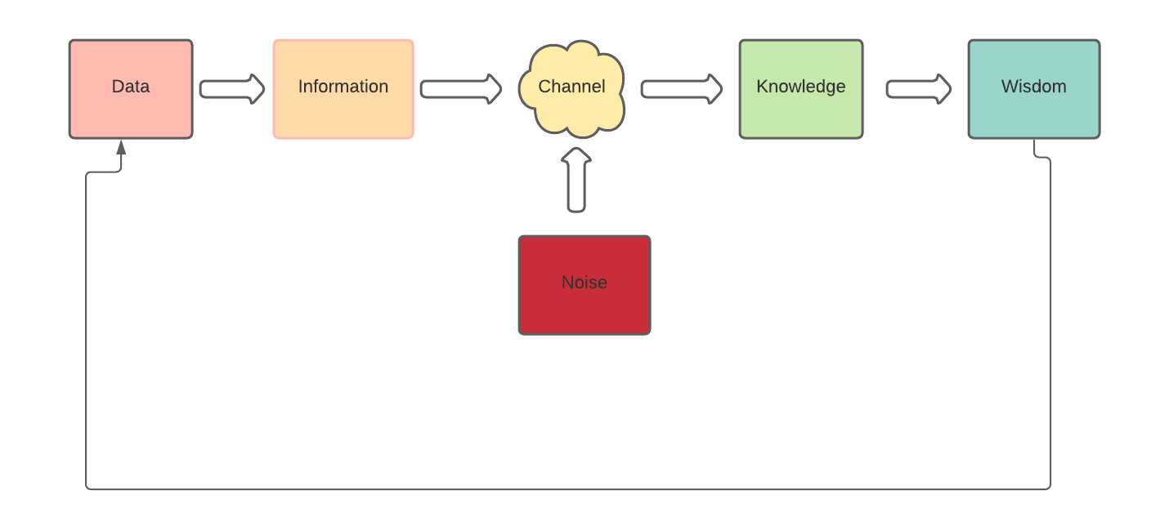
Appendix C

Organisation SWOT

- Knowledge  - Experience  - Reputation  - Customer service awards  - Branded products | - Turnover  - Outdated systems  - Poor online platform  - Complaints  - Staff shortage  - Sickness levels | - New products  - New contracts  - Cheaper energy tariffs  - Closure of smaller companies  - Government policy | - Competitors lower tariffs  - Consumer preference  - Regulations  - Social media  - Trade barriers  - Turnover  - Government policy

Appendix D

British Gas Logo



Appendix E

SECI Model

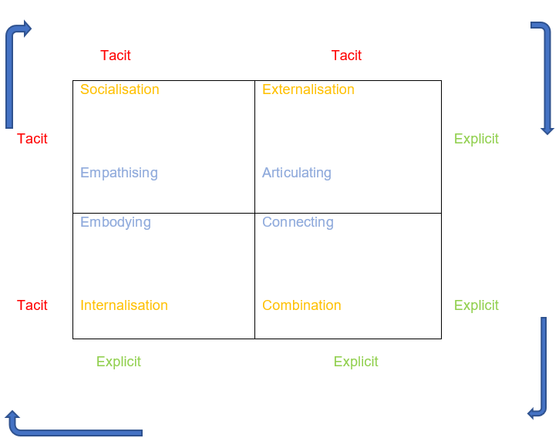

Appendix F

Flow chart

(Fig.1)

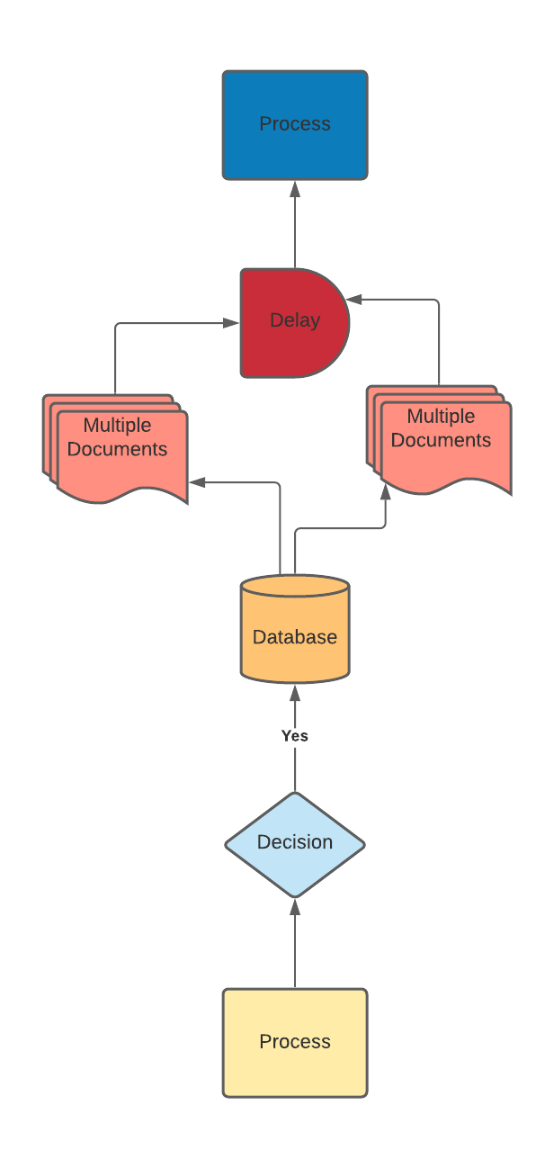
Process – customer on phone, agent needs to find out how to change information on bill.
Decision - Customer decides to check the knowledge hub for an answer or guidance.
Database - Organization’s knowledge platform - Knowledge hub
Multiple Documents – Agents needs to search multiple documents to find what she is looking for.
Delay – Agent is delayed getting back to the customer as it is taking a long time to find answers.
Process – Agent gets back to customer with Answers. By this time customer fed up and complains.

(Fig.2)
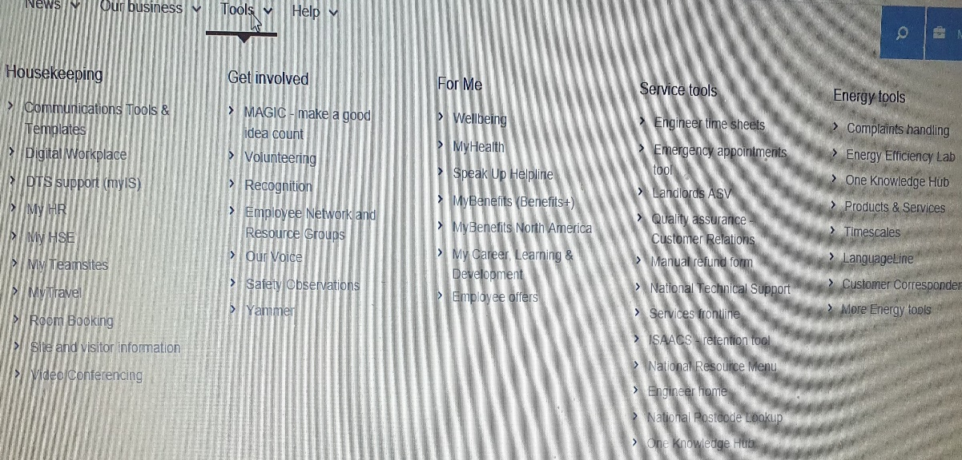

(Fig.3)
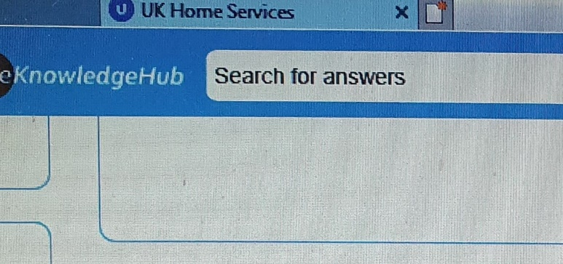

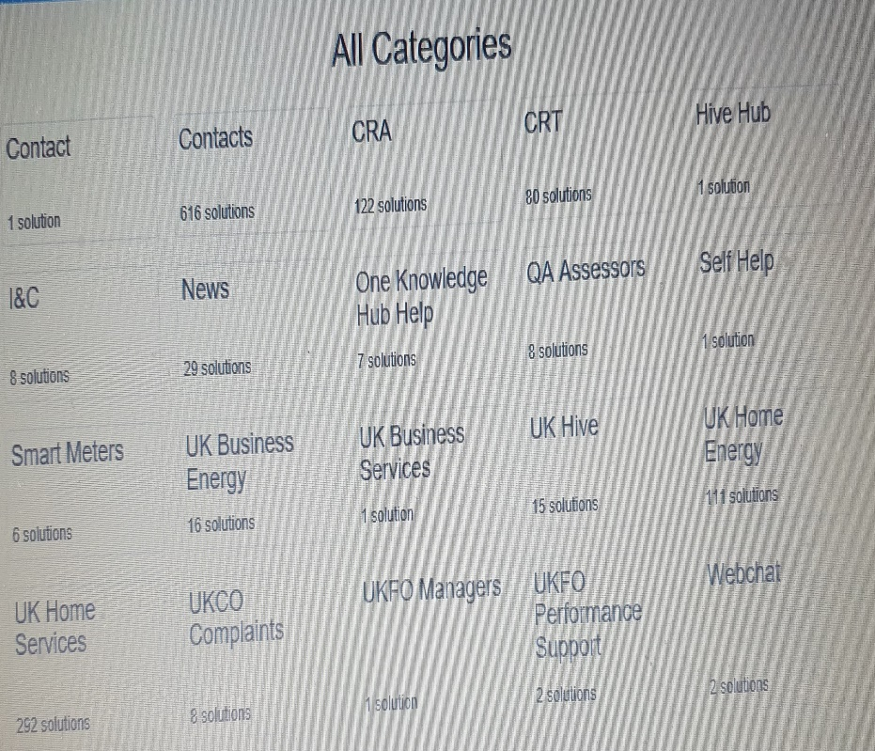
(Fig.4)

(Fig. 5)

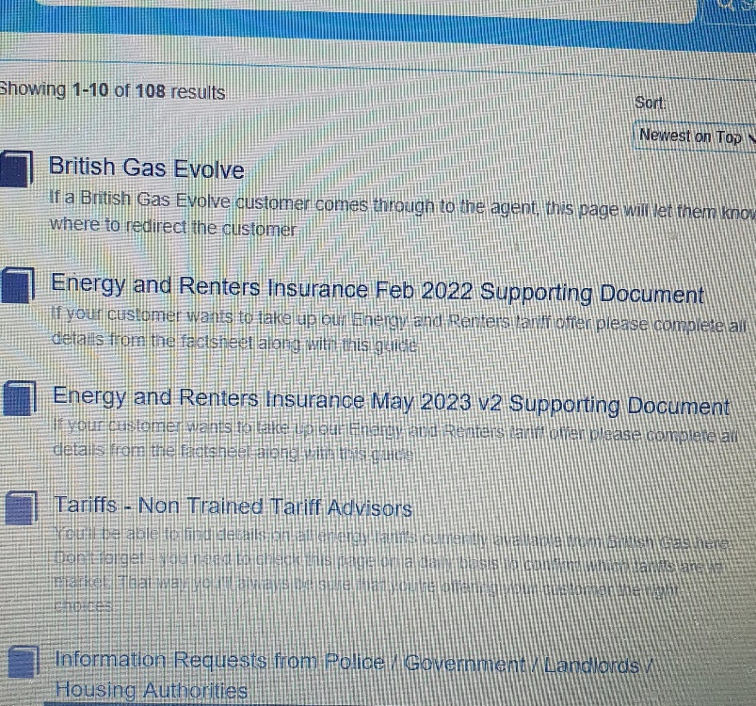

Appendix G

Employee Questionnaire Graph

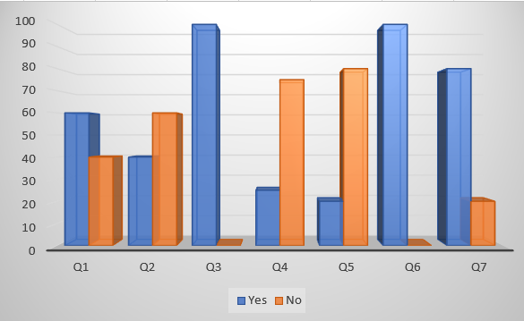

Q1 - if you have an enquiry and unsure of the answer, do you know where to find the information that will help you?
A – Yes 60% - No 40%
Q2 – Is the company knowledge page easy to use?
A – Yes 40% - No 60%
Q3 – Can you type in a search box to find what you are looking for?
A – Yes 100%
Q4 – Does it bring up only the relevant information you are looking for?
A – Yes 25% - No 75%
Q5 – Can you find the answer to your question in less than 5 minutes?
A – Yes 20% - No 80%
Q6 – Can your organisation’s knowledge page be better?
A – Yes 100% - No 0% give a suggestion on how the organization can make their knowledge guide better.
Q7 - Can you by sending a direct email to 1910919@student.uwtsd.ac.uk?
A – Yes 80% - No 20%

Appendix H

How the knowledge hub process should work
(Fig.1)

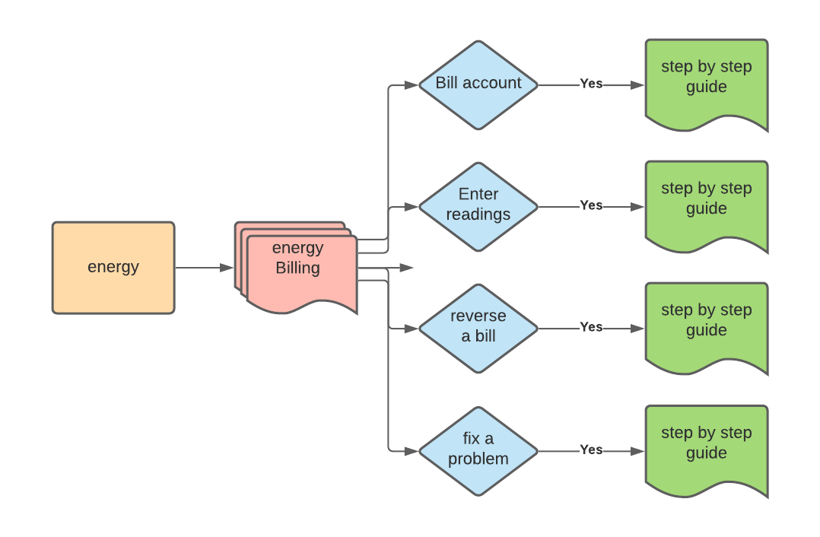

(Fig.2)


