Data Analysis

Introduction

This chapter presents the discussion of data collected from a questionnaire used to answer the objective of evaluating the public awareness of adverse childhood experiences and the links with criminality. All participants were exclusively 18 years of age or older, this criteria was established to ensure that all respondents had the legal capacity to provide informed consent and to maintain the relevance of the study to an adult population.The data collected has been systematically processed using thematice analysis and will be presented in the form of graphs and charts to enhance clarity and efficiency. Visual representations, such as bar charts, line graphs, and pie charts, provide an intuitive means of understanding trends, patterns, and correlations within the dataset (Tufte, 2001). These methods enable a concise yet comprehensive interpretation of the results, ensuring accessibility for a diverse audience (Few, 2012). The subsequent sections will detail the findings, utilising these visual tools to facilitate a structured and logical presentation of the data.

Age of Participants

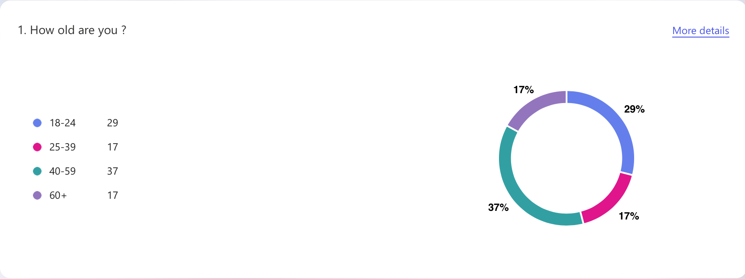
Table 1

Out of 100 participants, 29 were between the ages of 18-24,17 were between the ages of 25-39, 37 between 45-59 and 17 over the age of 60.Throughout this questionnaire,age can be an imperative factor as an individual's age can be crucial to their understanding and opinions regarding a subject such as ACEs or substance misuse.Age plays a crucial role in shaping opinions and understanding of adverse childhood experiences and criminality as a whole. Older generations may view ACEs as personal hardships to overcome, while younger people, influenced by modern psychology, recognise their lasting impact on mental health and addiction. Similarly, attitudes toward substance misuse differ,youth might see it as experimental or escapable, whereas older individuals often understand its deep-rooted connections to trauma. Awareness, life experience, and evolving research shape perspectives across generations(Tzouzara et al,2023).Linking to the public awareness of ACEs, there has always been a lack of education regarding ACEs especially regarding the older generations and this has a severe impact on their understanding of the subject and their ability to form opinions,whereas although there is still a lack of education,there there is a larger understanding of mental health and more support networks for individuals that may need them(Silva et al,2024).

Defining Adverse Childhood Experiences
Participants were asked to choice which experience they believed would class as an ACE,f the 99 people that answered the question, 82 stated that all of the above experiences classed an an ACE,21 stated that physical abuse classed as an ACE and 16 believed that sexual abuse classed as an ACE.
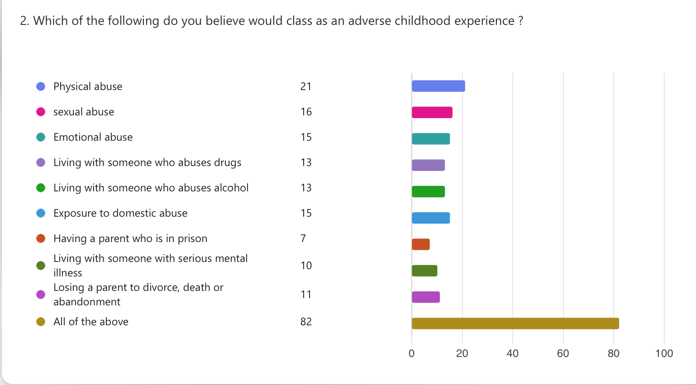Table 2
This shows that out of the responses a large quantity understand that ACEs are a varied range of experiences that can happen to a child that could impact their life.However, there is a further need for education to improve knowledge surrounding what an ACE actually is,from the 99 people that responded to the question,17 did not answer all of the above,13 of which were 40 and over,showing a lack of awareness of the subject within a certain age category(Hunt et al,2016).

Linking ACEs to criminality
For this question,participants were asked to what extent do they believe in this statement:
‘Criminal behaviour in adulthood can be linked to ACEs’
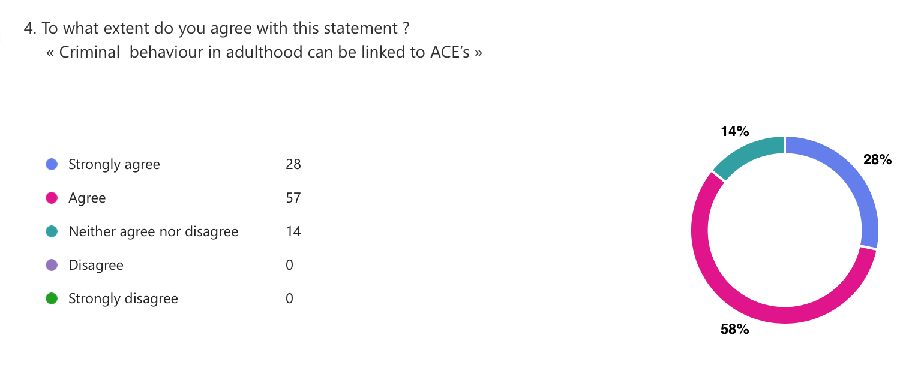
Table 3
The graph shows that out of the 99 respondents, a significant majority of respondents either agree 57 or strongly agree 28 that criminal behavior in adulthood can be linked to ACEs. Only 14% remain neutral, and no one disagrees. This overwhelming agreement suggests strong public awareness of the connection between early trauma and later criminality, likely influenced by growing research and societal discussions on the long-term effects of ACEs. The absence of disagreement further reinforces this understanding.Although the evidence clearly points to a connection between ACEs and criminality, it does not establish a direct cause-and-effect relationship. Not all people with ACEs commit crimes, despite evidence showing that trauma, emotional dysregulation, and socioeconomic circumstances raise the risk of criminal behaviour(Jahanshahi et al,2022). Despite childhood trauma, protective factors like education, support networks, and resilience can deter criminality. The intricacy of criminal behaviour is further shown by the fact that some people commit crimes without having experienced ACEs.

Awareness and education
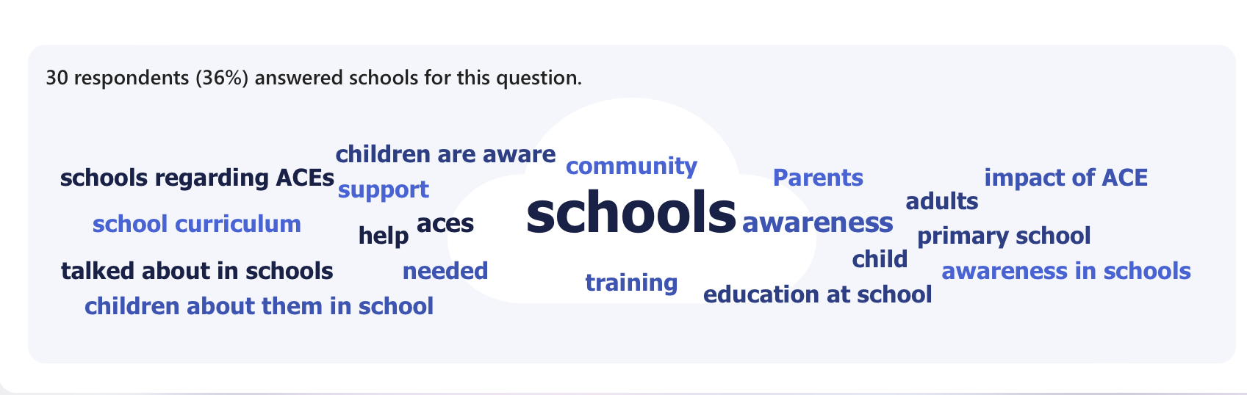
Table 4

When asked about more education and awareness on the impacts of ACE’s,83 responses varied the public's perception of ACEs and how they work .The most common response was that schools should play a major role in improving the awareness of ACE’s.Education in schools would potentially help to increase the awareness of what ACE’s are and how they can be spotted early to decrease the impact that they have (Bateman,2024).Education and awareness of ACE’s are crucial for supporting childrens mental and emotional well-being.Schools play a vital role in identifying,addressing and mitigating the effects of ACE’s by providing a safe supportive environment.Teachers and staff trained in trauma-informed practices can recognise signs of distress and connect students with necessary resources.Early intervention through education helps break cyclesnof trauma,fostering resilience and success.By prioritising awareness schools empower students to overcome adversity and thrive(Estyn,2020).As well as school,support,trainig and parents were also discussed,to further help with being able to increase awareness and education.

ACE’s having an impact on criminality.
For this question,participants were asked how far agree with the following statement on a scale of 1-5.
‘Do you believe that ACE’s have an impact on Criminality?’
On a scale of 1-5,1 being a significant impact and 5 being no effect,of the 99 responses,7 stated level 5,16 stated level 4,27 stated level 3,28 stated level 2 and 21 stated level 1.
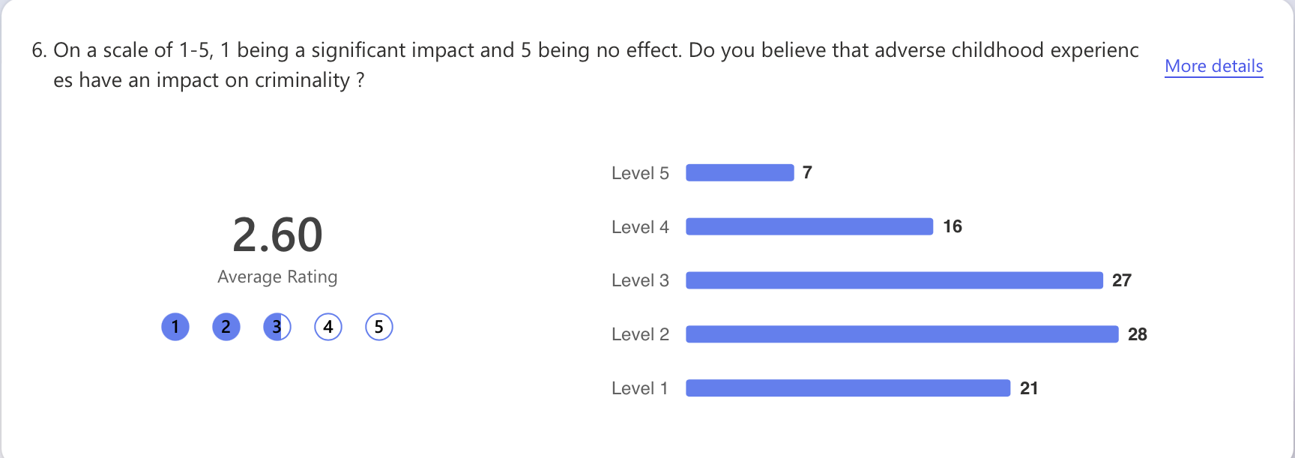
Table 5
These responses significantly show that the public believe that there is a link between ACE’s and criminality.After being asked to explain their answer to the question,many responded that it depended on the person,that they have a higher likelihood of leading to criminal behaviour.That the childs nature and childhood can lead to criminal activity.ACE’s can significantly impact criminality by increasing the risk of delinquency and future offences.Trauma,neglect and abuse can lead to poor impulse control,aggression,and risky behaviour.Without intervention,ACE’s can potentially contribute to cycles of crime,making early support and trauma care essential for prevention and rehabilitation(Cruz,2022).

ACE’s impact on brain development.
Out of 100 respondents,when asked about the impacts that ACE’s typically have on a child’s brain development,when given the options of; no impact,7 responses,Improved resilience and problem solving skills,28 responses,Can lead to changes in brain structure and function,82 responses and lastly,Only affects children with genetic predisposition to mental health issues,with with 11 responses.

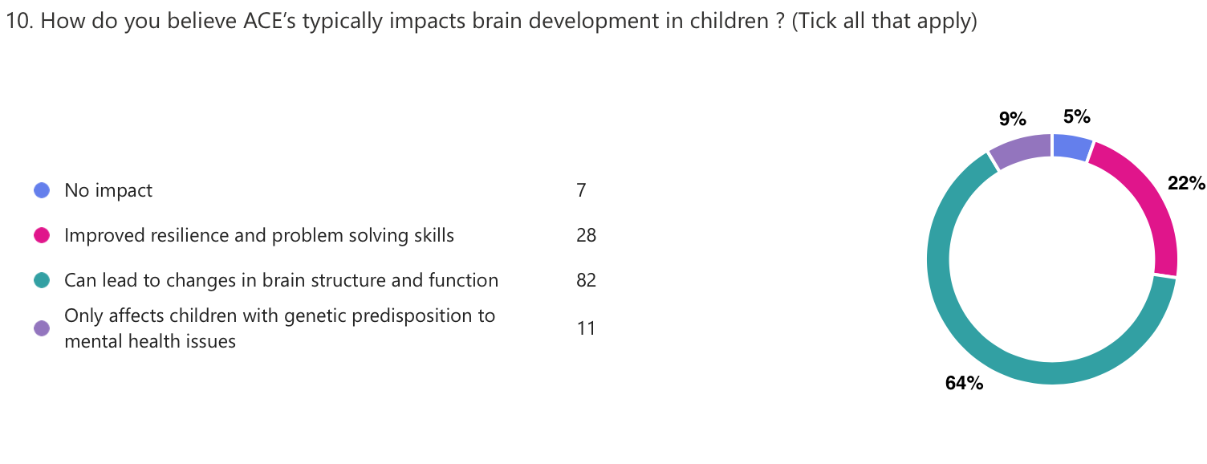
Table 6

These results indicate that with 64% of respondents believing that ACEs can lead to changes in brain structure and function, suggesting a strong public awareness of their neurological impact,it can reflect on the growing recognition of scientific research linking childhood trauma to long-term cognitive and emotional development issues. Additionally, the 22% that believe ACEs can improve resilience and problem-solving skills, demonstrate an understanding that while adversity can have negative effects, some individuals may develop coping mechanisms. However, the fact that 9% think ACEs only impact children with a genetic predisposition to mental health issues, and 5% believing there is no impact, indicates some misconceptions or a lack of awareness. These results highlight the importance of continued education on ACEs and their effects, as while most respondents acknowledge their significant influence, some still underestimate their widespread impact(Sheffler et al,2020). The data suggests increasing public understanding, likely due to broader discussions in psychology and social sciences.

ACE’s and health issues
The graph shows how the general public views the medical conditions associated with ACEs. The majority of respondents, who are aware of the behavioural and psychological effects of childhood trauma, link ACEs to substance abuse 34% and depression 33%. Nevertheless, despite studies showing the long-term physiological impacts of ACEs, only a small minority acknowledge connections to physical health disorders including diabetes 4%, and heart disease 4% as well. Interestingly, 26% of respondents chose "All of the above," suggesting a more comprehensive awareness of the extensive effects of ACEs.

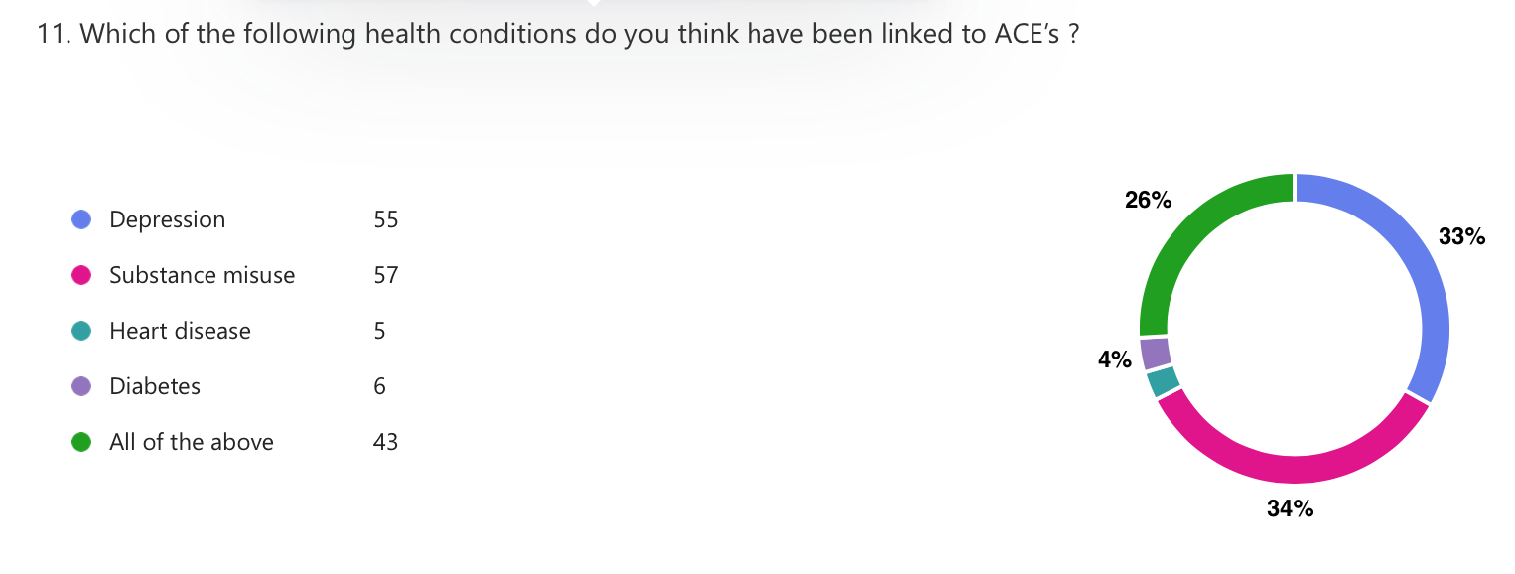
Table 7
These results imply that although the general population is reasonably aware of the negative effects of ACEs on mental health and addiction, less is known about their wider health implications. Given that substance abuse and mental health issues are risk factors for criminal behaviour, this relates to how people view criminality. Given the widespread understanding of these connections, it is possible that many people are aware of the ways in which early-life adversity influences behaviours that raise the risk of engagement with the criminal system.ACEs are still largely seen via a psychological or behavioural lens rather than as a public health issue, though, as evidenced by the ignorance around physical health repercussions. This constrained viewpoint could influence policy strategies by emphasising personal accountability over systemic change(Daníelsdóttir et al,2024). A more thorough strategy to crime prevention that emphasises early support over punitive responses to ACE-related behaviours may result from filling up knowledge gaps, especially with regard to how ACEs impact general well-being.

Can ACE’s be mitigated ?
After be asked whether ACE’s can be prevented or mitigated,there was a large variation of responses,between the 82 reponses, some said that ACE’s can be prevented or mitigated with certain tactics,,others were unsure and some said that they believe that they cannot be prevented mitigated.
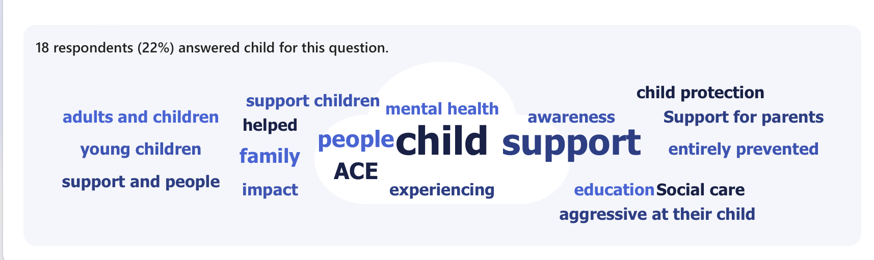
Table 8
This word cloud highlights key themes related to child support, ACEs (Adverse Childhood Experiences), and mental health. It suggests that awareness, education, and support for children, parents, and families can help mitigate the impact of ACEs. By increasing awareness of ACEs, more support systems such as social care, child protection, and education can be implemented to reduce negative outcomes(Addis et al ,2021). Providing resources to both children and adults ensures early intervention, which may prevent the long-term effects of trauma. The inclusion of words like "helped" and "support children" reinforces the idea that ACEs can be mitigated through targeted assistance and awareness.

Health issues associated with ACE’s
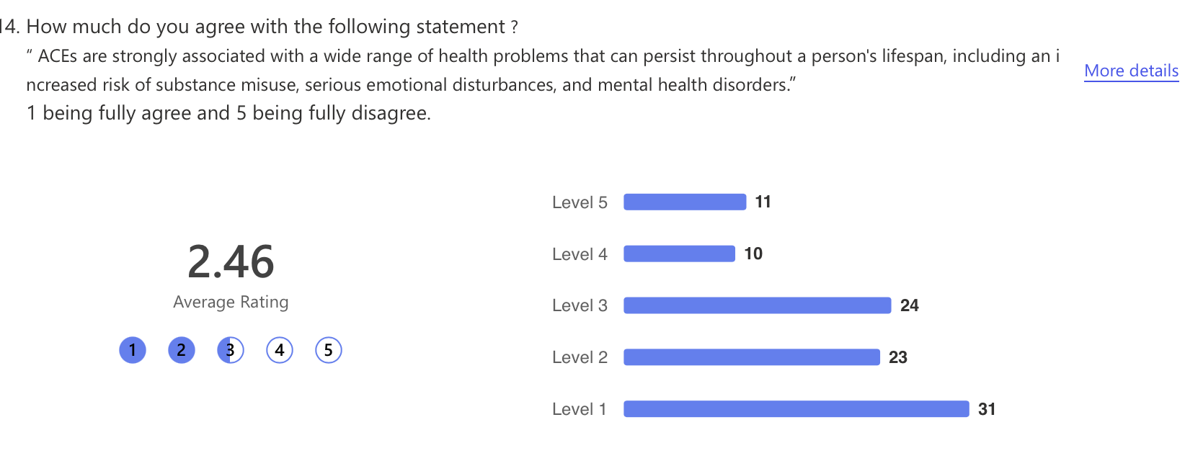
Table 9
This graph presents survey results on public agreement with the statement that ACEs are strongly linked to long-term health issues, including substance misuse and mental health disorders. The average rating of 2.46 indicates a general idea that the public beleive that ACEs have a significant impact on health. Notably, 31 respondents fully agreed, while only 11 fully disagreed. However, the presence of a large proportion of responses in Level 3 suggests that there is some uncertainty or gaps in knowledge. This reflects the various levels of public awareness, with some individuals recognising that ACEs' impact health but others remaining skeptical or uninformed. The conflicting answers emphasise the need for more information and understanding about ACEs and their long-term effects. Campaigns, education, and policy discussions aimed at raising public knowledge could enhance comprehension and promote actions that lessen the consequences of ACEs, thereby assisting in the reduction of related risks including substance misuse, criminal activity, and mental health issues(Stewart-Tufescu et al,2022).

ACE’s and Criminality
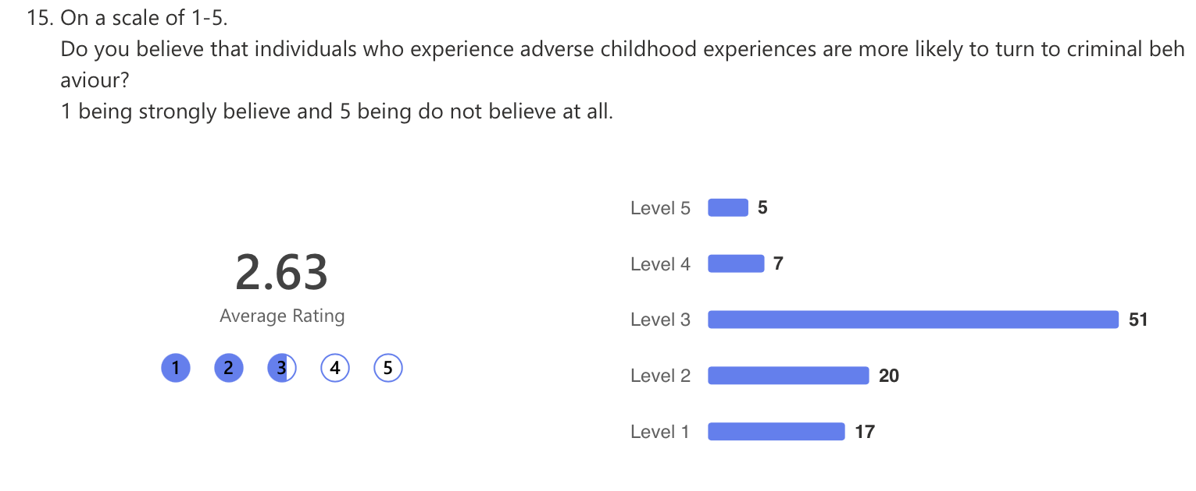
The survey's findings show that opinions on the relationship between criminal behaviour and ACEs are divided. There is a minor tendency to believe in this connection, with an average rating of 2.63, although a sizable portion is still unsure. 51 respondents selected Level 3, indicating ambivalence or a lack of strong belief, whereas 17 respondents strongly believe in the association. Just five people completely opposed the idea.According to this distribution, there is some but not much public awareness of ACEs and their long-term impacts, including possible behavioural repercussions. Although many respondents acknowledge that ACEs influence behaviour, they are unsure of how directly they relate to criminal action. These findings underline the importance of trauma-informed interventions in lowering the likelihood of adverse life outcomes and the necessity for additional education on the subject. Raising knowledge may cause the general public to view ACEs' wider societal impact more strongly(Morton et al,2022).

Therefore,to conclude,it can be noted that public awareness of ACEs and their long-term effects is growing, but there remains a lack of deep understanding specifically when looking at their connection to criminal behavior. The survey results indicate that while many people acknowledge a link between ACEs and negative life outcomes, uncertainty persists. This suggests that education and public discourse on ACEs need to be expanded, ensuring that people understand how early trauma influences emotional, behavioral, and social development(Gray et al,2021).ACE-related teaching should be incorporated into the criminal justice, healthcare, and educational sectors in order to raise awareness. People can learn more about the significance of trauma-informed approaches in prevention and rehabilitation through public campaigns, media coverage, and professional training. Raising awareness may also aid in changing public attitudes, lessening the stigma associated with childhood hardship and encouraging early intervention techniques(Doors,2023)

Reference list
Addis, S., Wey, T., Toll, E. and Hopkins, J. (2021). What Works to Prevent Adverse Childhood Experiences (ACEs) at the Community Level? an Evidence Review and Mapping Exercise. [online] Available at: https://phwwhocc.co.uk/wp-content/uploads/2022/02/What-Works-to-Prevent-ACEs-at-the-Community-Level.-An-Evidence-Review-Mapping-Exercise-Full-Report.pdf.
[Accessed; 8th March 2025]
Cruz, D., Lichten, M., Berg, K. and George, P. (2022). Developmental trauma: Conceptual framework, associated risks and comorbidities, and evaluation and treatment. Frontiers in Psychiatry, [online] 13(800687), pp.1–14. doi:https://doi.org/10.3389/fpsyt.2022.800687.
Daníelsdóttir, H.B., Aspelund, T., Shen, Q., Halldorsdottir, T., Jakobsdóttir, J., Song, H., Lu, D., Kuja-Halkola, R., Larsson, H., Fall, K., Magnusson, P.K.E., Fang, F., Bergstedt, J. and Valdimarsdóttir, U.A. (2024). Adverse Childhood Experiences and Adult Mental Health Outcomes. JAMA Psychiatry, [online] 81(6). doi:https://doi.org/10.1001/jamapsychiatry.2024.0039.
Doors, R. (2023). Department for Levelling Up, Housing and Communities Trauma-informed Approaches to Supporting People Experiencing Multiple Disadvantage a Rapid Evidence Assessment. [online] Available at: https://assets.publishing.service.gov.uk/media/642af3a77de82b000c31350d/Changing_Futures_Evaluation_-_Trauma_informed_approaches_REA.pdf. [Accessed; March 2025].
Estyn (2020). Knowing your children -supporting pupils with adverse childhood experiences (ACES). [online] Available at: https://www.estyn.gov.wales/system/files/2022-01/Knowing%2520your%2520children%2520%2520supporting%2520pupils%2520with%2520adverse%2520childhood%2520experiences_0.pdf [Accessed; 12 March 2025]
Few, S. (2012). Show Me the Numbers Designing Tables and Graphs to Enlighten. 2nd Edition, Analytics Press, Montgomery. - References - Scientific Research Publishing. [online] Scirp.org. Available at: https://www.scirp.org/reference/referencespapers?referenceid=2944983
[Accessed; March 2025].

Gray, P., Smithson, H. and Jump, D. (2021). Serious youth violence and its relationship with adverse childhood experiences. [online] Available at: https://www.justiceinspectorates.gov.uk/hmiprobation/wp-content/uploads/sites/5/2021/11/Academic-Insights-Gray-et-al.pdf . [Accessed; 10 March 2025].
Hunt, T.K.A., Slack, K.S. and Berger, L.M. (2017). Adverse childhood experiences and behavioral problems in middle childhood. Child Abuse & Neglect, [online] 67, pp.391–402. doi:https://doi.org/10.1016/j.chiabu.2016.11.005.
Jahanshahi, B., Murray, K. and McVie, S. (2021). ACEs, Places and Inequality: Understanding the Effects of Adverse Childhood Experiences and Poverty on Offending in Childhood. British Journal Of Criminology, 62(3). doi:https://doi.org/10.1093/bjc/azab079.
Morton, S., Curran, M. and Barry O’Gorman, M. (2022). Adverse Childhood Experiences, Domestic Violence and Substance Misuse: An Action Research Study on Routine Enquiry and Practice Responses. Frontiers in Psychiatry, [online] 13. doi:https://doi.org/10.3389/fpsyt.2022.892849.
Sheffler, J.L., Piazza, J.R., Quinn, J.M., Sachs-Ericsson, N.J. and Stanley, I.H. (2019). Adverse Childhood Experiences and Coping strategies: Identifying Pathways to Resiliency in Adulthood. Anxiety, Stress, & Coping, [online] 32(5), pp.594–609. doi:https://doi.org/10.1080/10615806.2019.1638699.
Silva, C., Moreira, P., Moreira, D.S., Rafael, F., Rodrigues, A., Leite, Â., Lopes, S. and Moreira, D. (2024). Impact of Adverse Childhood Experiences in Young Adults and Adults: A Systematic Literature Review. Pediatric Reports, [online] 16(2), pp.461–481. doi:https://doi.org/10.3390/pediatric16020040.
Tufte, E.R. (2001). The Visual Display of Quantitative Information. Taxon, [online] 38(3), p.451. doi:https://doi.org/10.2307/1222290.
Tzouvara, V., Kupdere, P., Wilson, K., Matthews, L., Simpson, A. and Foye, U. (2023). Adverse childhood experiences, mental health, and social functioning: A scoping review of the literature. Child Abuse & Neglect, [online] 139. doi:https://doi.org/10.1016/j.chiabu.2023.106092.
.

