
Strategic Management Analysis of British Airways: A Strategic Management Report
Submitted by: Rezaul Karim
Student ID: 2436008
Lecturer: Hoang Nguyen
Submission Date: 11th August 2026

Table of Contents
Introduction 3
Section 1: Organisational Context and Overview 4
1.1 Organisational Background and legacy 4
1.2 Business Model and Market Position 4
Section 2: External and Internal Analysis 5
2.1 PESTEL Analysis 5
2.2 VRIO Analysis & Value Chain Analysis 7
2.3 SWOT Analysis 8
2.4 TOWS Matrix Analysis 9
Section 3: Comprehensive and Holistic View 9
3.1 CSR Strategy and Alignment with Business Objectives 9
3.2 Balanced Scorecard Analysis 10
Section 4: Strategic Choices and Implementation 11
4.1 Strategic Choices at the Business Level 11
4.2 Implementation and Competitive Advantage 13
Action Plan 16
Reference List 17

Introduction
Strategic management is an ongoing, systematic process in which modern business organisations analyse the macro-environment of their operating environment, assess their internal resource capabilities, design competitive positioning strategies and design the implementation frameworks for their deployment to create sustainable competitive advantage. According to Barney and Hesterly (2015), strategic management is a disciplined process of diagnosis and action that greatly increases the likelihood that a firm will select strategies that will create superior economic value relative to the industry rivals. This involves an awareness of the dynamic macro-environment and senior leadership to be monitoring, analysing and responding to external influences that are impacting on their industry.
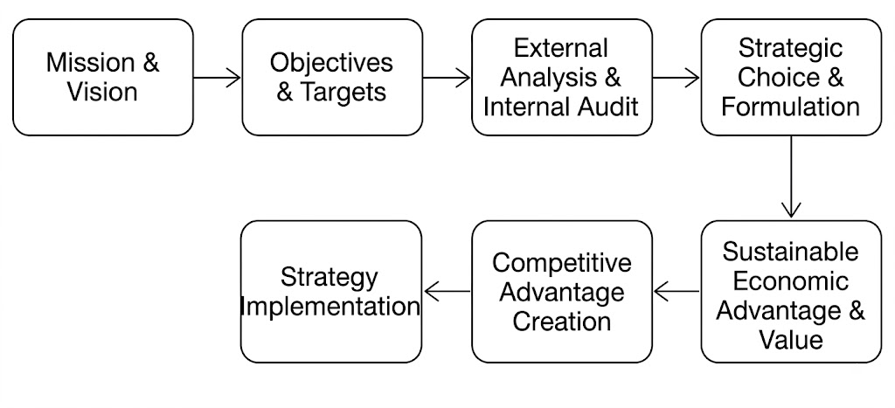
FIGURE 1: The Sequential Strategic Management Process
This report presents a complete strategic management analysis of British Airways (BA) the UK’s flag-carrier airline and a main operating subsidiary of International Airlines Group (IAG). British Airways strategic evaluation is an interesting one because of the structural complexity and volatility of the global commercial aviation industry. The airline industry is at the crossroads of intense global competition, changing passenger habits after the pandemic, technological change, complex labor relations and strict environmental decarbonisation requirements. Furthermore, BA's strategy is very much based on its leadership position in the Oneworld alliance and the transatlantic Atlantic Joint Business (AJB) with American Airlines, Iberia and Finnair. This is an illustration of how international cooperation via alliances improves the density of international routes, operational efficiencies and market access.
The report is intended to critically analyse the existing strategy of British Airways (BA) and to analyse the value proposition of the strategy. It then offers practical suggestions to improve the competitive position of BA in the long term. The report is prepared as an external Strategic Management Consultant and reports directly to the Board of Directors of British Airways and IAG. The report is organised in 4 main sections and then a formal self-reflection. The report ends with a reflective piece on the structure of Gibbs' Reflective Cycle.

Section 1: Organisational Context and Overview

1.1 Organisational Background and legacy
British Airways has a history of more than 100 years, starting with the establishment of Aircraft Transport and Travel Limited in 1919, which launched the world's first daily scheduled international air service between London and Paris. British Airways PLC was established in April 1974 as a result of a series of government-mandated mergers and nationalisations of British Overseas Airways Corporation (BOAC) and British European Airways (BEA). The airline was privatised in 1987 by the UK government, bringing in the discipline of the commercial market. In January 2011, BA joined forces with Spanish flag-carrier Iberia to form International Airlines Group (IAG), a dual-listed holding company which has grown into one of the world’s largest airline groups.
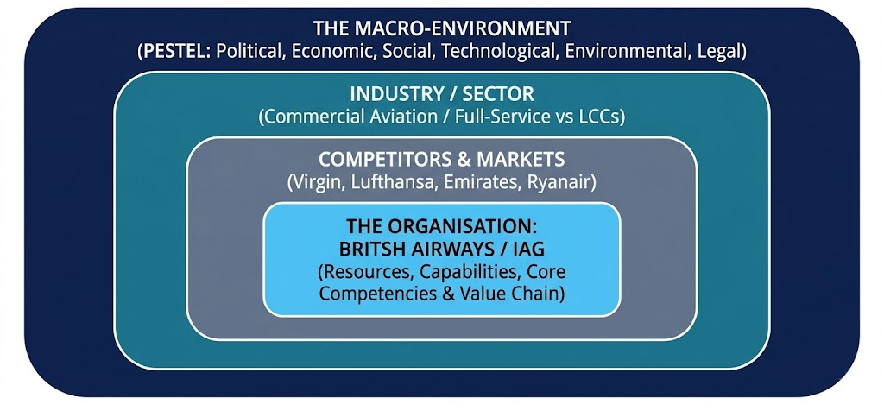
FIGURE 2: Layers of the Business Environment
Such long-term institutional evolution creates BA’s non-replicable historical brand equity and path-dependent assets. Today British Airways is the UK’s main flag carrier with an operational fleet of over 250 wide body and narrow body aircraft, employs around 30,000 people and flies over 39.8 to 40 million people a year to over 170 to 200 destinations worldwide in 74 to 80 countries. The company's annual turnover ranges from £14.3 billion to £14.7 billion and its latest full-year results show a net profit of £1.166 billion. BA’s stated corporate purpose ‘To connect Britain with the world and the world with Britain’ is consistent with its historic motto ‘To fly. To serve’. The mission and purpose of an organization are strategic anchors that are important and should be used as a benchmark for all future market expansion options, as Johnson et al (2017) and Lynch (2022) state.

1.2 Business Model and Market Position
British Airways' business model is a typical full service, premium airline, operating from a hub-and-spoke network, with the main hub at London Heathrow Airport (LHR) and secondary hubs at London Gatwick (LGW) and London City (LCY). LHR is an important international hub, enabling BA to transfer short-haul domestic and European passengers onto high-yielding, profitable long-haul international flights. The main revenue streams of BA are: a) scheduled passenger operations, in four cabin classes: Economy (World Traveller), Premium Economy (World Traveller Plus), Business Class (Club World / Club Suite) and First-Class b) cargo freight services (BA World Cargo) c) loyalty monetisation (Avios Executive Club) and d) ancillary travel packages (hotels, car rentals, insurance).
Table 1: British Airways' Principal Competitor Matrix and Strategic Positioning
Competitor Group | Key Rivals | Primary Basis of Competition | Hub Focus & Market Strategy
Full-Service Network Carriers | Virgin Atlantic, Lufthansa, Air France | Premium service quality, cabin innovation, corporate accounts and global alliance networks. | London Heathrow/Gatwick, Frankfurt, Paris CDG; focus on high-yield long-haul trunk routes.
Gulf 'Super-Connectors' | Emirates, Qatar Airways, Etihad | State-backed capital, luxury inflight product, modern wide-body fleets, global One-stop connectivity. | Middle East super-hubs (Dubai, Doha); transit traffic connecting EU/US with Asia, Africa, and Australia.
Low-Cost Budget Carriers (LCCs) | Ryanair, easyJet, Wizz Air | Price leadership, point-to-point operational efficiency, high fleet utilization, low overheads. | Secondary regional airports; unbundled ancillary pricing, dense short-haul European routes.
Alliance Joint-Business Partners | American Airlines, Iberia, Finnair | Revenue sharing, coordinated schedules, pooled frequent flyer benefits, antitrust immunity. | Transatlantic joint business (AJB); co-managed flight schedules and slot sharing across LHR, JFK, MAD.
An important lesson in the commercial model of BA is the concept of “Business Class as the Profit Engine”. Economy class provides volume and capacity utilisation, but low margins and price competition from low-cost budget carriers. In contrast, premium business cabins take up a smaller percentage of total aircraft space, but contribute disproportionately large share of total flight revenue and net profit margin. The net profitability of premium business seats is exponential because the basic costs of operating an aircraft (fuel, flight crew, navigation fees, airport slot charges) are relatively constant, irrespective of the mix of cabin types. BA’s strategic positioning is thus to defend its premium value proposition from budget rivals (easyJet, Ryanair) and full-service international network carriers.

Section 2: External and Internal Analysis

2.1 PESTEL Analysis
The macro-environment of British Airways is analysed using the six dimensions of PESTEL to identify the key external opportunities and threats.
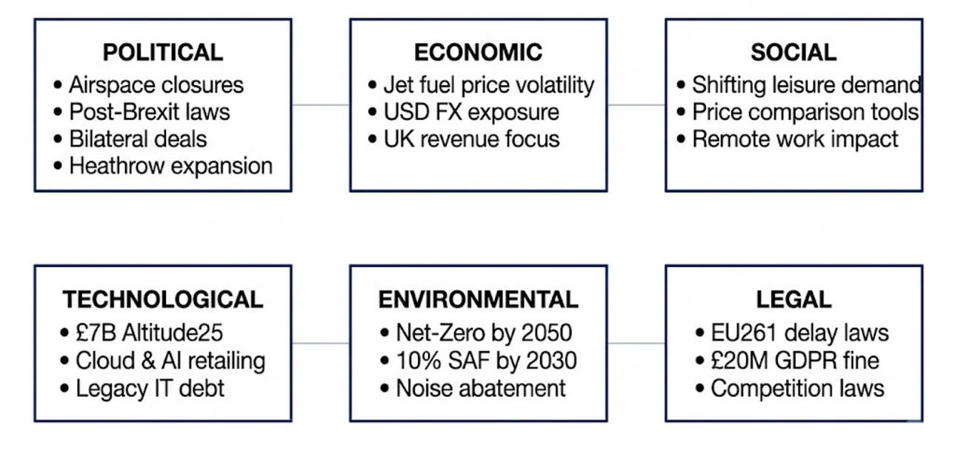
FIGURE 3: The PESTEL Macro-Environmental Framework
Table 2: PESTEL Matrix for British Airways with Operational & Financial Impacts
Dimension | Critical External Macro Trends | Direct Strategic & Financial Impact on BA
Political | • Post-Brexit bilateral aviation deals.  • Geopolitical airspace bans (Russia/Ukraine).  • Heathrow 3rd runway political delays. | • Rerouting around closed airspaces increases flight durations and fuel burn; bilateral constraints restrict route growth.  • Threat of business relocation over LHR capacity limitations.
Economic | • Jet fuel commodity price volatility.  • Exchange rate exposure (GBP vs. USD/EUR).  • Below-average margin compared to industry benchmarks. | • High exposure to USD fuel and aircraft lease costs.  • Heavy sales concentration in UK/US markets (50% UK).  • Profitability vulnerable to transatlantic recessions.
Social | • Digital price transparency and aggregators.  • Rise of remote working and video conferencing.  • Public backlash to unbundled short-haul food service. | • Zero customer switching costs increase price sensitivity.  • Structural softness in routine corporate travel offset by surging premium leisure demand.
Technological | • £7 Billion Altitude25 modernization plan.  • AI retailing (Amadeus Nevio platform).  • In-flight Wi-Fi fleet integration. | • Phase-out of legacy technical debt via cloud migration.  • Biometric boarding gates and predictive maintenance improve On-Time Performance (OTP) and dynamic pricing.
Environmental | • UK SAF Mandate (10% SAF usage by 2030).  • Net-Zero 2050 / 'BA Better World' commitment.  • Airport noise pollution restrictions. | • Accelerates fleet renewal (A350/B787 deliver 20-35% fuel savings) and reduction in cabin plastics.  • Higher short-term compliance and SAF procurement costs.
Legal | • EU261 passenger delay compensation rules.  • UK GDPR data protection regulations.  • Antitrust immunity for joint alliances. | • Financial exposure from mandatory delay refunds.  • Severe financial and reputational penalties from GDPR data breach fines.

2.2 VRIO Analysis & Value Chain Analysis
Use the VRIO framework of Barney and Hesterly (2015) to audit BA's tangible and intangible asset base to assess internal resources and capabilities.
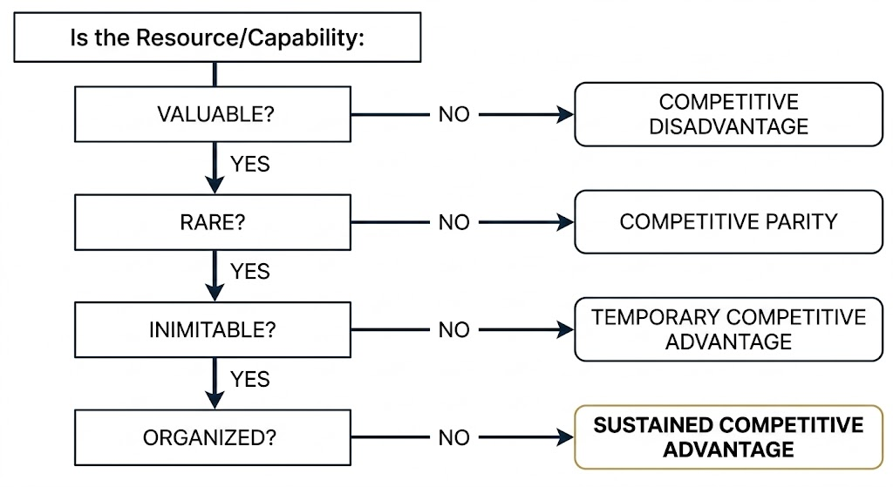
FIGURE 4: The VRIO Diagnostic Decision Tree
Table 3: VRIO Resource & Capability Audit for British Airways
Resource / Asset Base | Valuable? | Rare? | Inimitable? | Organised? | Competitive Performance Implication
100+ Year Brand Equity & UK Flag Identity | Yes | Yes | Yes  (Path-dependent) | Yes | Sustained Competitive Advantage  Historical brand trust commands premium pricing.
London Heathrow (LHR) Slot Portfolio | Yes | Yes | Yes  (Capacity constraint) | Yes | Sustained Competitive Advantage  Structural barrier to entry at UK gateway.
Atlantic Joint Business & Oneworld Alliance | Yes | Partial | Yes  (Antitrust immunity) | Yes | Sustained Competitive Advantage  Unmatched transatlantic network density.
Avios Executive Club Loyalty Scheme | Yes | No | Partial | Yes | Temporary Advantage / Competitive Parity  High customer retention, but rivals have similar programs.
AI Analytics & Risk Management Systems | Yes | Yes | No  (Replicable) | Y | -
The Porter's Value Chain framework can also be used to illustrate how primary and support activities create value in BA's operations, in addition to VRIO diagnostics:
- Inbound Logistics: Strategic jet fuel, sustainable local catering, and next-generation engine components.
- Operations: managing flight operations at LHR Terminal 5, predictive maintenance, load control and maintenance facilities at Gatwick.
- Outbound Logistics Scheduling flights at various hubs around the world, managing bags and making smooth connections for Oneworld connecting passengers.
- Marketing & Sales: Targeted digital campaigns, monetisation of Avios frequent flier, corporate B2B contracts and premium cabin branding.
- In-flight dining, Club Suite product delivery, 24/7 digital concierge support and passenger compensation management.
- Support Activities: Firm Infrastructure (IAG centralised risk management), Human Resource Management (pilot upskilling and union negotiations), Technology Development (£7B Altitude25 program), and Procurement (bulk fleet acquisition).

2.3 SWOT Analysis
Synthesizing the PESTEL and VRIO diagnostics yields a consolidated SWOT matrix.
Table 4: Comprehensive SWOT Analysis Matrix for British Airways
STRENGTHS (Internal Assets & Competencies) | WEAKNESSES (Internal Operational Shortfalls)
1. 100+ year flag-carrier brand equity.  2. LHR slot portfolio at capacity-constrained hub.  3. Atlantic Joint Business & Oneworld alliance.  4. Premium business class profit engine.  5. IAG group financial scale & capital backing. | 1. High legacy cost structure vs LCC rivals.  2. Historical pilot/crew labor strikes.  3. High revenue concentration in UK/US (79%).  4. Customer service rating volatility & refund issues.  5. Technical debt in legacy IT infrastructure.
OPPORTUNITIES (External Market Trends) | THREATS (External Environmental Risks)
1. Surging demand for premium leisure travel.  2. £7B Altitude25 AI digital transformation.  3. Route expansion in Asia, Africa & South America.  4. SAF leadership & 'BA Better World' branding.  5. Cargo freight optimization on long-haul routes. | 1. Fierce LCC short-haul competition (Ryanair, easyJet).  2. Gulf super-connector long-haul expansion.  3. Jet fuel price volatility & USD exchange risk.  4. Structural shift to Zoom/remote corporate work.  5. Strict EU261 passenger delay penalties & GDPR fines.

2.4 TOWS Matrix Analysis
The TOWS Matrix is a tool that helps to create effective strategic options by combining external opportunities and threats with internal strengths and weaknesses.
Table 5: TOWS Strategic Options Matrix for British Airways
TOWS Matrix Options | EXTERNAL OPPORTUNITIES (O) | EXTERNAL THREATS (T)
STRENGTHS (S) | SSTRATEGIES (Leverage Strengths for Growth):  • SO1: Utilize LHR slot dominance and brand equity to open high-yield routes in emerging markets (Asia, South America). | STRATEGIES (Use Strengths to Shield Risks):  • ST1: Leverage the Atlantic Joint Business revenue-sharing structure to absorb fuel price volatility and counter Gulf competition.
WEAKNESSES (W) | STRATEGIES (Overcome Weaknesses via Opps):  • WO1: Establish multi-year union profit-sharing contracts during digital upskilling to eliminate strike-related delays. | STRATEGIES (Minimize Weaknesses & Threats):  • WT1: Execute the £7B Altitude25 program to replace legacy IT and cap forward fuel derivatives at 70% to avoid losses.

Section 3: Comprehensive and Holistic View

3.1 CSR Strategy and Alignment with Business Objectives
British Airways’ Corporate Social Responsibility (CSR) program ‘BA Better World’ is based on three strategic pillars: People, Planet and Responsible Business. On the environmental side, BA is committed to Net-Zero carbon emissions by 2050 with interim targets to operate with 10% Sustainable Aviation Fuel (SAF) by 2030 in line with the UK SAF Mandate. Operational measures include a 14% decrease in net carbon intensity since 2019 and a 18% decrease in cabin single-use plastics since 2022, while capital investments are made in quieter and fuel-efficient aircraft (Airbus A350, Boeing 787). Socially, BA supports UK community initiatives thru the BA Better World Community Fund and its Flying Start partnership with Comic Relief which has raised over £28 million to £30 million for disadvantaged children, along with raising £1.8 million for global emergency appeals via the Disasters Emergency Committee (DEC).
This leads to a key question for the use of Fogel's (2016) Strategic Sustainability Lens: is BA Better World truly part of BA's business models or is there a conflict between growth of commercial aviation and environmental decarbonisation? More passengers flying . The fuel consumption per seat-kilometer will be reduced, but the total carbon emissions will be increased by nature. However, the BA partially fills this gap by connecting environmental objectives with investments that have commercial returns. Meanwhile, the addition of A350 and B787 aircraft to the fleet modernises the fleet, thereby cutting carbon burn and direct fuel operating costs. This is for both financial and environmental goals. Further, by focusing on high-yield Business Class passengers, BA can earn more revenue per tonne of carbon emitted than high-density budget models. BA can therefore adopt a less carbon-intensive growth strategy, per pound of revenue generated.

3.2 Balanced Scorecard Analysis
The corporate vision of BA is operationalised thru the use of the Balanced Scorecard framework of Kaplan and Norton (1992) which translates the corporate vision into operational objectives, performance measures, targets and strategic initiatives for each of four perspectives.
Table 6: Upgraded Balanced Scorecard Matrix for British Airways
Perspective | Strategic Objective | Key Performance Indicator (KPI) | Target & Strategic Initiative
Financial | • Improve profitability and cost discipline.  • Reduce net debt burden. | • Operating Margin % (15.2% in 2025 pre-exceptionals).  • Net debt balance (£7.5B peak). | • Target 10%–15% EBIT margin; optimize premium cabin revenue; delever £7.5B net debt balance.
Customer | • Elevate passenger NPS and premium service.  • Improve punctuality. | • Net Promoter Score (NPS).  • Customer retention rate.  • On-Time Performance (OTP %). | • Increase NPS by 12 points; reconfigure A380 fleets (110 upper-deck Club Suites) and lounges.
Internal Processes | • Modernize legacy IT debt.  • Enhance maintenance.  • Operational resilience. | • Transformation completion  • Maintenance turnaround speed.  • System outage frequency. | • Execute 1,000+ Altitude25 projects; acquire Gatwick engineering hub; deploy Amadeus AI retailing software.
Learning & Growth | • Digital skill upskilling.  • Improve labor relations.  • Embed CSR culture. | • Training completion rate %.  • Employee Engagement Index.  • Staff turnover rate. | • Embed sustainability in induction; establish joint labor-management panels to align incentives and prevent strikes.
When read in sequence, the Balanced Scorecard shows a logical causal chain: Investment in workforce upskilling and joint labour panels (Learning & Growth) enables a seamless roll-out of the £7B Altitude25 program (Internal Processes). Better maintenance turnaround times and upgraded IT systems directly affect flight punctuality and cabin comfort (Customer Perspective) and therefore operating margin (15.2%) and continued profit growth (Financial Perspective).

Section 4: Strategic Choices and Implementation

4.1 Strategic Choices at the Business Level
Generic Strategies & Bowman's Strategy Clock
At the business level, British Airways has to choose one of Michael Porter’s (1980) generic competitive strategies; Cost Leadership, Broad Differentiation or Focused Differentiation. BA has a legacy cost structure, multi-cabin operations and high LHR hub landing charges, which makes it impossible for BA to follow a Broad Cost Leadership strategy. Budget airlines like Ryanair and easyJet have lower cost bases than BA, which would have to match them to maintain brand equity.
Focused Differentiation strategy is the most appropriate strategy for BA as it targets price insensitive, high-yield corporate travellers and premium leisure travellers. From the Bowman's Strategy Clock perspective, BA is in Position 1 (Focused Differentiation) offering high perceived product benefits at high prices. This approach focuses on high-end cabin comfort (Club Suite), LHR Terminal 5 lounge ecosystems, smooth digital retailing and operational on-time performance, safeguarding high-margin corporate yields.
Porter's Five Forces Validation
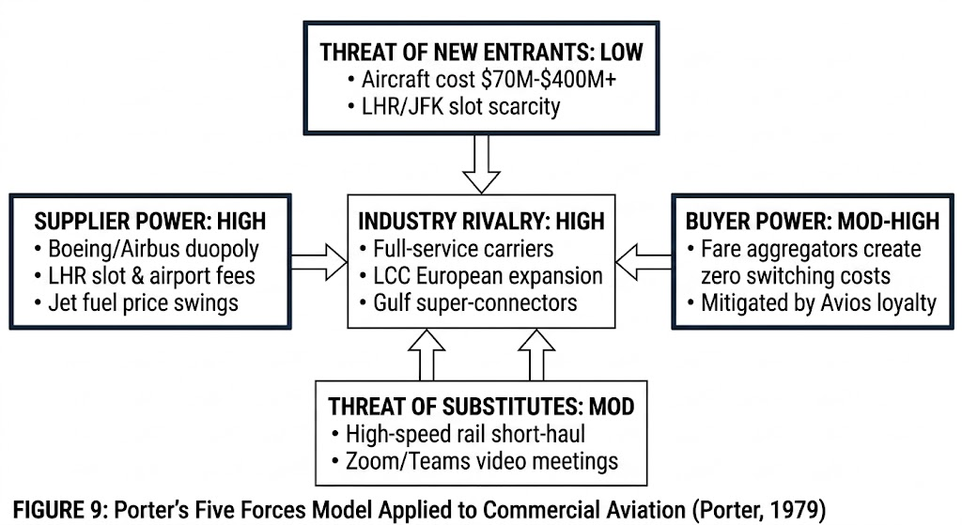
FIGURE 5: Porter's Five Forces Model Applied to Commercial Aviation
- Competitive Rivalry (High): High competitive rivalry among full service network carriers, Gulf super connectors and short haul LCCs. The shield of focused differentiation is for BA. It wins the loyalty of the corporate buyers who value the density of the flight schedule over the ticket price.
- Supplier Power (High): Aircraft manufacturers are in a concentrated duopoly (Boeing and Airbus) and monopoly airport hub pricing (LHR) and fuel suppliers. The high ticket margins also help BA to withstand the higher costs of its suppliers than low-margin budget airlines.
- Digital aggregators lower search costs for retail passengers (Buyer Power: Moderate to High). Corporate customers are less price sensitive, they want schedule density, proximity to the LHR hub and the benefits of Executive Club Avios.
- High capital requirements ($70M to $400M+ for commercial jets) and limited slots at LHR/JFK (regulated) provide high barriers to entry for incumbents.
- Threat of Substitutes (Moderate): High-speed rail on short-haul European legs, video conferencing tools (Zoom/Teams) to reduce routine corporate travel. Focused differentiation is directed at long-haul transatlantic routes where physical air travel is still irreplaceable.
Ansoff Matrix Application
Table 7: Ansoff Growth Vector Matrix Applied to British Airways
Strategy Vector | Strategic Application to British Airways | Specific Concrete Initiatives
Market Penetration | Deepen market share among existing UK and US corporate and premium leisure travelers in core LHR transatlantic markets. | • Avios loyalty program gamification.  • Personalized digital marketing via AI.  • Corporate schedule optimization.
Product Development | Introduce upgraded premium travel products and digital services to elevate customer differentiation and yield per seat. | • Fleet-wide Club Suite cabin rollouts.  • A380 upper-deck 110-seat business conversion.  • Amadeus Nevio AI digital retailing platform.
Market Development | Expand route network footprint into high-growth, non-saturated geographic markets to reduce UK/US revenue risk. | • Launch direct routes into emerging hubs across Asia, Africa, and South America.  • Expand secondary feeder codeshares.
Diversification | High-risk expansion into broader travel ecosystems; de-prioritized relative to core aviation investments. | • Expand BA Holidays (hotels/car rentals); avoid unrelated conglomerate ventures like banking or retail diversification.
Financial Risk & Fuel Hedging Strategy Reform
The financial risk management of BA is one of the key strategic recommendations. In the 2020 pandemic, BA suffered a multi-billion pound loss on derivatives. Its usual hedging policy was to buy fuel call options and simultaneously write short options (leveraged derivatives) to cover option premiums. The grounding of flights saw BA's cash reserves take a hit as there was no physical fuel consumption to offset losses on written options, which saw the airline's net debt peak at £ 7.5B. Speculative options writing must be stopped by BA and forward currency safe-havens and a 70% cap on forward fuel derivative hedging must be implemented, with commodity shocks absorbed by fleet fuel efficiency (Zhaoyi Shen, 2022).

4.2 Implementation and Competitive Advantage
British Airways (BA) needs to use four interdependent operational delivery mechanisms to implement the recommended focused differentiation strategy:
- Digital Transformation: A £7bn modernisation initiative, Altitude25, will allow for end-to-end customer self-service, improved digital retailing and AI-driven personalisation (Aviation Business News, 2025).
- Customer Experience Enhancements: Investment in high-end products such as new global lounge ecosystems, Club Suite cabins and First Class enhancements (Simple Flying, 2026). This encompasses strategic cabin reconfigurations such as the Airbus A380 updates, the introduction of 110 business-class seats to tap into high-yield long-haul traffic (Simple Flying, 2026).
- Operational Reliability: Modernising legacy check-in, flight planning and load-control systems to overcome historical technical debt and improve punctuality and flight regularity (Aviation Business News, 2025). As Lacy (2025) pointed out, premium offerings of goods do not matter if the airline cannot get the passengers to their destination on time.
- Sustainability Leadership: The airline will focus on environmental responsibility by investing in Sustainable Aviation Fuel (SAF), replacing its fleet with fuel-efficient aircraft such as the Airbus A350 and Boeing 787, and reducing carbon intensity (British Airways, 2026).
The implementation plan is assessed with the McKinley 7S Framework (Whittington et al., 2020) to ensure that these mechanisms are effectively integrated in the day-to-day operations:
- Strategy: The main business strategy is based on differentiation and providing high-quality services to high value transatlantic corporate and premium leisure passengers (Whittington et al., 2020; Grant, 2018).
- Structure: BA is organised in a matrix organization, which gives the commercial brands autonomy and leverages synergies in finance and operations within its parent holding, International Airlines Group (IAG) (IAG, 2025).
- The execution is backed by cloud-based IT infrastructure, Amadeus Nevio AI retailing platform and automated flight load-control systems (Aviation Business News, 2025).
- Shared Values: The corporate culture is actively embedding the 'BA Better World' sustainability commitment into the day-to-day business and long-term planning (British Airways, 2026).
- Style: Senior management adopts a participative leadership approach to foster open communication and to develop collaborative labour relations with trade unions (Johnson et al., 2017).
- Staff: At the heart of the transformation is the staff, with ongoing professional development and role-specific training (British Airways, 2026; Aviation Business News, 2025).
- Skills: The workforce is being systematically trained in advanced technical skills in artificial intelligence analytics, modern digital retailing and sustainable aviation fuel (SAF) operations (British Airways, 2026; Aviation Business News, 2025).
SAFe Evaluation Framework
The proposed strategy is evaluated using the SAFe criteria (Suitability, Acceptability, Feasibility).
Table 8: SAFe Evaluation Matrix of Strategic Options
Evaluation Criteria | Broad Cost Leadership Strategy | Focused Differentiation Strategy (RECOMMENDED)
Suitability | LOW (3/10)  • Fails to address LCC cost advantages.  • Risks diluting premium brand equity. | HIGH (9/10)  • Leverages brand equity, LHR slots, and alliance networks.  • Directly addresses high-yield premium market demand.
Acceptability | LOW (4/10)  • Unacceptable risk of margin erosion.  • Causes negative passenger reactions. | HIGH (8/10)  • Meets IAG shareholder margin targets (10%–15%).  • Elevates corporate Net Promoter Scores (NPS).
Feasibility | LOW (2/10)  • Financially unfeasible given the legacy cost base.  • Burdened by high London Heathrow (LHR) airport fees. | HIGH (9/10)  • Supported by the IAG group balance sheet.  • Fully backed by the £7 Billion Altitude25 capital plan.
Implementation Challenges and Mitigation
Table 9: Implementation Risk Mitigation Matrix
Implementation Challenge | Risk to Strategy Execution | Recommended Mitigation Action
Legacy IT Complexity | Modernization could trigger system outages and flight delays. | Implement phased cloud rollouts with parallel legacy testing and IT fallback contingencies.
SAF Cost & Supply Constraints | High Sustainable Aviation Fuel (SAF) premiums and supply shortages depress operating margins. | Secure multi-year SAF offtake agreements; leverage IAG group bulk purchasing scale.
Workforce & Union Disputes | Resistance to AI automation or pay disputes triggering strikes. | Form joint labor-management panels; link upskilling to multi-year profit-sharing contracts.
Geopolitical & Fuel Volatility | Airspace closures and jet fuel price spikes inflating costs. | Cap fuel derivative hedging at 70%; diversify routes into non-saturated emerging hubs.
Gibbs' Reflective Cycle
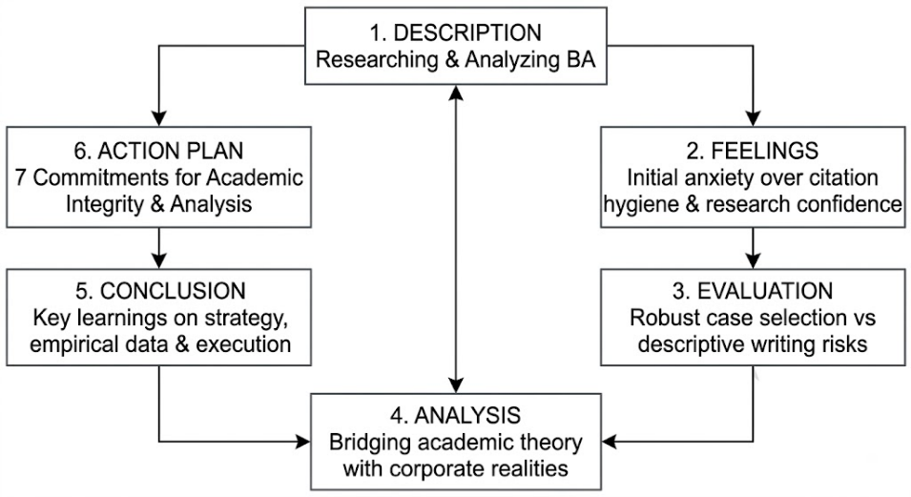
FIGURE 6: Gibbs' Reflective Cycle Architecture
Description
This strategic management analysis of British Airways has been carried out using a structured research and diagnostic process. British Airways was chosen as the case organization because of its strategic importance as the UK’s flag carrier, its complex operating environment within IAG and the availability of up-to-date financial disclosures and academic literature. IAG annual reports, BA corporate disclosures, industry analysis and core textbook literature were used to systematically analyse BA's competitive positioning using module frameworks such as PESTEL, VRIO, Value Chain, SWAT, TOWS, Green Value Chain, Balanced Scorecard, Porter's Generic Strategies, Porter's Five Forces, Ansoff Matrix and SAFe evaluation to develop strategic recommendations.
Feelings
At first, I was overwhelmed by the amount of data and the complexity of using several theoretical frameworks to a complex multinational company. I did the report and got more confident. I was interested in BA's strategic projects: the £7 billion Altitude25 digital project, the ‘BA Better World' sustainability project and fuel derivative risk management.
At the same time, I was concerned about the integrity of academic referencing and citation. I had previously been involved in an academic integrity incident because of incorrect citations, and I was determined to make sure that all sources were properly cited and that my own critical analysis was evident from the sources. This fear prompted me to make careful notes, checking each point as I went along with the sources.
Evaluation
British Airways was an appropriate case organization since there was ample empirical data in the form of recent IAG financial disclosures and industry studies, for the purpose of strategic evaluation. Multiple frameworks were applied to give a holistic perspective: macro external forces (PESTEL) and internal resource capabilities (VRIO, Value Chain) and synthesising these thru SWOT/TOWS. The Balanced Scorecard was used to operationalise the strategy and the Five Forces, Ansoff and SAFe criteria were used to validate the strategy.
It was difficult for me to not just talk about frameworks. It would have been better if I had explained what a framework is, instead of using it to assess BA's strategic decisions. Careful editing was also required to manage the word count in the complex sections to ensure that the focus was on the key strategic factors rather than on the operational details.
Analysis
The experience confirmed the core of strategic management, which involves finding a way for organisations to understand their operating environment, to evaluate the unique resource packages, to make decisions in the face of uncertainty, and to design the implementation process to achieve a competitive advantage. The reference to Nag, Hambrick and Chen (2007) helped me to understand strategic management as a field that is inductive and consensus-based.
The analytical judgement was put to the test in the practical application of theoretical concepts to real corporate situations. As Grant (2018) notes, strategic analysis is not about filling in the blanks. For instance, in the case of BA's fuel hedging debacle, it was evident that the decisions made on financial derivatives can have an impact on operational resilience to demand shocks, and that this is important to ensure strategies are aligned between finance, operations and marketing.
Most importantly, I learned that academic integrity is part of strategic consulting. Transparent referencing supports claims, allows for evidence to be verified and demonstrates good research practice. My previous experiences with citations have taught me that the more rigorous the referencing, the more it enhances the author's voice, not detract from it.
Conclusion
I have learned that strategic management is not just about the short-term financial bottom line, but also the long-term environmental scanning, resource alignment, stakeholder management and disciplined execution. In my research on British Airways, I examined how a legacy flag carrier can deal with the challenges of budget competition, digital modernisation and decarbonisation, and how it can leverage its brand equity and alliance networks to maintain its premium status. I have also developed a deeper understanding of the importance of thorough research methods, evidence-based thinking and academic honesty.

Action Plan
In my future education and career, I will commit myself to the following seven pledges:
- Use Running Reference Logs: While reading your sources, record complete bibliographic information as you read.
- Use Real-Time In-Text Citation: Cite as you go: cite external data or ideas as they are used.
- Strict Paraphrasing: Rephrase ideas from sources in my own voice, preserving my critical perspective as the main point.
- Audit Source Alignment: Check that each in-text citation exactly matches an entry in the final Reference List.
- Use primary and recent sources. Concentrate on the latest corporate reports, financial statements, and peer-reviewed publications.
- Critical Evaluation: Use frameworks analytically to assess strategic implications, not just describe concepts.
- Reference Conventions: Use the Harvard Cite Them Right referencing rules consistently in all documents.

Reference List
Ansoffs.com, 2020. Ansoff Matrix of British Airways.
Armstrong, M., 2021. Armstrong's Handbook of Strategic Human Resource Management. 7th ed. London: Kogan Page.
Aviation Business News, 2025. British Airways outlines £7bn transformation plan. Aviation Business News, 12(4), pp.14–18.
Barney, J.B. and Hesterly, W.S., 2015. Strategic Management and Competitive Advantage: Concepts and Cases. 5th ed. Essex: Pearson Education Limited.
BBC News, 2019. British Airways pilots strike for second day over pay. BBC News
BBC News, 2020. Coronavirus: BA reaches deal to suspend thousands of workers. BBC News, [online]
British Airways, 2026. Sustainability and Commitment to Aviation. London: British Airways Corporate.
Business Model Analyst, 2023. British Airways Value Chain Analysis.
Daniels, J.D., Radebaugh, L.H. and Sullivan, D.P., 2015. International Business: Environments and Operations. 15th ed. Essex: Pearson Education Limited.
Dudovskiy, J., 2016. British Airways Porter’s Five Forces Analysis. Research Methodology.
Fogel, D.S., 2016. Strategic Sustainability: A Natural Environmental Lens on Organizations and Management. New York: Routledge.
Gamble, J.E., Peteraf, M.A. and Thompson Jr, A.A., 2015. Essentials of Strategic Management: The Quest for Competitive Advantage. 4th ed. New York: McGraw-Hill Education.
Gibbs, G., 1988. Learning by Doing: A Guide to Teaching and Learning Methods. Oxford: Oxford Polytechnic.
Grant, R.M., 2018. Contemporary Strategy Analysis. 10th ed. New Jersey: John Wiley & Sons, Inc.
Hill, C.W.L., Schilling, M.A. and Jones, G.R., 2017. Strategic Management, Theory. 12th ed. Boston: Cengage Learning.
Hosted Aesthetics, 2024. Business Case Study: British Airways (Why Focus Beats Volume).
IAG, 2025. Annual Report and Accounts 2025. Madrid: International Airlines Group.
Johnson, G. and Scholes, K., 2010. Exploring Strategy. Harlow: FT Prentice Hall.
Johnson, G., Whittington, R., Regnér, P., Angwin, D., Scholes, K. and Ates, A., 2017. Exploring Corporate Strategy: Text and Cases. 11th ed. Harlow: Pearson Education Limited.
Kaplan, R.S. and Norton, D.P., 1992. The Balanced Scorecard Measures that Drive Performance. Harvard Business Review, 70(1), pp.71–79.
Lacy, S., 2025. Overcoming technical debt in airline ecosystems. Aviation Tech Review, 14(2), pp.45–58.
Lynch, R., 2022. Strategic Management. 9th ed. Harlow: Pearson Education Limited.
Nag, R., Hambrick, D.C. and Chen, M.J., 2007. What is strategic management, really? Inductive derivation of a consensus definition of the field. Strategic Management Journal, 28(9), pp.935–955.
PESTLE Analysis Team, 2024. British Airways PESTLE Analysis.
Porter, M.E., 1979. How Competitive Forces Shape Strategy. Harvard Business Review, 57(2), pp.137–145.
Porter, M.E., 1980. Competitive Strategy: Techniques for Analyzing Industries and Competitors. New York: Free Press.
Premier Dissertations, 2024. British Airways Analysis: A Strategic Deep Dive.
Shen, Z., 2022. Analysis of British Airway's Hedging Strategies. In: Proceedings of the 2022 International Conference on Economic Development and Business Culture (ICEDBC 2022), AEBMR Vol. 662. Atlantis Press, pp.307–311.
Simple Flying, 2026. British Airways fleet and cabin reconfiguration updates. Simple Flying, [online]
Strategy Story, The, 2023. British Airways PESTEL Analysis.
Warren, S., 2023. VRIO Analysis of British Airways. Essay Pandas.
Wheelen, T.L., Hunger, J.D., Hoffman, A.N. and Bamford, C.E., 2018. Strategic Management and Business Policy: Globalization, Innovation and Sustainability. 15th ed. Harlow: Pearson Education.
Whittington, R., Regnér, P., Angwin, D., Johnson, G. and Scholes, K., 2020. Exploring Strategy. 12th ed. Harlow: Pearson Education Limited.

