Feasibility Study for a

Housing Development in South Wales

Student – Melanie Wright
University number - p144061
Course Title – Building Surveying
Module – Cost Studies
Date of report publication – 3rd May 2019
Submitted to – N Tobin

Contents
Page
- Introduction 3
- Housing Demand 3

- Housing deprivation 3

- Yearly percentage changes and house prices 4

- Households 6

- Inflation 6

- Location Information 7
  - Cardiff
  - Caerphilly
  - Brecon

- Conclusion 8
- References 9
- Appendix 11
1 - Average yearly percentage change
2 - Average yearly house price

- Introduction

In this report an analysis of the current UK housing market has been undertaken. Described by Arc4 (2019) “Housing market analysis examines the market from countrywide trends to detailed, street-specific current activity, market demand and socio-economic and demographic profiles of the local area”.

The report was commissioned by FH Ltd, a major French developer who propose to invest in the UK housing market and are searching for the right site on which to build a number of housing developments. A prerequisite for them is a healthy return on their investment. FH Ltd have identified three prospective towns in South Wales that they want analysed: Cardiff; Caerphilly and Merthyr Tydfil.

This report will focus on the output cost index to predict the future housing market, by examining market trends and variations in inflation. A housing cost index measures house price fluctuations over a period of time. This method will enable FH Ltd to consider which, if any, of the three locations is the most advantageous and profitable site.

A feasibility study has been carried out to provide location housing price change indices and house price fluctuations, for a range of detached housing types from 2-4 bedrooms. This study will limit any potential financial risk but only if the cost indices are current, pragmatic and accurately understood. By collecting, collating and analysing data the report will explore statistical characteristics. Data from 2014-18 will be obtained to provide calculated projections for the forthcoming five years.

- Housing demand

This development would be extremely beneficial to the UK, particularly Wales because houses are in short supply. HBF (2019) reports that Wales has the oldest housing stock of any Western European nation and it is in a poor condition. Wales already has an unmet need of 33,000 houses and is set to suffer the worst housing crisis in the UK.

According to the Welsh Government (2018) they have a target to build 20,000 new affordable homes in Wales. With the elimination of the Severn bridge toll, ITV News (2018), states that house prices in Wales are set to rise by 19.3% by 2023 and in September 2018 they reached an all-time peak.

- Housing deprivation

Areas of deprivation are measured through different principles, encompassing housing, income, employment, education and access to services. According to Devine (2014) The Welsh Index of Multiple Deprivation (WIMD) ranked St James in Caerphilly, one of the top 10 most deprived places in Wales for 2005, 2008, 2011 and 2014. The Splott, Cardiff entered the ranking in 2014 whilst Pennydarren, Merthyr Tydfil was removed. Although usually every three years, the next WIMD ranking update will not be published until November 2019.

Rideout (2019) reported that Barry, a commutable distance from Cardiff, was classified in 2018 as the top hotspot for growth in house prices, rising by 10.6%

- Yearly percentage changes and house prices

The UK House Price Index (UKHPI) uses house sales data from HM Land Registry to calculate house trends. The data collected for this study is respective of January 2014 to December 2019 and is only inclusive of detached houses.
Wales has been incorporated into this data to be utilised as a comparison baseline. The figures displayed in the graphs below are the averages collated from statistical data supplied by Land Registry (2019). These figures demonstrate the year-over-year growth rate. If multiplied by 100 the number is converted into a percentage.

Graph 1 shows the “average yearly percentage change” (see appendix 1).

The baseline figures for Wales will assume the “average”. It is evenly distributed with slight increases year-on-year since 2015. Caerphilly has the most similar growth pattern.

The results below are compared to Wales’ “average”:

 | Cardiff | Caerphilly | Merthyr
2014 | Highest result | Highest result | Slightly below
2015 | Far above | Below | Highest result
2016 | Far above | Slightly above | Below
2017 | Below | Far above | Far above
2018 | Far above | Far above | Slightly below

- Cardiff has the best results with 4 years consistently far above average;
- Caerphilly has the second best results with 3 years far above average and it displays the highest recorded rate of growth;
- The most significant fluctuations are in Merthyr. They demonstrates a slightly lower than average rate for three years, inclusive of a significant drop in the last recorded year.

Graph two shows the ““average yearly house price” (see appendix 2).

The results below show the year-on-year percentage calculated from the yearly house price figures.
 | 2014 | 2015 | 2016 | 2017 | 2018
Wales | 202,450 | 208,827 | 217,025 | 227,145 | 237,937
% |  | 3.1% | 3.8% | 4.5% | 4.5%
Cardiff | 313,219 | 330,796 | 350,509 | 361,794 | 381,275
% |  | 5.3% | 5.6% | 3.1% | 5.1%
Caerphilly | 178,290 | 183,793 | 191,270 | 201,947 | 212,619
% |  | 3% | 3.9% | 5.3% | 5%
Merthyr | 143,259 | 151,589 | 155,776 | 164,479 | 171,647
% |  | 5.5% | 2.7% | 5.3% | 4.2%

This graph shows that house prices have risen steadily in all areas over the past 5 years. Wales will again be used as the “average”. The comparisons are:
- Cardiff has shown the best results with significantly higher than average house prices for 3 of the 4 periods. It has the highest overall percentage of 5.6;
- Caerphilly and Merthyr Tydfil both demonstrate 2 comparable above and below averages;
- Caerphilly emphasises the closest similarity to Wales.

- Households
Stats Wales (2019) is the Welsh Governments register for statistical data and the source of the following information. The table below displays projections for the number of households.
Year | Cardiff | Caerphilly | Merthyr Tydfil
2014 | 147,582 | 75,542 | 24,419
2019 | 156,349 | 77,029 | 24,620
2024 | 165,868 | 78,430 | 24,802

These findings show:
- All households have grown over the last five years and this growth is projected to continue.

The table below presents the forecast for the average size household.
 | Cardiff | Caerphilly | Merthyr
2014 | 2.322 | 2.368 | 2.399
2019 | 2.294 | 2.338 | 2.386
2024 | 2.268 | 2.309 | 2.370

These findings show:
- The average size of a household has decline in Caerphilly and Merthyr Tydfil over the past five years;
- Cardiff has seen a growth. This may correlate with the number of households growing exponentially and the lack of available housing forcing individuals to remain in the “family home”.
- All 3 locations are predicted to see a future decline over the next 5 years.
- Inflation

Keeping track of inflation rates are important to developers looking for a long term investment, as it will affect the build cost as well as the sale price. Inflation is an increase in the price of goods and services over time and a decrease in the value of money.
The diagram below was sourced from Statista (2019). It demonstrates the inflation rate in the UK from 2012, forecasting until 2022.

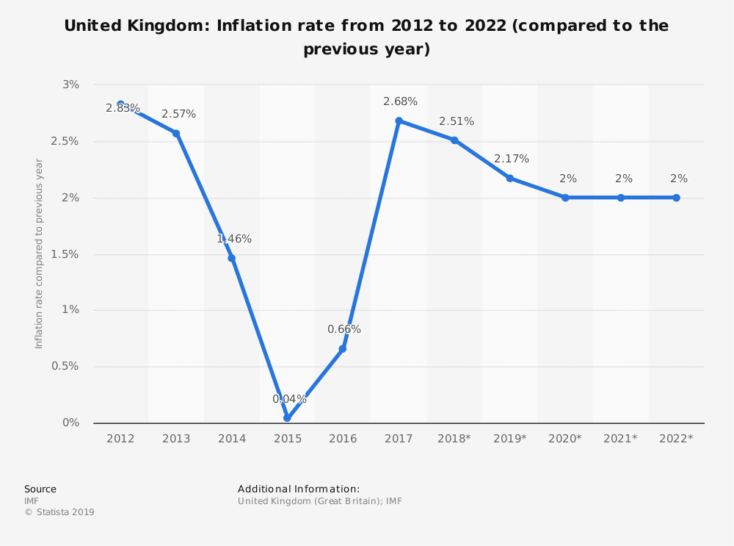

This graph shows that inflation is predicted to decrease and then level out and remain at a constant 2% for the foreseeable future.

- Location information

7.1 Cardiff
Cardiff is the capital of Wales and its largest city. The population is documented at 362,756 (Stats Wales, 2017). It is located near major motorways and is only a 2 hour drive from London.
Cardiff receives more than 18 million visitors a year ranking it the 6th most popular UK tourist attraction (World Population Review, 2019). Not surprisingly as Cardiff is packed with visitor attractions such as: Mermaid Bay; Cardiff Bay Barrage; Cardiff Castle; Bute Park; Flat Holm Island; National Museum; Roath Park & Lake; Techniquest; Welsh Mining Experience and St Fagan’s National Museum of History.

7.2 Caerphilly

Caerphilly is a large town located 8 miles from Cardiff, between Monmouthshire and Glamorgan. According to StatsWales (2017) the population is listed at 180,795.
There are numerous tourist attractions including: Blackwood Miners Institute; Caerphilly Castle; Cwmcarn Forest; Llancaiach Fawr; The Winding House Museum and Sirhowy Valley Country Park.

  - Merthyr Tydfil

Merthyr is a large town 23 miles from Cardiff with a recorded population of 59,953 (StatsWales, 2017). Tourist attractions include Cyfarthfa Castle and Park.
Dickins (2018) stated that Merthyr, once a very deprived town now saw the arrival of thousands of tourists to the BikePark Wales and 6.8 million visited the castle in 2017. Going on to say that unemployment has dropped so people have more disposable income to spend in the new leisure facilities, bars and restaurants.

- Conclusion

The recommendations to FH Ltd would be to choose Cardiff because:
- The yearly percentage changes show Cardiff far above the average of Wales as a whole or either of the other two towns;
- The average house prices are rising significantly higher than prices reflected in Wales or Caerphilly and Merthyr;
- There is a proven demand for housing in Wales;
- Households are undeniably growing;
- Household sizes are forecast to decline;
- Inflation is predicted to remain at a constant 2%.
- It has the most central location;
- It has a large population;
- It attracts millions of visitors each year impacting on the disposable income spent within the city, which in turn will appeal to people looking to move house.

- References

Arc4 (2019). Housing Need Surveys and Assessments. [online] Available at <https://www.arc4.co.uk/sectors/housing-needs-surveys-and-assessments> [Accessed 23 April 2019].

Devine. D., (2014). Why this top 10 of the most deprived areas in Wales should make us all despair. [online] Available at <https://www.walesonline.co.uk/news/ wales-news/top-10-most-deprived-areas-8177125> [Accessed 23 April 2019].

Dickens. S., (2018). Has Merthyr Tydfil shaken off its poor image? [online] Available at <https://www.bbc.co.uk/news/uk-wales-45034452> [Accessed 24 April 2019].

HBF (2019). Wales Housing Crisis. [online] Available at <https://www.hbf.co.uk/news/wales-housing-crisis/> [Accessed 24 April 2019].

ITV News (2018). House prices in Wales predicted to increase by 20% over next five years. [online] Available at < https://www.itv.com/news/wales/2018-11-02/house-prices-in-wales-predicted-to-increase-by-20-in-next-five-years/> [Accessed 23 April 2019].

Land Registry (2019). Compare UKHPI statistics across locations. [online] Available at <http://landregistry.data.gov.uk/app/ukhpi/compare?in=pac&location[]= W92000004&location[]=W06000015&location[]=W06000018&location[]=W06000024&st=det> [Accessed 23 April 2019].
Population City (2019). Caerphilly · Population. [online] Available at <http://population .city/united-kingdom/caerphilly/> [Accessed 23 April 2019].
Stats Wales (2019). Household projections by local authority and year. [online] Available at <https://statswales.gov.wales/Catalogue/Housing/Households/ Projections/Local-Authority/2014-Based/householdprojections-by-localauthority-year> [Accessed 23 April 2019].
Stats Wales (2017) Population estimates by local authority and year. [online] Available at <https://statswales.gov.wales/Catalogue/Population-and-Migration/Population/Estimates/Local-Authority/populationestimates-by-localauthority-year> [Accessed 23 April 2019].
Rideout, J. (2019). The Welsh town that's seen the biggest growth in house prices this year. Wales Online. 2 April. [online] Available at <https://www.walesonline.co.uk/ lifestyle/welsh-homes/barry-uks-top-hotspot-growth-15960746> [Accessed 23 April 2019].
Statista (2019). United Kingdom: Inflation rate from 2012 to 2022. [online] Available at <https://www.statista.com/statistics/270384/inflation-rate-in-the-united-kingdom/> [Accessed 23 April 2019].
Welsh Government (2018). Affordable Housing Supply Independent Review. [online] Available at <https://gweddill.gov.wales/topics/housing-and-regeneration/housing-supply/affordable-housing-supply-independent-review/?lang=en> [Accessed 23 April 2019].
World Population Review (2019). Cardiff Population 2019. [online] Available at <http://worldpopulationreview.com/world-cities/cardiff-population/> [Accessed 23 April 2019].

- Appendix

Appendix 1 - Average yearly percentage change

Appendix 2 - Average yearly house price



