Name :Cosmina Andrei
Student no:1809878
Course code: Project management LCBB5005)

PROJECT MANAGEMENT: ASDA

Table of Contents
Introduction 4
Schedule 4
Scope 6
Requirements 6
Deliverables 7
Cost 8
Time 9
Human resources 11
Risk 12
Quality plan 15
Communication 16
Conclusion and recommendation 16
References 18

Introduction
In this modern era of business, organizations involved into supermarket industries are trying hard to enable online shopping experience for customers. This is a report based on developing Software for a UK based supermarket ASDA (ASDA.com, 2019). Enabling digital experiences to ASDA’s customers through developing an application by using PRINCE2 methodology will be discussed throughout this report. Various aspects of the project plan will be discussed through this reports those are schedule, scope, requirement, cost and time. The software will help customers to save customers to navigate the location of their desired products in the supermarket. The software will be called as ‘Navihuer’ that is French term of navigate.

Schedule
Task/Milestone | Description | Responsible person | Duration (Estimated)
Prepare blueprint of the project plan | Project manager will develop the initial plan of the project execution plan in form of blueprint | Project planner | 2 weeks
Prepare budget | To execute the developed blueprint, project manager need some amount of funding. That funding can only be determined by developing budget. | Finance manager | 1-2 weeks
Take approval | After preparing blueprint and budget, project manager will have to wait for approval from ASDA’s managers. | Project manager | 1 week or less
Recruit employees | In order to conduct the project, a number of project planners, designer, software development team and testers are required. Recruitment process will take longer than expected time. | HR manager | 2-3 weeks
Assigning task | After recruitment is done, the whole task will be divided into each employee. | Project manager | 1 week
Release alpha and beta version of the software | After developing the software, the project manager will release an alpha version of the software to test initially. After fixing bugs and all a beta version will be released for public. | Software developers and testers | 12-16 weeks
Release final version of the software | Final software for customers of ASDA will be released | Project manager | 3 weeks
Table 1: Project Schedule
(Source: Mikhailov and Razmochaeva, 2018)
Through the above schedule it is found that taking approval of the project will take minimum time at the same time, releasing the very first version of the software will take longer time. As per the schedule, it is found that the total project will take around 6 months to complete.

Scope
In-scope | - Save time for visitors of ASDA supermarket  - Improve billing mechanism  - Allow customers to make a shortest route during shopping  - It will allow the company to generate revenue from play store and app store based on total downloads  - This will allow management team of ASDA to understand customer’s preference
Out-scope | - The project will be rejected if the budget crosses £ 10,000  - Project will be rejected if the total time takes more than 6 months
Table 2: Project Scope
(Source: Mir and Pinnington, 2014)

Requirements
Technical requirements:
The project will be developed based on the principles of PRINCE2. As a result, the project will be segmented into various factors those are organization, quality, plans, risk, change, progress and others. Every sector requires a number of technologies. The first one is a virtual map of the store’s layout. Project executive team need application like Javascript, Adobe Premiere Pro to design the store’s layout. In order to develop these layouts the management team require high-configured systems. High configured systems are nothing but computers having hardware like I9 processor, 512 GB SSD, AMD R9 series video card/ NVIDIA Ge-force 2080 titan, at least 16 GB RAM (Random Access Memory) and lastly, internet connection having 200MBPS speed.
Non-technical requirements:
The project management team required number of non-technical requirements in order to develop the software. The first one is funding, the company needs at least £ 10,000 to complete the project within the given time period. In order to meet financial requirements the project management team will seek funding from local banks and financial service providing firms. The company will able to arrange 50% of the project budget from their internal reserve and remaining money will be collected from additional sources.
Human resource is another requirement of the project. In order to complete, the project a number of people specialized in different field will be hired. Software engineer, coder, graphic designers, testers, technical support executives are some major human resources will be assigned in this project.

Deliverables
Through this project, a number of deliverables will be obtained to three different dimensions. Dimensions are nothing but deliverables for client, deliverables of customers and delivers for investors.
Deliverables for client:
In the current scenario, ASDA is the client. Deliverables through the current project is presented in the following section.
- Concerned team of ASDA will be able to understand customer’s perception through this application.
- Employees of ASDA will able to assign products as per customer’s preference.
- Long queue on the billing counter can be avoided to some extent.
Deliverables for customers:
People who visit ASDA’s store for shopping is customers here.
- ASDA’s customers will be able to customise their route as per their convenience.
- Total time taken into shopping can be reduced through application of this software.
- Customer’s satisfaction rate can be improved through this project.
- Customer retention rate can be enhanced due to application of the software.
Deliverables for investors:
- Software that has been planned through this project will be ported for both android and iOS devices. Therefore, the company will be able to gain a profit from those stores based on downloads. This profit will be issued to investors as a part of their dividend.
- If customers appreciate the application or software, then customer satisfaction rate will be increased to some extent. This will attract referral marketing as well and the company's financial condition will be improved. As a result, investors will get a higher return from their investment.
- Due to implementing this innovative idea, the company might generate more market share, which will attract new investors for the company as well.

Cost
Particulars | January (figures in £) | February (figures in £) | March (figures in £) | April (figures in £) | May (figures in £) | June (figures in £)
Opening balance | 0 | 2185 | 3772 | 5469 | 6957 | 8340
Website designing | 123 | 54 | 48 | 66 | 45 | 321
Human resource cost | 12 | 45 | 46 | 45 | 44 | 22
Equipments | 23 | 45 | 89 | 45 | 23 | 23
Material cost | 23 | 65 | 78 | 69 | 12 | 20
Stamp duty | 45 | 21 | 88 | 48 | 152 | 12
Advertisement expenses | 31 | 21 | 86 | 65 | 11 | 13
Rent for the house | 215 | 122 | 64 | 64 | 15 | 13
Procurement cost | 12 | 133 | 66 | 45 | 48 | 44
Transportation cost | 32 | 96 | 212 | 45 | 68 | 21
software development cost | 123 | 48 | 58 | 46 | 68 | 89
Electricity charges | 123 | 85 | 45 | 36 | 98 | 74
Telephone bills | 120 | 42 | 44 | 46 | 84 | 76
Miscellaneous expenses | 12 | 34 | 41 | 46 | 88 | 75
License cost | 45 | 9 | 30 | 44 | 64 | 63
Publishing expenses | 112 | 31 | 65 | 31 | 13 | 13
Team development cost | 154 | 223 | 123 | 223 | 35 | 223
Technology cost | 460 | 460 | 460 | 460 | 460 | 460
Security software charges | 520 | 53 | 54 | 64 | 55 | 98
Total cost | 2185 | 3772 | 5469 | 6957 | 8340 | 10000
Table 3: Budget of the project
(Source: Heldman, 2018)
Cost of each activity that will be taking place during this project has been presented through the above budget. Cost of activities for all six months is presented through the above budget. As per the budget it is identified that ASDA have to make maximum contribution during the first three months (ASDA.com, 2019). In the last two months the project management team need least amount of funding. If the project is delivered within the final budget amount that is £ 10,000 then only the project will be accepted.

Time
A Gantt chart has been prepared based on the themes of PRINCE2 methodology. A Gantt chart of six months and a project timeline is disclosed in the following section of the report.
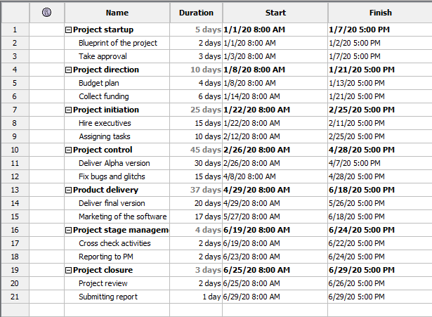
Figure 1: Project timeline
(Source: Gatewood et al. 2015)
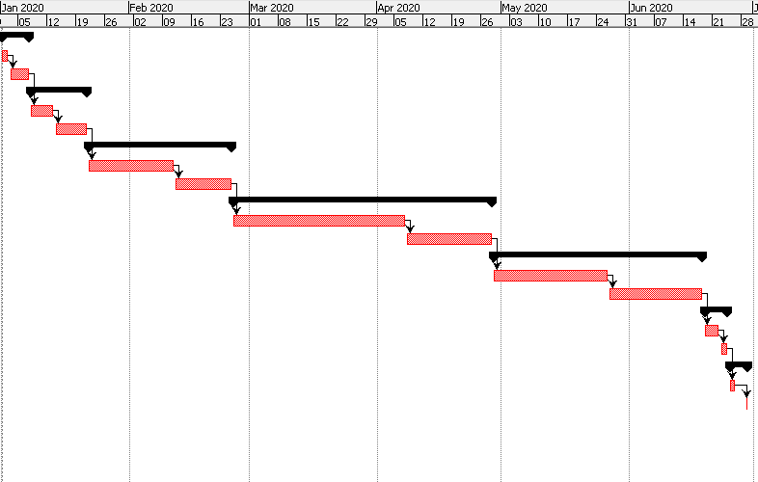
Figure 2: Project Gantt chart
(Source: Setiawan, Jambak and Jambak, 2017)

Human resources
Project manager: Project manager is the key person of this 6 months long project. Developing initial plan and deciding work according to expertise is the primary work of this project manager.
Project planner: Whether the initial plan is executable or not will be determined by project planner.
Project designer: Project designer is the person who will be involved with taking care of both technical and non-technical parts of the project. This project designer will make design of major activities associated with the project.
UI designer: This project is based on developing a mobile based application for ASDA. Every mobile-based application requires attractive user interface. Here, the UI designer will be involved in designing a user interface for the application.
Technical advisor: An application can be developed through different types of SDK (Software development kit) however, which kit is suitable for the current project will be decided by these technical advisors. Pinto (2014) discussed that technical advisor sometimes advice wrong SDK as a result, failure of IT projects comes in the picture.
Software engineer: Software engineer will be involved in core mechanism of developing the software. Software engineer will be working for the current project as per instructions from technical advisor and UI designers. Here, software engineers are basically software developers.
Quality analyst: Quality analyst is another major human resource involved with the current project. Whatever the software will be developed by software engineers will be evaluated by quality analyst team. The executives of quality analysis team will detect major issues involved with the application. This quality analyst team will evaluate security factors involved with the software. After analysing the application’s quality, an alpha version of the software will be released to testers.
Testers: Tester will be involved in analysing minor bugs and glitches involved with the developed software and a bug report will be prepared and will be forwarded to software engineers.
Support executives: after final release of the application if any customer faces any issue in operating the software then support team will assist the customer will proper resolution.

Risk
Identification of Risks | Description | Responsible person | Impact | Mitigation techniques
Financial risk | As per the discussion part it is found the project required £ 10,000. It is also found that the company can able to cover 50% of that cost. Remaining 50% will have to collect from banks and investors. Banks and investors do not get convinced then project manager could face financial risk due to lack of funding. | Finance manager | Medium | The financial risk can be resolved by investing a portion of the company's reserve amount
Technological risk | A technology advisor will be there in the context to give advice on SDK (Seymour and Hussein, 2014). If technology advisors advise wrong SDK then the company will fail to develop the software in an effective way. | IT expert | High | The company could mitigate this issue by consulting about the selected SDK with external consulting firms.
Human resource risk | Internal conflict among software developers, testers, coder might take place, which will cause project delay. | HR manager/executive | Low | This risk is very difficult to resolve. However, it can be avoided to some extent by bringing a policy like fine for conflict.
Quality risk | The software that will be developed for ASDA will be published in both play store as well as AppStore (Seymour and Hussein, 2014). If software engineers fail to complete strict security in the application then it might release information from application's database into public. | Quality analyst | High | The company should publish the beta version of the application on the platforms before releasing the final product to measure capability of the application’s security system.
Schedule risk | The client has asked the project management team to deliver the project within six months from its initiation. In that particular context, if project manager fail to schedule it in an effective way then project delay related issues might take place. | Project planner and project manager | Medium | While preparing the scheduling structure the company should assign 1-2 additional days for each activities.
Risk related to resource | This project requires a huge amount of human and technical resources. Lack of technical resources might take place and that might cause various issues in the project. | Project manager | Medium | Project manager could avoid this issue if they assign the procurement related activities to an external project management team.
Table 4: Project risks and its mitigation strategies
(Source: Seymour and Hussein, 2014)
Quality control
Quality of software can be controlled by four major activities. A detailed discussion of the project quality control mechanism involved with this project is discussed in the following section.

Quality plan
Project managers will initially setup some benchmarks of quality. During the development process, the quality analysis team will cross check if the quality of the software is meeting the benchmark or not.
Quality assurance
Based on understanding the quality assurance team give a green signal on the software quality. Quality analysis team initially give assurance on the quality for the initial release (Joseph, Erasmus and Marnewick, 2014). Quality measurement will be done strictly, when the final version of the software will be released.
Quality control
Quality will be controlled by varying the assured quality with the quality team supervisor. Quality usually controlled based on the applicability of any product (Joslin and Müller, 2015). As software is the major product here therefore, the quality of the software will be evaluated in this context.
Quality management
Quality management is extended version quality control. In the current project, project management team will develop a temporary department called quality management. Employees of that department will only involve with management quality of the final product.

Communication
Person to be communicated | Purpose of communication | Frequency | Medium | Responsible person
Project owner | Communication regarding taking a major decision of the project | Monthly | Meeting | Project manager
Stakeholder | For financial and advisory purpose communication will be done | As per need | Meeting/ video conferencing | Project manager
Executive staff | For resolving day to day activities | Daily | Telephone and status dairy | Project manager
Technical staff | To get to know the status of the project | Weekly | Meeting/ email | Project manager
Table 5: Communication plan
(Source: Karaman and Kurt, 2015)

Conclusion and recommendation
As per their study it is found that UK based Supermarket ASDA will enable a product navigation service to all its customers if this software is developed. The project will be considered by following principles of PRINCE2 methodology. The project will be completed within 6months if everything goes as per the plan. Management team will have to incur £ 10,000 as cost of the project. This project will not benefit the customers of ASDA but it will also leverage internal process of the company. Profitability of the company will increase to some extent. Despite having, a lot of opportunity ‘project management team’ might go through some risks like finance, schedule, resource, technology and others. Recommendations for the project are described in the following section:
- Management team of ASDA is highly recommended to choose SDK after consulting with external project management team.
- The company should develop a quality management team for measuring quality of final version of the software.

References
Books
Heldman, K., 2018. Project management jumpstart. New Jersey, US: John Wiley & Sons.
Journals
Joseph, N., Erasmus, W. and Marnewick, C., 2014. The idle state of information and communication technology project management. Journal of African Business, 15(3), pp.184-196.
Joslin, R. and Müller, R., 2015. Relationships between a project management methodology and project success in different project governance contexts. International Journal of Project Management, 33(6), pp.1377-1392.
Karaman, E. and Kurt, M., 2015. Comparison of project management methodologies: prince 2 versus PMBOK for it projects. Int. Journal of Applied Sciences and Engineering Research, 4(4).
Mikhailov, Y.I. and Razmochaeva, N.V., 2018, September. The Problems of Quality Management Automation in Retail Sales. In 2018 IEEE International Conference" Quality Management, Transport and Information Security, Information Technologies"(IT&QM&IS) (pp. 372-375). IEEE.
Mir, F.A. and Pinnington, A.H., 2014. Exploring the value of project management: linking project management performance and project success. International journal of project management, 32(2), pp.202-217.
Pinto, J.K., 2014. Project management, governance, and the normalization of deviance. International Journal of Project Management, 32(3), pp.376-387.
Seymour, T. and Hussein, S., 2014. The history of project management. International Journal of Management & Information Systems (Online), 18(4), p.233.
Gatewood, M.O.K., Wemple, M., Greco, S., Kritek, P.A. and Durvasula, R., 2015. A quality improvement project to improve early sepsis care in the emergency department. BMJ quality & safety, 24(12), pp.787-795.
Setiawan, P.S., Jambak, M.I. and Jambak, M.I., 2017, November. The effectiveness of using software development methods analysis by the project timeline in an Indonesian media company. In 2017 International Conference on Data and Software Engineering (ICoDSE) (pp. 1-6). IEEE.
Website
ASDA.com (2019). About ASDA. Available at: https://www.asda.com/ [Accessed on 18th December, 2019]

