

Retiring Azure Lab Services: A Case Study in Deploying Azure DevTest Labs at UWTSD

by
Joseph Evans

Supervisor: Dr Michael Dacey

Project submitted as part of the requirements for the award of BSc (Hons) Computing (Cyber Security & Networks)
July 2025

DECLARATION

I, Joseph Evans declare that I am the sole author of this Project; that all references cited have been consulted; that I have conducted all work of which this is a record, and that the finished work lies within the prescribed word limits.

This work has not previously been accepted as part of any other degree submission.

Date : 25/07/2025

FORM OF CONSENT

I, Joseph Evans hereby consent that my Project, submitted in candidature for the B.Sc.(Hons) Computing (Cyber Security & Networks) degree, if successful, may be made available for inter-library loan or photocopying (subject to the law of copyright), and that the title and abstract may be made available to outside organisations.

Date : 25/07/2025

Abstract
Cloud computing has had a transformative impact on higher education in recent years, transforming the way in which services and resources are managed and delivered. Azure Lab Services is a cloud based virtual lab platform for education environments, allowing institutions to deploy virtual machines to users to perform tasks that may be unsecure to carry out on physical machines. With Azure Lab Services upcoming retirement of June 28th, 2027, higher education institutions must identify and transition to an alternative solution.
This report explores the viability of Azure DevTest Labs as a potential replacement, conducting a case study within the University of Wales Trinity Saint David (UWTSD). The case study followed an iterative approach design, implement, and evaluate a functional DevTest Labs deployment. While the implementation met core technical requirements, several limitations were identified, particularly around cost control, scheduling, and ease of use for students.
The report concludes that although DevTest Labs is a technically feasible replacement, its enterprise-focused design presents challenges in an educational environment. It is recommended that UWTSD further explore third-party Azure partner solutions tailored specifically for education, to ensure feature parity with the outgoing system.
Contents
1. Introduction 5
1.1 Aim 6
1.2 Objectives 6
2. Literature Review 7
2.1 Cloud Computing in Higher Education 7
2.2 Azure Lab Services 9
2.3 Azure Virtual Machines 12
2.4 Microsoft Lab Alternatives 13
2.4.1 Azure Virtual Desktop 13
2.4.2 Microsoft Dev Box 14
2.4.3 Azure DevTest Labs 16
2.5 Third Party Alternatives 18
2.5.1 Apporto 18
2.5.2 CloudLabs by Spektra Systems 19
2.5.3 Nerdio Manager for Enterprise 20
2.5.4 Skillable 20
2.6 Literature Review Conclusion 22
3. Methodology 23
3.1 Project Methodology 23
3.2 Requirements 24
3.3 Development Methodology 25
3.4 Resources 25
3.6 Evaluation Methodology 25
4. Design and Implementation 26
4.2 Design 26
4.3 Implementation 26
4.2.1 Initial Setup 27
4.2.2 Second Iteration 27
4.2.3 Third Iteration 29
4.3 Challenges Encountered 32
5. Evaluation 34
6. Conclusions and recommendations 37
7. Reflection 39
8. References 41

1. Introduction
Cloud computing has had a significant impact on Higher Education Institutions (HEIs) in recent year, transforming how services are deployed, managed, and accessed. Through the adoption of Software-as-a-Service (SaaS) platforms such as Microsoft 365 and Google Workspace, both staff and students benefit from greater flexibility with regards to remote working and the ability to work from any device by leveraging cloud ecosystems; an improvement over a traditional domain setup constricting users to domain-joined, on-site machines to access resources. Furthermore, the adoption of cloud Infrastructure-as-a-Service (IaaS) platforms such as Microsoft Azure provides organisations with the ability to shift away from on-premises infrastructure to scalable cloud-based environments, further increasing cost efficiency and service availability.
The University of Wales Trinity Saint David (UWTSD) currently leverages various services within the Microsoft Azure suite, including Azure Lab Services to provide pre-configured, on-demand remote-access virtual labs to students. These isolated virtual environments enable students to carry out practical tasks such as programming, cybersecurity projects, or running specialised software, that may be impractical or insecure to perform on physical domain-joined university machines.
The cloud-based labs are accessible from any network or machine via a web portal authenticated against the users UWTSD Entra ID account. Azure Lab Services provides ease of use for students as well as simple, centralised management for IT administrators via the Azure portal. Administrators are able to rapidly provision and deploy both Windows and Linux virtual machines (VMs), scaling as required, whilst enforcing cost management policies such as usage quotas. Microsoft is retiring Azure Lab Services on June 28th, 2027 [1], therefore UWTSD must migrate to an alternative solution in order to continue to provide cloud-based virtual machines to students. Whilst there are numerous options available, including many third-party solutions, the alternative solution must meet the requirements of UWTSD, achieving the same level of functionality and usability as Azure Lab Services. Additionally, due to UWTSD already being integrated with services within the Azure tenant, for cost saving and staff training purposes an Azure-native solution would be preferable to a third-party solution.

1.1 Aim
The aim of this project is to design, deploy and evaluate a suitable cloud-based virtual lab solution to replace Azure Lab Services at UWTSD.

1.2 Objectives
To achieve the above aim, the following objectives were established:
- Conduct a literature and evaluate potential virtual lab alternatives.
- Design and configure a prototype virtual lab environment aligned with UWTSD’s requirements.
- Gather feedback from stakeholders to validate requirements during development.
- Assess and evaluate the suitability of the proposed solution through testing and stakeholder feedback.
- Provide recommendations and identify areas for further consideration.
The following chapter will review relevant literature and technologies, followed by an overview of methodologies and requirements in chapter 3. Chapter 4 outlines the design and implementation of the replacement solution, and chapter 5 details evaluation of findings and feedback. Conclusions and recommendations are offered in chapter 6, followed by a reflection in chapter 7.

2. Literature Review

2.1 Cloud Computing in Higher Education
Cloud Computing provides HEIs with scalable, on-demand access to computing resources, enabling greater flexibility, efficiency and cost management. A study by Alsufyani et al. [2] discussing the adoption of cloud computing in HEIs finds that a key driver in the transition to cloud platforms is the opportunity to reduce environmental and financial costs, especially in situations in which services are required only for a limited period. The scalable model of cloud computing allows HEIs to provision and decommission cloud resources as required, in contrast to on-premises infrastructure which traditionally requires significant initial investment for resources, as well as costly ongoing maintenance. A further point highlighted by Alsufyani et al. [2] is the simplified procurement process associated with the pay-as-you-go models of cloud computing platforms. This model reduces administrative barriers and facilitates faster access to resources, an advantage over the often lengthy approval process and barriers associated with the initial investment required for on-premises infrastructure.
In addition to financial benefits, several studies have identified further drivers behind the transition of HEIs to cloud computing. Olahova [3] highlights the enhanced collaboration enabled by utilising the Microsoft Office 365 SaaS platform, providing a common space for teachers and students to share resources. The author also emphasises the cloud-based authentication of Office 365 as a primary advantage, allowing users to securely access resources from any location or device.
In a study surveying the adoption of cloud computing in education, Almajalid [4] outlines several advantages of cloud infrastructure to HEIs. These include reduced dependence on backup solutions due to data being stored in the cloud, as well as built-in disaster recovery systems, ensuring high availability and rapid recovery in the event of failure. The author highlights virtualisation technology as a key feature, allowing institutions to expand hardware capacity without the need for investment in physical devices. Almajalid provides an example of this in the case of Florida Atlantic University, which leveraged Microsoft Hyper-V to virtualise its data centre, reducing IT expenditure by $600,000 USD – a substantial cost saving enabled by the adoption of cloud computing technology.
A significant driver for many HEIs in the transition to cloud computing was the impact of the Covid-19 pandemic on education, and the need to maintain learning remotely. Cloud platforms such as Microsoft 365 facilitated remote access to resources and collaboration tools for student and staff [4], providing a practical solution to the problem of on-site learning being suspended. A case study of Japanese HEIs found that 94% of HEIs agreed that Covid-19 had increased the awareness of cloud computing in education, and that the Council for the Implementation of Education Rebuilding in Japan recommends that cloud technologies are the primary key to developing new educational formats [5].
Whilst the aforementioned benefits of cloud computing to HEIs are significant, it would be remiss to ignore the challenges around cloud technology. One of the most notable concerns is the relinquishing of control over infrastructure when outsourcing to a cloud service provider. Whilst in many ways this is a benefit in terms of costs and reduced dependency on backups [4], it also means that institutions become dependent on the providers availability, leaving the customer institution powerless in the event of a major outage at the provider. One Microsoft Azure outage in February 2025 took down critical government services in Norway [6], whilst another global outage, exacerbated by Microsoft’s’ own cybersecurity systems, left customers unable to access essential Azure services [7]. It should be noted, however, that whilst downtime associated with service provider outages may be inevitable, there is no guarantee that HEIs would restore services from an on-premises outage more quickly, especially if it occurs outside of working hours.
In line with broader trends across the education sector, UWTSD has highlighted the benefits of cloud technologies within its own digital strategy [8]. The strategy highlights investment into SaaS and PaaS solutions as cost effective methods of improving availability of services. This commitment from UWTSD to adopting cloud technologies further reinforces the importance of identifying a suitable cloud-based virtual lab solution to replace Azure Lab Services, ensuring the university can continue to provide the resources necessary to deliver course material effectively.

2.2 Azure Lab Services
Azure Lab Services provides on demand, remote-access virtual machine labs for students, offering both Windows and Linux operating systems. Students access these labs by signing in to a web portal with their Entra ID credentials and connecting to the VMs via Remote Desktop Connection (RDP). Azure Lab Services also supports nested virtualisation, allowing for more complex lab scenarios simulating network environments by utilising hypervisor software to host additional VMs within the original VM. Microsoft describes a use case for Azure Lab Services in which cybersecurity students run a Windows Server lab with serval nested VMs, all isolated from the HEIs domain, ensuring no risks to the network [9].
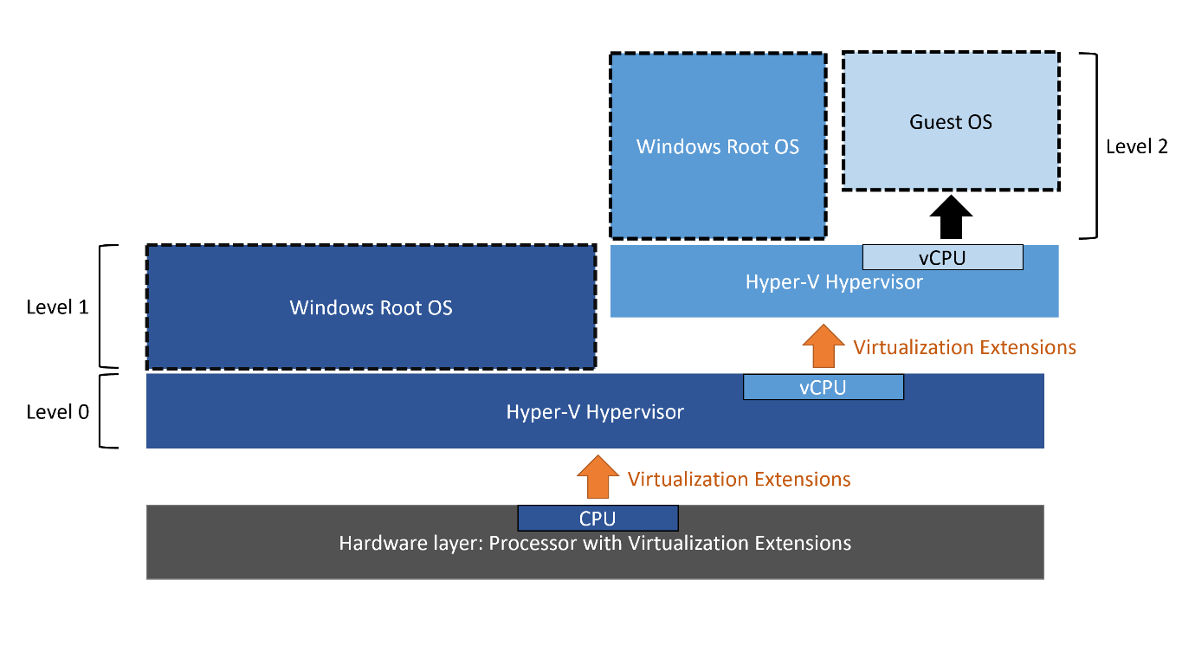
Figure 1. Nested virtualisation diagram [10]
A practical example of Azure Lab Services in use can be seen at Syracuse University, which implemented a cloud migration strategy to Azure in partnership with Microsoft [11]. The university deployed an Azure Lab environment to replace their traditional on premises infrastructure. This resulted in in a cost saving of $300,000 USD from expected hardware upgrade costs, as well as freeing up space from server rooms to become additional offices.
Azure Lab Services is designed with education environments in mind and is built around three core user roles: students, educators, and administrators [12]. These roles are assigned in Azure’s Role-Based Access Control (RBAC) to grant the required permission level to each user. For example, administrator users will have access to configure and deploy lab images, whilst educators will have more limited permissions to assign labs to students; student users have access to labs via the web portal, but do not have access to the Azure portal itself. Figure 2 depicts the setup process for Azure Lab Services:

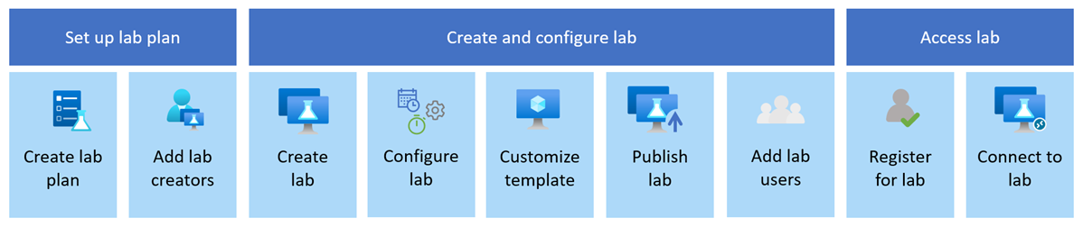
Figure 2. steps involved in creating and accessing labs with Azure Lab Services [13].
As shown in the diagram, an administrator first creates a lab plan and assigns users permission to create labs. Each lab plan contains a group of labs; different plans can be assigned to various classes to match their VM requirements. A lab is created by selecting an image from the Azure marketplace, then adding desired machine configurations. Once the lab is configured, templates can be customised to install required software on the lab machines. The lab is then published and assigned to students to access via the web portal.
Administrators can view lab usage information and set usage quotas for cost control. Labs can be configured to startup and shutdown at preset times to match lesson hours, and an additional usage quota can be configured to allow students a set number of hours of lab time outside of lesson hours [13]. These features allow students to maximise their utilisation of their virtual labs, whilst allowing administrators to maintain control over costs associated with resource usage. The pay-as-you-go model of Azure Virtual Labs, whilst beneficial, can amount to significant costs if high spec VMs are constantly running when not required. Therefore, cost management and sensible use of Azure’s cost management policies and usage quotas are key considerations.
Azure Lab Services is a complete solution for education environments deploying virtual labs, allowing simple management for administrators and educators, and easy access for students via a user friendly web interface. Ideally, the chosen successor solution should offer feature parity with Azure Lab Services, allowing for quick, scalable lab deployment, and robust policy enforcement.

2.3 Azure Virtual Machines
Microsoft offer a wide range of Virtual Machines across its various Azure services, with differing specification and pricing tiers to accommodate a variety of use cases. Microsoft’s offerings for general purpose VMs includes the Das v6-series, while other series such as the M and H series are optimised for high performance workloads [14]. General purpose VMs for user access running traditional software and performing basic tasks typically require only modest resources; in this case a VM instance such as the D2as v6 with 2vCPUs and 8GiB RAM would be suitable. On the opposite end of the spectrum, the highest-spec instance in the D v6 series, the D96as V6, offers 96vCPUs and 384 GiB RAM [15]. These high end VM offerings are only required in circumstances where substantial computing power is needed, such as 3D graphical rendering tasks or complex engineering simulations.
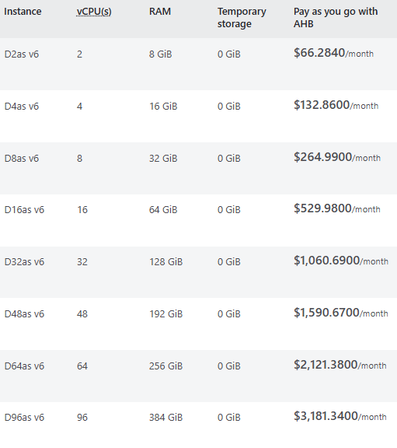
Figure 3. Azure pricing table for Das v6-series VMs [15]
Microsoft estimates the running costs of the D2as v6 at $66.28 USD per month, while the top tier D98as v6 is estimated at $3181.34 USD per month, with various tiers in between, highlighting the importance of careful VM instance selection according to use cases to manage costs [15]. Quotas limiting the number of deployable instances of each model VM can be set within Azure. It would be prudent to ensure that only the required specifications are available to provision, whilst also ensuring that shutdown policies are enforced, particularly on resource intensive VMs, to avoid unnecessary expenditure.

2.4 Microsoft Lab Alternatives
Following the announcement of the retirement of Azure Lab Services, Microsoft has outlined several first and third party alternative solutions that may serve as a replacement. While Microsoft’s own alternative solutions are not tailored specifically for education in the way that Azure Lab Services is, the company notes that these solutions are capable of supporting a range of education scenarios [1].
Microsoft’s recommended first party solutions include Azure Virtual Desktop, Microsoft Dev Box, and Azure DevTest Labs. Although the Microsoft solutions share the core functionality of providing cloud based VMs, they differ in user experience, costs, configuration complexity, and feature availability.

2.4.1 Azure Virtual Desktop
Azure Virtual Desktop is a desktop and application virtualisation service that delivers personalised Windows and Windows Server cloud desktops. The model of Azure Virtual Desktop is similar to a traditional virtual desktop infrastructure (VDI) solution, such as Citrix, offering a Desktop-as-a-Service (DaaS) platform for users to access their resources from any device [16] [17]. Azure Virtual Desktop also allows multiple users to connect to the same virtual machine for their remote desktop, enabling potential cost savings compared to running separate VM instances for each user. Furter to this, users are able to access virtual instances of Windows apps from any device through a web browser, granting flexibility for end users. Administrators can select instances to provision from the aforementioned range of Azure VMs, and have access to analytic insights into costs and usage.
Whilst Azure Virtual Desktop is feature rich, it does not fit the role of a sandboxed virtual lab service designed for education environments. The platform is instead centred around the VDI model, making it more suitable for enterprises seeking persistent cloud-based workstations, rather than HEIs requiring isolated lab environments to replace Azure Lab Services.

2.4.2 Microsoft Dev Box
Microsoft Dev Box is a developer focused cloud workstation solution providing preconfigured virtual machines for development teams. The solution supports only Windows-based VMs for deployment and does not offer native Linux VMs. Instead, Linux-based development scenarios are supported via Windows subsystem for Linux (WSL) [18]. Like Azure Lab Services, Microsoft Dev Box is structured around three core RBAC roles: Platform engineers, Dev team leads, and Developers [19]. The permission structure is depicted in Figure 4.
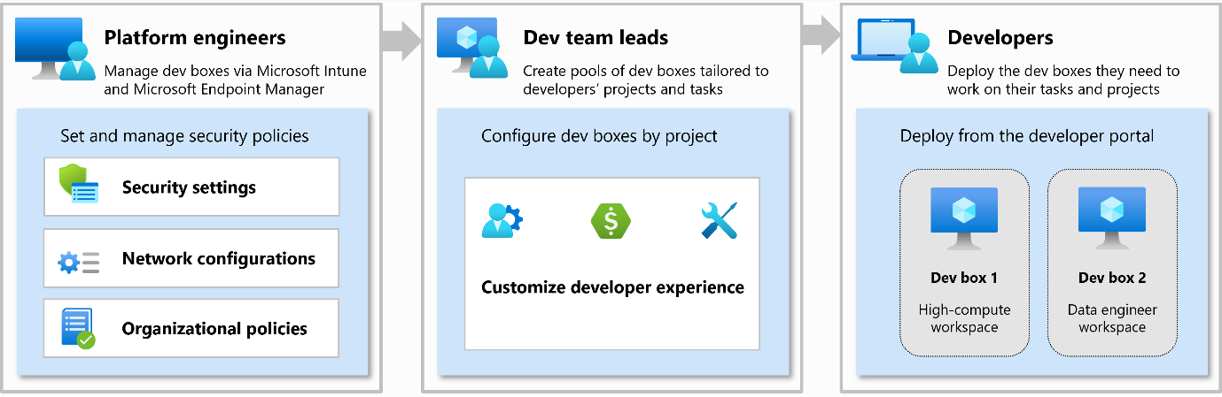
Figure 4. Microsoft Dev Box roles [19].
Once provisioned, Microsoft Dev Boxes are managed using Microsoft Intune, an enterprise mobile device management (MDM) solution. Within Intune, each Dev Box is treated as any other enrolled device, allowing administrators to assign the boxes to device groups, in order to target configuration and compliance policies and deploy apps [20]. As Microsoft Intune is a prerequisite for Dev Box, HEIs considering adopting the solution would also need to configure and integrate Intune into their environment, if not already in use.
Microsoft Dev Box shares some structural similarities with Azure Lab Services, particularly in its use of three core RBAC roles and end-user access via a web portal. While the integration with Microsoft Intune enables comprehensive management via configuration policies, it may also introduce complexity without careful planning of group structures, leading to increased workloads for IT teams.
The pricing model of Microsoft Dev Box is based on a pay-as-you-go structure, with a maximum monthly payment per VM instance. however, due to the solution being tailored for developer use, low-specification machines are not available for deployment. Azure’s pricing table for Dev Box starts with the lowest specification VM having 8 vCPU, 32 GB RAM, and 256 GB Storage, which is likely excessive for most educational lab scenarios. The lack of lower-tier VM options, such as the D2as v6 [15], could result in significantly higher operational costs for HEIs with modest requirements, in comparison to Azure Lab Services.
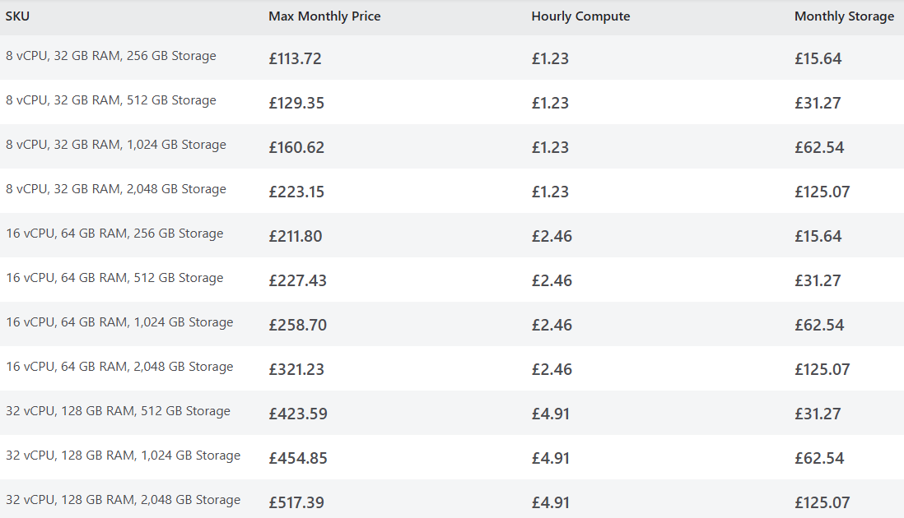
Figure 5. Microsoft Azure Dev Box pricing per instance [21].

2.4.3 Azure DevTest Labs
Azure DevTest Labs is a service within the Microsoft Azure ecosystem designed to support the rapid provisioning and deployment of self-service virtual lab environments for development and testing scenarios [22]. It enables administrators and lab owners to create preconfigured lab environments using custom VM images and artifacts to pre-install required software on lab machines. DevTest Labs supports both Windows and Linux native VMs and facilitates more complex lab scenarios through its support for nested virtualisation [23].
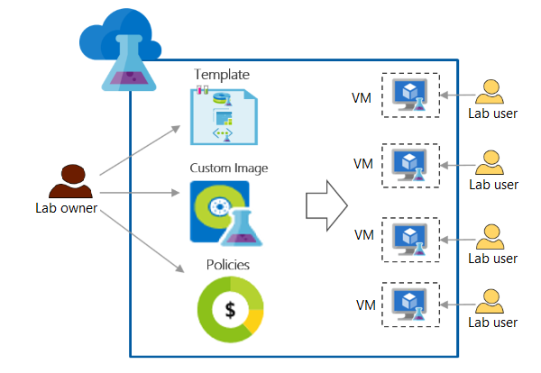
Figure 6. Azure DevTest Labs overview [24].
Microsoft recommends Azure DevTest Labs as a replacement to Azure Lab Services and has published a transition guide for HEIs seeking a successor solution following the latter’s retirement. The guide states that Azure DevTest Labs is the only first party Microsoft service that provides access to Linux, and that it works well with images using nested virtualisation due to the provision of a dedicated VM to each student, opposed to other Microsoft solutions utilising multi-user session VMs with no concept of isolation between users [23].
However, the same guide outlines several key limitations of DevTest Labs in education contexts. Microsoft state that DevTest Labs may not be suitable for customers requiring extensive cost controls features, including usage quotas and complex stop-start schedules. As the service is primary designed for enterprise development use, DevTest labs supports only daily start-stop scheduling, making it less flexible for academic timetable patterns. Furthermore, Microsoft advises that only students comfortable with the Azure portal should use DevTest Labs. in contrast to Azure Lab Services which provides a simplified web interface for accessing VMs, DevTest Labs requires students to navigate the Azure portal directly to access labs, potentially introducing usability barriers for students unfamiliar with the Azure environment [23].
Azure DevTest Labs follows the Azure pay-as-you-go pricing model, allowing the flexibility to provision any VM from the Azure lineup, with charges applied based on machine specification and usage durations [15]. Cost control functionality can be leveraged to help manging spending; policies can be created to specify VM sizes that are available to deploy within the Azure tenant, with a recommended best practice being to restrict any VM sizes that exceeds requirements or desired budget [25]. Azure DevTest Labs also integrates with Azure Cost Management, allowing administrators to assign tags to labs that correlate with classes or departments, enabling a consolidated billing view. This system allows costs to be filtered by tag, highlighting areas of high expenditure that might otherwise be difficult to isolate [26].
Despite the availability of cost management policies, the lack of built-in usage quotas in Azure DevTest labs presents the risk of over expenditure on resources, as there is no mechanism to restrict VM run-time on a per user basis. While DevTest labs is the closest Microsoft first party solution to Azure Lab Services, the absence of several core features including quotas, stop-start schedules, and a user-friendly access portal, could potentially limit its viability as a direct replacement in education environments.

2.5 Third Party Alternatives
As well as its first-party offerings, Microsoft also recommends several third-party Azure Partner solutions to existing Azure Lab Services customers as potential replacements. These platforms provide virtual lab environments built on Azure infrastructure and deliver similar functionality to Azure Lab Services, including simplified lab provisioning and management, web browser access portals, and cost control features such as usage quotas. The third party solutions recommended by Microsoft include Apporto, CloudLabs by Spektra Systems, Nerdio Manger for Enterprise, and Skillable [1]. The following sections provide an overview of each, evaluating their suitability for use in an education environment transitioning from Azure Lab Services.

2.5.1 Apporto
Apporto is a cloud-based virtual desktop platform that mirrors much of the functionality available in Azure Lab Services, including support for both Windows and Linux virtual machines, nested virtualisation, simplified lab provisioning, and a browser-based student access portal. It is currently available as a fully managed service, in which Apporto handles all setup, maintenance, and ongoing support; a self-managed option is also in development, designed for smaller-scale use where institutions manage the environment themselves with their own Azure subscription [28].
In a case study at the University of Portsmouth, Apporto was used to enhance cybersecurity teaching by replacing physical lab machines with scalable, cloud-hosted virtual desktops integrated directly into Moodle, improving accessibility for students [27]. Pricing for the fully managed model ranges from $27 to $101 per user per month, while the self-managed plan will offer platform access for $12 per user per month, plus Azure consumption costs [28].

2.5.2 CloudLabs by Spektra Systems
CloudLabs by Spektra Systems is an Azure Partner solution that provides virtual lab environments tailored for educational use. It replicates many of the core features available in Azure Lab Services, including simplified web portal access to Windows and Linux VMs, support for nested virtualisation, simplified provisioning, and usage-based quotas. Like Apporto, CloudLabs integrates with Learning Management Systems (LMS) such as Moodle, streamlining student access. Lab VMs can be accessed directly through the browser, eliminating the need for RDP and ensuring compatibility across diverse systems such as macOS and ChromeOS. However, unlike Azure Lab Services, CloudLabs does not currently support VM start-stop scheduling, which may restrict flexibility for aligning lab access with academic timetables [29] [31].
CloudLabs offers two pricing tiers, a bring-your-own-subscription (BYOS) model where institutions use their existing Azure subscription and resources and pay a platform fee of $12 per user per month - or a fully managed option in which infrastructure is provisioned by Spektra, priced at $6 per user per month [30].
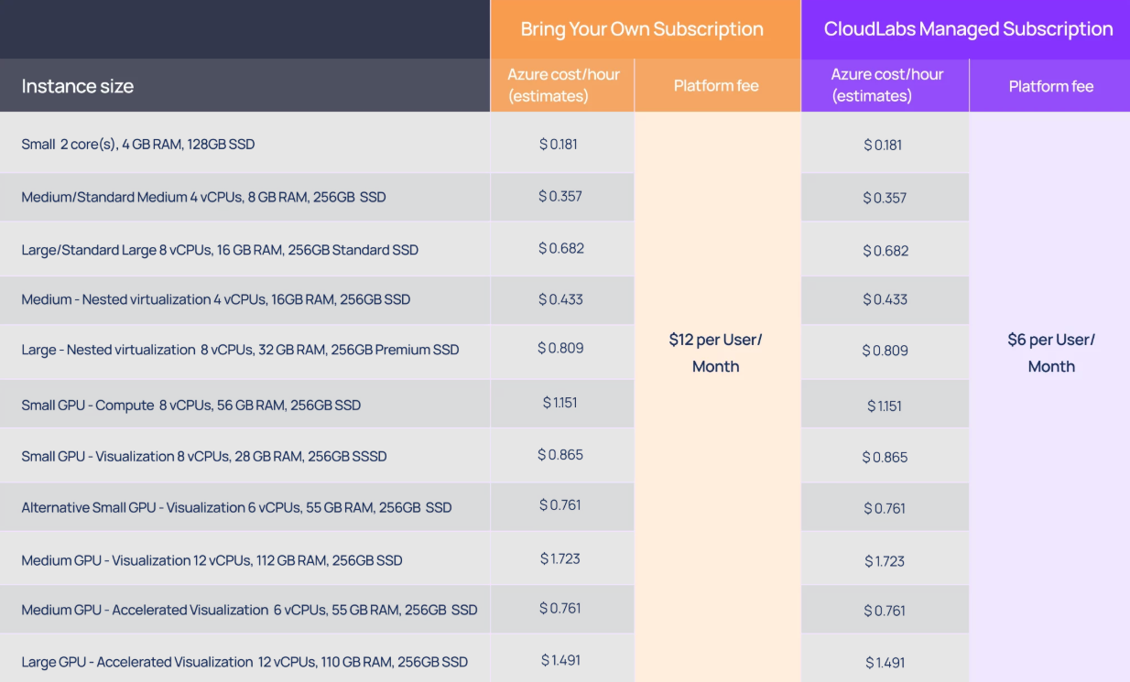
Figure 7. CloudLabs pricing table [30]

2.5.3 Nerdio Manager for Enterprise
Nerdio Manager for Enterprise (NME) is an Azure Partner solution that simplifies the management of Azure Virtual Desktop environments through an intuitive interface and automation features. As outlined in Section 2.4.1, Azure Virtual Desktop is centred around the VDI model, suited for enterprises aiming to implement persistent cloud based desktops for general use. NME enhances Azure Virtual Desktop’s viability in education settings by introducing LMS integration and cost optimisation via auto-scaling, adjusting computing resource on demand cutting costs. However, as it still builds upon the Azure Virtual Desktop infrastructure, it remains more suitable for institutions with a need for persistent cloud desktops, rather than those seeking isolated, sandboxed lab environments [32] [33].

2.5.4 Skillable
Skillable offers a virtual lab platform built on Azure, offering many of the same features as its competitor Azure Partner solutions, including LMS integration, simplified web portal access, as well as comprehensive cost control measures such as usage quotas, auto shutdown policies, and timeout settings [34]. The platform supports deployment through either an institution’s own Azure subscription or Skillable’s managed Azure infrastructure, providing flexibility in cost and resource control.
Skillable offers a unique selling point in the form of its inbuilt lab instruction sets and skill validations with integrated scoring. These features provide a structured pedagogical layer that may suit higher education institutions delivering computing courses. Instruction sets guide students through lab activities, while skill validations assess student understanding to ensure learning outcomes are met [35].
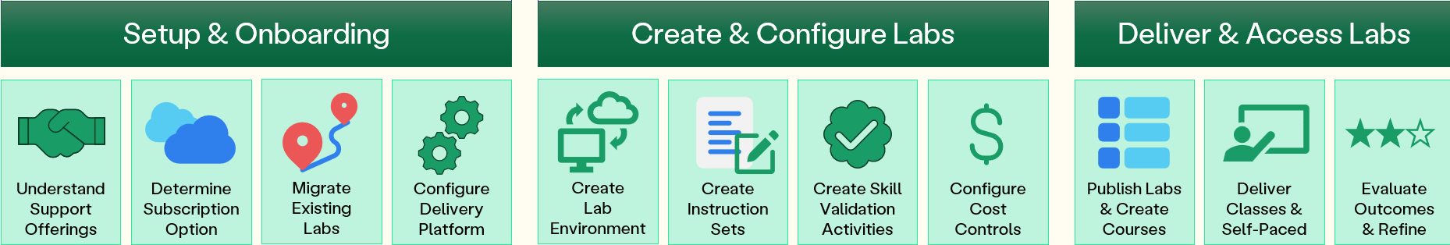
Figure 8. Skillable transition and deployment process [35].
Skillable labs can be connected to via the browser rather than relying on RDP, providing compatibility across a range of devices and operating systems. As with the other Azure Partner solutions, Skillable uses the Azure pay-as-you-go model for resource costs, with an additional platform charge of $1 per user per hour [34]. Whilst a seeming small charge, with serval cohorts of students utilising labs this could quickly amount to significant expenditure, as is the case for all third party offerings.
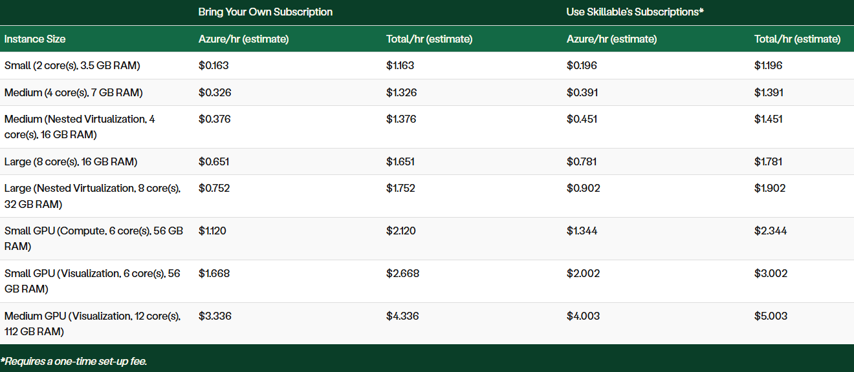
Figure 9. Skillable pricing structure [34].
Skillable stands out for its integrated instructional design features, which may appeal to HEIs seeking a more guided lab experience. Its support for flexible deployment models and cross-platform access makes it a competitive alternative for institutions transitioning from Azure Lab Services.

2.6 Literature Review Conclusion
The growing prevalence of cloud computing within the higher education sector transformed how computing resources are delivered and managed, particularly following the shift to remote learning driven by the Covid-19 pandemic [5]. Cloud computing platforms have enabled HEIs to provide students with access to resources from any location or device, increasing productivity while simplifying IT administration and reducing infrastructure costs compared to traditional on-premises environments. Although transitioning to a cloud-first environment introduces certain risks, such as potential service outages from cloud providers, the benefits often outweigh the negatives, especially in terms of scalability, flexibility, and operational efficiency.
Cloud-based virtual labs offer HEIs a secure way to provide students with isolated, sandboxed environments for coding, cybersecurity, and other hands-on tasks that cannot safely be performed on physical machines. Azure Lab Services is purpose-built for educational environments, centred around three core roles: administrators, educators, and students. It provides valuable features such as usage quotas, start-stop schedules that can be tailored to academic timetables, simplified lab management, and easy student access through a web portal. HEIs must find an alternative solution to Azure Lab Services before its planned retirement date of 28th June 2027.
For those wishing to remain within the Azure ecosystem, options include Azure Virtual Desktop, Microsoft Dev Box, and Azure DevTest Labs, with DevTest Labs offering the closest feature parity to Azure Lab Services. Microsoft’s Azure Partner solutions provide many similar features, with some, such as Skillable, introducing additional capabilities like integrated lab instructions and skill validations for a more tailored learning experience. However, using third-party platforms naturally introduces higher expenditure due to platform access fees, even under bring-your-own-subscription plans. Therefore, organisations aiming to keep costs lower by opting for a first party, Azure-native solution, would likely find Azure DevTest Labs to be the most suitable solution.

3. Methodology
This chapter outlines the methodology adopted for this development-based case study focused on implementing Azure DevTest Labs as a replacement for Azure Lab Services at UWTSD. It describes the approach taken to gather requirements, develop the solution, and evaluate its effectiveness.

3.1 Project Methodology
This project employs a development-base case study methodology. A case study approach is well-suited to demonstrating and reviewing the effectiveness of a solution in a real-world context, especially where experimental design in impractical [36]. Case studies additionally allow stakeholders to gain insights into the relevance and potential benefits of the research or solution, whilst also allowing for feedback between iterations [37].
Following the research onion framework [38], the underlying philosophy of this project is pragmatic, focusing on practical outcomes rather than theory. This project takes an inductive approach, where understanding and insights are developed through the process of implementation and stakeholder engagement, rather than testing a pre-defined hypothesis. A mono-method qualitative approach is used with a focus on iterative development, relying on a consistent strategy of observation, configuration testing, and stakeholder consultation, rather than combining multiple data collection methods. Due to the nature of this case study, a cross-sectional perspective is adopted, focusing on the effectiveness of the solution at a specific point in time, rather than through an extended longitudinal study.
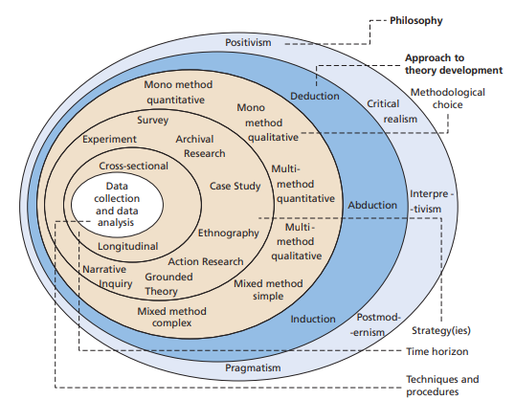
Figure 10. The research onion [38].

3.2 Requirements
Requirements for the replacement cloud lab solution were gathered through direct consultation with a member of UWTSD ICT staff responsible for managing Azure Lab Services. Several informal meetings were held with this stakeholder, providing an insight into the features and limitations of Azure Lab Services, whilst outlining the necessary capabilities of its successor.
The key requirements identified include:
- Support for both native Windows and Linux virtual machines.
- Compatibility with Generation 2 virtual machines.
- Capability for nested virtualisation to enable advanced lab scenarios.
- Built-in cost control features such as usage quotas and automated start-stop scheduling.
- The solution should be Azure-native, utilising the university’s existing Azure subscription to minimise additional costs and reduce the need for additional staff training on a new platform.
- Straightforward, repeatable lab provisioning to streamline setup and minimise administrative overhead for IT staff.
- Simple access for students both on campus and remotely.
These requirements led to the selection of Azure DevTest Labs as the proposed successor, being the only Azure-native solution with the capabilities to meet the identified needs. These requirements guided the solution’s configuration and provided the foundation for its evaluation throughout the project.

3.3 Development Methodology
An iterative development methodology was adopted to enable flexibility to configure the solution based on stakeholder feedback. The project will progress in small stages of configuration, testing, discissions with IT staff, and revisions or further development based on feedback. This approach allows for continuous improvement, while ensuring the solution remains aligned with stakeholder expectations. Whilst an iterative approach can be time-consuming due to the reconfiguration of the solution between iterations, Azure’s automation and template features help to mitigate this, with much of the lab configuration being repeatable beyond the initial environment setup.

3.4 Resources
Resources required for this project are limited, with Azure DevTest Labs being a cloud solution accessible through any web browser. No specialised hardware is required, and all testing can be carried out through one device with a stable internet connection. Access to an Azure subscription is required, as well as appropriate administrator permissions to provision VMs and access relevant resource groups, which are provided by ICT staff.

3.6 Evaluation Methodology
The evaluation of this project is split into two key areas. Firstly, the system will be tested against the gathered requirements, ensuring that lab environments function as expected, with appropriate resource controls in place. The other key area is stakeholder feedback, in which the solution is reviewed by UWTSD ICT staff to access its suitability as a replacement for Azure Lab Services. This evaluation process is qualitative and iterative, allowing refinements to be made through development based on feedback.

4. Design and Implementation
This chapter presents the design and implementation of Azure DevTest Labs as a replacement for Azure Lab Services. The design process was shaped by previously gathered requirements as outlined in section 3.2, and was implemented using an iterative development approach, with continuous stakeholder engagement.

4.2 Design
The design of the replacement Azure Lab Services solution was guided by the identified stakeholder requirements in section 3.2, with a core aim to retain much of the functionality and workflow familiarity of the outgoing solution.
As depicted by Figure 6 in section 2.4.3, the architecture of Azure DevTest Labs allows administrators to define templates, images, and policies within a DevTest lab environment, enabling VMs to be pre-provisioned rapidly and made accessible to users, with little manual setup once templates and custom images are in place. This aligns with the university’s requirements for ease of provisioning and simplified access for students.
A dedicated resource group will be created, containing the necessary resources to support the DevTest lab environment, such as an Azure compute gallery, virtual network, and key vault. In line with identified requirements, both Windows and Linux generation 2 VMs will be provisioned and deployed in the DevTest lab environment, with virtualisation software installed to enable testing of nested virtualisation. Cost control measures will be applied where relevant, such as auto-shutdown and, if possible, usage quotas to help mitigate unnecessary expenditure.

4.3 Implementation
The implementation phase of this project involved configuring Azure DevTest Labs in line with the requirements and design principles outlined in Sections 3.2 and 4.2. The process followed an iterative approach, allowing for refinement based on stakeholder feedback from UWTSD ICT. Each iteration focused on developing a specific element, testing its functionality, and then presenting it for informal review by university IT staff.

4.2.1 Initial Setup
The implementation began with the creation of a dedicated resource group, into which key supporting services for DevTest Labs were deployed. An Azure Compute Gallery was created in order to store custom VM images. Furthermore, a virtual network was created to allow secure communication between VMs, as well as a key vault used to store encrypted Azure credentials, and the Azure DevTest Lab itself.
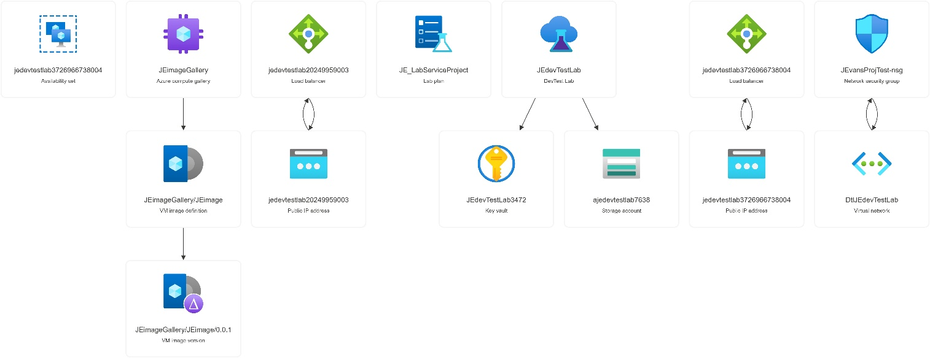
Figure 11. supporting resources visualisation in Azure.
Following the configuration of the resource group, the DevTest Lab was configured with basic settings, and a first Windows 10 VM was provisioned running on a D2s_v4 VM instance, a low specification generation 2 VM with 2vCPUs and 8GB RAM. A lower specification VM was deliberately selected to minimise expenditure, as this deployment served primarily to test the functionality of Azure DevTest Labs. The deployment of the initial VM within DevTest Labs marked the end of the first iteration. Initial feedback from UWTSD IT stakeholders was positive, with DevTest Labs preliminarily proving to offer a strong level feature parity with Azure Lab Services, especially around ease of provision VMs.

4.2.2 Second Iteration
Following the success of the initial setup, the next iteration focused on deploying a second, Linux based VM, creating custom images, and implementing lab usage policies to control resource usage and spending. Ubuntu Linux was selected due to its widespread use in education environments. An Ubuntu VM was deployed using a base image from the Azure gallery, running on the same D2s_4 VM as the initial Windows deployment.
Both machines were accessed via RDP and share the same credentials, which are encrypted and stored in the Azure key vault. In many cases, students will access identical sandboxed VMs with the same credentials; centralising these credentials in the Azure Key vault allows for secure reuse across VMs where appropriate, and simplified management for administrators.
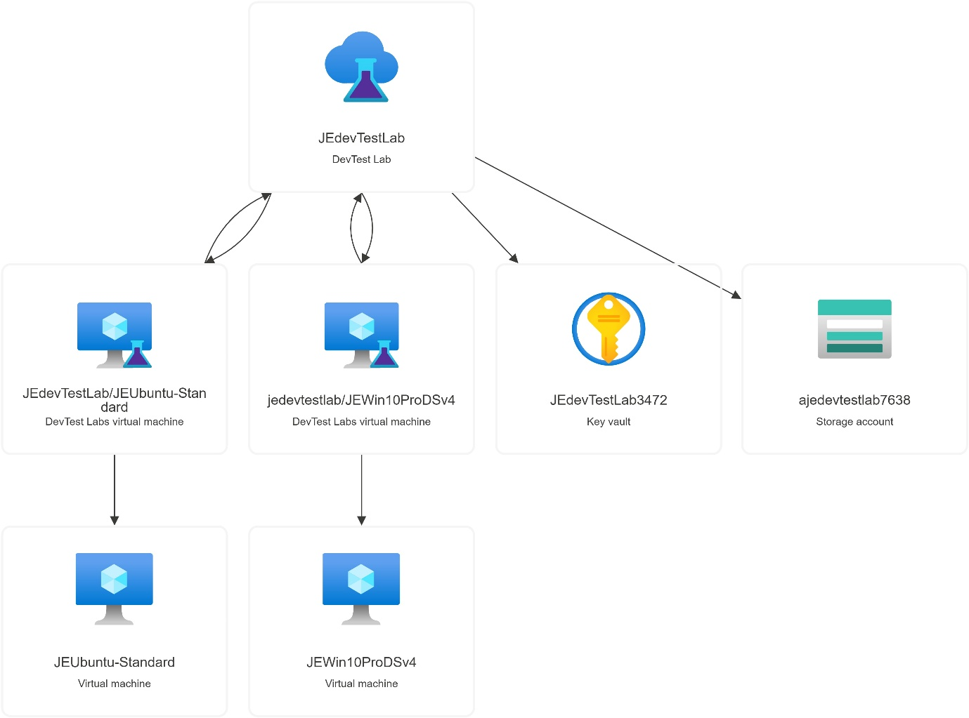
Figure 12. A visualisation of only resources contained within the Azure DevTest Lab.
Following these deployments, Azure DevTest Labs polices were explored and configured to limit usage and minimise the risk of overspending. A policy was configured to automatically shut down all lab VMs at 19:00, intentionally set outside of normal teaching hours. While DevTest Labs facilitates Auto-startup, it only allows for one auto-start per day, making it impossible to align VM start times to an academic timetable.
A further policy was added to restrict the VM sizes available to users when provisioning new machines. This limited options to the D2s_v4 already in use and a slightly higher-specification D4ds_v4, mitigating the risk of over expenditure on resource-intensive VMs.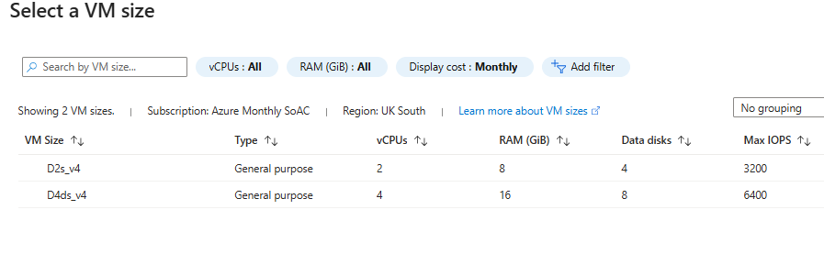
Figure 13. User view provisioning new VMs within DevTest Labs with policy enforcing limits on VM size.
While these steps were a technical success, feedback from UWTSD IT stakeholders highlighted the absence of usage limits in DevTest Labs as a potential concern. Without enforceable usage quotas, there is nothing preventing labs being started up for remote work and left running beyond the 10 hour limit usually enforced in Azure Lab Services, potentially driving up expenditure.
Furthermore, the inability to configure complex start-stop schedules represents a regression in functionality compared to the outgoing system. The member of UWTSD ICT staff responsible for managing Azure Lab Services noted how previously, labs had been configured to automatically start 15 minutes before lessons, ensuring that VMs were fully booted and ready for use at the start of a lesson, avoiding delays from mass start-ups at the beginning of sessions.

4.2.3 Third Iteration
Following the successful deployment of two VMs and configuration of lab policies, a custom image was created from the base Windows 10 VM. Required software was installed on the VM, including Visual Studio Code and Oracle VirtualBox, and the image was captured and stored in the Azure compute gallery. This custom image was then deployed to a D4ds_v4 VM with slightly higher specification in order to test both the compatibility of the image, as well as the performance of nested virtualisation using VirtualBox.
Deploying custom images rather than base images from the Azure gallery significantly decreases configuration time, allowing for multiple pre-configured VMs to be deployed rapidly. After deployment and testing, the image was stable and functioned as expected, and nested virtualisation performance within VirtualBox was adequate given the modest resources assign to the nested VM. With confirmation of compatibility and stable performance, this custom image is now suitable for wide deployment to student VMs. Each VM would be an identical instance on the custom image with no additional configuration required.
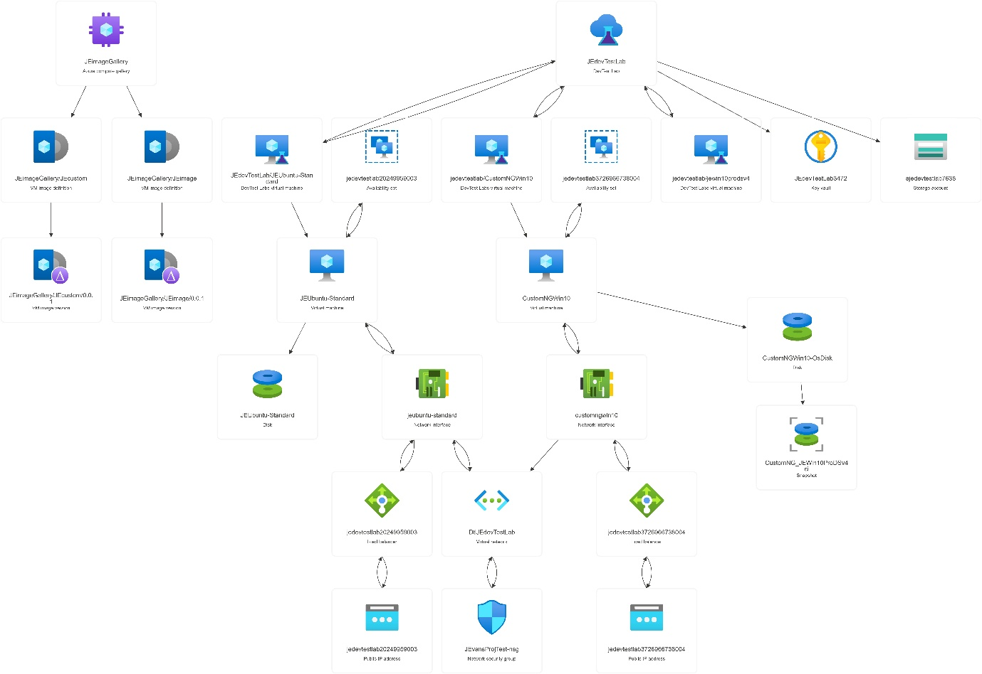
Figure 14. Logical visualisation of Azure resources after final iteration.
The final iteration demonstrates that Azure DevTest Labs can effectively support the rapid deployment of custom images at scale. Combined with its support for both Windows and Linux VMs, nested virtualisation, and centralised resource management via the Azure Portal, DevTest Labs presents a viable replacement for Azure Lab Services. However, limitations remain, particularly around the absence of robust resource cost management capabilities such as usage quotas and start-stop scheduling. Additionally, access for students is only available through the Azure Portal, rather than a dedicated, user-friendly web interface.
DevTest Labs places newly provisioned VMs together in a section for claimable machines. Students much access this section of the portal, claim a machine for themselves, and navigate to their ‘My VMs’ section to start the VM and connect. Once finished, the student unclaims the VM for it to re-enter the claimable pool [39] [40]. Feedback from UWTSD IT stakeholders following this iteration highlighted that the workflow for student access may cause issues, firstly around unfamiliarity with the Azure portal, and also failure to unclaim VMs could cause issues for other students accessing labs.

4.3 Challenges Encountered
While the technical implementation of Azure DevTest Labs was largely successful, several challenges emerged during the configuration process.
A dedicated resource group for this project was initially created by a UWTSD IT administrator, with ownership-level permissions assigned to enable the deployment of virtual machines and associated resources. However, partway through the implementation a secondary resource group was automatically created by Azure, and new resources began deploying there by default. As shown in Figure 15, the new resource group inherited restricted permissions from the tenant which prevented changes being made to resources and also blocked resources from being moved back into the original group. After investigation, the default deployment settings were reconfigured to ensure all new resources were assigned to the correct resource group. However, some elements of the setup process had to be repeated.
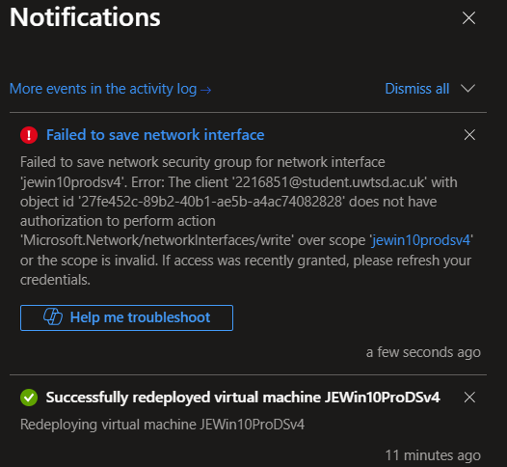
Figure 15. Error message caused by insufficient permissions to resource group.
Additionally, an error was encountered during the provisioning of a new virtual machine, as shown in Figure 16. Investigation revealed that the VM series selected for deployment had no assigned quota within Azure, resulting in provisioning failure. This was resolved by selecting an alternative but equivalent VM size with available quota, enabling deployment to proceed.
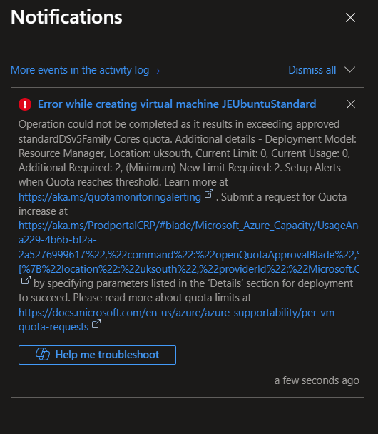
Figure 16. Error message when provisioning VM with no set quota.

5. Evaluation
Following the successful technical implementation of Azure DevTest Labs as a cloud lab solution, several conclusions can be drawn regarding its suitability and limitations as a replacement solution for Azure Lab Services. The iterative development methodology applied during the implementation of this project allowed for the progressive addition of functionality, enabling a practical assessment of the solutions merits, as well as the areas in which it falls short. The case study approach was appropriate for this project, allowing the solution to be evaluated in a real-world context, specifically in the context of UWTSD’s technical and operational requirements.
Overall, the implementation demonstrated that Azure DevTest Labs meets many of the requirements established in section 3.2, such as support for both Windows and Linux native generation 2 VMs with nested virtualisation, scalable lab provisioning, and by being an Azure-native first party solution, minimises additional costs associated with third party solutions. The use of custom images and the Azure compute gallery significantly reduces configuration time for labs, allowing one base image to be adapted and deployed at scale. Furthermore, the use of Azure Key Vaults allows for the secure, centralised storage of encrypted credentials, able to be applied to machines at a click, further simplifying configuration management.
However, key shortcomings have also been highlighted during the implementation of this project, particularly in relation to user experience and cost management. Whilst Azure’s pricing model is transparent, and cost analytics within the Azure platform are insightful, the absence of usage quotas on VMs introduces the risk of overspending on resources, with little administrators can do to prevent it. Email alerts can be configured to warn administrators when expenditure is approaching a pre-determined budget, however without the ability to restrict lab usage hours, it could be difficult to mitigate overspending. With this feature available in Azure Lab Services, and offered by third-party Azure Partner platforms, its absence from DevTest Labs is a key drawback. This is a consequence of DevTest Labs being intended primarily as a platform for enterprise development teams who do not require usage quotas, in contrast to the other aforementioned platforms being built specifically for educational environments.
A further consequence of DevTest Labs design around development teams in the lack of a user-friendly web portal for access to VMs, instead requiring users to navigate the Azure portal. Whilst not an issue in industry, the process of claiming, connecting to, and releasing labs within the Azure portal could be a barrier for users unfamiliar with Azure, or less technical students. Although virtual labs at UWTSD are primarily leveraged to support computing students, were the solution to be rolled out further in future, less technical users may find the interface challenging. This point was highlighted as a concern in feedback, with both the portal itself and the system of claiming and releasing labs introducing complexities compared to Azure Lab Service’s web portal access.
As outlined in the literature review, Azure DevTest Labs is the only first party solution that matches the core functionality of Azure Lab Services and meets UWTSD’s requirements. Whilst third party Azure partner solutions may be better suited for an education environment than DevTest Labs, their implementation would be beyond the scope of this project, with one of the requirements being that the chosen solution is first party.
The key aim of this project, set out in chapter 1, was to design, deploy and evaluate potential virtual lab alternatives. To achieve this aim, five core objectives were established in section 1.2.
The first objective, to conduct a literature review and evaluate potential virtual lab alternatives, was successful. A literature review was conducted to explore cloud computing in higher education, with focus on alternative cloud based virtual lab solutions to Azure Lab Services. After reviewing Microsoft first party, and third-party solutions, Azure DevTest Labs emerged as the most viable solution in line with UWTSD requirements. While potential drawbacks of DevTest Labs were identified during the literature review, this early understanding of potential issues helped shape the design process, for example through attempting to mitigate over expenditure with the configuration of the available cost control measures.
The second objective, to design and configure a prototype virtual lab environment aligned with UWTSD’s requirements, was also achieved. A fully functional lab environment was iteratively developed, with communication with stakeholders to ensure requirements were met. The final implementation delivered on the majority of the requirements, with inherent platform limitations acknowledged.
The next two objectives were to gather feedback from stakeholders to validate requirements during development, and to assess and evaluate the suitability of the proposed solution through testing and stakeholder feedback. Both of these objectives were met, with an iterative development methodology enabling stakeholder engagement. Whilst testing and UWTSD IT feedback were used to assess the suitability of DevTest Labs, it would have been advantageous to also collect feedback from student users. The fifth aim, to provide recommendations and identify areas for further consideration, is addressed in chapter 6.
Overall, the project achieved its core aim, to design, deploy and evaluate a suitable alternative to Azure Lab Services. From a technical perspective, Azure DevTest Labs meets most of the core requirements, with some being partially met due to inherent limitations with the platform. While not a perfect substitute, Azure DevTest Labs presents a viable platform for HEIs seeking a scalable, cost-effective virtual lab solution, provided its limitations are managed.

6. Conclusions and recommendations
As the paradigm of cloud computing continues to transform the delivery of resources and services in higher education, virtual lab solutions play an increasingly significant role in supporting flexible, scalable and accessible cloud-based learning environments. This project aimed to design, deploy and evaluate a suitable cloud-based virtual lab solution to replace Azure Lab Services at UWTSD. Following findings from the literature review, Azure DevTest Labs was identified as the best suited solution based on the university's requirements.
An iterative development based case study methodology was adopted to deploy DevTest Labs, allowing for the continual development of the solution in line with UWTSD’s requirements. Key functional requirements such as support for both Windows and Linux gen 2 VMs with nested virtualisation, as well as scalable custom image deployment, were successfully implemented. Furthermore, the use of Azure features such as Azure Key Vault and Azure Compute Gallery provided secure, efficient methods for credential management and image replication and deployment.
However, several limitations were identified which may impact on the suitability of Azure DevTest Labs in education contexts. DevTest Labs lacks key features previously offered by Azure Lab Services, such as usage quotas and automated start-stop scheduling. The absence of these features introduces the risk of increased resource expenditure, as administrators are unable to restrict lab runtime. This shortcoming is a consequence of DevTest Labs being designed for enterprise development team use, in contrast to Azure Lab Services, and third-party solutions, that are tailored specifically to higher education environments. Furthermore, the omission of a dedicated, user-friendly web portal means students must navigate the Azure portal directly to access labs. Stakeholder feedback, as well as Microsoft documentation have both highlighted the potential for usability barriers imposed by this access method for users unfamiliar with the Azure portal [23].
HEIs face a trade off in implementing a replacement solution to Azure Lab Services, with DevTest Labs offering much of the same functionality but with additional drawbacks and added complexities, and third-party vendors offering education tailored solutions, but with the added cost of their platform fees.
While Azure DevTest Labs meets many of UWTSD’s technical requirements and presents a viable replacement for Azure Lab Services, its limitations, particularly around cost management and user accessibility, warrant further consideration before full implementation.
Given the identified limitations of DevTest Labs, this report recommends that UWTSD consider evaluating third-party Azure partner lab platforms tailored specifically for educational use. These platforms offer close feature parity with Azure Lab Services, with features such as stop-start scheduling, usage quotas, and simplified user access via web portals. Although they introduce additional licensing costs, the benefits in reduced IT administration, enhanced cost control, and user experience may counter-balance these expenses. Further research or testing of Azure partner platforms would be beneficial in providing a more comprehensive basis for long-term decision-making regarding the future of cloud based lab delivery.

7. Reflection
Undertaking this project has reinforced several skills, as well as provided me with the opportunity to broaden my knowledge in various areas. Firstly, the opportunity to gain hands on experience with Azure has been beneficial for my own professional development and technical understanding. I have previously worked with aspects of the Azure suite such as Intune and Entra but haven’t had direct exposure to the Azure portal and its virtual machine services. The implementation of DevTest Labs, as well as the supporting Azure systems in the resource group such as the Azure Compute Gallery and Key Vaults has given me a deeper appreciation for cloud architecture. I am very grateful to UWTSD’s technical demonstrator for facilitating my access to Azure services, as well as to my project supervisor for providing guidance.
The implementation of DevTest Labs went generally smoothly, although some issues were encountered these were worked around after troubleshooting and exploring the Azure portal for relevant settings. Through this troubleshooting, I bolstered my understanding of how various Azure services and configurations link together. By the end of the implementation phase I had configured a fully functional cloud lab service with the facility to rapidly deploy custom VM images at scale. I found the whole experience of deploying DevTest Labs genuinely interesting and feel that I have developed skills and knowledge within Azure that I would not have had the opportunity to otherwise.
In addition to my technical skills, this project has broadened my understanding of the role of cloud computing in education. Through conducting the literature review, I gained insight into the factors driving HEIs to transition to the cloud, and the benefits they have observed afterwards. Moreover, I have acquired a deeper understanding of both the technical and pedagogical benefits of cloud-based virtual lab platforms.
If I were to approach a similar project in the future, there are some changes I would make in order to potentially improve outcomes. Firstly, I would begin gathering feedback soon and attempt to gather feedback from students to gain a better understanding of usability concerns. While the feedback gathered from ICT is insightful and grounded with in depth knowledge of cloud platforms and their requirements, this project could have benefitted from an additional source of feedback
Overall, I am pleased with how the project has been carried out, with all objectives met and the overall aim of deploying and analysing an alternative lab solution achieved. Having spent considerable time working within DevTest Labs, I can certainly see its merits and do believe that it is a viable replacement solution to Azure Lab Services. However, I cannot recommend it is a direct replacement for UWTSD due to its lack of robust cost measurement systems, and potentially usability issues surrounding the Azure portal. Research conducted during the literature review on Azure partner solutions revealed their feature parity to Azure Lab Services, with some adding additional education focused features. While Azure DevTest Labs is viable, it is not inherently designed for education use cases and therefore will struggle to compete with the functionality offered by tailor-made solutions. Pricing may be an issue with third-party solutions, especially at scale due to the per user per month models, but I believe further exploration into these solutions would be beneficial.

8. References
[1] Microsoft, “Azure Lab Services retirement guide,” Microsoft Learn, Apr. 3, 2024. [Online]. Available: https://learn.microsoft.com/en-us/azure/lab-services/retirement-guide (accessed Jul. 14, 2025).
[2] R. Alsufyani, F. Safdari, and V. Chang, “Migration of cloud services and deliveries to higher education,” Leeds Beckett Repository, Leeds Beckett University, Jan. 2015, doi: https://doi.org/10.5220/0005528500860094
[3] E. Oláhová, “Using the Office 365 cloud solution in the education process,” in Proc. Int. Scientific Days 2018. Towards Productive, Sustainable and Resilient Global Agriculture and Food Systems, Dec. 2018, doi: https://doi.org/10.15414/isd2018.s10.09
[4] R. M. Almajalid, “A survey on the adoption of cloud computing in education sector,” Jun. 2017, doi: https://doi.org/10.48550/arXiv.1706.01136
[5] D. Soto, S. Shirai, M. Ueda, M. Higashida, Y. Uranishi, and H. Takemura, “Cloud computing challenges and needs in higher education institutions in post-COVID-19 times: A case of a Japanese survey,” IEEE Access, vol. 12, pp. 168043–168059, Jan. 2024, doi: https://doi.org/10.1109/access.2024.3493422
[6] P. Kunert, “Microsoft Azure faceplants in Norway, taking government services with it,” Theregister.com, Feb. 20, 2025. [Online]. Available: https://www.theregister.com/2025/02/20/microsoft_azure_outage_norway/ (accessed Jul. 14, 2025).
[7] A. I. Patel, “DDoS attack triggered Azure outage – and then Microsoft’s defences finished the job,” The Stack, Jul. 30, 2024. [Online]. Available: https://www.thestack.technology/microsoft-outage/ (accessed Jul. 14, 2025).
[8] University of Wales Trinity Saint David, “UWTSD IT Strategy 2021–24,” UWTSD IT Strategy. [Online]. Available: https://itstrategy.uwtsd.ac.uk/ (accessed Jul. 14, 2025).
[9] L. Dunlap, “Education scenarios with Azure Lab Services and Azure Virtual Desktop,” Microsoft Tech Community, 2023. [Online]. Available: https://techcommunity.microsoft.com/blog/azurelabservicesblog/education-scenarios-with-azure-lab-services-and-azure-virtual-desktop/3737800 (accessed Jul. 14, 2025).
[10] Microsoft, “Nested virtualization,” Microsoft Learn. [Online]. Available: https://learn.microsoft.com/en-us/virtualization/hyper-v-on-windows/user-guide/nested-virtualization (accessed Jul. 14, 2025).
[11] Microsoft, “Syracuse University’s School of Information Studies creates a modern learning lab with Azure, saving nearly $300,000 in hardware costs,” Microsoft Customer Stories, 2023. [Online]. Available: https://www.microsoft.com/en/customers/story/1662748013281034159-ischool-higher-education-azure-en-united-states (accessed Jul. 14, 2025).
[12] Microsoft, “What is Azure Lab Services?” Microsoft Learn, Mar. 17, 2024. [Online]. Available: https://learn.microsoft.com/en-us/azure/lab-services/lab-services-overview (accessed Jul. 14, 2025).
[13] Microsoft, “Manage lab users - Azure Lab Services,” Microsoft Learn, Oct. 11, 2023. [Online]. Available: https://learn.microsoft.com/en-us/azure/lab-services/how-to-manage-lab-users (accessed Jul. 14, 2025).
[14] Microsoft, “Virtual machine series,” Microsoft Azure. [Online]. Available: https://azure.microsoft.com/en-gb/pricing/details/virtual-machines/series/ (accessed Jul. 17, 2025).
[15] Microsoft, “Windows virtual machines pricing – Windows,” Microsoft Azure. [Online]. Available: https://azure.microsoft.com/en-gb/pricing/details/virtual-machines/windows/#ddv4-series (accessed Jul. 17, 2025).
[16] Microsoft, “What is Azure Virtual Desktop?” Microsoft Learn, Jun. 20, 2025. [Online]. Available: https://learn.microsoft.com/en-us/azure/virtual-desktop/overview (accessed Jul. 17, 2025).
[17] Citrix, “Virtual Desktop Infrastructure (VDI) for your desktop virtualization solution,” Citrix.com. [Online]. Available: https://www.citrix.com/solutions/virtualization-vdi.html (accessed Jul. 17, 2025).
[18] I. Levin, “Effectively building Linux apps with Microsoft Dev Box and WSL,” Microsoft Developer Blogs, Sep. 30, 2024. [Online]. Available: https://devblogs.microsoft.com/develop-from-the-cloud/effectively-building-linux-apps-with-microsoft-dev-box-and-wsl/ (accessed Jul. 21, 2025).
[19] Microsoft, “What is Microsoft Dev Box?” Microsoft Learn, Jan. 23, 2024. [Online]. Available: https://learn.microsoft.com/en-us/azure/dev-box/overview-what-is-microsoft-dev-box (accessed Jul. 21, 2025).
[20] Microsoft, “Device features and settings in Microsoft Intune,” Microsoft Learn, Mar. 3, 2025. [Online]. Available: https://learn.microsoft.com/en-us/intune/intune-service/configuration/device-profiles (accessed Jul. 21, 2025).
[21] Microsoft, “Microsoft Dev Box - Pricing,” Microsoft Azure, 2025. [Online]. Available: https://azure.microsoft.com/en-us/pricing/details/dev-box/ (accessed Jul. 21, 2025).
[22] Microsoft, “Azure DevTest Labs overview,” Microsoft Learn. [Online]. Available: https://learn.microsoft.com/en-us/azure/devtest-labs/devtest-lab-overview (accessed Jul. 21, 2025).
[23] Microsoft, “Transition from Azure Lab Services to Azure DevTest Labs,” Microsoft Learn. [Online]. Available: https://learn.microsoft.com/en-us/azure/lab-services/transition-devtest-labs-guidance (accessed Jul. 21, 2025).
[24] Microsoft, “Azure DevTest Labs guidance for getting started,” Microsoft Learn. [Online]. Available: https://learn.microsoft.com/en-us/azure/devtest-labs/devtest-lab-guidance-get-started (accessed Jul. 21, 2025).
[25] Microsoft, “Best practices for virtual machine cost optimization - Azure Virtual Machines,” Microsoft Learn, Aug. 22, 2024. [Online]. Available: https://learn.microsoft.com/en-us/azure/virtual-machines/cost-optimization-best-practices (accessed Jul. 21, 2025).
[26] Microsoft, “Track costs associated with a lab in Azure DevTest Labs,” Microsoft Learn, Jun. 11, 2024. [Online]. Available: https://learn.microsoft.com/en-us/azure/devtest-labs/devtest-lab-configure-cost-management (accessed Jul. 21, 2025).
[27] Apporto, “Next-generation labs: How Portsmouth University scaled and enhanced cybersecurity teaching with Apporto,” Apporto Case Study. [Online]. Available: https://www.apporto.com/resources/university-of-portsmouth-case-study (accessed Jul. 21, 2025).
[28] Apporto, “Apporto Virtual Labs,” Apporto. [Online]. Available: https://www.apporto.com/apporto-virtual-labs (accessed Jul. 21, 2025).
[29] CloudLabs, “Microsoft Azure Lab Service | CloudLabs VM Labs,” CloudLabs. [Online]. Available: https://cloudlabs.ai/azure-lab-services (accessed Jul. 21, 2025).
[30] CloudLabs, “Bring your own Azure subscription (BYOS),” CloudLabs Documentation. [Online]. Available: https://help.cloudlabs.ai/docs/byos (accessed Jul. 21, 2025).
[31] CloudLabs, “Azure Lab Services vs. CloudLabs feature mapping,” CloudLabs Documentation. [Online]. Available: https://help.cloudlabs.ai/docs/alb-cloudlabs-mapping (accessed Jul. 21, 2025).
[32] Nerdio, “Azure Virtual Desktop - Nerdio,” Nerdio, 2025. [Online]. Available: https://getnerdio.com/solutions/nerdio-for-avd/ (accessed Jul. 21, 2025).
[33] Nerdio, “Azure Virtual Desktop (AVD)? Benefits and how to use,” Nerdio, 2025. [Online]. Available: https://getnerdio.com/avd/ (accessed Jul. 21, 2025).
[34] Skillable, “Microsoft Azure Lab Services,” Skillable Courseware. [Online]. Available: https://www.skillable.com/courseware/microsoft/microsoft-azure-lab-services/ (accessed Jul. 21, 2025).
[35] Skillable, “Azure Lab Services,” Skillable.com, 2024. [Online]. Available: https://docs.skillable.com/docs/azure-lab-services (accessed Jul. 21, 2025).
[36] S. Crowe, K. Cresswell, A. Robertson, G. Huby, A. Avery, and A. Sheikh, “The case study approach,” BMC Med. Res. Methodol., vol. 11, no. 1, Jun. 2011, doi: https://doi.org/10.1186/1471-2288-11-100
[37] S. Minocha, “How a case study can be a useful tool on your path to impactful research and scholarship,” Shailey Minocha, Mar. 14, 2024. [Online]. Available: https://www.shaileyminocha.info/blog/2024/3/13/how-a-case-study-can-be-a-useful-tool-on-your-path-to-impactful-research-and-scholarship (accessed Jul. 21, 2025).
[38] M. Saunders, P. Lewis, A. Thornhill, and A. Bristow, Research Methods for Business Students, 8th ed., Harlow, UK: Pearson Education, 2019, ch. 4.
[39] Microsoft, “Access, claim, and connect to lab VMs - Azure DevTest Labs,” Microsoft Learn, Apr. 8, 2025. [Online]. Available: https://learn.microsoft.com/en-us/azure/devtest-labs/tutorial-use-custom-lab (accessed Jul. 21, 2025).
[40] Microsoft, “Use claim capabilities - Azure DevTest Labs,” Microsoft Learn, Mar. 31, 2022. [Online]. Available: https://learn.microsoft.com/en-us/azure/devtest-labs/devtest-lab-use-claim-capabilities (accessed Jul. 21, 2025).

