Comparative quantitative studies of academic procrastination

Content page
Introduction 4
Discussion of methodology and research design 6
Conclusion and recommendations 13
Reference 16
Appendices 20

Abstract

Academic procrastination has long been a hot area of educational and psychological research. The COVID-19 pandemic has made online education a major part of school education. Academic procrastination is mainly manifested in the postponement of academic behavior, accompanied by negative emotions and pressure.. Academic procrastination is associated with negative emotions such as anxiety, insomnia and depression. Prior to this, studies on academic procrastination were mainly focused on classroom teaching. Since 2020, a large number of studies on academic procrastination in online education have appeared. Academic procrastination in face-to-face courses focuses on different directions such as teaching system and teachers, students' self-control, teaching environment and group effect. In the case of online education, there is a new situation of academic procrastination. The author chooses two articles on quantitative research of academic procrastination published after 2020. The author analyzes the theories and research methods of the two articles respectively, and puts forward some suggestions for revision. The author suggests choosing a mixed approach and adding qualitative research as the research method of academic procrastination. In fact, the author hopes to build a theoretical model based on the original research, adding some factors such as family influence, cultural differences, professional and educational level. The author suggests choosing a mixed approach and adding qualitative research as the research method of academic procrastination.

Introduction

Procrastination, described as a failure of self-efficacy, is widespread among students and employees.（Ferrari,2010 and Steel,2007）. The theories of different schools of psychology also have different influences on the authors. Procrastination is often thought of as a problem of phenomenon, cause difficulty with time management and organization, their studies into a low grade, distracted, the apparent gap between intention and action(Akhtar and Faisal Malik, 2016). External factors were not as difficult as the task, work environment, and internal factors such as self-time management and emotional control were not considered to be directly related to procrastination（Steel,2010 and Saltürk, 2021）. Negatively correlated with students' mental health (Duru & Balkis, 2017 Sirois,2014). Humanistic psychology pays more attention to the elite class and regards the research objects as ordinary people or elite class (DeRobertis, 2020). In contrast to other psychological theories, psychoanalysis and experimental psychology focus on brain imaging and patients(Hook, 2017). Therefore, it is important to consider different psychological theories about the orientation and focus of procrastination. There are different interpretations of how these theories constitute procrastination. (Al-Imarah, Shields and Goroshit and Hen, 2019 and Zhou, 2018)These different theories and terminology explain some of the obstacles to research in the field of academic procrastination. For example, scholars in the past believed that procrastination was a psychological problem, unrelated to individual impulsivity and motivation. (Grund and Fries, 2018 and Steel and Weinhardt, 2018) Other studies have shown that individuals' short-term emotions and impulses influence decision-making(Krause,& Freund, 2014)..
Academic procrastination
Academic procrastination is often considered a type of state-related procrastination, defined as "voluntary delay of an expected course of learning-related action despite the expectation that procrastination will make the situation worse" (Steel,2007 and Agustin and Winarso,2021). Research in this area has found many inconsistencies in its causes and consequences. Surveys show that more than 70 percent of college students are reportedly associated with poor academic performance, low happiness, stress and anxiety((Tavakoli,2013). Studies have found that academic procrastination is closely related to task aversion, task delay, self-efficacy, impulsivity, conscientiousness and its self-control, distraction, organization and achievement motivation (Steel 2007 and Ferrari,2001).

My research focuses on the impact of online education on academic procrastination during the lockdown. The subjects were Chinese international students in the UK. While this issue has received widespread attention, more research has focused on self-efficacy and outside interventions in universities, and the results have not been encouraging. (Michałowski, Wiwatowska and Weymar, 2020 and Dias, et al. ,2020 ) Due to the rapid development of Internet technology and mobile phone services, online education is becoming more and more common, and online procrastination has become a new hot spot. ((Zheng et al., 2016; Şahin, 2014 and (Beech and Anseel, 2020), 2019) although many students reported low participation in online courses. In many cases, the teacher did not know about the students because the students did not turn on the camera (Walker, et al., 2020). I first chose two 1-star Psychology journals on ABS that I am familiar with, namely, Psychological Reports and Current Psychology. After extensive reading and comparison, I chose Online and Academic Procrastination in Students With Learning Disabilities: The Impact of Academic Stress and self-efficacy (Article 1) and The effects of decisional and Academic procrastination on The two article will serve as research papers for quantitative analysis.

Discussion of methodology and research design

Both articles begin with a very detailed theoretical review of procrastination and academic procrastination. For example, Klingsieck (2013) identified four main theoretical perspectives to understand the causes of this behavior. All studies will mention academic procrastination as a typical self-regulatory failure (Steel, & Ferrari, 2013 and Ferrari,2001). Interestingly, although a self-correcting failure, earlier studies have shown that, in some cases, upset mood and negative academic outcomes are only weakly associated with academic procrastination (Naaman, 1996). In some cases, academic procrastination is not necessarily dysfunctional, and the result may motivate students to deal more effectively with boring and everyday tasks.
In the theoretical part, the two articles respectively introduce the key words of their concerns, such as the Decisional Procrastination of article 1; Article 2 learning disabilities （LD）and online procrastination. Next, I will introduce the data collection and analysis process of the two quantitative analysis articles respectively.

Article 1
The effects of decisional and academic procrastination on students’ feelings toward academic procrastination

Decisional Procrastination
Decision-making procrastination is considered to be a chronic cognitive procrastination, which represents a stable variable of individual differences and is characterized by the delay of decision-making, especially under stressful circumstances (Ferrari 1994). One possible explanation for this behavior is the protection of self-esteem and social self-esteem. Procrastinators are afraid to expose possible incompetence to themselves and others, so they make endless excuses (Ferrari et al. 2007).
Decision delay has also been found to be strongly associated with decision anxiety and regret, discomfort, and high anxiety ( Steel,2010;; Tibbett and Ferrari 2015). In addition, decision supports have reported more difficulty making important life choices, and they show negative health outcomes and lower life satisfaction (Patalano and LeClair, 2011).
Participants
Data Collection Instruments
The study participants were 373 undergraduates (85 per cent female) in professional social sciences at a university in northern Israel. Their ages ranged from 19 to 58 years (m = 25.44, SD = 4.19). 37% According to the general principle of random sampling, 1 the proportion of women is too high, although there is a gender imbalance in many majors and many studies show that men and women show the same performance in academic procrastination (Dami, Tameon and Saudale, 2020). The sampling needs to be broadly representative, for example: the distribution of majors is only social humanities, not engineering and basic subjects, and the arts.
There is no incentive for participation throughout the data collection phase. This part is encouraged and welcomed by academics. Scholars do not expect interviewees to complete the questionnaire due to reward or temptation. We received online questionnaires from 373 students (83% participation rate) out of 450 students. This truly reflects that students' participation in the project is normal, and there is no subjective enthusiasm to complete the questionnaire due to the hope of winning rewards.
Statistical Analysis
Hayes (2013) analyzed the PROCESS macro developed in SPSS21.0. In our study, there were two predictors discomfort associated with academic procrastination and the desire to change the procrastination habit. To test our hypothetical mediation model, where these two variables are predicted by decision delay caused by academic procrastination, the importance of the connection effect is the only requirement for mediation . When the confidence interval of the deviation correction does not include zero, we can account for significant indirect effects. To assess the vulnerability of regression coefficients to the possibility of spurious associations, we input some control variables. Consistent with previous studies on learning behaviour, these included gender and year of learning. The data were normally distributed and were parameterized.
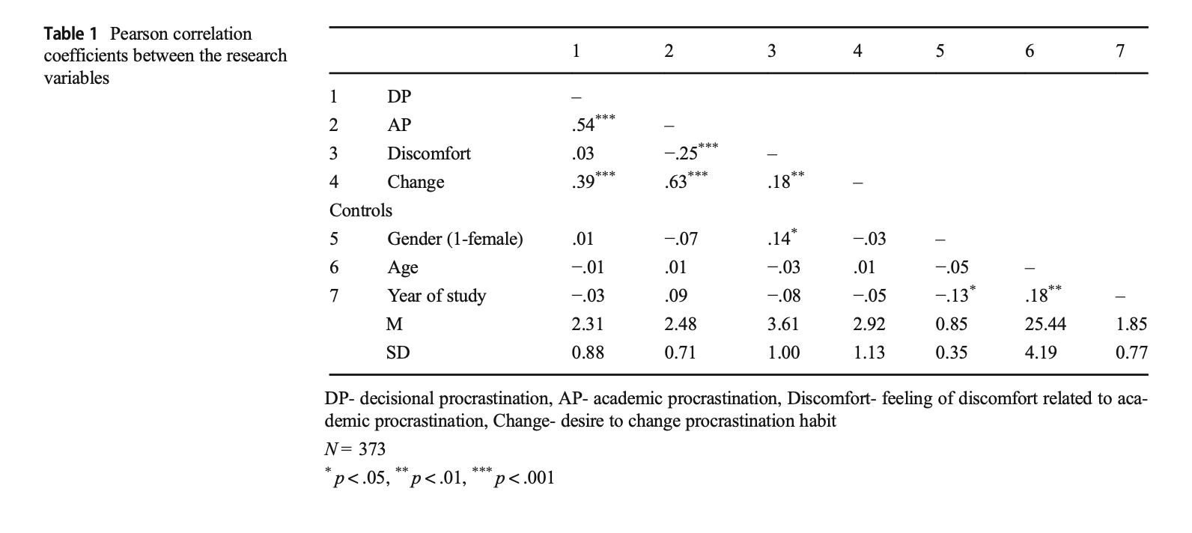
When we looked at the relationship between academic procrastination in decision making, discomfort associated with academic procrastination, and the desire to change this habit, we noticed a pattern change. Decisive procrastination had a negative indirect effect on academic procrastination related discomfort and a positive indirect effect on the desire to change this habit. This pattern change may indicate that there are immediate effects when the decision-making process is mediated by an actual technical procrastination, such as mitigation, tactical emotional changes (Sirois and Pychyl, 2013) or protection of the vulnerable self by avoiding tasks (Ferrari, 2010). And these tasks can only be shielded from the negative emotions associated with decision delay. Furthermore, it can be argued that the existence of academic procrastination has also raised awareness of this dysfunctional behaviour and its consequences far beyond the despair raised in the decision-making process (Fernie et al. 2015).
This is a pilot study examining the relationship between decision-making tendency procrastination and academic procrastination and discomfort and desire to change procrastination behavior. Limitations of this study are self-reported measurements, cross-sectional study design, and specific samples, mostly women studying the social sciences. The sample needs to consider major, age, school, gender ratio, cultural conflicts and other factors. In addition, future research should explore more specifically the root causes of students' academic procrastination, how the tendency to procrastinate on decisions affects the tendency to procrastinate on behaviors, and how to address this problem. The impact of other types of behavioral procrastination (i.e., workplace procrastination) on procrastination and contributes to a comprehensive understanding and unique intervention in other situations and areas of life.
P < 0.001 in the data analysis of the article is a valid statistical analysis. The level of R value shows the correlation degree and positive and negative correlation among different factors. For example, (1) there is a weak positive correlation between the discomfort related to academic procrastination and the desire to change the procrastination habit (R = 0.18; P < 0.01), indicating that these are two different concepts; (2) There was a moderate positive correlation between decision making and academic procrastination (R = 0.54; P < 0.001); (3) There was a moderately positive correlation between decisive procrastination and the desire to change the procrastination habit (R = 0.39; P < 0.001) and was not associated with discomfort of academic procrastination (r = 0.03; P = 0.56); (4) There was a weak negative correlation between academic procrastination and academic procrastination related discomfort (R =-0.25; P < 0.001), was positively correlated with the desire to change the procrastination habit (r = 0.63; P < 0.001). In addition, there is a decisional reduction (r = −.09; P =.07). Negative and weak correlations between years of study and decisive procrastination (r =-0.09; P = 0.07).

Article 2
The introduction and theory section of article 2 provides additional definitions and research on learning disabilities and online procrastination。

Learning Disabilities and online procrastination
A learning disability is defined as a neurodevelopmental disorder that focuses on specific difficulties in reading, writing, and arithmetic. Earlier studies have shown that learning disabilities can affect academic performance and social skills. There has been little research on academic procrastination among students with learning disabilities. In fact, more often than not, academic procrastination is specific to the student population as a whole rather than a specific disability group. Some research on Internet and smartphone addiction reveals a positive correlation between our smartphone addiction and academic procrastination. Online procrastination is thought to be a common behavior among students and employees, and a wealth of management and educational research supports this view.

Methods
Participants
The 173 participants were all from one University in Israel. The distribution of students participating in the survey team is as follows: 74% female students, 45.7% from the department of psychology, 54.3% from the department of humanities and Social Sciences. The test results showed that 77 students were considered to have LD. Later in the article, it was described that many students had received extra intervention from the school（Niazov, Hen and Ferrari, 2021）. Students with learning disabilities were recruited through the School's Learning Support Center and non-learning disabilities through the computer experiment system of the School's Department of Psychological Education. Existing problems: 1. Is there a major distribution problem for students without the introduction of majors? 2. LD is mainly about whether reading and writing disorders are affected by language or cultural differences among international students. 3. A formal LD examination (MATAL) is performed to determine whether there is an error in the diagnosis of learning disability.
An online questionnaire was conducted for students without learning disabilities using Qualtrics (www.Qualtrics). Com), through the school's experimental system. Participants answered the questionnaire online in a confidential and ethical manner. The only problem was that students were asked to leave email addresses, and participants were given breakfast vouchers as gifts. The returns are small, but not encouraging. Although academic circles discourage paid participation in questionnaires, small gifts or small amounts of money have been used to attract participants in many surveys.
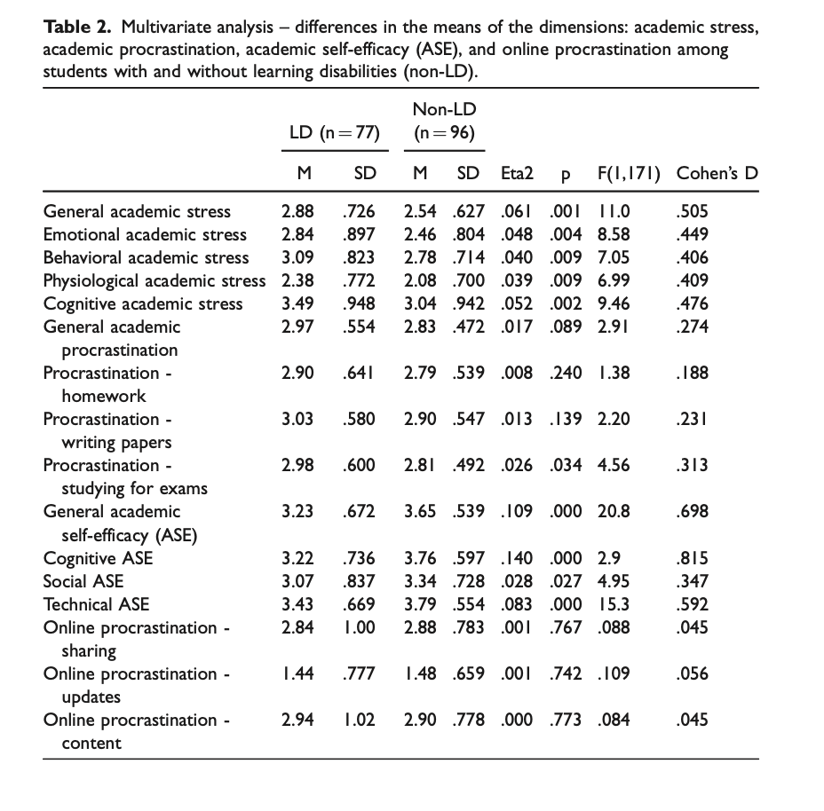
As shown in Table 2, general academic stress levels and stress levels in each content area were significantly higher for students with learning disabilities than for students without learning disabilities. In fact, high academic pressure is directly related to academic performance. Confidence and learning ability may be other factors leading to high academic pressure. In addition, the study found that multivariate analysis of variance (MANOVA) is a procedure for comparing multivariate sample means with students without learning disabilities in statistics . As a multivariable procedure, it is used when there are two or more dependent variables and is usually followed by a saliency test involving each dependent variable separately.
LD was positively, weakly and significantly correlated with academic stress, and negatively, weakly and significantly correlated with ASE. Academic stress is positively, moderately and significantly correlated with academic procrastination, and negatively, moderately and significantly correlated with academic procrastination. In article 1, the authors analyzed that LD was positively, weakly and significantly correlated with academic stress, and ASE was negatively, weakly and significantly correlated. The analysis process is strictly forbidden to be logical, and the previous paragraph only says that it needs to be improved on the issues that cause the delay.
The data receipt and validation process in Article 2 has several questions. One comes from data collection. First, this is a cross-sectional and correlated design study, using self-reported measures that tend to be biased towards various research biases, such as social expectations, and the effect of time at the time of performing intermediate design. Second, most subjects reported that they had received help from the university support center, which could be interpreted as an intervention from the outside that may have affected LD. In addition, almost half of the subjects from the university psychology department, whether or not there was other confusion, self-reported. Finally, the entire sample is from a university, which may also affect the validity of the study.
Another limitation has to do with research tools. Variables of online procrastination, and academic stress and procrastination are logically problematic due to the lack of a core theory of psychology. This is also supported by research on the relationship between self-efficacy and online procrastination. On the other hand, some related factors of Internet procrastination are not considered, such as sharing and the short-term lure of mobile phones. Finally, psychology students are familiar with classic questionnaires, which leads to inaccurate data receipts. New psychometric tests may be needed.

Conclusion and recommendations

The qualitative analysis process of article 1 and Article 2 has basically achieved the author's initial goal. There are some problems in the process of data collection, such as uneven distribution of majors from the same university. Article 2 Breakfast vouchers in the process of data collection do not encourage the voluntary data collection will bring some interference. SPSS and other qualitative analysis tools were selected in the two articles, and P < 0.01 was controlled to ensure the statistical validity. Data normal distribution is parameterized design. Assumptions are set up in accordance with norms, without advance judgment. Based on the current academic level of the author, the analysis of the two articles proves that the understanding degree is limited, which is considered to be a very high level of quantitative analysis of the articles.

Recommendations

1 Mixed research design
It is suggested to adopt a mixed research design, that is, a combination of quantitative and qualitative research methods, and draw conclusions on this basis. The quantitative phase is helpful to understand the relationship between academic expectation and academic delay and decision delay. The qualitative stage is used to analyze why students have academic procrastination. Quantitative data was collected using two self-report instruments (closed question- naire) and one self-report instrument (open questionnaire). The interviews took place in the coaching and consulting room. When students come in for an interview, a questionnaire is collected and the format of the interview is briefly explained to students. Students were told they were free to discontinue participation and to refuse to answer questions without penalty. All interviews were recorded on smartphones. In fact, qualitative methods are more helpful to collect information and judge whether students are decision-making procrastinators. In article 2, since many participants had received LD intervention from schools, qualitative research could more effectively distinguish LD students.
2 A theoretical study of the psychology of procrastination
The two articles are deficient in theory. For example, the author previously focused on TMT theory as a theoretical model for effective research on procrastination.

Expectancy × Value 1
Motivation = __________________
+ Impulsiveness × Delay

(Steel et al.， 2019; Akbay and Delibalta, 2020) This theory has been used by many researchers to study academic procrastination and other types of procrastination . This can better explain the influence of time control, motivation, temptation and other related factors mentioned in the last two articles.

3. Data collection
As mentioned above, there are some problems in the data collection process of the two articles. We can expand the data collection scope of the survey and increase data sources from different levels, majors and countries. Avoid the influence of the latter major of a single school on the reliability and validity of the sample. Another problem with data collection is the influence of religion in Israel. Previous studies have shown a highly positive correlation between religious factors and motivation to learn. The influence of middle and culture on academic procrastination and students' self-control is not mentioned in the two articles.

A final suggestion for improvement comes from the introduction of online education systems. At present, the questionnaires we see are all subjective answers. Even if the quantitative research method is added, it is also the information expression of students. Online learning systems may provide objective statistics on students' learning behaviors, such as homework upload time, reading progress, including online discussion reproduction times and grading. Such objective analysis in the case of big data has reference value for determining whether students are LD or decision-making delay. In fact, similar teaching functions have been rapidly developed due to the promotion of online education by the COVID-19 pandemic. In many cases, teachers can also use the data analysis system of the teaching department to alert and judge students' learning status and procrastination.
Bibliography

Reference
Akbulut, Y., Dursun, O€. O€., Do€nmez, O., & S ̧ ahin, Y. L. (2016). In search of a measure to investigate cyberloafing in educational settings. Computers in Human Behavior, 55, 616–625.

Hayes, A. (2013). Introduction to mediation, moderation, and conditional process analysis: A regression-based approach. New York: Guilford Press.
Ferrari, J. R., 2010. Still procrastinating? The no regrets guide to getting it done. Hoboken: Wiley.

Steel, P., 2007. The nature of procrastination: A meta-analytic and the- oretical review of quintessential self-regulatory failure. Psychological Bulletin, 133(1), 65–94.

DeRobertis, E., 2020. The Humanistic Revolution in Psychology: Its Inaugural Vision. Journal of Humanistic Psychology, 61(1), pp.8-32.

Al-Imarah, A., Shields, R. and Kamm, R., 2020. Is quality assurance compatible with technological innovation? Case studies of massive open online courses (MOOCs) in United Kingdom higher education. Quality in Higher Education, 27(1), pp.4-19.

Goroshit, M. and Hen, M., 2019. Academic procrastination and academic performance: Do learning disabilities matter?. Current Psychology, 40(5), pp.2490-2498.

Zhou, M., 2018. Gender differences in procrastination: The role of personality traits. Current Psychology, 39(4), pp.1445-1453.

Krause, K., & Freund, A. M.,2014. How to beat procrastination. European Psychologist, 19(2), 132–144. https://doi.org/10.1027/ 1016-9040/a000153.

TAVAKOLI, M.A., 2013. A study of the prevalence of academic procrastination among students and its relationship with demographic characteristics, preferences of study time, and purpose of entering university.

Lin-Siegler, X., Dweck, C. S., & Cohen, G. L. (2016). Instructional interventions that motivate classroom learning. Journal of Educational Psychology, 108(3), 295–299.

Klingsieck, K. B. (2013). Procrastination. When good things don’t come to those who wait. European Psychologist, 18(1), 24–34.

Ferrari, J. R.,2001. Procrastination as self-regulation failure of perfor- mance: Effects of cognitive load, self-awareness, and time limits on Bworking best under pressure^. European Journal of Personality, 15(5), 391–406.

Steel, P., & Ferrari, J. R.,2013. Sex, education and procrastination: An epidemiological study of procrastinators’ characteristics from a global sample. European Journal of Personality, 27(1), 51–58.

Kandemir, M., İlhan, T., Özpolat, A. R., & Palanci, M.,2014. Analysis of academic self-efficacy, self-esteem and coping with stress skills predictive power on academic procrastination. Educational Research and Reviews, 9(5), 146–152. https://doi.org/10.5897/ err2014.1763.

Hen, M. and Goroshit, M., 2018. The effects of decisional and academic procrastination on students’ feelings toward academic procrastination. Current Psychology, 39(2), pp.556-563.

Niazov, Z., Hen, M. and Ferrari, J., 2021. Online and Academic Procrastination in Students With Learning Disabilities: The Impact of Academic Stress and Self-Efficacy. Psychological Reports, p.003329412098811.

Saudale, J., 2020. The Predictive Role of Academic Hope in Academic Procrastination Among Students: a Mixed Methods Study. Pedagogika, 137(1), pp.208-229.

Li, L., Gao, H. and Xu, Y., 2020. The mediating and buffering effect of academic self-efficacy on the relationship between smartphone addiction and academic procrastination. Computers & Education, 159, p.104001.

Moller, N., Clarke, V., Braun, V., Tischner, I. and Vossler, A., 2021. Qualitative story completion for counseling psychology research: A creative method to interrogate dominant discourses. Journal of Counseling Psychology, 68(3), pp.286-298.

Govender, P., 2019. Use of Mixed Methods and Reflection: A Novice Researcher’s Perspective. Global Journal of Health Science, 11(13), p.8.

Tandon, A., Dhir, A., Islam, N., Talwar, S. and Mäntymäki, M., 2021. Psychological and behavioral outcomes of social media-induced fear of missing out at the workplace. Journal of Business Research, 136, pp.186-197.

Collings, D. G. et al. (2021) Leading through paradox in a COVID‐19 world: Human resources comes of age. Human resource management journal. [Online]

Clark-Gordon, C., Workman, K. and Linvill, D., 2017. College Students and Yik Yak: An Exploratory Mixed-Methods Study. Social Media + Society, 3(2), p.205630511771569.

Nie, D., Panfilova, E., Samusenkov, V. and Mikhaylov, A., 2020. E-Learning Financing Models in Russia for Sustainable Development. Sustainability, 12(11), p.4412.

Uher, J., 2021. Quantitative psychology under scrutiny: Measurement requires not result-dependent but traceable data generation. Personality and Individual Differences, 170, p.110205.

Appendices
Article 1

https://link.springer.com/article/10.1007/s12144-017-9777-3

Hen, M. and Goroshit, M., 2018. The effects of decisional and academic procrastination on students’ feelings toward academic procrastination. Current Psychology, 39(2), pp.556-563.

Article 2

https://journals.sagepub.com/doi/abs/10.1177/0033294120988113

Niazov, Z., Hen, M. and Ferrari, J., 2021. Online and Academic Procrastination in Students With Learning Disabilities: The Impact of Academic Stress and Self-Efficacy. Psychological Reports, p.003329412098811.

