

Assignment 1: Blog Posts 1-3

Liya An 2005347∣IDENTITY AND APPROACHES TO APPLIED BUSINESS RESEARCH∣22nd March 2021

Blog 1
In the past several years, I got my research concerns switched for times, resulting from the experiences of being an auditor in the Literature and Mass Media Faculty of Sichuan University for more than one year. During this period, I had enhanced my expertise of Chinese classical works and studied a series called The Thirteen Classics of Chinese philosophy and literature, including The Analects, The Book of Mencius, The Book of Changes, The Book of Rites, Laozi, and Zhuangzi, just to name a few. For the Western part, I had studied the history of Western literary theories and criticism, and acquired a basic understanding of Western Marxism, Russian Formalism, constructionism, deconstructionism, the ideas of Plato and Aristotle, so on and so forth. Notably, I encountered a prestigious professor in Semiotics in this period and simultaneously began to get trained in Symbolic Narratology, which enlightened and inspired me to produce two pieces of articles, published in journals.
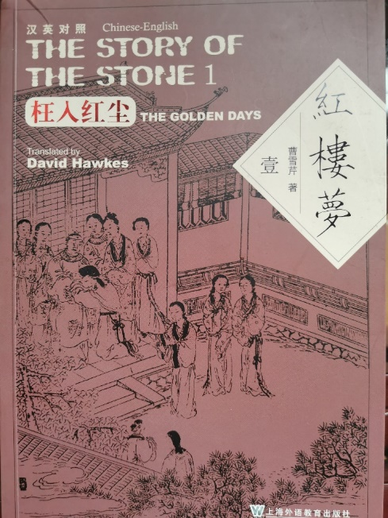
Figure 1: The Story of the Stone, translated by David Hawkes (Source: the blogger ’s book)
I had ever discussed the interaction between empirical actual worlds and fictional narrative worlds, trying to assess the truth value of fictional worlds. As the well-known statements
involved in a couplet from "The Story of the Stone", one of the Chinese classic literature, says, "Truth becomes fiction when the fiction's true; Real becomes not-real where the unreal’s real” (Cao, Hawkes trans, 2014, p.13), subjectivism is always intertwined with objectivism.
That critique towards essentialism legitimizes subjectivity and intersectionality in social critical understandings and incorporates the implication and complexity in knowledge production (Lowthers et al, 2017, p.3) and I turn myself into a true believer of constructionists, who hold the basic belief of multi-layers of reality. After Guba proposed that "facts are only within some theoretical framework" (Guba and Lincoln, 1994, p.107), which means cognition and facts are inseparable. That knowledge constructed within theoretical domains strikes a strong chord with my basic understanding of the ‘truth’ of this world. Positivist upholds the dichotomy that objects are independent of any subjective consciousness stems from ancient Greek philosophy (Crotty,1989,p.35). Archimedes says, “Give me a place to stand on, and I will move the Earth”, but the premise is that this place and Archimedes himself must both be outside of the earth. Similarly, there are no possible ways to go outside of the framework of our observation to directly comprehend and understand reality (Neurath, 1983). With the uprise of post-positivism, especially with Bohr's complementary theory in quantum research, which stresses the uncertainty or 'idealization' of definition and observation in a state of 'elimination of all external disturbances' (Bohr, 1928, p.580), the mindset of positivism and its priority as 'hard' science has thereafter been challenged. It begins to been queried regarding 'context stripping' (Guba and Lincoln, 1994, p.106) in that selected variables analysed in a closed laboratory have reduced the complexity of this world. Besides, the interpretive force of positivist which comes from induction and generalization has become dubious because one black swan just can overturn the proposition that swans are white (Guba and Lincoln, 1989, p.107). These insights are all from the doctor's training later in UWTSD but have perfectly overlapped with my previous cognition.

Figure 2: Archimedes (Source: Wikipedia)
However, despite postpositivist advocate to reject verification and replace it with falsification (Popper, 1959, p.2), every theory is provided with alternative versions and therefore is impossible be absolutely and completely falsified (Lakatos, 1976). What’s more, constructivism has a hazardous inclination to extreme relativism and even nihilism in some radical forms (Derrida, 1978). Thus, even though I am a steadfast proponent of constructivist and interpretivist, I have to admit there is a need for combining these two paradigms in my future doctoral thesis efforts.
Frankly, I have obsessed with Chinese classical literature and philosophy which is given prior epistemic status in my knowledge framework. I am attracted by Western philosophy as well, and curious about similarities and differences of the ethics in Aristotle, Kant, Confucius, and even Adam Smith. That previous knowledge preparation makes me believe my future research is going to focus on the organization's culture or business ethics.
Those books are all representatives in the related research fields. Despite the date of publishing of some of them is not quite current, they keep high referential value given their authors’ high-status of professional credentials, such as Navigating Cross-Cultural Ethics (Eileen Morgan, 1998), Confucius: the secular as sacred (Herbert Fingarette, 1972), The Protestant ethic and the "spirit" of capitalism and other writings (Max Weber,2002), The power of ideas (Isaiah Berlin, 2014), The theory of moral sentiments (Adam Smith, 1875). And they can inspire me think deeper. For example, Max Weber's classical works will help me ponder conflicts between morality and the "iron cage" grounded by instrumental rationality; How societies interact with belief systems (Stein and Storr, 2020, p.529). Isaiah Berlin believes there are many different values in the world of human beings and they are often incompatible with each other and may even have serious conflicts (Berlin, 1972, pp.50). Berlin's value pluralism will spur me to concern the moral conflicts in the context of international organizations. Tu Wei Ming, a Confucian expert who was given the Lifelong Achievement Award by the American Humanist Society in 2007, his articles proposed a very interesting hypothesis, that the impact from capitalism grown from Confucian ethic may probably turn out to be much more profound on the 21st century than that from the classic capitalism rooted in asceticism tradition of the Puritan ethic (1996, p. 10). Although this piece of article is about twenty years ago, the discussion is continuing on the role of Confucian ethic in industrial modernity in today’s China. Another American philosopher, Herbert Fingarette, even though he cannot be entitled as a "sinologist", his book about Confucius is a household name and becomes a must-read in the Chinese philosophy circle in the West.

Figure 3: Herbert Fingarette (20 January 1921-2 November 2018) was an American philosopher and emeritus professor of philosophy at the University of California, Santa Barbara. (Source: Wikipedia)
As for Smith, what he wants to prove is that individuals with egoistic nature (mainly refers to capitalists pursuing profits) can control their selfishness in the market and social relations, to establish the behavior rules of a good order society (Paganelli, 2008, p.373). These idea resources will be used as a significant part of my knowledge framework to reach the primary goal of exploring Fuyao Group and the relationship between the Fuyao’s development and its corporate culture, trying to answer the following research questions, such as how this multinational corporate integrates heterogeneous culture in organizational culture in the context of globalization and what Confucius ethics contributes to develop this international enterprise.
Some of the journals, in my source lists, that cannot be found in the AJG, or are rated as three-star in ABS, are not because they have no qualification guarantee, but mainly because they are classified to be Asian management researches, out of the mainstream in the predominant Western journal publication. On the other hand, some of the articles are extracted from the books, which are not from ABS and AJG, are reliable as well for those publishing presses enjoy high recognized status in the academic circle, such as University of Chicago Press, Harvard University Press, and Singapore Federal Publications. (The lists of sources are attached to the appendix)
The theme interrogated in this project is eye-catching and highly topical because it is extended from a documentary film in 2019, which won the best Documentary Oscar that year. The film tells the story of Fuyao Group, a Chinese glass manufacture, investing in Dayton, Ohio to reopen the former General Motors assembly plant as a glass factory. The issues reflected from this film became hot topics and were discussed by the media around the whole world. For example, IndieWire believed the film was a charming tragicomedy in which Chinese and American enterprises are competing (Kohn, 2019). The Beijing News had reported this film as well and represented ‘political interpretation’ with a Chinese style: “It is undoubted that Obama’s political ideas played a role in film production. In terms of economy, Obama is an active advocator of globalization, and the bright ending of American Factory also demonstrates that globalization is not a poison of American economy” (Di, 2019). Notably, there are few academic researches on Fuyao Group so far, except for numerous media articles. But it doesn’t mean it does not deserve the attention from academic circles.

Blog 2
Since China has to get involved increasingly in the process of globalization, Chinese people's awareness of business ethical issues is becoming explicit and international (Xiang, 2018, p.602). A documentary film called “American Factory” in 2019 focused on the cultural conflicts in an international enterprise, concerning different corporate cultures and even national cultures. Thus, this trend of economic globalization enlightens me to the theme that is about how a Chinese international enterprise grown from Confucianism develops in the context of globalization and what kind of balance should be stricken in the multicultural workplace is conducive to the development of an international corporate. The conceptual framework will be oriented by “Confucius business ethics”, “corporate culture” and “sustainable development”.
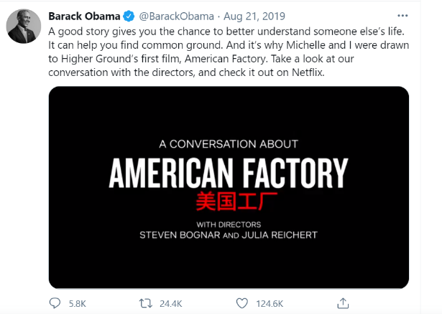
Figure 4: Obama's Twitter
Max Weber does not uphold Confucianism as an impetus to improve industrial capitalism in the process of modernization of China (Weber, 1951), while some contemporary scholars contend Confucian ethics is not incompatible with the capitalist logic and may probably help China to construct a proper form of modern industrial capitalism (Tu, 1996, p.10; Elstein, et al, 2017, p.53). Even though Confucius delt much about ethics and politics, and articulated few regarding business, it contains the ethical ideas serving as the origin and resources for some concepts and thoughts which are related to Chinese business ethical studies (Elstein, 2017, p.55).
In terms of “Organization culture”, it has been defined widely in distinctive ways and therefore has various competing ideas concerning the fundamental framework. It can be the shared beliefs of the top management (Schwartz, 1981; Bernstein, 2004); the rules or norms for behavior (Trice, 1984; Kuttner, 1994); the pattern describing the behavior and emotions in the organizations (Smircich, 1983; Head, 2004; Schein, 2004)；an organizational environment to promote organizational members’ job performance and engagement (Meng, J. and Berger, B.K., 2018); a shared social construction in an organization that influences the ways that employees interact with each other and with the environment (Elsbach & Stigliani, 2018; Balaji et al., 2020); the codes and habits taken as truth accepted by all members in communicating within an organization (Nruyen, P.T., et al., 2020). According to Linnenlueche et al, they create a ‘three-level typology of culture’ (2010, p.358), involving ontological study, three reliable representations, and the role of organizational culture.

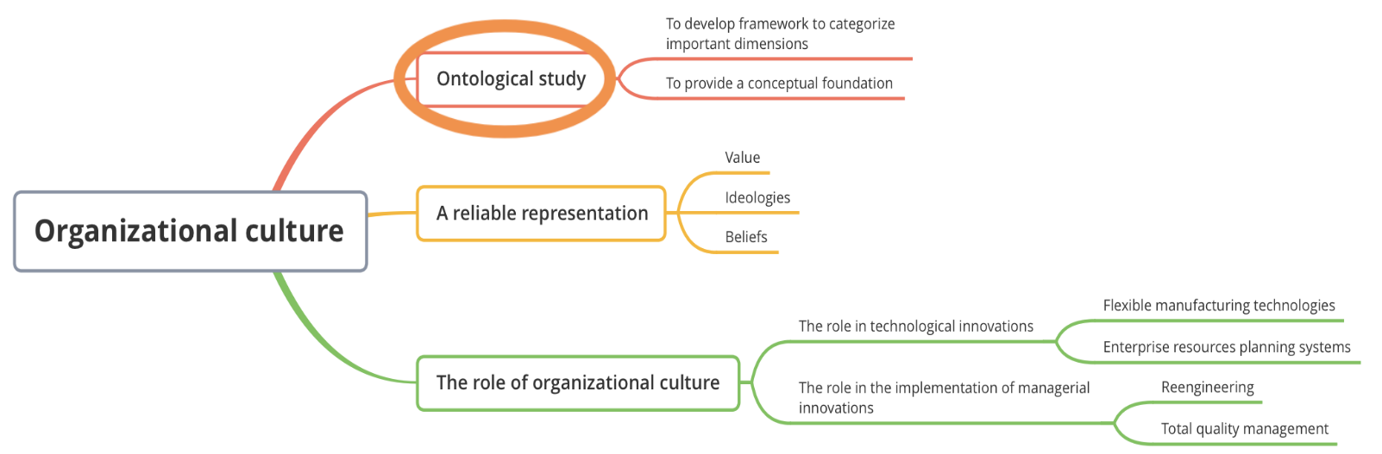
Figure 5: Organizational culture structure
(Source: This graph is based on Linnenluecke et al. 2010, with some nuance adaption by the blogger)
The author of this blog is going to adopt the model as the theoretical framework, called ‘the competing values framework (CVF)’ (Linnenluecke et al, 2010, p.359). The four quadrants articulate the rivalry demands in an organization on two dimensions: the flexibility-control dimension and the internal-external dimension (Quinn& Kimberly, 1984). These two competing dimensions result in four quadrants.
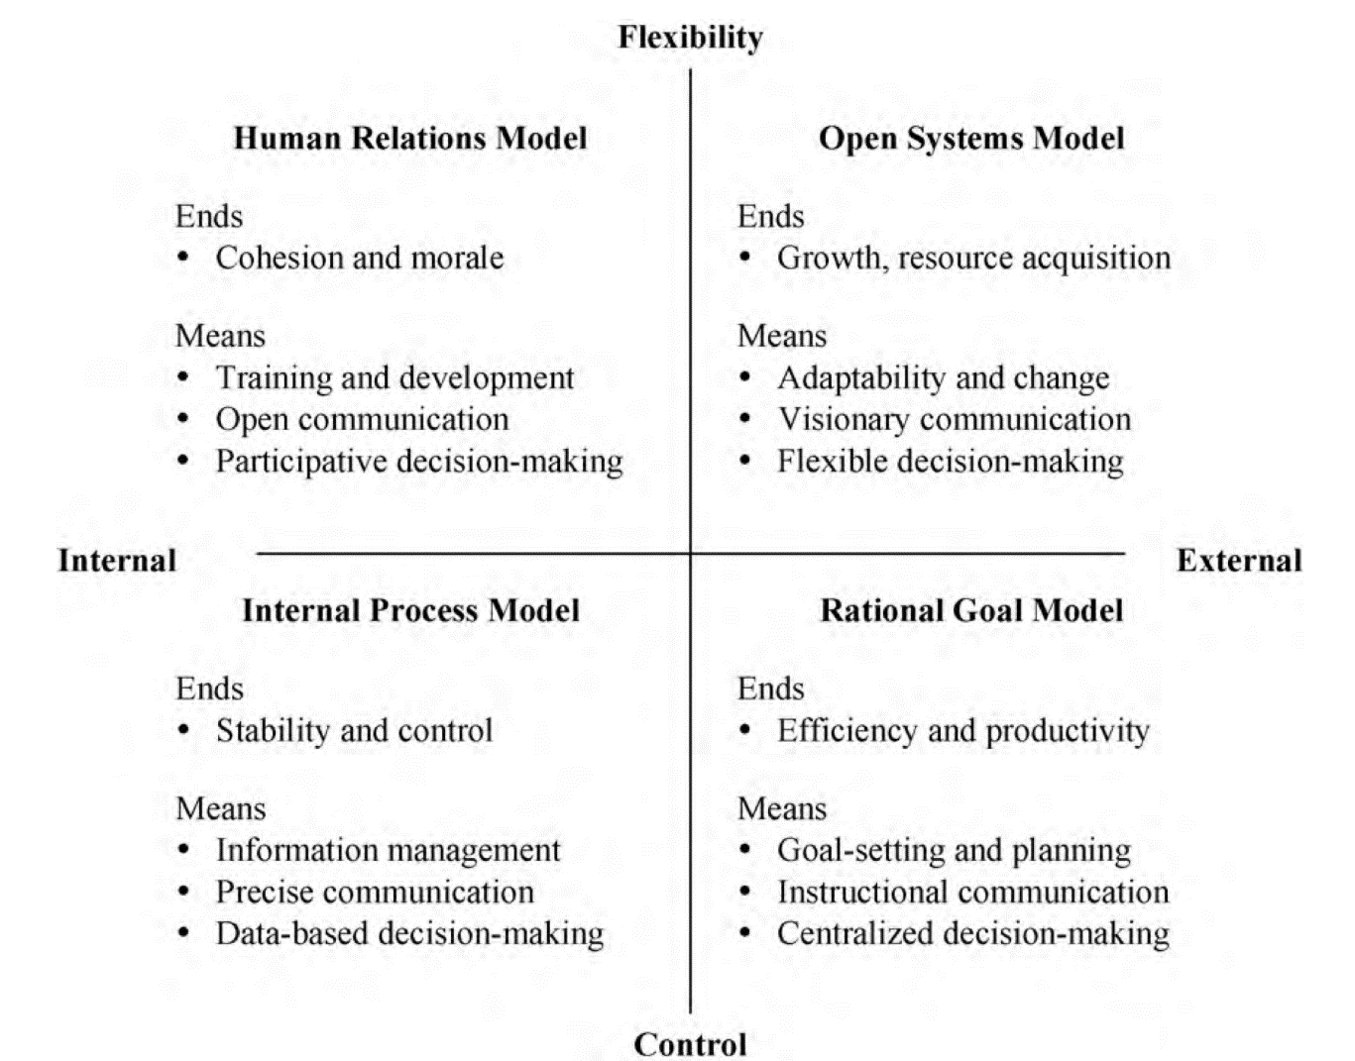
Figure 6: the competing values framework (CVF) (Source: Linnenluecke et al. 2010)
Those quadrants have displayed the four major theoretical frameworks in organizational culture theories (Scott, 2003) and it is a combination of various single culture frameworks. It has involved most of the proposed aspects of organizational culture and has been proved to be validated in previous studies and (Cameron & Quinn, 2011). Additionally, it is conducive to analyse the correlation between a corporate culture type and its sustainable development plans. The weakness of CVF is that the reality is far more complex than four clarified quadrants and a certain organization’s culture can cross the boundaries of quadrants and be featured with more than one of those types (Cameron & Quinn, 2011). The theories of CVF can be an adaptive assessment system for a wider environment with various organizational forms and cultures. It is not a rigid culture measurement system, but an inclusive structure trying to explain that different corporate culture types underpinned by different value orientations will understand and interpret differently an organization's sustainable development and accordingly produce different sustainable development outcomes. Meanwhile, the related theory of CVF, namely, differentiation perspective, does not highlight a unified culture throughout an organization but supports the co-existence of subcultures within a corporate, which is called ‘multicultural’ (Gregory, 1983). This does conform to reality and therefore indicates a better interpretation toward the complex situation in practice.
To research a certain corporate culture may be seen from different perspectives about ethical risks. For example, one of the effective ways to access the culture of an organization is to investigate its internal journals. Some of them are open to the public, but some private, only available to the internal employees. Fuyao Group’s internal journals, Fuyao people, can be accessed and downloaded only before 2019. In fact, this information has been cut off for this internal journal has been required to step out of the public domain due to the company’s latest guidelines. Therefore, the research has to be implemented on the premise of the permission of the internal journals from the company. The first step is to send an email to the relevant administrative officer, asking for accessibility of the journals and if this application has been turned down, the research target will have to be switched to those corporates with publicized internal journals, such as Huawei company. Comparing the internal journals, the other theoretical resources are much easier to obtain. For instance, the accessibility to Google Scholar, ResearchGate, Emerald, Wiley online library, ICPSR, and other related academic websites is available, and the research assistants from my workplace will also provide literature search services for free. Notably, the trickiest research problem I have to carefully consider is the insider/outsider positionality. Chave’s typology of positionality (2008, p.476) can helpful for investigators to locate their position in the process of study.
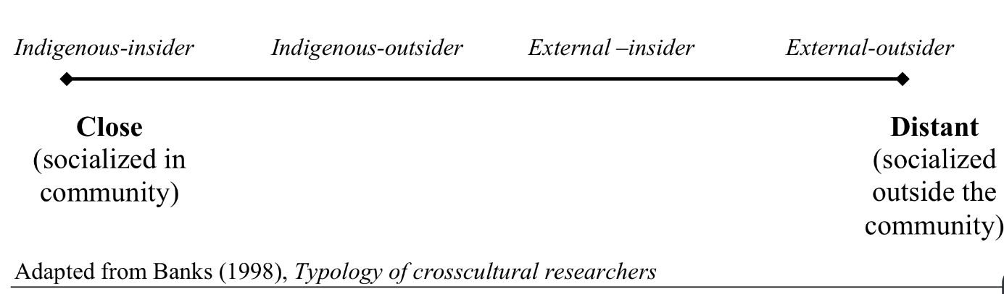
Figure 7: the spectrum of insider/outsider positionality based on the cultural, intellectual, and social distance to the indigenous community (Source: Chave’s thesis, 2008)

According to this spectrum, I am in the position of external-outsider on the most distance of the community, which implies, to be a researcher of Fuyao Group, I am in the advantage of detachment to this organization without intervention from internal impact, and possible bias will not generate in the data collection. However, on the other hand, the disadvantage of a total outsider is obvious either, such as lack of legitimacy of internal information, immediate relationship with participants, and a nuanced observation and interpretation.

Blog 3
The application of the research approaches of this project will be analyzed regarding Quantitative, Qualitative, and Mixed Methods. Generally speaking, this project has grounded in content analysis, which is the start point of observing the corporate culture of Fuyao Group. Content analysis has experienced several phases in history, from the earliest typical quantitative approach to the press in the 1930s to a generalized application to qualitative studies recently (Krippendorff, 2004, p.3). Therefore, if the content analysis was taken as a quantitative research method in its formal definition (Kaplan, 1943; Berelson, 1945) and carried out under the paradigm of positivism, it would provide supportive investigation tools for dealing with hundreds of data without getting buried under piles of texts and various types of documents. In the case of Fuyao's internal journals, the issues have exceeded 200 since the foundation of Fuyao People in 1987. The workload to covering all of these transcripts is enormous and can be impossible without the help of software like SPSS. Moreover, the findings on the position of positivists are objective due to the advantage of non-contact, which means the researcher's value orientation will not intervene or affect the way of investigating and interpreting (Tashakkori and Teddlie, 2009, p.12). However, on the other hand, it can ignore 'the subtle nuances in the production of meaning' (Lewis-Beck, 2004, p.189) if this research is only under a positivistic perspective. Some scholars contended that text is qualitative from the very beginning, to sort and categorize textual units can be taken as the most fundamental element of measurement (Stevens, 1946). Thus, a content analysis may turn out to be verbal responses to research questions. Just as Kracauer (1952) argued, what perhaps makes sense about a certain text can be incompatible with quantification. Content analysis tries to work out the hidden implication which cannot be revealed by the statistical findings, such as metaphors and figures of speech (Pickering, 2001; Creswell and Poth, 2013).
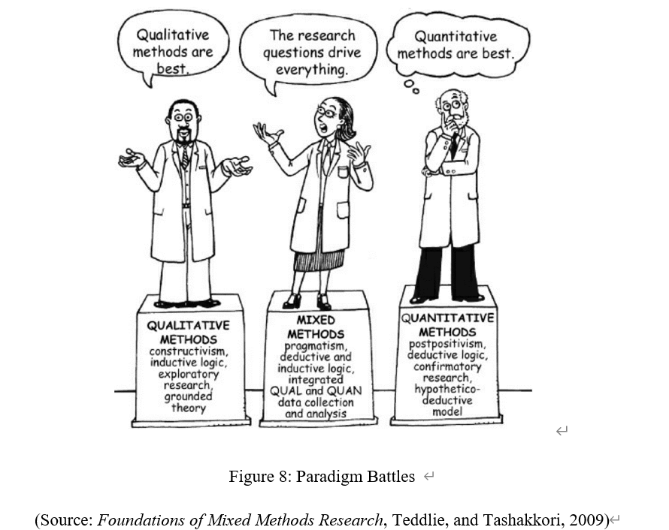
When a certain culture of corporate is under survey, the focus has to be placed on the ideas from top management or leaders, who usually dominate corporate value orientation. And Mr. Cao, the founder of Fuyao Glass, his autobiography and interviews have reflected there is a need to be considered under content analysis in qualitative perspective. In practice, many scholars have achieved consensus that the dichotomy of quantitative and qualitative approach regarding content analysis is a pseudo proposition or 'a misguided approach' (Franzosi, 2003; Krippendorff, 2013). In fact, this content analysis can be conducted in a mixed way, which combines scientific procedures like sampling and coding scheme with a typical qualitative method like narrative analysis or case study. The qualitative method can be used to follow up the quantitative method and helps explain connections and mechanisms on causal models or theories.
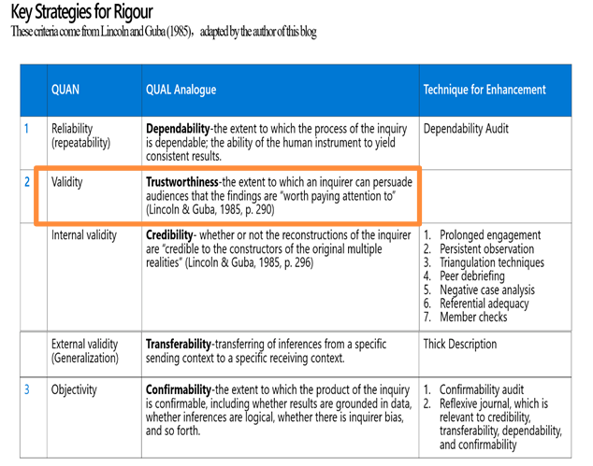
Figure 9: Key Strategies for Rigor
(Source: This table is adapted by the blogger, based on Guba and Linclon, 1985; Tashakkori, A. and Teddlie, C., 2009)

Primarily, this project plans to be conducted on the secondary data, which implies there will be the disadvantage that it may not include some particular interviews or observations at the spot. After all, the corporate culture sometimes can be effectively perceived by the customs and atmosphere in the corporate, by people's speech, behaviors, and the way they are dressing at the workplace (Ferrell, 2008). According to Lincoln and Guba (1985), internal validity concerns the fit of participants' realities and the researcher's representations and constructions toward those realities (Tashakkori and Teddlie,2009, p.258). Secondary data reliance may miss out on nuances without researcher’s observing in person at the site. To enhance the credibility, this project tries to apply the triangulation technique, the application of more than one method (Patton, 2015, p.247) to answer the research question. Except for secondary data, the primary data will be collected by the software SPSS, used for analyzing variables involving in the theory of CVF discussed in blog 2, such as 'internal dynamics', 'demand of external environment', 'organizational preferences for structuring, coordination and control' (Linnenluecke, 2010, p.359). Through triangulation both of secondary and primary sources, the uncertainty will be reduced and trustworthiness will be strengthened.
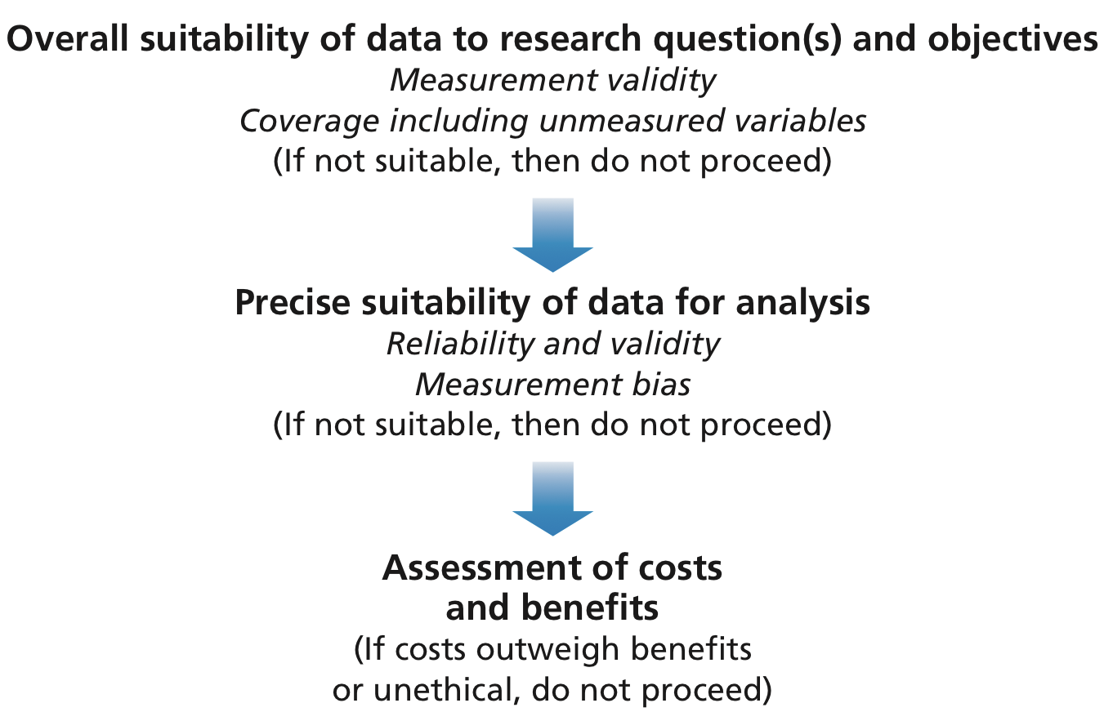
Figure 10: Evaluating potential secondary data sources
(Source: Saunders et al, 2019)

According to Saunders (2019), some secondary data sources may not contain useful variables identified as being conducive to the research project, which is called measurement bias. For example, Fuyao People, the internal journal of the corporate, has inserted pictures, corporate logos, and slogans to beautify or publicize their organization, or just for the sake of pursuing design effect. These contents are not closely related to the research topic and should be excluded from the category of coding for reducing the measurement bias. Perhaps the most difficult part of secondary data filtering lies in 'real control over data quality ' (Saunders, 2019, p.354), even though they are the publicized information because the documents can be intentional interpretations from the complier rather than an objective and neutral description of the reality. Notably, except for the open publications, other likely sources of the secondary data can be those the work papers at the ResearchGate and lectures coming from webinars at SagePub or MOOCs.
Based on integrating these three concepts discussed in blog 2 ─ “Confucius capitalist”, “corporate culture” and “corporate citizenship”, this project is trying to explore how a Confucianism capitalist, the founder (Cao Dewang) of Fuyao Glass, creates a multicultural organization to achieve sustainable development in his international corporate and what are those typical characteristics of its corporate culture. Trying to answer the "what" question, the survey strategy is suitable while trying to answer the "how" question, a case study has to be resorted to (Yin, 2003, p.6). Given that those research questions are engaged in various aspects of culture, institution, and philosophy, and ideologies, they are too complicated to be discovered, which results in appealing for the utility of multiple methods. Thus, except for data triangulation, methodological triangulation has to be turned to as well. The general conceptual framework involving both thematic and statistical strategies is described as follows:

Figure 11：Conceptual framework (This flow chart is designed by the author of this blog)
Content analysis targets at explaining the degree to which Confucius ideology influences idea of development of a corporate and how it moulds and shapes the corporate culture. By this methodology, a scale can be design to discover the evidence of impact of Confucianism by virtue of explore the leader’s autobiography and internal journals. The comparative analysis targets at looking back on oneself from others, referring in a sense that a reference substance will better reflect what has been described, to minimize the subjectivity interference in research. The counterpart of Confucius's business ethics is corporate citizenship from the western world.
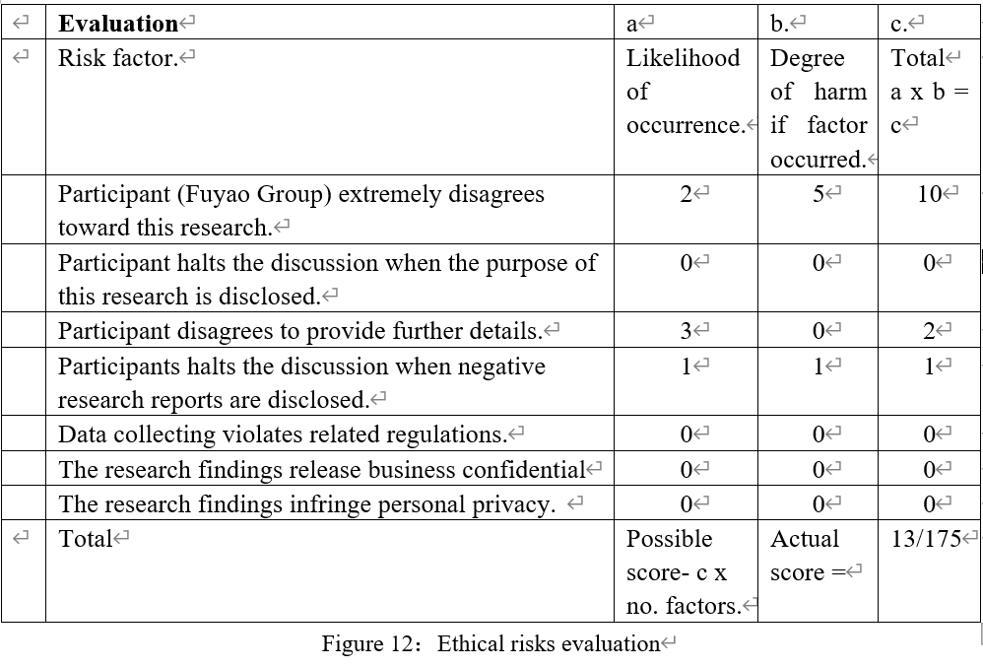

In terms of ethical risks evaluation, as it has been mentioned in the second blog, before conducting the study, the permission of accessing Fuyao people will have to be obtained. If the request has been turned down, the whole plan will fall apart. At the primary phase of the study, it is necessary to disclose the purpose of this research project by contacting its related administrative officers and to enquire whether there is any sensitive information, such as business confidential needs to avoid. In the process of data collecting, keep in touch with the company's relevant staff and discuss the use of the study data as well as store the data and materials in secure places in case of leakage. When analysing data, if contrary findings occurred, to report the negative results honestly. After publishing the study, provide copies to participants.

Appendices:
- The list of Books:
Beck, L.W. (1966) A commentary on Kant's "Critique of practical reason", Chicago: University of Chicago Press.
Berlin I. (2013) The power of ideas, Princeton University Press.
Carroll, A.B. and Buchholtz, A.K. (2014) Business and society: Ethics, sustainability, and stakeholder management, Nelson Education.
Crane, A. (2016) Business ethics: managing corporate citizenship and sustainability in the age of globalization, 4th edn, Oxford: Oxford University Press.
Fingarette, H. (1972) Confucius: the secular as sacred, New York; London: Harper and Row.
Heath, E. (2018) The Routledge companion to business ethics, 1st edn, New York: Routledge.
Hulme, A. (2014) The changing landscape of China’s consumerism, Elsevier.
Nolan, J. et al. (2016) Business networks in East Asian capitalisms: enduring trends, emerging patterns, Chandos Publishing.
Smith, A. (1804) The theory of moral sentiments: or, An essay towards an analysis of the principles by which men naturally judge concerning the conduct and character, first of their neighbours, and afterwards of themselves, 10th edn, London: T. Cadell and others.
Weber, M. (1978) Economy and society: An outline of interpretive sociology, CA: University of California Press.
Weber, M. (2002) The Protestant ethic and the "spirit" of capitalism and other writings, Penguin.
- The list of Articles:
Bailey, A.D. and Strudler, A. (2011) ‘Dialogue: The Confucian Critique of Rights-Based Business Ethics’, Business ethics quarterly, 21(4), pp. 661-677.
Berlin, I., et al. (1972) ‘The originality of Machiavelli’, in Matravers, D., et al. (eds.) Reading Political Philosophy: Machiavelli to Mill, 1st edn, New York: Routledge Associated with the Open University.
Hennig, A. (2016) ‘Three Different Approaches to Virtue in Business―Aristotle, Confucius, and Lao Zi’, Frontiers of philosophy in China; Frontiers of Philosophy in China, 11(4), pp. 556-586.
Koehn, D. (2001) ‘Confucian Trustworthiness and The Practice of Business in China’, Business ethics quarterly, 11(3), pp. 415-429.
Koehn, D. (2020) ‘East Meets West: Toward a Universal Ethic of Virtue for Global Business’, Journal of Business Ethics, 116(4), pp. 703-715.
Koehn, D. (2020) ‘How Would Confucian Virtue Ethics for Business Differ from Aristotelian Virtue Ethics?’, Journal of Business Ethics, 165(2), pp. 205-219.
Koehn, D. (2020) ‘How Would Confucian Virtue Ethics for Business Differ from Aristotelian Virtue Ethics?’, Journal of Business Ethics, 165(2), pp. 205-219.
Linnenluecke, M.K. and Griffiths, A. (2010) ‘Corporate sustainability and organizational culture’, Journal of world business, 45(4), pp. 357-366.
Linnenluecke, M.K.et al. (2009) ‘Subcultures and sustainability practices: the impact on understanding corporate sustainability’, Business strategy and the environment, 18(7), pp. 432-452.
Lopis, J. et al. (2007) ‘Corporate governance and organizational culture: The role of ethics officers’, International journal of disclosure and governance, 4(2), pp. 96-105.
Sison, A.J.G., et al. (2020) ‘Some Virtue Ethics Implications from Aristotelian and Confucian Perspectives on Family and Business’, Journal of Business Ethics, 165(2), pp. 241-254.
Tae, W.K. (2014) ‘Confucian Ethics and Labor Rights’, Business ethics quarterly, 24(4), pp. 565-594.
Tea, W.K. and Strudler, A. (2012) ‘Workplace Civility: A Confucian Approach’, Business ethics quarterly, 22(3), pp. 557-577.
Tu, W. (1984) ‘Confucian ethics and the entrepreneurial spirit in East Asia’, Confucian Ethics Today: The Singapore Challenge, Singapore: Federal Publications.
Tu, W. (1996) ‘Introduction’, Confucian Traditions in East Asian Modernity: Moral Education and Economic Culture in Japan and the Four Mini-Dragons, Cambridge, MA: Harvard University Press.
Tu, W. (2006) ‘The Confucian ethic and the spirit of East Asian modernity’, in Samantha Wauchope, S. (ed.) Cultural diversity and transversal values: East–West dialogue on spiritual and secular dynamics, UESCO, pp. 7-13.
Tu, W. (2012) ‘A spiritual turn in philosophy: Rethinking the global significance of Confucian humanism’, Journal of philosophical research, 37(Supplement), pp. 389-401.
Woods, P.R. and Lamond, D.A. (2011) ‘What Would Confucius Do? — Confucian Ethics and Self-Regulation in Management’, Journal of Business Ethics, 102(4), pp. 669-683.
ZHU, W.,et al. (2019) ‘Ethical Leadership with Both “Moral Person” and “Moral Manager” Aspects: Scale Development and Cross-Cultural Validation’, Journal of Business Ethics, 158(2), pp. 547-565.
Hanafin, J.J. (2002) ‘Morality and the Market in China: Some Contemporary Views’, Business ethics quarterly, 12(1), pp. 1-18.
Liu, T.Q., et al. (2016) ‘The contextualization and de-contextualization of Confucian morality: Making Confucianism relevant to China’s contemporary challenges in business ethics’, Asia Pacific journal of management, 33(3), pp. 821-841.
Mccloskey, D.N. (2017) ‘Confucian Business Ethics: Possibilities and Challenges’, Wealth, Commerce, and Philosophy: Foundational Thinkers and Business Ethics, Chicago: University of Chicago Press.
3. The original table created by Tashakkori, A. and Teddlie, C, 2009.
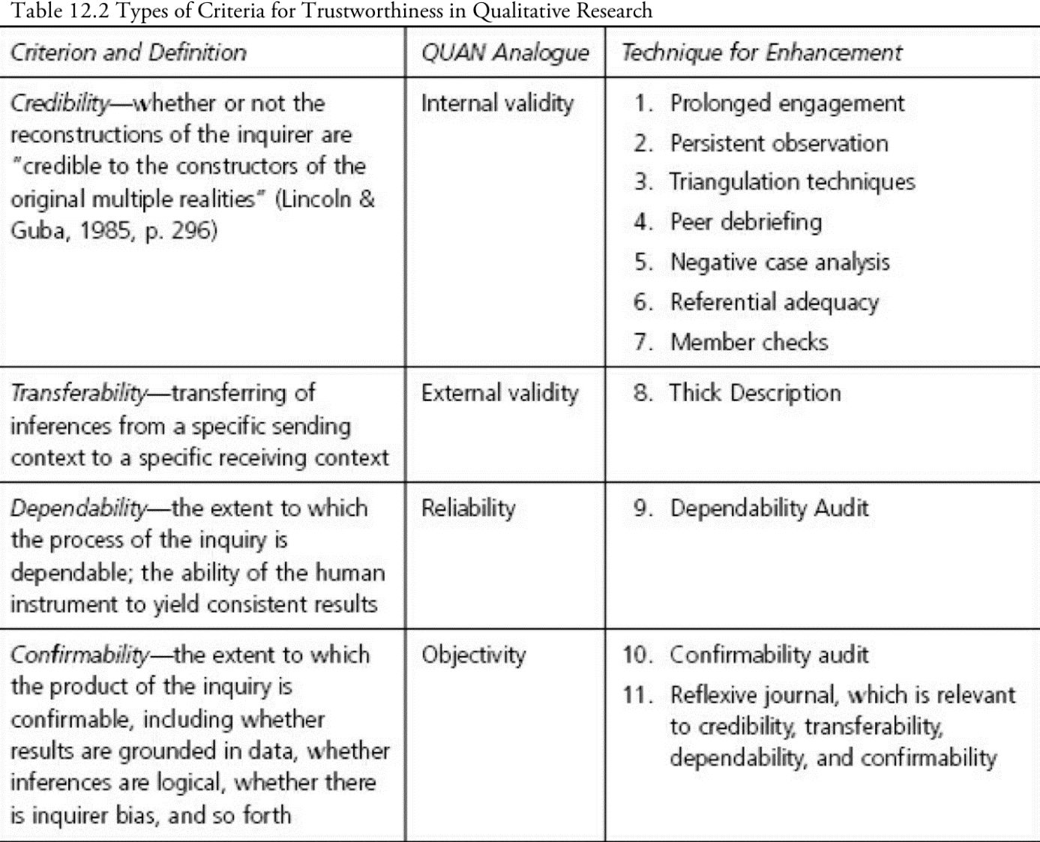

Bibliography:

Berelson, B. (1954) ‘Content analysis’, in Lindzey, G.E. and Aronson, E.E. (eds.) The handbook of social psychology, 1, MA: Addison-Wesley, pp. 488-522.
Berlin, I., et al. (1972) ‘The originality of Machiavelli’, in Matravers, D., et al. (eds.) Reading Political Philosophy: Machiavelli to Mill, 1st edn, New York: Routledge Associated with the Open University.
Bernstein, A. (2004) ‘Can this Man Save Labor?’, BusinessWeek, 24th September.
Bohr, N. (1928) ‘The quantum postulate and the recent development of atomic’, Nature, 121, pp.580–590.
Cameron, K.S. and Quinn, R.E. (2011) Diagnosing and changing organizational culture: Based on the competing values framework, John Wiley & Sons.
Cao, X. 曹雪芹. 2014. Honglou Meng红楼梦, Howkes, D.(trans). Shangha: Shanghai jiao yu chu ban she.
Chavez, C. (2015) ‘Conceptualizing from the Inside: Advantages, Complications, and Demands on Insider Positionality’, The Qualitative Report, 13(3), 474-494.
Chen, C.C. and Lee, Y. T. (2018) Leadership and management in China: Philosophies, Theories, and Practices, Cambridge University Press.
Creswell, J.W. and Poth, C.N. (2013) Qualitative inquiry and research design: choosing among five approaches, 3rd edn. Los Angeles: SAGE Publications.
Crotty, M. (1989) The foundations of social research. London: Sage.
Derrida, J. (1978) Writing and difference, Chicago: University of Chicago Press.
Di, X. 狄宣亚. 2019. Ao Bama zhuan hang pai dian ying, juran jiang le Cao DeWang de gushi 奥巴马转行拍电影，居然讲了曹德旺的故事，The Beijing News 新京报，20th August. Available at: https://www.bjnews.com.cn/detail/156626315914748.html (Accessed: 14th March 2021)
Elsbach, K.D. and Stigliani, I. (2018) ‘Design Thinking and Organizational Culture: A Review and Framework for Future Research’, Journal of Management, 44(6), pp. 2274-2306.
Ferrell, O.C., et al. (2014). Business ethics: ethical decision making & cases, 10th edn, Australia: South-Western.
Franzosi, R. and Roberto, F. (2004) From words to numbers: Narrative, data, and social science, Cambridge University Press.
Gregory, K.L.(1983) ‘Native-View Paradigms: Multiple Cultures and Culture Conflicts in Organizations’, Administrative Science Quarterly, 28(3), pp. 359-376.
Guba, E. G. and Lincoln, Y. S. (1989) Fourth generation evaluation, London: Sage.
Guba, E.G. (1990) ‘The alternative paradigm dialog’, in E.G. Guba (ed.), The paradigm dialog, CA: Sage, pp. 17-30.
Guba, E.G. and Lincoln, Y.S. (1994) ‘Competing paradigms in qualitative research’, Handbook of qualitative research, 2(163-194), pp. 105.

Head, S. (2004) ‘Inside the Leviathan’, New York Review of Books, 16th December.

Jajja, M.S.S., et al. (2019) ‘The influence of institutional pressures and organization culture on Supplier Social Compliance Management Systems’, International journal of physical distribution & logistics management, 49(5), pp. 552-574.
Jones, R.A., et al. (2005) ‘The Impact of Organizational Culture and Reshaping Capabilities on Change Implementation Success: The Mediating Role of Readiness for Change’, Journal of management studies, 42(2), pp. 361-386.
Kantabutra, S. (2021) ‘Exploring Relationships among Sustainability Organizational Culture Components at a Leading Asian Industrial Conglomerate’, Sustainability (Basel, Switzerland), 13(4), pp. 1733.
Kaplan, A. (1943) ‘Content analysis and the theory of signs’, Philosophy of Science, 10(4), pp. 230-247.

Kimberly, J.R. and Quinn, R.E. (1984) ‘Paradox, planning, and perseverance: Guidelines for managerial practice’, Managing organizational transitions, Homewood, IL: Dow Jones-Irwin.
Kimberly, J.R. and Quinn, R.E. (1984) Managing organizational transitions. McGraw-Hill/Irwin.
Kirk, J., et al. (1986) Reliability and validity in qualitative research, Sage.
Kohn, E. (2019) “American Factory Review: A Cross-Culture Working-Class Doc, Via ‘The Office’─ Sundance”, 26th January, IndieWire. Available at: https://www.indiewire.com/2019/01/american-factory-review-sundance-1202038438/ (Accessed: 14th March 2021)
Kracauer, S. (1952) ‘The challenge of qualitative content analysis’, Public opinion quarterly, pp. 631-642.
Krippendorff, K. (2004) Content analysis: an introduction to its methodology. 2nd edn, London: Thousand Oaks.

Krippendorff, K. (2013) Content analysis: an introduction to its methodology, 3rd edn, London: SAGE.
Kuttner, R. (1994) ‘Labour and Management---Will They Ever Wise-Up’, BusinessWeek, 9th May.
Lakatos, I. (1976) ‘Falsification and the methodology of scientific research programmes’, Can theories be refuted, Springer, pp. 205-259.
Lewis-Beck, M., et al. (2003) The Sage encyclopedia of social science research methods. Sage Publications.
Lincoln, Y.S. and Guba, E.G. (1985) Naturalistic inquiry, California: Beverly Hills.
Lincoln, Y.S. and Guba, E.G. (1985) Naturalistic Inquiry, London: Beverly Hills, Calif.
Linnenluecke, M.K. et al. (2009) ‘Subcultures and sustainability practices: the impact on understanding corporate sustainability, business strategy, and the environment, 18(7), pp. 432-452.
Lowthers, M.et al. (2017) ‘A Sex Work Research Symposium: Examining Positionality in Documenting Sex Work and Sex Workers’ Rights’, Social sciences (Basel), 6(2), pp. 39.
Maxwell, J.A. (2005) Qualitative research design: an interactive approach, 3nd edn, London: Sage Publications.
Mccloskey, D.N. (2017) Wealth, Commerce, and Philosophy: Foundational Thinkers and Business Ethics. Chicago: University of Chicago Press.
McDonald, P. (2012) ‘Confucian foundations to leadership: a study of Chinese business leaders across Greater China and South-East Asia’, Asia Pacific business review, 18(4), pp. 465-487.
Meng, J. and Berger, B.K., (2019) ‘The impact of organizational culture and leadership performance on PR professionals’ job satisfaction: Testing the joint mediating effects of engagement and trust’, Public relations review, 45(1), pp. 64-75.
Neurath, O. (1983). ‘Physicalism’, Philosophical Papers 1913–1946. Springer, pp. 52-57.
Nruyen, P.T., et al. (2020) ‘Factors That Influence Employee Performance: Motivation, Leadership, Environment, Culture Organization, Work Achievement, Competence And Compensation (A Study Of Human Resource Management Literature Studies)’, Dinasti International Journal of Digital Business Management, 1(4), pp. 645-662.
Paganelli, M.P. (2008) ‘The Adam Smith Problem in Reverse: Self-Interest in The Wealth of Nations and The Theory of Moral Sentiments’, History of political economy, 40(2), pp. 365-382.
Patton, M.Q. (2015) Qualitative research and evaluation methods, 4th edn, Los Angeles: SAGE.
Popper, K. (2005) The logic of scientific discovery, Routledge.
Priest, G. (2017) ‘Charles Darwin’s Theory of Moral Sentiments: What Darwin’s Ethics Really Owes to Adam Smith’, Journal of the history of ideas, 78(4), pp. 571-593.
Ralston, et al. (2008) ‘The Impact of National Culture and Economic Ideology on Managerial Work Values: A Study of the United States, Russia, Japan, and China’, Journal of International Business Studies, 39(1), pp. 8-26.
Saunders, M. (2016) Research methods for business students, 8th edn, Harlow: Pearson Education.
Schein, E.H. (2010) Organizational culture and leadership, John Wiley & Sons.
Schwartz, H. and Davis, S.M. (1981) ‘Matching corporate culture and business strategy’, Organizational Dynamics, 10(1), pp. 30-48.
Scott, W.R. (2003) Organizations: Rational, natural, and open systems. Prentice Hall.
SONG, Y., 2002. ‘Crisis of Cultural Identity in East Asia: On the meaning of Confucian ethics in the age of globalisation’, Asian philosophy, 12(2), pp. 109-125.
Stein, S. and Storr, V.H. (2020) ‘Reconsidering Weber's Protestant Ethic and the Spirit of Capitalism’, The independent review, 24(4), pp. 521.
Stevens, S.S. (1946) ‘On the theory of scales of measurement’, Science, 102(2684).
Tashakkori, A. and Teddlie, C. (2009) Foundations of mixed methods research: integrating quantitative and qualitative techniques in the social and behavioral sciences, London: SAGE.
Tu, W. (1996) ‘Introduction’, Confucian Traditions in East Asian Modernity: Moral Education and Economic Culture in Japan and the Four Mini-Dragons, MA: Harvard University Press.
Tu, W. (1996) ‘Introduction’, tu Cambridge, MA: Harvard University Press.
Woods, P.R. and Lamond, D.A. (2011) ‘What Would Confucius Do? — Confucian Ethics and Self-Regulation in Management’, Journal of Business Ethics, 102(4), pp. 669-683.
Yin, R.K. (2009) Case study research: design and methods. 3th edn, London: SAGE.

Quoted by Pappus of Alexandria in Synagoge, Book VIII
The author of this blog believes since capital logic and the market economy have been introduced into China, it has helped China achieved industrial modernization. But what needs to be clear is that, in practice, what China is developing is a market economy with Chinese characteristics, or socialist market economy. Maybe Chinese traditional wisdom and culture will prepare spiritual elements for learning critically from capital logic.
IndieWire is a film industry and review website that was established in 1996. The site's focus is independent film. It is a subsidiary of Variety, which is part of the Penske Media.
The competent sponsor of The Beijing News is the Propaganda Department of Beijing Municipal Party Committee.
Obama is one of the producers of this film.
The term ‘ontological study’ is invented by the author of this blog, summarizing the original author’s ideas about the first aspect of organizational culture research. The author’s original statements: Despite the variety of interpretations and cultural dimensions, a number of common themes and similarities can be identified in organizational culture research. First, concepts used to identify and define organizational culture tend to overlap between studies; consequently, several scholars have attempted to develop frameworks to categorize important dimensions and to provide a conceptual foundation for the study of organizational culture; Second,…
The idea that Validity in quantitative is replaced by trustworthiness in qualitative comes from Foundations of mixed methods research: integrating quantitative and qualitative techniques in the social and behavioral sciences (Tashakkori, A. and Teddlie, C., 2009, pp. 31), which is not included in the original table (see the appendices).

