

Assignment 1

Marketing Fundamentals

Name: Sorina Elvira Mariana Soflau-Moscaliuc
Student ID: 2247224
Module code: LCBB4004
Module name: Marketing Fundamentals
Lecturer: Piyumika Kithulgoda Gamage

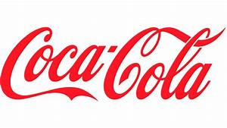

Fig 1. (StudioWorkz Productions, 2019)

1.Short history of Coca-Cola
The birth of this well-known worldwide drink took place in 1886 in Atlanta, Giorgia, when Dr. John Stith Pemberton who was a pharmacist came up with a new syrup for Coca-Cola, which then was offered to people walking past Jacobs ‘Pharmacy. The drink was declared excellent ( The Coca-Cola Company, 20023). Putting the syrup on sale for 5 cents a glass near a soda fountain led to the new idea of combining the two and producing the best drink ever declared “ Delicious and Refreshing” which travelled through the years till nowadays ( The Coca-Cola Company, 20023).
The name Coca-Cola was suggested by Dr. Pemberton’s partner, Frank M. Robinson who thought that the two Cs looked very nice together. Soon after the launching hand-painted signs were seen on the shop's entrance inviting passersby to have a refreshment drink, underestimating the great value his drink would have Dr. Pemberton sold his business to different partners ( The Coca-Cola Company, 20023).

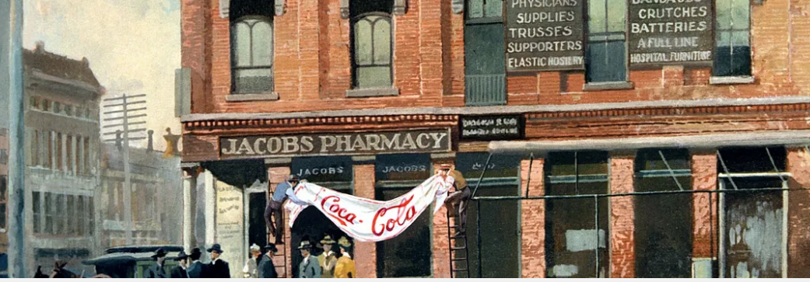
Fig.2 (The Coca-Cola Company, 2023)

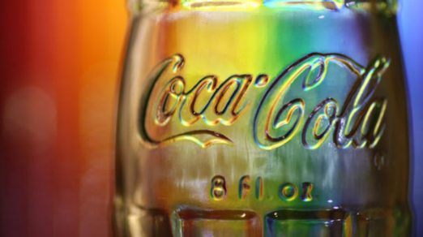
2. Mission statement of Coca-Cola
The purpose of the company is to refresh the world and make a difference. Their vision is to make people happy and enjoy life by drinking a good refreshment drink which will revive their body and soul. Their aim is to produce and maintain a sustainable company which will improve the people’s lives and the environment in an equal proportion (The Coca-Cola Company, 2023).
Fig. 3 (The Coca-Cola Company, 2023)

For a company to be successful in the market it is very important to be centralized on the customer's needs and attract them continuously with quality and valuable services or products keeping them away from competitors (Kotler, et al., 2019). Companies must use the appropriate strategies to attract customers because each business is well aware they cannot satisfy the whole market at the same time, therefore most businesses divide the market and choose the segments that can bring the most profitable percentage of customers leading to high revenues (Kotler, et al., 2019).

3. Segmentation, Targeting and Positioning strategies

3.1 Segmentation and Targeting Strategies

According to Kotler, Armstrong, Harris, and He, (2019), market Segmentation means classifying different people into potential buyers’ groups with different needs, and tendencies. Segmentation of the market is classified in four categories, demographic, geographic, behavioural, and psychographic ( Kotler et al., 2019). After deciding which segments of the market are the right ones for the success of the business each company has to target those specific segments. Targeting can be defined as the process of evaluating each market segment’s and choosing which one is the most attractive to serve. Each company starts by choosing the right segments and then select one or more depending on which one can bring more profit and customer value in the future (Kotler et al.,(2019).
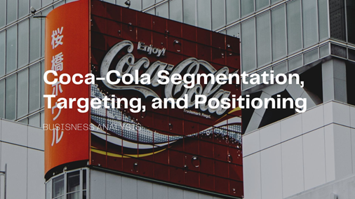
Coca-Cola is one of the leading companies that produces and sells soft drinks worldwide. The evolution of this company increased from nine drinks per day to becoming a well-known brand with more than 200 brands under the same company and millions of sold products in different countries ( PDF Agile, 2023). Coca-Cola developed their marketing strategy by using a centralised approach around market segmentation, targeting and positioning ( PDF Agile, 2023). This organization is a global brand which has a worldwide audience, the customers of Coca-Cola differ from young through middled aged who are attracted by the vibe of refreshens this soft drink offers to whoever consumes it ( Start, 2023).
Fig. 4 (PDF Agile, 2023)

3.1.1 Coca-Cola Demographics Segmentation and Targeting

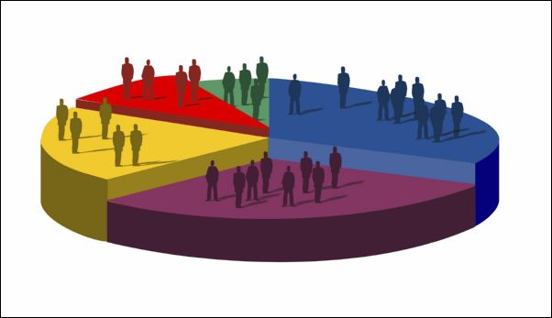
This company has a very good understanding of their targeted customers through a deep analyse of the targeted audience age, occupation, race , religion, lifestyle, social class or nationality. This analyse helped Coca-Cola to adapt their products to each individual segment in the market, including customers from young age such as 10 to mid-life age such as 40, covering areas from children and teenagers to married couples or persons living alone (PDF Agile, 2023).

Fig. 5 (slideshare, 2023)

3.1.2 Coca-Cola Geographic Segmentation and Targeting
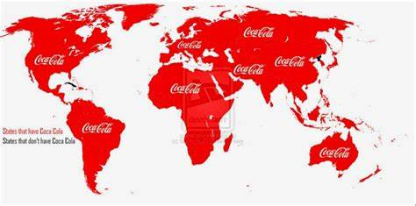
The organization has coke lovers worldwide and customers live in the urban areas as well in the rural areas. A very interesting fact is that Coca-Cola products own 28% share in Europe, Middle East and Africa comparing with sales from the birth country US, in the whole world this company holds 34,1% of worldwide revenue (Start, 2023). Considering to be the market leader in soft drinks Coca-Cola developed targeting strategies which tend to perfection. Using a successful strategy, the organization wants to reach out to different customers with different kind of products, to accomplish the needs, wants and preferences of the targeted audience. As for the World population review United States holds the record followed by Mexico, China, Brazil, Japan, Germany, Russia, India, Indonesia and on the 10th place United Kingdom (World Population Review, 2023).

Fig. 6 (Start, 2023)
3.1.3 Coca-Cola Behavioural Segmentation and Targeting
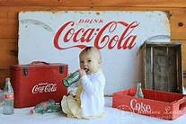
Along its evolution, this organization has identified two types of loyal consumers who enjoy a Coke on some special occasions called “soft” loyal customers and consumers who have a coke daily called “hard” loyal customers. The market chosen by the company could be defined as easy-going with highly determined personalities (Start, 2023). Choosing the right market segment Coca-Cola targets the older people who think about their health by offering Coke Zero or diet Coke, and as for the other age groups they did think and chose wise even the size and packaging addressing to families’ celebrations, different occasions, different lifestyles and for those who are always on the go they offer small bottles and cans.
Fig. 7 (Pinterest, 2023)
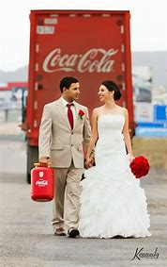
Moreover, they even thought about the customers that do not like cola and came up with purified water (PDF Agile, 2023). Another technique used by Coca-Cola so that the customers feel a sense of belonging and trendy is by using stars for promoting (PDF Agile, 2023).

Fig. 8 (Pinterest, 2023)
3.1.4 Coca-Cola Psychographic Segmentation and Targeting
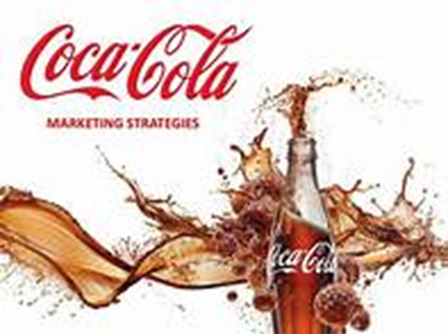
According to company customer analysis from the psychographic point of view the targeted market belongs to a wide socio-economic category from the middle class to upper class of the level of income. The approach that has been fixed for coke consumers is the “conscious progressive” personality which puts in evidence that customers aspire to independence and personal growth and look for new experiences in the brands they use (Start, 2023). One campaign which included this type of segmentation is “Share a coke” from 2011 and targeted the whole segments in their market. The campaign aimed people who values relationships and family and included different names printed on the Coca-Cola packaging (Two Teachers, 2023).
Fig. 9 (Avada, 2023)

3.3 Positioning

Kotler et al., (2019) defines positioning as the process of placing a product in a clear, distinctive and favourable position on the market winning among competitive products and creating brand-recognition in the minds of customers. The marketing department of every organization aims to place their products on the highest position in the consumers’ minds by giving their products distinctive characteristics differentiating them from the competitors products (Kotler et al., 2019).
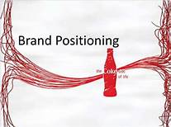
Coca-Cola’s positioning strategy it is based on the marketing mixt for the right chosen segment. Every business worldwide faces competition, but to be able to stand out on the market an organization needs to position itself in the right direction offering the same products but unique in the eyes of customers (PDF Agile, 2023).
Choosing a multi-segment strategy Coca-Cola positioned as the perfect soft drink offering refreshment of the body and satisfying the thirst. Moreover, thanks to the use of different marketing techniques, Coca-Cola holds the first place when it comes to choosing a high-quality drink for different occasions in people’s lives from weddings to birthdays and even holidays (PDF Agile, 2023).
Fig. 10 (slideshare, 2023)

4. Advantages and Disadvantages of using STP as a marketing strategy for Coca-Cola
Advantages
One of the important aspects of using the STP market strategy is segmenting the marketing, targeting specific groups of customers and positioning the products on the highest level in people's minds giving the organizations the power to customize each product with the required characteristics preferred by the customers (Mahathy and Kalam, 2020).
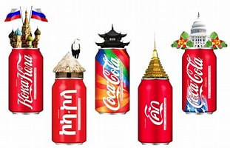
Another important aspect of using this strategy can be evidenced through the analysis of various demographic aspects of consumers such as
culture, norms, religion, values, location age, and gender which offers a great benefit to the companies such as producing and launching products that are specific for each targeted group of customers (Mahathy and Kalam, 2020).
Fig. 11 (Coca-Cola, n.d)

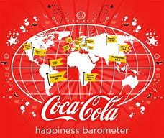
According to Vrontis (2003), Coca-Cola has a standard strategy based on the economy of scales but uses an integrated adaption stand approach as well. Being a multinational company Coca-Cola developed strong leadership in the beverage industry, owning bottling partnerships in over 200 countries all over the world, and operating franchises on the global market giving them the opportunity to grow and become known globally (Mahathy and Kalam, 2020).

Fig 12.(ViralBlog, n.d)

This strategy gives Coca-Cola Company the advantage of building profitable relationships with target customers by offering a clear brand image, quality and affordable prices leading to customer loyalty (Mahathy and Kalam, 2020).

Disadvantages

One disadvantage of using STP marketing strategy for Coca-Cola is that producing more versions of the same products could lead to increasing the cost (Shaikh, 2020). Another downsize of implementing this strategy for the company is that using this model the organization needs to focus on each segment chosen and create different marketing campaigns for each one of them increasing the cost (Shaikh, 2020).
In the eventuality that a segment from the market chosen by the company has a change in its characteristics will automatically lead to the loss of capital invested by the company.

5. Marketing mix of Coca-Cola
Kotler et al. (2019) defines the marketing mix as “a set of tactical marketing tools-product, price, place, and promotion- that the firm blends to produce the response it wants in the target market”.
Product Strategy
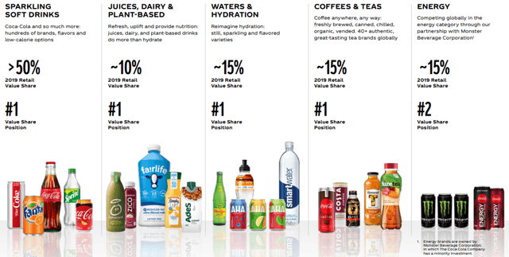
Coca-Cola increased its variety of products from one to over 500 sparkling and still beverages brands. Now the organization holds near four thousands options in their portfolio (Shastri, 2023). Even though they had developed significantly over the years coming up with so many products, their original drink Coca-Cola soft drink it is the most sold one worldwide (Shastri, 2023). Along with the original product this organization sells other products such us Fanta, Sprite, Diet Coke, and Coca-Cola Zero they also sell coffee and tea (Shastri, 2023).
Fig.13 (The Coca-Cola Company, 2023)
Core benefit - To satisfy the thirst and refresh the body.
Basic product - Soda and Sweetness.
Expected product - It must be served cold to feel the real taste.
Augmented product - Coca-Cola come up with the idea of sugar free for customers having health problems.
Potential product - Coca-Cola has a continuous tendency towards improving and innovation to satisfy the customers’ needs at the highest level (Coursehero, 2023).
Durability and tangibility – the beverage drinks are non-durability products with a shelf life up to nine months.
Consumer’s goods – this products are considered convenience goods which can be purchased with no effort.
Product differentiation – Coca-Cola has a unique glass bottled Coke and different sizes and shapes for every product they produce and sell.
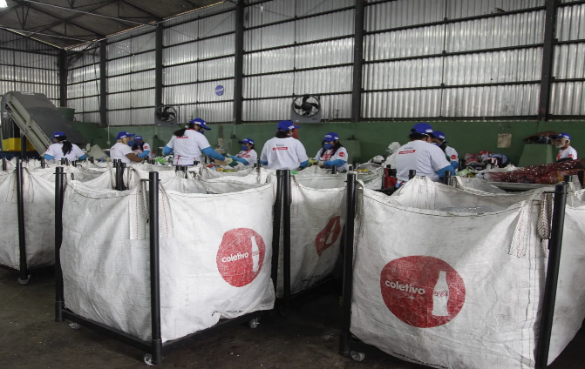
Coca-Cola aims to make its packaging 100% recyclable by 2025 to use 50% recycled material for packaging and to collect and recycle a bottle or can for each one sold by 2030. According to the company, more than half of the packaging used for products in 2022 was collected, refilled, or recycled. Being aware of the global challenges such as plastic waste and pollution they made partnerships with experts and different governments to support a sustainable change by creating innovative packaging all the way through the supply chain(Coca-Cola Company, 2023).

Fig.13 (The Coca-Cola Company, 2023)

Price Strategy

Coca-Cola implemented the theory of Kotler and Armstrong(2014) by using a combination of customer value-based and competition-based pricing strategies and considering the demand on the market as well. The main purpose of using this strategy is to offer the customers the perception that the quality of the products is directly correlated with the price paid. Before deciding on the pricing strategy, the organization analyses the competitor's offers, prices, and costs mainly Pepsi, then sets the final price(Vasiliki, 2023).
Valued Based Pricing – Coca-Cola focuses on offering their customers value and quality products which come with a strong brand and brings happiness in their lives.
Premium Brand Positioning – Being a premium brand in the beverage industry Coca-Cola affords to charge high prices for its products compared to other competitors.
Product Differentiation – Coca-Cola has a wide portfolio of products with different packaging and aroma, therefore targeting the customers preferences in the smallest detail.
Psychological Pricing – The company uses psychology to attract customers by offering strategic prices using numbers, an example could be that instead of putting the price for 2 £ they chose 1.99£ and people are attracted by the smallest price(Cuofano, 2023).
Coca-Cola uses a different approach when it comes to price strategy, they follow a price discrimination strategy offering different prices for each segment of the market chosen. The beverage industry is an oligopoly therefore there are only a few sellers and many buyers, the main sellers are Coca-Cola and PepsiCo so when they agreed to maintain a price parity in order that none of the company loses customers and coexist on the market(Mba Skool, 2023)

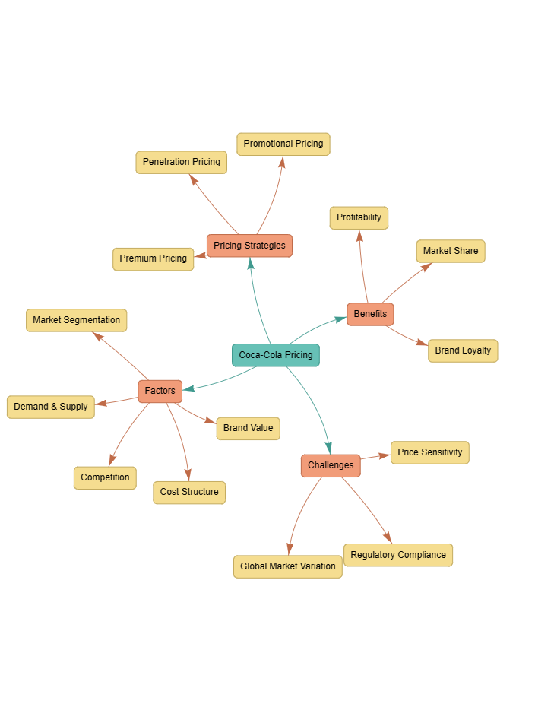
Fig.14 (FourWeekMBA, 2023)

Coca-Cola VS Pepsi

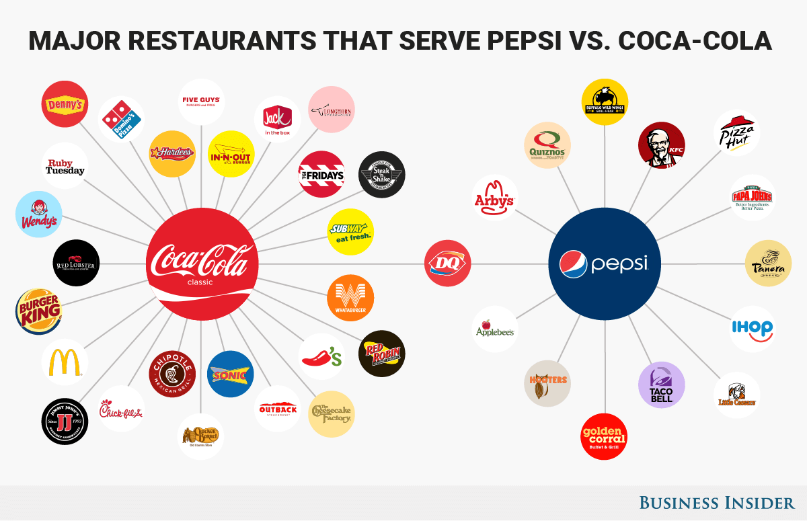
These two companies are in fierce competition since early 19 th century. They became well known on the market, coming up with similar products different brands, nowadays Coca-Cola holds 42% of the market share while Pepsi holds only 31% of the market share(BrandonGaille, 2017). In Table 1 and 2 it is compared the price for different products with the same packaging cans and the same quantity for Coca-Cola and Pepsi. As per comparison of these prices , it is clear that Coca-Cola has slightly bigger prices that Pepsi but apparently that does not affect the sells and profit of the company. For example the net income for Coca-Cola for one year was approximately $11.8 Billion compared to Pepsi who had only $6.3 Billion(BrandonGaille, 2017).

Fig.15 (BrandonGaille, 2017)
Product 330 ml, can | Coca-Cola | Diet Coke | Coke Zero | Fanta | Sprite
Price £ | 0,65 | 0,70 | 0,40 | 0,41 | 0,60
Table. 1
Product 330 ml, can | Pepsi | Pepsi Max | 7 UP | Pepsi Diet | Pepsi max cherry | 7 UP free
Price £ | 0,5 | 0,37 | 0,48 | 0,37 | 0,56
Table. 1

Place Strategy
Referring to place it is not only about the physical location of a company but includes the location where a product can be purchased. It is extremely important for a company to correctly apply the marketing mix and that customers have access unrestricted to the products produced, this process can be called distribution channels. Coca-Cola owns 24 manufacturing plants and the other 34 are offered to a third party in the leasing system (Maurya, Makda, and Paiman, 2016).
Coca-Cola had developed a wide distribution network, starting from north America, Latin America, Pacific, Eurasia and Africa including Europe (Banerje,2021). The main location is in Atlanta, Giorgia. Apart from the main location Coca-Cola has 218 offices around the world. The organization produces the products using their special recipe then distributes it to the bottlers which are located all around the globe. After the process of bottling the beverage, the products are distributed further to agents, then to stocklists, then to distributors, and in the end, they reach to retailers where can be purchased by customers. Thanks to the well-created distribution channel Coca-Cola products are available to buy in almost every retail outlet or supermarket in each corner of the planet(Mba Skool, 2023).

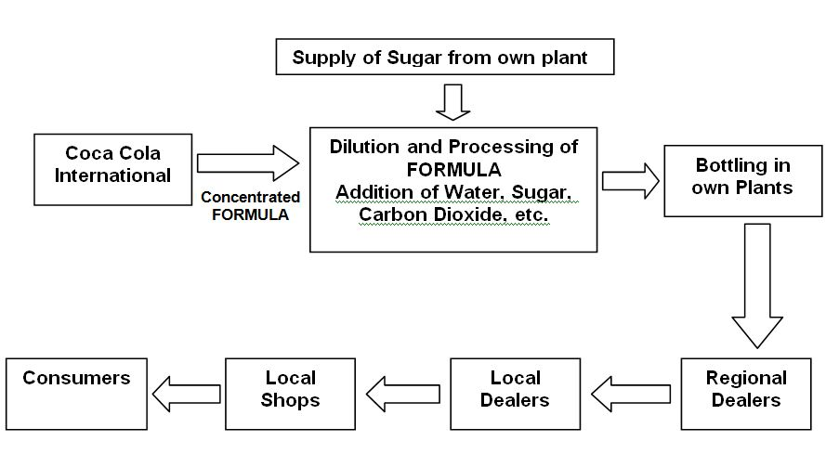
Distribution channels of Coca-Cola

Fig.16(Tiwana and Lu, 2015)

Coca-Cola is a global business and operates almost everywhere thanks to partnerships with over 250 bottling partners all over the globe. The organization only sells the syrups which are distributed to the bottling
partners who manufacture and pack the products with the branded beverages to distributors and in the end to customers(Tiwana and Lu, 2015). The products can be sold by distributing from wholesalers distributors, retail, corner shops, supermarkets, cafes, and petrol stations, this strategy has been such a success that the distributors and the wholesalers need their products to grow and make a profit(Tiwana and Lu, 2015).

Promotion Strategy
Coca-Cola focuses on aggressive marketing through different channels such as social media, TV campaigns, and printed media but they also sponsor different events, for example, FIFA World Cup or the Olympic Games so they become more recognizable with their brand and increase their sales. The business also promotes its products through TV advertisements created in different languages targeting different countries which can lead to business increase and stability(Mba Skool, 2023). The organization mainly focuses on integrated marketing communications using multiple channels to promote its products as much as possible.
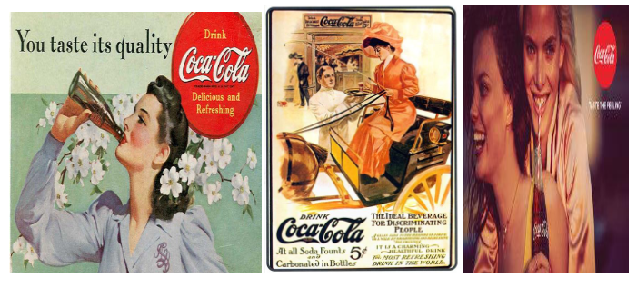
They follow different steps for promotion such as advertising, personal selling. Direct marketing. Sales promotion, Publicity, and public relations.
Fig.17 (Anik and Habiba, 2020)
Advertising- the key for success is the right advertisement so the organization spends a significant sum of money each year for advertising so they will always be successful.
Personal Selling – B2C Coca-Cola took this selling to a different level coming up with booths where customers can buy directly. They also launched a soda fountain of Coca-Cola so customer could choose from over 100 assortments of coke.
Direct Marketing – the organization took a different approach instead of talking directly with customers they call different organizations and serve their products to customers through them, in exchange the organizations received different benefits from Coke (Anik and Habiba, 2020). They also have different campaigns where they sell their products associating them with food. They also sponsor different events in the entire world.
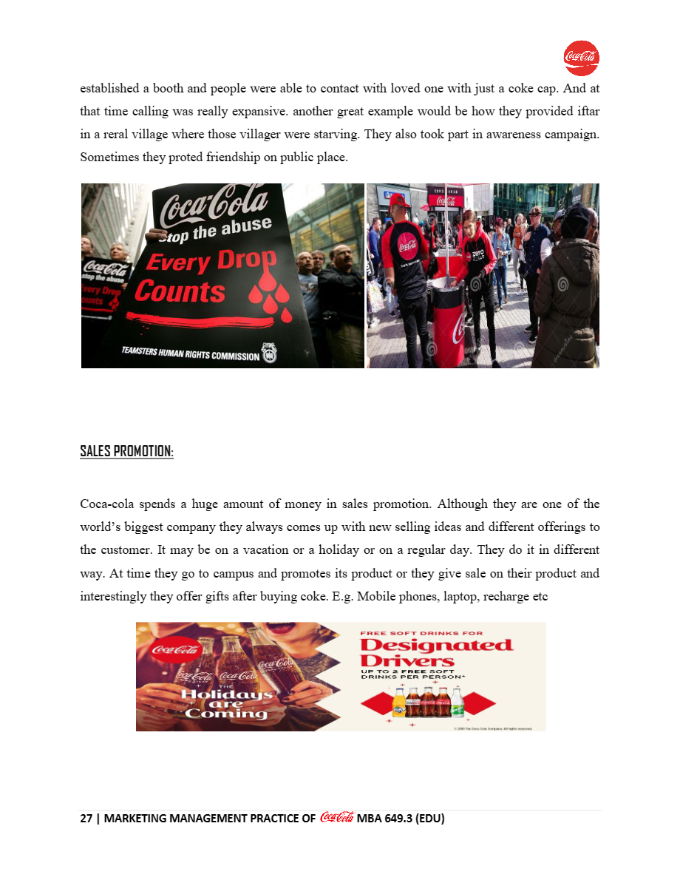
Public relations – the business rules different awareness campaigns including CSR activities in order to engage as much as possible with their customers or future customers. A good example can be when the company established a booth and people were able to call their loved ones with just a coke cap(Anik and Habiba, 2020).

Fig, 17 (Anik and Habiba, 2020)
Sale Promotion –Coca-Cola a well-known brand can be said doesn’t need any more promotion, although the company spends huge amounts of money on new and innovative selling ideas to attract more customers, they do think about different events like holidays to promote or even offering free drinks (Anik and Habiba, 2020).

Fig.18 (Anik and Habiba, 2020)
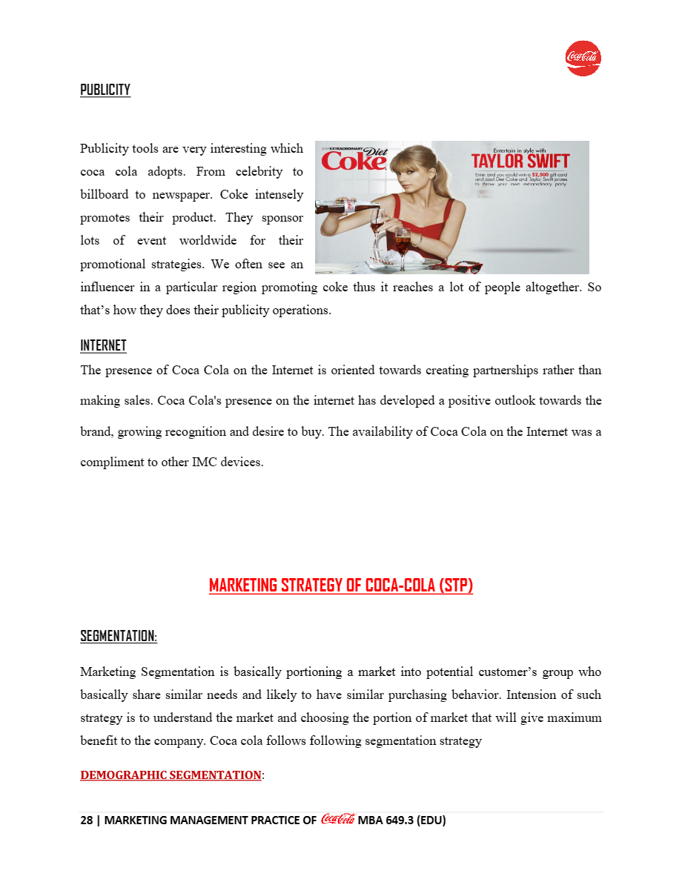
Publicity – the organization uses a wide variety of tools to increase people's awareness about their products, for example using celebrities or sponsoring different events like sports matches so their logo will appear everywhere and make people aware of the brand(Anik and Habiba, 2020).

Fig.19 (Anik and Habiba, 2020)

Internet – the company uses the internet but more for finding partners rather than selling online, although the brand is well known all over the social media platforms and even on the ads, therefore creates the desire for buying (Anik and Habiba, 2020).
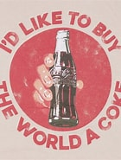
I’d like to buy the world a coke!
Reference list

Anik, K. and Habiba, W. (2020) ‘Marketing Management Practice of Coca-Cola’, Available at: (PDF) MARKETING MANAGEMENT PRACTICE OF Coca-Cola (researchgate.net) (Accessed 23 November 2023).
BrandonGaille (2017) 29 Coca Cola vs. Pepsi Statistics, Available at: 29 Coca Cola vs. Pepsi Statistics - BrandonGaille.com(Accessed 21 November 2023).
BrandonGaille(2023) Available at: 29 Coca Cola vs. Pepsi Statistics - BrandonGaille.com(Accessed 21 November 2023).
Coca-Cola (2023) Available at: Coca-Cola UNITED map of locations, local bottlers - Coca-Cola UNITED (cocacolaunited.com) ( Accessed 23 November 2023).
Coca-Cola (n.d), Available at: Global Distribution - Coca-Cola (weebly.com),(Accessed: 16 November 2023).
Coca-Cola(n.d) Available at: coca cola in different countries | Coca-Cola (wordpress.com) (Accessed 17 November 2023).
Coursehero (2023) Available at: ENGLISH101 - Cocacola Product.docx - Product PRODUCT LEVEL: The Customer-Value Hierarchy • CORE BENEFIT: The product to quench the thirst while dining at | Course Hero(Accessd 20 November 2023).
Four Week MBA(2023) Coca-Cola Pricing Strategy, Available at: Coca-Cola Pricing Strategy - FourWeekMBA (Accessed 21 November 2023).
Kotler, PT. Armstrong, G.(2014) “Principles of Marketing: global edition. 15th. Pearson Limited.
Kotler, PT. Armstrong, G., Harris, and LC. & He. H (2019), “Principles of Marketing”, Pearson Education Limited, Harlow, United Kingdom. Available from: ProQuest Ebook Central - Book Details. (Accessed: 13 November 2023).
Mahathy, H.J. and Kalam, K.K., (2020)‘The importance and level of adaptation of STP strategies for growth in Foreign Markets: In the case of Coca-Cola Company’. Available at: (PDF) The importance and level of adaptation of STP strategies for growth in Foreign Markets: In the case of Coca-Cola Company (researchgate.net) (Accessed: 16 November 2023).
Maurya, H., Makda, B., and Paiman, (2016) ‘A Study on Development of Coca-Cola’s Place Strategy’, International Journal In Management and Social Science,04(02), Available at: (5) A STUDY ON DEVELOPMENT OF COCA COLA’S PLACE STRATEGY | Journal ijmr.net.in(UGC Approved) - Academia.edu(Accessed 21 November 2023).
Mba Skool (2023) Coca Cola Marketing Strategy & Marketing Mix (4Ps), Available at: Coca Cola Marketing Strategy & Marketing Mix (4Ps) | MBA Skool(Accessed 23 November 2023).
Pdf Agile(2023), Business Analysis: Coca-Cola Segmentation, Targeting, and Positioning, Available at: Coca-Cola Segmentation, Targeting, and Positioning | PDF Agile,(Accessed: 16 November 2023).
Pinterest(2023) Available at: https://www.pinterest.com/pin/20336635790559077/ (Accessed 20 November 2023).
Shaikh, H.(2020) ‘A Beginner’s Guide to STP Marketing’, Available at: Martechlive Is A Marketing Strategy Content Provider | Helping Leaders to Succeed via Online Marketing. (Accessed 19 November 2023).
Slideshare (2023) Coca-Cola brand positioning and differentiation, Available at: https://www.slideshare.net/SaraAmjad6/coca-cola-brand-positioning-and-differentiation, (Accessed 16 November 2023).
Slideshare(2023) Marketing strategies, Available at: https://www.slideshare.net/TharushikaRuwangi/marketing-strategies-of-coca-cola-company (Accessed: 16 November 2023).
Start (2023), Coca-Cola Target Market Segmentation – Customer Analysis & Marketing Strategy, Available at: Coca-Cola Target Market Segmentation & Marketing Strategy | Start.io (Accessed: 16 November 2023).
StudioWorkz Productions (2019), Available at: StudioWorkz Productions – Visual Branding, Ecommerce Branding, Logo Design, Packaging Design, Website Design & Brand Guide Development – We Make Brands Look Good, (Accessed: 6 November 2023).
The Coca-Cola Company Sustainability (2023) Available at: Sustainable Packaging (coca-colacompany.com) (Accessed 20 November 2023).
The Coca-Cola Company(2023), Available at: The Birth of a Refreshing Idea - News & Articles (coca-colacompany.com), (Accessed: 13 November 2023).
The Strategy Story(2021) Coca Cola Marketing Strategy, Plan and Mix(4Ps), Available at: Coca Cola Marketing Strategy, Plan & Mix (4Ps) - The Strategy Story(Accessed 21 November 2023).
Tiwana, S. and Lu, L. (2015) The Coca-Cola Company’s distribution strategy, Available at: The Coca-Cola Company’s distribution strategy | Marketing Management Blog T1 2015 (wordpress.com) (Accessed 23 November 2023).
Two Teachers(2023) The Power of Psychographic Segmentation: How Coca Cola's 'Share a Coke' Campaign Succeeded, Available at: Post | Two Teachers(Accessd 20 November 2023).
Vasiliki, P. (2023) Marketing mix strategy of Coca-Cola& line stretching strategies adoption, Available at: (5) Marketing mix strategy of Coca-Cola & line stretching strategies adoption MASTER IN BUSINESS ADMINISTRATION (MBA) MODULE: MBA 61 MARKETING | Vasiliki Panagiotopoulou - Academia.edu(Accessed 21 November 2023).
ViralBlog(n.d) Available at: Why I Admire Coca-Cola For Its Brilliant Global Marketing? (viralblog.com) (Accessed 17 November 2023).
Vrontis, D. (1999), “Global Standardisation and/or International Adaptation?, A Tactical Marketing Decision for Multinational Businesses in Crossing Borders and Entering Overseas Markets”, , Business and Economics Society International (B&ESI), Volume III pp.140-151.
World Population Review(2023) Available at: Coca Cola Consumption by Country 2023 (worldpopulationreview.com)(Accessed 20 November 2023).

