

Marketing Environment Analysis

Programme: Master of Business Administration

Module: Marketing Management

Module Code:LCMB7024

Assignment Title: Marketing Environment Analysis

Student Name: Niraj Vastabhai Odedara

Student ID Number: 2541726

Lecturer

Word Count: 2,634 words

Submission Date:26 June 2026

Table of Contents
1 Introduction 3
2 Task 1: Marketing Environment Analysis 3
2.1 Tata Steel’s Strategic Context 3
2.1.1 Company Position and Growth Pressures 3
2.2 External Actor One: The Natural Environment 4
2.2.1 Climate Change and Carbon Intensity 4
2.2.2 Pollution, Water and Local Environmental Legitimacy 4
2.3 External Actor Two: Industrial Customers and Regulators 5
2.3.1 Customer Demand for Lower-Carbon Steel 5
2.3.2 Regulation, Policy Support and Green Steel Barriers 6
3 Task 2: Strategic Growth and Competitive Positioning 7
3.1 Applying the Ansoff Matrix 7
3.1.1 Strategic Options for Tata Steel 7
3.2 Recommended Strategic Growth Approach 8
3.2.1 Product Development: Low-Carbon and Traceable Steel 8
3.2.2 Circular Economy and Scrap-Based Growth 9
3.3 Competitive Positioning 9
3.3.1 Differentiation Through Verified Green Steel 9
3.3.2 Dynamic Capabilities and Transition Readiness 10
3.4 Implementation and KPIs 10
3.5 Critical Evaluation of Risks 11
4 Task 3: Critical Reflection on AI Usage 12
4.1 AI Tools and Tasks Performed 12
4.2 Critical Evaluation of AI Output 12
4.3 Contribution Analysis 12
4.4 Ethical and Professional Reflection 13
5 Conclusion 13
6 References 14

Introduction
Steel plays an important role in the global steel industry and the economy in general, which are essential for economic development, infrastructure, transport, construction, renewable energy and manufacturing. It is also one of the most carbon intensive industrial sectors, however. According to Worldsteel, 1,886 million tonnes of steel was made worldwide in 2024 and the industry accounted for about 4.1 billion tonnes of CO₂e, which corresponds to about 7%–8% of global anthropogenic GHG emissions (World Steel Association, 2025). This poses a significant marketing, operational and strategic challenge in the steel decarbonisation.
Tata Steel has been chosen as the case organisation in this report. Tata Steel is an integrated steel company that has a global crude steel capacity of 35 MTPA (Tata Steel, 2025a) including 26.6 MTPA capacity in India (Tata Steel, 2025b) among various steel plants. Tata Steel's consolidated production for FY2024-25 was 30.92 MT, while the deliveries were 30.96 MT and the consolidated turnover was ₹2,18,543 crore (Tata Steel, 2025a). As seen in these numbers, the scope of the business and the significance of the shift to lower carbon steel. The report covers LO1 by critically appraising the key actors in the marketing environment which impact Tata Steel's marketing activities and LO2 by evaluating future trends in marketing through decarbonisation technology, disclosure at the product level, AI driven marketing analysis and sustainable positioning.

Task 1: Marketing Environment Analysis

Tata Steel’s Strategic Context

Company Position and Growth Pressures
The transformation of Tata Steel needs to be seen in the context of growth and decarbonisation. Tata Steel has been scaling up its capacity in India to cater the growing demand of steel in the country. The FY24-25 report of the same shows the Indian country's record-high production and delivery of crude steel, with Tata Steel India in the news for producing 21.68 MT and delivering 20.94 MT of crude steel (Tata Steel, 2025a), and the consolidated production of 30.92 MT and consolidated deliveries of 30.96 MT (Tata Steel, 2025a). The company has also invested significantly in the state of Odisha, with over ₹1,00,000 crore invested in the state over the years and around 15 MTPA of steel-making capacity in the state (Tata Steel, 2025a). Tata Steel's mindset of growth was seen in its Kalinganagar expansion which added a capacity of 5 MTPA with an investment of ₹27,000 crore (Tata Steel, 2025a).
But it's a strategic contradiction because of this expansion. The production of steel is a prerequisite for the infrastructure and industrialisation of India; however, traditional blast furnace-basic oxygen furnace steelmaking process has high emissions intensity (IEA, 2025a; World Steel Association, 2025). However, Tata Steel's Indian capacity additions could not align with its goal of 2045 Net Zero as a large amount of the new capacity is based on the use of coal-fired blast furnace technology, according to Carbon Tracker (2025). As a result, Tata Steel is having to respond to an increasing demand for steel, while establishing that the steel produced by Tata Steel can be cleaner, traceable and creditable.

External Actor One: The Natural Environment

Climate Change and Carbon Intensity
The natural environment is the biggest external actor impacting Tata Steel's move for reduced carbon products. The steel industry is highly vulnerable to climate risks due to the strong reliance on coal, coke, iron ore and industrial processes with high temperatures in traditional production (IEA, 2025a; World Steel Association, 2025). Currently, the energy and feedstock consumption of the iron and steel sector is mainly provided by coal and the sector has experienced a relatively low decline in emissions intensity that is still required to achieve the IEAs Net Zero Emissions by 2050 Scenario (IEA, 2025a). This puts significant pressure on Tata Steel to become carbon neutral and to present the truth about the environment.
Tata Steel has pledged to be a net zero Group by 2045 (Tata Steel, 2025b). In the case of Tata Steel Limited, its emission intensity target is 10%–15% reduction by 2030, based on the regulatory framework it is subject to, while in the first phase of decarbonisation for Tata Steel Nederland, it is targeting a 40% reduction in CO₂ emissions by replacing one blast furnace and coke ovens with a DRI-EAF route (Tata Steel, 2025b). The targets demonstrated strategic intent, but they also need to be carefully considered. The transition to lower carbon steel is more than just a technical undertaking—it's also a marketing credibility challenge, as customers, investors, and regulatory bodies increasingly demand climate action evidence-based claims (Delmas & Burbano 2011; Nygaard 2024; Torelli et al. 2020).

Pollution, Water and Local Environmental Legitimacy
Other aspects of the natural environment are local air quality, water use, biodiversity and material efficiency. Tata Steel's ESG targets include having all its key raw-materials, steelmaking and downstream facilities in India under a Biodiversity Management plan by FY2026–27; eliminating specific effluent discharge at all steel-making sites in India by 2026–27 and reducing specific freshwater consumption to less than 1.5 m³ per tonne of crude steel by 2030 (Tata Steel, 2025b). These statistics are significant as sustainability marketing can't just be about carbon. While a company may be reducing its CO₂, there could be a risk of reputational harm to the communities if they suffer from dust, water stress or air pollution (Hart, 1995; Kotler et al., 2024).
Tata Steel has implemented a windbreaker (Tata Steel, 2024) which is 18 metres high and 1,000 metres long to reduce dust levels, and a DeNOx installation at the pellet factory to reduce NOx emissions of about 80% in the Netherlands. This illustrates that decarbonisation of the transition should go hand-in-hand with environmental performance at the local level. In the natural-resource-based perspective, companies can benefit from having pollution prevention, product stewardship and sustainable development capabilities (Hart, 1995). Lower Carbon Steel marketing for Tata Steel will be accompanied by measurable reductions in carbon, dust, water, waste, local pollution.

External Actor Two: Industrial Customers and Regulators

Customer Demand for Lower-Carbon Steel
The second external player which is important is the industrial customer and regulatory environment of Tata Steel. Automotive, construction, packaging and engineering and infrastructure customers are now more likely to be required to report Scope 3 and/or are under pressure to reduce embodied carbon in their products (Bocken & Geradts, 2020; Geissdoerfer et al., 2018; Nygaard, 2024). Tata Steel market opportunity is therefore, not only to sell steel volume, but also to sell verified Low Carbon steel, Transparency and Lifecycle Data of the products.
Product sustainability targets have been identified and integrated into Tata Steel's marketing differentiation efforts. In India, over 80% of the products made will be under Life Cycle Assessment from 2025 onwards and the company has set a target to provide environmental information for 100% of the products made in India by 2030 (Tata Steel, 2025b). These statistics are significant as they indicate that environmental information is becoming a part of the product. For many B2B markets, such as a steel buyer, the verified product carbon information can be of value in the procurement process, as well as in meeting regulatory requirements and communicating with customers as part of sustainability messaging (Porter, 1985; Teece, 2007).

Regulation, Policy Support and Green Steel Barriers
In addition, regulators also are influencing Tata Steel's transition. The Carbon Border Adjustment Mechanism and national climate policies put pressure on European steel producers to decarbonize their operations, and a supportive policy framework is required to enable the investment in large-scale hydrogen production, DRI and electric arc furnace technologies (IEA, 2025a; Reuters, 2026a). Tata Steel Nederland aims to lower CO₂ emissions from 2030 by 5 MT by Phase out the blast furnace 7 and coking and gas plant 2 and replace them with a Direct Reduced Iron plant and electric arc furnace (Tata Steel, 2024). However, the plan is subject to the policies, finance, infrastructure and the availability of hydrogen which is cost competitive (Tata Steel, 2024).
This puts a strain on the situation. The concept of green steel can be a positioning play for Tata Steel, but it does not have 100% control over the hydrogen infrastructure, the prices of renewable power, and customer willingness to pay. For the purpose of achieving near zero steel emission technologies, IEA (2025a) proposes that they be commercialised this decade and that they constitute over 8% of primary steel production by 2030 in the near zero scenario. Limited investment and lack of demand and hydrogen supply continue to hold back progress for green steel, reports Reuters (2026a). Tata Steel will thus need to be careful about overclaiming, and should instead give information about the transition milestones, technology readiness and verified emissions data.
Table 1. External marketing environment actors affecting Tata Steel
External actor | Key data/statistic | Opportunity | Threat | Marketing implication
Natural environment | Steel sector: 4.1 billion tonnes CO₂e in 2024 | Demand for cleaner steel | High carbon intensity | Claims must be evidence-based
Climate regulation | Tata Steel net zero target: 2045 | Differentiation through low-carbon steel | Regulatory cost and compliance risk | Need transparent climate reporting
Industrial customers | 80%+ Indian finished products to be covered by LCA from 2025 | Product-level carbon data | Customers may resist green premium | Build B2B value proposition around verified data
Circular economy | 3 MTPA Indian steel recycling business by 2030 | Scrap-based lower-carbon growth | Scrap availability and quality constraints | Market recycled and lower-emission steel lines
Local communities | Zero effluent discharge target in India by FY2026–27 | Stronger social licence | Pollution and community opposition | Integrate carbon, water and air quality messaging

Task 2: Strategic Growth and Competitive Positioning

Applying the Ansoff Matrix

Strategic Options for Tata Steel
The Ansoff's matrix offers four growth alternatives: market penetration, market development, product development and diversification (Ansoff, 1957). Product development, along with selective market development is the right approach for Tata Steel. The market entry into the conventional sales of steel will boost revenue, but may also bring about a higher level of climate transition risk. Unrelated diversification would be hazardous as Tata Steel's competitive value is in steelmaking, metallurgy, industrial customer relations and downstream processing and supply chain (Barney, 1991, Porter, 1985).
Product development is more appropriate as Tata Steel can develop better steel products and services, to meet changing customer needs. This encompasses low-carbon steel, scrap-based steel, DRI-EAF steel, product-level environmental disclosures, lifecycle assessed products and lower emission logistics (Tata Steel, 2024, 2025b). This strategy should be complemented by market development focusing on customers in the automotive, infrastructure, renewable energy, construction and packaging industries who are faced with pressure to reduce the embodied carbon in their goods (IEA, 2025a; World Steel Association, 2025).
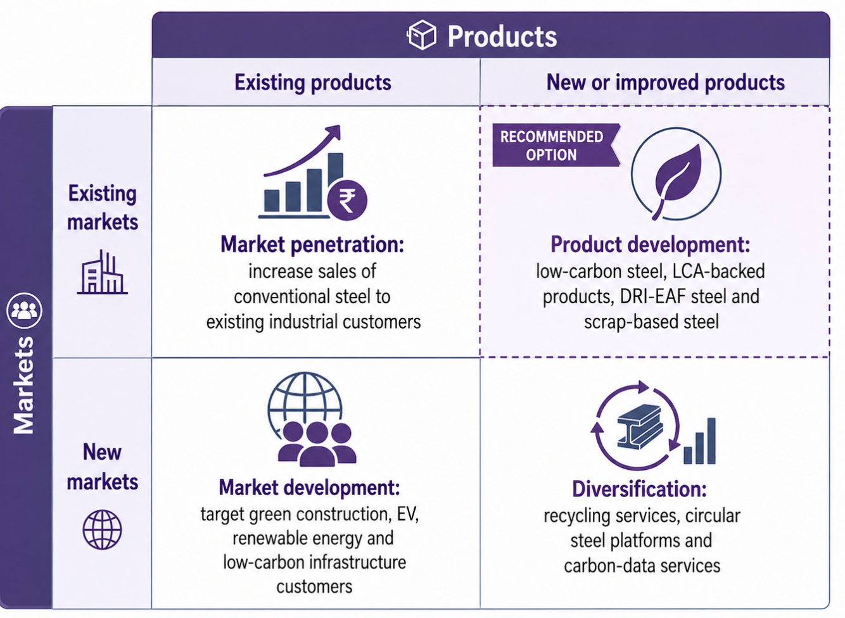
Figure 1. Ansoff Matrix for Tata Steel’s lower-carbon growth strategy(Tata Steel, 2025b)

Recommended Strategic Growth Approach

Product Development: Low-Carbon and Traceable Steel
Tata Steel needs to be seen as a provider of certified lower carbon and circular steel options. The first strategic priority should be focused on product development of low carbon steel. The CO₂ reduction of blast furnace technology is considered to be up to 5 MT/year from 2030 (Tata Steel, 2024) in the Netherlands, by replacing blast furnace assets with DRI-EAF technology. This will create a firm ground for promoting the lower carbon European steel products. The Indian business, however, must have a more conservative tack as the capacity continues to be partially based on blast furnace. (Carbon Tracker, 2025). Hence, Tata Steel should not make false claims (Delmas & Burbano, 2011; Torelli et al., 2020), as it needs to be careful about the short-term ‘lower-emission improvement'’ products and the longer term ‘near-zero steel'’ products.
Secondly, the product level environmental transparency is to be prioritized. Tata Steel's goal of providing environmental performance data for 100% of products in India by 2030 could even be a marketing tool if third-party assurance and lifecycle assessment (LCA) are provided in support (Tata Steel, 2025b). Product transparency can generate customer value by providing the automotive and construction industry customers with reliable data on embodied-carbon for their own sustainability reporting (Nygaard, 2024; Porter, 1985).

Circular Economy and Scrap-Based Growth
Circular economy should be the third priority on growth. By 2026–27 Tata Steel aims to increase ferrous scrap procurement in North India to 1 MT per annum, and increase steel recycling business in India to 3 MTPA by 2030 (Tata Steel, 2025b). This is a key factor as it is more energy efficient than primary steelmaking (IEA, 2025a). But there are limits to the scrap available and its quality. IEA (2025a) reports that the global scrap collection rate is already approximately 85%, and therefore, scrap is not the solution for decarbonising all steel production. Therefore, Tata Steel should adopt a combination of the recycling and energy efficiency, DRI-EAF pathways, Renewable electricity and long term hydrogen readiness.

Competitive Positioning

Differentiation Through Verified Green Steel
On the basis of Porter's generic strategies, it is recommended that Tata Steel should strive for differentiation instead of a pure cost leadership (Porter, 1985). While steel competition is still important, the shift to lower carbon products needs technology and environmental data systems, as well as collaboration with customers, which are capital intensive. Lower-carbon steel that is certified, lifecycle assessment coverage, reliable supply, and customer-specific carbon-reduction support are differentiators that Tata Steel can offer (Bocken & Geradts, 2020; Geissdoerfer et al., 2018; Teece, 2007).

Dynamic Capabilities and Transition Readiness
Dynamic capabilities theory proposes that firms need to sense (discover and monitor opportunities) and seize (capitalize on opportunities) the opportunities and reconfigure assets in changing environments (Teece, 2007). Tata Steel is seeing a demand for lower-carbon steel and is capitalizing on that by investing in EAF in the UK, planning DRI-EAF in the Netherlands and expanding recycling capabilities in India (Tata Steel, 2024; 2025b). But the reconfiguration is far from complete, as coal continues to be a key component of India's expansion (Carbon Tracker, 2025). The ability to scale the cleaner technologies quickly, and effectively, will be the key in determining Tata Steel's competitive position when it comes to demand growth.
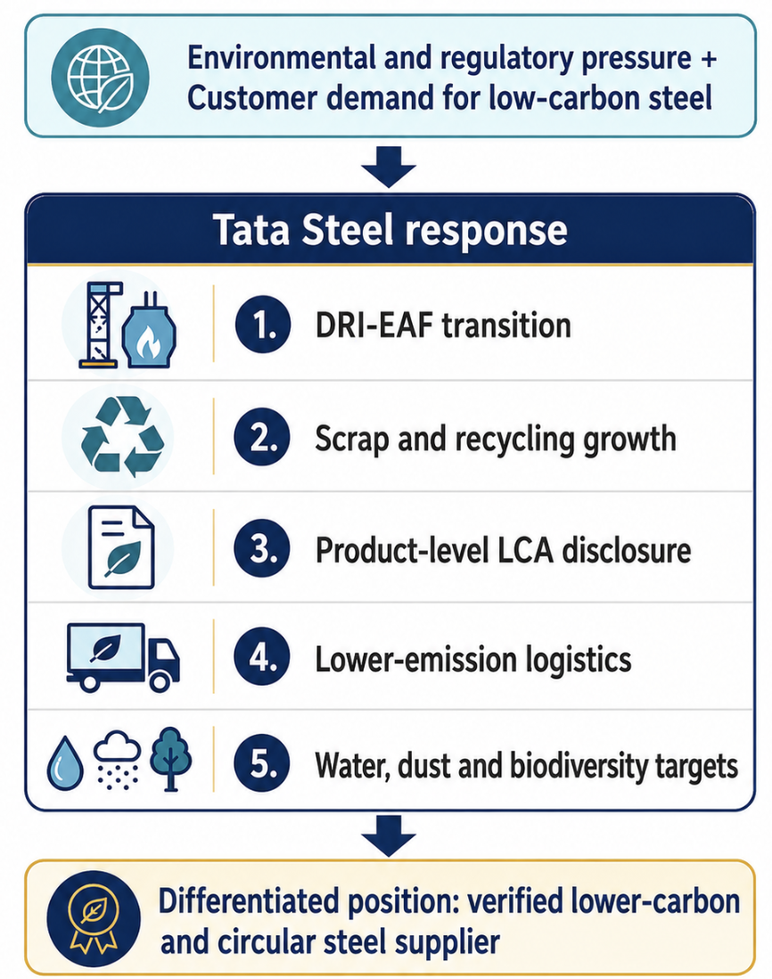
Figure 2. Competitive positioning framework for Tata Steel(Hart, 1995)

Implementation and KPIs
Table 2. Strategic roadmap for Tata Steel
Strategic action | Data target or milestone | Marketing objective | KPI
Expand LCA coverage | 80%+ finished products from 2025 | Build trust in product claims | % products with verified LCA
Full environmental product disclosure | 100% products in India by 2030 | Support B2B customer reporting | % product portfolio disclosed
Build recycling business | 3 MTPA in India by 2030 | Grow circular steel offer | Recycled steel volume
Reduce water consumption | <1.5 m³/tcs by 2030 | Strengthen natural-environment credibility | Specific freshwater consumption
Netherlands DRI-EAF transition | 5 MT annual CO₂ reduction from 2030 | Market low-carbon European steel | CO₂ reduction achieved
Material efficiency | 100% at Indian steel sites by 2030 | Improve resource productivity | Material efficiency percentage

Critical Evaluation of Risks
The recommended strategy has four main risks. First, the technology risk is high as the DRI-EAF and hydrogen-based routes are dependent on reliable supply of low-carbon electricity and hydrogen infrastructure and supportive policy (IEA, 2025a; Tata Steel, 2024). Secondly, the willingness to pay is still unknown. While industrial customers can advocate for green steel in the public image, they might not accept premiums unless there are targets for low-carbon procurement (Reuters, 2026a). Third, Tata Steel's Indian expansion poses credibility risk since investments in the blast furnace will commit the company to emissions for decades (Carbon Tracker, 2025). Fourth, the greater the discrepancy between marketing claims and actual emissions reductions, the more vulnerable to greenwashing the project is (Delmas & Burbano, 2011; Torelli et al., 2020).
Nevertheless, product development with selective market development is the best approach to take despite the risks involved. Tata Steel must not come across as green; it must come across as a steel company who is on the transition, has measurable progress in that journey, has verified data and solutions that are relevant to their customers' needs and lower-carbon.

Task 3: Critical Reflection on AI Usage

AI Tools and Tasks Performed
Artificial Intelligence is only used for categories allowed for this assessment: Research support, Proofreading and Creative support. AI tools, particularly ChatGPT, aid in the early stages of research by creating initial search terms, narrowing down on source themes and summarizing background information, which were later narrowed down and verified by manually selecting credible academic and industry sources. AI was also applied in proofreading, such as grammar checking, clarity of sentences and shaping the academic expression. Furthermore, AI-integrated creative tools were employed to compile the figures in the report, such as the environmental pressure diagram, Ansoff Matrix and competitive positioning framework.
There were no instances of the use of AI to replace independent academic judgment. The choice of Tata Steel, the environmental actors, the use of the Ansoff Matrix and the final recommendations are derived by the student. All claims, statistics and examples have been verified from credible sources like Tata Steel reports, IEA data, worldsteel information, academic articles, and independent analysis.

Critical Evaluation of AI Output
Hallucination was the primary risk for using AI. While AI can generate grammatically correct and academically-appropriate text, it might also present inaccurate or misleading references, outdated statistics, or unsupported claims (Bender et al., 2021; Dwivedi et al., 2023). To minimise this risk, Tata Steel-specific information was verified with Tata Steel's annual report, ESG goals and climate transition disclosures. The claims in the wider steel sector were compared with IEA, worldsteel, Reuters and Carbon Tracker sources. AI wording not supported by evidence was removed/rewritten to critical analysis of evidence.

Contribution Analysis
AI was used to assist with support activities. It assisted in the organization of research, proofreading, and figure development, but the analysis was still done by humans. The key decision was based on assessing the paradox of Tata Steel's growth plans, coal-based growth plans, the 2045 net zero target and lower carbon product opportunities. AI has thus played a supporting role to the process but not replaced the original analysis.

Ethical and Professional Reflection
Leveraging AI for market analysis involves ethical considerations regarding transparency, accuracy, confidentiality, and accountability. It is important to consider the risk of greenwashing when using unverified AI generated claims because statements about the environment need to be backed up with proof (Delmas & Burbano, 2011; Torelli et al., 2020). As a consequence, AI was only used as an aid to the student and ultimate responsibility for verification, source selection and academic judgement was retained by the student.

Conclusion
The natural environment and industrial customers and regulators are the two most important influences on Tata Steel's lower-carbon journey. Natural environment pressure: due to climate change, carbon emissions, air pollution, water use, biodiversity concerns. Pressure building from customers and regulators for reduced carbon products, lifecycle transparency and verified environmental disclosure. The recommended approach is product development with a focus on low-carbon steel, transition towards DRI-EAF, and scrap-based circular steel, product-level environmental disclosures, and lower emission logistics. Tata Steel can gain competitive advantage by being different, dynamic capabilities, and verified data. But, it's credibility in the market hinges on whether it can handle the paradox between growth in India and decarbonisation pledges. The best approach is thus not to say that they are ‘sustainable', but rather to convey measurable progression towards sustainability with verifiable evidence.

References
ACCR. (2024). BHP climate transition action plan analysis. Australasian Centre for Corporate Responsibility. https://www.accr.org.au/research/bhp-climate-transition-action-plan-analysis/
Ansoff, H. I. (1957). Strategies for diversification. Harvard Business Review, 35(5), 113–124. https://hbr.org/1957/09/strategies-for-diversification
Barney, J. (1991). Firm resources and sustained competitive advantage. Journal of Management, 17(1), 99–120. https://journals.sagepub.com/doi/10.1177/014920639101700108
Bender, E. M., Gebru, T., McMillan-Major, A., & Shmitchell, S. (2021). On the dangers of stochastic parrots: Can language models be too big? Proceedings of the 2021 ACM Conference on Fairness, Accountability, and Transparency, 610–623. https://dl.acm.org/doi/10.1145/3442188.3445922
Bocken, N. M. P., & Geradts, T. H. J. (2020). Barriers and drivers to sustainable business model innovation: Organization design and dynamic capabilities. Long Range Planning, 53(4), 101950. https://www.sciencedirect.com/science/article/pii/S0024630119304754
Carbon Tracker. (2025). Measuring transition: Tata Steel. https://carbontracker.org/reports/measuring-transition-tata-steel/
Delmas, M. A., & Burbano, V. C. (2011). The drivers of greenwashing. California Management Review, 54(1), 64–87. https://www.ioes.ucla.edu/wp-content/uploads/2017/04/2011-Delmas-Cuerel-Burbano-California-Management-Review.pdf
Dwivedi, Y. K., Kshetri, N., Hughes, L., Slade, E. L., Jeyaraj, A., Kar, A. K., Baabdullah, A. M., Koohang, A., Raghavan, V., Ahuja, M., Albanna, H., Albashrawi, M. A., Al-Busaidi, A. S., Balakrishnan, J., Barlette, Y., Basu, S., Bose, I., Brooks, L., Buhalis, D., ... Wright, R. (2023). “So what if ChatGPT wrote it?” Multidisciplinary perspectives on opportunities, challenges and implications of generative conversational AI for research, practice and policy. International Journal of Information Management, 71, 102642. https://www.sciencedirect.com/science/article/pii/S0268401223000233
Freeman, R. E. (1984). Strategic management: A stakeholder approach. Cambridge University Press. https://www.cambridge.org/core/books/strategic-management/9AAFD8E0BD2780C59D33C2EBD6D1A75F
Geissdoerfer, M., Vladimirova, D., & Evans, S. (2018). Sustainable business model innovation: A review. Journal of Cleaner Production, 198, 401–416. https://www.sciencedirect.com/science/article/pii/S0959652618321951
Hart, S. L. (1995). A natural-resource-based view of the firm. Academy of Management Review, 20(4), 986–1014. https://www.jstor.org/stable/258963
IEA. (2025a). Iron and steel. International Energy Agency. https://www.iea.org/energy-system/industry/steel
IEA. (2025b). Global critical minerals outlook 2025. International Energy Agency. https://www.iea.org/reports/global-critical-minerals-outlook-2025
Kotler, P., Armstrong, G., Harris, L. C., & He, H. (2024). Principles of marketing (19th ed.). Pearson. https://www.pearson.com/en-gb/subject-catalog/p/principles-of-marketing/P200000003371
Nygaard, A. (2024). Green promotion and marketing communication. In Green marketing and entrepreneurship. Springer. https://link.springer.com/book/10.1007/978-3-031-50333-7
Porter, M. E. (1985). Competitive advantage: Creating and sustaining superior performance. Free Press. https://www.simonandschuster.com/books/Competitive-Advantage/Michael-E-Porter/9780684841465
Reuters. (2026a). Steel industry sounds alarm over slow progress on green steel. https://www.reuters.com/business/environment/steel-industry-sounds-alarm-over-slow-progress-green-steel-2026-06-19/
Reuters. (2026b). Iron ore industry sees a bright future, but green steel fades. https://www.reuters.com/commentary/reuters-open-interest/iron-ore-industry-sees-bright-future-green-steel-fades-2026-06-18/
Tata Steel. (2024). Climate change report. https://www.tatasteel.com/investors/integrated-report-2023-24/climate-change-report.html
Tata Steel. (2025a). Integrated report and annual accounts 2024–25. https://www.tatasteel.com/media/23973/fy25-integratedreport.pdf
Tata Steel. (2025b). ESG goals achieved in FY2024–25. https://www.tatasteel.com/investors/integrated-report-2024-25/esg-goals.html
Teece, D. J. (2007). Explicating dynamic capabilities: The nature and microfoundations of sustainable enterprise performance. Strategic Management Journal, 28(13), 1319–1350. https://onlinelibrary.wiley.com/doi/10.1002/smj.640
Torelli, R., Balluchi, F., & Lazzini, A. (2020). Greenwashing and environmental communication: Effects on stakeholders’ perceptions. Business Strategy and the Environment, 29(2), 407–421. https://onlinelibrary.wiley.com/doi/10.1002/bse.2373
UNESCO. (2023). Guidance for generative AI in education and research. https://www.unesco.org/en/articles/guidance-generative-ai-education-and-research
World Steel Association. (2025). Climate change and the production of iron and steel. https://worldsteel.org/climate-action/climate-change-and-the-production-of-iron-and-steel/

