

Portfolio
4 Components

Module: Foreign Languages and Cultural Awareness
Module code: BMIH5003
Lecturer Name: Giulia Chifari
Student name: Elena Stenic
Student ID: 2246472

Component 1: Professional Reflection
Cultural misunderstanding is likely to happen when two or more people from different cultural backgrounds have interactions due to cultural differences among them (Amin, 2020). Not only cultural differences but also differences in languages may cause a nuisance between different people in terms of communication. Cultural misunderstanding and language barriers are crucial issues in the hotel sector, especially in restaurants and bars which affect the service quality and lead to guest dissatisfaction. The people who arrive from Italy are likely to face these issues in the UK due to the differences in culture and language. The main reason for the issues is that all the hospitality staff in the UK are not capable of multilingualism and they have a lack of cultural awareness.
The UK is the country where several people from different regions, languages and cultural backgrounds arrive for various purposes and the hotels have to deal with people from various backgrounds. In the hotel Britannia International, which is located at Canary Wharf, London, a large number of foreign guests take accommodation regularly and the majority of them are Italians. As a result of cultural and lingual differences, several incidents of miscommunication and cultural misunderstanding take place in Britannia International between the hotel staff and the Italian guests. These problems have the most negative impacts on the restaurants and bars of the hotel in terms of understanding, order and serving etiquette (Bezkorovafana et al., 2021). It is a very common problem in restaurants and bars to deliver the wrong dishes due to misinterpretation of the exact needs of the Italian guests. As a result of these incidents, the Italian guests of Britannia International become dissatisfied with the hotel and its services and also feel uncomfortable due to the communication issues. It also hurts the brand image of the hotel which affects its campaign to attract international guests.
To mitigate the issues in Britannia International with the Italian guests, I need to learn and understand the Italian language and culture to properly interpret the needs and preferences of the Italian guests. The problem of a lack of cultural awareness causes unintentional emotional hurts to people who are from a different culture as they have some specific customs which are emotionally attached to them. It is important to know and understand the Italian culture along with the language of the hotel staff as they fear hurting the guests unintentionally with their etiquette. As a beginning step, the staff may learn some basic Italian words to greet the guests in their native language such as 'grazie', which means thank you in Italian. Greeting the Italian guests in their language will make them feel comfortable about the communication which will enhance the guest satisfaction in the hotel. Secondly, I may use virtual assistance systems and AI technologies such as ChatGPT which are now in trend in the hospitality sector and can translate several foreign languages including Italian (Gursoy et al., 2023). I may also try to improve my listening and observing skills to enhance the interpretation of verbal and non-verbal communication of the Italian guests.

References
Amin, S., 2020. Diversity, tourism, and economic development: A global perspective. Tourism Analysis, 25(1), pp.21-41.
Bezkorovafana, L., Makovetskaya, N., Sydoruk, A., Korolenko, K. and Naumchuk, V., 2021. Professional training of future specialists in tourism and hotel and restaurant business in European countries.
Gursoy, D., Li, Y. and Song, H., 2023. ChatGPT and the hospitality and tourism industry: an overview of current trends and future research directions. Journal of Hospitality Marketing & Management, 32(5), pp.579-592.

Component 2: Training Plan
The most common problems in Britannia International are the cultural differences and language barriers between the hotel staff and the Italian guests which affect the service quality and brand image of the hotel. A lack of language competence and cultural awareness among the hotel staff bothers the Italian guests and makes them feel uncomfortable while trying to express their needs. The incidents of delivering wrong orders of food and beverages often occur and awkward situations due to different tastes of etiquette arise due to a lack of cultural awareness among the hotel staff. To mitigate these issues and to enhance guest satisfaction in Britannia International, a training plan is needed for the hotel staff especially to handle the Italian guests.
The training plan will be focused on educating the employees about the Italian language and culture including customs and etiquette to reduce the misunderstanding during a conversation. The language training will improve the understanding of verbal communication and the cultural training will improve the understanding of non-verbal communication along with the etiquette of their preferences (Koc, 2020). It is important to train the employees to efficiently communicate with the guests as they are responsible for informing the guests about the basic hotel policies such as check-in, check-out and other relevant things. The training should also include providing problem-solving knowledge to interpret the exact problems of the Italian guests and to resolve those strategically which will enhance the guest satisfaction in the hotel. A cuisine training course for the F&B employees will help them to understand the food preferences of the Italian guests along with their table manners and expected serving etiquette. It is also important to teach them about the proper ways of taking orders despite the lingual issues to avoid the issues of delivering wrong orders to the Italian guests. To evaluate the success of the training plan, a process of taking feedback from the employees and the guests should be implemented about the procedures and the services of the hotel respectively.
To organise the training procedures, the hotel should prepare a workshop with the employees as it is a proven method of educating the hospitality employees (McCartney and Kwok, 2023). The experts in the hospitality sector may be invited as guest lecturers in the workshop to help the employees with their knowledge and experiences. The experts in the Italian language may also join the campaign to teach the employees about the language and the basic phrases to communicate with the Italian guests. The workshop should include some role-play exercises to understand the customs and etiquette of Italian culture and to increase cultural adaptability among the employees. The language training and role-play exercises will help the employees serve the Italian guests better and it will also increase the bonding among the staff. There should be a group discussion session where all the employees will share their knowledge from training about the Italian language and cultural awareness (Guilherme and Sawyer, 2021). The authority should ensure that each employee shares their feedback to identify the shortcomings of the workshop session and to find ways to improve those.

References
Guilherme, M. and Sawyer, M., 2021. How critical has intercultural learning and teaching become? A diachronic and synchronic view of “critical cultural awareness” in language education. In Intercultural Competence Past, Present and Future: Respecting the Past, Problems in the Present and Forging the Future (pp. 185-208). Singapore: Springer Nature Singapore.
Koc, E., 2020. Cross-cultural aspects of tourism and hospitality: A services marketing and management perspective. Routledge.
McCartney, G. and Kwok, S.S., 2023. Closing the gap between hospitality industry and academia research agendas: An exploratory analysis case study. Journal of Quality Assurance in Hospitality & Tourism, 24(2), pp.192-210.

Component 3: Student Self-Reflection
There are several self-reflection models and to write the student self-reflection part, I will use Kolb's experiential learning cycle as a self-reflection model. This model is known as an influential learning model for learning through reflection and action (Morris, 2020). It includes four stages which are Concrete Experience, Observation and Reflection, Abstract Conceptualisation and Active Experimentation.
Concrete Experience: Guests from various regions and cultural backgrounds including Italian guests come to Britannia International and dine in the restaurants and bars of the hotel. The Italian guests feel uncomfortable expressing their needs due to a lack of lingual knowledge and cultural awareness among the staff of Britannia International. The staff and the guests both struggle to communicate with each other and as a result, delivery of wrong orders and conflicts because of cultural differences often take place. These things make the guests dissatisfied with the services and put down the reputation of the hotel in their eyes.
Observation and Reflection: The language barriers and a lack of cultural awareness among the staff make the customers of personalised services which leads to guest discomfort. The staff feel frustrated as they are unable to serve their best to the Italian customers which brings doubt among them about their abilities. The staff analysed the reasons behind the communication issues and identified the importance of having multilingual knowledge and cultural awareness to serve the Italian guests. The reflection is there is a need for improvement in the communication skills of the staff to take orders efficiently and to understand the gestures to provide the guests with their preferred etiquette. An improvement in cultural awareness is also important to avoid hurting the guests unintentionally by violating any of their customs or cultural norms (Lim and Ok, 2021).
Abstract Conceptualisation: In this stage, the staff try to find a way to improve their services based on their knowledge about the experience they are facing with the Italian guests. They try to fill the communication gap and avoid misunderstandings between them and the Italian guests by improving their methods of interaction. They become aware of the importance of understanding and speaking the Italian language to communicate properly with the Italian guests and to provide them with personalised services. They start understanding the importance of cultural resilience and awareness of different customs, taboos and etiquettes to avoid conflicts with the Italian guests and to provide them with a comfortable ambience. These conceptualisations among the hotel staff increase their adaptability to different cultures and improve their resilience skills. These open a way for the staff to improve their communication skills along with their customer handling behaviour. Abstract conceptualisation helps to provide a direction to adapt required behaviour for certain situations and in this case, it will help the staff to mitigate the issues with the Italian guests (Tuerlan and Scott, 2021).
Active Experimentation: In this stage, the staff will apply the concepts which they have developed in the Abstract Conceptualisation stage to take practical actions. They will try learning the Italian language and will use basic Italian phrases such as 'grazie' to greet the Italian guests and to make them comfortable with communication. They will try learning Italian customs and norms to avoid conflicts and to provide the guests with a personalised service which will increase guest satisfaction as well as the hotel's reputation.

References
Lim, S.E. and Ok, C.M., 2021. A meta-analytic review of antecedents of hospitality and tourism firms’ performance: A cross-cultural comparison. Tourism Management, 86, p.104325.
Morris, T.H., 2020. Experiential learning–a systematic review and revision of Kolb’s model. Interactive learning environments, 28(8), pp.1064-1077.
Tuerlan, T., Li, S. and Scott, N., 2021. Customer emotion research in hospitality and tourism: conceptualization, measurements, antecedents and consequences. International Journal of Contemporary Hospitality Management, 33(8), pp.2741-2772.

Component 4: Training Presentation

Introduction
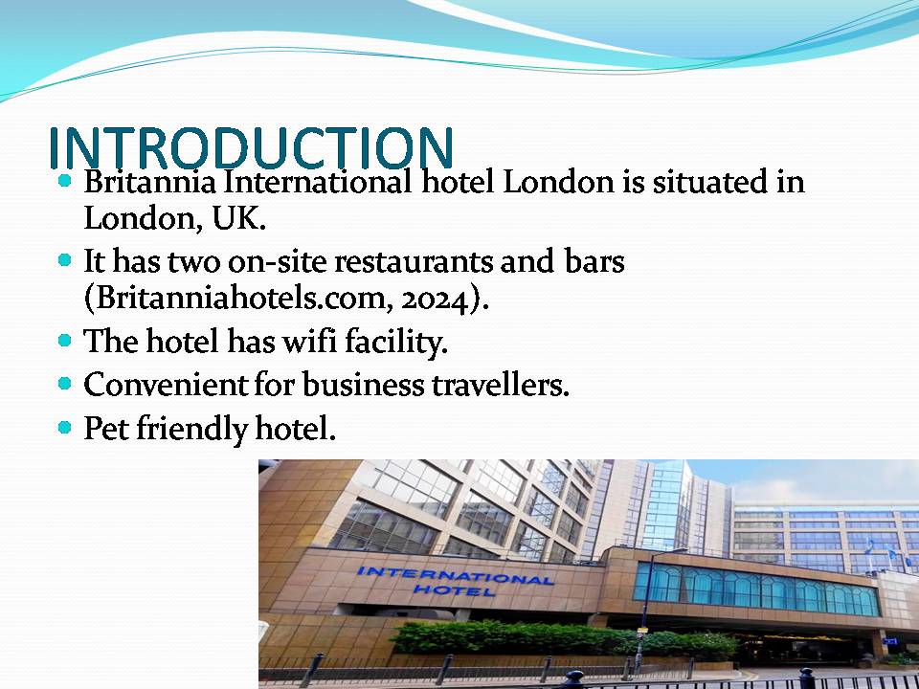

Significance of Multilingualism
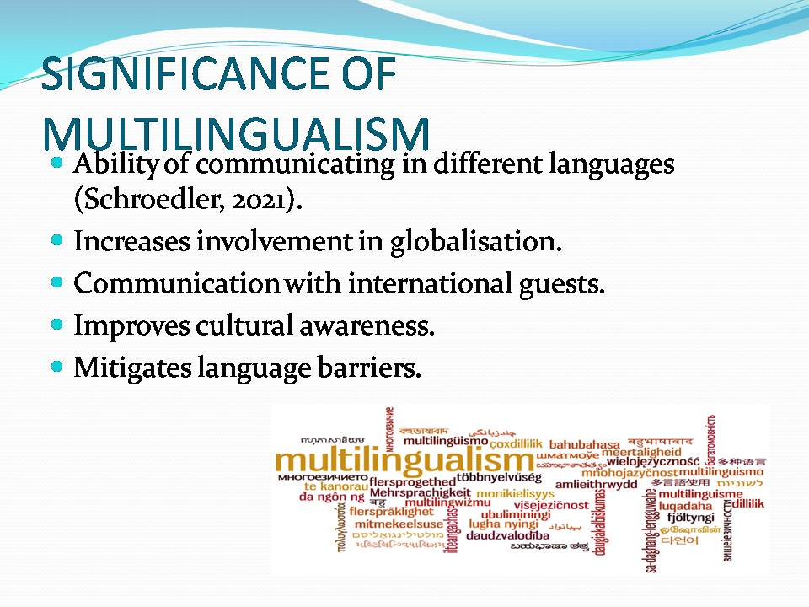

Benefits of Language Awareness Skills
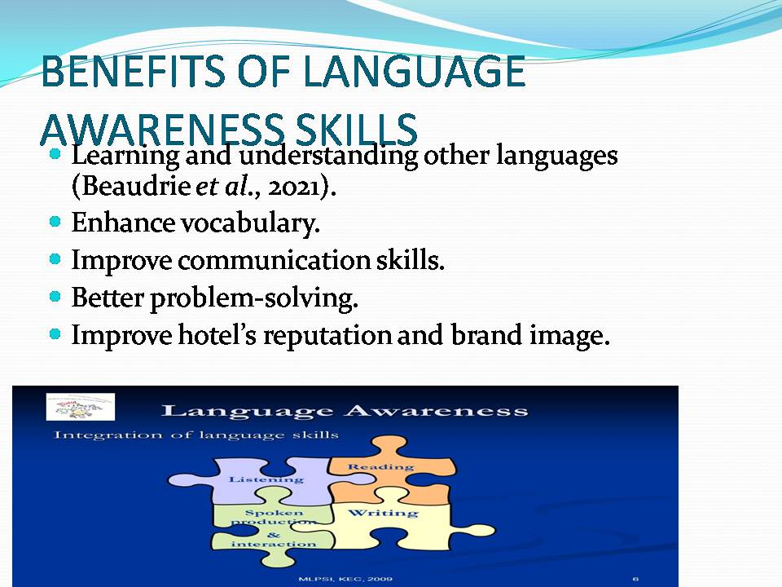

Overview of the Italian Language
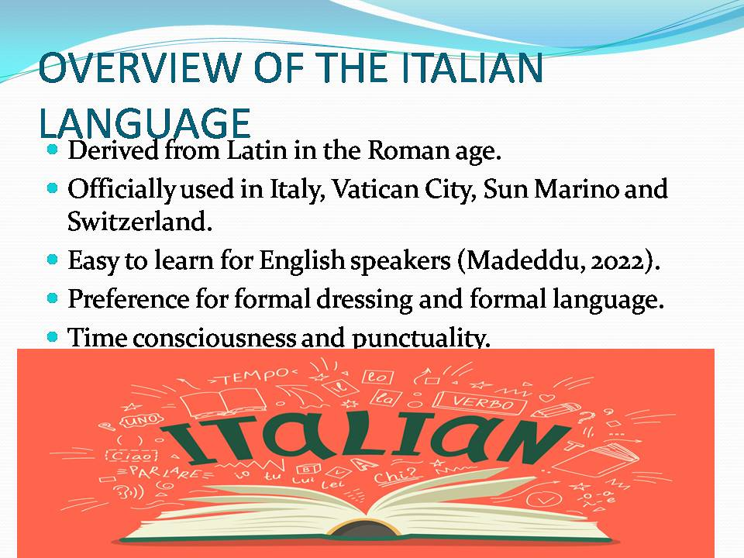

Conclusion
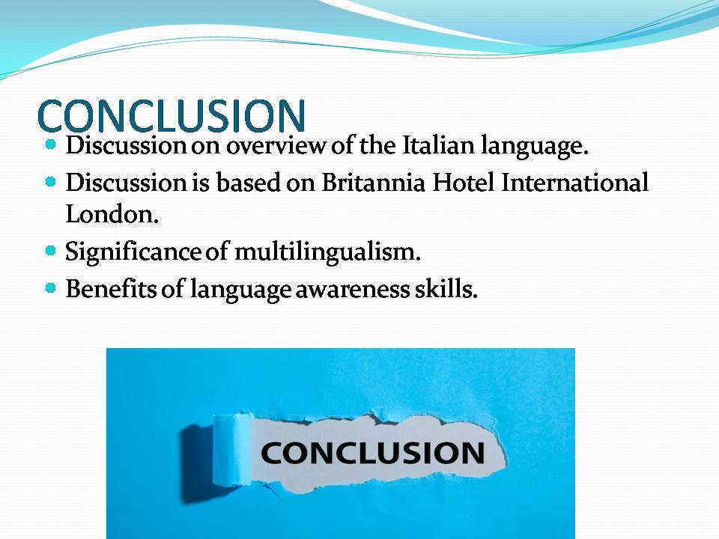

References
Beaudrie, S., Amezcua, A. and Loza, S., 2021. Critical language awareness in the heritage language classroom: Design, implementation, and evaluation of a curricular intervention. International Multilingual Research Journal, 15(1), pp.61-81.
Britanniahotels.com. 2024. International Hotel London [online] Available at: <https://www.britanniahotels.com/hotels/the-international-hotel?gad_source=1&gclid=Cj0KCQjwir2xBhC_ARIsAMTXk87Suq3rBeUT8zQI-5KYKIpNnY1H64Z0FrYNovpKr5qk03s9nq-lqQEaAu1aEALw_wcB> [Accessed on: 29/04/2024].
MADEDDU, M., 2022. Assessing Island Effects in Italian Transformer-based Language Models.
Schroedler, T., 2021. What is multilingualism? Towards an inclusive understanding. Preparing teachers to work with multilingual learners, pp.17-37.
Ushakov, R.N., Kryukova, E.M., Khetagurova, V.S., Mukhomorova, I.V. and Zelenov, V.V., 2020. Efficiency of hotel management. Training of specialists in hotel industry field. Journal of Environmental Management and Tourism, 11(2), pp.388-395.

