

Foreign Languages & Cultural Awareness (BMIH5003)
Florin Grosu

PART 1: Restaurant Concept
My restaurant idea is a cutting-edge European food café that joins the flavors of a vegetarian cafe, offering an array of dishes for vegetarians and meat-eaters the same. To make an exceptional and creative menu, the eatery will zero in on high-quality ingredients, locally sourced, whenever the situation allows. My whole interest group is the developing well-being cognizant populace, with many of the dishes being gluten-, dairy-free and lactose-free. The café will additionally target young professionals searching for a one-of-a-kind feasting experience. I need to make a cafe that takes care of individuals who are on extraordinary weight control plans or have food sensitivities. Higgins-Desbiolles, Moskwa and Wijesinghe (2017) agree that everybody should approach delicious menu choices, paying little heed to dietary limitations. The menu will incorporate various starters, mains, treats, and refreshments mirroring the theme and style of the eatery.
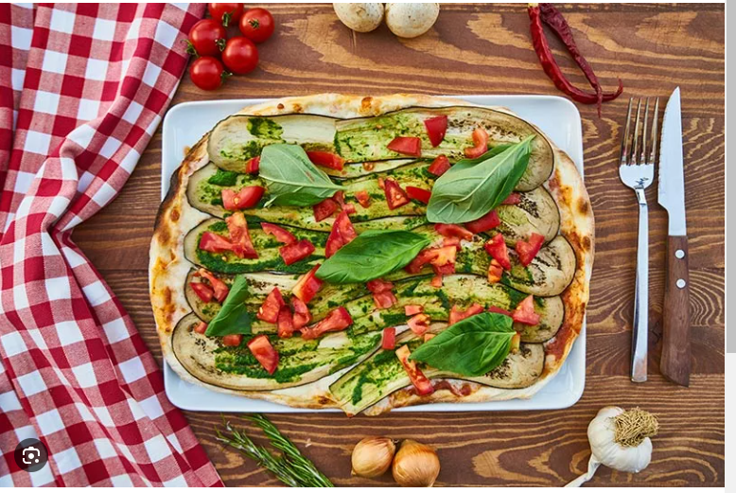
My menu design centers on making dishes for various diet needs (Lin and Chang, 2020, p.778). My principal focus is revolved around vegetarian options, for example, plant-based burgers, fries, mixed greens, quinoa bowls, vegetarian pizzas, and choices for meat-eaters, similar to chicken or fish dishes with many solid sides. To guarantee quality, occasional and nearby fixings will be utilized as much as possible. My menu will likewise incorporate exemplary sides like soup and french fries and a choice of smoothies, milkshakes and juices. Some of the starters we will offer include smoked salmon terrine with horseradish cream, relieved meats with occasional pickles, and cooked courgettes with burned artichokes. The mains will incorporate cooked chicken with hazelnuts, spinach, and shallots; skillet-singed monkfish with pea risotto; and steamed bass with artichoke puree and wild mushrooms. We'll offer good vanilla crème brulee for sweets, a lemon tart finished with meringue, and poached pear with almond custard. Our drink menu will have a determination of brews, wines, and mixed drinks such as cocktails.
I am ensuring that my eatery considers sustainability and seasonality. I will involve sustainable sources for my ingredients and stress seasonality. Likewise, I will zero in on purchasing local ingredients to lessen food waste and reduce conveyance costs. Harmless to the ecosystem, menus and bundling will likewise be utilized. The menu will have an outwardly engaging plan, with tones and text styles that mirror the café's theme and brand picture. We will involve manageable and occasional fixings in our dishes to guarantee the restaurant is by current health and natural patterns. Seo and Lee (2021) argue for utilizing locally sourced ingredients in any place conceivable to decrease the natural effect and to support local businesses.
PART 2: Menu Design
My menu will comprise a range of starters, mains, sides, desserts and refreshments that mirror the café's theme. I will offer starters, for example, cut vegetable platters with herby hummus, an assortment of veggie lover soups, spinach and artichoke plunge, bison cauliflower, and seitan tenders. For mains, I will offer a scope of protein-rich dishes, for example, plant-based burgers, mixed greens with different fixings, veggie lover pizzas, quinoa bowls, vegetable fajitas, tempeh tacos, and seitan sandwiches. My menu will likewise offer a determination of fish and chicken dishes, for example, salmon with cooked vegetables, barbecued chicken with quinoa, and pesto-broiled chicken. Moreover, our everyday specials include protein-rich choices, healthy grains, and new vegetables, conveying a balanced eating experience. To improve your menu investigation, striking pictures accompany each dish, exhibiting their visual allure and featuring their healthful profiles (Madeira, Palrão and Mendes, 2020). At our foundation, we endeavor to make an outstanding eating experience that joins flavor, balance, and visual joy, guaranteeing each visitor finds something brilliant to relish.
Our menu brags of tasty exhibit sides to supplement your dinner. Look over good top picks like fresh French fries and rich pureed potatoes, or settle on a better choice with our determination of occasional vegetables and mixed greens. Yam fries are ideal for those hankering an exciting turn (Haenlein et al., 2020). Likewise, Orîndaru et al. (2021) emphasize to fulfill your sweet tooth with a calibrated treat choice making sure to please. Enjoy different scones with coagulated cream or veggie lover margarine alongside enticing choices like vegetarian biscuits, treats, and brownies. Extinguish your thirst with our reviving refreshment contributions, including smoothies with nutritious fixings, heavenly milkshakes, and newly pressed juices. At our café, we borrow from insight from (Ozturk & Akoglu, 2020) in giving a various scope of sides, pastries, and refreshments that take care of various preferences and dietary inclinations, guaranteeing a great and fulfilling feasting experience for all.
The menu is insightfully intended to take care of a different scope of dietary inclinations while guaranteeing incredible taste and adjusted sustenance, as Boca (2021) cites. Divided into sections, it starts with alluring starters that tempt your sense of taste. Our scrumptious mains exhibit a variety of veggie lovers and vegan choices, giving a nutritious feasting experience. Supplementing these dishes are our tasty sides, impeccably created to upgrade your feast. Enjoy our overpowering pastries, designed to fulfill your sweet tooth without settling on nourishment. Not halting there, we likewise offer a nutritious breakfast menu to launch your day with healthy goodness.
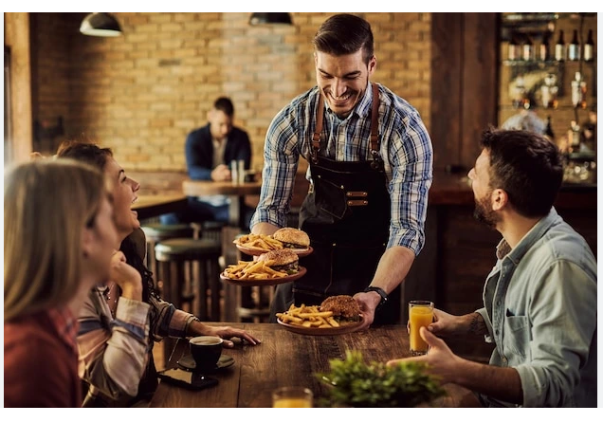

Considering the evaluation structure for my menu, I will consider my leading interest group. According to Chen, many dishes should be evaluated respectably to draw in clients on a more modest spending plan while giving many choices to those with more deep pockets (Chen et al., 2019, pp.197-198). Concerning nourishment, fixings are thoroughly examined, and menus will zero in on giving scrumptious yet adjusted dinners. I will allow clients to alter their orders to take care of explicit dietary necessities like veggie-lover, vegan, or sensitive delicate choices. My café will likewise give segment sizes in light of the client's nutritional inclinations. The pricing for starters and desserts will be between £8 - £12, while the mains will be between £20 - £25. The valuing system should be cautious, offering quality food at cutthroat costs to draw in clients needing a quality feasting experience (Roma, Panniello and Lo Nigro, 2019, p.18). We will likewise have choices for clients with great dietary necessities, for example, veggie lovers, vegetarian, sans gluten, and lactose-free. Our menu will incorporate nourishing nutritional information, like calories and sugars for each dish, to make clients mindful of the dietary substance of their decisions.

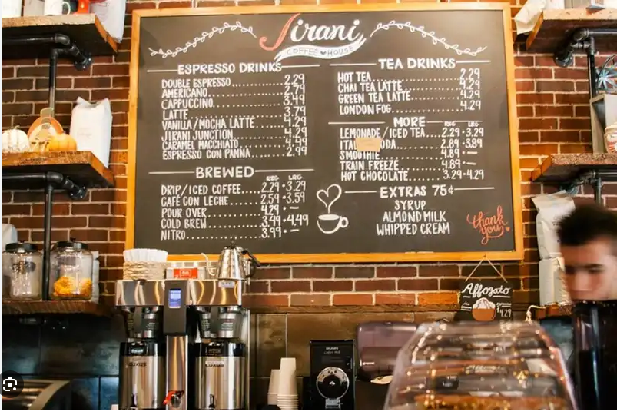
According to Alaini, Rajikan and Elias (2019), a valuing methodology is carefully created to find harmony among competitiveness and keep up with the extraordinary nature of diverse dishes. We think about contender evaluating to guarantee our costs remain competitive. Our menu takes care of a great many dietary prerequisites and inclinations. We offer an assortment of the veggie lover, vegan, sans gluten, and without lactose dishes, guaranteeing that everybody can track down something heavenly to appreciate. It is essential to determine the significance of taking care of unique dietary necessities and give choices that meet those prerequisites (Brewer & Sebby, 2021). In addition, we stay refreshed with current well-being and health patterns. Our menu features dinners that align with these patterns, offering decisions that advance a sound way of life. With our obligation to taste and nourishment, we intend to give an eating experience that fulfills your desires and your dietary inclinations.
The plan of any menu is a significant part of our café's character (Cupertino et al., 2021). We will make an outwardly dazzling design that mirrors our image picture. Insightful determination of textual styles, varieties, and pictures will add to a robust and outwardly engaging menu plan. One of our needs is straightforwardness in nourishment. Each dish will have noticeable signs of its nourishing substance, permitting our visitors to pursue informed decisions that align with their dietary requirements and inclinations. Yazdani et al. (2021 point to a deliberate focus on maintainability, and is harmless to the ecosystem. Our menu will feature our devotion to reasonable works, including dishes made with privately obtained, natural fixings whenever the situation allows. Moreover, we invest heavily in involving biodegradable bundling for our to-go requests, limiting our effect on the climate. By joining a tastefully satisfying plan, wholesome data, and an eco-cognizant methodology, our menu intends to make a positive and drawing-in feasting experience that reverberates with our visitors' qualities.
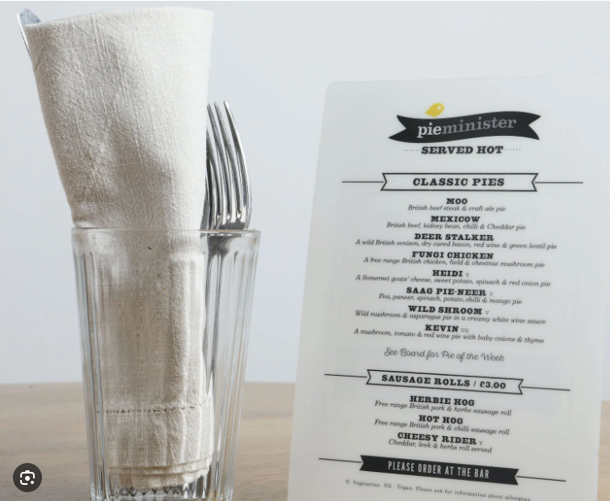
In general, the menu at this café will offer various scrumptious, nutritious and practical feasts. The valuing is cutthroat, and the food choices take special care of a wide range of dietary limitations while being aware of current well-being and prosperity patterns (Yoon, Chung and Jun 2020). The objective is to establish a practical and exceptional feasting climate that takes care of cognizant cafes that value quality cooking and need to help privately obtained and occasional fixings. This café offers coffee shops the chance to find new flavors, dishes, and cooking methods, so their feasting experience is essential. Considering this, the menu should be planned in light of the eatery's idea, aiming to mirror the excellent fixings and unique air.
Reference list
Alaini, R., Rajikan, R. and Elias, S.M. (2019). Diet optimization using linear programming to develop low cost cancer prevention food plan for selected adults in Kuala Lumpur, Malaysia. BMC Public Health, 19(S4). doi:https://doi.org/10.1186/s12889-019-6872-4.
Boca, G.D. (2021). Factors Influencing Consumer Behavior in Sustainable Fruit and Vegetable Consumption in Maramures County, Romania. Sustainability, 13(4), p.1812. doi:https://doi.org/10.3390/su13041812.
Brewer, P. and Sebby, A.G. (2021). The effect of online restaurant menus on consumers’ purchase intentions during the COVID-19 pandemic. International Journal of Hospitality Management, 94(102777), p.102777. doi:https://doi.org/10.1016/j.ijhm.2020.102777.
Chen, D., Ignatius, J., Sun, D., Zhan, S., Zhou, C., Marra, M. and Demirbag, M. (2019). Reverse logistics pricing strategy for a green supply chain: A view of customers’ environmental awareness. International Journal of Production Economics, 217, pp.197–210. doi:https://doi.org/10.1016/j.ijpe.2018.08.031.
Cupertino, A.F., Maynard, D. da C., Queiroz, F.L.N. de, Zandonadi, R.P., Ginani, V.C., Raposo, A., Saraiva, A. and Botelho, R.B.A. (2021). How Are School Menus Evaluated in Different Countries? A Systematic Review. Foods, [online] 10(2), p.374. doi:https://doi.org/10.3390/foods10020374.
Haenlein, M., Anadol, E., Farnsworth, T., Hugo, H., Hunichen, J. and Welte, D. (2020). Navigating the New Era of Influencer Marketing: How to Be Successful on Instagram, TikTok, & Co. California Management Review, [online] 63(1), pp.5–25. doi:https://doi.org/10.1177/0008125620958166.
Higgins-Desbiolles, F., Moskwa, E. and Wijesinghe, G. (2017). How sustainable is sustainable hospitality research? A review of sustainable restaurant literature from 1991 to 2015. Current Issues in Tourism, pp.1–30. doi:https://doi.org/10.1080/13683500.2017.1383368.
Lin, S.-Y. And Chang, C.-C. (2020). Tea for Well-Being: Restaurant Atmosphere and Repurchase Intention for Hotel Afternoon Tea Services. Sustainability, 12(3), p.778. doi:https://doi.org/10.3390/su12030778.
Madeira, A., Palrão, T. and Mendes, A.S. (2020). The Impact of Pandemic Crisis on the Restaurant Business. Sustainability, [online] 13(1), p.40. doi:https://doi.org/10.3390/su13010040.
Orîndaru, A., Popescu, M.-F., Alexoaei, A.P., Căescu, Ș.-C., Florescu, M.S. and Orzan, A.-O. (2021). Tourism in a Post-COVID-19 Era: Sustainable Strategies for Industry’s Recovery. Sustainability, [online] 13(12), p.6781. doi:https://doi.org/10.3390/su13126781.
Ozturk, S.B. and Akoglu, A. (2020). Assessment of local food use in the context of sustainable food: A research in food and beverage enterprises in Izmir, Turkey. International Journal of Gastronomy and Food Science, 20, p.100194. doi:https://doi.org/10.1016/j.ijgfs.2020.100194.
Roma, P., Panniello, U. and Lo Nigro, G. (2019). Sharing economy and incumbents’ pricing strategy: The impact of Airbnb on the hospitality industry. International Journal of Production Economics, 214, pp.17–29. doi:https://doi.org/10.1016/j.ijpe.2019.03.023.
Seo, K.H. and Lee, J.H. (2021). The Emergence of Service Robots at Restaurants: Integrating Trust, Perceived Risk, and Satisfaction. Sustainability, 13(8), p.4431. doi:https://doi.org/10.3390/su13084431.
Yazdani, M., Pamucar, D., Chatterjee, P. and Torkayesh, A.E. (2021). ‘A multi-tier sustainable food supplier selection model under uncertainty’. Operations Management Research. doi:https://doi.org/10.1007/s12063-021-00186-z.
Yoon, B., Chung, Y. and Jun, K. (2020). Restaurant Industry Practices to Promote Healthy Sustainable Eating: A Content Analysis of Restaurant Websites Using the Value Chain Approach. Sustainability, 12(17), p.7127. doi:https://doi.org/10.3390/su12177127.

The Garden Bistro
Restaurant Concept: "Garden Bistro" Target Audience: Health-conscious individuals, nature enthusiasts, and urban dwellers seeking a refreshing dining experience.
The Garden Bistro is a novel restaurant concept that endeavours to provide a distinctive gastronomic encounter influenced by environmental principles and conservation. The restaurant is situated in the heart of the city and seamlessly integrates elements of urban refinement and organic tranquillity (Petre, 2016). The Garden Bistro is a restaurant that caters to individuals who prioritize their well-being while enjoying culinary delights. It achieves this through an eco-friendly design, emphasis on locally sourced ingredients, and a menu curated to satisfy health-conscious palates.
The central idea pertains to the establishment of a tranquil sanctuary amidst the urban landscape, which enables customers to retreat from the commotion and restore their connection with the natural environment. The interior of the restaurant is embellished with abundant greenery, vertical gardens, and expansive windows that facilitate the ingress of natural light (Watson, 2019). The atmosphere is intentionally crafted to elicit feelings of serenity and peacefulness, rendering it a suitable environment for small social events, corporate luncheons, or informal meals.
The Garden Bistro attracts health-conscious, sustainable, and nourishing diners. Vegetarian, vegan, and gluten-free diets are accommodated on the menu. The Garden Bistro uses seasonal, locally-sourced ingredients to support the local agriculture business and reduce transportation emissions. Sustainable beverages are the restaurant's focus . Organic and ethically produced wines, craft beers, and artisanal non-alcoholic beverages are available.
The menu choices are based on a dual rationale. Firstly, the menu places emphasis on the provision of fresh, nutritious, and well-balanced dishes with the aim of promoting a healthy lifestyle. The menu showcases a variety of colourful salads, substantial grain bowls, and protein-rich plant-based alternatives, each exhibiting a plethora of distinct tastes and textures (Yu, 2019). The menu offerings may comprise of a salad made with roasted beetroot and quinoa, a grain bowl with marinated tofu that draws inspiration from Mediterranean cuisine, and a plant-based burger that is prepared using locally sourced vegetables and legumes, which is highly appetizing.
The menu endeavours to provide a comprehensive experience by integrating botanical components and distinctive flavour combinations (Shubrook, 2019). The bistro's menu features meals infused with herbs, edible flowers, and innovative spice and herb combinations to enhance the dining experience. Herbs and spices add flavour to meals like lavender-infused panna cotta with fresh berries, grilled fish marinated in chamomile and ginger, and roasted chicken with lemon and thyme.

Reference List
NHS (2022). The vegan diet. [online] nhs.uk. Available at: https://www.nhs.uk/live-well/eat-well/how-to-eat-a-balanced-diet/the-vegan-diet/#:~:text=A%20vegan%20diet%20is%20based.
Petre, A. (2016). Vegan Food List: 11 Foods That Healthy Vegans Eat. [online] Healthline. Available at: https://www.healthline.com/nutrition/foods-vegans-eat.
Watson, S. (2019). What Is a Vegan Diet? [online] WebMD. Available at: https://www.webmd.com/diet/vegan-diet-overview.
Vigoreaux, G. (2018). 54 Vegan Recipes That Your Whole Family Will Love. [online] Good Housekeeping. Available at: https://www.goodhousekeeping.com/food-recipes/healthy/g807/vegan-recipes/.
Vegan.com. (2014). Easy Vegan Foods: The Definitive Gigantic List. [online] Available at: https://vegan.com/food/easy-vegan-foods/.
Yu, C. (2019). The Vegan Food List You Need To Take On Your Next Grocery Trip. [online] Women’s Health. Available at: https://www.womenshealthmag.com/food/a28322972/vegan-food-list/.
I LOVE VEGAN. (2014). Building a Healthy Vegan Grocery List. [online] Available at: https://ilovevegan.com/resources/building-a-healthy-vegan-grocery-list/ [Accessed 8 Jun. 2023].
BBC Good Food. (2014). Vegan recipes. [online] Available at: https://www.bbcgoodfood.com/recipes/collection/vegan-recipes.
Shubrook, N. (2019). The best vegan protein sources. [online] BBC Good Food. Available at: https://www.bbcgoodfood.com/howto/guide/best-sources-protein-vegans.
EverydayHealth.com. (2016). Vegan Diet Guide: Benefits, Risks, Weight Loss Effect, Food List. [online] Available at: https://www.everydayhealth.com/diet-nutrition/diet/vegan-diet-guide-benefits-risks-weight-loss-effect-food-list/.
JamieOliver.com (2019). Easy vegan recipes | Jamie Oliver. [online] Jamie Oliver. Available at: https://www.jamieoliver.com/recipes/category/special-diets/vegan/.

‌Zikos, G. (2018). 21 Authentic Mediterranean Food Recipes. [online] Mediterranean Living. Available at: https://www.mediterraneanliving.com/21-authentic-mediterranean-food-recipes/.
BBC Good Food. (2015). Mediterranean recipes. [online] Available at: https://www.bbcgoodfood.com/recipes/collection/mediterranean-recipes.
Culinary Institute of the Mediterranean. (2017). Discover the Mediterranean cuisine. [online] Available at: http://www.mediterraneanculinary.com/mediterranean-cuisine/ [Accessed 8 Jun. 2023].
Zawadzki, J. (2022). Mediterranean Food: 30 Iconic Dishes You Should Try. [online] Chef’s Pencil. Available at: https://www.chefspencil.com/mediterranean-food/

‌

Menu Items and Prices at Garden Bistro

Starters
- Seasonal Vegetable Soup - A comforting blend of locally sourced seasonal vegetables. - Price: £6.50
- Garden Salad - Mixed greens, cherry tomatoes, cucumbers, and radishes with a tangy herb dressing. - Price: £8.50
- Quinoa Stuffed Portobello Mushrooms - Portobello mushrooms filled with quinoa, spinach, and feta cheese. - Price: £9.50

Mains
4. Roasted Beetroot and Goat Cheese Salad - Roasted beetroot, mixed greens, goat cheese, candied walnuts, and balsamic glaze. - Price: £12.50
- Garden Grain Bowl - A hearty bowl with mixed grains, marinated tofu, roasted vegetables, and a lemon tahini dressing. - Price: £13.50
- Plant-Based Burger - A delicious vegan burger made from locally grown vegetables and legumes, served with sweet potato fries. - Price: £14.50
- Herb-Roasted Chicken Breast - Tender chicken breast marinated with lemon and thyme, served with roasted potatoes and seasonal vegetables. - Price: £16.50
- Grilled Salmon with Citrus Salsa - Fresh grilled salmon fillet topped with a zesty citrus salsa, accompanied by quinoa pilaf and sautéed greens. - Price: £18.50

Desserts
9. Lavender-Infused Panna Cotta - Creamy panna cotta infused with lavender, garnished with fresh berries. - Price: £7.50
- Dark Chocolate Avocado Mousse - Rich and velvety chocolate mousse made with ripe avocados, served with a berry compote. - Price: £8.50
- Seasonal Fruit Parfait - Layers of seasonal fruits, Greek yogurt, and granola for a refreshing and healthy dessert option. - Price: £6.50

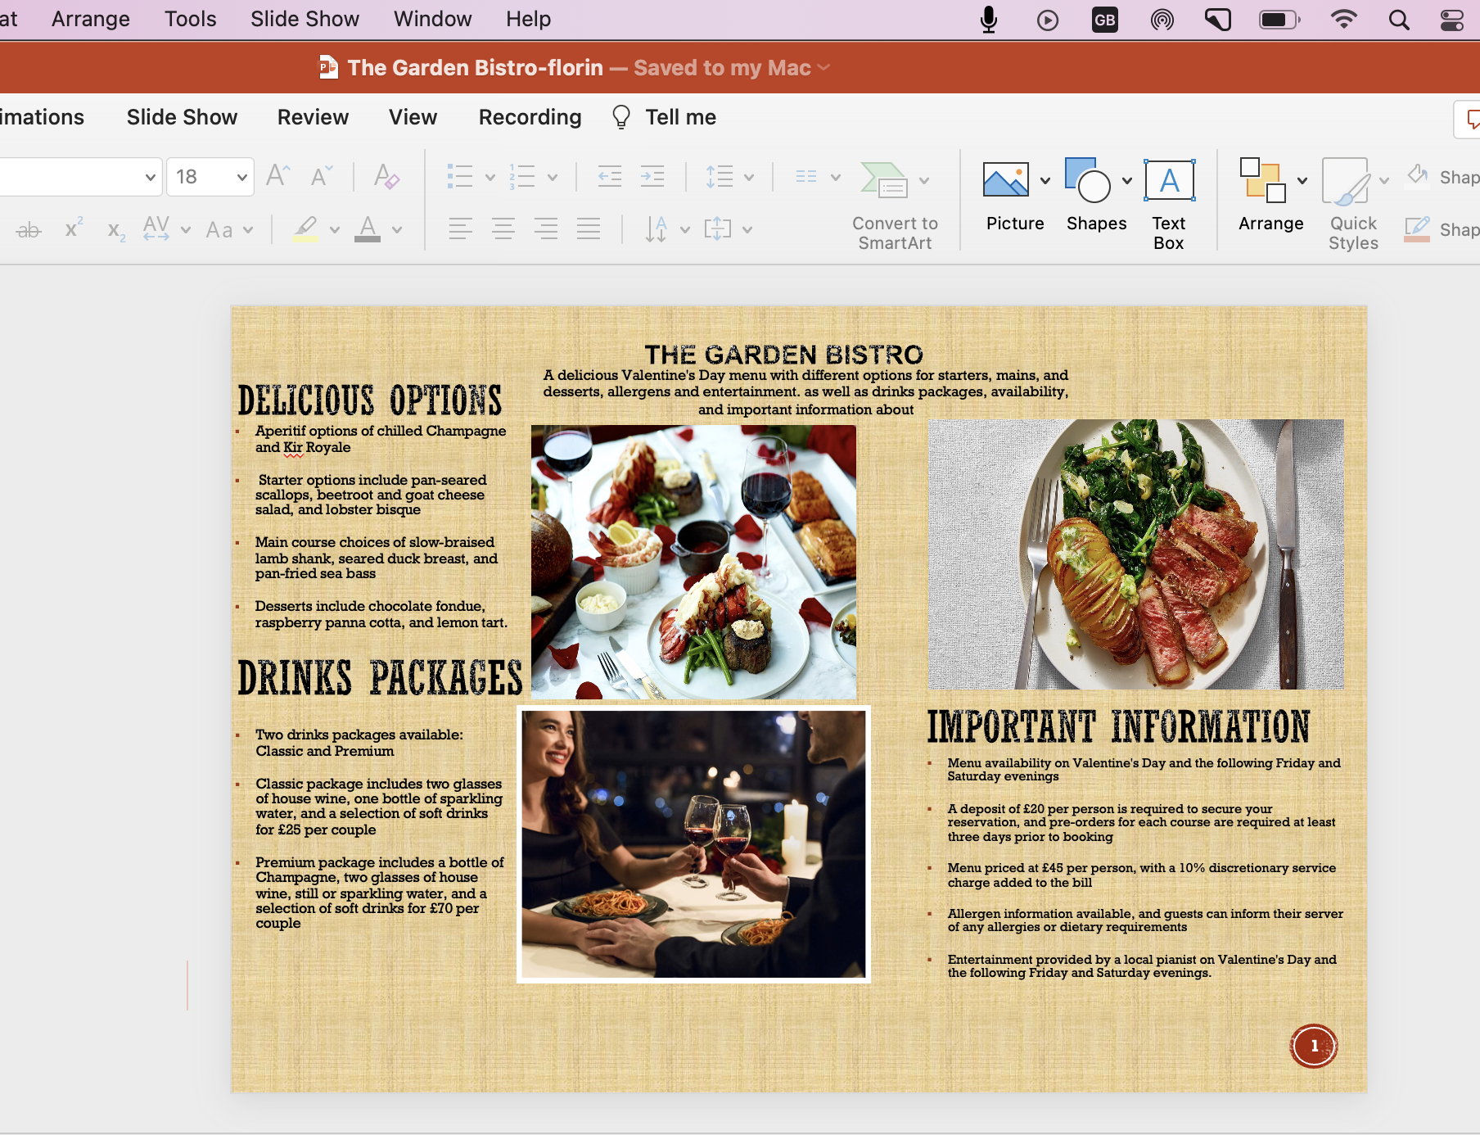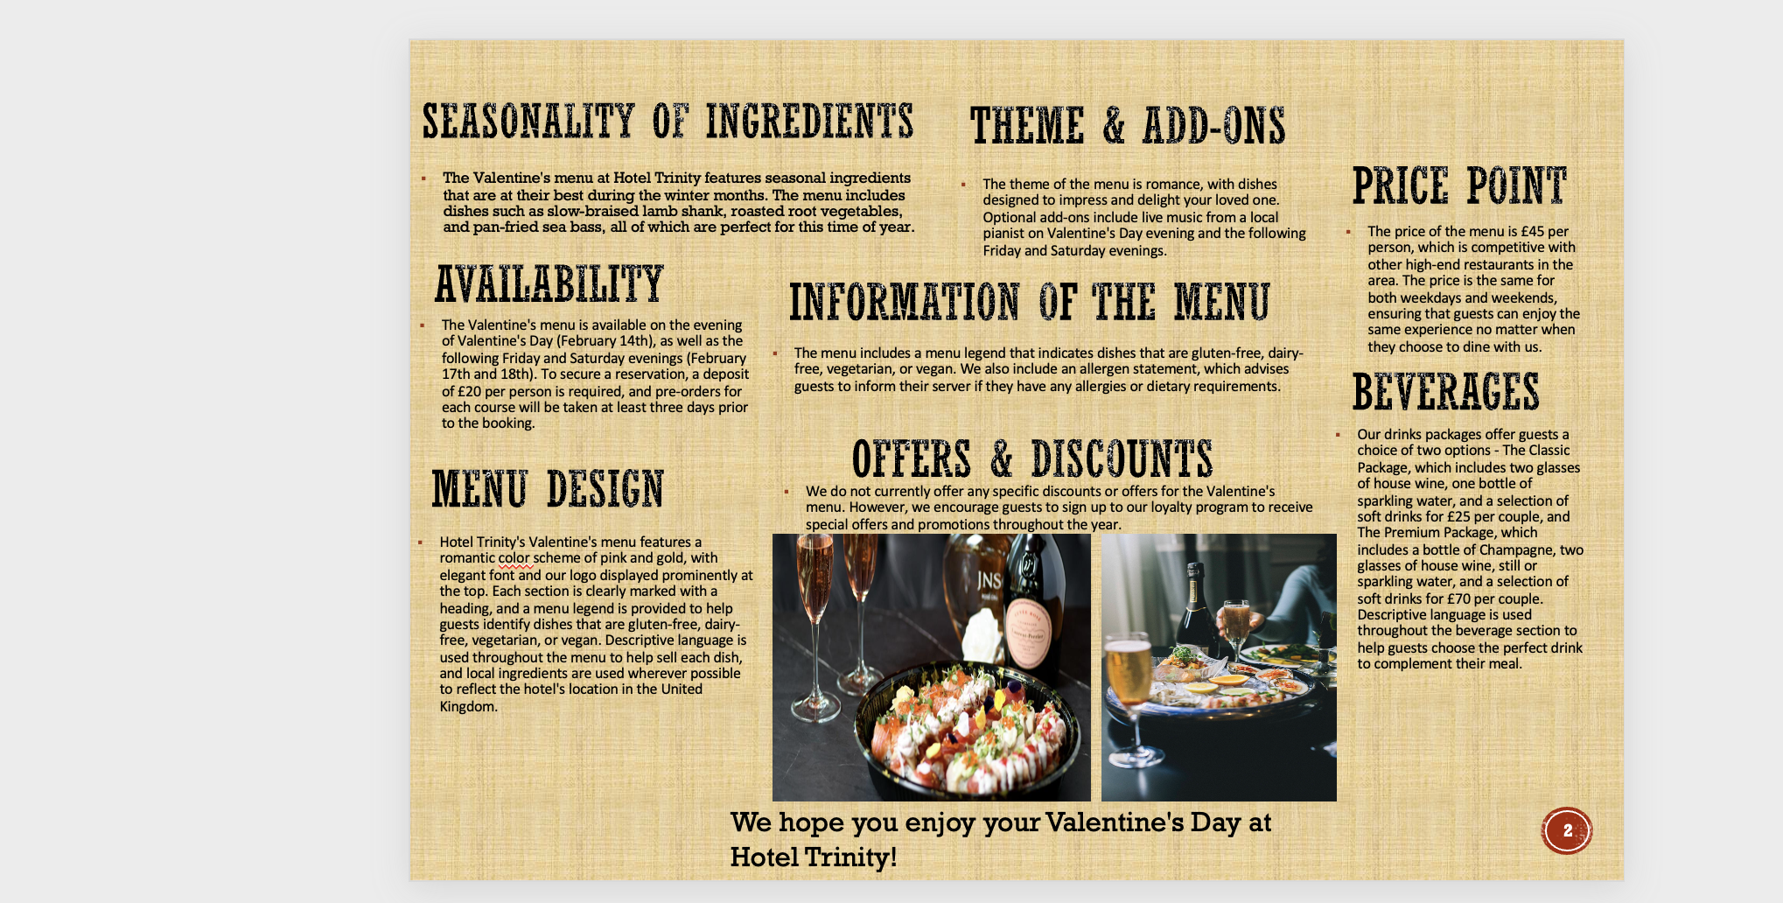

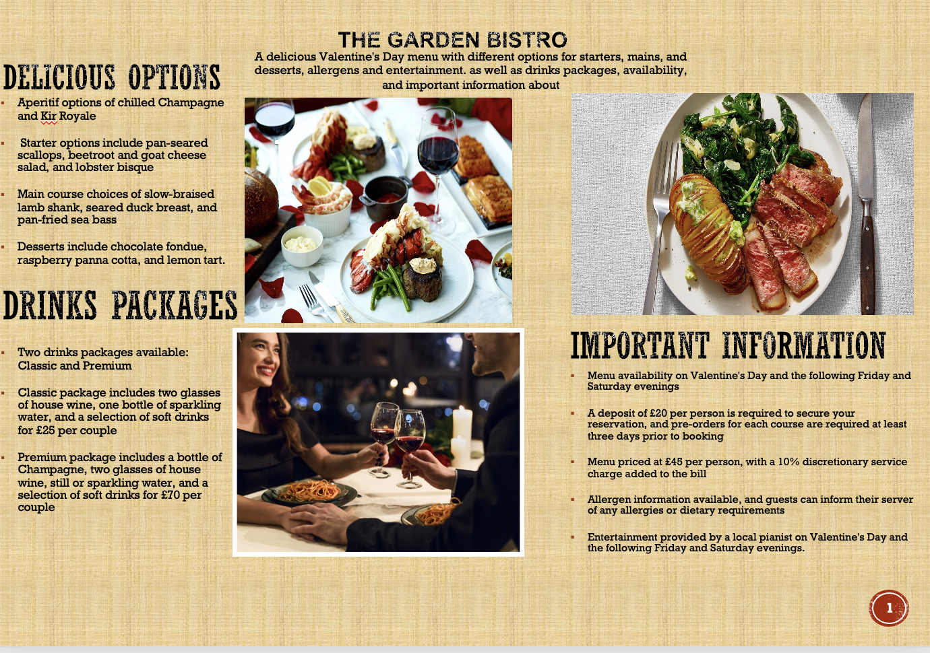

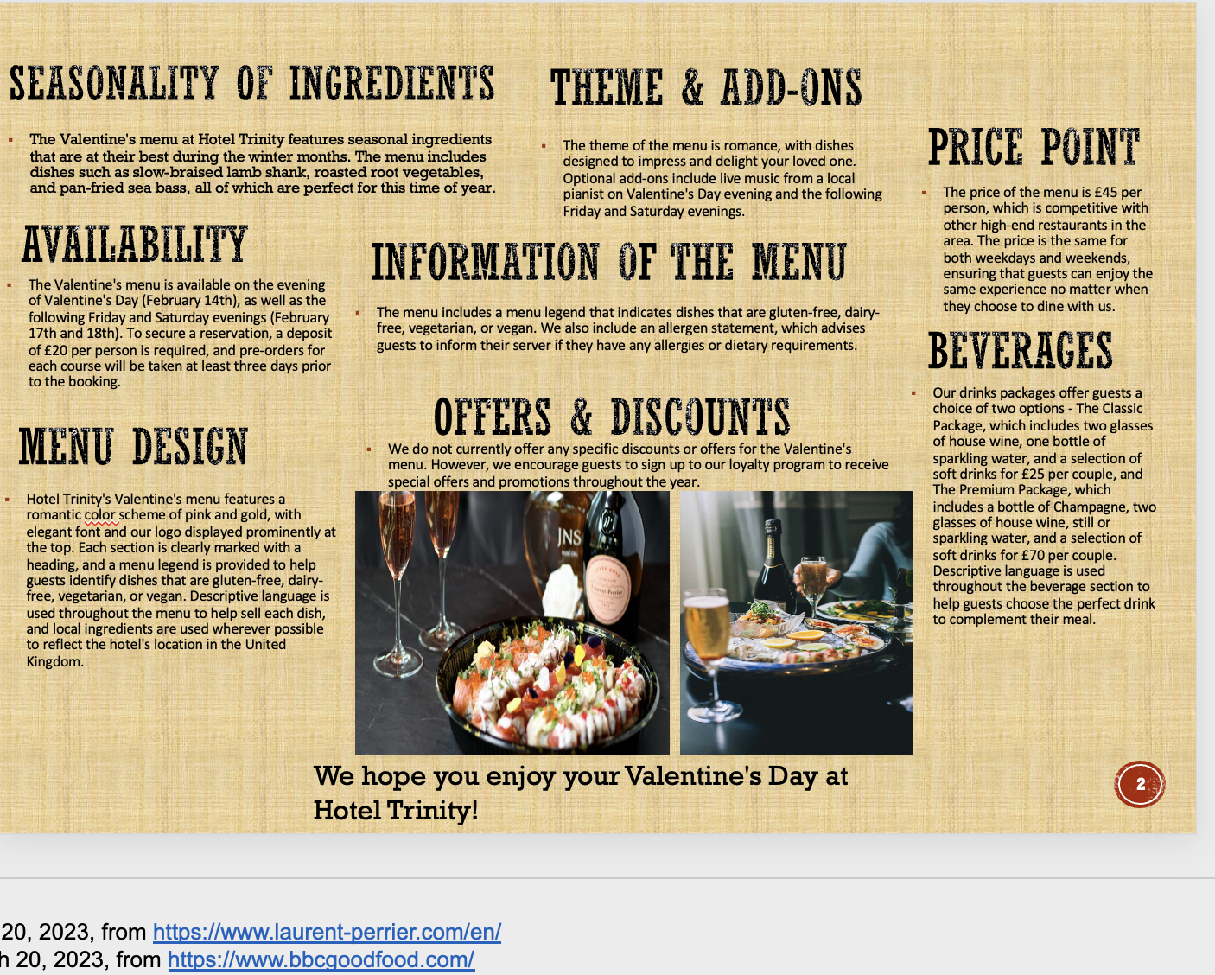

Main
- Roasted Beetroot and Goat Cheese Salad- £12.50
- Garden Grain Bowl - £13.50
- Plant-Based Burger - £14.50
- Herb-Roast Chicken Breast - £16.50
- Grilled Salmon with Citrus - £18.50

Desserts
- Lavender-Infused Panna Cotta - £7.50
- Seasonal Fruit Parfait £6.50

Starters
-Seasonal Vegetable Soup - £6.50
-Garden Salad £8.50
-Quinoa Stuffed Mushrooms - £9.50

MENU

