STRATEGIC MANAGEMENT FOR SME’s
BMSW6104
MOMEANA CHOWDHURY (HELEN)
1711893
LECTURER: DR RICHMOND LAMPTEY

Table of Contents
1.0 Introduction 3
2.0 Organization's current strategic direction. 4
3.0 Environmental scanning 4
3.1 External environment to identify opportunities and threats 4
3.2 Internal environment to identify strengths and weaknesses 10
4.0 Stakeholder analysis 15
5.0 Strategic growth choices for SMEs 16
6.0 Strategic Recommendations 19
7.0 Conclusion 20
References 21

1.0 Introduction
Every business has a crucial function for strategic management. It is essential for firms to continuously plan, monitor, and analyze their total environment. From the perspective of Verdant Leisure, strategic management principles will be applied from this report. There will be a discussion of the overview and current strategic direction of Verdant Leisure. There will be a critical analysis of the external environment to identify opportunities and threats, as well as a critical analysis of the internal environment to identify the strengths and weaknesses of the organization’s (Hesterly and Barney, 2018). In this report, we will use the PESTEL analysis, Porter's 5 forces, SWOT analysis, value chain analysis, and VRIO analysis, etc. to identify the strengths, weaknesses, opportunities, and threats. This report will discuss the stakeholder analysis to apply the Mendelow Matrix. This report will also talk about different strategic growth matrices, like the BCG growth matrix and the Ansoff matrix and draw a meaningful conclusion based on these analyses.

2.0 Organization's current strategic direction.
Verdant Leisure is a UK-based holiday park. It is situated in Scotland, Northern England, and Devon. Verdant Leisure sale holidays home at a superb range. They provide a good environment for the customers. Their behavior with customers is very friendly. Verdant Leisure was first founded in 1990. They have a total of 11 parks in England. Graham Hodgson is the current Chief executive. Verdant Leisure has a total of 290 employees who are working currently in the organization. In 2021, the total turnover of the company is 14 million. The total gross profit of the organization is 9 million whereas the cash is 1 million. According to the previous year, turnover of the Verdant Leisure increased by 2.49%.
Verdant Leisure updates their strategic directions for maintaining customer satisfaction. The organizations now mostly focus on green and eco-friendly tourism for the customer. As an SME, it is a big challenge for Verdant Leisure to build a green tourism scheme. The company trying to use recycled materials to motivate the customers about sustainable ways of living. The main focus of the organizations is to make the parks very close to nature. It helps the company to give an experience to the customers of nature. It will help the customers to understand the importance to live green. After the covid-19 the organization change their operations differently. The organizations become strict to maintain the hygiene of the park. They provide hand sanitizer before entering the park. They help the customers to maintain distance from others. Because for covid 19, most of the people I like to maintain distance with others. The organizations provide a full refund for the customers if they are affected by covid-19 when they spend time in the park. It helps the organizations attract customers after the covid 19. The vision of Verdant leisure is to become one of the best holiday parks in the United Kingdom. The mission of the company is to make a green holiday park (Omari et al., 2021).

3.0 Environmental scanning

3.1 External environment to identify opportunities and threats
Organizations must understand and analyze the external environment. When organizations analyze the external environment, it helps the organizations to identify opportunities and threats. Identifying the opportunities and threats is a very significant part of the organization. If the organizations are not able to understand the opportunities and threats, it can make it difficult and barriers for the organizations to achieve success. When organizations can know about the opportunities, it helps the organizations to utilize the opportunities to get the best outcome for organizations. Each of the opportunities is an asset to the organization. That's why it is very significant for organizations to identify opportunities. When the Organization said able to know about their threats, it will help the organization to make prepared for overcoming the threats. These will help the organizations identify the lack of the organizations (Hesterly and Barney, 2018). When the Organizations rebuild to overcome the lack, it will help the organizations to overcome the threats. Identifying the threats is another opportunity for organizations to achieve success. Most organizations use different analyses and theories to understand the external environment. This analysis of the external environment helps the organizations identify the opportunities and threats. There will use and different theories and analysis to identify the opportunities and threats of Verdant Leisure.

- PESTEL analysis for Verdant Leisure

Figure: PESTEL ANALYSIS; Source: (Rose et al., 2020)

Political
The United Kingdom left the European Union officially in 2021. Leaving the European Union directly affects the tourism sector of the country. Almost 27 million people travel to the United Kingdom across Europe. So, it is a direct threat to tourism-based organizations in the United Kingdom. With this political decision in the country, tourism organizations face threats. That's why political factors play significant roles in the threats and opportunities of the organizations. To leave the European Union makes a big threat to Verdant Leisure. On the other hand, the labour law of the United Kingdom can be a threat to organizations. But it’s not affected Verdant Leisure. The reason behind this is the organizations use the local employee for operations of organizations. Increasing the voices of the labour in the United Kingdom can make little threats to the organizations in the future (Powell, 2015).
Economic
The economic growth of the United Kingdom is very much dependent on the European Union. Ashley to lift the European Union will directly affect the economic growth of the United Kingdom. It will make very much damage to the country and the organizations of the country. The Damage mostly depends on trade, productivity, and foreign direct investment. The stock market in European was affected by these decisions (Knight et al., 2020). The market is very sensitive, and these decisions make a big shock to the market. These economic threats to the country are also a big threat to Verdant Leisure. But the organizations manage the overall economy of the organizations for taking different decisions. The organizations approved rent the houses and also selling the houses to maintain the economy of the organizations. The Organizations are now focusing to buy more places in Scotland. Since we will give future benefit and helps the organizations to maintain the future economy of the organizations. That's why the economic factors are also a threat to the organizations. The organizations have to overcome this threat to make the opportunities.
Social
Social factors explain the culture of the local area. Understanding the culture is a very necessary thing for organizations. Culture varies from area to area, there is a difference in the culture of different areas. Keeping the organizations applying the culture in the business it can make the organizations more profitable (Powell, 2015). Culture can create big opportunities for organizations. The culture of the United Kingdom is different from others. They are influenced by the different histories of different countries. There are many churches in the United Kingdom. These are the factors of the culture in the United Kingdom. Verdant can use this factor of the culture as an opportunity. The people of the United Kingdom are alive to go to the church. The organizations can make a church in the park. It is an opportunity for the organizations to attract local customers.
Technology
Good use of technology can be an opportunity and their use of technology can be a threat to the organizations. The organizations must understand who the technology is they need to get the opportunities. The United Kingdom is very updated with technology. Mercedes the opportunities for Verdant Leisure. There is much work that organizations can do with the help of technology. Technology helps to reduce the cost and time of the organizations (Nuryanta, 2018). There aren’t many that organizations can do with technology without the help of an employee. It will help the organizations to reduce the cost to pay the salary of the employee. Verdant Leisure already uses many technologies to run the daily operations of the organization. The Organizations also try to update their operations with technology to reduce cost and time.

Environment
The environmental factor is very essential to understanding the opportunities and threats for the organizations. Verdant Leisure is a holiday park. That's why environmental factors play a significant role in organizations. The organization must have to maintain the environment of the holiday park. The United Kingdom are love a green environment. They said the organization already tried to make the environment of the part very hygiene. Not only make the environment hygienic but also the organization tried to make a green environment for its customers of the organizations (de Sousa Filho et al., 2020). This is an opportunity for the organizations to attract customers who love to stay close to nature.
Legal
The government of the United Kingdom are currently announcing to increase in the minimum salary of the employee and labour. It is an opportunity for the labour and employee, but it is a threat to the organizations. Applying the law will increase the cost and expenses of the organizations. Asians have to pay more salary for the employee and pay more wages for the labour. It will increase the cost and the expenses of the organizations. When the cost and expenses increase, it will make a big threat to the organizations (Shrivastava, 2015). Because the expenses increase that makes a loss for the organizations. The legal factor is also a significant factor to analyze for identifying the opportunities and threats for the organization.

- Porter’s 5 forces
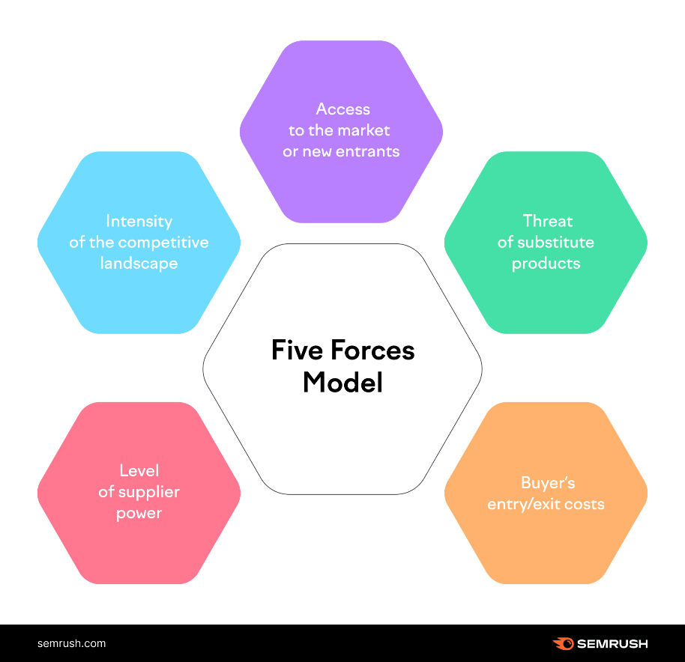
Figure: Porter’s 5 forces; Source: (Barney and Hansen, 2019)

Competitive Rivalry
Among the five forces, the first force is competitive rivalry. It is explained how strong the competitor of the organization is. In this part of the theory, the organizations analyze the quantity and the quality of the rival and compare with their product and services. How much the organizations have rivals as much as the threats the organizations have. The product and the service quality of the rival are better than the organization (de Sousa Filho et al., 2020). He's also a big threat to the organizations. To get the opportunities the organizations have to fight with the rival. Must make equality for product and services for the customers better than the rival. Then can take different estate to compete with the competitor. Organizations can decrease the prices of services. It will help the organizations to compete with their rivals. If the organizations have a minimum number of rivals and they are not supposed to compete with you. Opportunities for the organizations to maximize the profit. The organizations have not to compete with others. That's why the organization get the maximum number of customers than others. Directions to maximize profit and achieve success are smooth.
Supplier Power
Supplier power explains the power of supply to increase their prices. Also, explain the potential suppliers that organizations have. Services that the supplier provides for the customers. An organization also analyze how expensive for the organization to change the supplier. If the organization have more supplier, it will be a big opportunity for the organization. Organizations can easily switch suppliers and buy the product at a cheaper rate. They said the organization have to analyze how much the supplier has in the area to start the business. If there is fewer supplier for the organizations, it can be a big threat for the organizations. Because it will be difficult for the organizations to switch the supply easily (Barney and Hansen, 2019). When there is a fever supplier there must be an increase in the product and service price of the supplier. Expensive supplier is a threat to the organization because they increase the cost and expenses of the organization. That's why the organizations face making a loss.
Buyer Power
Buyer power is the third force among the five forces of porter's theory. Buyer power explains how easy for the buyer to switch to new and cheaper suppliers. If it is easy for the buyer to switch and get cheaper competitors, then he will be a reason to down the prices of the product and services. It is a big threat too. When the number of buyers is low then the number of suppliers. It is a reason to decrease the prices of the product and service. If it happens it can be a threat to Verdant Leisure. By leaving the European Union, YouTube decreases the number of buyers very much than before. That's why it is a threat to organizations (Black and Boal, 2016). When the organizations have a few customers, the customers or the buyer have more power than the organizations. When the organizations have many customers then the organizations have more power than the buyer. The organizational power explains the opportunities of the organizations. If the organizations have many customers and few competitors, then it can be a big opportunity for the organization and the organization will get the maximum power.
Threat of Substitution
The threat of substitution is a very significant force of porter's five forces. It explains the possibility for the customer to find new ways of the product that they provide. Organizations must understand. For example, if the organizations produce a product that the customers can make their own easily. Then the customers will not attract to buy the product the customer will make his product for use. these threads are called the threats of substitutions. Substitution plays and significant role to make the organization we can and make big threats to the profitability of the organization. Before making a product or service for the customers, the organizations must have to analyze whether is a substitute or not for the customers (Royer, 2018). Substitute for the customers then the organization must have to avoid this product to announce in the market. In this perspective, Verdant Leisure happy opportunities because their services are a holiday park. Which cannot substitute the customers easily. Provide different services that are unique and very tough to substitute for the customers. They provide a green environment and hygiene environment for the customers in the holiday park. Which is tough for the customers to substitute.

The threat of New Entry
New entry as a competitor can be a threat to the organization. A new entry can happen for a different reason, the business of the organization is easy and needless money and less effort to enter. Then new entries are a big problem for the organizations. Verdant Leisure has a business holiday park. This business needs a huge amount of money to start and needs a huge effort to achieve success. That's why It is difficult to start a new business on this site. A new entry cannot be a threat to the organizations. Because it is not easy to start a new business on this side of the organization (Alamri, 2018). To start a new business, they need a huge amount of money and a huge amount of effort. That's why the organizations have fewer number of new competitors. But the organizations also have many competitors already in the market which is a big threat for the organizations. Organizations need to analyze other organizations to complete them and make better products or services.

3.2 Internal environment to identify strengths and weaknesses
The internal environment must be understood and analyzed by organizations. Organizations can determine their strengths and shortcomings by conducting an internal environment analysis. Finding your organization's strengths and shortcomings is a crucial component. It may be challenging and tough for businesses to succeed if they are unable to recognize their strengths and shortcomings. Organizations may use their strengths to achieve the greatest results for themselves when they are aware of their strengths. The company benefits from each of the opportunities. Because of this, organizations must recognize their strengths. Knowing about the challenges an organization faces will enable it to prepare for overcoming those threats. These will aid organizations in identifying their deficiencies. Organizations' shortcomings will be made stronger whenever they can overcome their deficiencies. Another asset that helps organizations succeed is the ability to recognize their weaknesses. To comprehend the internal environment, the majority of businesses employ various studies and ideas. The internal environment study assists firms in identifying their strengths and shortcomings. To determine Verdant Leisure's strengths and shortcomings, many theories and studies will be used (Alamri, 2018).

- SWOT analysis for Verdant Leisure
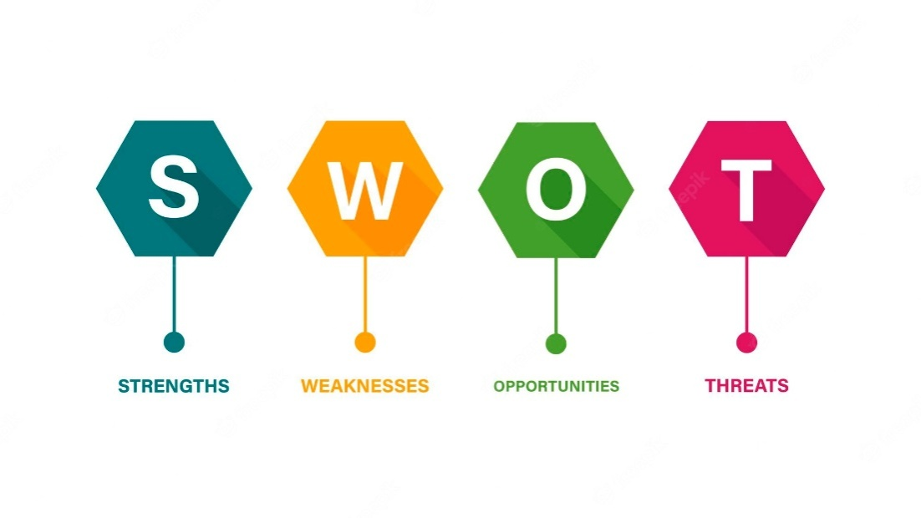
Figure: SWOT ANALYSIS; Source: (Betts and Ofori, 2019)
Strength | Weakness
Verdant Leisure I know I barely to make them a strong brand in the United Kingdom. This is a strength of the organization. The employee of the company is very skilled than other companies there is a big exchange between the organizations. The organizations have many loyal customers which makes the organization strong internally. Many things make the organization strong (Betts and Ofori, 2019). First of all, organizations use unique technology to run their operations. This is an exchange of the organization that makes the organization strong internally. | With the strengths, there are also many weaknesses for the organizations. The organizations must understand the weakness to overcome it. The most significant weakness of the organizations is the lack of capital. Verdant Leisure I don't know focusing to increase the area of the business. The organizations already take decisions to buy less in different areas in the United Kingdom. But to the lack of capital, the organization faces different problems to buy a place and increase the business area.
Opportunities | Threats
There are many opportunities that the organizations have for the business. For covid-19, most people like to avoid others. What the customer said don't like to interact physically with others that's why the organizations are using this as an opportunity. Since even late different unique technology to help them avoid physical interactions with others. Now, customers can directly hotel and park on the internet without interacting with others. That helps the organizations attract customers. | The most significant threat for organizations is increasing competition. The organizations face big problems facing other competitors. There is a big number of competitors that make the organization difficult to run the business with compete others. Another significant trait of the organizations is rising the cost of the materials. It increases the cost and expenses of the organizations that's why the organizations have to increase the price of the services and products for the customers. That directly effect to decisions of the customers which is a threat for the organizations.

- Value Chain Analysis
Value chain analyses are used to improve the opportunities for the organizations. The organization analysis the value chain of the company for cost reduction and product differentiation. Organization analysis to reduce the cost of the different activities of the organizations. Organizations also Analyse the value chain to make the differentiation between the product and services.
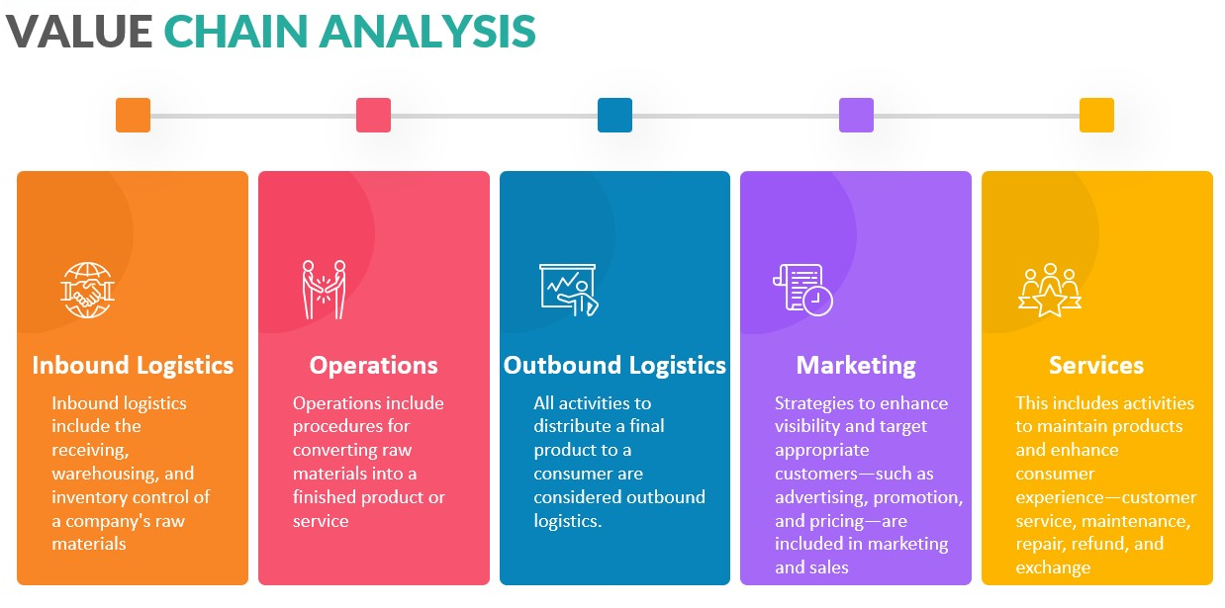
Figure: Value chain analysis; Source: (Arend, 2019)
Identify Value Chain Activities
First. Verdant Leisure must identify what is the value chain activities of the organizations. If the organizations are not happy to identify the values in activities, it will be difficult for the organizations to reduce the cost of the value chain activities. The company provides several products and services the organizations must focus on each of the processes to make the product and services (Betts and Ofori, 2019). Organization focus on each of the processes of the product will help the organization to reduce the cost of the processing for each of the product and services.
Determine the Cost and Value of Activities
When the organizations identify the value chain activities, the organizations have to identify the value of each of the activities. Organizations have two identify the value-created activities that help the organizations to identify the opportunities. The organizations also have to focus on the cost of each process. It is necessary to analyze otherwise the price of the product or services will increase which makes a loss for the organization (Arend, 2019).
Identify Opportunities for Competitive Advantage
When the organizations can understand the value chain activities and the value and cost of the activities then the organization have to identify opportunities to get a competitive advantage. For example, if Verdant Leisure wants to reduce farms cost, the organizations must focus on each of the activities to reduce the cost and identify opportunities. On the other hand, he's the company wants to accept the product differentiations, the organizations must analyze each of the opportunities of product differentiations to achieve the goal (Muthusamy, 2018).

- VRIO
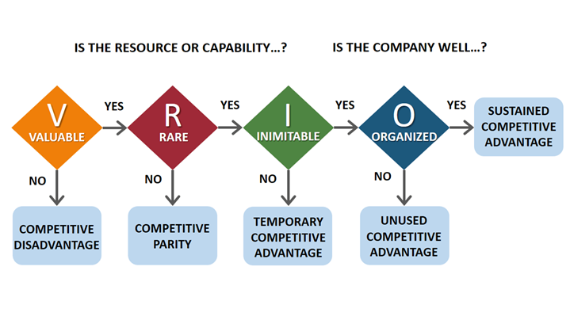
Figure: VRIO; Source: (Muthusamy, 2018)
Value
Value explained what the capability of the product and services is to achieve the satisfaction of the customers. Verdant Leisure queen gets more opportunities to add more value to the product and services. Value gives opportunities internally to the organizations. Verdant Leisure analysis the needs and satisfaction of the customers to add value to the product or services. This gives competitive advantages and opportunities to the organization (Arend, 2019).

Rarity
Rarity explains the availability of the resources and how the resources are accessible to the competitors. If the organizations have availability of the resources, it is an opportunity for organizations. Another hand if the computers of the organizations are not available the resources, it is also an opportunity for the organizations to accept the services (Eloranta and Turunen, 2015).
Imitability
Imitability explains what the ability of the competitors is to duplicate your resources and solutions. If the ability of the competitor is high to duplicate your Solutions, then it is a threat to the organization. If the ability of the computers is not good to duplicate the solution and resources of the organization then it is our opportunity for the organization (Muthusamy, 2018).
Organization
The organization internally analysis how the business operates and how the structure of the business is close to success. Organizations analyze how the structure of the business is strong to compete with other's competitors. Verdant Leisure uses internal analysis to make the structure of the business strong to compete with others.

4.0 Stakeholder analysis
Now verdant Leisure gives the most important to the stakeholders. The opportunities of the internal environment and external environment of the organizations mostly depend on the stakeholders. Stakeholders play a significant role to achieve success in a project or a business. There will discuss the key stakeholders of the organizations and how they are important to the organizations.

Apply Mendelow Matrix to identify the key stakeholders and their specific interests
Manage closely
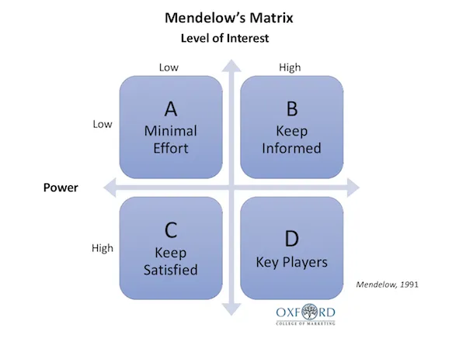
Figure: Mandelow’s Matrix; Source: (Eloranta and Turunen, 2015)
This is because stakeholders consist of the upper management of the organizations. The directors and the major investors of the organizations are including these stakeholders. These stakeholders as high interest and high power over the organizations. These types of stakeholders are directly responsible for making decisions for the organizations. They have the power to start and stop a project for the organizations (Eloranta and Turunen, 2015).
Keep informed
This type of stakeholder consists of the staff members and employees of the organization. They don't have the right to decision-making for the organizations, but this type of stakeholders has a high interest in the organizations. Stable display holders have high interest and low power over the organizations. These stakeholders have a big hand in the improvement of the organizations but have no right to decision-making for the business.
Keed satisfied
These types of stakeholder holders include the government of the country. They have a low interest in the organizations, but they have high power over the organizations in decisions making. They don't apply decisions for a single organization. They apply decisions to all the organizations in the country. The organizations have always focused to keep them satisfied. Without satisfying the government the organization will never achieve the goal. To achieve success, organizations have to maintain the decisions of the organizations (Rouse and Daellenbach, 2019).

Low priority
These stakeholders have low interest and low power over the organizations. They are not related to the organizations. They have no right decisions for the organizations. They have also low interest in the organizations. Verdant Leisure does not have to focus on this type of stakeholder. The Organizations do not need to satisfy these stakeholders. But the organizations can monitor this stakeholder.
Make the relations between the stakeholders and organizations. First, the organizations must identify the stakeholders. All the stakeholders are not the same. The organizations take different decisions for different stakeholders to make the relations sustainably. For example, the government are also a stakeholder. They have low interest in the organizations, but the organizations always must satisfy the government. Organizations need to adopt a new strategy for the benefit of the customers. For example, if the government apply any law. Verdant Leisure also must apply the law to the organizations. When organizations apply new laws, the organizations need to adopt a new strategy. Because to apply the new law, the strategy must change for the organization (Rouse and Daellenbach, 2019).

5.0 Strategic growth choices for SMEs

- Ansoff Matrix
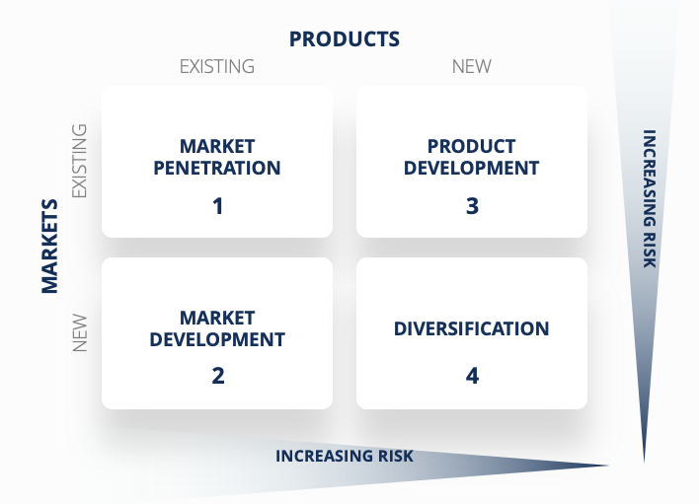
Figure: Ansoff Matrix; Source: (Barney, J.B., 2017)
Market Penetration
Verdant Leisure is now focused to increase sales of the services in the existing market. For that, the organization has already taken different steps to attract customers. The organizations are now trying to make a green environment for the customers. Most of the customers like to spend their holiday in a green environment. By applying this concept, Verdant Leisure has already started to make a green environment. This will help to increase the sales of the organization in the existing market.
Market Development
Verdant Leisure is already a place in Scotland. Organizations already by a different place in a different area to extend the business area. For market development, the organization expanded its business area. Verdant Leisure wants to increase sales and growth in a different place. The organizations are trying to increase their sales and growth through market development to expand the business area in a different place (Barney, J.B., 2017).
Product Development
Verdant Leisure not only focuses on market development but also focuses on product development. The Organizations already and different new services for the customers. For covid-19, the customers are not like to interact with others. They're so the organizations are now making their services based online. The Organizations try to provide the services through the internet. That helps the customers to avoid interacting with others (Mauri, and Michaels, 2018).
Diversification
Verdant Leisure is now trying to make a green environment for the holiday park. The reason behind making a green environment is product diversification. The organizations are trying to make diversify their product. Diversification in the products helps to increase the sales and growth of the organizations. When organizations make diversify their products, it helps the organization attract customers and increase the sales and growth of the organization (Barney, J.B., 2017).

- BCG Growth Matrix

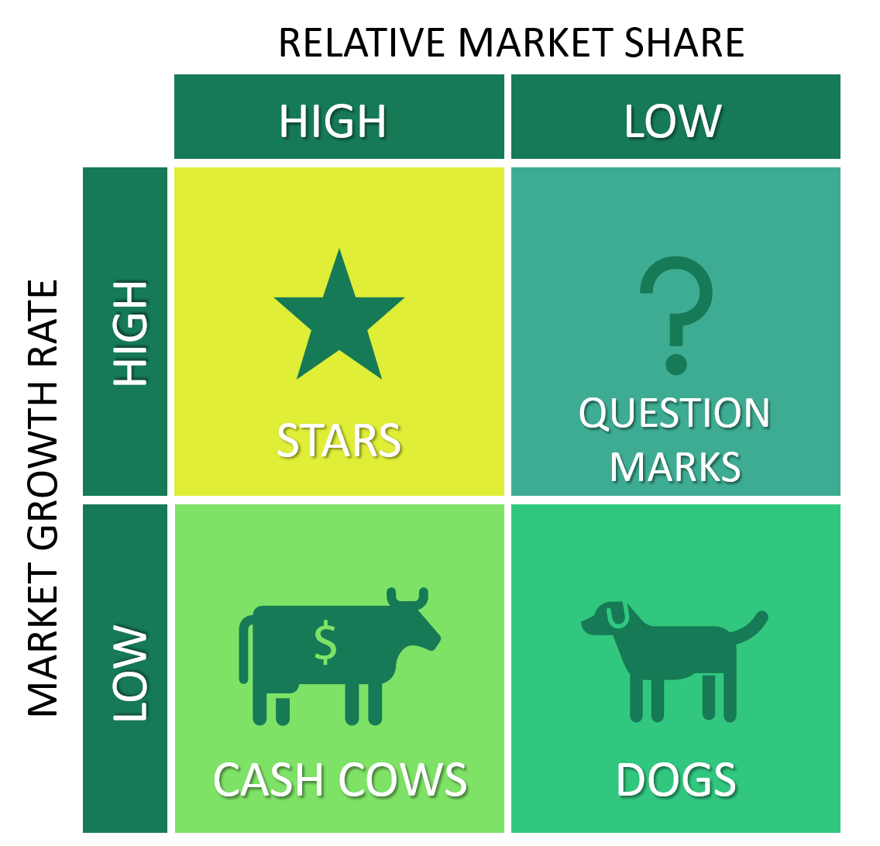
Figure: BCG Matrix; Source: (Rose et al., 2020)

Star
Star where the growth rate of the organizations is high, and market share also high. Verdant Leisure consumes a large amount of cash, to increase the growth and market share of the organization. The organizations already by different places and make diversify their product and services. That makes the organization consume a big amount of cash. For consumer beacon account of cash, the organizations can increase the sales growth and market share of the company (Rose et al., 2020).
Dogs
Dogs explain the low market share and the low growth rates of the organizations. When the organizations have a big number of competitors and lack the capital to increase the market area and business. To overcome the dogs' position in the BCG growth matrix, the organizations must make the market development and product development and diversify the product to attract more customers and increase the sales and growth of the organizations (Huggins and Izushi, 2021).
Cash cow
In a cash cow, the organization generates more cash, but the organizations consume less cash. In this position, the organizations get a high market share. But the growth rate of the organizations is very low. That's why the organizations consume less cash and generate more cash. In cash cows, the question mark act as a market leader and that reduces the cost of the company and helps with development and research. The maximum company invest in the cash cow to maintain the current level of productivity of the company. A high market share helps organizations maintain their level of productivity of the organizations (Powell and Dent‐Micallef, 2017).
Question mark
In question mark, the organizations have high growth but low market share. Verdant Leisure invested in a question mark, to increase the growth of the organization. When organizations focus on the growth of the organizations, it makes the organizations make consume a big amount of cash. To increase the growth of the organizations, organizations have to increase the market area. The organization in western for product development and market development and product diversifications. This tree is very significant for organizations to increase the market growth. Low market share makes the risk for the organizations, but a high growth rate gives a big amount of profit and productivity to the organizations (Huggins and Izushi, 2021).

6.0 Strategic Recommendations
Verdant Leisure should Analyse the external environment and internal environment both to make competitive advantages for the organizations. For external environment analysis, the organization should focus on the PESTEL analysis. It helps the organizations to analyze the significant factors that are necessary to analyze the external environment of the organizations. For internal environment analysis, the organization should focus on the SWOT analysis. SWOT analysis also very significant for the organization to analyze the internal environment. it helps the organization to understand what the organization’s internal strengths, weaknesses, opportunities, and threats is. The Organizations also should focus on stakeholder analysis. There are many theories that organizations can apply for stakeholders’ analysis. But the organizations should focus on the Mandelow Matrix, which helps the organizations to understand the importance of the stakeholders for the organizations and how the organizations should respect the stakeholders’ interests. The organizations should adopt a new strategy to maintain the benefit of the stakeholders which is significant for the organizations. For strategic growth choices, Verdant Leisure should focus on the Ansoff matrix. It will help the organizations with market penetration, market development, product development, and diversification. That is significant for the organizations to increase sales and growth of the organizations.

7.0 Conclusion
Strategic management plays a significant role in every organization. It is necessary for organisations to conduct ongoing planning, monitoring, and analysis of their overall environment. Organizational strategy plays a vital role in achieving the success of the organization. Strategic management should help the organisation analyse the external and internal environment of the organization. Organizations must analyse the external environment, which should help Verdant Leisure understand the opportunities, threats, strengths, and weaknesses of the organization. Verdant should use strategic management for stakeholders’ analysis, which is very necessary for organizations. Verdant Leisure also has a list of different growth choices that help to understand the organizations.

References
Alamri, A.M., 2018. Strategic Management Accounting and the Dimensions of Competitive Advantage: Testing the Associations in Saudi Industrial Sector. International Journal of Academic Research in Accounting, Finance and Management Sciences, 8(2), pp.48-64.
Arend, R.J., 2019. Revisiting the logical and research considerations of competitive advantage. Strategic Management Journal, 24(3), pp.279-284.
Barney, J.B. and Hansen, M.H., 2019. Trustworthiness as a source of competitive advantage. Strategic management journal, 15(S1), pp.175-190.
Barney, J.B., 2017. Gaining and sustaining competitive advantage.
Betts, M. and Ofori, G., 2019. Competitive advantage in construction: reply. Construction management and economics, 11(1), pp.73-74.
Black, J.A. and Boal, K.B., 2016. Strategic resources: Traits, configurations and paths to sustainable competitive advantage. Strategic management journal, 15(S2), pp.131-148.
de Sousa Filho, J.M., Wanderley, L.S.O., Gómez, C.P. and Farache, F., 2020 Strategic corporate social responsibility management for competitive advantage. BAR-Brazilian Administration Review, 7(3), pp.294-309.
Eloranta, V. and Turunen, T., 2015. Seeking competitive advantage with service infusion: a systematic literature review. Journal of Service Management.
Hesterly, W. and Barney, J., 2018. Strategic management and competitive advantage. Pearson Prentice Hall: Upper Saddle River, NJ, USA.
Huggins, R. and Izushi, H. eds., 2021. Competition, competitive advantage, and clusters: the ideas of Michael Porter. Oxford University Press.
Knight, E., Kumar, V., Wójcik, D. and O’Neill, P., 2020. The competitive advantage of regions: economic geography and strategic management intersections. Regional Studies, 54(5), pp.591-595.
Mauri, A.J. and Michaels, M.P., 2018. Firm and industry effects within strategic management: An empirical examination. Strategic management journal, 19(3), pp.211-219.
Muthusamy, S., 2018. Minding the cognition: toward a strategic knowledge management for competitive advantage. Strategic Change, 17(5‐6), pp.145-153.
Nuryanta, N., 2018. The Implementation of Strategic Management on Competitive Advantage in Islamic University of Indonesia (Uii) Yogyakarta. Indonesian Journal of Interdisciplinary Islamic Studies (IJIIS), pp.1-30.
Omari, A.O., Nyongesa, W.J., Ochieng, O.E. and Simeon, K., 2021. Strategic management: The link between the Agency theory and the Company's competitive advantage. International Journal of Business and Social Science, 2(23).
Powell, T.C. and Dent‐Micallef, A., 2017. Information technology as competitive advantage: The role of human, business, and technology resources. Strategic management journal, 18(5), pp.375-405.
Powell, T.C., 2015. Research notes and communications strategic planning as competitive advantage. Strategic management journal, 13(7), pp.551-558.
Rose, R.C., Abdullah, H. and Ismad, A.I., 2020. A Review on the Relationship between Organizational Resources, Competitive Advantage and Performance. Journal of International Social Research, 3(11).
Rouse, M.J. and Daellenbach, U.S., 2019. Rethinking research methods for the resource‐based perspective: isolating sources of sustainable competitive advantage. Strategic management journal, 20(5), pp.487-494.
Royer, S., 2018. Strategic Management and Online Selling: Creating competitive advantage with intangible web goods. Routledge.
Shrivastava, P., 2015. Environmental technologies and competitive advantage. Strategic management journal, 16(S1), pp.183-200.

