Title:Innovative Marketing Strategies
Yangsenyun
9 May 2022

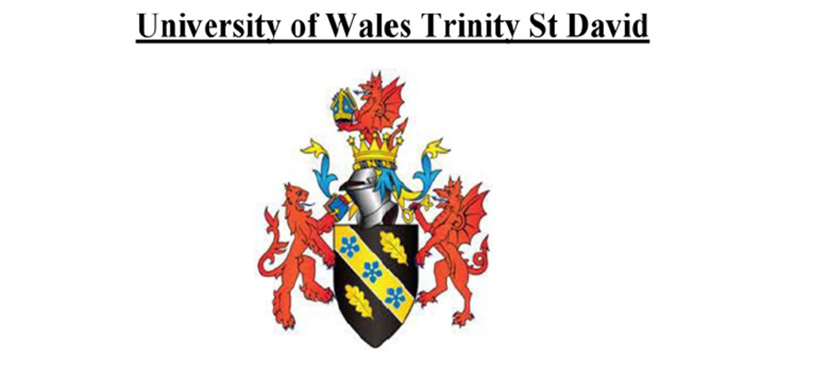

MOUDLE NAME | strategic marketing
MOUDLE CORE | BMBM6016
STUDENT NAME | YANGSENYUN
STUDENT NUMBER | 2100118

Table of Contents
Executive Summary 3
Introduction 5
Main Findings 7
Strategic Marketing Objective and its Justification 7
SMART Goal Analysis 7
SOSTAC Analysis of the Marketing Plan 8
Recommendations 11
Conclusion 13
References 14

Executive Summary
Recent studies show that approximately more than two billion people in the globe consume either a drink or food every day from hotels, especially during the morning hours, lunch hours, and the evening period (Stevens et al., 2021). With such vast numbers of people consuming foods from hotels and restaurants, the hotels make a lot of income. For instance, in the United States, food and drinking places make approximately 622 billion dollars annually (Vinerean, 2017). It is incredible to make such sales and profits to the food selling sector, and that is why it is vital to make sure the consumers are served the best and their needs fulfilled to their liking. As a result, this article focuses on the crucial aspect of improving the consumer experience of the large number who have food and drinks from this hotel.
The article commences with an introduction that shines ample light on the aspect of the company's marketing plan. The introduction lucidly elaborates the purpose of having a concise and practical marketing plan for the hotel, especially regarding the issue of setting and achieving the set goals. A marketing plan gives the hotel management team and every other employee a sense of direction towards a common goal. Having a marketing plan also ensures that there is efficiency within the business activities of the hotel. The introduction further introduces two vital marketing analyses: SMART analysis and SOSTAC marketing analysis.
A single objective is lucidly elaborated in the main findings, the objective of attaining an excellent consumer experience by the hotel management. The objective is vital in ensuring the hotel's clients' needs are fully satisfied, and in turn, the hotel gets to maintain and attract more potential consumers. Maintaining and attracting more consumers means increased sales for the hotel and more profits, which could serve other essential purposes like expanding to novel places. The article proceeds to check the various ways through which the set objective could be effectively implemented and the period the company ought to see results of the marketing plan. There are also some recommendations made that, when executed, could serve as an anchor to the company's success, especially concerning the satisfaction of consumer needs.

Innovative Marketing Strategies

Introduction
A wise saying goes, failure to plan is planning to fail, and its purpose is to inform people of the numerous merits that come alongside effective planning. Additionally, the wise saying warns the essential consequences of failing to have a plan that guides an individual towards attaining a particular goal. The same aspect is quite applicable in the marketing segment of any business, whether a big enterprise or a small and medium enterprise (Roy, 2019).
Marketing plans refer to the unique company document in which the company's objectives are outlined and the estimated period needed to achieve the noted objectives (Chernev, 2020). Objectives are the goals that a company wishes to attain, not just for the company’s benefits but for the consumer’s great experiences. There are several purposes of having a marketing business plan, and the first purpose is to provide a company with a sense of direction by stating what needs to be done and how. The period the objective will take to be attained. A sense of direction is achieved when the company takes into action various steps meant to complete the set objectives (Fast et al., 2017). The other purpose of having a marketing plan is avoidance of making mistakes when actualizing the objectives. The company saves a lot of investments by avoiding the noted errors and failures during the planning.
The set market plans dictate a company's managerial efficiency because it becomes easier to allocate and supervise duties. With adequate knowledge of expectations, the administrative team can manage and lead the whole group of employees in the right direction and offer them the proper channels for growth (Fuentes, 2021). A marketing plan is an essential document for assessing what is already achieved and what needs to be done to achieve the remaining objectives. As a result, all small or big companies need to have an effective marketing plan that can be accessed through SMART and SOSTAC strategies.
The SMART analysis is an acronym that represents specific, measurable, achievable, realistic, and time-bound. The goals set by the hotel ought to show the five characteristics stated above. The set objectives of the hotel ought to be specific; the objectives should be straightforward, pointing out the expected outcome (Girton, 2018). The objectives need to be measurable to imply that the hotel management ought to have ways to evaluate the goals' execution effectively. For example, how far have the said objectives been achieved? How much has been invested in the plan, and does the income invested match what has been achieved? The set goals ought to be achievable in terms of the set time frame and within the managerial and financial capacity, which means that the goals ought to be realistic (Kozlovskyi et al., 2018). Time is a crucial factor to consider while formulating marketing plans.
SOSTAC is an acronym for situation, objectives, strategy, tactics, action, and the 'C' stands for control. The hotel marketing team ought to access the current situation by looking at the prevailing micro and macro environment (O'Neill, 2019). The hotel managerial team ought to have a lucid goal and then set strategies for achieving the objectives. While drafting the purposes, the hotel executive team needs to state the tactics they will use to achieve the set objectives and incorporate the available digital tools. The company needs to develop the actions that it will do to achieve the set goals within the specified time. Lastly, there is the need for control which implies that the management ought to access the objectives through methods like web analytics to ensure that there are positive changes in the issue at hand.

Main Findings

Strategic Marketing Objective and its Justification
The strategic marketing objective under concern is to improve the consumer experience that have their meals from the hotel and ensure their satisfaction has been achieved to the core within the coming half year. Consumer satisfaction refers to the levels of fulfillment expressed by consumers after interacting with the hotel's services and goods, efficiency, and timely response, among other factors. The stated objective comes alongside many merits both to the company and to the consumers. The hotel's success is tied to consumer satisfaction in that the fulfilled consumers always come back, and that means a steady improvement in the hotel's sales. Increased sales alternatively see improvements in the fundamental components of the hotel business like increased salaries, diversifying the various meals offered, and providing more services associated with hospitality. Consumer satisfaction is crucial to measuring the hotel's competence in the multiple services and goods offered.

SMART Goal Analysis
The succinct market objective of improving the consumers' experience within the hotel ought to achieve the SMART goals analysis format, and indeed it does. The aim is precise in that it is clear what the hotel management looks forward to performing and complete consumer satisfaction (Kilpelä, 2019). The objective is also measurable through marketing analytics which entails a keen study of collected big data from consumers and the conduction of surveys meant for consumers to rank the hotel's competency. The objective is achievable because it is within the resources of the hotel managerial team and the hotel's financial status. The set goal is also realistic, as it is every business unit's dream to attract and maintain its consumers (Muhonen, 2017). Similarly, there is nothing wrong with the hotel wanting to achieve the set goals. The set objective is also time-bound because there is a time frame of six months attached. Within the six months, alternations in the current consumer satisfaction status and the futuristic consumer satisfaction must be attained because the hotel management will have undertaken some actions to see to that (Tafesse and Wien, 2018).
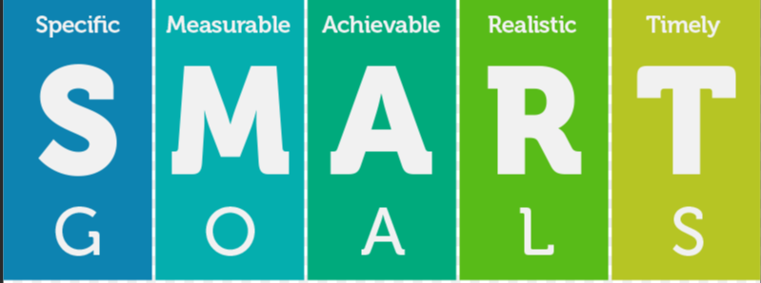
Figure one; SMART goals.

SOSTAC Analysis of the Marketing Plan
As pointed out in the introduction, the SOSTAC analysis is an acronym for situation, objectives, strategy, tactics, action, and control. It is always said that for anyone to have a desire to achieve more, they must have adequate information about the current situation. One of the best ways of accessing the current situation of the hotel is through the SWOT analysis (Girton, 2018). SWOT analysis enables the hotel to know its current strengths, its weaknesses, the current opportunities, and the posed threats. The hotel's strength is the existing consumer base that could be used to bring in more consumers. Another strength is the availability of different services in the hotel (Komari, 2020). Apart from selling food and drinks, the hotel has room for a spa and hairdressing services. The weaknesses of the hotel include a limited number of service providers and several complaints from consumers because of delayed benefits. The current opportunities are new services which could be availed in the hotel like an artificial natural scenery of different plants and unharmful wild animals. There is also the opportunity to use digital social media platforms to give consumers a great experience (Malesev and Cherry, 2021). The posed threats include stiff competition from other hotels, posing a comparison space for the hotels.
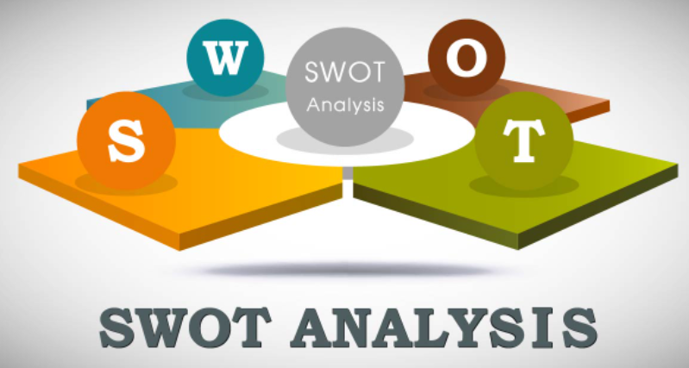
Figure two; SWOT analysis
The objective of the hotel, as stated earlier, is the improvement of the hotel's consumer experiences. The purpose is the hotel's goal of where it would like to be in the coming six months. The hotel would like to have achieved an incredible consumer experience in terms of quality service provision and diverse recreational activities availed to the consumers (Orynbayeva, 2018).
There should be strategies for how the hotel will achieve the set goal in the provided time frame (Gerritsen and Olderen, 2020). Some of the systems include having enough employees to cater for all the clients, especially in peak hours, having a form of coordination where the clients could order food and have it delivered during the crucial period, getting away to diversifying the meals and drinks provided so the customers will have a diverse menu to pick food from, frequent training of the cooks and waiters on the modernized and attractive means of preparing and serving food and lastly, set aside a plot of land and create beautiful scenery where the clients can enjoy their time away from the four walls of the hotel (Stephenson, 2021).
There are specific tactics that ought to lead the company step by step into the achievement of the marketing plan (Diaz et al., 2021). The tactics state the precise steps like for the company to have adequate employees, it ought to hire people from the required fields of hospitality, tourism, and leisure to ensure that even at pick time, all consumers are served to their best. To ensure coordination between the ordering of food by clients and timely delivery, there should be a transparent system of communication between the two parties (Keegan and Rowley, 2017). To ensure there is diversification of available foods and drinks in the hotel, the managerial team ought to make orders within the country and abroad for the raw materials needed.
The actions which the hotel ought to engage in to achieve the set objective include secluding time to post job vacancies and taking time to scrutinize the most competent applicants fit for the job. Through that, the hotel will hire the needed number of employees, and there will be efficiency in delivering orders (Юровская, 2017). The company ought to create websites or applications through which the clients could order food from any other part of the country and get their orders quickly (Stephenson, 2021). The hotel management needs to hire an expert in planning and design to find a strategic place within the hotel's compound to create an outside space where the customers could enjoy beautiful sceneries while enjoying their meals. The hotel also needs adequate finances to execute the market plan (Matidza et al., 2020).
The aspect of control is achieved when the hotel managerial team uses marketing analytics to assess whether the set objectives have been completed (Hwangbo et al., 2017). Marketing analytics could track the steps involved in achieving the set goals. The aspect of control is critical as it reveals whether the implied actions are working. The hotel could achieve marketing control through having a frequent competitor analysis, the customer analysis and conducting market researches to ensure they get right trends and adjust accordingly to the market.
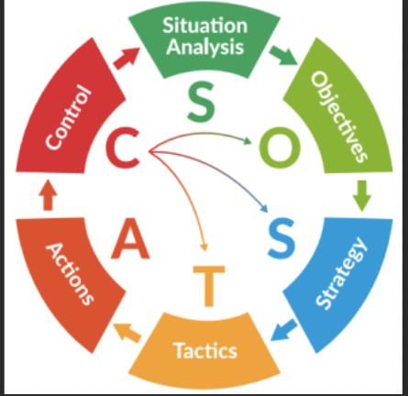
Figure three: SOSTAC marketing analysis.

Recommendations
With the technologically advancing world, the hotel needs to embrace the use of digital marketing platforms like social media spaces, Facebook, Twitter, and Instagram. For instance, the hotel could partner with Twitter, and consumers would be able to shop right from their Twitter feeds, thanks to a recent collaboration. As a result of this decision, a fundamental shift in how social media is utilized to market products may occur. As a result of the change, Twitter and the hotel would enjoy an increase in revenue in the short-term, and both platforms will become more enticing to business owners in the long-run. Above all, the marketing platforms will enable interaction with their customers and get to know what the consumers need (Backman, 2019).
The hotel could strive to keep its content short and sweet to keep it as light and breezy as possible. The fact that the hotel has embraced the social component of Twitter and ran with it would enable them to create something truly unique in the marketplace (Wijaya and Hermawan, 2018). The hotel ought to be willing and ready to adopt a conversational tone and take an informal approach to present its contents due to their desire to make their followers aware that they are taking part in a more significant debate about the subject at hand. Customers would have the impression that the hotel is targeting them in the manner stated further down this page (McCormick et al., 2017).
The hotel would acquire customers by holding contests and using hashtags such as the ones listed below: Using a Twitter contest is an unavoidable step in attempting to reach new customers through the social networking site Twitter (Calzada, 2020). Even though there are a variety of approaches that can be used to achieve success or failure, the hotel is currently undertaking the aspect of improving interactions with their target consumers by providing a channel where they could air out their concerns. The hotel could also learn more about the consumers by following their Twitter accounts, telling a story, and directing them to their website (Threlkeld, 2018).

The marketing plan ought to be adapted into the business activities to support continuous improvement of the hotel. Some of the ways that the hotel could adapt the marketing are through promotional activities like giving discounts for whoever purchases the new recipes, having a wide range of recipes for many people, having a smooth communication and transport means that ensures clients can order meals and the ordered packages are delivered on time them. A smooth interaction of the hotel and the consumers ensures a great consumer experience.
The hotel management should have various ways to measure and monitor the marketing plan by having a lucid track of the key performance indicators. For the hotel management to access the success of marketing plan it has to track the consumer’s retention rate, check the consumer feedback and access whether they are satisfied, have a track of their revenue growth and the rate of the sales. With a keen observation on these key performance indicators, it will be easy to monitor the marketing plans. For example, if the consumer retention is increasing, that is a sign that the marketing plan is successful. If the consumer feedback is positive and expressing their satisfaction, that would mean that the marketing plan is working and enhancing the hotel’s goals.

Conclusion
To summarize, a marketing plan is a critical factor for the success of every business unit, whether small, medium, or significant. A market plan has many purposes in the company, like providing a company with a sense of direction by stating what needs to be done, how, and the period the objective will take to be attained. Any managerial team with a lucid marketing plan also has an effective management process, and the company, both employers and employees, heads in the appropriate direction of a common goal. The set objective for this particular hotel is to improve the consumer experience in the coming six months. The objective is of quality and adheres to the SMART goal analysis. The SMART goal analysis ensures that the set goal is specific, measurable, achievable, realistic, and time-bound. The set marketing plan needs to achieve the SOSTAC marketing concept. According to the SOSTAC concept, the company ought to access the prevailing market situation, and the SWOT analysis works best for that. The company ought to have a clear objective within the market plan and have strategies that will be implemented to achieve the set goal. The hotel management ought to have tactics and actions that will lead to the achievement of the set goals. Lastly, there ought to be control meant to dictate and measure the progress of the steps being taken to reach the set objective.

References
Backman, J. (2019). Marketing and communication plan, CASE: Riihisoft Oy, RIIHI DMA.
Calzada, J. A. (2020). Communication, Marketing Plan, and Strategy. In Comprehensive Healthcare Simulation: Program & Center Development (pp. 133-140). Springer, Cham.
Chernev, A. (2020). The marketing plan handbook. Cerebellum Press.
Diaz, E., Esteban, Á., Vallejo, R. C., & Navarro, D. M. C. (2021). Digital tools and smart technologies in marketing: a thematic evolution. International Marketing Review.
Fast, A., Chang, J., Nguyen, N., Imai, Y., & Stoner, Z. (2017). Marketing plan. Nitori, Smoke.
Fuentes, M. (2021). Internet Marketing (Doctoral dissertation, Masarykova univerzita, Ekonomicko-správní fakulta).
Gerritsen, D., & van Olderen, R. (2020). Events as a strategic marketing tool. CABI.
Girton, C. (2018). Creating a marketing plan with a marketing team of one.
GURL, E. (2017). SWOT analysis: A theoretical review.
Юровская, М. Б. (2017). Use of the SOSTAC model and SMART method in developing marketing campaigns. In Наука, образование, общество: тенденции и перспективы развития (pp. 238-239).
Hwangbo, H., Kim, Y. S., & Cha, K. J. (2017). Use of the smart store for persuasive marketing and immersive customer experiences: A case study of Korean apparel enterprise. Mobile Information Systems, 2017.
Keegan, B. J., & Rowley, J. (2017). Evaluation and decision making in social media marketing. Management decision.
Kilpelä, J. (2019). Creating a social media marketing plan for a small luxury hotel.
Komari, A., Indrasari, L. D., Tripariyanto, A. Y., & Rahayuningsih, S. (2020, July). Analysis of SWOT Marketing Strategies and 7P Influence on Purchasing Decision. In Journal of Physics: Conference Series (Vol. 1569, No. 3, p. 032002). IOP Publishing.
Kozlovskyi, S., Shaulska, L., Butyrskyi, A., & Popovskyi, Y. (2018). The marketing strategy for making optimal managerial decisions by means of smart analytics. Innovative Marketing, 14(4), 1.
Malesev, S., & Cherry, M. (2021). Digital and social media marketing-growing market share for construction SMEs. Construction Economics and Building, 21(1), 65-82.
Matidza, I., Ping, T., & Nyasulu, C. (2020). Use of digital marketing in estate agency industry in Malawi. E-Learning and Digital Media, 17(3), 253-270.
McCormick, T. H., Lee, H., Cesare, N., Shojaie, A., & Spiro, E. S. (2017). Using Twitter for demographic and social science research: Tools for data collection and processing. Sociological methods & research, 46(3), 390-421.
Muhonen, T. (2017). Forming a Digital Marketing Plan For a Start-up Brand.
O'Neill, C. (2019). The quest towards relevant and useable strategic marketing plans. Global Business & Economics Anthology, 2.
Orynbayeva, B. Y. (2018). Theoretical basis of the marketing strategy-swot analysis ana and its place in the enterprise. In ЕВРАЗИЙСКАЯ ЭКОНОМИЧЕСКАЯ КОНФЕРЕНЦИЯ (pp. 37-41).
Roy, S. K., Singh, G., Hope, M., Nguyen, B., & Harrigan, P. (2019). The rise of smart consumers: role of smart servicescape and smart consumer experience co-creation. Journal of Marketing Management, 35(15-16), 1480-1513.
Steinert-Threlkeld, Z. C. (2018). Twitter as data. Cambridge University Press
Stephenson, R. (2021). How to write a digital marketing plan using PR Smith’s SOSTAC® planning model.
Stevens, R. E., Loudon, D. L., Wrenn, B., & Warren, W. E. (2021). Marketing planning guide. CRC Press.
Wijaya, P. K., & Hermawan, A. (2018). E-Marketing Applications Based On Virtual Reality Using Sostac Planning Method On Sales Property. Tech-E, 1(2), 16-25.
Tafesse, W., & Wien, A. (2018). Implementing social media marketing strategically: an empirical assessment. Journal of Marketing Management, 34(9-10), 732-749.
Vinerean, S. (2017). Importance of strategic social media marketing.

