UNIVERSITY OF WALES
TRINITY SAINT DAVID

FINANCIAL MANAGEMENT FOR THE HOTEL INDUSTRY
BMIH5007
ASSIGMENT 1: Business report – comparison of two
hospitality organisations.

MODULE TUTOR: ERNEST WAVEU Student name: KALLE Clement DITOU
Student Number: 2029083

Executive summary
The following business report has presented an in-depth analysis of Shangri-La Hotels and Travelodge Hotels. The study has effectively compared the total revenue generated by each of the organisations. It has been found that Shangri-La Hotels generate a higher amount of revenue, compared to Travelodge Hotels. Moreover, the study has analysed the market positioning of both hotel groups. For example, the brand perception, market share and consumer demographics are critically evaluated. The report has also featured the growth potential of the organisation, such as expansion strategies and potential barriers to growth. The financial commitments of both groups towards CSR are critically evaluated.
Table of Contents
Introduction 3
Discussion on the Organisations 3
Market Position of the Organisation 5
Potential Growth of the Organisations 6
Financial Commitment to CSR of the Organisations 7
Recommendations 8
Conclusion 9
References 10

Introduction
This report aims to acknowledge the business operations of Travelodge and Shangri-La Hotels along with highlighting the various initiatives adopted by these two businesses resulting in a better analysis of the key strategies that influence their revenue collection. The comparison between the financial strategies which led to the incorporation of various business strategies will be discussed in this report. The market position of these two hotel businesses along with potential growth aspects will be highlighted in this report. The financial commitment towards CSR programs will be mentioned in this report.

Discussion on the Organisations
Travelodge is known for its commitment towards utmost comfort and convenience to the consumers which is the prime reason for its present-day success in the hospitality sector of the UK requires suitable changes in the financial management for fluctuations in the dynamic business market along with the changes in the needs and expectations of the consumer base (Travelodge, 2024). The pricing strategy adopted by the marketing team of Travelodge resulted in an enhancement in customer retention that significantly boosted their financial stability in the competitive hospitality market. The dedicated efforts of the business towards offering a wide range of services along with the essential amenities greatly influenced the customers' perspectives and resulted in enhanced business growth. Incorporating digital technology into their operations management resulted in high efficiency in customer service and improved brand awareness through social media marketing, which led to communicating with a large consumer base regarding their services and business purpose (Drury, 2021).
Shangri-La Hotel is considered among the leading hotel businesses in the UK that have the potential to achieve better sustainability through addressing the various issues associated with proper revenue management along with identifying the most suitable methods for optimum utilisation of the resources leading to enhanced financial stability in the competitive business market. The marketing initiative highlighted the premium services which resulted in enhanced customer satisfaction along with significantly impacting the customer loyalty rate which is responsible for the growth of the business in the highly competitive business environment (Shangri-La, 2024). The ability of Shangri-La Hotel to ensure high-quality customer service by analysing the feedback and reviews of past customers resulted in the formulation of effective strategies that have the potential to provide enhanced experience leading to increased brand awareness. The efficient booking system enables the business representatives to arrange suitable rooms for the guests without any delay which significantly enhances the overall convenience of the guests.
Comparison of Revenue
The approach of the management of both hotels has significantly influenced the perspectives of the consumer base resulting in great success in the business growth aspects (Seal, 2019). It ensures better sustainability associated with accomplishing the goals and objectives of the businesses which aim at fulfilling the business purpose of both hotels (Sanders and Wood, 2024). The enhancement in the brand awareness of Shangri-La Hotel in the hospitality sector of the UK greatly influenced the revenue of the business enabling them to incorporate enhanced strategies associated with operations management leading better focus on the convenience and comfort of the customer which is required for achieving a competitive advantage (Choi et al., 2022). The estimated revenue generated by the business organisation is over 25 million GBP which highlights the potential of the hotel to expand its operations in various parts of the globe which leads to creating more sources of funding from the business partnership with investors.
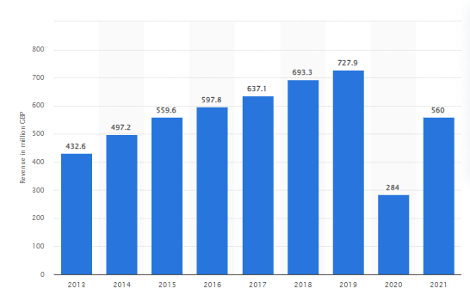
Figure 1: Revenue of Travelodge in the United Kingdom
(Statista, 2024)
The growth in the revenue of Travelodge can be seen in the graph that highlights the potential of the business to provide enhanced services to the customers along with focusing on the financial stability that was severely impacted by the devastating consequences of the pandemic along with the introduction of Brexit that resulted in a lower number of tourists from the European nations leading great loss to the overall profitability of the business (Statista, 2024). The incorporation of an enhanced strategy regarding revenue management resulted in the recovery of the majority of the losses along with paving the way for business growth in the competitive hospitality market (Guilding, 2014).

‌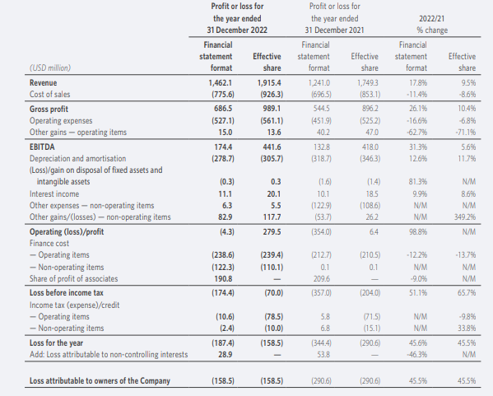
Figure 2: Financial report of Shangri-La Hotels
(Source: Shangri-La Hotels, 2024]

As per the financial report of Shangri-La Hotels, the total amount of revenue generated by the organisation is 1165.4 million GBP. The gross profit earned by the hotel chain was 546 million GBP. The total operating expenses of Shangri-La Hotels is 420 million GBP (Shangri-La Hotels, 2024). The EBITDA achieved by the hotel chain was 138 million GBP. Comparing the revenue generated by Travelodge in the year 2022, Shangri-La gets an advantage. The revenue of Travelodge across the world is 909.9 million GBP.
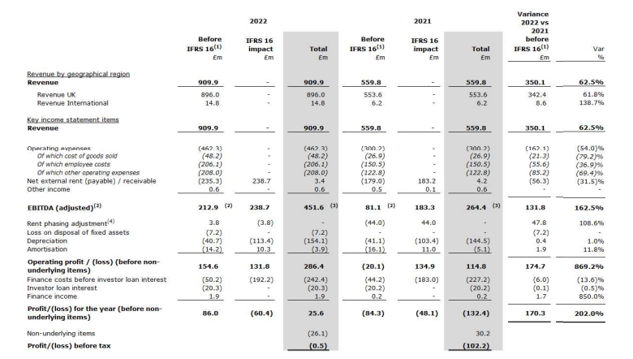
Figure 3: Financial report of Travelodge
(Source: Travelodge, 2024]
The organisation alone generated around 896 million GBP from the marketplace present in the UK. Shangri-La has achieved an excess of 236 million GBP in revenue, compared to Travelodge. The total operating expenses of Travelodge are 462 million GBP, which is higher compared to the revenue generated by Shangri-La. However, the EBITDA of Travelodge Hotels is higher, amounting to 212.9 million GBP (Travelodge, 2024). A higher EBITDA typically indicates that an organisation's operating profitability is higher and stronger. The metric is often used by investors to assess the financial health of an organisation. The metric provides an image of the organisation's core business profitability.
As of September 2023, the total underlying revenue generated by Travelodge Hotels was £782.0 million. An increase from £669.9 million is noticed, from the year 2022. The consolidated revenue generated by Shangri-La Hotel is 805.60 million GBP, in 2023. The RevPAR of Travelodge saw an increase of 15.2%, which amounted to £59.68. However, the RevPAR of Shangri-La was £82.48, witnessing an increase of 102% from the year 2022 (Shangri-La Hotels, 2024). A high RevPAR critically indicates the increase in revenue earned by the hotels. It can effectively lead towards higher profitability and increased cash flow. Moreover, a hotel with high RevPAR increases high market growth and strong market positioning. Henceforth, Shangri-La Hotels gets an edge over Travelodge Hotels.

Market Position of the Organisation
The ability of business organisations to achieve enhanced brand awareness along with obtaining the attention of a large consumer base greatly influences the potential of the business to obtain better market share along with a competitive advantage in the area of operation resulting in enhanced financial resources that can be utilised for focusing on the key challenges associated with the changes in the business environment that are causing several issues regarding efficiency of the operations management (Abou-Shouk and Soliman, 2021). The ability of Shangri-La Hotel to offer exclusive and premium rooms along with all the essential services associated with the convenience of the guests resulted in great feedback and reviews on the online platforms that significantly promoted business growth of the hotel business through better revenue collection which is correlated with the effectiveness of the revenue management initiatives that focus on optimum utilisation of the resources. The approach from Shangri-La Hotel towards engaging their staff in effective training sessions that aim to enhance the skills and knowledge resulting in a better understanding of the needs and expectations of the consumer base leading to enhanced customer satisfaction which is the key reason for establishing a successful business organisation in the competitive hospitality market of the UK (Alzoubi et al., 2022). The quality of the services along with the promotion of gender equality at the workplace by the hotel business resulted in the upliftment of the reputation of the business resulting in enhanced brand awareness leading to increased sustainability of the business growth (Cavagnaro and Curiel, 2022).
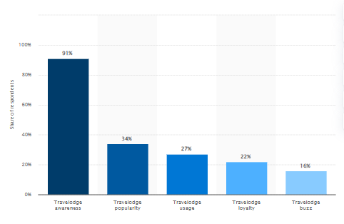
Figure 4: Brand Profile of Travelodge
(Source: Statista, 2024)
The effectiveness of the efforts of the management of Travelodge significantly helped them to achieve an enhanced reputation in the hospitality sector of the UK that resulted in better market share which is highly essential for business growth in a competitive market. The brand awareness of the business organisation can be seen in the graph that highlights the potential of the hotel to incorporate enhanced marketing strategies that aim to develop better services along with ensuring better sustainability in the upcoming years (Statista, 2024).

Potential Growth of the Organisations
The growth of any business organisation greatly depends on the ability to evaluate the changes in the business market along with identifying the essential changes that need to be incorporated into the existing business process for better prevention from unforeseen challenges in the future that can impact the financial stability of the business leading slowdown of the operations management that impact the overall sustainability of the business organisation (Prasad, 2020). The efforts of both the hotel businesses to understand the needs and expectations of the consumer base resulted in their enhanced brand awareness along with the incorporation of better technological advancements into their operations management led to enhanced efficiency and accuracy of the services offered by them. The Ansoff’s Matrix Model is highly effective in determining the most suitable business strategy that has the potential to achieve a competitive advantage along with enhanced business growth which requires a proper understanding of the various aspects associated with the existing operational activities that aim to acknowledge the essential changes that will promote better efficiency resulting in enhanced customer satisfaction (Zugay and Zakaria, 2023).
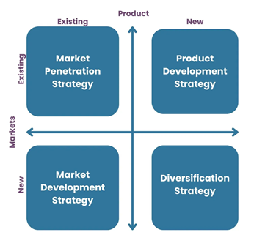
Figure 5: Ansoff’s Matrix Model
(Source: Zugay and Zakaria, 2023)
The great understanding of the various factors associated with the hospitality sector by the Shangri-La Hotel highlights the opportunity to enhance their business function by identifying the most suitable areas in the hospitality sector that can be enhanced through better incorporation of technological advancements along with addressing the key challenges and issues faced by the consumer base to achieve a better market share along with achieving a sustainable business model that ensures enhanced financial stability (Shakeel et al., 2020). The issues faced by the customers while booking the rooms which often lead to overbooking situations causing delays in arranging suitable rooms for the guests highlights a great opportunity to enhance the business reputation through incorporating digital technology that can manage all the online services efficiently without any error resulting in utmost comfort and convenience to the customers. Travelodge can adopt the diversification strategy to enable the customers to choose the services according to their budget and convenience resulting in enhanced sales rates.

Financial Commitment to CSR of the Organisations
The approach toward formulating effective corporate social responsibility initiatives plays a significant role in highlighting the voluntary efforts of the business organisation to address the challenges and issues associated with environmental problems along with focusing on the betterment of society leading to better attention of the consumer base that greatly influences the brand image of the business resulting in better opportunities to engage in efficient business process to provide better services to the customers for maintaining the sustainability of the industry in the competitive market (Walker, 2021). The stakeholder's theory can be used to explain why the organisation needs to invest in CSR activities. It is a view of capitalism, which focuses on the interconnected relationships between a business and its stakeholders (Freeman et al., 2023). Investing in CSR activities can enhance the relationships with the stakeholders, and ensure long-term viability and sustainability.
The growing concerns of the consumer base towards the increasing contribution of carbon emissions from the supply chain management of the hospitality sector that resulted in great harm to the local communities associated with tourist destinations highlights the opportunities to address this issue through the allocation of funds in the CSR programs that can minimise the negative impact of the hotel business on the environment along with upscale their brand image leading enhanced business growth.
The commitment towards new zero carbon emissions by Travelodge hotels can be achieved through shifting the energy requirements from non-renewable resources to sustainable resources can significantly enhance the perspectives of the consumer base regarding the dedicated efforts of the business organisation towards minimising its carbon footprint. The adoption of recycling initiatives in the hotel's various services and avoiding single-use plastics (Tansel et al., 2021). It promotes enhanced sustainability in operations management resulting in the requirement for additional expenditure on alternative sustainable business practices.
The development of effective CSR initiatives that comprise offering excess food from the hotel to needy people through partnering with an NGO can enhance the reputation of the hotel business resulting in better growth aspects (Khan et al., 2021). Both of the organisations analysed in the study are profitable. Shangri-La Hotels has generated an annual revenue of 116.54 million GBP, while Travelodge has incurred a profit of 909.9 million GBP. The excess of revenue generated can help these organisations to achieve their CSR aims. For example, Travelodge can reduce can form charity partnerships and prevent child abuse and human trafficking. Similarly, Shangri-La Hotels wants to promote fair labour practices and assist employees via training and development opportunities (Su and Zabilski, 2022).

Recommendations
Based on the financial analysis, Shangri-La Hotels needs to improve EBITDA. A suitable revenue management procedure can be implemented. Adoption of a dynamic pricing strategy can be useful, based on competitor analysis and seasonal fluctuations in demand patterns (Fridson and Alvarez, 2022). To increase the total revenue generated, the marketing team of Travelodge needs to understand the significance of social media marketing. It leads to better communication with the targeted consumer base which leads to enhancing their brand awareness along with promoting their business purpose (Praditya and Purwanto, 2024).

Conclusion
This report has discussed the significance of financial stability for better business growth in the hospitality sector along with highlighting the impact of various external factors associated with the business environment on the overall revenue of the hotel business. The comparison between the revenue collection of Travelodge and Shangri-La Hotel has been mentioned in this report evaluating the key aspects along with the various reasons for their present-day success in terms of high revenue collection. The market position of these hotel businesses has been discussed in this report along with highlighting the significance of brand awareness that helps in enhanced business growth. The key aspects associated with the potential growth and the financial commitments towards CSR initiatives have been mentioned in this report.

References
Abou-Shouk, M. and Soliman, M. (2021) The impact of gamification adoption intention on brand awareness and loyalty in tourism: The mediating effect of customer engagement. Journal of Destination Marketing & Management, 20, p.100559.
Alzoubi, H.M., Ahmed, G. and Alshurideh, M. (2022) An empirical investigation into the impact of product quality dimensions on improving the order-winners and customer satisfaction. International Journal of Productivity and Quality Management, 36(2), pp.169-186.
Cavagnaro, E. and Curiel, G.H. (2022) The three levels of sustainability. Routledge.
Choi, T.M., Kumar, S., Yue, X. and Chan, H.L. (2022) Disruptive technologies and operations management in the Industry 4.0 era and beyond. Production and Operations Management, 31(1), pp.9-31.
Drury, C. (2021) Management and Cost Accounting, 11th Edn. London, Prentice Hall
Freeman, R.E., Phillips, R. and Sisodia, R. (2020) Tensions in stakeholder theory. Business & Society, 59(2), pp.213-231.
Fridson, M.S. and Alvarez, F. (2022) Financial statement analysis: a practitioner's guide. John Wiley & Sons.
Guilding, C. (2014) Accounting Essentials for Hospitality Managers, 3rd Edn. London, Routledge
Khan, S.A.R., Yu, Z., Panait, M., Janjua, L.R. and Shah, A. (2021) Global corporate social responsibility initiatives for reluctant businesses. IGI Global.
Praditya, R.A. and Purwanto, A. (2024) The Role of Viral Marketing, Brand Image and Brand Awareness on Purchasing Decisions. PROFESOR: Professional Education Studies and Operations Research, 1(01), pp.11-15.
Prasad, L.M. (2020) Principles and practice of management. Sultan Chand & Sons.
Sanders, N.R. and Wood, J.D. (2024) Foundations of Sustainable Business. John Wiley & Sons.
Seal, W. (2019) Management Accounting, 6th Edn. London, McGraw Hill
Shakeel, J., Mardani, A., Chofreh, A.G., Goni, F.A. and Klemeš, J.J. (2020) Anatomy of sustainable business model innovation. Journal of cleaner production, 261, p.121201.
Shangri-La Hotels, (2024) JEN Shenzhen Qianhai by Shangri-La 2. Kerry Hotel. (Online). Available at: <https://sitecore-cd.shangri-la.com/-/media/Project/Shangri-La-Group/Investor/Files/Public-Disclosures/Latest-Top-Publications/e0069_230418_AR.pdf.> [Accessed on 4th May, 2024]
Shangri-La, (2024) Luxury Hotel in London | Shangri-La Hotel, At The Shard, London. [Online] Available at: <https://www.shangri-la.com/en/london/shangrila/> [Accessed 27 Apr. 2024].
Statista, (2024) Annual revenue of Travelodge UK from 2013 to 2021 [Online] Available at: <https://www.statista.com/statistics/429089/travelodge-total-revenue-united-kingdom-uk/#:~:text=Travelodge%20revenues%202013%2D2021&text=Travelodge%20UK%20generated%20revenues%20of,year's%20total%20of%20284%20million.> [Accessed on: 27th April 2024]
Statista, (2024) Travelodge brand awareness, usage, popularity, loyalty, and buzz among hotel customers in the UK in 2022 [Online] Available at: <https://www.statista.com/forecasts/1335657/travelodge-hotels-brand-profile-in-the-uk> [Accessed on: 27th April 2024]
Su, Z. and Zabilski, A. (2022) What is the relationship between quality of working life, work–life balance and quality of life?. Worldwide Hospitality and Tourism Themes, 14(3), pp.247-260.
Tansel, T., Yeshenkulova, G. and Nurmanova, U. (2021) Analysing Waste Management and Recycling Practices for the Hotel Industry. Journal of Environmental Management and Tourism, 12(2), pp.382-391.
Travelodge, (2024) Travelodge | Great value hotels throughout the UK & Ireland. [Online] Travelodge. Available at: <https://www.travelodge.co.uk/> [Accessed 27 Apr. 2024].
Walker, J. (2021) Introduction to Hospitality, Harlow, Pearson
Zugay, B. and Zakaria, R. (2023) Ansoff matrix. SAGE Publications, Inc.

