Tamara Khoury- 1602243
Strategic management (SBMA7103D)
10th August 2018

Strategic Management

Assessment

United Nations World Food Programme (UNWFP)

Contents
Executive Summary…………………………………………………………………………3
Introduction ………………………………………………………………………………….4
UNWFP Assessment ....………………….…………………………………………………6
- About WFP……………………………………………………………………….......6
- Strategic Direction …………………………………………………………….........6
- Organizational Health ………………………..……………………………………..7
UNWFP SWOT Analysis……………………………………………………......................8
Corporate Strategy………………………………………………………………………...10
Evaluation…………………………………………………………………………………...12
- Bowman’s Strategy Clock ………………………………………………….........12
- Ansoff’s Matrix………………………..…………………………………………….15
The Change Kaleidoscope ……………………………………………………………….19
Conclusion ………………………..…….………………………………………………….21
Recommendations…………………………………………………………………………22
References………………………………………………………………………………….25

Executive Summary
The strategic analysis report highlights the importance of having an effective corporate strategy for the United Nations World food Programme (UNWFP), where plans and methods are created to allow the organisation to continue growing despite the changes in the environment. Using the SWOT analysis framework, to help identify the key external and internal issues facing the organisation in maintaining its competitive position, where the organisation can focus on reducing weaknesses, taking advantage of its strengths, anticipating any future problems and predicting any possible opportunities.
Furthermore, the report evaluates the potential corporate level strategic directions that have been taken by UNWFP to date in order to develop and sustain its competitive position, using tools such as Bowman’s Strategy Clock and Ansoff’s Matrix, to explain the main strategic direction of the organisation, which is based on differentiation, strong brand awareness and loyalty. In addition, the report stresses the need for WFP to focus on new strategies using new innovative techniques and methods to improve both value and cost (Hybrid strategy) especially in times of crisis.
The report also describes the wider implications for strategic management decisions and the incorporation of new strategies on certain areas within the organisation, which can help the organisation to implement change effectively.
Finally, recommendations are provided based on the findings to highlight the important issues that WFP needs to focus on to develop a change management strategy for the organisation using new tools and methods, where managers can design a 'context sensitive' approach to change.
Introduction:
Strategy is about finding a unique position that will enable the organisation to maintain an advantage over competitors in the long-term (Porter 2008). Therefore, a strategy needs to be in line with the company’s mission, vision, and long-term objectives. In addition, strategy includes assessing the organization’s resources and place in its environment and making sure all its activities are set to achieve its values and expectations (Johnson et al. 2017).
Strategy in the non- profit sector emphasises more on the pattern of purposes, policies, programs, actions, decisions, or resource allocations that define what an organization is, what it does, and why it does it (Bryson 1996). In the United Nations World Food Programme (UNWFP), strategy is defined as the process by which the organization’s medium- to long-term goals, as well as the resources, plans to achieve them, are defined (Inomata 2012). It is also about having a clear vision of what the organisation wants to achieve, for what purpose and how. However, in the complex environment of the UN system where crosscutting issues are addressed by different bodies, it is essential to analyse, what exactly is anticipated of a strategic plan, what it will include, what methods and procedures will support it, and how its implementation and effective achievement will be measured and monitored (Inomata 2012). It should also be considered as a dynamic to enabling the organizations to evolve as they adapt to the changing world environment in which they have to deliver their mandated services, making sure that they thrive to be innovative at each step to achieve uniqueness, which aligns with a Porter’s version of the Strategy, where nonprofit organisations are competing for talented staff members, sufficient funding, engaged donors and corporate partners. Porter also explains that, competitive advantage is not about beating competitors; it is about creating superior value (Cited in Sinclair 2017). The measure of performance in the non-profit sector should be whether resources are used efficiently. According to Sinclair (2017), “the measurement of nonprofit performance is the degree to which your activities result in higher value for those you serve or lower costs of serving them”. Therefore, it is important for any organisation to find its unique position by assessing its internal and external environment. As strategic management activities are focused on reducing weaknesses of an organization and taking advantage of its strengths, in addition to anticipating future problems and possible opportunities.

For the United Nations World Food Programme (UNWFP), a global humanitarian organisation fighting hunger around the world and delivering food assistance in emergencies (WFP 2018), assessing the organisation’s place in its environment is a vital tool when preparing a strategy that will ensure the achievement of the long-term objectives and growth. At the UN, the most suitable tool to achieve the objective of the strategic planning, analytical process will be the SWOT analysis, where the objective of this exercise is to identify the gap and create an action plan. As the organisation cannot accurately assess the gap without getting clarity exactly where it is now in relation to the internal operations, programmes, strategy, current team and other aspects of the organisation and its environment (Zenker 2018).

UNWFP Assessment:

About WFP:
The UNWFP’s core business is responding to complex emergencies. WFP has a strong presence in 80 countries, where it manages successfully large-scale and complex logistics operations due to its technical expertise and extensive local networks. While its focus remains on delivering food and saving lives, UNWFP is aligning itself within the One UN initiative by providing other services that include the transportation and storage of goods and non-food items, the transportation of donors and humanitarian aid employees and the coordination of the logistics response on behalf of the humanitarian community (WFP 2018).
Strategic Direction:
WFP is the largest humanitarian organization addressing the issues of global hunger and nutrition. While the WFP’s strategic direction clearly articulates humanitarian and development activities, the organization’s comparative advantage and long experience call for prioritization of emergency, life-saving and development-enabling work that benefits the poorest and most vulnerable people. The strategic direction, goals requires moving beyond saving lives to changing lives, focusing first on the people in greatest need, not just in least-developed countries but also globally throughout the world (WFP 2018).

Organisational Health:
WFP delivered positive outcomes, achieving food security and improving nutrition. This positive performance reflected by the strong donor support, through which, 70 percent of the total needs in emergencies were met (WFP 2018).
WFP’s greatest strength is the dedicated people who work for it. The WFP People Strategy, endorsed by the Board in 2014, has sought to build an engaged workforce with the right skills in the right roles to enable WFP to achieve its humanitarian response role while building its capabilities to address the longer-term goal of zero hunger. WFP is also keen to retain and attract the right talent by building the right skills and capabilities to enable WFP to deliver on its evolving mandate.
In addition, to improving early warning risk assessments. WFP leads the Inter-Agency Standing Committee, which prepares risk assessments and early warning, early action and readiness reports on capacity and preparedness. These complement established reporting channels for risk analysis and monitoring of resident and humanitarian coordinators and humanitarian country teams (WFP 2018).

UNWFP SWOT Analysis:
Strengths:
- WFP is world's largest humanitarian organization addressing hunger and promoting food security. It has an incomparable reputation as an emergency responder, one that gets the job done quickly, at scale, in the most difficult environments, as it has a deep field presence and a hyper-local understanding of food security and people’s needs around the world.
- WFP saves governments in vulnerable countries some responsibilities and costs.
- Engaged workforce with the right skills in the right roles.
- WFP has a strong donor’s support, due to its great reputation.
- The board of directors at the UN have legitimate power to oversee the management of the organisation and ensure that the organization fulfils its mission, as good governance impact on the development, implementation and monitoring of the strategic plan. This can also help boost the reputation of the organisation.

Weaknesses:
- High dependence on funds from high-income donors/countries.
- Poor support from government officials in some countries where crisis may arise.
- Uncertain and complex government regulations in some countries where WFP operates.
- Donors may restrict the use of their donations to a particular purpose or a project. They also can have time limits over the funds allocated for special projects or specific programmes, which might have an impact on the medium/long term strategic planning process.

Opportunities:
- Availability of more funding support or investment from donor countries.
- Opportunities to collaborate with the private sector, other UN agencies, NGOs and other UN agencies to increase funding opportunities.
- The opportunity to gain the trust of the stakeholders by sharing internal information and corporate governance policies with key stakeholders. This can include donors, partners, government agencies, employees, the media, vendors and suppliers.
- The opportunity to strengthen the awareness of communities and people of the mission, cause and vision of the organisation, which is all about using food aid to meet emergency needs and support economic & social development ( WFP 2004).

Threats:
- Changes in the government’s policies, where WFP operates.
- Drain of funding support, especially during emergencies.
- Adverse political intervention in countries where WFP operates, especially in times of crisis, which can affect the decision-making and strategic planning process, thus, can have an impact on WFP operation.
Corporate Strategy:
The above analysis highlights the importance of having an effective corporate strategy for the United Nations World Food Programme, where plans and methods can be created to allow the organisation to continue to develop despite the changes in the environment. Therefore, strategic planning helps the organization make choices and respond to all existing pressures – emerging issues, needs and mandates. A good strategy drives focus, accountability, and results (UN 2015).
The importance of a corporate strategy depends on its being an effective means to allocate a company’s resources, establish business expectations and improve a company’s competitive position, as well as increase shareholder value (Nordmeyer 2017). Moreover, to have an effective strategic planning process for the UN is crucial as it will pave the way for transparent and meaningful reporting to stakeholders/ donors, and will facilitate further endorsement of the following plans by the Member States and other stakeholders of the organizations (UN 2015). It also plays a pivotal role in the corporate governance of an organization and its management, as a tool to communicate the goals to staff and results to the Member States, through related monitoring and reporting tools.
Corporate strategy is also crucial when planning for operational activities as it can link them to overarching core and mandates of the UN that shape the long-term goals at the global level, which can help when measuring results and performance. According to Nordmeyer (2017), an organisation expresses its corporate strategy to separate business units to fuel performance and establishes the expectations of external and internal stakeholders, or those with an interest in the success of the organisation. It is through expectations that stakeholders align their actions with the organisation’s strategic goals and adopt specific activities to ensure a corporate strategy is carried out effectively.
Without a corporate strategy, it is impossible for an organisation to have a long-term plan or process to achieve its goals and objectives, which are vital to any form of strategic planning. Therefore, organisations can lose sight of their main objectives. As The Corporate-level strategy should define the organization’s main scope (Johnson et al. 2017), which is all about the purpose, vision and mission of the organisation. It also directs all downstream decision-making. Therefore, the objectives in the levels below (business level and functional level) should have a direct line with the goals defined at the corporate level (Weaver 2018).

Having a firm understanding of the three levels of strategy can help us to align the firm’s goals from the top of the organization (the corporate level) to the bottom (the functional level) (Weaver 2018). Boyer and McDermott (1999) have stated that strategic alignment means that individuals at various organizational levels agree on the issues of cost, quality, delivery and flexibility, which are important to the organization’s success. Studies indicate that the important outcome of alignment is an enhancement of organizational, where organizations that have created a suitable alignment between the elements of their strategy have a high performance (Joshi & Porth 2003). Therefore, the effective alignment between the levels of strategy will help us to evaluate the strategic direction of the organisation successfully, which will enhance performance.

Evaluation:
Using different tools to evaluate the potential corporate level strategic directions that have been taken by the UNWFP can help to develop and sustain its competitive position.
Bowman’s Strategy Clock:
Bowman’s Strategy Clock (Figure 1) is used to analyse the competitive position of an organisation’s offerings in comparison to those of its rivals.
There are eight possible options, three of which (6,7 and 8) are uncompetitive because the price is greater than the perceived value.

Figure 1- Bowman’s Strategy Clock
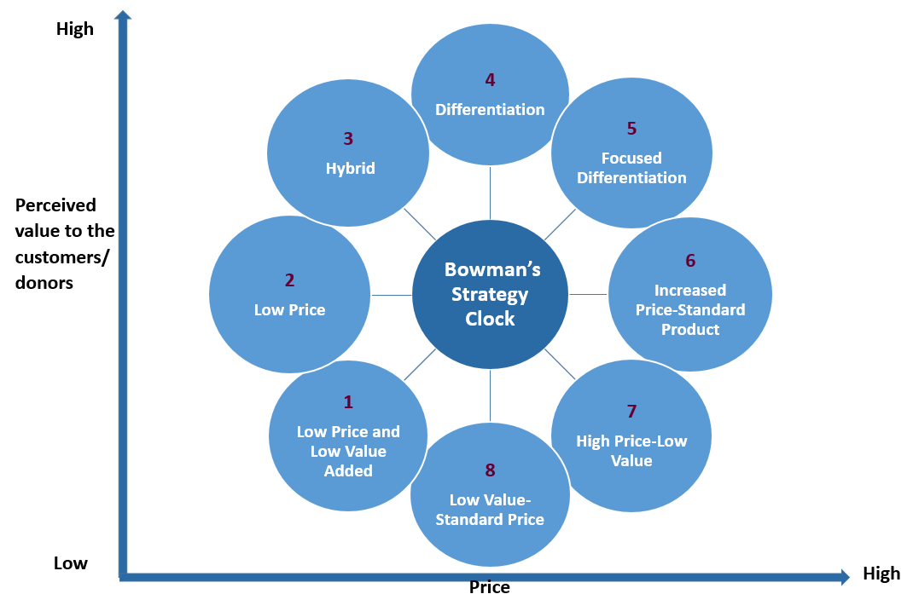
Bowman’s Strategy Clock (1997)
Table 1 - Bowman’s Strategy Clock (1997):
No. | Option | Explanation
1 | Low Price and Low Value Added | Likely to be segmented specific.
2 | Low Price | Risk of a price war and low margins/need to be a ‘cost leader
3 | Hybrid | Low-cost base and reinvestment in low price and differentiation.
4 | Differentiation | This requires a high-quality product with strong brand awareness and loyalty.
5 | Focused Differentiation | Perceived added value to a ‘particular segment’ warranting a premium price.
6 | Increased Price-Standard Product | Very short-term strategy as the opportunity to sell for a high price without justification seldom lasts long
7 | High Price-Low Value | Only feasible in a monopoly situation.
8 | Low Value-Standard Price | Loss of market share.

As with Porter’s Generic Strategies (1985), Bowman’s Strategy Clock (1997) considers a competitive advantage in relation to cost advantage or differentiation advantage. It is also an influential way of looking at how to create and sustain the organisation’s competitive position.
Competitive advantage can also be thought of as a positional advantage. Positional advantage describes a company's position in relation to the broader industry. If the company has strategic superiority to its rivals, it has a positional advantage (Bradley n.d).
In the non-profit sector, positioning to be effective must be clear, compelling and differentiated. Therefore, if we apply the strategy clock concept to the non-profit sector, then we need to find the sustainable competitive advantage by preserving what is distinct about the organisation (Porter 1985). Thus, we need to either perform different activities from rivals or perform similar activities in different ways as a result, donors will appreciate what the organisation stands for in relation to its rivals.
The main strategic direction of the UNWFP is based on differentiation, strong brand awareness and loyalty- targeting high-income donors and governments (WFP 2018). However, WFP recognised the need to focus on both value and cost (Hybrid) especially in times of crisis, where every little can make a difference. Using technology and the social media to target more people, made the shift in strategy easier and more effective (WFP 2008).
One example where the Hybrid strategy was used in an effective and unique way, is the social media campaign occurred in times of a crisis when WFP was forced to suspend food assistance to nearly 1.7 million Syrian refugees in 2014. WFP used the power of social media to launch a three-day campaign, asking members of the public to donate $1 towards food aid for Syrian Refugees. The fundraising campaign exceeded WFP expectations; surpassing its initial goal of $64 million as a result of “massive expression” of support from the public, the private sector and donor countries ( WFP 2014). The result is a value proposition that is not only effective and clear, but also allows donors to make a huge difference with a small donation, which is both differentiated and low cost.

Another tool, which can be used to evaluate the strategic direction of organisations to help them develop and sustain competitive advantage, is the Ansof’s Matrix, where we can adapt to suit the nonprofit sector.

Ansoff’s Matrix:
The Ansoff’s Matrix was developed by Igor Ansoff in 1957 to help organisations decide on their product and market growth strategy (Morrison 2016). This matrix, commonly used in commercial settings, however, it can be adapted to make it relevant to the nonprofit sector, where it might be useful to identify how the organisation can balance the payoffs and benefits of present versus future fundraising developments – fundamentally, where it should invest most time and resources to be most efficient and effective.
Adapting the matrix by turning the two key dimensions from the commercial settings (Markets and Products), into the Nonprofit fundraising setting where we can substitute parallel ideas by using (Donors and Offerings) instead.
The matrix below (Figure 2) has four choices (quadrants). Each of these choices has a specific name to describe the strategic approach within the matrix.
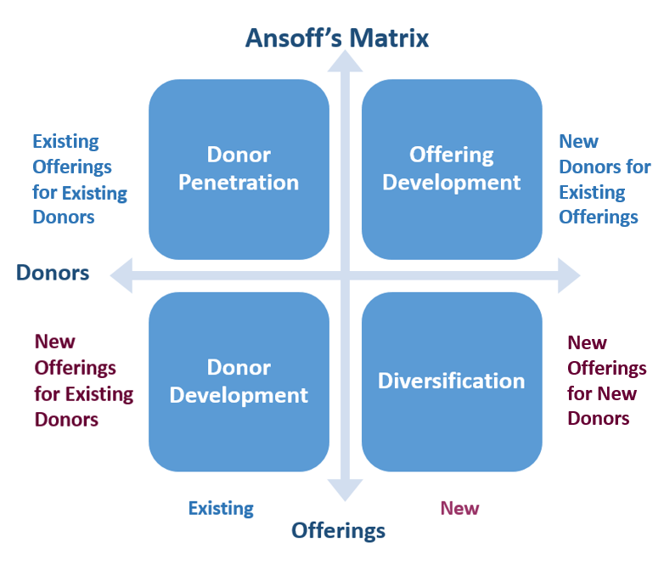
Figure 2-Adapted from Ansoff (1984)
The choices are:
- Donor Penetration: Existing Offerings for Existing Donors i.e. persuading current donors to give us more using our current fundraising techniques, this is when UNWFP decides if it should focus on donor penetration to get the results it needs. WFP focuses on retaining existing donors by having an effective relationship with donors, supporters, volunteers and employees built on trust and transparency. WFP continues to focus on activities, tools and methods of communication to spread the message and support the cause such as engaging donors in the fundraising activities using the social media, fundraising events or/and Thank- you ceremonies ( WFP 2008).

- Offering Development: New Offerings for Existing Donors i.e. developing new fundraising strategies for our existing donors, this is when WFP identifies what else its current donors might be interested in, such as developing new programs or fundraising techniques to attract and persuade our exiting donors to give more donations. For example, ShareTheMeal is a WFP smartphone app that enables users to "share their meal" with hungry children – with just a tap (WFP 2018).

- Donor Development: New Donors for Existing Offerings by establishing who else might be interested in WFP current offering i.e. persuading new donors to give using the organisation’s existing techniques or offerings – so here WFP might ask if it can find companies/ corporate partners who might commit to the foundation proposal or if an online giving currently targeted new audience. Donor development can be achieved by finding suitable partners, where WFP can develop a strategic partnership that creates synergy between both interests and goals, exchanging valuable expertise to generate impact that shifts business one step closer to Zero Hunger (WFP 2018). This can include partnering with other non-profits, NGOs, governmental institutions, civil society, academia and the private sector to scale up the funding process as WFP has always depended on establishing and maintaining sound relationships and effective partnerships to achieve its Strategic Objectives and helping the organisation to handle complex food and nutrition security challenges. WFP’s collaboration with its funding partners actively contributes to the achievement of the donor’s respective humanitarian and development goals (WFP 2018).

- Diversification: New Offerings for New Donors i.e. coming up with a new – or new to us – project with new donors – so an example here might mean using a new web approach to target new donors. Taking a risk and try some new approaches with some new donors. WFP aspires to convert supporters (potential donors) from an awareness phase to an action phase. Therefore, WFP can use technology to segment and personalize donor communications, where big data can help the organisation to see each donor in a 360-degree view (Turnali 2014). With this level of detail, it is possible to personalise messages and interactions, creating a personal donating experience to attract attention to the mission and the cause of the organisation while increasing its funding.

The Ansoff Matrix is employed by organisations in decision-making processes surrounding product (offerings) and market (donors) growth strategies. Therefore, it is used to help organisations in evaluating available options for growth given their product and market mix. Johnson et al (2008), also describes it as a method of ascertaining the benefits or risks associated with each strategic option.
WFP strategic direction is a mixture of the three first strategies, however, having a strong and reputable brand name respected by the public can be an advantage to organisations like UNWFP by encouraging them to take a risk and try some new approaches with some new donors and leveraging their brands across different markets ( donors) due to high customer loyalty (Hooley et al, 2004).
The need for organisations to expand and develop has been known to drive product and marketing innovation, which prompts organisations into adopting different strategies, based on the products (offerings) they sell and markets (donors) they target (Ansoff 1984).

The UN has adopted the classical approach to strategy by planning and analysing for a long time (UN 2015). However, the UN recognised that this traditional approach to strategy couldn’t achieve the purpose of the organisation without acknowledging the concerns of changing and complex environment where crosscutting issues are addressed by different organizations or entities. Therefore, it is necessary to supplement the UNWFP traditional approach with dynamic and adaptive capabilities to enable the organization to evolve as it adapts to the changing world environment in which WFP has to deliver its mandated services, making sure that it thrives to be innovative at each step to achieve uniqueness (Reeves 2014).
However, for the change to be successful, implementation efforts need to fit the organizational context. Therefore, using The Change Kaleidoscope (Figure 3) developed by Hope Hailey & Balogun (2002) can help leaders of the organisation to design a 'context sensitive' approach to change. It can also highlight how a set of contextual features can take various forms supporting or resisting change.

1 | Time | How fast is change needed? Is the organisation in crisis?
2 | Scope | The amount of change needed.
3 | Perseverance | The organisational resources, assets and characteristics that need to be maintained.
4 | Diversity | How homogenous are the staff groups and divisions within the organisation?
5 | Capability | Managerial and personal capability to implement change.
6 | Capacity | Change resources available.
7 | Readiness | Is the workforce ready for change?
8 | Power | The relative power the change leader in relation to other influencers on the change process.
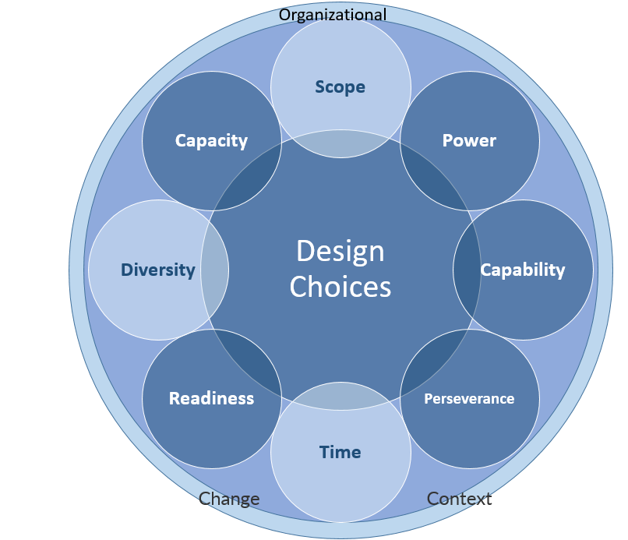
Figure 3- The Change Kaleidoscope Table 2- The Change Kaleidoscope
Hope Hailey & Balogun (2002)

To the UN, the below three aspects of the change Kaleidoscope are most relevant.
• Scope
For the UN, change is not a single event. It is instead a process that requires concerted efforts to align conflicting interests of nearly 200 stakeholders (its member states) and a large multinational bureaucracy, spread across global headquarters, five regional economic commissions, and roughly thirty field-based peacekeeping and political missions. Including UN agencies, funds, and programs in this dynamic adds another layer of complexity (WFP 2018).
• Time
For the UN, crisis presents opportunities for change. For over 50 years, the World Food Programme (WFP) has provided emergency food assistance, regularly in conflict, post-conflict or disaster situations. Therefore, in this volatile and complex environment, the WFP has learned that it needs to adapt and react quickly to emergencies and crisis (WFP 2018).
• Diversity
The UN manages a diverse workforce from more than 80 countries around the world with different cultures, values and attitudes. However, all are working together to achieve the UN System-Wide Action Plan. Therefore, for effective change, diversity needs to be embedded as a factor in all parts of the employee life cycle, from recruitment to exit (WFP 2018).
However, managing change can present so many challenges for organisations such as the UN, therefore, to succeed, established reform efforts must be supported by public officials. Though, officials may resist new systems if they challenge existing incentive structures or require officials to change their behaviour (World Bank, 2005). Failing to create a sense of urgency and win over hearts and minds will reduce impact of change programmes (Kotter, 1995). Moreover, employees at each level of the organisation must be convinced of the need to change. Success of organisational change depends equally on the reliability of the change approach as on the implementation, respect for different points of view and the degree of support from influential organisation members.

Conclusion:
In order for the United Nations World Food Programme to be strategically managed with success, it has to create an effective corporate strategy, where plans and methods are created to allow the organisation to continue to develop despite the changes in the environment. However, in the complex environment of the UN system, it is necessary to analyse, what exactly is expected of a strategic plan, what it will cover, what processes and tools will support it, and how its implementation and effective achievement will be measured and monitored. Therefore, using different tools such as the Bowman’s Strategy Clock and the Ansoff’s Matrix to evaluate the potential corporate strategic directions of the UNWFP can help us to develop and sustain our competitive position, explore new strategies for growth and measure the implications of such strategies so the organisation can implement changes effectively. However, for change to be successful, implementation efforts need to fit the organizational context. Therefore, developing a change management strategy for the organisation using new tools and methods can help managers design a 'context sensitive' approach to change. As the success of organisational change depends equally on the reliability of the change approach as on the implementation, respect for different points of view and the degree of support from influential organisation members.

Recommendations:

- Alignment is needed between each level of the strategy to achieve the purpose of the organisation. For example, the regional or county level strategies need to be aligned with the global strategy. Also, within departments and offices, WFP needs to align divisions, sections, units or teams’ strategies to the higher-level strategy, where the UN strategic planning is undertaken in departments and offices in line with the periodic budget and this planning feeds into “Strategic Framework” and “Programme Budget” documents for each department. However, WFP may need to adapt or develop strategies outside the timeframes and the parameters of the budget process.
Studies indicate that the important outcome of alignment is an enhancement of organizational, where organizations that have created a suitable alignment between the elements of their strategy have a high performance (Joshi & Porth 2003). Therefore, a direct relationship between strategic alignment and performance can be defined.

- WFP needs to continue to empower donors by rightfully thanking and praising them for their partnership, their vision, their contributions and even their friendship. However, WFP needs to harness this power for the benefit of the organisation and therefore, making sure that donor power is balanced, where they can have control over their gifts without so many restrictions/ time limits over the funds allocated for special projects or specific programmes. Therefore, WFP needs to keep the donors interested and in control as their enthusiasm is extremely important to the growth and vision of the organisation (UN 2015).

- UNWFP needs to find a sustainable competitive advantage by preserving what is distinct about the organisation. Thus, it needs to either perform different activities from rivals or perform similar activities in different ways as a result, donors will appreciate what the organisation stands for in relation to its rivals. WFP needs to focus on both value and cost (Hybrid strategy) especially in times of crisis, where every little can make a difference. Using technology and the social media to target more people can make the shift in strategy easier and more effective. In addition, having a strong brand name respected by the public can be an advantage to organisations like UNWFP, where it can encourage them to take risks and try some new approaches with some new donors (diversification) and leveraging their brands across different markets (donors) due to high customer loyalty.

- The UNWFP needs to continue to focus on developing its strategies by finding new innovative ways to engage donors, employees and volunteers, where technology can play a vital role in helping spread the message and promote the cause. In addition, WFP needs to find new opportunities for growth by creating a new funding structure and partnering with other non-profits, NGOs, governmental institutions, civil society, academia and the private sector to scale up the funding process. WFP’s collaboration with its funding partners actively contributes to the achievement of the donor’s respective humanitarian and development goals.

- It is also necessary to supplement WFP traditional approach to Strategy with dynamic and adaptive capabilities to enable the organizations to evolve as they adapt to the changing world environment in which they have to deliver their mandated services, making sure that they thrive to be innovative at each step to achieve uniqueness (Reeves 2014).

- WFP needs to focus on change leadership and implement new strategy for change in the organisation as it concerns with the visions, driving forces and processes that fuel large-scale transformation (Kotter, 2011). Therefore, the leaders of the change in the organisation need to help in transforming the workplace openly and transparently to ensure proper management in the workplace. According to Hannagan (2008), leadership change motivates and inspire people to act in a particular way to achieve specific goals.

References:
Ansoff, H. I., (1984). Implanting Strategic Management, Prentice-Hall: NJ.

Ansoff, I. H., (1957). Strategies for Diversification, Harvard Business Review, Vol. 35.

Bowman, C. and Faulkner, D. (1997) Competitive and Corporate Strategy, Irwin, London.

Boyer KK, McDermott C (1999). Strategic Consensus In Operations Strategy. J. Oper. Manag. 17:289-305.

Bradly, J., (n.d). Examples of Competitive Advantages For-Profit Organisations. [Online]. Available at: http://smallbusiness.chron.com/examples-competitive-advantages-forprofit-organizations-71431.html [Accessed: 12 May 2018]
Bryson, John M. (1995). Strategic Planning for Public and Nonprofit Organizations. Jossey-Bass.
Hannagan T., (2008) "Leadership concepts & Practices. Fifth Edition, Published by Pearson Education.

Hooley, G. J., Saunders, J. A. and Piercy, N. (2004) Marketing Strategy and Competitive Positioning, 3 rd Ed, Pearson Education: London, 622pp.

Hope Hailey V., Balogun,J., (2002), 'Devising Context Sensitive Approaches to Change: the example of Glaxo Wellcome.', Long Range Planning, 35(2), p.153-178.

Inomata, T., (2012). Strategic Planning in the United Nations System. [Online]. Available at: https://www.unjiu.org/sites/www.unjiu.org/files/jiu_document_files/products/en/reports-notes/JIU%20Products/JIU_REP_2012_12_English.pdf [Accessed: 7 May 2018]

Johnson, G., Scholes, K. and Whittington, R. (2008) Exploring corporate strategy: text & cases. 8th Ed. Pearson Education Limited.

Johnson,G., Whittington R., Scholes, K., Angwin D. and Regner, P. (2017) Exploring Strategy Text and Cases. Eleventh edition. Pearson Education Limited.

Joshi MP, Kathuria R, Porth RJ (2003). Alignment of strategic priorities and performance: an integration of operations and strategic management perspectives. J. Oper. Manag. 21(3):352-369.
Joshi MP., Kathuria R., Porth RJ., (2003). Alignment of Strategic Priorities and Performance: an integration of operations and strategic management perspectives. J. Oper. Manag. 21(3):352-369.

Kotter, J. P. (1995). Leading change: Why transformation efforts fail. Harvard Business Review, March-April, 1-10.

Kotter, J.P., (2011). Change Management vs. Change Leadership -- What's the Difference? [Online]. Available at: https://www.forbes.com/sites/johnkotter/2011/07/12/change-management-vs-change-leadership-whats-the-difference/ [Accessed: 16 June 2018]

Morrison, M., (2016). Ansoff’s Matrix Product V Market Grid. [Online].Available at: https://rapidbi.com/ansoff-matrix-product-v-market-grid/ [Accessed: 12 June 2017]

Nordmeyer, B. (2017). “Why is corporate strategy important” [online]. Available at https://bizfluent.com/info-7959300-corporate-strategy-important.html [Accessed: 20 June 2018]
Porter, M. (2008). What strategy is. Leaders in London Summit [Online]. Available at: https://www.youtube.com/watch?v=0BgMQkKMKaE [Accessed: 7 May 2018]

Porter, Michael E., "Competitive Advantage". 1985, Ch. 1, pp 11-15. The Free Press. New York.

Reeves, M., (2014). “Your strategy needs a strategy”, Ted. [Online].Available at: https://www.ted.com/talks/martin_reeves_your_strategy_needs_a_strategy [Accessed: 18 May 2018]

Sinclair, C., (2017), Focus on your Nonprofit’s Unique Differentiation. [Online]. Available at: https://www.nonprofitkinect.org/article/10688-focus-on-your-nonprofit-s-unique-differentiation[Accessed: 7 May 2018]

The World Bank (2005). Staff Incentives and Project Implementation: Lessons from e-government, Public Sector Prem Notes, no. 101. [Online]. Available at: http://www1.worldbank.org/prem/PREMNotes/premnote101.pdf [Accessed: 16 June 2018]

Turnali K., (2014). Using Customer Data for Informed Marketing Decisions. (Online). Available at: http://www.iacquire.com/blog/using-customer-data-for-informed-marketing-decisions (Accessed: 20 June 2017).

UN (2015). UN Strategic Planning Guide For Managers. [Online]. Available at: https://hr.un.org/sites/hr.un.org/files/4.5.1.6_Strategic%20Planning%20Guide_0.pdf [Accessed: 7 May 2018]
Weaver, J., (2018), Levels of Strategy. Clear Point Strategy. [Online]. Available at: https://www.clearpointstrategy.com/levels-of-strategy/#1 [Accessed: 18 May 2018]

WFP (2004). WFP Mission Statement. [Online]. Available at: https://documents.wfp.org/stellent/groups/public/documents/newsroom/wfp076289.pdf [Accessed: 7 May 2018]

WFP (2008), WFP Communications Strategy. [Online]. Available at: http://one.wfp.org/eb/docs/2008/wfp176667~1.pdf[Accessed: 12 May 2017]

WFP (2014). For 64 Million People, It's A Dollar, For 1.7 Million Syrian Refugees It's A Lifeline. [Online]. Available at: https://www.wfp.org/news/news-release/64-million-people-its-dollar-17-million-syrian-refugees-its-lifeline [Accessed: 11 May 2017]

WFP (2018). Innovation- World Food Programme. [Online]. Available at: http://innovation.wfp.org/projects [Accessed: 12 June 2018]

WFP (2018). The World Programme Website. [Online]. Available at: http://www1.wfp.org[Accessed: 7 May 2018]

Zenker, P., (2018). SWOT or SOAR, Which Is Better? [Online]. Available at: http://tugofwarwithtime.com/swot-or-soar-which-is-better/[Accessed: 2 June 2018]

