GEMECHU ALIYI (2117285)
LEARNING IN DIGITAL ERA
(REFLECTIVE REPORT)
UNIVERSITY OF WALES TRINITY SAINT DAVID
[Course title]
TUTOR – CHRISTIAN FELICES
Contents
INTRODUCTION 2
GIBBS’ REFLECTIVE CYCLE 2
DESCRIPTION 3
FEELING’S 3
EVALUTION 3
ANALYSIS 3
CONCLUSION 4

INTRODUCTION
In order to achieve and sustain competency throughout the course of learning in the digital era, self-reflection is a critical part of acquiring knowledge from situations. Despite the lack of concrete evidence from the literature connecting reflective practise to competences, professional associations and governmental authorities mandate that it be a component of work. The reader's understanding of reflection as well as its use will be updated by this essay. By including elements of an educational tradition of self-cultivation, it will demonstrate the value of reflection and help the reader employ common reflecting models of Gibbs (“Description, feeling, abstract, Evaluation, Analysis, conclusion, and action plan”) to foster greater levels of knowledge. To demonstrate how the ideas covered in this article can be implemented in practise, an example situation will be used. The justification for using reflection in professional practise has been covered in this reflective report. (CHAPMAN, 2013)

GIBBS’ REFLECTIVE CYCLE
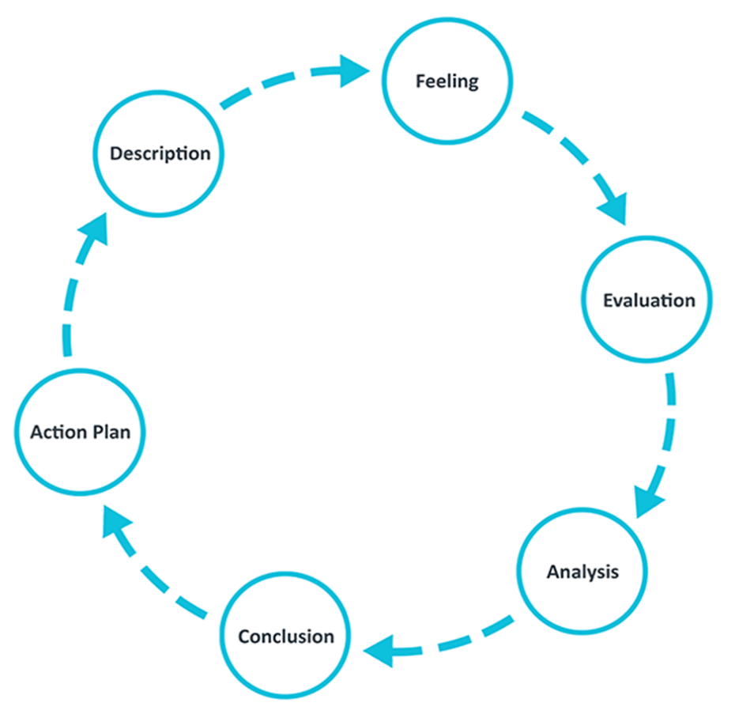
Graham Gibbs developed the Gibbs-Reflective Cycle in 1988 to offer learning from experiences structure. It offers a tool for assessing events, and because it is cyclical, it is especially suited to recurrent interactions. Making strategies for the future is made possible by being able to learn from both positive and negative endeavours. Covered are six steps.
Gibbs’ reflective cycle
GIBCYLE
Description
I am reflecting upon the Assessment Day which offered me a clear insight of what placements require when
applying, and the focal points which were group tasks and presentations
Blog 3 – A Reflection on Assessment Day 1 (Gibbs Reflective Cycle)
Description
I am reflecting upon the Assessment Day which offered me a clear insight of what placements require when
applying, and the focal points which were group tasks and present

DESCRIPTION
I am remembering the assignment session, which offered me a strong sense of what was expected of candidates for coursework and consisted primarily of team tasks and presentations. I already gave a presentation; therefore, I used my acting abilities. in spite of the acting, I put a lot of time into preparing it the way I have seen others put their presentations together. My colleague's presentation at the most recent team meeting went well; she used PowerPoint, so I chose to utilise it as well. I made the decision that having all the information someone would need and doing thorough planning are the keys to a successful presentation, so I invested a lot of time in the preparing and walked into the presentation with confidence.
Blog 3 – A Reflection on Assessment Day 1 (Gibbs Reflective Cycle)
Description
I am reflecting upon the Assessment Day which offered me a clear insight of what placements require when
applying, and the focal points which were group tasks and presentations
Blog 3 – A Reflection on Assessment Day 1 (Gibbs Reflective Cycle)
Description
I am reflecting upon the Assessment Day which offered me a clear insight of what placements require when
applying, and the focal points which were group tasks and presentations

FEELING’S
when I noticed that everyone was waiting for me to talk, my voice began to tremble from anxiety. I had no idea how to put a stop to it. I soon became aware that without the PowerPoint, folks did not appear to recognize what I was speaking. By using PowerPoint, I ensured that my audience understood both what I was speaking and the information on the prepared slides. In a way, this meant they heard it two times, but I noticed Dear Melanie repeating parts of my words repeatedly and occasionally filling in for me when I was unable to. I was uneasy about this. I was irritated because I thought it was extremely patronising. Thereafter, my co-workers told me that she usually does that. I was upset that my presentation did not appear to have gone well. I experienced a range of feelings during the final presentation, particularly emotional agony and resentment at the individuals from my group who did not attend. My heart rate started to increase along with the tense energy because there was not adequate individual thoughts or commitment. At this time, my negative thoughts overcame me because of the poor contributions, and I lost the courage to speak out. While there was still a worry concerning discomfort when I used hand movements, my strength was the quick awareness that I am in control. I thought that if individuals became inactive, my hands would act as a barrier to keep me safe. I assumed control as the dominant participant and encouraged others to share their thoughts and feelings around the Next Sales. Even if there was not a full collective effort, I believe that my happy attitude contributed to creating a nice atmosphere.

EVALUTION
My team was enthusiastic and complimented me for acting as the representative; this made me feel valued and like the group recognised my efforts. Self-disappointment was a shortcoming; I lacked the courage to talk about my ineffectiveness and lack of personal responsibility. I regret forcing myself to collaborate with those I did not believe were capable of the job in the past. I have learned from this situation that I need to focus on increasing my confidence.

ANALYSIS
My own experience supports the social loafing theory, according to which motivation wanes when working alone rather than in a group to accomplish a task. The fact that I was given more responsibility led me to believe that the bad outweighed the good. After considering the situation, my skills act as role models, openness, and patience. In addition, I believe that one outcome of my feelings could be that we lost an effective leadership to monitor and evaluate progress, which diminished my individual actions in the latter stages. It emphasises the nature of experience-based learning and the significance of fusing propositional knowledge with specialised expertise and individualised knowledge. To progress my craft and deliver higher levels of service, I must build critical reflection abilities as I go from being novices to experts.

CONCLUSION
I will handle stress in the future in a non-defensive and open way rather than making excuses by revealing all of my beliefs. I might pay more attention to my surroundings and incorporate the opinions of classmates who do not add anything to the group's satisfaction. Furthermore, I must begin by considering the steps involved in making a strong presentation. My confidence on my acting abilities may not have been all that useful. Acting made my voice stronger and faster, but I was not simply trying to say someone else's lines; I had my own, and I wanted to be able to go into more detail rather than just say the line. (UNIVERSITY, 2018/2019)
ACTION- PLAN
I need to work on increasing my self-confidence in the future, therefore I must set SMART goals. Example, I will concentrate on advantageous outcomes and activities. I will learn how to use emotional self-regulation, a technique that identifies my attitudes, emotions, and behaviours and transforms my action drive into meaningful action, in order to avoid experiencing unpleasant emotions. After contemplating the presentation for a few days, I discussed it with Dear Melanie. She provided me a list of things to work on for the next time. They included dialling back the PowerPoint presentation, speaking more slowly, and finding a way to relax. For the figures to be more easily understood, I also need to rewrite them. She advised me to give a presentation to a few team members perhaps next week so I can get better at what I do. It seems to me as I write this how helpful it is to review earlier writings on the subject. I had the ability to see things differently, it seems. When I first wrote this, I believed the presentation to be terrible and that there was nothing I could have done to make it better. I later came to understand that there were things I was not aware of at the time. Additionally, I am aware of some of my mistakes. I was blind to that at the time. Like my low self-worth got in the way. Realizing where I went so wrong and admitting my mistakes to myself offers me the ability to do better the next time - and maybe even help. (R.GORDIN, 2004)
CONCLUSION
The justification for using reflection in professional practise has been covered in this reflective report. It emphasises the nature of experience-based learning and the significance of fusing propositional knowledge with specialised expertise and individualised knowledge. To progress my craft and deliver higher levels of service, I must build critical reflection abilities as I go from being novices to experts.

REFERENCES

cardiffmet, n.d. [Online]
Available at: https://study.cardiffmet.ac.uk/AcSkills/Documents/Guides/AS_Guide_Reflective_writing_Kolb.pdf
CHAPMAN, J., 2013. Enhancing skills of critical reflection to evidence learning in professional practice. SCIENCE DIRECT, AUGUST.Volume VOL 14.
R.GORDIN, P., 2004. SPRINGER LINK. [Online]
Available at: https://link.springer.com/article/10.1023/B:COTR.0000045557.15923.96
UNIVERSITY, S. H., 2018/2019. STUDOCU. [Online]
Available at: https://www.studocu.com/en-gb/document/sheffield-hallam-university/understanding-and-managing-financial-roles/blog-3-a-reflection-on-assessment-day-1-gibbs-reflective-cycle/1672009

