

Academic Discipline of Hospitality and Tourism Management

BMIH6007
International Meetings Management for the Hotel Industry

Student Name: Alexandra Adriana Popa
Student ID: 2133013
Table of Contents
Slide 1- Assignment Title 3
Slide 2- Content 3
Slide 3- Introduction 4
Slide 4- Market considerations 5
Slide 5 -Operational factors 6
Slide 6-Budgetary considerations 7
Slide7- Expenditure 8
Slide 8- Conclusion 9
References 10

Slide 1- Assignment Title
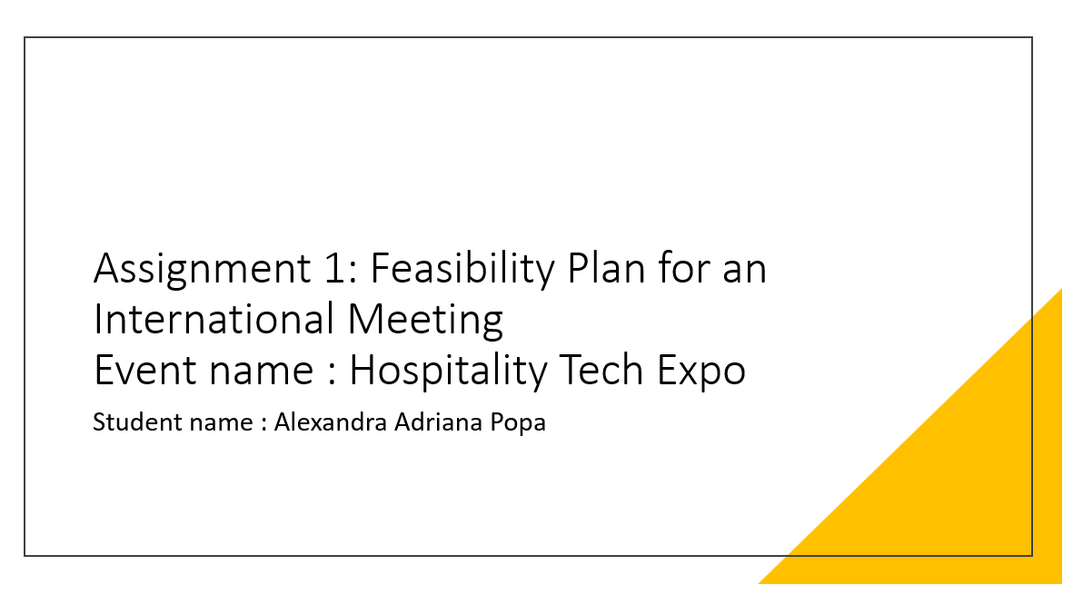

Slide 2- Content

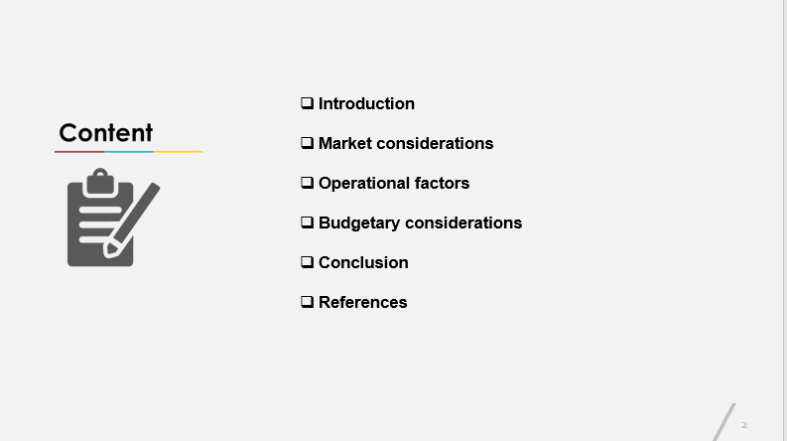

Slide 3- Introduction
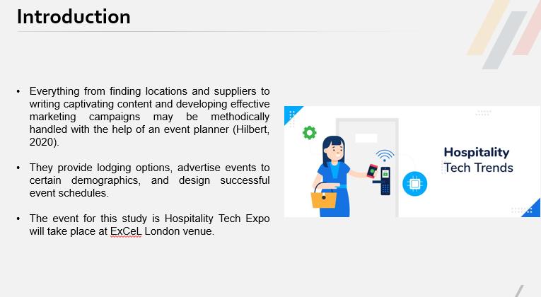
Everything from finding locations and suppliers to writing captivating content and developing effective marketing campaigns may be methodically handled with the help of an event planner (Hilbert, 2020). They provide lodging options, advertise events to certain demographics, and design successful event schedules. Now, the event for this study is Hospitality Tech Expo, which highlights the latest technological advancements and innovations that are being used within the hotel industry which will take place at ExCeL London venue. Now, this report focuses on the analysis of target markets, demand, supply, competition of the event, venue availability, suitable reason for the event, staff required skills, required resources including catering, lighting, parking facilities, seating, and an income and expenditure table.

Slide 4- Market considerations
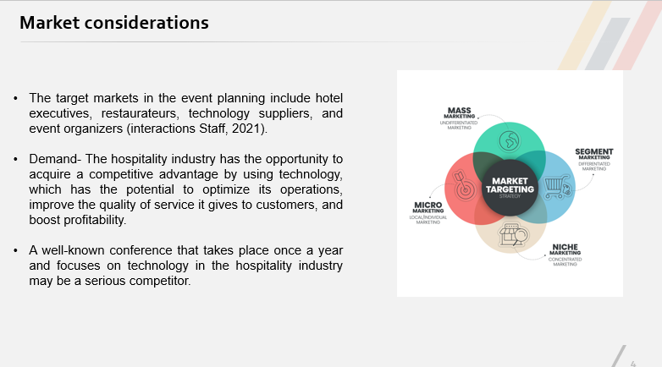
There are many facets to tech expo hospitality marketing, such as advertising before the event, creating a booth, interacting with attendees at the event, and finally, evaluating and following up after the event (Lockyer, 2021). So, the target markets in the event planning include hotel executives, restaurateurs, technology suppliers, and event organizers (Joliot, 2023). It is also possible that those working in the tourism industry, the information technology industry, and the hotel industry might be interested. Demand- The hospitality industry has the opportunity to acquire a competitive advantage by using technology, which has the potential to optimize its operations, improve the quality of service it gives to customers, and boost profitability (Oskam & Zandberg, 2019). Additionally, advancements in technology make it feasible to make choices based on data and make it possible to obtain overall efficiency benefits by providing beneficial insights (Molina-Castillo et al., 2023). This suggests that there is a substantial degree of interest in attending an event that will include cutting-edge technology by a considerable quantity of people. The year 2024 is shaping up to be just like any other, with AI continuing to advance, immersive events becoming more popular, and inclusion and sustainability taking center stage (Festa et al., 2020). Similarly, virtual components are included in 45% of the platform's event programming. Supply- The "Hospitality Tech Expo" can attract a more specialized audience that is interested in the hospitality industry by exhibiting technologies and offer wide variety of solutions (O'Toole, 2022). Although digital solutions are seldom the focus of their own dedicated show space. This is in addition to the fact that it provides a more complete choice of solutions. Competition- In addition, there will be a great number of other events that will focus on hospitality technology or disciplines that are linked to it, providing the Hospitality Tech Expo with strong competition. A well-known conference that takes place once a year and focuses on technology in the hospitality industry may be a serious competitor (Pirnar, 2020). This is particularly true if the conference has a full program, reliable attendance, and an outstanding reputation. The more general technology expo might be considered an additional rival that draws in the target audience while also reducing the amount of participation from those who are looking to concentrate on the hospitality industry (Ramanujan, 2022).

Slide 5 -Operational factors
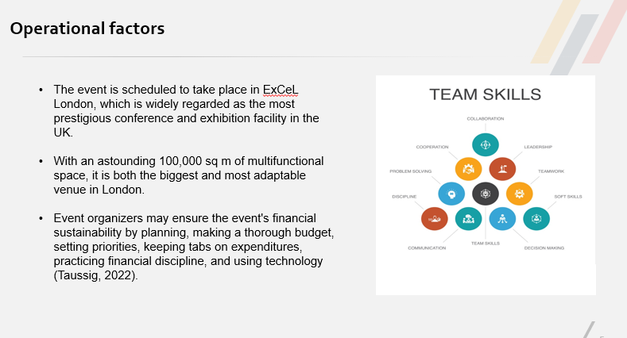
The event is scheduled to take place in ExCeL London, which is widely regarded as the most prestigious conference and exhibition facility in the UK. Due to the many benefits that this location offers, it may be an appropriate choice for the Hospitality Tech Expo event. Additionally, the event will be held over two days, beginning on May 12 and ending on May 13, and the site is accessible for reservations. With an astounding 100,000 sq m of multifunctional space, it is both the biggest and most adaptable venue in London. To host events with a high number of guests, the venue has two huge halls, two conference centers, forty-five meeting rooms, and the largest, most versatile auditorium in the United Kingdom. Again, visitors will have no problem reaching ExCeL because of its prime location, proximity to London City Airport, and plenty of public transport choices. The event staff will require a wide range of capabilities to make the event successful without any hitch. When it comes to planning for and managing an event from the beginning to the end, having the ability to manage projects is essential as it allows one to deal with pressure and ensures that everything goes off without a hitch. Any competent Event Logistics Coordinator would have mastered the art of logistics coordination. Locating an appropriate location, coordinating transportation, and keeping costs in check are all parts of event preparation. Event organizers may ensure the event's financial sustainability by planning, making a thorough budget, setting priorities, keeping tabs on expenditures, practicing financial discipline, and using technology (Taussig, 2022). Effective problem-solving skills are essential for event planners. Everyone on the event crew is familiar with the myriad of little and large problems that might arise and threaten to disrupt an event's implementation (Curran, 2021). By using their problem-solving skills, they can perhaps discover a way to mitigate the negative effects in no time. For the event to be a success, certain resources are going to be needed. The success or failure of an event is directly related to the catering services, which are vital for several reasons (Wrathall & Steriopoulos, 2022). At the Hospitality Tech Expo, event caterers create menus, research possible alternatives (such as breakfast buffets, coffee breaks, lunch packages, and cocktail receptions), and then prepare, distribute, and serve the food. The venue must have lighting resources to highlight the capabilities of its technology and make the ambiance more aesthetic. Parking facilities are important at the site and will have a direct impact on the success of the event, the guests' experience, and the promotion of environmentally conscious travel choices. It will be necessary to provide suitable seating arrangements at the venue to promote active participation from all of the attendees.

Slide 6-Budgetary considerations
Here is the breakdown of the revenue streams
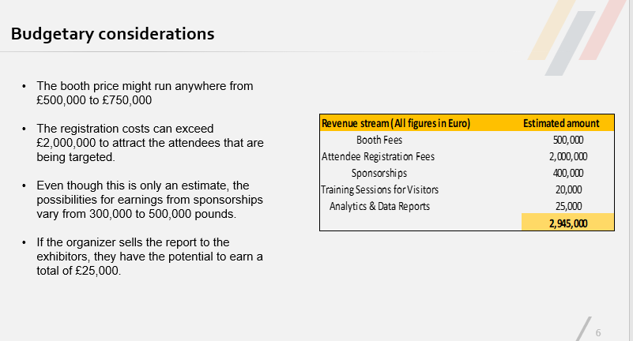
The booth price might run anywhere from £500,000 to £750,000, depending on criteria such as the size of the booth, its location, and the amenities available as the ideal number of guests would be 10,000. The registration costs can exceed £2,000,000 to attract the attendees that are being targeted. Even though this is only an estimate, the possibilities for earnings from sponsorships vary from 300,000 to 500,000 pounds. Pre-event workshops on topics such as navigating the show or utilizing hospitality technologies may potentially bring in an estimated twenty thousand pounds for the organizer. If the organizer sells the report to the exhibitors, they have the potential to earn a total of £25,000. Now, the total revenue stream is £2,945,000.

Slide7- Expenditure
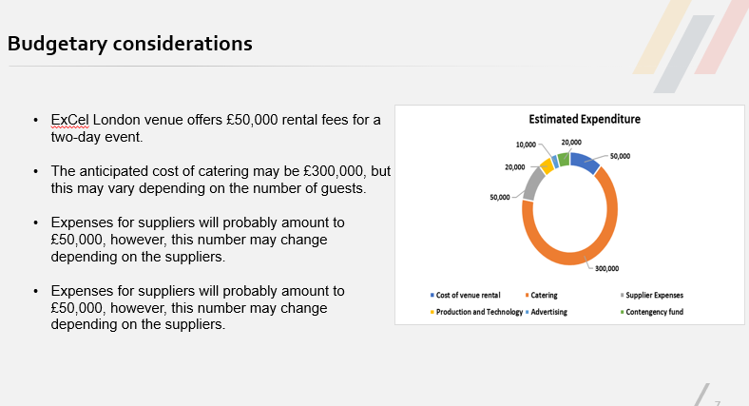
ExCel London venue offers £50,000 rental fees for a two-day event. The anticipated cost of catering may be £300,000, but this may vary depending on the number of guests, the menu that they choose, and the style of service. Expenses for suppliers will probably amount to £50,000, however, this number may change depending on the suppliers. The expenditure for manufacturing and technology might exceed £20,000, according to what is required. This amount accounts for costs like lighting, audiovisual equipment, internet upgrades, and technical help, among other things. Approximately, around £10,000 is used as a part of marketing strategy. On top of that, there is a reserve fund of around £20,000 for dealing with unforeseen expenditures and the total expenditure is £450,000. Because of the financial potential of the account, it makes the event even more feasible.

Slide 8- Conclusion
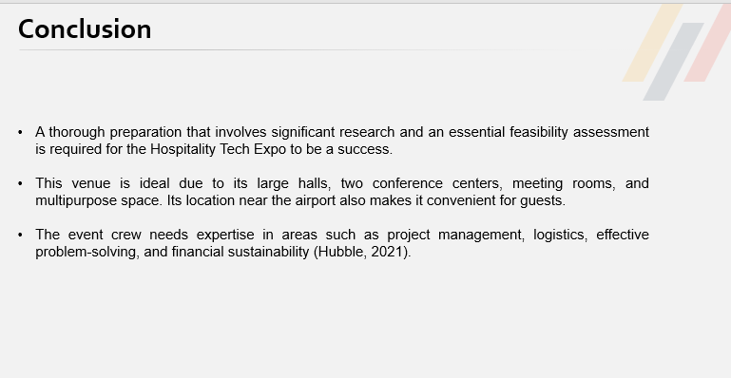
A thorough preparation that involves significant research and an essential feasibility assessment is required for the Hospitality Tech Expo to be a success. The Hospitality Tech Expo aims to attract a wide variety of individuals, including but not limited to hotel management, restaurant owners, owners of technology providers, and event planners (Moseley, 2022). The need for this event is high for several reasons, two of which are the requirement of doing market research and the advancement of technology. The Hospitality Tech Expo, which shows a range of technologies, is another opportunity. The Hospitality Tech Conference has some competitors including regional webinars and online forums, that might discourage attendance. The next two days, May 12th and 13th, the event will be held in ExCeL London. This venue is ideal due to its large halls, two conference centers, meeting rooms, and multipurpose space. Its location near the airport also makes it convenient for guests. Now more than ever, the event crew needs expertise in areas such as project management, logistics, effective problem-solving, and financial sustainability (Hubble, 2021). Catering, lighting, parking facilities, and seating resources are all things that the organizer needs to ensure that the event goes off without a hitch throughout its execution. Now, the revenue stream is estimated at £2,945,000 and the expenditure is estimated at £450,000. And, the account is profitable for 10,000 attendees.

References




