Student Name: Ashleigh Simons

Student Number: 2003948

Course Name: Computing

Module Name: L4 – Introduction to Web and Database Concepts

Contents

Page 3 – Introduction Page

Page 4 – Requirements

Page 5 - 8 – Web Page Designs

Page 9 - 15 – Implementation

Page 16 - 17 – Evaluation

Page 18 - 19 – Reference List

Introduction Page

Within this assignment I will be completing two tasks the first being documentation and creation of a hand-coded website. This will involve me creating a responsive website with a reasonable amount of relevant and related pages. The second task will involve creating a report of the created website and designs made. Throughout this I will outline the requirements, purpose, subject matter, and target audience of the website. Next, I will show all the screenshots of the created webpages and then I will be validating the HTML and CSS that I create to show any errors that I have made and how I have fixed the errors that I find. Finally, I will be evaluating my website looking at the website’s usability, accessibility, and search engine optimization.

Requirements
Website
Within this report I need to design and create a website that promotes a personal interest or hobby or organisation of my choice. For this, I will be choosing the first option and choosing to make a website for American rapper, singer, songwriter Austin Richard Post, ‘Post Malone’.
Purpose
The purpose of this website will be to give fans and listeners of Post Malone a hub to have everything they would need. It will include areas for the users to buy Products and Merchandise, find out Information on Post Malone and News about Tour Dates and Events, and other areas to give fans a website they can use effectively for everything they might want to get around Post Malone.
Subject Matter
The Products that will be on this website will be Records/ CDs and Web Links to his albums and music. Merchandise and apparel with several different options of clothing and prices. Furthermore, Concerts and Tour Dates of future events. Links to social media accounts for fans to stay up to date with Post Malone.
Target Audience
The target audience of this website will be Adults and young adults including teenagers (15-35), music lovers and people who are interested in the American rapper. Also, people who are interested in attending concerts / festivals that Post Malone will be performing at or attending. It will be created for the users that want to purchase products or merchandise so any users who are also looking for that are part of the target audience for this website.

Web Page Designs
Wireframes
To create wireframes for each of my pages I will be using Microsoft PowerPoint and the various shapes to give a concept of how the website will look when it is being created and the types of content that will be included. As these are just wireframes, they do not contain any colour or design that the user will see just the layout.
Page 1 – Homepage

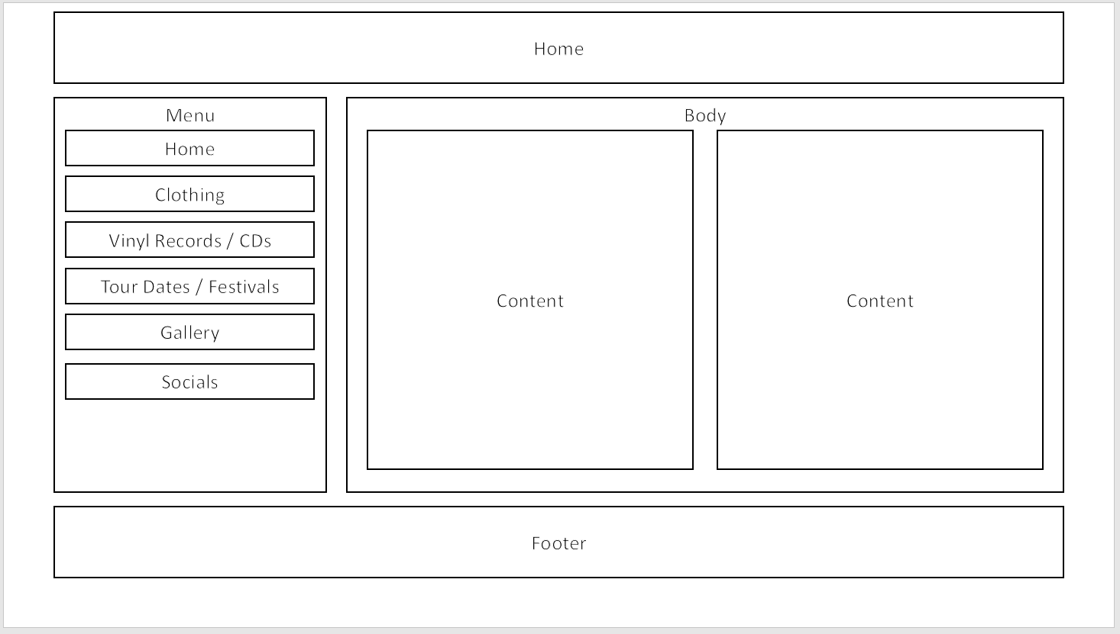

Clothing

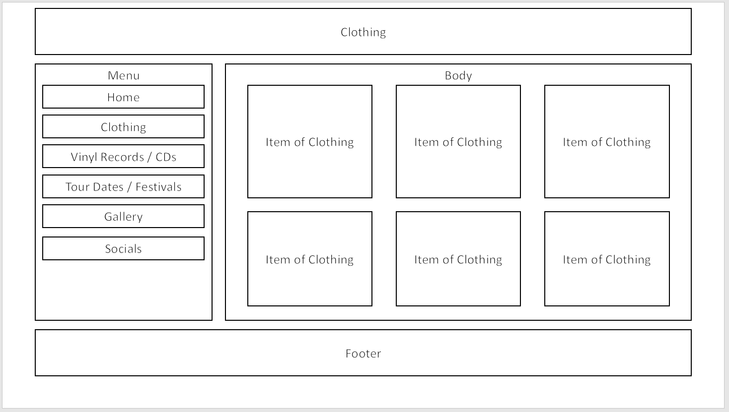

Vinyl Records / CDs
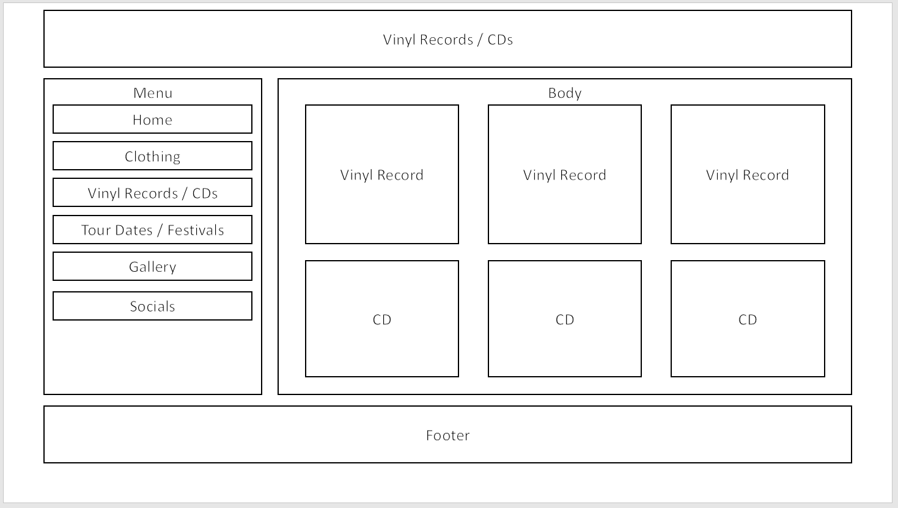

Tour Dates / Festivals
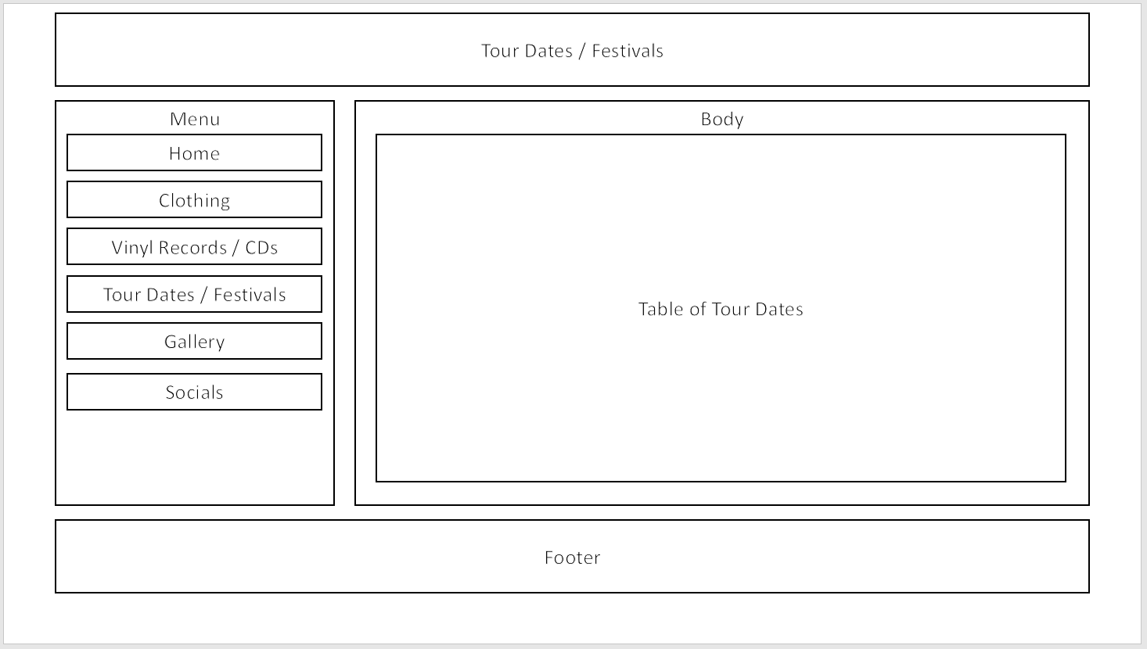

Gallery
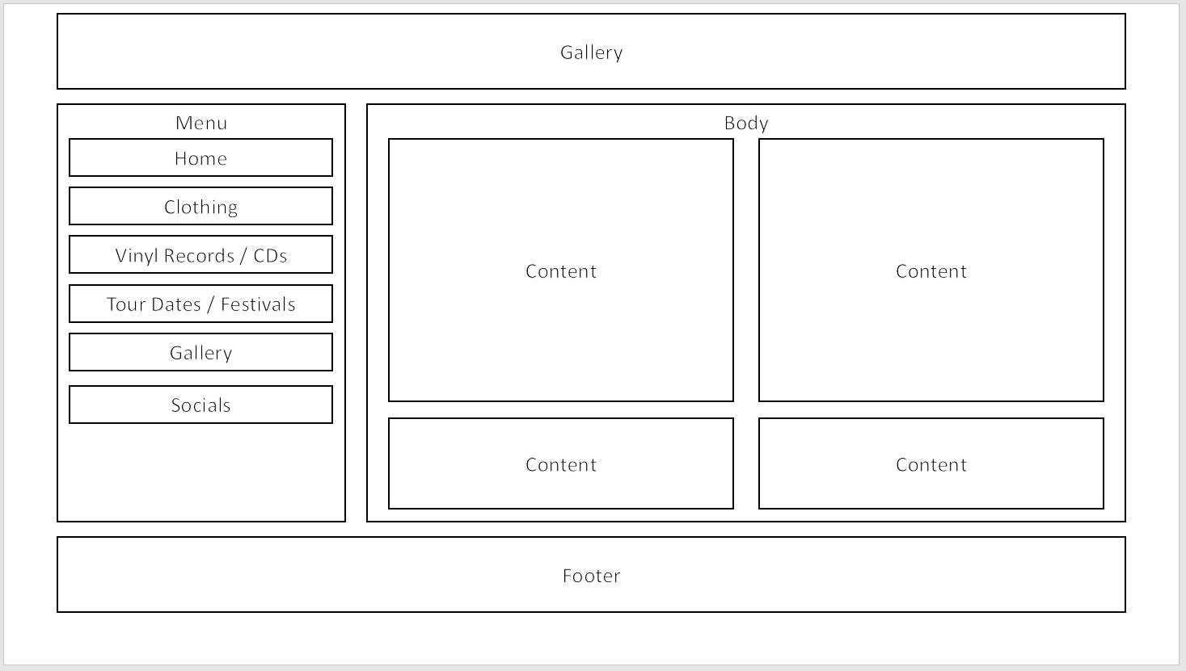

Socials
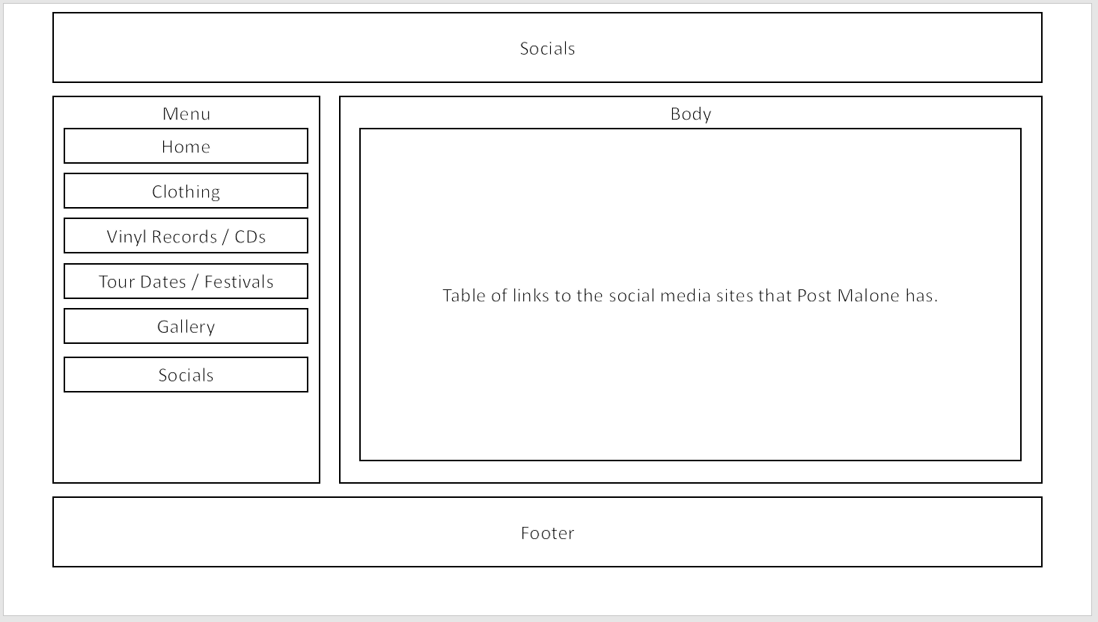

Font Styles
To choose a font that will benefit this website and suit the design I am going for I want to make sure that the font use is web safe. Using a web safe font means that it is “a font universally installed across all devices.” [1] This means that as the devices that the user will have will already have the font installed it will be better for the website. This also means that the website “should load faster” [2] using a font like this and it will benefit the users experience on the website. As this is the case I will use Arial, Times, and Helvetica. These three fonts are all web safe and will also give the website a good appearance. They will also do the purpose effectively as they are very readable and clear helping any users who have impaired vision.

Colour Scheme
For the colour scheme of this website I would like to stay consistent with the colours that Post Malone has used previously within album covers, merchandise and Vinyl Records as this will keep consistency with the artists brand and style, having colours that are also familiar to his fans will make it easier for them to distinguish this website as legitimate and trustworthy as it looks more professional. To find out these colours I will research colours previously used and select the ones that I think would look fitting on the website.
The colours that I have found and going to use are #EC5840 which is close to a light salmon colour, #1E1F23 which is a dark navy colour, #FFFFFF and #000000 which are black and white, #CCCCCC which is a light grey colour. The websites that I chose were “postmalone.com” [3], “shop.postmalone.com” [4] and “shop.postmalone.com/collections/tee” [5] as these are all official websites and have used these colours that I have selected from these websites.
Platforms
The website that I intend on creating should be able to be viewed on PC browsers and mobile devices, from what I can see on the brief this is not specifically required however having features to make the website work on both mobile and on PC will give better accessibility to more users and make the website better. To be able to do this I would like to create the layout using floats so that the layout of the website can change and resize to what the user sees on their screen or device.
Accessibility
To make my website more accessible I will be making sure to use alt tags where sensible and text font sizes that are suitable for the target audience of this website. Also, the colours used will be focused on making sure that users with visual impairments can distinguish the colour differences and understand text and view images on the website. If the website does not have these then it will be accessible to less users and reduce the impact of the website so getting these right as much as I can, as this will lead to a better outcome for accessibility.
Images for the Website
For the pictures and images on the website I will use images that are free to be used from websites such as ‘https://unsplash.com’ and ‘ https://www.shutterstock.com/ ’. These websites have several users that upload photos that can be used freely without royalties. Also, some of the images will be of my own creation too. The images selected will be cropped and be compressed for the web so that they do not take as long to load for the user making the website more usable.

Implementation
Screen Shots of Pages
About PostMalone.com Page
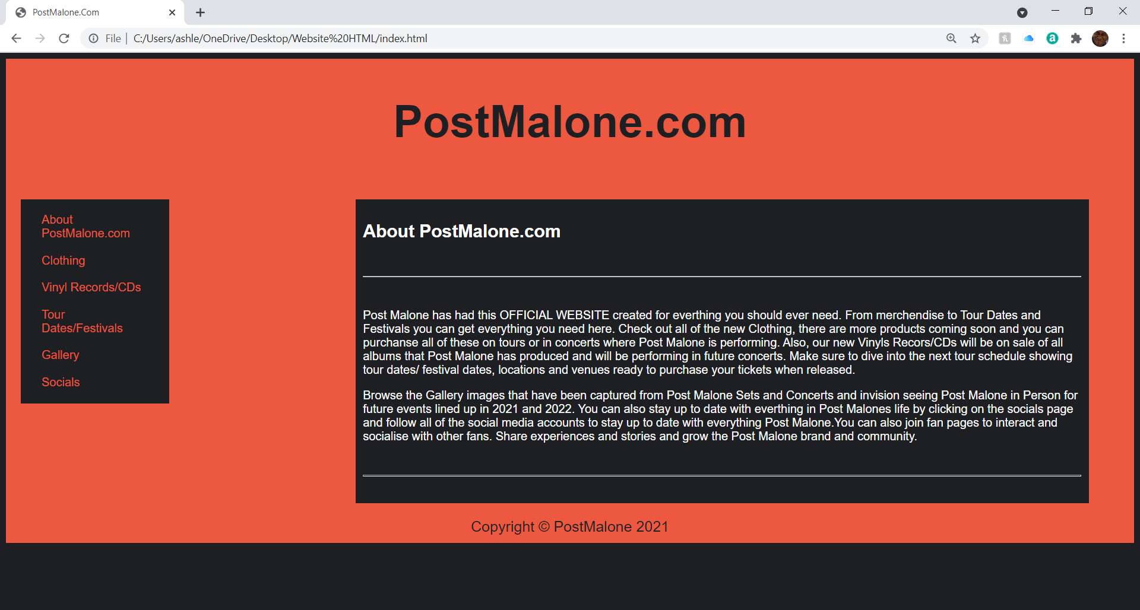

Clothing Page
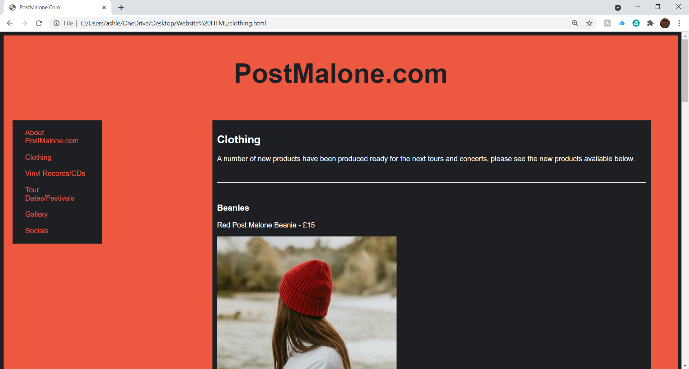

Vinyl Records/CDs Page
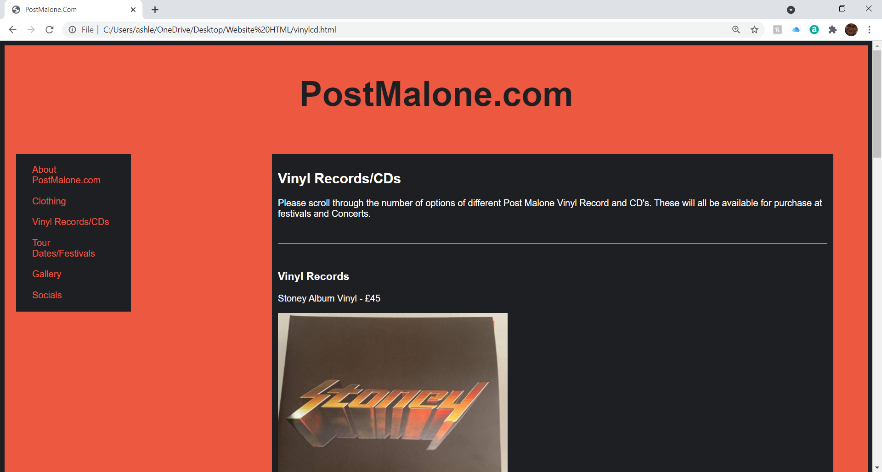
Tour Dates/Festivals Page
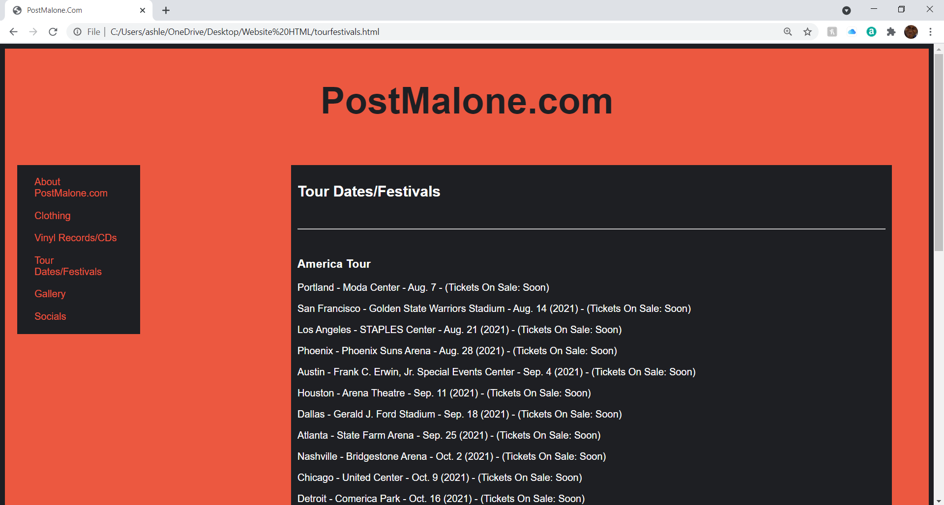

Gallery Page
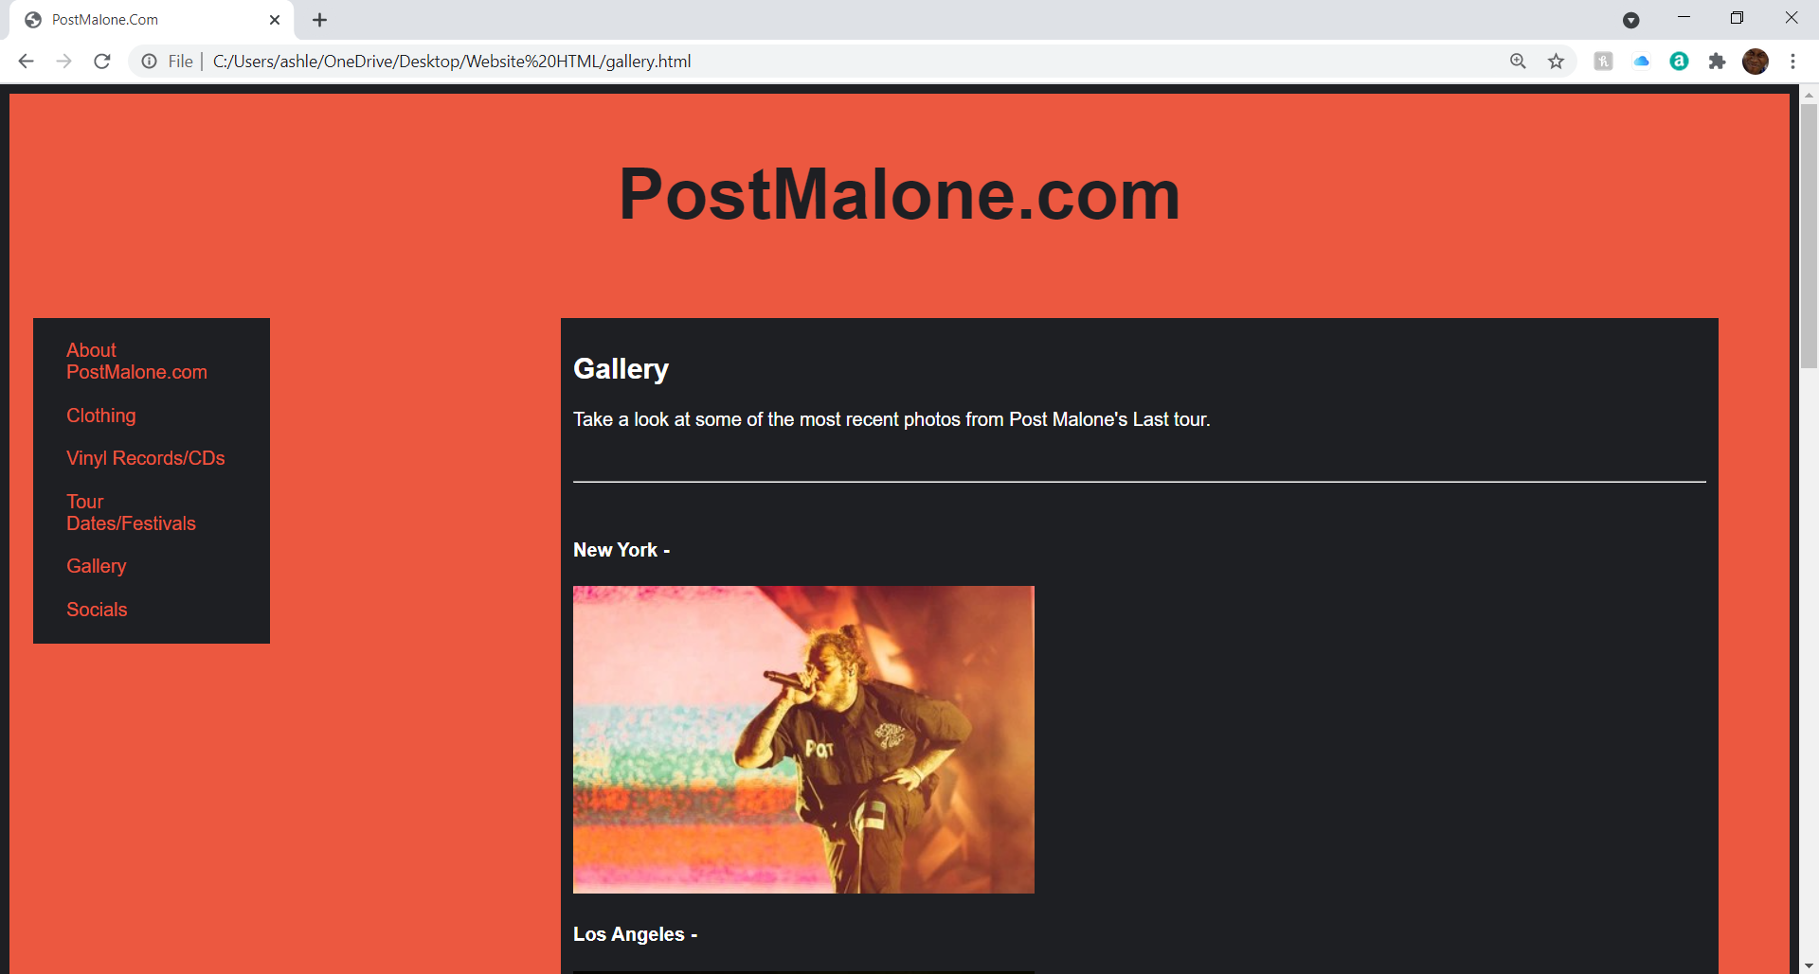
Socials Page
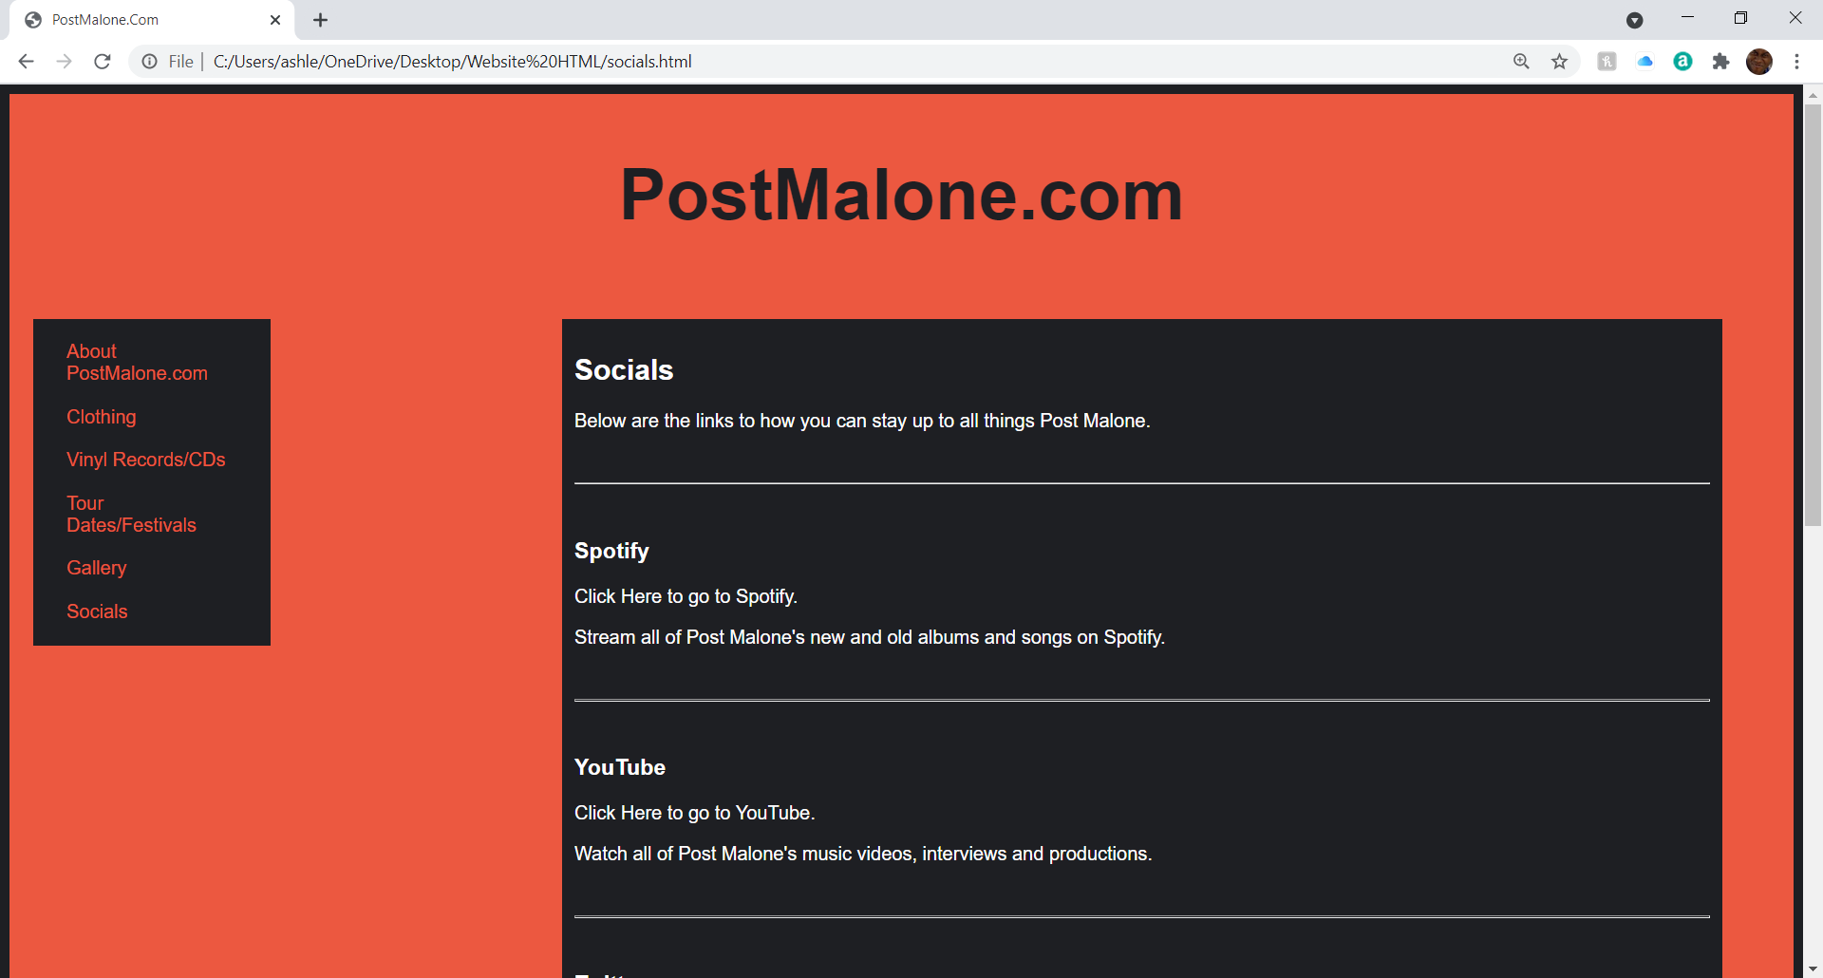

I understand that the webpages do not look completely as planned or designed completely and this is down to me developing ideas whilst creating the website and not being able to fully create what I envisioned with the wireframe designs. If I had a longer time frame and a better understanding I would like to create the website into what was planned and designed.

Validation
To Validate my html, I will use an online validator created by “w3.org” [6] as it allows me to copy the html I have created and get instant validation about my html. I will do this for every individual page.
About PostMalone.com Page
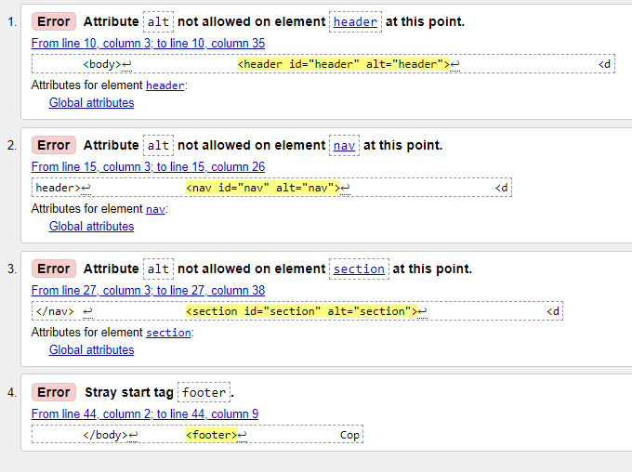
Changes Made - I have removed the alt tags attributes from each of the elements as it is not required now. I have also now put the footer within the body as this was not in the correct place, there was also an id missing so I have added this to the footer as well. After the changes I then checked the html again and the following appeared.
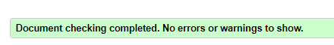
Clothing Page
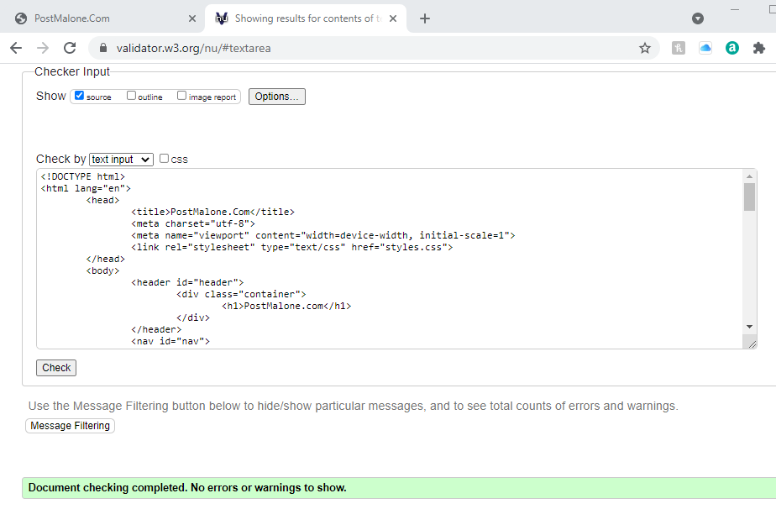
Changes Made - There was no new changes that had to be made, the same issue with the footer and alt tags however no new errors or warnings.

Vinyl Records/CDs Page
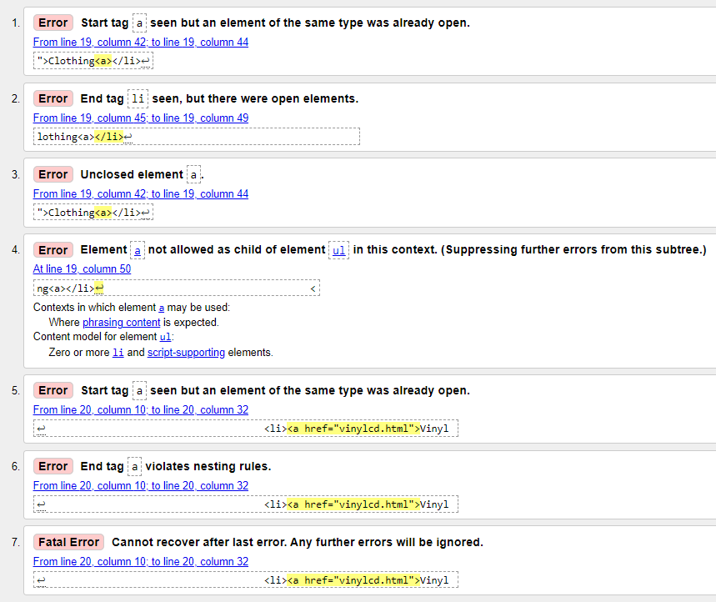
Changes Made - I forgot to have a closing ‘</a>’ and left it as ‘<a>’ instead, I have now fixed that and the following messaged appeared when I re-validated the html.
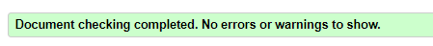
Tour Dates/Festivals Page
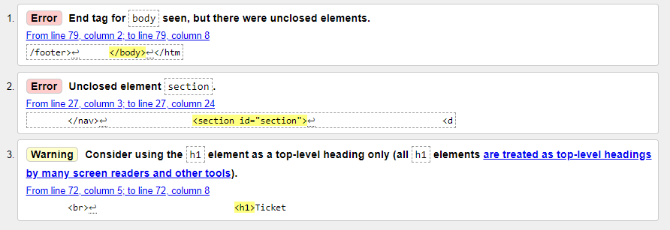
Changes Made - I forgot to close the <section> so I will need to add a </section> so that it is correct and there is a warning about using a h1 at the bottom of the page. However, I am going to ignore this as I wanted that heading to be larger and to stand out to the users.

Gallery Page
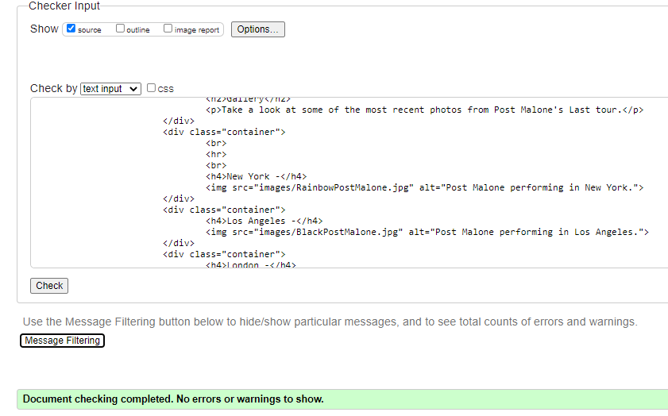
Changes Made – There is no new warning or errors within this html so I will not be changing anything.

Socials Page
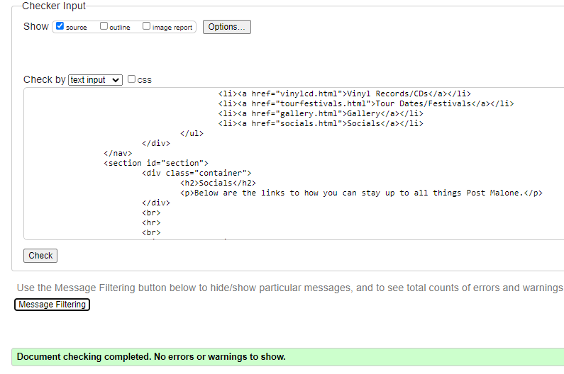
Changes Made – There were also no new warning or errors within this html so I will not be changing anything about it.
CSS Page Validation
I am also going to run my styles.css page through the validator as it has an option to check this and so I will see if there are any errors or warnings with my CSS and see if I need to change anything.

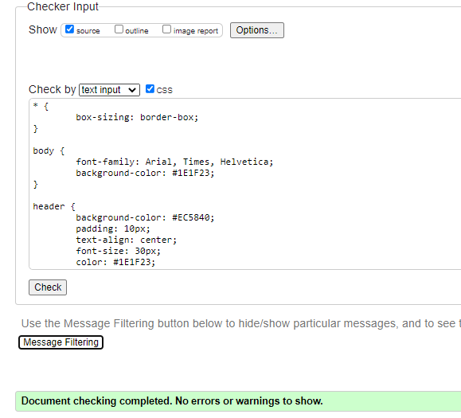
Changes Made - There is no changes or errors that have been highlighted about my CSS so I will not be making any changes to this.

Evaluation
Usability, Accessibility, and Search Engine Optimisation
Within this discussion I aim to describe each of these terms and the roles they have in web development. Also, discuss relevant research and studies to summarize key findings that support why they are all very important for the quality of a website.
Firstly, Usability. Within the ‘Human-Computer Interaction: Design and Evaluation pp143-151’ it demonstrates the use of the term ‘Usability’ and how it can be used to judge the effectiveness and satisfaction of a product. According to ISO 9241-11 Revised it suggests “usability was operationalized primarily in terms of the user’s performance, which was regarded as the prime issue given the many problems that were experienced by users” [7]. This means that usability of a system was decided upon how effective and efficient the users of the system were able to be. This is important for a website as if the users are not able to use the website for its intended use then it is no use. This also leads to less people using the website as there would be no reason to as they cannot perform the tasks that they want to if they tried to use the website. Also, according to ISO 9241-11 Revised it suggests “Users today take the ‘ease of use’ part of the product concepts for granted and will not praise the fact that a product or service has good usability” [8]. Meaning that if the websites usability is good then the user will not have any issues with it and no comments will be made, however if there are issues and something does not work how it should or is intended to then users will be critical and complain. ISO 9241-11 Revised also suggests “usability can be used as a qualifier to refer to design related activities and product attributes” [9]. This shows that having usability and good usability is judged based on if the product does what it need to do, if the users are able to do what they need to do then the product has usability and is good.
I believe that the website I have created has good usability but can be improved on to make it far more usable. If I continue to research and gain more of an understanding I believe I could make this website a lot better however with the time scale I am happy with what I have created and I believe what I have created fits the purpose and target audience of the website. I also believe that I have completed in creating a website that users can use and navigate and understand and to complete tasks.
Secondly, Accessibility. Within ‘Advances in Human – Computer Interaction’ it discusses how websites have been vital in modern day marketing and developing business and the level of usability of websites and how well users can take advantage of websites that designers create. They go onto discuss the World Wide Web Consortium and how they define accessibility. They have stated that they “defines accessibility as an attribute by which people with disabilities can perceive, understand, navigate, and interact, and they can contribute to the web” [10]. This shows that accessibility needs to be considered for users with all abilities and disabilities When creating a website. If you create a website that is not accustom to all types of people and disabilities then you are not looking for accessibility on your website and it will become less usable which is not what you want to create.
I believe that I have made the website accessible as I have used techniques so that it is better for people with disabilities. I have used a clear and understandable font for the content on the website, there is also alt tags that have been used to give users information about images or products if they are unable to see what is there or what should be there. I have also used a colour scheme that focuses on making the content understandable for all users, the colours are contrast to each other making text easier to read and understand if someone is unable to see colours. Users with deuteranomaly or protanomaly are the collective of colour blindness that find it hardest to see colours like orange however the other colours that they see on the website will be able to distinguish the text and make it more understandable. The images that I have used do have multiple colours that some users could struggle to see however if this is the case then they are able to use the alt tags and see what is within the images.
Finally, Search Engine Optimization (SEO). Within V, Eugene B and W, Melius’s south African journal of information management it discusses website usability elements and how they affect search engine optimization. It says that “SEO is the process of designing or making a website with greater ease, resulting in improved rankings” [11] it also says, “SEO is needed to please one specific audience, namely search engine crawlers, whilst website usability is aimed at the human user audience” [12]. These both suggest that if you have a better design then the users will be able to use the website better and at the same time the SEO will be better and good as users are able to use the website well so there will be more traffic toward the website. Within the journal it mentions “search engine crawlers” [13]. These are also another way you can make the website more optimized on the search engines as if you are regularly updating the website and making changes and adding link then the crawlers will recognize these changes and update the websites index.
I believe that I have made my website optimized as there are several links within my website to different webpages and these webpages also have links. I would also have contents that is updating on this website like the products on offer (clothing/ vinyl records and CDs), the tour and festival dates, the gallery would all be updated with time as more tours are completed. Meaning that the SEO would be made better and be updated as the website would be updating and having new content added a lot so the website would hopefully be more optimized. I would also like to believe that the target audience of this website would return to the website as it has information about many things and products on sale so this traffic to the website would also make the website SEO better.

References
[1] Irfan F, “The 20 Best HTML Web Fonts To Use In 2021”, Mar 02, 2021, [Accessed Online], https://www.hostinger.co.uk/tutorials/best-html-web-fonts , [Last Accessed: 15/04/2021].
[2] Irfan F, “The 20 Best HTML Web Fonts To Use In 2021”, Mar 02, 2021, [Accessed Online], https://www.hostinger.co.uk/tutorials/best-html-web-fonts , [Last Accessed: 15/04/2021].
[3] postmalone.com, “Live in Concert”, [Accessed Online], http://www.postmalone.com/ , [Last Accessed: 18/04/2021].
[4] shop.postmalone.com, “POSTY CO”, [Accessed Online], https://shop.postmalone.com/ , [Last Accessed: 18/04/2021].
[5] shop.postmalone.com/collections/tee, “POSTY CO”, [Accessed Online], https://shop.postmalone.com/collections/tee, [Last Accessed: 18/04/2021].
[6] validator.w3.org, “Markup Validation Service”, [Accessed Online], https://validator.w3.org/#validate_by_input , [Last Accessed: 25/04/2021].
[7] N. Bevan, J. Carter, S. Harker, “International Conference on Human-Computer Interaction”, pp143-151, July 21. 2015, “ISO 9241-11 Revised: What Have We Learnt About Usability Since 1998?”, [Accessed Online], https://link.springer.com/chapter/10.1007/978-3-319-20901-2_13 , [Last Accessed: 25/04/2021].
[8] N. Bevan, J. Carter, S. Harker, “International Conference on Human-Computer Interaction”, pp143-151, July 21. 2015, “ISO 9241-11 Revised: What Have We Learnt About Usability Since 1998?”, [Accessed Online], https://link.springer.com/chapter/10.1007/978-3-319-20901-2_13 , [Last Accessed: 25/04/2021].
[9] N. Bevan, J. Carter, S. Harker, “International Conference on Human-Computer Interaction”, pp143-151, July 21. 2015, “ISO 9241-11 Revised: What Have We Learnt About Usability Since 1998?”, [Accessed Online], https://link.springer.com/chapter/10.1007/978-3-319-20901-2_13 , [Last Accessed: 25/04/2021].
[10] A. Dingli, S. Cassar, “An Intelligent Framework for Website Usability”, “Advances in Human – Computer Interaction”, Vol. 2014, [Accessed Online], https://search-proquest-com.ezproxy.uwtsd.ac.uk/docview/1564234212?accountid=130472&pq-origsite=primo , [Last Accessed: 25/04/2021].
[11] Eugene B Visser, Melius Weideman, “An empirical study on website usability elements and how they affect search engine optimization”, “South African Journal of Information Management”, Vol. 13, Iss. 1, 2011, [Accessed Online], https://search-proquest-com.ezproxy.uwtsd.ac.uk/docview/878044433/fulltext/477CA34C001147ADPQ/1?accountid=130472 , [Last Accessed: 26/04/2021].
[12] Eugene B Visser, Melius Weideman, “An empirical study on website usability elements and how they affect search engine optimization”, “South African Journal of Information Management”, Vol. 13, Iss. 1, 2011, [Accessed Online], https://search-proquest-com.ezproxy.uwtsd.ac.uk/docview/878044433/fulltext/477CA34C001147ADPQ/1?accountid=130472 , [Last Accessed: 26/04/2021].
[13] Eugene B Visser, Melius Weideman, “An empirical study on website usability elements and how they affect search engine optimization”, “South African Journal of Information Management”, Vol. 13, Iss. 1, 2011, [Accessed Online], https://search-proquest-com.ezproxy.uwtsd.ac.uk/docview/878044433/fulltext/477CA34C001147ADPQ/1?accountid=130472 , [Last Accessed: 26/04/2021].

