LCBB 5008 Management Economics
Assessment 1 Essay
Lecturer Taye Osadiya

Student Name:Mariya Ilieva
Student ID:2123768
Table of Contents
1. Introduction 3
2. Analysis and Discussion 3
Identification of Demand and Market Equilibrium 3
Price of substitutes 3
Price of complements 4
Consumer Income 4
Consumer tastes & preferences 5
Consumer expectations of price 6
Demographics 6
Factors including the Price of Elasticity of Demand 7
Substitution effects 7
Income effects 8
Adoption of pricing policy with reason 9
Recommendations 9
3. Conclusion 10
Reference list 11

1. Introduction
AMD or Advanced Micro Devices established in Santa Clara County, California, USA has been the leading semiconductor business organisation which has been developing remarkable microprocessors and associated technologies. The activities of AMD include powering millions of computing devices such as PC or Personal Computers, gaming consoles and servers. The microprocessors of the business have been named Ryzen™ which includes different series of product line-ups starting from Ryzen™ 3, Ryzen™ 5, Ryzen™ 7 and Ryzen™ 9 which are mobile desktop processors. Moreover, for servers, AMD has developed the Ryzen™ Threadripper which accommodates remarkable technology (AMD, 2023). The current essay defines the management economics of the business in the concerned industry.

2. Analysis and Discussion

Identification of Demand and Market Equilibrium
Demand and market equilibrium in the market are two key factors which shape a market and it also defines the way in which customers interact with the leading businesses in the market. It is evident that there are certain factors which shape the functioning of the organisations such as the prices of the substitutes, the prices of complements, the income of the customer or consumer, their taste and preferences, their expectations regarding the price of the product or service and finally the demographics. Analysis of AMD in the semiconductor market and computing industry is being performed on the basis of the factors that have been stated above to deeply understand and identify the demand as well as equilibrium in the market (AMD, 2023).

Price of substitutes
The prices of the substitute help in the knowledge of the states or risks which are evident to the business to the extent that the key products can be regulated (Baker, 2003). In the case of AMD, the key competitor is Intel which is another key brand in the market of microprocessor development. It is evident that the business has the same lineup as compared to AMD, Intel’s i3 against Ryzen™ 3, i5 against Ryzen™ 5, i7 against Ryzen™ 7 and i9 against Ryzen™ 9. When the prices of the products of both brands are compared side by side it is found that the prices are €500 to €650 for AMD’s Ryzen™ while in the case of Intel, the prices are perceived to be around €500 to €650 therefore, the prices of the product. However, regardless of the prices the customers are perceived to be divided on the basis of usage which has affected the demand for the products of AMD as well as that of Intel (Hanindhitoet al., 2021).
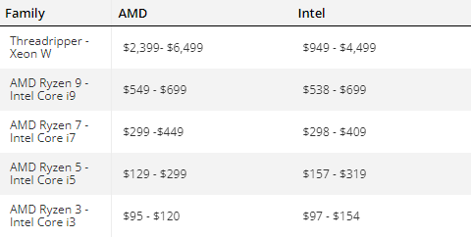
Figure 1: Global price comparison of AMD and Intel's different processors line-up
(Source: Hanindhitoet al., 2021)

Price of complements
When being complimented, it is evident that AMD’s microprocessors have acquired a huge share of the market which has helped the brand present itself as a leading market share. However, with continuous technological advancements and growth, Apple has been perceived to be a key player in the market with its new and innovative System of Chips or SoCs which has granted huge competition to AMD as well as Intel. It has been due to the fact that Apple has moderated how processors function. With the integration of CPU or Central Processing Unit, RAM or Random Access Memory and GPU or Graphical Processing Unit, Apple has been able to deliver much better performance even if the architecture of the processors is kept the same. Finally, the adoption of the balance between the performance cores and efficiency cores in Apple’s M1 and M2 SoCs business has been perceived as a key complement for AMD as well as Intel (Krivovet al., 2020).

Consumer Income
On the basis of the global rate of employment, the income of the masses is increasing. The ratio of employment to population in different continents around the whole world is increasing. In the present times, the percentage of employment has been recorded to be around 55.8% which is quite stable since the advent of COVID-19. Moreover, it is also recorded that with an increased amount of employment, the income of the masses is increasing which has been producing a rise in the spending of the consumers as well. Furthermore, with enhanced graphics and ray-tracing capabilities in different video games also for the purpose of 3D content creation, there has been a dire need for the inclusion of additional cores in the CPUs. It has affected AMD and therefore, Ryzen™ 5 now has at least 6 physical cores and 12 threads while it used to have 4 cores and 8 threads. Thus, the product of AMD has been widely influenced by increased income which has pushed more demand in terms of performance (Statista, 2023).
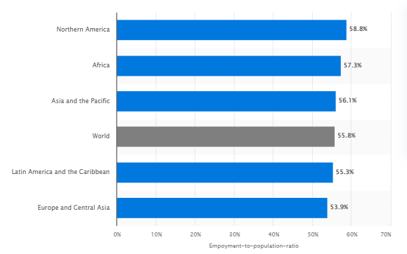
Figure 2: Employment rate around the whole world in 2022
(Source: Statista, 2023)

Consumer tastes & preferences
As already defined the income of the customers has led them to spend more in microprocessors in order to get the best out of their PCs. However, it has not just been a key factor which has led to a moderation of the demand Ryzen™ CPUs line-up. The gaming and the graphic industry have been increasing rapidly. It has been forecasted that the global gaming industry will generate a revenue of about €533 billion by 2027. However, the number has been recorded to be broken every year. In 2017, the revenue was recorded to be around €170 billion, then in 2018, it was around €190, in 2019 a record was established as revenue generation crossed €200 billion even during COVID-19. Finally, in 2023 the amount of around €400 billion. Therefore, it shows that with increased gaming more and more demand of powerful computing devices is on demand which has compelled AMD to make remarkable products. Over the years AMD has reduced the size of the transistors in the processors which has reduced from 7 nm or nanometre to 5nm (Statista, 2023).
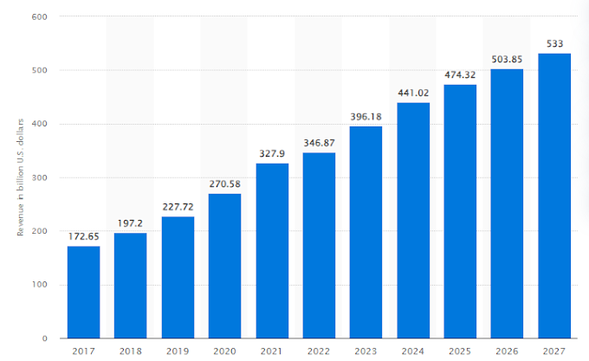
Figure 3: Revenue generation in the gaming industry
(Source: Statista, 2023)

Consumer expectations of price
Over the years, the demands of the customers of AMD have been ever-changing which has shaped the industry throughout time. It is recorded that with the addition of new technologies to deliver bleeding-edge performance to the customers, AMD has invested a huge sum of money to innovate its processors through the reduction of the size of the transistors. AMD Ryzen™™ Master Utility has helped users organise their desktops and laptops efficiently. The use of AMD PRO security and AMD ROCm™ have widely enhanced the experiences of consumers. However, these additions have incurred high charges as well. In 2018, the Ryzen™ 5 CPUs used to cost €150 while in 2023 the prices soared up €370. It is also evident that increased prices have reduced the moderate user share of AMD due to rapid performance increases however as the prices are high consumers are looking out for other options and alternatives (Dufeket al., 2021).

Demographics
When it comes to demographics, it is reported that the customers of AMD are quite loyal to the business. The new customer regardless of high prices understands that AMD delivers remarkable performance as compared to Intel when it comes to gaming or it comes to general usage of computers such as browsing. Moreover, it is reported that the organisation has generated a revenue of about €23,000 billion in 2022 when compared to the last decade, in 2012 the organisation generated a revenue of about €5,000 billion. Therefore, in a time period of ten years, the revenue generation becomes almost five times that of 2012. The numbers express that the customer base of the organisation is ever-increasing which has been a key factor that has helped AMD gain a much better market share within a small amount of time as compared to its bitter rival Intel (Veltenet al., 2022).
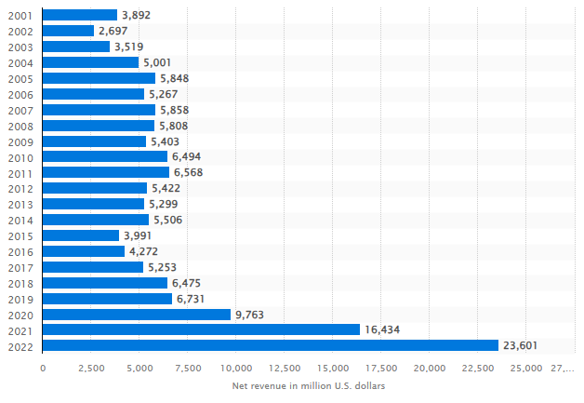
Figure 4: Revenue generation of AMD from 2001 to 2022
(Source: Statista, 2023)

Factors including the Price of Elasticity of Demand

Substitution effects
When AMD’s Ryzen™ line-up is analysed it is perceived that the organisation has kept the product quite diversified. The organisation has made a focus on the acquisition of customers that desire entry-level processors or CPUs, and customers that prefer high-end gaming or cutting-edge technologies when it comes to gaming, rendering and others. Finally, AMD has also targeted the corporates as well with its Ryzen™ Threadripper CPUs, specially designed for servers. Organisations like Lenovo have relied on the Threadripper product of AMD which has helped the business advance its products and services. In other words, it is perceived that the Ryzen™ line-up of AMD has maintained a key balance for the customers (Ouroet al., 2021). It has designed luxury products such as Ryzen™ 5950X and Threadripper while making sure that customers that desire pocket-friendly items are also collected by the sales of the products such as Ryzen™ 3, Ryzen™ 5 and Ryzen™ 7.
AMD has gained a core knowledge of the demands of the customers and a balance has been maintained in its products which has satisfied the necessity of the customers as well as luxurious temptations for hard-core gaming performance and low time when rendering 3D models of videos at 4K 60 FPS or Frames Per Second. Furthermore, when the demand is analysed on the basis of the elasticity or inelasticity it is perceived that the demand for the products of AMD have been increasing over the year and it has been leading towards moderation of prices at larger scales. Moreover, it is also found that hype in the market is established especially among gamers as AMD is the leading brand which offers the best gaming experience at great prices. Thus, an elasticity regarding demand has been perceived in the computing market as well as gaming markets around the globe (Aigner-Walder, 2015).

Income effects
Income has been another key factor which has been moderating the elasticity of the price on demand and it has served as a component which has been taken into core consideration by AMD for the effective and advanced levels of knowledge of the preferences and requirements of the customers which has shaped the business effectively. It is reported that price has placed a key factor for the customers when they are required to make a decision to purchase whether AMD or Intel. It is reported that the price-to-performance ratio in the case of AMD has helped the customers to take or make effective decisions which have supported the organisation in the improved levels of knowledge or the approaches which are required to be maintained by the organisation or the subtle growth and development of the business organisation (Bagwell, 2005).
A large portion of the population of the customers of AMD has been perceived to be increased over the years. It is evident that consumers that have high incomes are compelled to purchase Ryzen™ 7 or Ryzen™ 9. Income customers desire to have the best out of their PCs and thus they opt for such configurations. Often such large customers that desire to make huge purchases are lured into buying AMD’s one GPUs or Graphic cards such as AMD Radeon RX 7000 Series GPUs which sync well with the CPUs delivering the customers with optimal and seamless experience and enjoyment in their tasks. Overall, a substantially increasing group of customers have been perceived to be the foundational stone for AMD and has delivered different instances and opportunities for AMD to grow and advance. In simple words, it has been leading the demand to become more elastic over the years which has helped AMD sustain against competition, Intel (Magnussen et al., 2021).

Adoption of pricing policy with reason
From the discussion held above, it is noteworthy that AMD widely focuses on delivering meaningful and valuable products to the customers so that the customer base is responsive and increases over a period of time. However, when it comes to pricing strategy, the organisation has made use of penetration strategy over the recent years which has eloped the brand to keep the price low for the acquisition of the share of the market in a rapid manner. The strategy has been quite helpful in the case of AMD which has granted the business an upper hand when it comes to acquiring the marketing share of its bitter rival Intel. Furthermore, the business has also been able to lure in new customers with competitive pricing while making sure core values are delivered to the customers bringing about sustained or subtle rise in the performance of the business while advancing the image of the brand in different markets around the globe (Zhang, 2021).
Finally, the business is required to make use of dynamic pricing on the basis of the availability of the raw materials that are used in different production areas or factories of AMD around the globe. However, the price of the Ryzen™ line-up is required to be maintained in a manner that the customers perceive it is a highly valuable product therefore, the application of dynamic pricing is quite beneficial and suitable in the present situations of AMD. These will widely help the organisation as the revenue generation and profitability of the organisation will improve rapidly helping the business in making better investments and driving innovation within the products as well as the business environment. Such a pricing strategy can also help the organisation moderate the flow of competition against SoC companies such as Apple, Qualcomm, Samsung and MediaTek (Liao et al., 202).

Recommendations
It is clearly evident from the discussions performed above that AMD has maintained great approaches which have granted the business key results and outcomes enhancing the overall performance of the organisation. However, the industry in which AMD leads is quite prone to new innovation that requires new changes day by day to survive against competition. Therefore, the application of change management is to be applied in the business to make sure that different changes in the business are aligned with the aims and objectives AMD seeks to achieve. Models of change management such as “ADKAR Change Management” can be applied in the business (Chawla et al., 2023).

3. Conclusion
In conclusion, it can be said that AMD’s products are remarkable and their vision has shaped the industry over the years. It is evident that AMD widely relies on innovation which has supported the business in the delivery of meaningful products and items keeping the customers excited about the next or future releases. With that being mentioned, AMD’s approaches to GPUs have also been quite foundational which has advanced the overall performance of the organisation and has paved the way for the subtle development and growth of the business within the business environment as well as in associated industries such as the gaming industry.

Reference list
Aigner-Walder, B., 2015. Effects of the Demographic Changes on Private Consumption: An Almost Ideal Demand System Analysis for Austria. Journal of Economic and Social Studies, 5, 1, 33-57
AMD. 2023. Advancing Technologies with Emulation and Prototyping. [online] Available at: <https://www.amd.com/en.html> [Accessed: 12 July 2023].
Bagwell, K., 2005. The Economic Analysis of Advertising. Columbia University Discussion Papers No. : 050601
Baker, J., 2003. Competitive Price Discrimination: The Exercise of Market Power Without Anticompetitive Effects (Comment on Klein and Wiley). Articles in Law Reviews & Other Academic Journals. Paper 278.
Chawla, N., Liu, C., Chakraborty, A., Chervatyuk, I., Sun, K., Hamasaki, T.M. and Kawakami, H., 2023. The Power of Telemetry: Uncovering Software-Based Side-Channel Attacks on Apple M1/M2 Systems. arXiv preprint arXiv:2306.16391.
Dufek, A.S., Gayatri, R., Mehta, N., Doerfler, D., Cook, B., Ghadar, Y. and DeTar, C., 2021, November. Case study of using Kokkos and SYCL as performance-portable frameworks for Milc-Dslash benchmark on NVIDIA, AMD and Intel GPUs. In 2021 International Workshop on Performance, Portability and Productivity in HPC (P3HPC) (pp. 57-67). IEEE.
Hanindhito, B., Swaminathan, K., Narayanan, V. and John, L.K., 2021. Intel Wins in Four Decades, but AMD Catches Up. IEEE Micro, 41(6), pp.168-171.
Krivov, M.A., Iroshnikov, N.G., Butylin, A.A., Filippova, A.E. and Ivanov, P.S., 2020, November. Comparison of AMD Zen 2 and Intel Cascade Lake on the Task of Modeling the Mammalian Cell Division. In International Conference on Mathematical Modeling and Supercomputer Technologies (pp. 320-333). Cham: Springer International Publishing.
Liao, X., Li, B. and Li, J., 2022, March. Impacts of Apple’s M1 SoC on the Technology Industry. In 2022 7th International Conference on Financial Innovation and Economic Development (ICFIED 2022) (pp. 355-360). Atlantis Press.
Magnussen, B.M., Kawasumi, T., Mikami, H., Kimura, K. and Kasahara, H., 2021, October. Performance Evaluation of OSCAR Multi-target Automatic Parallelizing Compiler on Intel, AMD, Arm and RISC-V Multicores. In International Workshop on Languages and Compilers for Parallel Computing (pp. 50-64). Cham: Springer International Publishing.
Ouro, P., Lopez-Novoa, U. and Guest, M.F., 2021. On the performance of a highly-scalable Computational Fluid Dynamics code on AMD, ARM and Intel processor-based HPC systems. Computer Physics Communications, 269, p.108105.
Statista. 2023. AMD revenue from 2001 to 2022. [online] Available at: <https://www.statista.com/statistics/267872/amds-net-revenue-since-2001/#:~:text=In%202022%2C%20AMD's%20revenue%20amounted,U.S.%20dollars%20recorded%20in%202021.> [Accessed: 12 July 2023].
Statista. 2023. Estimated employment-to-population ratio worldwide in 2022, by region. [online] Available at: <https://www.statista.com/statistics/1258882/global-employment-rate-by-region/#:~:text=In%202022%2C%20the%20employment%2Dto,working%20age%20population%20were%20employed.> [Accessed: 12 July 2023].
Velten, M., Schöne, R., Ilsche, T. and Hackenberg, D., 2022, April. Memory performance of AMD EPYC Rome and Intel Cascade Lake SP server processors. In Proceedings of the 2022 ACM/SPEC on International Conference on Performance Engineering (pp. 165-175).
Zhang, Z., 2021, September. Analysis of the Advantages of the M1 CPU and Its Impact on the Future Development of Apple. In 2021 2nd International Conference on Big Data & Artificial Intelligence & Software Engineering (ICBASE) (pp. 732-735). IEEE.

