

Financial Performance and
Investment Appraisal Report
Unilever PLC and Beard Plc
Student: Riaza Emama Mou
Student ID: 2510980
Module: BMMB7005 – Finance for Business Managers
Assessment:Resubmission
Submission: 22 October 2026


Executive Summary
This report is to appraise the investment prospects of Beard Plc, with a focus on three investment options and also to evaluate the financial performance of Unilever plc of 2025 and 2024. The company ended up making more money from its continuing operations despite a 3.8% decline in turnover. All of the above mentioned margins have been improved, as well as ROCE and ROE. Liquidity continued to be tight and the inventory turnover favorable. Receivable Days were not favorable, however, due to the Ice Cream demerger, there were transition balances. Net debt declined but a decrease in equity caused an increase in the ratio of net-debt-to-equity from 108.71% to 131.21%. As such, the improvement is actual but the impact of the demerger and year-end balance measures should be taken into account in reading it.
The highest net present value (NPV) for Beard Plc is £91.23k with an internal rate of return (IRR) of approximately 8.57% which is over the cost of capital of 5%. The optimal amount of money to put into each of the two options is £1,000,000 in Option C and £500,000 (55.56%) in Option B, resulting in a total NPV of approximately £132.31k. The report suggests Option C is the best single project option (with market testing and risk analysis), and a funding package that is mostly internal plus debt, which maintains liquidity and control.

Table of Contents
Executive Summary 1
1. Introduction 3
2. Main Findings 4
2.1 Part 1: Unilever PLC Financial Performance 4
2.1.1 Analytical basis and ratio overview 4
2.1.2 Profitability 4
2.1.3 Liquidity and operating efficiency 5
2.1.4 Gearing and investor performance 6
2.1.5 Limitations of the analysis 7
2.2 Part 2: Beard Plc Investment Appraisal 7
2.2.1 NPV and project choice 7
2.2.2 IRR and decision reliability 8
2.2.3 Theory, practice and non-financial factors 8
2.2.4 Divisible capital rationing 9
2.2.5 Financing the investment 9
3. Overall Conclusion 11
4. Recommendations 11
References 13
Appendices 16
Appendix A: Extracts from published financial statements 16
Appendix B: Unilever ratio calculations 19
Appendix C: Beard Plc investment calculations 21

1. Introduction
There is a need for both evidence and judgement in the making of financial decisions, and the evidence must be backward looking as well as the judgement. Ratio analysis presents published accounts in terms of the following ratios: profitability, liquidity, efficiency, gearing and shareholder return. But it doesn't mean anything by itself, as far as performance. Beaver (1966), Altman (1968), and Nissim and Penman (2001) demonstrated that ratios can be used to indicate financial weakness and that the ratio decomposition can be used as a link to valuation. New evidence, if it's any better, is more conservative. However, Afzali (2023) demonstrates that the reporting decisions made by the organisation impact the comparability of the ratios, and Seretidou, Billios and Stavropoulos (2025) recommend using both cash-flow and accrual ratios. Hence this report does not use terms like ‘good' or ‘bad' for ratios but rather looks at the contents of the ratio in context.
Using the latest annual report of the company, Unilever PLC, Part 1 compares its asset figures in 2025 and 2024 in terms of its continuing operations. Nestlé is focused as a peer company due to its international consumer goods brand but due to differences in product mix and currency/ GAAP classification the two cannot be compared directly. In Part 2 the Beard Plc data given in the assignment brief is used to apply discounted cash-flow techniques. Unilever and Nestlé's monetary values are in millions of Euros and Swiss Francs respectively and for Beard Plc in £000. Appendix B shows the calculations for the region, while Appendix C shows the calculations for the area of the region. The report then provides integrated conclusions and recommendations to the practices.

2. Main Findings

2.1 Part 1: Unilever PLC Financial Performance

2.1.1 Analytical basis and ratio overview
The separation of its Ice Cream business has been accounted for in the analysis and the net result of the business before the separation is reported as the re-presented continuing income statement. There are new IFRS rules to be presented separately (IFRS 5) and to be further strengthened (IFRS 18) with regard to presentation and disaggregation of discontinued operations (IFRS Foundation, 2022; IFRS Foundation, 2024). Therefore, it is a better indicator of the working performance of the group than total profit for assessing the current group. Final figures of the balance sheets are utilized for working capital and asset turnover ratios because a fully re-presented balance sheet on the same basis is not available. This option results in consistency, but also brings with it year-end timing risk.
Table 1. Unilever ratio summary and 2025 peer indicators
Ratio | 2025 | 2024 | Change | Nestlé 2025
Gross profit margin | 46.95% | 46.69% | +0.26 pp | 45.59%
Operating profit margin | 17.89% | 16.82% | +1.07 pp | 13.72%
Net profit margin (continuing) | 12.30% | 11.51% | +0.79 pp | n/a
ROCE | 18.51% | 16.20% | +2.31 pp | n/a
Current ratio | 0.79x | 0.76x | +0.03x | 0.79x
Quick ratio | 0.60x | 0.56x | +0.05x | 0.47x
Net debt / total equity | 131.21% | 108.71% | +22.50 pp | 155.40%
Interest cover | 8.83x | 8.88x | −0.05x | n/a
Inventory days | 55.08 | 67.54 | −12.46 | 96.04
Receivable days | 35.07 | 29.40 | +5.67 | 35.68
Asset turnover | 0.72x | 0.66x | +0.06x | n/a
ROE (continuing) | 31.99% | 28.51% | +3.48 pp | n/a
Basic EPS (continuing) | €2.60 | €2.45 | +6.12% | n/a
Dividend cover | 1.28x | 1.26x | +0.02x | n/a

Sources: Unilever PLC (2026); Nestlé S.A. (2026). pp = percentage points. Full formulae are in Appendix B.

2.1.2 Profitability
The €50,503m turnover of continuing operations declined by 3.77% from the previous year's figure of €52,479m. But gross margin was up to 46.95% and operating margin up to 17.89%. Unilever PLC (2026) reports operating profit of €9,037m, compared with €8,829m in 2024. The result of the movement is that operating costs were lower than sales. In addition, Unilever has higher 2025 margins than Nestlé, whose operating margin was 13.72% and gross margin was 45.59% (Nestlé, 2026). This peer evidence confirms that Unilever was able to maintain pricing and cost discipline, despite the fact that it has differences in currencies and in its product/service offerings.
Net margin increased from 11.51% to 12.30%, while return on capital employed (ROCE) rose from 16.20% to 18.51%. The gain is positive as both the operating profit and the turnover/asset ratio are favourable. But that part of the increase in ROCE was driven by the demerger of the Ice Cream business which reduced asset size. The 2025 report will list the new structure, whereas the larger pre-separation group will be listed in Unilever's 2024 report (Unilever PLC, 2025; Unilever PLC, 2026). This meant that management efficiency was also enhanced but the increase in ROCE of 2.31 points is not fully operational. The same applies in the case of changing contexts as has been warned by Afzali (2023) that comparability can weaken in such instances.
There is a need for a working-capital point of view for the margins as well. Deloof (2003) showed that shorter operating cycles can be a positive for profitability, whilst Baños-Caballero, García-Teruel and Martínez-Solano (2014) showed that there was a non-linear relationship: too little working capital can have a negative impact on both sales and resilience. The conclusion of value maximisation is the same as that of Aktas, Croci and Petmezas (2015). So, for Unilever, it is not okay to reduce the costs if it compromises on the availability of the product, its reliability with the suppliers or its investment in the brand. Better margins are plausible but underpinning value will rely upon the continued preservation of resources to safeguard future sales.
The examination of the figures reveals that the improvement was not an absolute improvement in every case – in other words, that each of the absolute profit figures rose. The turnover was reduced from €52,479 million to €50,503 million, whereas gross profit was reduced from €24,503 million to €23,709 million. However, gross margin went up as cost of sales went down faster than turnover. The increase in operating profit was from €8,829 million to €9,037 million. The distinction is key as the margin growth could be due to a combination of cost discipline and portfolio change and currency effects, not necessarily to robust revenue growth. However, the reported turnover loss for Unilever PLC (2026) is largely attributed to the negative currency movements, with the underlying sales activity being positive. So, management ought to evaluate reported margins along with underlying sales growth, as well as volume growth and currency-neutral profitability, before deciding it's made a permanent turnaround.
Nestlé is a good comparator but it should not be seen as a representative industry standard. The gross margins of Unilever (46.95%) and operating margins (17.89%) were higher than Nestlé's gross margin (45.59%) and operating margin (13.72%). The comparison is, however, limited by the fact that the reporting structure, the currency and the product mix are different, which means that it does not demonstrate operational superiority but only a relative position (Nestlé S.A., 2026). In the same vein, Afzali (2023) reveals that there may be differences in organisational and reporting that hinder financial-statement comparability. The positive change in ROCE also must be interpreted with caution. It showed higher operating margin and the asset turnover, but the closing asset base for the demerger was the Ice Cream business. As a result, some of the improvement was due to mechanical factors and not solely to an improvement in management performance. This will help to justify using a longer, demerger adjusted trend. Furthermore, profitability needs to be taken into consideration along with working-capital efficiency, as suggested by Deloof (2003) and Aktas, Croci and Petmezas (2015). Unilever should thus not be prepared to sacrifice their margin increases by cutting inventories, supplier assistance or brand spending below what is necessary to sustain future revenues.

2.1.3 Liquidity and operating efficiency
The current ratio went up from 0.76x to 0.79x and the quick ratio increased from 0.56x to 0.60x. Both have stayed below 1.0x, but a universal one to one relationship is tenuous. According to Li (2024), the prediction of failure through liquidity ratios varies across levels, and Khoza (2025) and Nam and Tuyen (2024) have found that there is a need to use liquidity ratios and leverage ratios together. Unilever's current ratio is 0.79 with respect to Nestle's 0.79 and its quick ratio is also higher than Nestle's quick ratio of 0.47. The position is thus not automatically in distress, but is tight. The size of the group and its regular demand by consumers and access to the markets diminish the risk of short-term refinancing, but it is important to have a low buffer and be constantly alert to cash forecasting.
Improvement was very solid in Inventory. The closing-balance inventory days dropped from 67.54 to 55.08 while the inventory turnover rose from 5.40x to 6.63x. Nestlé's 96.04 days will give a general idea, but the division consists of different products. Kiymaz et al. (2024) conclude that effective working capital and performance have a correlation in both developed and emerging markets. The decisions on inventory and receivables also have an impact on profitability as demonstrated by Umar and Al-Faryan (2024), Aldubhani et al. (2022) and Mandipa and Sibindi (2022). The reduction in the inventory days is plus for Unilever. But, it is important that management keep an eye on service levels as an understocked inventory position can lead to lost sales.
The days outstanding on receipts went against the trend, increasing from 29.40 to 35.07. In the 2025 balance the amounts associated with transitional arrangements following the Ice Cream separation also form part of the amounts. Therefore a collection-performance interpretation of the 2025 balance is not suitable (Unilever PLC, 2026). Despite this, the rise binds up cash, and is nearly equal to Nestlé's 35.68 days. Ahmad, Bashir, and Waqas (2022) demonstrate that the working-capital effects are different in crisis periods, and Koroma and Bein (2024) find that when there is uncertainty in the UK policy, the working capital effect is different with respect to profitability. Hence, Habib and Kayani (2022), Sawarni et al. (2022) and Mahmood et al. (2025) advocate for a holistic approach to the policy through the use of multiple ratios, instead of one ratio.
The asset turnover increased from 0.66x to 0.72x. This means that there are more sustainable revenues per euro of closing assets, but it's once again attributable to the smaller asset base following the demerger. Laghari et al. (2023) find that cash-flow management has an impact on the performance of the firm, and Kumar et al. (2024) prove that composite measures are more informative than a single working-capital ratio. Furthermore, the optimal choice of working capital depends upon risk (Akbar et al., 2021), competitive strategy (Ameer and Othman, 2021) and operating systems (Zimon, Habib and Haluza, 2024). Therefore, it is recommended that Unilever align ratio targets with the operational metrics like forecast accuracy, fill rate and balances due.

2.1.4 Gearing and investor performance
Net debt fell from €24,519m to €23,076m. However, total equity fell faster, from €22,555m to €17,587m, so net-debt-to-equity increased from 108.71% to 131.21%. The increase is significant, but not in terms of an increase in debt. The denominator shrank as a result of the de-merger and shareholder distributions. The interest cover also performed well of 8.83X as compared to 8.88X. For context, the ratio of net-debt to equity that Nestlé reported is 155.4%. Note that this is the same ratio and is unaffected by currency denomination (Nestlé S.A., 2026). So, Unilever has the ability to refinance but its diminished equity cushion makes it less appealing to continue to distribute via debt.
There is no one single target of capital-structure theory. Under certain assumptions, financing is not relevant, as Modigliani and Miller (1958) show. Other views of debt are offered by Myers (1984), who suggests that it is a compromise between tax saving and distress costs, and by Myers and Majluf (1984), who show how information gaps can cause firms to prefer internal finance. There's been a mixed bag of recent evidence. Boshnak (2023) and Ahmed, Nugraha and Hágen (2023) suggest that on certain occasions, leverage can have a negative impact on performance, while on other occasions, it can have a positive impact on the SME. Manyanga et al. (2023) report positive effects on SME performance when the debt is used to finance productive activity. Similarly, Priyan, Nyabakora and Rwezimula (2024) find that asset structure is important. Therefore, for Unilever, having stable cash flows to support debt service is more important, while the higher ratio suggests that it is advisable to manage debt downwards rather than setting a sector limit.
Investor measures improved. Basic earnings per share (EPS) grew by 6.12% to €2.60, the return on equity (ROE) improved from 28.51% to 31.99% and dividend cover went up from 1.26x to 1.28x. It's better to have continuing EPS rise compared to total EPS, as total 2025 earnings also include the discontinued-operation gain. However, lower average equity helps to boost ROE. Governance and relationship information is added to ratios to predict outcomes, and Gallucci et al. (2023) demonstrate this. Therefore, investors must consider the ROE in conjunction with gearing, cash conversion and the smaller equity base. The cover of the dividend is still modest and the margin of safety is limited.

2.1.5 Limitations of the analysis
Two years is not a long enough period to be considered a trend. The year end timing, inflation effect, currency translation effect as well as judgemental effect in accounting estimates and Ice Cream demerger also impact the ratios. The peer comparison is not comprehensive or a true sector benchmark. Also, the balance sheet was not re-presented for all prior period items thereby using closing balances for some ratios. These constraints are not to say that these changes are not going in the right direction, but they are not as precise. Prior to making a strategic decision, ratios should be used in conjunction with qualitative and cash-flow evidence and governance evidence, as suggested by Seretidou et al. (2025), and Gallucci et al. (2023).

2.2 Part 2: Beard Plc Investment Appraisal

2.2.1 NPV and project choice
Net present value is the present value (PV) of cash flows after taxes, minus the initial investment, at the cost of capital of 5%. If NPV is positive, it indicates value being created today. The calculation assumes that the company pays taxation at 25% and capital allowances at 20% straight-line over the years. Beard Plc is a well-established company so the small loss of tax on Option A is assumed to be provided instant relief against other taxable profits. There is only one use of HM Revenue & Customs (2026) to aid the tax context, the number and the allowance is as per the assignment brief.
Table 2. Beard Plc investment appraisal (£000)
Option | Outlay | After-tax cash flows: Y1–Y4 | PV inflows | NPV | PI
A – expand retail | 600.00 | 105.00; 165.00; 187.50; 225.00 | 596.74 | −3.26 | 0.995
B – internet sales | 900.00 | 210.00; 247.50; 307.50; 345.00 | 973.95 | 73.95 | 1.082
C – purses and wallets | 1,000.00 | 237.50; 282.50; 350.00; 372.50 | 1,091.23 | 91.23 | 1.091

The project with the highest positive NPV is the best project to undertake out of the three projects. If Beard Plc can only undertake one project, then the project with the highest positive NPV as shown in Option C is to be selected. Also, Option B can be used on its own and Option A would reduce shareholder value by approximately £3.26k at the required return. Purnamasari and Adriza (2024) have determined that sophisticated capital budgeting techniques are correlated with better company's financial performance, while Darmansyah, Ali and Parveen (2025) have found that they are related to risk management. Thus, the suggestion is not only on the high amount of cash influx but on the value creation.

2.2.2 IRR and decision reliability
Option C’s NPV is £13.75k at 8% and −£10.18k at 9%. The results of linear interpolation is an IRR of about 8.57% which is greater than the cost of capital(5%) and accepted. Sokolov (2024) combines NPV, IRR, profitability index and payback into a single decision family. IRR can, however, have the tendency to misrank mutually exclusive projects as it gives a percentage and assumes a rate-based comparison. NPV is a measurement that reflects the absolute value added and for this reason is a better primary rule. To justify using IRR as a cross check, Graham and Harvey (2001) have found that the firms use both NPV and IRR.

2.2.3 Theory, practice and non-financial factors
Theoretically, NPV is the preferred as it takes into account the time value, all the forecast cash flows and discounts at an opportunity cost that reflects risk. It is additive, that is, values from divisible projects can be aggregated. However, it is dependent upon the level of reliability of the forecast and the discount rate. Trigeorgis (1993) claims that there is real option value that a fixed forecast can overlook due to the flexibility of the manager. Beard Plc should therefore conduct tests in the following areas: demand test, selling price test, operating cost test, online returns test and launch delay test. A particular amount of sensitivity and scenario analysis are particularly significant as the margin of £91.23k can be taken away by a slight change.
For this reason, non-discounting methods are still in use today as they are easy to use and make it easy to understand that cash is being recovered. Even managers that know about discounted methods, payback is still used, according to Mota and Moreira (2023), as it is among smaller companies. Payback will be beneficial if the technology will become outdated or if liquidity is limited. It does not consider cash flows post cut-off, however, and in its simplest form it does not regard for the time value of money. Accounting rate of return is based on familiar profits, is influenced by accounting policy and not cash value. Payback, therefore, is a good secondary liquidity measure, but should never replace a positive NPV for a project unless there is a strategic reason.
The operational and strategic evidence also needs to be taken into account in making the final decision. Beard Plc needs to verify the size of the market for purses and wallets, fit of the brands, production capacity, sourcing of leather, product quality, skills of the staff, cannibalisation of handbags and the capacity to sell through existing channels. It should also have a look at the environmental and labour standards in the supply chain. A staged launch or pilot may help to save the option to expand or to stop. A review of the completed project should, in addition, be compared of actual sales, costs & timing with the approved case. These controls take care of the bias in the forecasts and preserve the value signal provided by NPV. The financial benefits of Option C needs to be considered with respect to the magnitude and the risk of the investment. This has a NPV of £91.23k or about 9.12% of the initial outlay of £1mil. A positive value cushion but it is not sufficiently large to make the project insensitive to forecasting error. The IRR is 8.57% which is 3.57 percentage points over the cost of capital of 5%. This helps to achieve acceptance but does not eliminate the risk of selling prices, production costs or cash receipt timing. Both the NPV and IRR and the profitability index provide different aspects of the investment decision and Sokolov (2024) suggests that these should be considered together. However, it is worth remembering that NPV is always the most important measure as it is the measurement of the absolute value created for shareholders.
Therefore, a base case, a realistic downside case and a severe but credible downside case should be tested prior to approving. The analysis should be done by changing the quantities of sold products, the unit contribution, material and labour costs, expenditure on launching and costs due to delays in cash collection. Trigeorgis (1993) states that value of real options can arise due to managerial flexibility that does not show up in a static cash-flow forecast. Beard Plc could maintain this flexibility by going on a pilot launch, gradual increments in capacity or supply contracts that don't demand for a full commitment at the outset. The measures would enable management to find out the market value before it puts up the £1 million.
Payback can also be used in conjunction with this analysis to indicate how long the investment probably will take to pay off. But, as Mota and Moreira (2023) demonstrate, its simplicity contributes to its popularity. Payback should only be considered as a secondary risk indicator, therefore. The factors that should ultimately be taken into account when deciding on the brand include production capacity, product quality, responsible sourcing, employee ability, and capacity of the channel and potential cannibalisation of the existing handbag business. These conditions should now be something that can be measured as an approval criteria and should be reviewed in the post-completion review.

2.2.4 Divisible capital rationing
If it is divisible projects which are available for spending £1.5m, and it is scarce capital, then the ranking should be by the NPV per £1 spent. Option C ranks first at 0.0912, Option B second at 0.0822 and Option A last at −0.0054. As such, Beard Plc should invest £1.0m into Option C and the remaining £0.5m into 55.56% of the option B. The total NPV is approximately £132.31k. Osmundsen, Løvås and Emhjellen (2022) reveal that allocation rules are important in the light of capital constraints. In this case, the profitability-index ranking can be used since the projects are divisible and independent. If either condition does not hold, then management should consider the possible combinations of the parts of the project that is feasible.

2.2.5 Financing the investment
The first source is going to be cash that's kept in reserve, as long as the business maintains enough cash flow to meet its operating needs. Internal finance does not have a fixed interest rate and does not dilute the control. It is also based on the logic of the pecking order of Myers and Majluf (1984). Jansen et al. (2023) also uncover a preference for internal finance followed by debt financing in private family firms. But excessive cash could result in reduced resilience and restrict handbag operations. As such, cash should only be used to cover the cash shortfall of the amount that goes beyond the working-capital and contingency requirement of Beard Plc based on their cash flow statement.
The four-year benefits can be matched by a medium-term bank loan and maintained the ownership. If the interest is fixed, it is predictable but if the interest is paid on debt, there will be covenants, security needs, and a pressure to repay the debt. Resources from external sources continue to be significant for smaller businesses in the UK and the Growth Guarantee Scheme can provide assistance to viable businesses that are restricted from accessing finance (British Business Bank, 2026a, 2026b). However, it should not be assumed that it is available and the cost should be checked with an accredited lender. While Manyanga et al. (2023) conclude that productive debt is conducive to the performance of SMEs, Boshnak (2023) demonstrates that higher debt can adversely affect firm performance.
If the use of machinery can be identified, then leasing or asset finance can be a good solution since it keeps initial cash while payments are made based on the usage. Hu, Li and Xu (2023) demonstrate that leasing can help enhance finance allocation. The disadvantages are it is expensive, it has contractual restrictions and it may not be owned. New equity removes repayment requirement and shares risk, but reduces control and future returns.A strategic investor removes repayment requirement and shares risk, but results in decreases in control and future returns. Santos, Cincera and Cerulli (2024) discover that the influence of various sources varies and therefore an asset must be matched with a source and a purpose. Government intervention could open up access to capital, but Crawford, Cui and Kewley (2024) and Dvouletý, Srhoj and Pantea (2021) demonstrate that for schemes to be effective, they must be designed and be additional. Recent shocks led to tighter financing conditions for SMEs, according to OECD (2024).

3. Overall Conclusion
In 2025, Unilever's ongoing operations were enhanced. All of the margins, ROCE, asset turnover, inventory efficiency, ROE and continuing EPS were improved. Liquidity also marginally improved and was in the vicinity of Nestlé's benchmark. However, Receivable days went up while there was a net-debt-to-equity increase due to the decrease in equity. The demerger of the Ice Cream has an impact on comparability. So the overall verdict is good, but with reservations: The group is more profitable and efficient but must be careful to maintain cash conversion and restore balance-sheet liquidity.
Of the options given to Beard Plc, Option C is the best single investment because it has an NPV of £91.23k and an IRR of 8.57%, with the NPV positive and the IRR above the required return. If the £1.5m limit is applicable to divisible projects, then the optimal level of investment is to invest in C, and 55.56% of B, which maximises the NPV at approximately £132.31k. Market testing, sensitivity analysis and post completion control should be included in the financial case. It is preferable to have a combination that is measured than to have just one source (retained cash, term debt and selective leasing).

4. Recommendations
- Unilever needs to have a structured receivables recovery plan for both its trade receivables and those arising from the Ice Cream demerger. The days' receivables grew from 29.40 to 35.07 days and the amount of trade receivables grew from €4,227 million to €4,852 million. This rise has been driven by cash flows being short of the recovery phase, but balanced with transitional flows. Thus, it is essential to put limits on ageing, name owners and make monthly cash-conversion reporting to ensure that the working capital is released and overdue balances are identified as early as possible.

- Unilever needs to maintain the improvement of inventory management as the inventory days have reduced from 67.54 days to 55.08 days. This cut helped to free up cash and boost operating efficiency. But, if there were too many inventory cuts, there could be stock shortages, lost sales and production disruption. In addition to maintaining the inventory ratio, management should also track how good their forecasting accuracy is, how they are doing on order fulfillment, how they are doing on customer service and how reliable suppliers are.

- Unilever needs to focus more on reducing its net-debt position and should refrain from paying out to the shareholders with debt money till they improve their equity and cash-conversion positions. Net debt decreased from €24,519 million to €23,076 million but the net-debt-to-equity ratio rose from 108.71% to 131.21% due to a significant decrease in total equity. Furthermore, the dividend cover was just 1.28 times. Debt reduction will restore the equity cushion, maintain credit quality, and reduce the risk of future refinancing and interest rates.

- Continued operations and demerger adjusted performance trends over a period of over 2-years should be assessed by management for future performance. The Ice Cream separation had a mechanical impact on ratios like ROCE, asset turnover and gearing as it decreased the asset and equity base. If not adjusted, improvements could be incorrectly thought of as purely operational. A long-term basis would then provide more robust target setting and managerial decisions.

- Therefore, Option C is the most preferred individual investment for Beard Plc because it has an estimated IRR of 8.57% which is higher than the 5% cost of capital and an NPV of £91.23k. These results are subject to the forecast sales, price, cost and time of implementation. Management should, therefore, undertake downside NPV and sensitivity analysis and record all the assumptions prior to investing. If the project still has a positive NPV with realistic worst case scenarios, then the project should move forward.

- Beard Plc should invest all the £1 million in Option C and the remaining £0.5 million in 55.56% of Option B because Option C is the highest NPV per pound invested followed by Option B. This allocation produces a collective NPV of around £132.31k whilst option C alone produces £91.23k. Funding should not be provided to Option A as it results in an NPV of -£3.26k, which will decrease the wealth of shareholders with the forecasts used.

- Beard Plc should have surplus cash and debt both with cash-flow periods of four years, the same period that the projects cash-flow will extend over. Retained funds ensure that there is no ownership dilution nor any external issue costs, matched-term debt means that the short-term refinancing risk is eliminated. Only assets that are clearly identified and whose overall cost and flexibility is more advantageous in leasing than buying should be leased. A formal liquidity reserve should also be kept since cash inflows may be lower and/or delayed than anticipated.

- There should be a post completion review for Beard Plc at the end of each operating year. The actual sales, operating costs, tax effects, timing and net cash flows should be compared with the investment case approved. The implication of material adverse variances is that something must be done to address the variance, typically cost control, production capacity and pricing changes. This would lead to less optimism in the forecast, better managerial accountability and better quality going forward investments.

References
Afzali, M. (2023) ‘Corporate culture and financial statement comparability’, Advances in Accounting, 60, 100640. https://doi.org/10.1016/j.adiac.2022.100640
Ahmad, M., Bashir, R. and Waqas, H. (2022) ‘Working capital management and firm performance: are their effects same in COVID-19 compared to the financial crisis 2008?’, Cogent Economics & Finance, 10(1), 2101224. https://doi.org/10.1080/23322039.2022.2101224
Ahmed, A.M., Nugraha, D.P. and Hágen, I. (2023) ‘The relationship between capital structure and firm performance: the moderating role of agency cost’, Risks, 11(6), 102. https://doi.org/10.3390/risks11060102
Akbar, A., Akbar, M., Nazir, M., Poulova, P. and Ray, S. (2021) ‘Does working capital management influence operating and market risk of firms?’, Risks, 9(11), 201. https://doi.org/10.3390/risks9110201
Aktas, N., Croci, E. and Petmezas, D. (2015) ‘Is working capital management value-enhancing? Evidence from firm performance and investments’, Journal of Corporate Finance, 30, pp. 98–113. https://doi.org/10.1016/j.jcorpfin.2014.12.008
Aldubhani, M.A.Q., Wang, J., Gong, T. and Maudhah, R.A. (2022) ‘Impact of working capital management on profitability: evidence from listed companies in Qatar’, Journal of Money and Business, 2(1), pp. 70–81. https://doi.org/10.1108/JMB-08-2021-0032
Altman, E.I. (1968) ‘Financial ratios, discriminant analysis and the prediction of corporate bankruptcy’, Journal of Finance, 23(4), pp. 589–609. https://doi.org/10.1111/j.1540-6261.1968.tb00843.x
Ameer, R. and Othman, R. (2021) ‘The impact of working capital management on financial performance of cost leadership and differentiation strategy firms in different business cycles: evidence from New Zealand’, Journal of Asia-Pacific Business, 22(1), pp. 39–57. https://doi.org/10.1080/10599231.2021.1866398
Baños-Caballero, S., García-Teruel, P.J. and Martínez-Solano, P. (2014) ‘Working capital management, corporate performance, and financial constraints’, Journal of Business Research, 67(3), pp. 332–338. https://doi.org/10.1016/j.jbusres.2013.11.038
Beaver, W.H. (1966) ‘Financial ratios as predictors of failure’, Journal of Accounting Research, 4, pp. 71–111. https://doi.org/10.2307/2490171
Boshnak, H.A. (2023) ‘The impact of capital structure on firm performance: evidence from Saudi-listed firms’, International Journal of Disclosure and Governance, 20(1), pp. 15–26. https://doi.org/10.1057/s41310-022-00154-4
British Business Bank (2026a) Small Business Finance Markets 2025/26. Available at: https://www.british-business-bank.co.uk/sites/g/files/sovrnj166/files/2026-03/report-small-business-finance-markets-2026.pdf (Accessed: 4 August 2026).
British Business Bank (2026b) Growth Guarantee Scheme. Available at: https://www.british-business-bank.co.uk/finance-options/debt-finance/growth-guarantee-scheme (Accessed: 4 August 2026).
Crawford, J., Cui, Z.-Y.A. and Kewley, D. (2024) ‘Government finance, loans, and guarantees for small and medium enterprises (SMEs) (2000–2021): a systematic review’, Journal of Small Business Management, 62(5), pp. 2607–2637. https://doi.org/10.1080/00472778.2023.2246061
Darmansyah, A., Ali, Q. and Parveen, S. (2025) ‘Sophisticated capital budgeting decisions for financial performance and risk management—a tale of two business entities’, Journal of Risk and Financial Management, 18(6), 297. https://doi.org/10.3390/jrfm18060297
Deloof, M. (2003) ‘Does working capital management affect profitability of Belgian firms?’, Journal of Business Finance & Accounting, 30(3–4), pp. 573–588. https://doi.org/10.1111/1468-5957.00008
Dvouletý, O., Srhoj, S. and Pantea, S. (2021) ‘Public SME grants and firm performance in European Union: a systematic review of empirical evidence’, Small Business Economics, 57, pp. 243–263. https://doi.org/10.1007/s11187-019-00306-x
Gallucci, C., Santulli, R., Modina, M. and Formisano, V. (2023) ‘Financial ratios, corporate governance and bank–firm information: a Bayesian approach to predict SMEs’ default’, Journal of Management and Governance, 27(3), pp. 873–892. https://doi.org/10.1007/s10997-021-09614-5
Graham, J.R. and Harvey, C.R. (2001) ‘The theory and practice of corporate finance: evidence from the field’, Journal of Financial Economics, 60(2–3), pp. 187–243. https://doi.org/10.1016/S0304-405X(01)00044-7
Habib, A.M. and Kayani, U.N. (2022) ‘Does the efficiency of working capital management affect a firm’s financial distress? Evidence from UAE’, Corporate Governance, 22(7), pp. 1567–1586. https://doi.org/10.1108/CG-12-2021-0440
HM Revenue & Customs (2026) Corporation Tax rates and allowances. Available at: https://www.gov.uk/corporation-tax-rates (Accessed: 4 August 2026).
Hu, W., Li, K. and Xu, Y. (2023) ‘Leasing and the allocation efficiency of finance’, Journal of Empirical Finance, 74, 101426. https://doi.org/10.1016/j.jempfin.2023.101426
IFRS Foundation (2022) IFRS 5 Non-current Assets Held for Sale and Discontinued Operations. Available at: https://www.ifrs.org/content/dam/ifrs/publications/pdf-standards/english/2022/issued/part-a/ifrs-5-non-current-assets-held-for-sale-and-discontinued-operations.pdf (Accessed: 4 August 2026).
IFRS Foundation (2024) IFRS 18 Presentation and Disclosure in Financial Statements: Effects Analysis. Available at: https://www.ifrs.org/content/dam/ifrs/publications/amendments/english/2024/effect-analysis-ifrs18-april2024.pdf (Accessed: 4 August 2026).
Jansen, K., Michiels, A., Voordeckers, W. and Steijvers, T. (2023) ‘Financing decisions in private family firms: a family firm pecking order’, Small Business Economics, 61(2), pp. 495–515. https://doi.org/10.1007/s11187-022-00711-9
Kiymaz, H., Haque, S. and Choudhury, A.A. (2024) ‘Working capital management and firm performance: a comparative analysis of developed and emerging economies’, Borsa Istanbul Review, 24(3), pp. 634–642. https://doi.org/10.1016/j.bir.2024.03.004
Khoza, F. (2025) ‘The impact of liquidity and leverage on the financial performance of Johannesburg Stock Exchange-listed consumer goods firms’, Journal of Risk and Financial Management, 18(9), 510. https://doi.org/10.3390/jrfm18090510
Koroma, S. and Bein, M. (2024) ‘The moderating effect of economic policy uncertainty on the relationship between working capital management and profitability: evidence from UK non-financial firms’, SAGE Open, 14(2), pp. 1–19. https://doi.org/10.1177/21582440241242552
Kumar, S.S., Sawarni, K.S., Roy, S. and Naresh, G. (2024) ‘Influence of working capital efficiency on firm’s composite financial performance: evidence from India’, International Journal of Productivity and Performance Management, 73(9), pp. 2787–2806. https://doi.org/10.1108/IJPPM-07-2023-0374
Laghari, F., Ahmed, F. and López García, M. de las N. (2023) ‘Cash flow management and its effect on firm performance: empirical evidence on non-financial firms of China’, PLOS ONE, 18(6), e0287135. https://doi.org/10.1371/journal.pone.0287135
Li, K. (2024) ‘Liquidity ratios and corporate failures’, Accounting & Finance, 64(1), pp. 1111–1134. https://doi.org/10.1111/acfi.13174
Mahmood, F., Ahmed, Z., Hussain, N. and Ben-Zaied, Y. (2025) ‘Working capital financing and firm performance: a machine learning approach’, Review of Quantitative Finance and Accounting, 65(1), pp. 71–106. https://doi.org/10.1007/s11156-023-01185-w
Mandipa, G. and Sibindi, A.B. (2022) ‘Financial performance and working capital management practices in the retail sector: empirical evidence from South Africa’, Risks, 10(3), 63. https://doi.org/10.3390/risks10030063
Manyanga, W., Kanyepe, J., Chikazhe, L. and Manyanga, T. (2023) ‘The effect of debt financing on the financial performance of SMEs in Zimbabwe’, Cogent Social Sciences, 9(2), 2282724. https://doi.org/10.1080/23311886.2023.2282724
Modigliani, F. and Miller, M.H. (1958) ‘The cost of capital, corporation finance and the theory of investment’, American Economic Review, 48(3), pp. 261–297. https://doi.org/10.2307/1809766
Mota, J. and Moreira, A.C. (2023) ‘Capital budgeting practices: a survey of two industries’, Journal of Risk and Financial Management, 16(3), 191. https://doi.org/10.3390/jrfm16030191
Myers, S.C. (1984) ‘The capital structure puzzle’, Journal of Finance, 39(3), pp. 574–592. https://doi.org/10.1111/j.1540-6261.1984.tb03646.x
Myers, S.C. and Majluf, N.S. (1984) ‘Corporate financing and investment decisions when firms have information that investors do not have’, Journal of Financial Economics, 13(2), pp. 187–221. https://doi.org/10.1016/0304-405X(84)90023-0
Nam, N.H.P. and Tuyen, T.T.M. (2024) ‘Impact of liquidity on capital structure and financial performance of non-financial-listed companies in the Vietnam stock market’, Future Business Journal, 10, 123. https://doi.org/10.1186/s43093-024-00412-7
Nestlé S.A. (2026) Financial Statements 2025. Available at: https://www.nestle.com/sites/default/files/2026-02/financial-statements-2025-en.pdf (Accessed: 4 August 2026).
Nissim, D. and Penman, S.H. (2001) ‘Ratio analysis and equity valuation: from research to practice’, Review of Accounting Studies, 6, pp. 109–154. https://doi.org/10.1023/A:1011338221623
OECD (2024) Financing SMEs and Entrepreneurs 2024: An OECD Scoreboard. Paris: OECD Publishing. https://doi.org/10.1787/fa521246-en
Osmundsen, P., Løvås, K. and Emhjellen, M. (2022) ‘Investment allocation with capital constraints: comparison of fiscal regimes’, The Energy Journal, 43(1), pp. 263–284. https://doi.org/10.5547/01956574.43.1.posm
Priyan, P.K., Nyabakora, W.I. and Rwezimula, G. (2024) ‘Firm’s capital structure decisions, asset structure and firm’s performance: application of the generalized method of moments approach’, PSU Research Review, 8(3), pp. 813–827. https://doi.org/10.1108/PRR-06-2022-0069
Purnamasari, P. and Adriza (2024) ‘Capital budgeting techniques and financial performance: a comparison between SMEs and large listed firms’, Cogent Economics & Finance, 12(1), 2404707. https://doi.org/10.1080/23322039.2024.2404707
Santos, A.M., Cincera, M. and Cerulli, G. (2024) ‘Sources of financing: which ones are more effective in innovation–growth linkage?’, Economic Systems, 48(2), 101177. https://doi.org/10.1016/j.ecosys.2023.101177
Sawarni, K.S., Narayanasamy, S., Chattopadhyay, S. and Chakrabarti, P. (2022) ‘Working capital management, financial performance and growth of firms: empirical evidence from India’, Journal of Indian Business Research, 14(4), pp. 361–381. https://doi.org/10.1108/JIBR-12-2020-0382
Seretidou, D., Billios, D. and Stavropoulos, A. (2025) ‘Integrative analysis of traditional and cash flow financial ratios: insights from a systematic comparative review’, Risks, 13(4), 62. https://doi.org/10.3390/risks13040062
Sokolov, M.V. (2024) ‘NPV, IRR, PI, PP, and DPP: a unified view’, Journal of Mathematical Economics, 114, 102992. https://doi.org/10.1016/j.jmateco.2024.102992
Trigeorgis, L. (1993) ‘Real options and interactions with financial flexibility’, Financial Management, 22(3), pp. 202–224. https://doi.org/10.2307/3665621
Umar, U.H. and Al-Faryan, M.A.S. (2024) ‘The impact of working capital management on the profitability of listed halal food and beverage companies’, Managerial Finance, 50(3), pp. 534–557. https://doi.org/10.1108/MF-12-2022-0606
Unilever PLC (2025) Annual Report and Accounts 2024. Available at: https://www.unilever.com/files/unilever-annual-report-and-accounts-2024.pdf (Accessed: 4 August 2026).
Unilever PLC (2026) Annual Report and Accounts 2025. Available at: https://www.unilever.com/files/unilever-annual-report-and-accounts-2025.pdf (Accessed: 4 August 2026).
Zimon, G., Habib, A.M. and Haluza, D. (2024) ‘Does the quality management system affect working capital management efficiency? Evidence from Polish firms’, Cogent Business & Management, 11(1), 2292787. https://doi.org/10.1080/23311975.2023.2292787

Appendices

Appendix A: Extracts from published financial statements
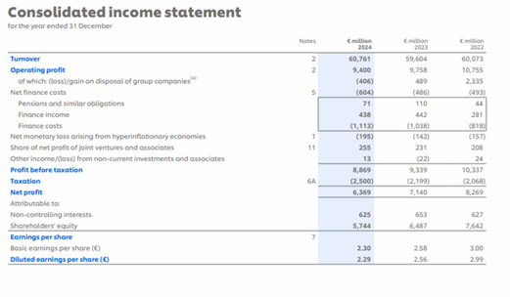
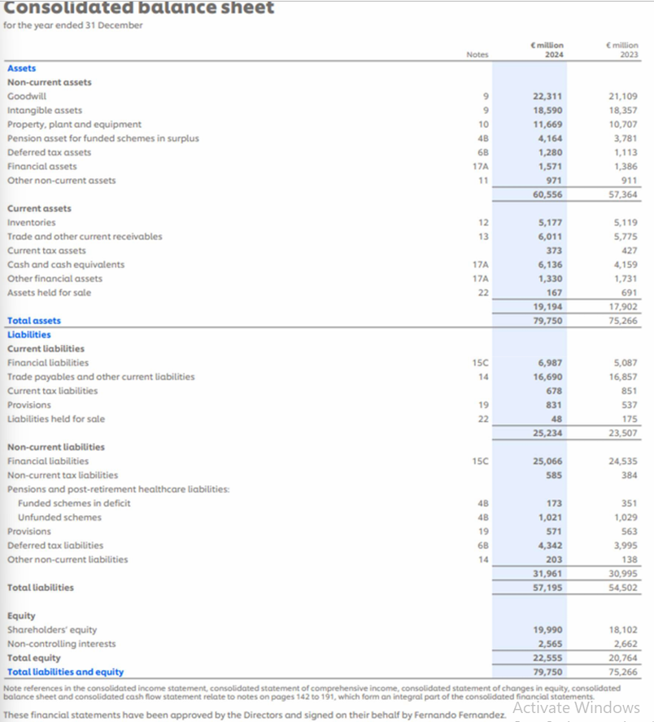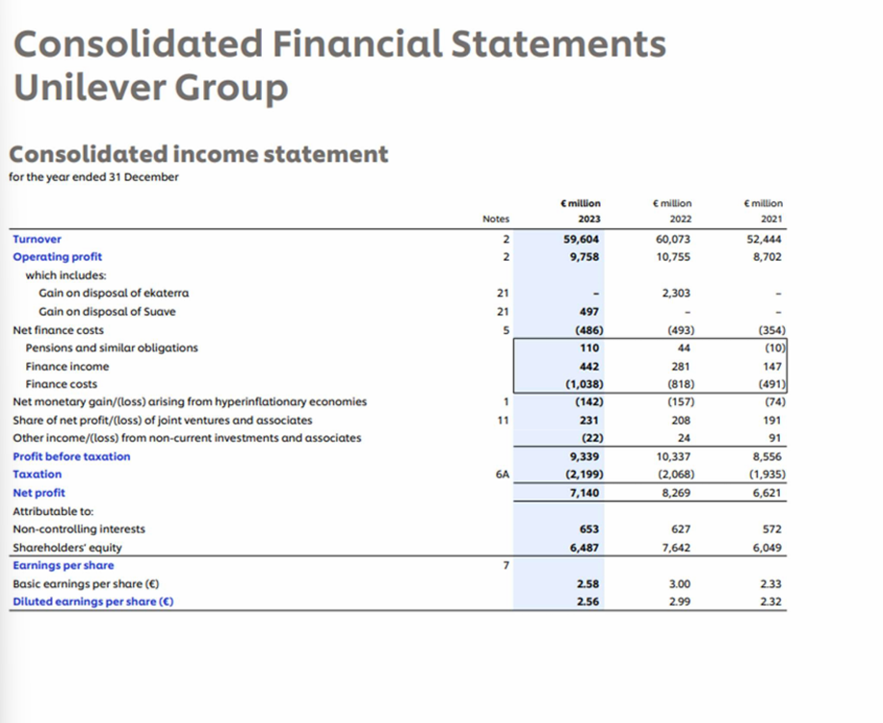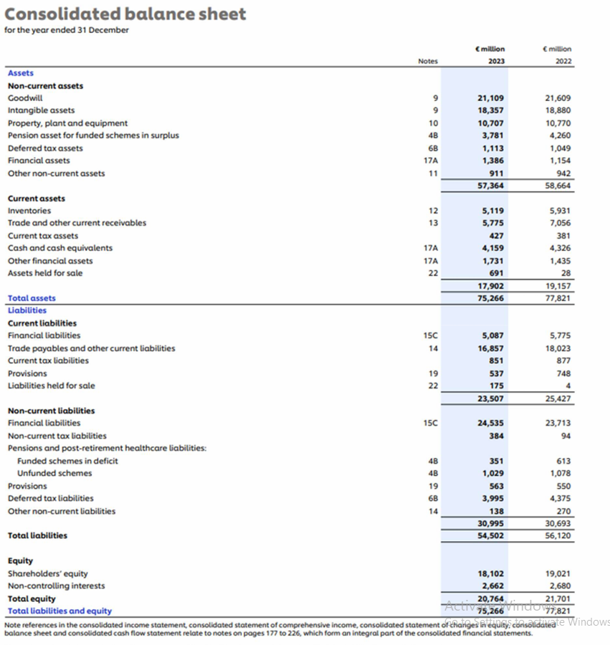

Appendix B: Unilever ratio calculations
Ratio | Formula | 2025 substitution | 2025 | 2024 substitution | 2024
Gross margin | Gross profit / turnover | 23,709 / 50,503 | 46.95% | 24,503 / 52,479 | 46.69%
Operating margin | Operating profit / turnover | 9,037 / 50,503 | 17.89% | 8,829 / 52,479 | 16.82%
Net margin | Continuing net profit / turnover | 6,213 / 50,503 | 12.30% | 6,039 / 52,479 | 11.51%
ROCE | Operating profit / (assets − current liabilities) | 9,037 / 48,809 | 18.51% | 8,829 / 54,516 | 16.20%
Current ratio | Current assets / current liabilities | 17,066 / 21,662 | 0.79x | 19,194 / 25,234 | 0.76x
Quick ratio | (Current assets − inventory) / current liabilities | 13,023 / 21,662 | 0.60x | 14,017 / 25,234 | 0.56x
Net debt / equity | Net debt / total equity | 23,076 / 17,587 | 131.21% | 24,519 / 22,555 | 108.71%
Interest cover | Operating profit / finance costs | 9,037 / 1,024 | 8.83x | 8,829 / 994 | 8.88x
Inventory turnover | Cost of sales / closing inventory | 26,794 / 4,043 | 6.63x | 27,976 / 5,177 | 5.40x
Inventory days | Closing inventory / cost of sales × 365 | 4,043 / 26,794 × 365 | 55.08 | 5,177 / 27,976 × 365 | 67.54
Receivable days | Trade receivables / turnover × 365 | 4,852 / 50,503 × 365 | 35.07 | 4,227 / 52,479 × 365 | 29.40
Asset turnover | Turnover / closing total assets | 50,503 / 70,471 | 0.72x | 52,479 / 79,750 | 0.66x
ROE | Continuing attributable profit / average shareholders’ equity | 5,682 / 17,760 | 31.99% | 5,430 / 19,046 | 28.51%
EPS growth | (EPS 2025 − EPS 2024) / EPS 2024 | (2.60 − 2.45) / 2.45 | 6.12% | — | —
Dividend cover | Continuing attributable profit / ordinary dividends | 5,682 / 4,453 | 1.28x | 5,430 / 4,320 | 1.26x

Appendix C: Beard Plc investment calculations
Table C1. Tax and after-tax operating cash flows (£000)
Option | Year | Pre-tax CF | Capital allowance | Taxable CF | Tax @ 25% | After-tax CF
A | 1 | 100.00 | 120.00 | -20.00 | -5.00 | 105.00
A | 2 | 180.00 | 120.00 | 60.00 | 15.00 | 165.00
A | 3 | 210.00 | 120.00 | 90.00 | 22.50 | 187.50
A | 4 | 260.00 | 120.00 | 140.00 | 35.00 | 225.00
B | 1 | 220.00 | 180.00 | 40.00 | 10.00 | 210.00
B | 2 | 270.00 | 180.00 | 90.00 | 22.50 | 247.50
B | 3 | 350.00 | 180.00 | 170.00 | 42.50 | 307.50
B | 4 | 400.00 | 180.00 | 220.00 | 55.00 | 345.00
C | 1 | 250.00 | 200.00 | 50.00 | 12.50 | 237.50
C | 2 | 310.00 | 200.00 | 110.00 | 27.50 | 282.50
C | 3 | 400.00 | 200.00 | 200.00 | 50.00 | 350.00
C | 4 | 430.00 | 200.00 | 230.00 | 57.50 | 372.50

Table C2. NPV calculations at 5% (£000)
Item | Year 0 | Year 1 | Year 2 | Year 3 | Year 4 | NPV
Discount factor | — | 0.952381 | 0.907029 | 0.863838 | 0.822702 | —
A: PV | (600.00) | 100.00 | 149.66 | 161.97 | 185.11 | −3.26
B: PV | (900.00) | 200.00 | 224.49 | 265.63 | 283.83 | 73.95
C: PV | (1,000.00) | 226.19 | 256.24 | 302.34 | 306.46 | 91.23

Table C3. Option C IRR interpolation (£000)
Trial rate | PV of inflows | NPV
8% | 1,013.75 | 13.75
9% | 989.82 | −10.18

IRR ≈ 8% + [13.75 / (13.75 + 10.18)] × 1% = 8.57%. The exact numerical solution is approximately 8.5699%.
Table C4. Divisible capital-rationing schedule (£000)
Rank | Option | NPV / outlay | Investment used | Fraction | NPV obtained
1 | C | 0.091226 | 1,000.00 | 100.00% | 91.23
2 | B | 0.082169 | 500.00 | 55.56% | 41.08
3 | A | −0.005438 | 0.00 | 0.00% | 0.00
Total | — | — | 1,500.00 | — | 132.31

