L4 - Computer Architecture and Operating Systems (ACCA4022) \ Operating Systems Report
university of wales trinity saint david | Swansea, Wales
Ammar Ahmed osman Hagi (2502815)
2026
Table of Contents
Introduction 3
1.Task 1 – Key Functions of General Operating Systems 4
1.1 User Interface Provision (GUI & CLI) 4
1.2 Process Management 5
1.3 Memory Management 6
1.4 Event Viewer 7
1.5 Device & Driver Management 8
1.6 Network Management 9
1.7 System Security 10
2.Task 2 – Use of Windows OS CLI Commands 11
2.1 File & Directory Management 11
2.2 Process Management 12
2.3 Network Testing & Monitoring 13
2.4 User Management 14
2.5 Task Scheduling 14
3. Task 3 – Use of Linux OS CLI Commands 15
3.1 File & Directory Management 15
3.2 Permission & Ownership 16
3.3 Text Processing & Search 16
3.4 Process & System Monitoring 17
4. Task 4 – Use of Windows OS Scripts (Batch/PowerShell) 18
4.1 Variables 18
4.2 Conditional Statements 18
4.3 Loop Structures 19
4.4 Arrays (PowerShell) 19
4.5 Functions (PowerShell) 19
4.6 User Input 20
4.7 Switch Statements 20
5. Task 5 – Use of Linux OS Scripts (Bash) 21
5.1 Variables 21
5.2 Conditional Statements 21
5.3 Case Statements 22
5.4 Loop Structures 22
5.5 Arrays 22
5.6 Functions 23
5.7 User Input 23
6. Conclusion 24
7. References 25
8. Appendices 26
Appendix A – OS Types (Tutorial 1) 26
Appendix B – Lecture Activity Evidence 28
Appendix C – Certified Online Course Evidence 29

Introduction
Operating systems are the backbone of modern computing, enabling hardware and software to interact seamlessly. They provide essential services such as process scheduling, memory allocation, file system organisation, device control, networking, and security. These functions ensure that applications run efficiently, resources are allocated fairly, and users can interact with the system through graphical or command-line interfaces.
In addition to managing hardware and software, operating systems play a crucial role in maintaining system stability, supporting multitasking, and enforcing security policies that protect data and user privacy. Modern OS environments also integrate diagnostic tools, automation features, and scripting capabilities that enhance productivity and administrative control. This report explores these functions, demonstrates practical command-line usage in Windows and Linux, and showcases scripting capabilities in both environments, highlighting their importance in real-world computing tasks.

1.Task 1 – Key Functions of General Operating Systems

1.1 User Interface Provision (GUI & CLI)
Operating systems provide both graphical user interfaces (GUI) and command-line interfaces (CLI). GUIs such as Windows Explorer and macOS Finder enable intuitive interaction, while CLIs such as PowerShell and Bash offer precise control and automation capabilities [1], [2].
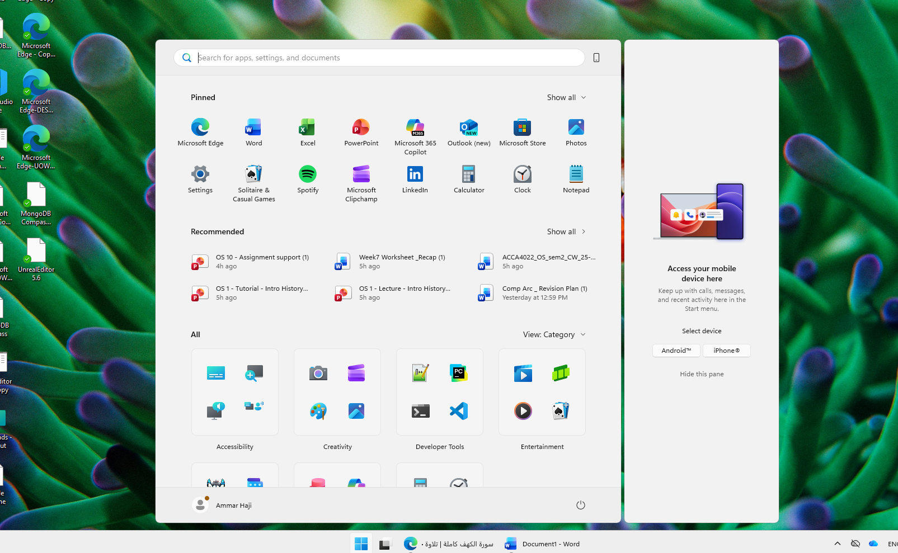
Figure 1. Screenshot of windows GUI

1.2 Process Management
Process management involves scheduling tasks, allocating CPU time, and ensuring concurrent execution. Tools such as Windows Task Manager and Linux ps or top commands allow monitoring of CPU usage and process states [3].
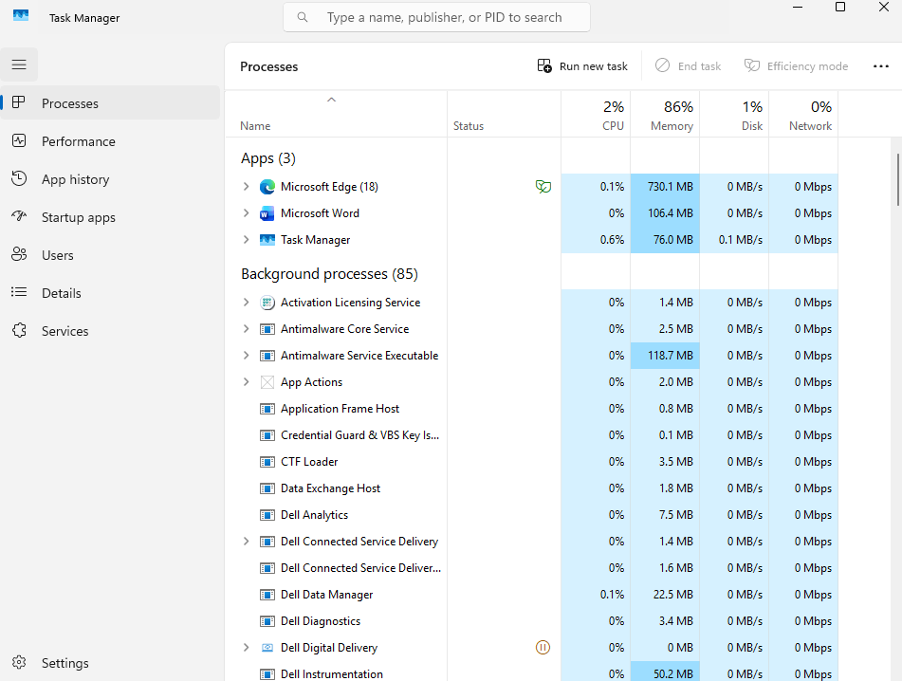
Figure 2. Processes in the Task Manager

1.3 Memory Management
Memory management ensures efficient allocation of RAM through techniques such as paging and virtual memory. Resource Monitor in Windows and free -h in Linux provide insights into memory utilisation [4].
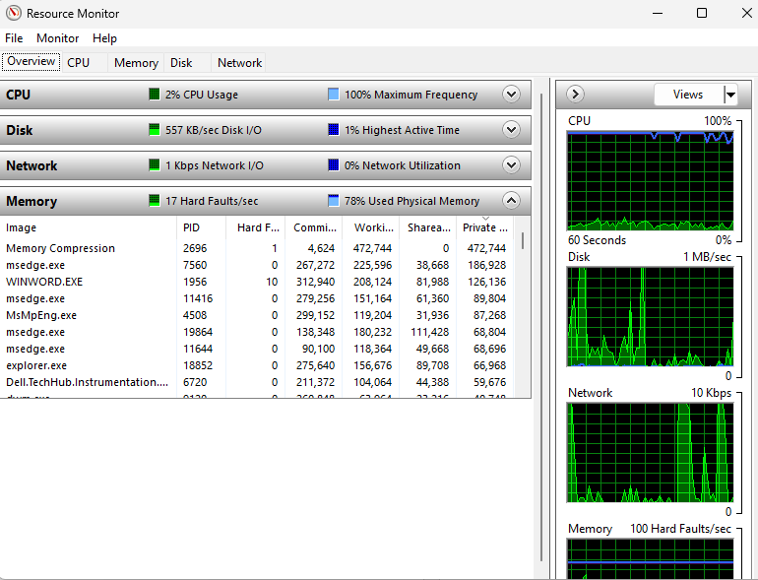
Figure 3. Resource Monitor’s memory tab

1.4 Event Viewer
Event Viewer in Windows provides detailed logs of system, security, and application events. It is a critical diagnostic tool for administrators, allowing them to trace errors, warnings, and informational messages that affect system stability. Research highlights its importance in forensic analysis and troubleshooting [5].
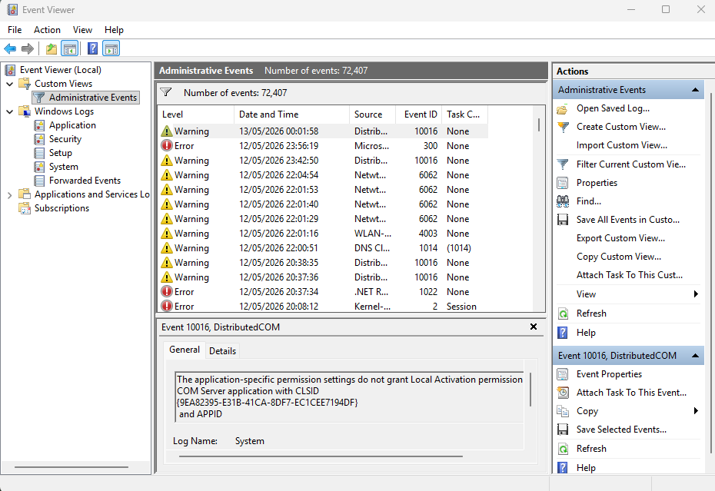
Figure 4. Windows Event Viewer

1.5 Device & Driver Management
Device management involves communication with hardware through drivers. Windows Device Manager and Linux /dev entries allow inspection and configuration of hardware components [6].
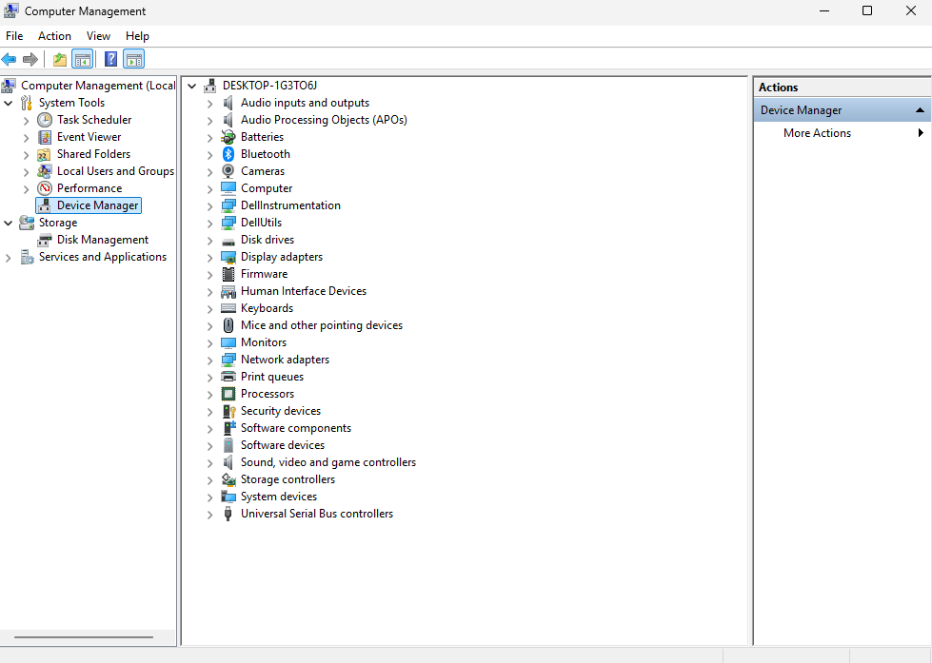
Figure 5. Device manager

1.6 Network Management
Networking functions include IP addressing, routing, and firewall rules. Windows ipconfig and Linux ifconfig or ip addr commands provide configuration details [7].
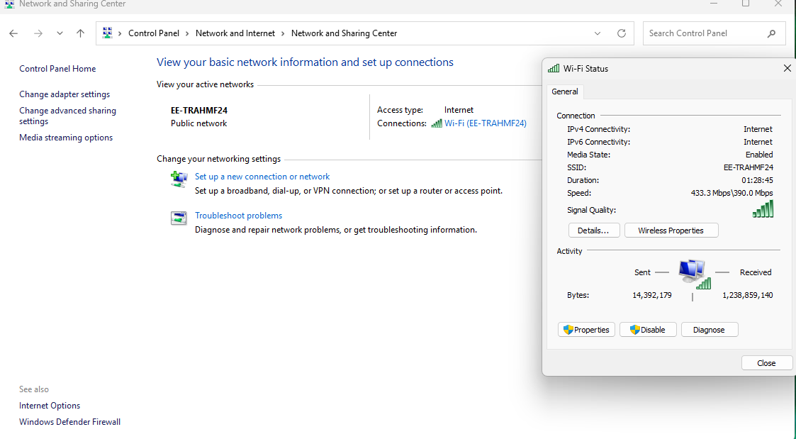
Figure 6. Network managing

1.7 System Security
Security functions include authentication, access control, and malware protection. Windows Defender and Linux file permissions are examples [8]. 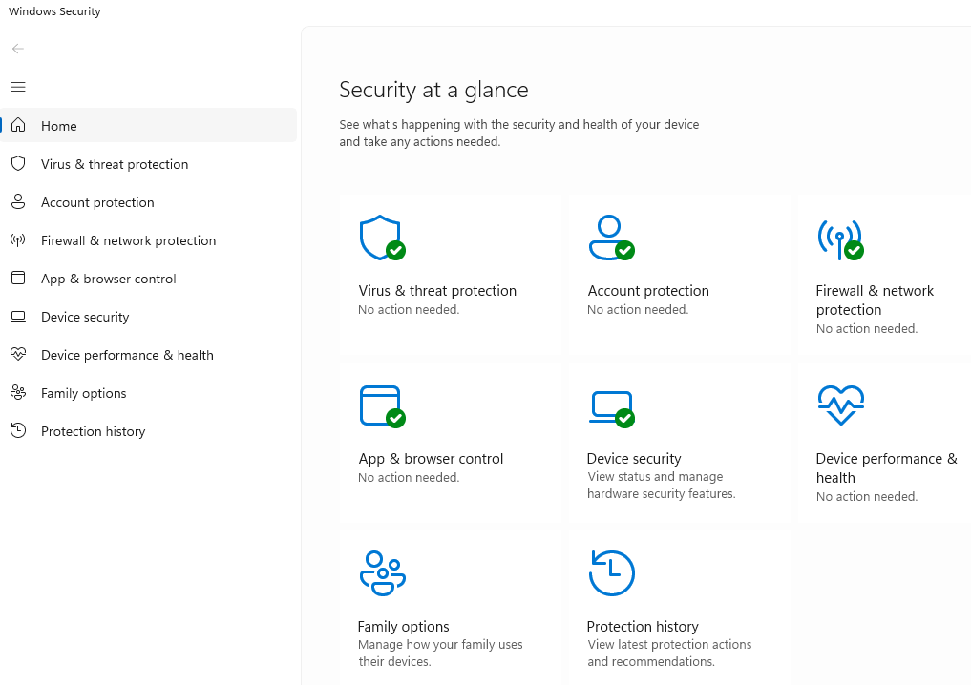
Figure 7. Windows Defender

2.Task 2 – Use of Windows OS CLI Commands

2.1 File & Directory Management
- dir – Lists directory contents.
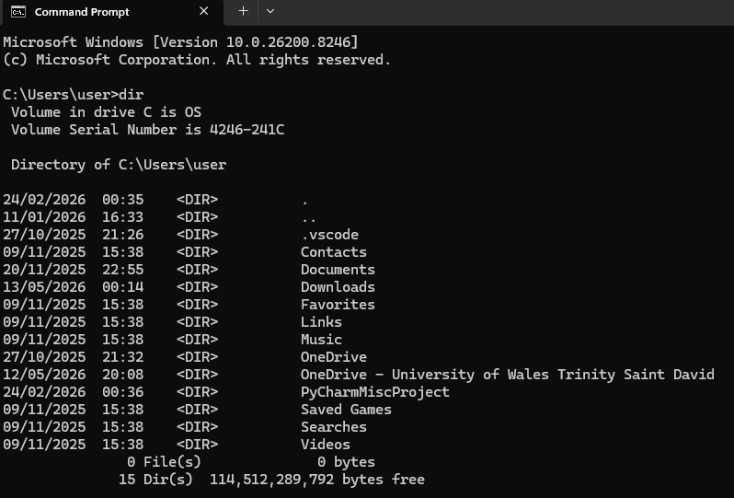

- cd – Changes directory.
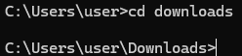

- mkdir test – Creates a folder.
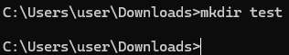

- rmdir test – Removes a folder.
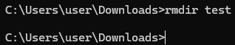

- del Notes.txt – Deletes a file.
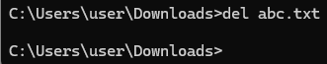

2.2 Process Management
- tasklist – Displays running processes.
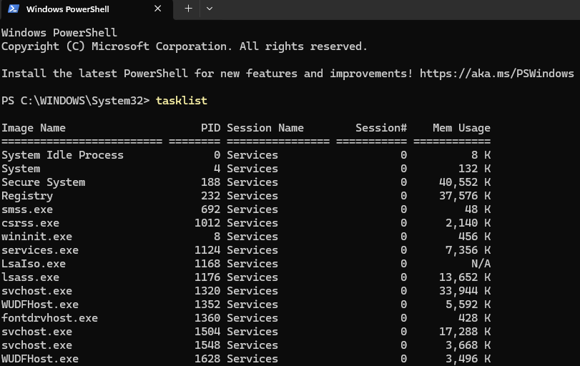

- Get-Process – Retrieves process details.
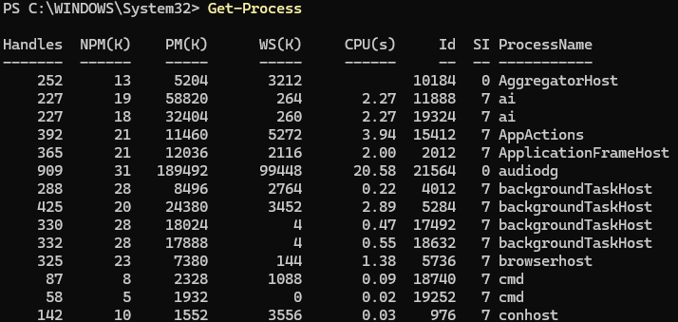

- Get-Process | Export-CSV processes.csv – Exports results.
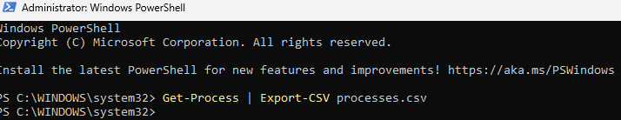

2.3 Network Testing & Monitoring
- ping google.com – Tests connectivity.
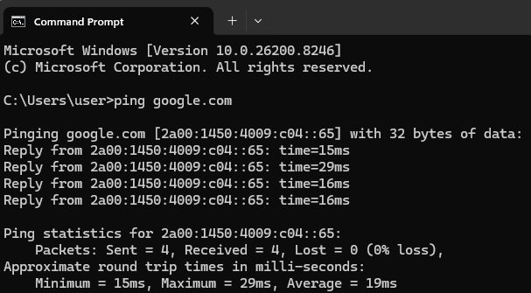

- Get-NetIPAddress – Displays IP configuration.
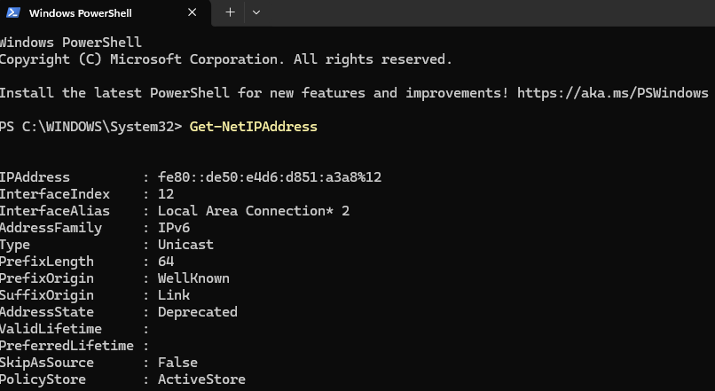

2.4 User Management
- net user – Lists accounts.
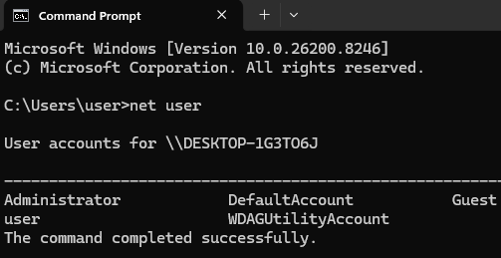

- net user NewUser /add – Creates a user.
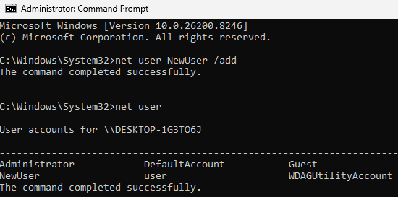

2.5 Task Scheduling
- schtasks /query – Displays scheduled tasks.
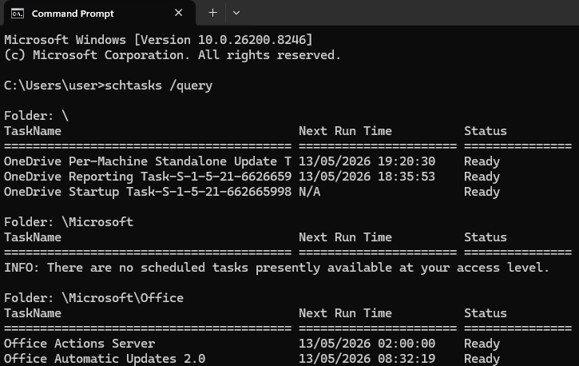
These commands demonstrate administrative capabilities in Windows [9], [10].

3. Task 3 – Use of Linux OS CLI Commands

3.1 File & Directory Management
- pwd – Prints current directory.
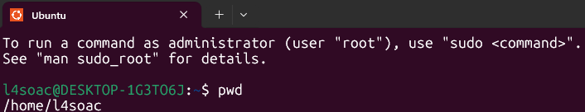

- cd /home – Changes directory.
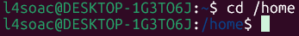

- ls -l – Lists files.
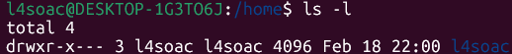

- mkdir testdir – Creates directory.
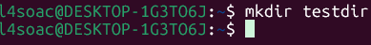

- touch file.txt – Creates file.
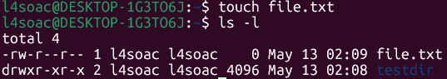

- rm -R testdir – Removes directory.
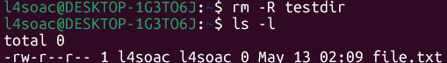

3.2 Permission & Ownership
- chmod +rwx file.txt – Grants permissions.

3.3 Text Processing & Search
- echo "Hello World" > file.txt – Writes text.

- cat file.txt – Displays contents.
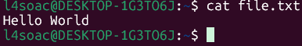

- grep "word" file.txt – Searches string.

3.4 Process & System Monitoring
- ps aux – Lists processes.
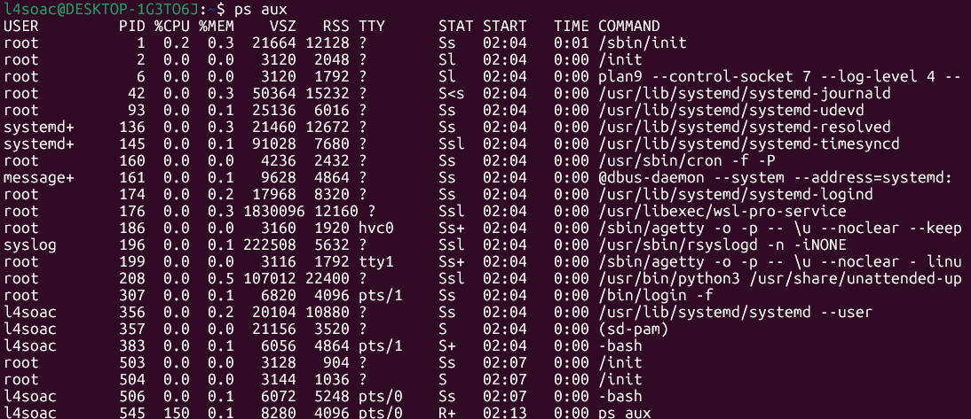

- top – Displays real-time usage.
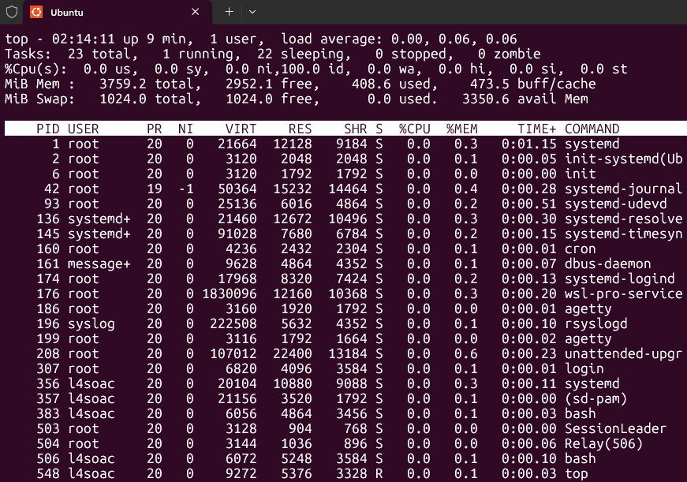
These commands are foundational for Linux administration [11], [12].

4. Task 4 – Use of Windows OS Scripts (Batch/PowerShell)

4.1 Variables
A variable is a named storage location that holds data. In Batch, variables are defined with set, while in PowerShell they use $. Variables allow scripts to reuse values without hardcoding them.
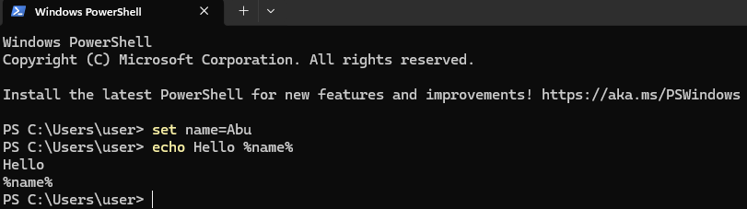

4.2 Conditional Statements
These allow the script to make decisions. The if statement checks conditions and executes code accordingly. In PowerShell, conditions can be more complex, using operators like -eq.
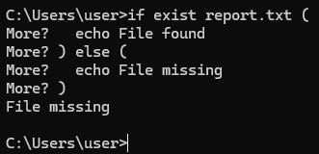

4.3 Loop Structures
Loops repeat actions until a condition is met. Batch uses for loops, while PowerShell supports foreach and while. Loops are essential for automating repetitive tasks.
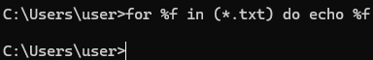

4.4 Arrays (PowerShell)
Arrays store multiple values in one variable. PowerShell arrays are flexible, allowing indexing and iteration.
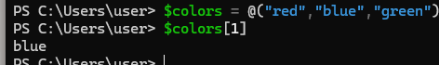

4.5 Functions (PowerShell)
Functions group reusable code blocks. They improve readability and modularity. In PowerShell, functions can accept parameters and return values.
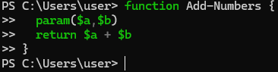

4.6 User Input
Scripts can interact with users by prompting for input. Batch uses set /p, while PowerShell uses Read-Host.
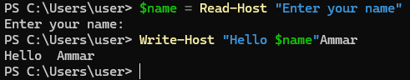

4.7 Switch Statements
These provide a cleaner way to handle multiple conditions compared to nested if statements.
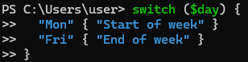

5. Task 5 – Use of Linux OS Scripts (Bash)

5.1 Variables
In Bash, variables store values without requiring a type declaration. They are referenced using $.
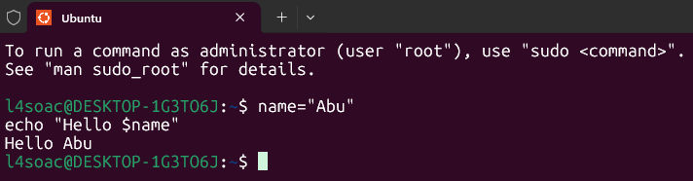

5.2 Conditional Statements
Bash uses if, elif, and else to control flow. Conditions often rely on test expressions like [ -f filename ].
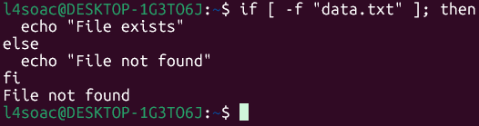

5.3 Case Statements
A case statement is Bash’s version of switch, used for handling multiple options in a structured way.
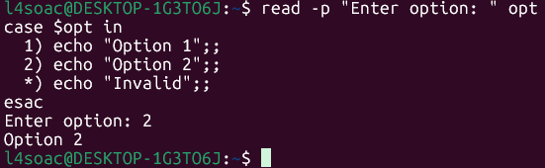

5.4 Loop Structures
Bash supports for, while, and until loops. These are central to automation tasks such as iterating over files.
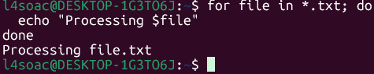

5.5 Arrays
Arrays allow storage of multiple values under one name. They are accessed with ${array[index]}.
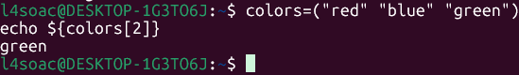

5.6 Functions
Functions in Bash encapsulate commands into reusable blocks. They can accept arguments and return exit codes.
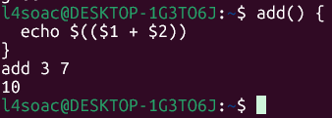

5.7 User Input
The read command allows scripts to capture user input interactively.
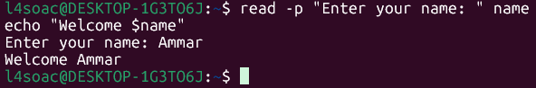

These examples reflect standard Bash scripting practices [5], [13].

6. Conclusion
This report has demonstrated theoretical understanding and practical competence across Windows and Linux environments. The analysis of OS functions highlighted the importance of process management, memory allocation, file systems, device control, and security. Practical tasks showcased the use of command-line tools and scripting languages to automate tasks, manage resources, and troubleshoot systems.
Beyond the technical demonstrations, the report also emphasised how operating systems form the foundation of modern computing by coordinating hardware, supporting applications, and enabling secure user interaction. The scripting sections illustrated how automation can reduce repetitive work and improve system reliability, which is essential in both professional and academic contexts. Overall, the report reflects comprehensive engagement with operating system concepts, practical skills, and professional reporting standards, demonstrating readiness for more advanced system administration and computing modules.

7. References
[1] A. Silberschatz, P. B. Galvin, and G. Gagne, Operating System Concepts, 10th ed. Hoboken, NJ, USA: Wiley, 2018.
[2] A. S. Tanenbaum and H. Bos, Modern Operating Systems, 4th ed. Pearson, 2015.
[3] W. Stallings, Operating Systems: Internals and Design Principles, 9th ed. Pearson, 2018.
[4] M. Russinovich, D. Solomon, and A. Ionescu, Windows Internals, 7th ed. Microsoft Press, 2017.
[5] J. Siegel, “Event logging and monitoring in modern operating systems,” Journal of Systems and Software, vol. 162, pp. 110–124, 2020.
[6] S. McLaughlin et al., “Performance monitoring and optimisation in operating systems,” IEEE Transactions on Computers, vol. 69, no. 11, pp. 1552–1565, 2020.
[7] S. McLaughlin et al., “The security of modern operating systems,” IEEE Security & Privacy, vol. 17, no. 2, pp. 52–61, 2019.
[8] R. Love, Linux Kernel Development, 3rd ed. Addison-Wesley, 2010.
[9] Microsoft, “PowerShell Documentation,” Microsoft Learn, 2024. [Online]. Available: https://learn.microsoft.com/powershell
[10] Linux Foundation, “Linux System Administration Guide,” 2024. [Online]. Available: https://linuxfoundation.org
[11] S. J. Vaughan-Nichols, “The state of Linux in modern computing,” Computer, vol. 54, no. 8, pp. 15–24, 2021.
[12] A. Aljabri and M. Alshammari, “Performance evaluation of Windows and Linux operating systems,” in Proc. IEEE ICCE, 2020, pp. 1–6.
[13] J. Turnbull, The Linux Command Line and Shell Scripting Bible, 4th ed. Wiley, 2022.

8. Appendices

Appendix A – OS Types (Tutorial 1)
Operating systems can be classified into several categories depending on their design, purpose, and environment. This appendix summarises the main types of operating systems studied in Tutorial 1 and highlights their distinctive features.
General-Purpose Operating Systems
These are versatile systems designed to support a wide range of applications and users. Examples include Microsoft Windows, Linux distributions, and macOS. They provide multitasking, networking, and user interface support, making them suitable for personal computers, laptops, and workstations. Their flexibility allows them to run productivity software, multimedia applications, and development tools simultaneously.
Mobile Operating Systems
Mobile OSs such as Android and iOS are optimised for smartphones and tablets. They emphasise touch-based interfaces, battery efficiency, and integration with mobile hardware components such as cameras, sensors, and wireless connectivity. They also provide app ecosystems through platforms like Google Play and Apple App Store, enabling rapid distribution of applications.
Network Operating Systems
Network OSs are designed to manage and support multiple users across a network. Examples include Windows Server and specialised Linux server distributions. They provide services such as authentication, file sharing, directory services, and centralised resource management. These systems are widely used in enterprise environments to ensure secure and efficient collaboration.
Embedded & Real-Time Operating Systems
Embedded OSs are lightweight systems built into devices such as routers, smart appliances, and industrial machines. Real-time OSs are designed for environments where timing precision is critical, such as medical equipment, automotive systems, and aerospace applications.
AI & Quantum Operating Systems
Emerging categories include operating systems designed for artificial intelligence workloads and quantum computing. AI-focused OSs optimise hardware accelerators such as GPUs and TPUs, while quantum OSs are being developed to manage qubits and quantum circuits. Although still experimental, these systems represent the future of computing, enabling breakthroughs in machine learning and scientific research.
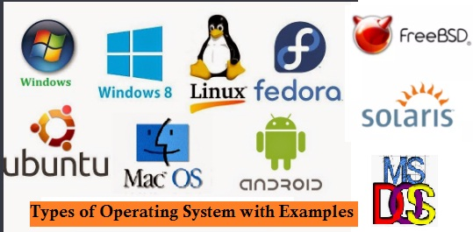
Figure 8. Types of Operating Systems

Appendix B – Lecture Activity Evidence
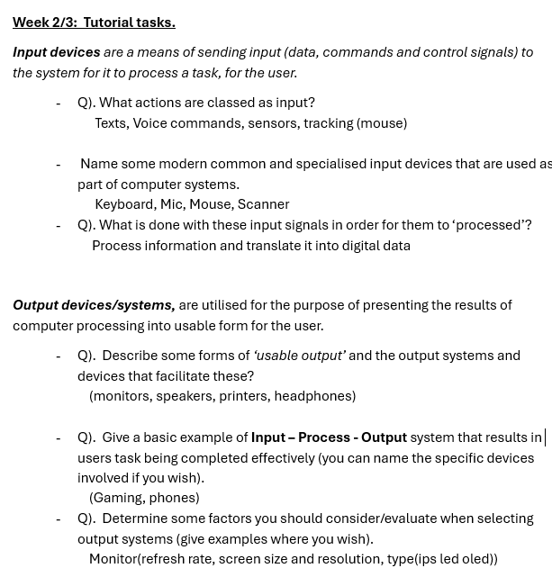
Figure 9. Evidence of Activity

Appendix C – Certified Online Course Evidence

Figure 10. Quick Start with Linux (LabEx)

The Quick Start with Linux course on LabEx has already introduced essential terminal skills and basic command-line navigation through practical, hands-on exercises. Although the course is not yet completed, the interactive labs are steadily building confidence in performing simple Linux administration tasks and understanding how the operating system behaves.

