Report- Research Report
Student Name: Ioana Vasiliu
Student Number: 2017455
Lecturer Name: Seyed Navid Nasirpour

BMSW4003_BIRM
Digital Skills and Research Methods

Abstract
There is a increase in the technology development in the education system after the breakout of the covid-19 pandemic. All the universities had to adopt virtual learnig immediately. It has various positive and negative impact in the learnig process of students in universities. Any new development in the technology has a lot of effect on the user as it includes several requirments of skills to adopt the change. Learning process is the most vital part in the education in universities. Different students have different capabilities and that impacts their process of learning.

Table of Contents

Introduction 4
Rationale 4
Research Objectives 4
Literature Review/Review of the existing literature 4
Research Methodology 6
Research method and the methodology 6
Qualitative, Quantitative and combined approaches 6
Data, Primary and secondary data 7
Data collection process 7
Population, Sample and Sample size 7
Ethics in data collection? 8
Results/Findings, analysis and discussion 8
Primary data analysis 8
Secondary data analysis 9
Thematic analysis 1- “Professional learner’s engagement using VLE” 9
Thematic analysis 2- “Impact of VLE on students” 9
Summary of the findings 9
Conclusion and Recommendation 10
References: 11
Appendices 13
Appendix 2 (Class activity 2-Excel Result table) 13

Introduction
The purpose of the below study is to discuss the impact of virtual learning on the learning experience of students in the UWTSD Birmingham Campus. UWTSD Birmingham is the fourth campus of the university and a very popular university in England. The university was formed after the merger of two universities, the University of Wales and the Trinity Saint David. Later in 2013 the university also merged with Swansea Metropolitan University.

Rationale
After the breakout of the covid-19 pandemic, the system of virtual learning got popular among the universities of the United Kingdom. The virtual learning process of UWTSD Birmingham Campus has lots of advantages but it also has challenges that impact the learning of students. The most important challenge that students face is the problem of distractions during virtual learning. Distractions are the most difficult challenge in virtual learning in the absence of classroom setups. Another challenge the university faces is providing education to those who do not have access to digital platforms and have limited or no broadband provisions (UWTSD, 2022).

Research Objectives
- To discuss the positive and negative impact of the virtual learning process on the learning of the students in UWTSD Birmingham Campus .
- To research, the effects students face in the process of virtual learning in UWTSD Birmingham Campus.
- To discuss the strategies to overcome the challenges faced by the students during the process of virtual learning at UWTSD Birmingham Campus.

Literature Review/Review of the existing literature
Moodle
It is a form of e-learning that involves the use of technological tools. It is a process through which students learn from anywhere at any time that extends the classroom education to the web. The study shows that the introduction of Moodle learning has increased productivity, enhanced efficiency and improved the performance of the students. As the process includes a lot of research and reading to find the information from the links and sources provided by the lecturers of the students which better informs about the learnings the students. The acceptance of Moodle among the students is positive but the speed of the tool needs to be increased which is to be done by the universities through special arrangements (QUANSAH and Essiam, 2021).
Impact of VLE:
The impact of Virtual Learning Environment (VLE; as an example, Moodle of our university) on the learning experience of the students at UWTSD Birmingham campus.The virtual learning environment is beneficial for students as well as brings negative effects. Students who do not have technological skills can cause anxiety and poor learning for the students. Whereas the students who have excellent technical skills are highly beneficial for the introduction of virtual learning. Most students find it easy to learn from the virtual environment. It is very effective for distance learning as students do not require to travel, it saves on the cost of travel and accommodation. The virtual learning environment also saves a lot of time in the process of learning as it eliminates the time required in travelling in distance learning and motivates the students to balance their learning and other work. Virtual learning saves a lot of time that is included in the process of traditional classroom learning (Jimmy, 2021).
Challenges of Moodle
Moodle is a virtual learning platform that has a challenge of lack of interaction between the students and teacher in the process of learning. From the review, it is found that the platform does not provide effective ways to have interactions between the teachers and classmates. Another challenge to the lack of interaction is fear of speaking in public due to the judgment from the other classmates and teachers. Distraction is the other most important challenge faced by students while learning in Moodle. The main reason for this challenge is the absence of an appropriate learning environment. Many students do not have internet connections in their homes and have to rush to the net shops or cafes to get access to the internet and those places are generally full of crowds which is the most distracting element for the students. It is challenging to have an effective learning process through Moodle (Tu and Luong, 2021).
VLE creates independent learners
The virtual learning process involves a lot of self-determination and dedication to learning in the students and several factors distract students from learning effectiveness in the absence of a traditional learning environment. It encourages the process of successful independent learning as it helps students to absorb content more effectively which enables them to achieve more information regarding their studies. It motivates the students and eliminates the requirement of continuous monitoring by the teacher as the students have to read and research from the source given by the teacher in online learning and there are very minimal interactions between the teachers and students (Handayani et al., 2022).

Research Methodology

Research method and the methodology
The researcher will use close-ended survey research methods to collect the topic-related information. Due to primary research, the researcher will apply this method. The survey will be done through questionnaires where a total of 5 questions will be asked. The respondents have to give answers on 'strongly agree', 'agree', 'neutral', 'disagree' and 'strongly disagree'. It is the simplest quantitative research form due to information being simple to be combined and quantified.
The researcher will apply thematic analysis to collect the data. Due to secondary research, the researcher will apply thematic analysis. The researcher will use authentic or peer-reviewed journals, articles or books to collect the data. The data will be collected related to VLE or Virtual Learning Environment impact on student's learning experience at the Birmingham campus of UWTSD (Library, 2022).

Qualitative, Quantitative and combined approaches
The researcher will use both primary quantitative and secondary qualitative methods to collect the data. The researcher will apply these to collect data related to the positive and negative impact of VLE on the learning experience of students at UWTSD's Birmingham campus. Quantitative research's purpose is to attain bigger knowledge and the social world's understanding. Even the researcher applies this method for observing the events or situations which affect the people (Hafidz and Elihami, 2021).
The researcher applies secondary qualitative research to collect the data. The secondary analysis has vital implications for the qualitative research for investigating sensitive topics like VLE's role in student learning.

Data, Primary and secondary data
The researcher will collect primary data from UWTSD Birmingham Campus students and teachers to understand their opinion on online learning. For this primary data will be collected through surveys. On the other hand, the researcher will collect secondary data from journals or articles on VLE learning's impact on UWTSD Birmingham Campus's students.

Data collection process
For primary quantitative data collection, a survey technique will be used. The researcher will distribute survey questions via email to respondents and collect the data from the same process. The questions will be close-ended and will be asked as per the topics.
The secondary qualitative data will be collected by researching peer-reviewed sources on URLs like Google Scholar or the university library. Peer-reviewed sources will ensure the authenticity and originality of the data (Pandey and Pandey, 2021).

Population, Sample and Sample size
The research population for this research is 120 and the sample size is 79. The respondents will be mainly teachers and students of UWTSD Birmingham Campus. The researcher to collect the data will use random probability sampling where researchers can randomly collect data from the respondents.

Ethics in data collection?
The researcher will ensure respondents that data will be collected only for University purposes. The confidentiality and security will be maintained by the respondent's data. For that purpose ethics, an approval form will be signed.

Results/Findings, analysis and discussion

Primary data analysis
The table and graph show out of 79 respondents 29 strongly agreed about the fact which is 36.7% of the total percentage. The graph also states that out of 79 respondents 20 agreed, and 19 disagreed about the fact which is 25.31% and 24.05% respectively.
The graph and table show out of 79 respondents 20 agreed about the fact which is 25.31% of the total percentage. The table also shows out of 79 respondents 19 agreed and disagreed about the fact which is 24.05%.
The table and graph show out of 79 respondents 20 strongly agreed about the fact that is 25.31% of the total percentage. The table also shows out of 79 respondents 14 strongly disagreed about the fact which is 17.72%.
The graph and table show out of 79 respondents 29 strongly agreed about the fact which is 36.7% of the total percentage. The table also shows out of 79 respondents 19 disagreed and 10 strongly disagreed about the fact which is 24.05% and 12.65% respectively.
The graph and table show out of 79 respondents 19 disagreed about the fact which is 24.05% of the total percentage. The table also shows out of 79 respondents 18 strongly agreed and agreed about the fact which is 22.78%.

Secondary data analysis

Thematic analysis 1- “Professional learner’s engagement using VLE”
The secondary data shows that VLEs constitute a vital resource for learners in higher education however information on learners' engagement with the VLEs is entirely limited. From the secondary research, it is determined the information described in the case study is linked solely to the part-time, also distance learners instead of well-known institutional learners as a whole. The results of secondary research show that WWBL learners can become unique from the perspective of existing literature on the engagement of VLE. This tends to be considered either the full-time, campus-based students or are entirely distance-based. These learners on the module were highly work-based and also received both VLE support and 'face-to-face' based on the blended provision. The secondary research shows the role of tutors in promoting engagement (Davies and Harris, 2022).

Thematic analysis 2- “Impact of VLE on students”
This secondary research determines the impact of VLE moodle usage on learning and determines whether VLE usage has a positive impact on student learning, VLE usage in learning and teaching supports independent learning. The research highlights usage of Moodle develops the improvement in motivation and learning for learning as reported by participants of students. Even research identifies a teacher's role in promoting VLE usage for enhancing learning (Barker and Gossman, 2022).

Summary of the findings
The primary research determines Moodle is user-friendly and supports learning during COVID-19. The research also determines that VLE develops a positive impact on learnings as this saves time and also transport costs. Research also identifies teaching in the moodle that is effective enough for handling students and delivering answers to the students. Even research that determines the development of online learning creates isolation among students.
The secondary data identify tutors who are promoting the VLE engagements and create positive impacts and motivation for VLE students.

Conclusion and Recommendation
Conclusion:
In conclusion, the Virtual learning environment has a lot of positive and negative impacts on the learning of the students at UWTSD Birmingham Campus. Moodle is a user-friendly tool and helped in the process of learning during the pandemic. Although it has a challenge regarding the interaction of the teachers and students, it has been proven to be helpful for the students as it promotes independent learning. The virtual learning environment has a negative impact in that it can create feelings of isolation in the students but there are a lot of positive impacts on the learning of the students as it saves the time the students and transport cost. It also helps to motivate students by identifying the tutors.
Recommendation
● Students can avoid isolation problems by starting with empathy during an online class. It will be hard to start with empathy in wonderful and strange times. Therefore, students can presume that when they talk online with teachers or other students have a bad day. This will help the student to overcome the isolation issue (Lui, 2022).
● Teachers should let all students interact after the session. It will help students to interact and feel to ask questions to lecturers and other students to avoid loneliness.

References:
Barker, J. and Gossman, P., 2022. The Learning Impact of a Virtual Learning Environment: Students’ views. [online] Available at: <https://www.semanticscholar.org/paper/The-Learning-Impact-of-a-Virtual-Learning-Students%E2%80%99-Barker-Gossman/983e3d3775dd8ede730b3fcf4d945851e5abece4> [Accessed 29 July 2022].
Davies, C. and Harris, L., 2022. Engaging professional learners using the Virtual Learning Environment (VLE): a case study from social care - Research Repository. [online] Repository.used.ac.uk. Available at: <https://repository.uwtsd.ac.uk/id/eprint/1309/> [Accessed 29 July 2022].
Hafidz, M.A. and Elihami, E., 2021. LEARNING THE NONFORMAL EDUCATION THROUGH RESEARCH METHODOLOGY: A LITERATURE REVIEW. JURNAL EDUKASI NONFORMAL, 2(1), pp.47-55.
Handayani, I., Lustiyantie, N. and Chaeruman, U., 2022. Self Determined Learning Practice in English Speaking Class: A Heutagogical Perspective in EFL Class. IJLECR-INTERNATIONAL JOURNAL OF LANGUAGE EDUCATION AND CULTURE REVIEW, 8(1), pp.9-18.
Jimmy, M., 2021. The Factors Affecting the Adoption of Virtual Learning Environments (VLE) and Learner Management Systems (LMS) by Higher Education Students during and post-COVID-19 In Kenya. Journal of Language, Technology & Entrepreneurship in Africa, 12(2), pp.187-207.
Library, P., 2022. Pfeiffer Library: Research Methodologies: What are research methods? [online] Library.tiffin.edu. Available at: <https://library.tiffin.edu/researchmethodologies/whatareresearchmethods#s-lg-box-25345879> [Accessed 29 July 2022].
Lui, W., 2022. 7 Ways To Solve The Problem Of Loneliness In Online Learning. [online] eLearning Industry. Available at: <https://elearningindustry.com/ways-solve-problem-loneliness-in-online-learning> [Accessed 29 July 2022].
Pandey, P. and Pandey, M.M., 2021. Research methodology tools and techniques. Bridge Center.
QUANSAH, R. and Essiam, C., 2021. The use of learning management system (LMS) moodle in the midst of covid-19 pandemic: Students’ perspective. Journal of Educational Technology and Online Learning, 4(3), pp.418-431.
Tu, N.P. and Luong, T.K.P., 2021, March. Online language learning via Moodle and Microsoft Teams: students’ challenges and suggestions for improvement. In Proceedings of the AsiaCALL International Conference-Atlantis Press (Vol. 533, No. 978-94-6239-343-1, pp. 106-113).
UWTSD, W., 2022. Press Releases 2020 | University of Wales Trinity Saint David. [online] Uwtsdacuk. Available at: <https://www.uwtsd.ac.uk/news/press-releases/press-2020/uwtsds-digital-transformation-.html> [Accessed 29 July 2022].

Appendices
Appendix 1 (Class activity 1-Questionnaire)
- Do you think Moodle is user friendly and helps you in your learning during a pandemic?
- Do you agree, VLE creates a positive impact on your learnings as it saves time and transport costs?
- Do you think teaching in a moodle is effective enough to handle the students and give answers to students properly?
- Do you agree, online learning creates isolation and you are missing UWTSD campus?
- Do you think VLE learning helps you to become independent learners?

Appendix 2 (Class activity 2-Excel Result table)

Deliverables | Total respondents | Number of respondents | Percentage
Strongly agreed | 79 | 29 | 36.70%
Agreed | 79 | 20 | 25.31%
Neutral | 79 | 1 | 1.26%
Disagreed | 79 | 19 | 24.05%
Strongly disagreed | 79 | 10 | 12.65%
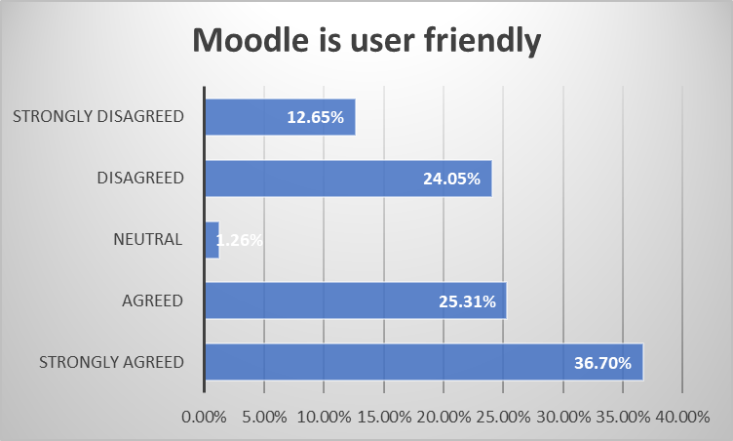
Deliverables | Total respondents | Number of respondents | Percentage
Strongly agreed | 79 | 19 | 24.05%
Agreed | 79 | 20 | 25.31%
Neutral | 79 | 10 | 12.65%
Disagreed | 79 | 19 | 24.05%
Strongly disagreed | 79 | 10 | 12.65%
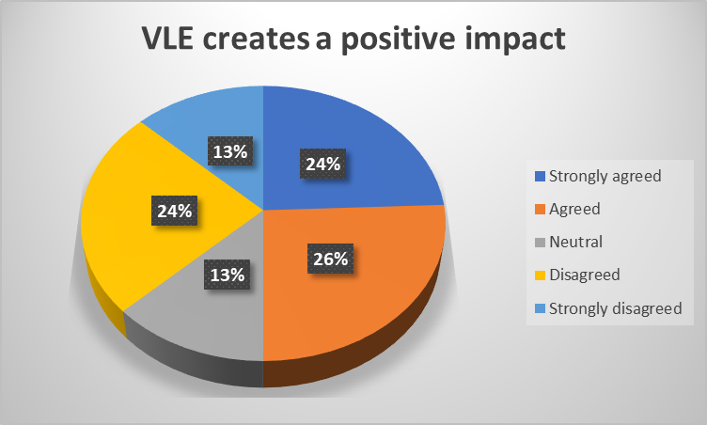
Deliverables | Total respondents | Number of respondents | Percentage
Strongly agreed | 79 | 20 | 25.31%
Agreed | 79 | 20 | 25.31%
Neutral | 79 | 5 | 6.32%
Disagreed | 79 | 20 | 25.31%
Strongly disagreed | 79 | 14 | 17.72%
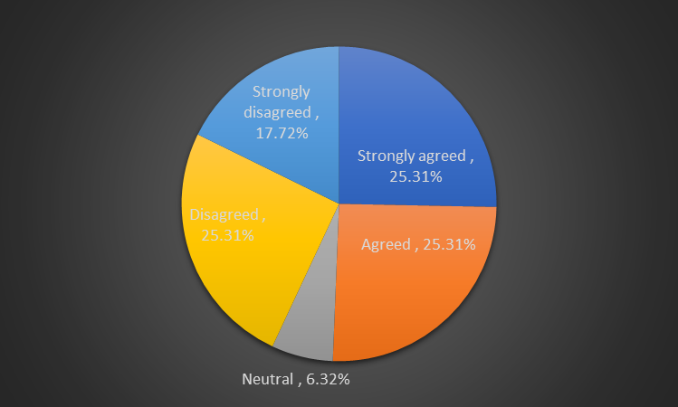
Deliverables | Total respondents | Number of respondents | Percentage
Strongly agreed | 79 | 29 | 36.70%
Agreed | 79 | 20 | 25.31%
Neutral | 79 | 1 | 1.26%
Disagreed | 79 | 19 | 24.05%
Strongly disagreed | 79 | 10 | 12.65%
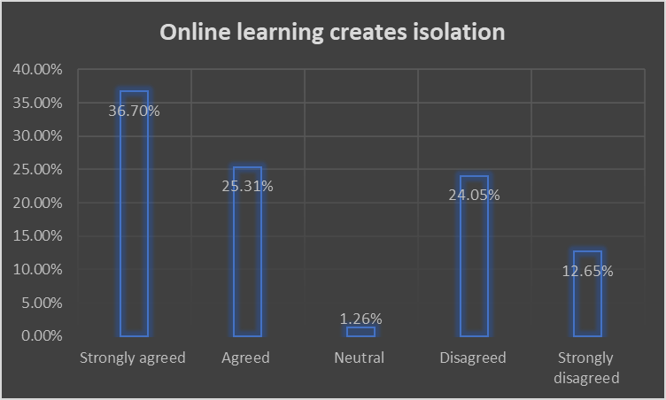
Deliverables | Total respondents | Number of respondents | Percentage
Strongly agreed | 79 | 18 | 22.78%
Agreed | 79 | 18 | 22.78%
Neutral | 79 | 10 | 12.65%
Disagreed | 79 | 19 | 24.05%
Strongly disagreed | 79 | 14 | 17.72%


