

Module Code: LCMB7023

Module Title: Human Capital Management

Assignment Title: Assessment Component 1: Individual Report – HR Strategy

Student Name: Md Abdulla Al Mamun

Student ID: 2503784

Module Tutor: Dr Charles Oham

Group: 02

Word Count: 2363

EXECUTIVE SUMMARY
Aether Innovations, a technology company with a workforce of 300, is presently facing flat revenue growth, rising employee turnover, and falling customer satisfaction; these challenges collectively suggest a core misalignment between its human resources strategy and its broader business goals. This scenario, as Ulrich (1997, p. 25) argues, serves as an illustration of the failure to incorporate human resources as a genuine strategic partner. This report responds with an evidence-based integrated HR strategy across two connected parts. There are two sections in this report. Both sections are connected. The first part is about how Aether Innovations could develop its strategic talent ecosystem. This part examines the competitive landscape of the tech talent market and recommends a hybrid build-buy approach for the company based on three broad approaches for retaining employees: mentorship programs, dual-path leadership development programs, and a lifelong learning framework. Part 2 provides a systematic personal reflection on the module learning journey, employing Gibbs’ Reflective Cycle (1988) to evaluate how engagement with HRM theory has established a developmental baseline as a student, and explores a personal strategy for sustaining professional relevance in an AI-enhanced labor market. Taken together, these strategies are expected to reduce voluntary turnover by satisfying employees’ needs for autonomy, competence, and relatedness (Deci & Ryan, 2000, p. 229); raise innovation output through an embedded learning culture (Senge, 1990, pp. 139–173); and recover customer satisfaction through a more engaged and capable workforce — outcomes grounded in Ulrich’s HR Value Chain (1997, pp. 24–27), which establishes the causal link between aligned people practices and sustainable business performance.

Table of Contents
PART 1: OPTION 3 — DESIGNING THE TALENT ECOSYSTEM 4
1.1 The Tech Talent Landscape 4
1.2 Strategic Build vs. Buy Talent Model 4
1.3 Mentorship, Leadership Pathways, and Lifelong Learning 5
1.3.1 Mentorship 5
1.3.2 Leadership Pathways 6
1.3.3 Lifelong Learning 6
1.4 Synthesis 7
PART 2: PERSONAL REFLECTION 8
2.1 Reflective Learning Journey — Gibbs’ Reflective Cycle 8
2.2 Staying Relevant in an AI-Augmented World 11
CONCLUSION 12
REFERENCES 12

PART 1: DESIGNING THE TALENT ECOSYSTEM

1.1 The Tech Talent Landscape
In the present day, the job market is becoming more and more competitive, especially in the field of technology. For the technology industry, the main competitive resource is intellectual capital, so the talent strategy is essentially the business strategy (Barney, 1991, pp. 99-106). LinkedIn Talent Solutions (2025, pp. 9-18) shows that tech roles are taking more than 45 days on average to fill, while McKinsey (2024, pp. 6-15) shows that 65% of tech employees are willing to accept reduced salary in exchange for better development opportunities, highlighting that the situation has clearly moved from the traditional focus on salary as a motivator, with the implication that any strategy based on this approach is therefore certain to fail in terms of preventing turnover.

1.2 Strategic Build vs. Buy Talent Model
Aether must develop a build vs. buy approach to its talent strategy as opposed to a default approach to external recruitment. Cappelli and Keller’s work (2014, pp. 316-319) highlights that external recruit have an 18-20% more salary and an 18-month to reach productivity. Deloitte’s research (2024, pp. 4-12) highlights that internally mobile organizations have employees who stay with the organization almost twice as long. This illustrates the returns that compound as a result of a build-first approach. The table below maps this logic across Aether’s talent segments, reserving external acquisition only where internal timelines are strategically prohibitive:

Talent Segment | Strategy | Rationale | Timescale
Graduate / Early Career | Build | Long-term pipeline, high adaptability | 2–4 years
Mid-Level Engineers | Build + Mobility | Retain institutional knowledge | 1–2 years
Senior Specialists (AI/Cyber) | Buy (targeted) | Rapid capability gap closure | Immediate
Leadership Roles | Build (succession) | Culture continuity, lower cost | 3–5 years
Niche / Emerging Roles | Buy or Partner | Scarce supply, time-sensitive | As needed

1.3 Mentorship, Leadership Pathways, and Lifelong Learning
To ensure sustained retention, there are three mechanisms that need to be present, all of which have their foundation in Self-Determination Theory. Deci & Ryan (2000, pp. 227-268) clearly prove that sustained engagement is a result of satisfaction of three needs: autonomy, competence, and relatedness, which cannot be satisfied by external rewards. This is why salary raises always fail, and this is why Aether’s strategy needs to address all these needs structurally.

1.3.1 Mentorship
People do not leave bad jobs; they leave places where they feel invisible. Mentorship directly satisfies the Self-Determination Theory need for relatedness (Deci & Ryan, 2000, pp. 229–231), and the evidence is compelling: Sun Microsystems found mentored employees were promoted five times more often and retained at significantly higher rates than peers. Aether should deploy three tiers simultaneously:
- Formal one-to-one pairings: Senior leaders matched with high-potential staff on structured six-month rotations, with defined goals, bi-weekly sessions, and HR-logged reflective reviews.
- Reverse mentorship: Junior employees coach senior leaders on emerging technologies, building intergenerational knowledge flow and signaling that all voices carry value.
- Peer cohorts: Groups of four to six employees at similar career stages meeting monthly, building the cross-functional psychological safety Edmondson (1999, pp. 350–383) identifies as essential to organizational learning.
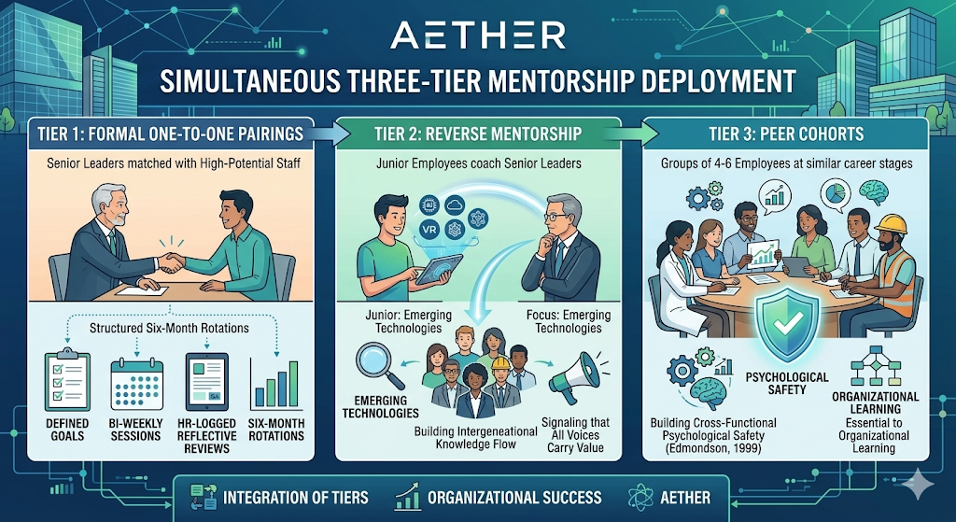
Fig: Three tier mentorship deployment
For impact, mentors must be trained, participation tracked by HR, and mentoring contribution recognized in performance reviews. Without institutionalization, even well-intentioned programs quietly fade under operational pressure.

1.3.2 Leadership Pathways
High performers leave when they cannot see where they are going. McClelland (1961, pp. 36–46) identified goal clarity as fundamental to achievement motivation; Buckingham and Goodall (2019, pp. 68–84) show that forcing technical specialists into management produces both managerial failure and engineer disengagement. Aether’s solution is a transparent dual-track framework:
- Management Track: Team Lead → Engineering Manager → Director → VP → C-suite, with competency frameworks at each level and a structured 90-day manager integration program at each transition.
- Technical Track: Senior Engineer → Staff → Principal → Distinguished → Fellow, with Principal-level compensation matching Director-level management pay — removing the financial penalty for choosing depth over breadth.
Every employee receives a co-created Individual Development Plan (IDP) annually, reviewed quarterly by HR business partners, documenting current competency, target role, and specific development actions. London (2002, pp. 44–62) shows the development conversation itself — a manager visibly investing in someone’s future — raises engagement independently of whether every goal is met.

1.3.3 Lifelong Learning
In technology, skills have a half-life. Senge (1990, pp. 139–173) argued that organizations capable of continuous learning hold a structural competitive advantage. Aether should build learning at three levels:
- Individual: An annual personal learning budget of £2,000–3,000, freely spent on courses, conferences, or books. Autonomy over the budget satisfies the SDT need for self-direction and produces deeper engagement than mandatory training (Deci & Ryan, 2000, pp. 235–238).
- Team: Monthly learning sprints where one member shares a recent insight; quarterly hack days for unstructured exploration. Amabile and Kramer (2011, pp. 81–93) link protected exploration time directly to innovation output and intrinsic motivation.
- Organization: An AI-curated Learning Management System personalizing content to each employee’s role, skills gap, and career goals. Marler and Boudreau (2017, pp. 3–26) identify personalized learning analytics as among the highest-impact HR technology investments available.
Culture is the critical enabler. Dweck (2006, pp. 6–14) shows growth mindset must be modelled, not mandated: when senior leaders publicly share what they are learning and admit what they do not know, intellectual curiosity becomes the organizational norm rather than the exception.

1.4 Synthesis
The three mechanisms above form a mutually reinforcing system that transforms people strategy into competitive advantage. Ulrich’s HR Value Chain (1997, pp. 24–27) establishes that people practices generate business value only when integrated with organizational strategy: mentorship builds the relational pipeline, leadership pathways channel talent into strategic roles, and learning keeps the system adaptive.

PART 2: PERSONAL REFLECTION

2.1 Reflective Learning Journey — Gibbs’ Reflective Cycle
Gibbs’ Reflective Cycle (1988, pp. 46-65) is a six-stage process for structuring experiential learning. The six stages of the cycle take the learner from description to action. Moon (2004, pp. 80-95) claims that the progression through the stages prompts critical examination of the assumptions underlying the experience, rather than simple recall. This is particularly important for a student with no professional experience, as the six stages of the Gibbs cycle offer the opportunity for rigorous examination of the theoretical material in the absence of any reference points. The six stages of the Gibbs cycle will now be related to my experience of the Strategic HRM module.
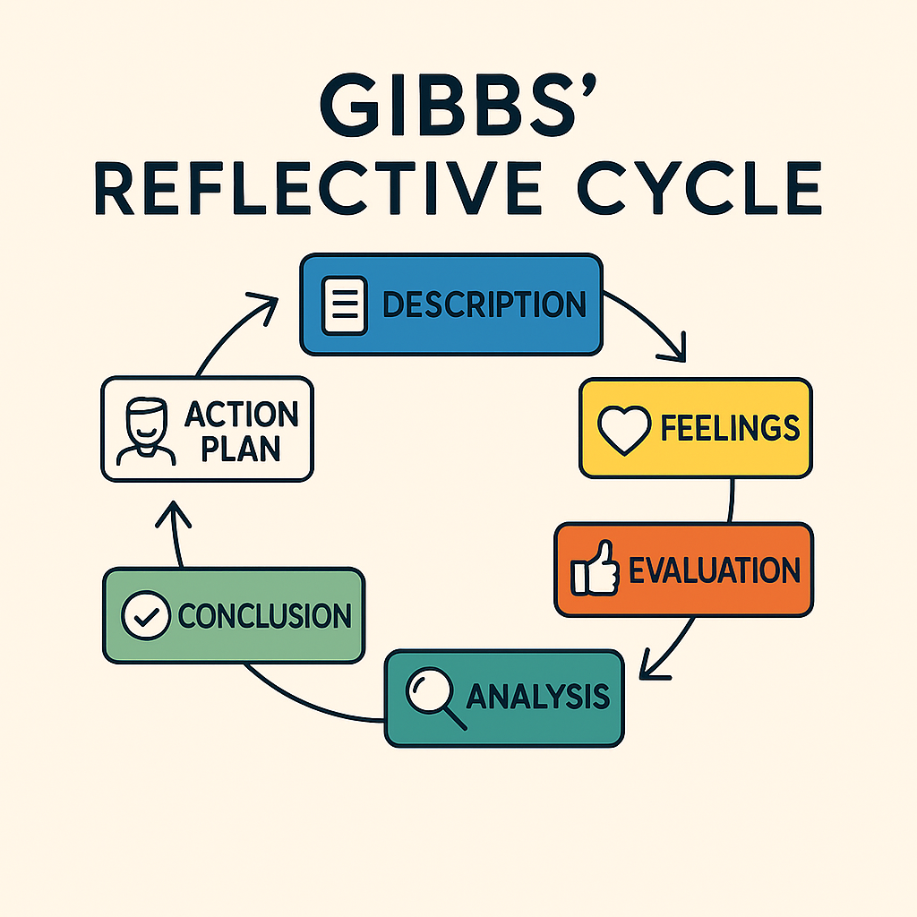
Fig: The Gibbs Reflective Cycle diagram.
Stage 1 — Description
Before this lesson, my understanding of HRM was basically just hiring people, contracts, and rules. I did not appreciate how strategically significant people management is, or how rich the academic literature has become. The module changed that. Working through theories such as the Resource-Based Theory (Barney, 1991), Self-Determination Theory (Deci & Ryan, 2000), Senge’s Learning Organization (1990), and Dweck’s growth mindset (2006) has given me a new vocabulary for thinking about organizations. Using these theories with the Aether scenario pushed me from understanding the theory to applying it.
Stage 2 — Feelings
Engaging with HRM theory without a professional reference point produced a tension between intellectual stimulation and cognitive dissonance. Mezirow (1991, pp. 168-180) calls this a ‘disorienting dilemma,’ an engagement with knowledge that challenges assumptions and sparks transformation; in this case, engaging with the build versus buy model directly challenged my unverified assumption that hiring outside was a safer bet to begin with. This discomfort, however, ultimately served a purpose as, without a framework to fall back on, each theory had to be evaluated on an individual basis, which led to more lasting transformation.
Stage 3 — Evaluation
What worked well was the breadth of the module’s theoretical range. Each framework functioned as Ausubel’s (1968, pp. 137–147) ‘advance organizer’, scaffolding onto which the next idea could attach, modelling the interdisciplinary competency Ulrich et al. (2012, pp. 3–19) say effective HR professionals need. What was harder — and I want to be honest — was the absence of workplace grounding. Kolb (1984, pp. 20–38) argues deep learning requires a cycle of concrete experience, reflection, and conceptualization; as a student, that first stage simply was not there.

Stage 4 — Analysis
The experiential gap is best understood through situated learning theory, which frames the student position as the recognized entry point to professional practice. Lave and Wenger (1991, pp. 29–43) argue knowledge deepens within authentic contexts of application; students occupy ‘legitimate peripheral participation’ (Wenger, 1998, pp. 100–115) — a transitional condition through which novices progressively appropriate professional norms. Dweck’s (2006) growth mindset, reread through Vygotsky’s (1978, pp. 79–91) zone of proximal development, simultaneously reframes knowledge gaps as productive learning sites rather than markers of inadequacy. This reframe converts the dissonance of Stage 2 into structured opportunity.
Stage 5 — Conclusion
Several alternative approaches would have deepened learning and strengthened Part 1’s recommendations. Rousseau (2006, pp. 256–269) argues professional decisions require peer-reviewed evidence rather than theoretical frameworks alone; more systematic journal engagement would have strengthened empirical foundations, while CIPD practitioner contact could have partially compensated for the situated learning deficit, and engagement with critical HRM scholarship (Townley, 1993; Legge, 2005, pp. 101–121) would have surfaced the power and equity dimensions of talent management largely absent from this analysis. These alternatives precisely diagnose the three capability gaps — empirical literacy, practitioner networks, and critical reflexivity — that the action plan below must address.
Stage 6 — Action Plan
These reflections point toward five commitments I am making to my own development:
- Secure an HR internship to gain the lived, contextual experience Kolb (1984) and Lave and Wenger (1991) identify as foundational — moving me from the periphery of the profession toward active participation.
- Build a consistent reading practice in peer-reviewed HRM literature, starting with Edmondson (2018) and Legge (2005), developing the empirical grounding Rousseau (2006) argues is non-negotiable for evidence-based practice.
- Develop HR analytics capability through self-directed study; Marler and Boudreau (2017, pp. 3–26) make clear this is no longer optional for anyone serious about strategic HR.
- Maintain a fortnightly Gibbs reflective journal; as Moon (2004) argues, reflection only becomes a developmental habit when practiced regularly, not saved for assessment moments.

2.2 Staying Relevant in an AI-Augmented World
The major professional challenge for those graduating into today’s job market is to position oneself to add value as a complement to, rather than a competitor with, artificial intelligence. Autor, Levy, and Murnane’s (2003, pp. 1279-1333) seminal work confirms that automation replaces routine tasks but complements non-routine judgment and interpersonal tasks. Brynjolfsson and McAfee’s (2014, pp. 177-195) extension of this work to the current AI environment confirms that AI is no exception and that relational trust (Rousseau et al., 1998), psychological safety (Edmondson, 1999), and transformational leadership (Bass, 1985, pp. 11-20) are uniquely human capabilities that AI cannot replace. This is my developmental focus: rather than competing with AI in information processing, I must focus on further developing those uniquely human capabilities that AI can support in synthesis but cannot replace in judgment and relationships. The key threat to be avoided is Braverman’s (1974, pp. 85-94) ‘deskilling’ phenomenon, which is ensured through the consistent unaided use of analysis to support AI’s augmentation rather than degradation of those uniquely human capabilities that make us indispensable.
In the end, my professional worth in a world with AI will not be based on what I know, but on my ability to ask better questions, make better decisions, establish stronger relationships, and turn complicated ideas into real change. These are capabilities that this module has helped me see more clearly — and that I am committed to developing with the same deliberateness I would recommend to any organization designing its talent ecosystem.

CONCLUSION
Aether Innovations is not suffering from a market problem or a product problem — it is suffering from a people problem. This report has argued that Aether Innovations’ operational crisis is a people strategy failure requiring a coherent, theoretically grounded response. Part 1 proposed a hybrid build-buy talent model, tiered mentorship, dual-track leadership pathways, and a lifelong learning infrastructure — each grounded in Barney (1991), Deci and Ryan (2000), McClelland (1961), and Senge (1990) respectively — forming an integrated system validated by Ulrich’s HR Value Chain (1997, pp. 24–27). Part 2 applied Gibbs’ Reflective Cycle (1988) to establish a student developmental baseline, producing an evidence-based action plan that mirrors the same principles of intentional development and continuous learning proposed for Aether at an organizational level. Both parts converge on a shared conclusion: as AI progressively handles routine cognitive tasks, the competitive premium — for organizations and individuals alike — will rest on the distinctly human capabilities of judgment, empathy, and adaptive leadership that no algorithm can replicate.

REFERENCES
Amabile, T., & Kramer, S. (2011). The progress principle. Harvard Business Review Press. pp. 81–93.
Ausubel, D. P. (1968). Educational psychology: A cognitive view. Holt, Rinehart and Winston. pp. 137–147.
Autor, D. H. (2015). Why are there still so many jobs? Journal of Economic Perspectives, 29(3), pp. 3–30.
Autor, D. H., Levy, F., & Murnane, R. J. (2003). The skill content of recent technological change. Quarterly Journal of Economics, 118(4), pp. 1279–1333.
Barney, J. (1991). Firm resources and sustained competitive advantage. Journal of Management, 17(1), pp. 99–120.
Bass, B. M. (1985). Leadership and performance beyond expectations. Free Press. pp. 11–20.
Biggs, J., & Tang, C. (2011). Teaching for quality learning at university (4th ed.). Open University Press. pp. 95–110.
Braverman, H. (1974). Labor and monopoly capital. Monthly Review Press. pp. 85–94.
Brynjolfsson, E., & McAfee, A. (2014). The second machine age. W. W. Norton & Company. pp. 177–195.
Buckingham, M., & Goodall, A. (2019). Nine lies about work. Harvard Business Review Press. pp. 68–84.
Cappelli, P., & Keller, J. R. (2014). Talent management. Annual Review of Organizational Psychology, 1, pp. 305–331.
Deci, E. L., & Ryan, R. M. (2000). The “what” and “why” of goal pursuits. Psychological Inquiry, 11(4), pp. 227–268.
Deloitte. (2024). Global human capital trends 2024. Deloitte Insights. pp. 4–12.
Dweck, C. S. (2006). Mindset: The new psychology of success. Random House. pp. 6–14.
Edmondson, A. C. (1999). Psychological safety and learning behavior in work teams. Administrative Science Quarterly, 44(2), pp. 350–383.
Edmondson, A. C. (2018). The fearless organization. Wiley. pp. 8–20.
Gibbs, G. (1988). Learning by doing. Further Education Unit, Oxford Polytechnic. pp. 46–65.
Kolb, D. A. (1984). Experiential learning. Prentice Hall. pp. 20–38.
Lave, J., & Wenger, E. (1991). Situated learning. Cambridge University Press. pp. 29–43.
Legge, K. (2005). Human resource management: Rhetorics and realities. Palgrave Macmillan. pp. 101–121.
LinkedIn Talent Solutions. (2025). Global talent trends report 2025. LinkedIn Corporation. pp. 9–18.
London, M. (2002). Leadership development. Lawrence Erlbaum. pp. 44–62.
Marler, J. H., & Boudreau, J. W. (2017). An evidence-based review of HR analytics. International Journal of Human Resource Management, 28(1), pp. 3–26.
McClelland, D. C. (1961). The achieving society. Van Nostrand. pp. 36–46.
McKinsey & Company. (2024). The future of work after COVID-19. McKinsey Global Institute. pp. 6–15.
Mezirow, J. (1991). Transformative dimensions of adult learning. Jossey-Bass. pp. 168–180.
Moon, J. A. (2004). A handbook of reflective and experiential learning. Routledge Falmer. pp. 80–95.
Rousseau, D. M. (2006). Is there such a thing as evidence-based management? Academy of Management Review, 31(2), pp. 256–269.
Rousseau, D. M., Sitkin, S. B., Burt, R. S., & Camerer, C. (1998). Not so different after all. Academy of Management Review, 23(3), pp. 393–404.
Schon, D. A. (1983). The reflective practitioner. Basic Books. pp. 49–69.
Senge, P. M. (1990). The fifth discipline. Doubleday. pp. 139–173.
Townley, B. (1993). Foucault, power/knowledge, and its relevance for HRM. Academy of Management Review, 18(3), pp. 518–545.
Ulrich, D. (1997). Human resource champions. Harvard Business School Press. pp. 24–27.
Ulrich, D., Younger, J., Brockbank, W., & Ulrich, M. (2012). HR from the outside in. McGraw-Hill. pp. 3–19.
Vygotsky, L. S. (1978). Mind in society. Harvard University Press. pp. 79–91.
Wenger, E. (1998). Communities of practice. Cambridge University Press. pp. 100–115.

