Business strategy

Moving Masala’s food trucks vision is to be customers favourite local brand in the future for food passionate individuals for food on the go, by offering nutritional fast food, freshly prepared ethnic cuisine and beverages. We will apply both cost leadership and differentiation strategy. Our focus will be based on price, quality, presentation and marketing, since we are a new newly starting food business.
Market research
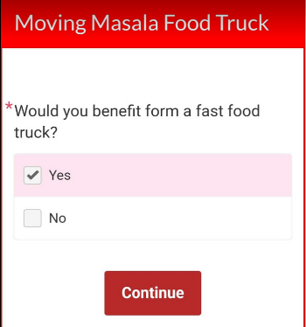
It was difficult to access information on food truck businesses and their demand, therefor Shahidur Rahman decided to hold an online poll via Facebook and a customer survey questionnaire at imperial park to analyse customer preferences, also interviewed a local food truck business in Newport.
(facebook, 2019)
Moving Masala food truck questionnaire can be found on appendix 1.
Customers
Our targeted customers are mainly employees within imperial business park and other close by businesses, we are targeting people who enjoy eating freshly prepared food on the go and appreciate a healthy nutrition. We will offer some basic fast foods, popular ethnic curry’s, traditional food and beverages. As a newly starting business we will have a limited supply chain therefor our price for some products maybe be slightly higher than our competitors. Based on a customer survey questionnaire conducted by Shahidur Rahman, age group from 18 – 35 and spending £4 -£6 would likely to use our service. Imperial park will be our main location, however we will also be operating in local events and festivals, such as: party in the park, colour clash, Pill annual fair etc.
‘Target customer is the person you've identified as most likely to purchase your products.’ (Belcher, 2019)
Competitor analysis
A competitive analysis is a critical part of a company’s marketing plan. With this evaluation, we can establish what makes our product or service unique and therefore what attributes we play up in order to attract our target market. (Entrepreneur, 2019)
The only competition Moving Masala will face, is Greggs, a well-established food-on-the-go business. Greggs strategic plan, first announced in 2013, set out to show that Greggs could be a winning brand in the highly competitive food-on-the-go market. Greggs business has been transformed in that time, delivering an unbroken record of positive like-for-like sales and new levels of profit. Their purpose being to make good freshly prepared food accessible to everyone, with the aim of becoming the ‘customers’ favourite for food-on-the-go. (Greggs, 2019)
Greggs strategic plan focus on four key elements:
- Great tasting freshly prepared food
- Best customer experience
- Competitive supply chain
- First class support teams
Greggs new strategic plan accounts for 30% of their sales. Greggs offer an extensive range of products and meal deals, newly introducing a new £2 ‘pizza slice + drink’ offer after 4pm, breakfast deals, vegan products and an expanding vegetarian range. Greggs continues to grow products inline with changing food trends, at affordable prices.
Greggs annual turnover and profits example from 2015:
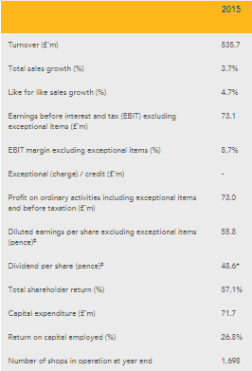 (Greggs, 2019)
To gain competitive advantage over Greggs we will focus on:
- Good Taste and excellence of food
- Welcoming customer service
- Freshly prepared ethnic cuisines
- Value for money
- Social media and marketing
- First class teamwork
Moving Masala will constantly develop products with the changing food trend and strike the right balance between innovation and tradition, nutrition and indulgence, value and values.
SWOT analysis of Moving Masala
Strength  - Good taste and excellence of food  - Welcoming customer service  - Freshly prepared ethnic cuisines  - Value for money  - Social media and marketing  - First class teamwork | Weakness  - Lack of experience in food truck business  - No customer base  - Limite mechanical knowledge of vehicle
Opportunities  - Well established nearby locations  - Local events and festivals  - Potential to collaborate with catering companies and business premises | Threats  - Established band competition  - Brexit  - Damaging weather

As suggested by (Houben, et al., 1999) ‘good performance within a company is the result of correct interaction of business management with its internal and external environment. The recognition of internal strengths and weaknesses, as well as external opportunities and threats, takes place based on a SWOT-analysis.’
To overcome the weakness, Moving Masala will use different measures like:
- Constantly observe and analyse competitors
- Collaborate in private booking facilities for personal and commercial use
- Involvement in local events and festivals
- High social media and marketing involvement
- Collaboration with local catering firm and businesses
- Appealing direct marketing (vehicle design)
- Loyalty scheme
Marketing plan
Marketing Mix is a tool used by businesses and Marketers to help determine a product or brands offering. The 4 Ps have been associated with the Marketing Mix since their creation by E. Jerome McCarthy in 1960. (Professional Academy, 2019)
Our marketing strategy can be defined by 4Ps of marketing mix initially, once established we can implement the 7Ps of marketing mix.
Product: we are planning to serve nutritious fast food, freshly prepared authentic dishes. We will use fresh and quality ingredients to outstand the market. Our menu will be innovative and limited, meaning customers will receive quality meals. Our way of delivery will be stand-up service and local delivery will be considered.
Price: we will set a fix price for the products available, also offer special meal deals according to promotional offers. We are using cost leadership and differentiation strategy. Our products will be moderately priced, our pricing strategy will be cost oriented. We aim make a net profit on each ranging from 20 – 25 percent.
Place: main location imperial business park, Newport. Location may vary depending on situation of events and festivals. Imperial business park has been considered as our main location based on market research: ease of access, visibility, cost and customer demand.
Promotion: our website will be our main promotional tool and the internet. We will use the following measures:
- Word of mouth
- Participation in local events and festivals
- Food truck vacuum wrap, flayers, menus and loyalty cards.
- Social media (Facebook, Instagram, YouTube, twitter, blogs and website
- Sponsorship
- Adverting; google ad word, Facebook ad and snapchat ad.
- Charity events
(Maund, et al., 2017) suggested the internet is a global network of computers that communicates using a common language. It is simply a “network of networks.”
Of all internet users in the UK, 78% of them use Facebook. More compelling is that a whopping 40 million people, or 71% of UK adults (+13 years old) can be reached with adverts on the platform.
According to Facebook Audience Insights, there are 35-40 million monthly active users on the platform. Of these, 52% identify as women and 48% men (based on users aged 18 and older).
There are now over 60 million active business Pages on Facebook globally, which is why many are turning to advertising on the platform to cut through the noise and reach your desired audiences. (Battisby, 2019)
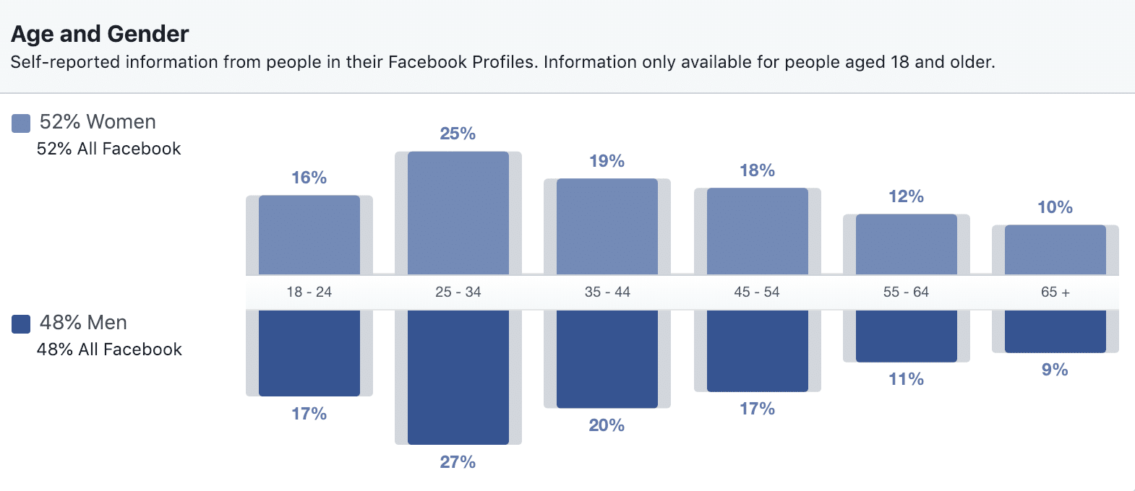
(Battisby, 2019)

Bibliography
Battisby, A., 2019. Avacadosocial. [Online]
Available at: https://www.avocadosocial.com/latest-social-media-statistics-and-demographics-for-the-uk-in-2019/
[Accessed 05 06 2019].
Belcher, L. M., 2019. Chron. [Online]
Available at: https://smallbusiness.chron.com/target-market-vs-target-customer-20674.html
[Accessed 06 06 2019].
Entrepreneur, 2019. Entrepreneur. [Online]
Available at: https://www.entrepreneur.com/encyclopedia/competitive-analysis
[Accessed 07 06 2019].
facebook, 2019. Poll. [Online]
Available at: http://www.kremsa.com/
[Accessed 30 05 2019].
Greggs, 2019. corporate.greggs. [Online]
Available at: https://corporate.greggs.co.uk/strategy/strategy-in-action
[Accessed 08 06 2019].
Houben, G., Lenie, K. & Vanhoof, K., 1999. Decision Support Systems. A knowledge-based SWOT-analysis system as an instrument for strategic planning in small and medium sized enterprises, 26(2), pp. 125-135.
Maund, A., Schriek, M. & Tinkler, P. K., 2017. Writing a Succesful Busniess Plan. In: Certificate in Higher Education: Skills for the Workplace Student Yearbook. London: SAGE Publications Ltd, p. 487.
Professional Academy, 2019. Marketing Theories - The Marketing Mix - From 4 Ps to 7 Ps. [Online]
Available at: https://www.professionalacademy.com/blogs-and-advice/marketing-theories---the-marketing-mix---from-4-p-s-to-7-p-s
[Accessed 09 06 2019].

Appendices
Appendix 1.
Moving Masala food Truck Questionnaire
This questionnaire consists of 13 questions that will help improve breakfast & lunch services at Imperial Park.

- What is your gender?
- Male
- Female

- What is your age?
- 18 – 24
- 25 – 35
- 36 – 50
- Over 50

- Do you enjoy fast food?
- Yes
- No

- Number of times a week you buy breakfast or lunch?
- 0 times
- 1 – 2 times
- 3 – 4 times
- 5 times or more

- When do you typically eat fast food?
- Breakfast
- Lunch
- Dinner
- Snack

- What attracts you to eat fast food?
- Advertisement
- Enjoy the taste
- Limited time
- Cost / Price
- Variety of menu

- How many times a week would you eat curry for lunch?
- 0 times
- 1 – 2 times
- 3 – 4 times
- 5 times or more

- Does branding affect the chosen fast food?
- Agree
- Neutral
- Disagree

- On average how much do spend on breakfast or Lunch?
- £2 - £4
- £4 - £6
- £6 - £9
- £10 or more

- What would food would you like to be available on the truck?
- Sandwiches
- Salads
- Snacks
- Curry & rice
- Beverages

- Does nutrition information influence your choice regarding fast food?
- Not at all
- Rarely
- Sometimes
- Most of the time
- Always

- What time do you have a short break?
- Between 8am – 9am
- Between 9am – 10am
- Between 10am – 11am
- Between 11am – 12am
- Other

- what time do you have a lunch break?
- Between 11am – 12pm
- Between 12pm – 1pm
- Between 1pm – 2pm
- Between 2pm – 3pm
- Other



