Hotel Placement Research Project
Proposal: A critical comparison between insourced and Outsourced housekeeping departments for saving operation costs of a hotel: A study based on the London Marriot Hotel in London

Student Name: Khalida Miah
Student ID: 2017369
Module Leader: Chris Wilkin

Table of Contents
Introduction: 3
The rationale of the research: 3
Research Aim and Objectives: 4
Aim: 4
Objectives 4
Questions: 5
Literature Review: 5
Project Methodology: 7
References: 9

List of figures:
Figure 1: UK inflation rate 4
Figure 2:Benefits and drawbacks of Insourced and outsourced housekeeping 6
Figure 3: General cost comparison of insourced and outsourced housekeeping 7

Introduction:
The housekeeping staff plays a crucial role in the smooth operation of any hotel. It is responsible for keeping the hotel tidy and pleasant for visitors and ensuring everyone's peace of mind. According to a Market Facts poll commissioned by Procter & Gamble, 63% of respondents emphasise a hotel's cleanliness and general presentation when making their booking decision, per business wire (2017). The rooms, food, drinks, and ancillary services keep a hotel afloat. At least half of these earnings come from renting out sleeping quarters. Since a hotel room can be resold several times, room revenue accounts for most of a hotel's earnings. The effort put forth by the housekeeping staff in providing a pleasant room for a guest directly impacts the guest's overall impression of the hotel. Housekeeping is a support service that plays a significant role in a hotel's overall image stated by Bhatnagar and Dheeraj (2019). Hotels may have their housekeepers or temporarily insource housekeepers through a recruiting agency. Both have their advantages and disadvantages. As the housekeeping reasons for the maximum cost of a hotel, it impacts the operating costs of a hotel.

The rationale of the research:
The primary service of a hotel is giving rent to their hotel rooms to the customers, and customers want their rooms to be neat and clean whenever they enter the room. Therefore, the need for the housekeeping department is the most in a hotel stated by Raghubalan and Raghubalan (2015). Housekeeping costs are the reason for the higher operating cost in a hotel because the hotel recruits housekeeping employees most than any other department's employees in a hotel; therefore, salary, bonus, pension and other employee-related benefits are associated with time. Ultimately the burden goes to customers' shoulders, but after covid-19, tourists have been cost-sensitive since the UK's inflation is increasing daily, as per BBC (2023). The following figure represents it:

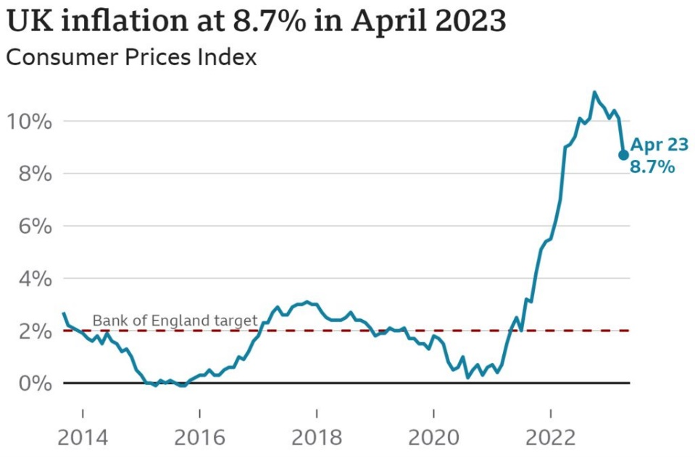
Figure 1: UK inflation rate
Source: (BBC, 2023)
As the inflation rate has increased, customers are looking for hotels offering them the same service at a lower cost. The organisation can reduce their operation cost substantially if they outsource housekeepers since hotels do not need to bear employees' fringe benefits and other related costs; therefore, hotels can offer room to a minimum cost and acquire a good number of costs, as Sudhir Andrews (2019). Although insourcing and outsourced housekeeping departments have merits and demerits, the hotels must consider them before deciding. Marriot is a renowned five-star hotel in London. There are 771 five-star hotels in the UK, which has been increasing daily. This project paper allows the hotel to decide whether it should continue its current housekeeping practice or they need to change its practice to sustain itself in the competitive market.

Research Aim and Objectives:

Aim:
This project aims to critically compare insourced and Outsourced housekeeping departments for saving operation costs of a hotel: A study based on the London Marriot Hotel in London

Objectives
- To compare the merits and demerits of both insourced and outsourced housekeeping departments of a hotel
- To critically discuss the impacts of housekeeping on the operational cost
- To analyse the housekeeping practice adopted by the Marriot Hotel in London

Questions:
- What are the merits and demerits of a hotel's insourced and outsourced housekeeping departments?
- What are the impacts of housekeeping on operational costs?
- What is the housekeeping practice adopted by the Marriot Hotel in London?

Literature Review:
After heavy losses from the pandemic, several hotels and other hospitality businesses re-evaluated their current policies and practices. The need to keep costs in check, especially when interest in vacationing and travelling has hit a record low, has been the primary impetus for this shift, according to research by Deloitte (2020). Since labour expenditures make up such a sizable percentage of a hotel's total operating expenses, they would be an obvious target for cost-cutting measures. Due to massive layoffs by significant firms like Hyatt and Novotel Paris, outsourcing housekeeping has become a controversial move that has garnered opposition from labour organisations, as per Bragg (2018).
While an upfront cost is associated with hiring and training an in-house team, the benefits outweigh the costs. One advantage is that new hires receive instruction on the company's core principles. The staff's welcoming attitude is why the company has become well-known. The main reasons these market leaders always have their housekeeping crew is to train their employees in proper behaviour and conduct, instil the brand's values in them, and generate real brand value via their professionalism, as Jones and Siag (2009). The second benefit follows naturally from creating more promising job prospects for skilled workers in this field. Because outsourcing firms specialise in low-cost services, their employees make less money than they would if an in-house team employed them. The brand policy spells out their entitlements (which also appeases labour unions). Internalising administrative tasks leads to higher-quality outputs, which is especially important for companies that value attention to detail.
The most obvious perk of outsourcing is cost reduction. Housekeeping expenses can be reduced by using an agency that manages cleaners for many companies at once, thanks to economies of scale stated by Rowson (2017). The ability to customise work schedules is another perk of cleaning outsourcing in the hotel business. With the help of outsourcing, the hotel's staffing needs are only sometimes met, and it is feasible to increase the number of available workers at peak times while keeping numbers low during slower times. According to Szende, Dalton and Michelle (Myongjee) Yoo (2021), the cost of maintaining their housekeeping staff is the primary disadvantage of using such a service in the modern era.
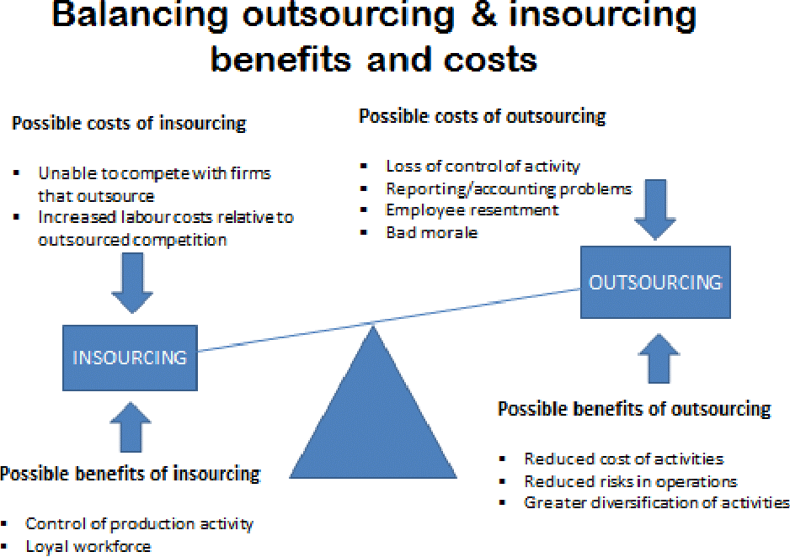
Figure 2:Benefits and drawbacks of Insourced and outsourced housekeeping
Source: (George and Hancer, 2008)
The second issue with in-house housekeeping is the need for team management and training. Hotels are responsible for hiring, training, and supervising the housekeeping personnel. Increases in base pay, incentives, performance reviews, education, and other benefits are all under the brand's purview.
Hotel housekeeper outsourcing has some apparent benefits, but it also has some drawbacks. When outsourcing, businesses give up virtually all say over who represents the brand. Due to outsourcing, there needs to be more responsibility on the personnel's part, which might lead to issues for the visitors. Compared to an internalised cleaning arrangement, an outsourced team's quality of work can sometimes be on par stated by Zagade and Tyagi (2017). Second, the personnel are fully interchangeable, so it is challenging to train and educate new hires per the brand guideline when they may be the ones who show up to work.
The operational costs of a hotel are the ongoing bills that must be paid to keep the business open. Rent, property taxes, and insurance are examples of fixed expenditures. In contrast, hourly wages, energy bills, and travel agency fees are examples of variable costs in the hotel sector, opinioned to Bragg (2018). Each hotel department is responsible for its operating expenses, which are then added together and reported on the P&L. A hotel's gross operating profit (GOP) may be found in the profit and loss statement after total revenue has been deducted from operating expenditures by month and by the department—housekeeping reasons for the maximum cost of a hotel. If hotels can keep minimum its housekeeping costs minimum, therefore, their operational costs will be decreased. Therefore, hotels can gain much profit compared to their competitors and charge lower prices than competitors, resulting in a competitive advantage in this modern hotel business. In comparison, hotels which have a housekeeping department housekeeping costs too much, resulting in higher operating costs, and they need to charge higher prices to the customers (Rowson, 2017).
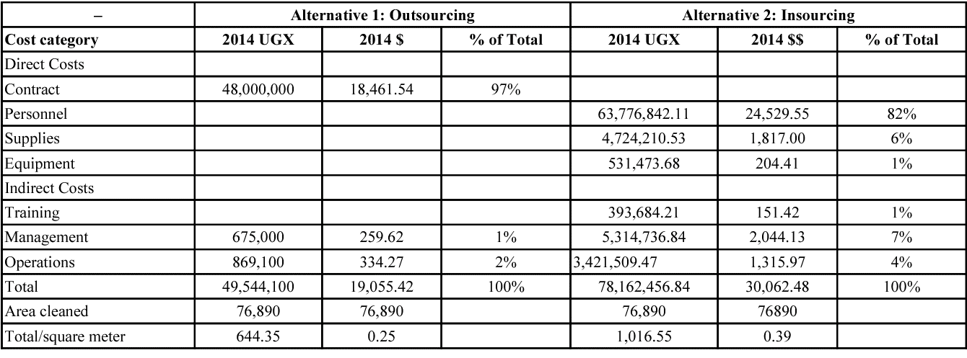
Figure 3: General cost comparison of insourced and outsourced housekeeping
Source: (Ramdeen, Santos and Kyung Chatfield, 2007)
After weighing the benefits and drawbacks of insourced and outsourced housekeeping departments, here are my concluding views. Hotels that place a premium on upholding specific standards of behaviour within the property will benefit more from employing their housekeeping staff. Housekeeping services are best outsourced by businesses that want to save money without sacrificing cleanliness.
The central gap of the existing literature reviews is that all the papers have discussed the merits and demerits of insourced and outsourced housekeeping. However, they should have discussed the five-star hotel's strategy regarding housekeeping because these hotels need to reduce operating costs simultaneously and maintain or increase visitor satisfaction.

Project Methodology:
The researcher will use the positivist approach instead of the interpretivism approach. The researcher will not use the interpretivism approach since the researcher needs to be physically present at the research spot or place to interpret or analyse the situation, so the researcher will not be physically present but will be virtually analysing or interpreting the data (Dane, 2022). The researcher will collect secondary data for this research. The researcher will collect secondary data over primary data because it is costly for the researchers to collect primary data, and it requires much time to collect the data through primary research provides first-hand and quite reliable information (Creswell, 2014). Since the researcher needed more time and resources to commit, secondary data will be gathered. Data from newspapers, websites, journals, and magazines from the last ten years will be collected. The sources will be reputed and reliable. The researcher will apply mixed methods in this research because quantitative data will provide more accurate information about the impact of the housekeeping cost on the organisation's operating expenses, and qualitative data will answer "why". Why insource and outsource housekeeping should be used and their impact on operation cost and to understand the practice of Marriott Hotel related to housekeeping. The researcher will do content analysis for analysing the secondary data. Researchers can use content analysis to analyse quantitative and qualitative data and identify a specific theme. The researcher can answer the research objectives (Panneerselvam, 2014).

References:
BBC, 2023. What Is the UK's Inflation Rate? [Online]. BBC News [Online], 15 February. Available from: https://www.bbc.com/news/business-12196322 [Accessed 20 June 2023].
Bhatnagar, E. and Dheeraj, N., 2019. Impact of Housekeeping Services and Practices on Customer Satisfaction and Repeat Business [Online]. Prabandhan: Indian Journal of Management [Online], 12(8), p.46. Researchgate. Available from: https://doi.org/10.17010/pijom/2019/v12i8/146417.
Bragg, S.M., 2018. Hospitality Accounting: A Financial and Managerial Accounting Reference. Centennial, Colorado: Accountingtools, Inc.
BusinessWire, 2017. P&G Professional Survey Reveals Nearly All US Consumers Consider Cleanliness When Deciding Whether or Not to Return to a Business [Online]. www.businesswire.com. Available from: https://www.businesswire.com/news/home/20171102005805/en/PG-Professional-Survey-Reveals-Nearly-All-U.S.-Consumers-Consider-Cleanliness-When-Deciding-Whether-or-Not-to-Return-to-a-Business [Accessed 20 June 2023].
Creswell, J.W., 2014. Research Design: Qualitative, Quantitative, and Mixed Methods Approaches. 4th ed. London: Sage Publications Ltd.
Dane, F.C., 2022. EVALUATING RESEARCH: Methodology for People Who Need to Read Research. S.L.: Sage Publications.
Deloitte, 2020. Impact of COVID-19 on the Hospitality Industry [Online]. Deloitte Netherlands. www2.deloitte.com. Available from: https://www2.deloitte.com/nl/nl/pages/consumer/articles/impact-of-covid-19-on-the-hospitality-industry.html [Accessed 20 June 2023].
George, R.T. and Hancer, M., 2008. Housekeeping Managers and the Administration of Housekeeping Service [Online]. International Journal of Hospitality & Tourism Administration [Online], 9(4), pp.365–383. Available from: https://doi.org/10.1080/15256480802427313.
Jones, P. and Siag, A., 2009. A re-examination of the Factors That Influence Productivity in hotels: a Study of the Housekeeping Function [Online]. Tourism and Hospitality Research [Online], 9(3), pp.224–234. Available from: https://doi.org/10.1057/thr.2009.11.
Panneerselvam, 2014. Research Methodology. Delhi: Phi Learning.
Raghubalan, G. and Raghubalan, S., 2015. Hotel Housekeeping: Operations and Management. New Delhi, India: Oxford University Press.
Ramdeen, C., Santos, J. and Kyung Chatfield, H., 2007. Measuring the Cost of Quality in a Hotel Restaurant Operation [Online]. International Journal of Contemporary Hospitality Management [Online], 19(4), pp.286–295. Available from: https://doi.org/10.1108/09596110710747625.
Rowson, B., 2017. Modern Hotel Operations Management. Wolters-Noordhoff B.V.
Sudhir Andrews, 2019. Introduction to the tourism and hospitality industry. 8th ed. New Delhi: Tata Mcgraw-Hill.
Szende, P., Dalton, A.N. and Michelle (Myongjee) Yoo, 2021. Operations Management in the Hospitality Industry. Emerald Group Publishing.
Zagade, Dr.S. and Tyagi, H., 2017. Impact of Outsourced Housekeeping Services on Guest Satisfaction concerning Star Hotels [Online]. International Journal of Trend in Scientific Research and Development [Online], Volume-2(Issue-1), pp.1076–1080. Available from: https://doi.org/10.31142/ijtsrd7187.

