Assessment 1

Module Code: LCBB5003
Student Name: Nikolay Petkov
Student ID: 2011288

Table of Contents
Introduction 1
THE DEMAND CURVE 2
FACTORS AFFECTING THE DEMAND SIDE 2
Price of Goods or Services 3
Consumer’s Income 3
Price of related goods and services 5
Consumer Expectations 5
Clients Taste 6
THE SUPPLY CURVE 6
PRICE AND QUANTITY EQUILIBRIUM 7
The Equilibrium Curve 9
Conclusion 9
References 10

Introduction
McDonald's is one of the largest and most well-known fast-food restaurants in the UK, which has several other options. In Malaysia, where there are just a few other fast-food restaurants, the company sells everything from fries to burgers to sweets like Mcflury and sundaes. In other words, the company sells everything. However, throughout this piece, the McChicken burger will serve as a metaphor for everything that the firm has to offer. Richard and Maurice McDonald established the first McDonald's restaurant in 1955 in the city of San Bernardino, which is located in the state of California. McDonald's currently operates 282 restaurants around the United States, where it serves 14.5 million people every month. It would appear from this data that the McDonald's Corporation in Malaysia is expanding at a rapid rate on an annual basis. According to the annual report of the corporation, the company currently operates 38,695 restaurants in 119 different countries. The whole revenue of the company comes from company-owned restaurants as well as franchise fees collected from stores that are independently owned and operated by franchisees. According to McDonald's 2019 Annual Report, the fast-food giant made a total of $9.069 billion in revenue during the fiscal year that concluded in March 2019 (Filos-Ratsikas et al., 2021). When compared to the prior year, this is a 13 per cent gain. According to McDonald's website, the company's mission statement is as follows: "To be our customers' favourite place to eat and way to drink." McDonald's has achieved much more than this objective by emphasizing the quickness with which it serves its customers, maintaining cheap costs, and producing meals that are both good and healthful. Additionally, it has maintained its status as the world's largest quick-service restaurant, catering to approximately 70 million people daily. As a result, the purpose of this research is to disseminate information to the public that will assist them in comprehending the challenges that are associated with microeconomic issues. This demonstrates the significance of McDonald's and the McChicken burger to the investigation (Khan et al., 2021).

THE DEMAND CURVE
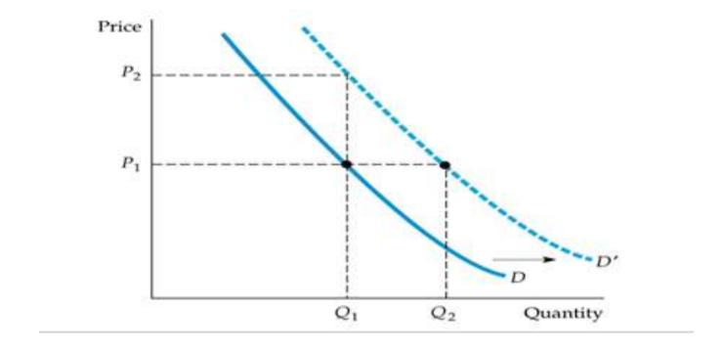
Fig1: Demand Curve
When the price of a product changes over time, the demand curve shows how much customers are willing to buy. The demand curve is shown to be going down in figure 1.1. In this case, a fixed price of P2 will be paid for only one burger. But if every unit of a product was sold at its lowest possible price, people would be much less likely to buy it (P1). People are willing to buy two burgers even though the price has gone down from P2 to P1. Malaysians, for instance, won't buy more than one McChicken burger if it costs RM 14. If the price of a burger drops from RM14 to RM7, Malaysians will gladly buy two of them. The demand-supply curve above shows how the price of McChicken burgers in the United Kingdom is related to how many people want them (Palani et al., 2021).

FACTORS AFFECTING THE DEMAND SIDE
Malaysians decide how much they need based on things like price, income, the cost of related goods and services, and customer expectations and preferences. By changing these things, you can change the demand curve for oil and gas. To figure out how much each of these factors affects demand, we have to assume that all other factors stay the same. When figuring out how customer choice affects the demand for a McChicken Burger, for example, we'll assume that the price of the product, the income of consumers, and other factors stay the same. In economics, "ceteris paribus," which means "other things being equal," means that all other factors should stay the same (Schultze et al., 2021).

Price of Goods or Services
One of the most important things that affect how much people want something is how much it costs. The price of McDonald's burgers is sensitive to any change from the market equilibrium position. This is because there are global companies like Subway and Burger King, as well as many local producers (Scott et al., 2022). So, if McDonald's burgers cost more than the average price of burgers in Malaysia, customers will switch to the other brands listed above. If the price of McDonald's burgers goes down and everything else stays the same, the number of burgers sold will go up. This point is shown in Figure 1.

Consumer’s Income
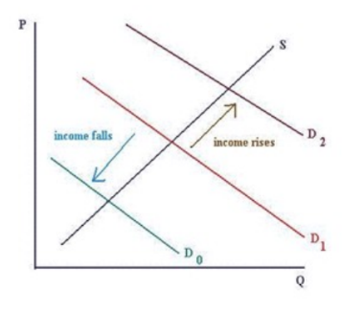
Fig2: Consumer Income pt.1
Another factor that influences people's demand is the sum of money that is now sitting in their respective bank accounts. On the other hand, the relationship between a consumer's income and the quantity that they desire may change based on the kind of good that they are interested in purchasing (Filos-Ratsikas et al., 2021). When it comes to conventional products, such as consumer durables, technology, and leisure and service activities, there is a direct correlation between income and demand. Figure 2 illustrates this correlation by depicting how the quantity of a product required to satisfy a consumer's demand increases when that consumer's income does as well as how it decreases when that consumer's income does. Figure 3 demonstrates that when people's incomes increase, they become less interested in purchasing inexpensive items.

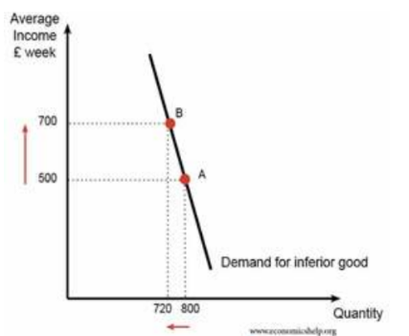
Fig3: Consumer Income pt.2
The demand curve will shift to the left as a result of this. Bread and rice are two examples of foods that aren't as healthy as they may be if they were prepared differently. It shouldn't come as a surprise that McDonald's burgers aren't very good because the restaurant is widely renowned for serving quick food that is both inexpensive and of poor quality (Khan et al., 2021). When a person's income increases, the percentage of the money that they spend on fast food also decreases. This is the reason why, as nutritious food tends to be more expensive than junk food. On the other side, studies have shown that as people's income drops, they are more likely to eat at McDonald's.

Price of related goods and services
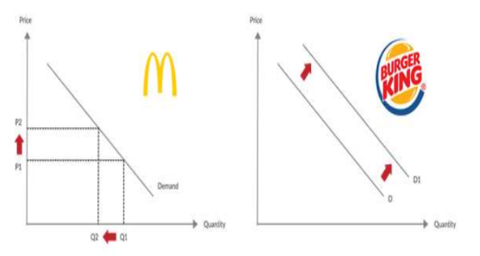
Fig4: Price related to McDonald’s and Burger King
The prices of the goods and services that are directly tied to Malaysian to McChicken burgers have a significant impact on how much people want them. Products that are highly comparable to one another can either substitute for one another or complement one another. For instance, when the price of a substitute rises, there is a greater increase in the demand for substitutes. Both the quality of the burger and the pricing of the burger sold at Burger King are comparable to those sold at McChicken. As seen in Figure 4, the number of persons who are interested in purchasing a McChicken burger increases in direct proportion to the burger's price. When they need a burger, a growing number of consumers are getting their burger fixed at fast food restaurants like Burger King. The demand for additional items tends to increase if there is a decrease in the price of a good that pairs well with another good (Schultze et al., 2021). This is not the same as doing away with a complimentary thing. For instance, when the price of chicken drops, there is a greater demand for McChicken burgers since they are more affordable.

Consumer Expectations
"Consumer Expectation" is a list of things that a customer thinks a company should do. Different things can go wrong with a demand curve because of what a client wants. It seems likely that people won't buy something like a McChicken burger right away if they think the price will go down. Right away, the demand for McChicken burgers drops, which causes a shift to the right. Customers who think that the price of a McChicken burger will go up soon will buy one now instead of waiting until the price goes up. Because of this, the demand curve for McChicken burgers will move up.

Clients Taste
The term "consumer taste" means how much a buyer likes a group of products. Because of this, Malaysians will like McChicken more than Burger King burgers because they both meet the same needs. The demand curve for a product can be affected by many things, including what consumers want (Schultze et al., 2021).

THE SUPPLY CURVE
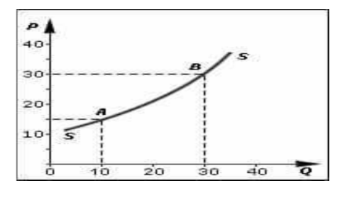
Fig5: Supply Curve
The amount of goods available depends on how much producers are willing and able to make. As prices go down, suppliers have less reason to try to make more money. This means that the supply curve moves to the left, which means that less of that product is being made. The more a product costs, the more profit it makes, so suppliers put a lot of time and money into making a lot of it. McDonald's will produce at a normal level of safety as long as the price of the McChicken stays at RM 15 and there is a 20% profit margin (refer to Figure 5). Altogether, ten. When the price of a McChicken goes up to RM 30, this won't be the case because McDonald's will have to make more of them to make more money (Scott et al., 2022). The law of supply says that when the price of an item goes up, so does the amount that is sold, and when the price goes down, so does the amount that is sold. In the diagram, the supply curve is shown to be moving up. Several things can change how much product is delivered. The price of the raw materials needed to make hamburgers is an important factor that could change the supply curve. When sellers are willing to make more at a certain price, the supply curve moves to the right. When the number of hamburgers on the market goes up, the price usually goes down and the number of hamburgers goes up. The curve moves to the left when the amount that sellers can and are willing to make at any given price goes down. When there are fewer things available, the price goes up and the amount goes down (Filos-Ratsikas et al., 2021).

PRICE AND QUANTITY EQUILIBRIUM
Obtaining equilibrium in the market is an essential first step in achieving market stability and efficiency, which go hand in hand with one another. To put it another way, supply and demand are considered to be in equilibrium when both the price and the quantity on the market are considered to be in equilibrium. On the other hand, economic forces are currently at work, even if they are not yet completely realised, to bring the price and quantity of goods on the market into equilibrium. Things may not be in a state of equilibrium if the quantity that is produced is greater than what is required on the market or if the quantity that is required is greater than what producers are willing to produce. Since an efficient market is better able to maintain equilibrium, this has the side effect of making the market less competitive. The goal of being efficient is to complete tasks successfully without sacrificing a significant amount of anything or much at all. Economists consider a situation to be efficient when it is difficult to improve the standing of one party without adversely affecting the status of another. On the other side, if the market isn't functioning properly, it's more probable that one party will benefit at the expense of other individuals who are obligated to pay for it. The point on a graph that represents equilibrium is the intersection of the supply curve and the demand curve (Scott et al., 2022). When both the buyer and the producer want the same item, we say that "equilibrium" has been reached about the price. To put it another way, this is the price that people are willing to pay for a commodity as well as the price that individuals are willing to sell it for (the quantity that is being sought) (quantity supplied). When there is an "equilibrium quantity" of a product on the market, there is neither an excess nor a shortage of that product. It is currently believed that supply and demand are at a point of equilibrium with one another. If consumers are willing to pay the same price for a specific quantity of a product as its manufacturers are willing to accept, then the market price for the product in question is equivalent to the amount that consumers are willing to pay. When there is consensus amongst buyers and sellers in a market, it is obvious that the market has arrived at a very high level of stability or equilibrium. Because the amount that is being requested does not surpass the amount that is being offered at any price, there will not be an imbalance in the market (Khan et al., 2021).
Suppose that entity that demanded McChicken Burger is given by the following equation:
QD = 50 000 - 2000P Units
Where QD (quantity demanded) is the amount of McChicken Burger that customers are willing to buy, and P is the price of McChicken Burger. Suppose the supply of McChicken Burger is:
QS = - 45 000 + 2000P Units
Where QS (quantity supplied) is the amount of McChicken Burger that sellers are willing to produce. The market hits equilibrium when the supply and demand curves intersect, which means that QD = QS. So,50 000 - 2000P = - 45 000 + 2000P50 000 + 45 000 = 2000P + 2000P
95 000 = 4000PP = 23.75
The equilibrium price of McChicken Burger where QS = QD, is 23.75. To determine the exact amount of the quantity supplied and demanded, substitute 23.75 with P in both equations.
QD = 50 000 - 2000P
QS = - 45 000 + 2000P= 50 000 - 2000(23.75) = - 45 000 + 2000(23.75)
= 50 000 – 47 500 = - 45 000 + 47 50
QD = 2 500 QS =forore, for 23.75, the quantity so toppled and demanded to meet wherein McDonald’s is willing to produce 2 500 McChicken Burger, at the same time, the consumers are willing to aty 2 500McChicken in the given price. This can be drawn graphically as follows.

The Equilibrium Curve
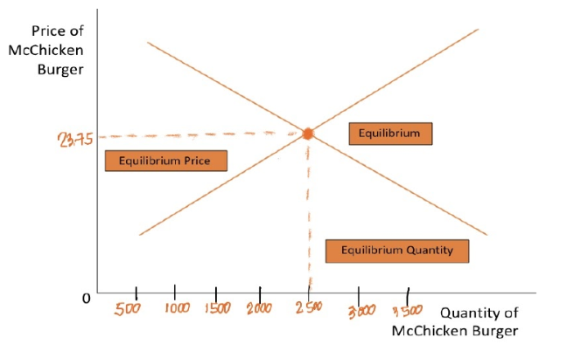
Fig6: Equilibrium Curve
The graphic depicts the equilibrium between Demand and Supply for Manufacturersntly, manufacturers are willing to produce 2,500 McChicken Burgers, and consumers are eager to purchase the same quantity for $23.75 each.

Conclusion
Demand and supply drive the economy. The supply of McChicken Burgers is how many can be bought. The demand for these things is the demand. It determines how much a group will pay for a product or service. Two economic theories may interact. They affect the prices of products and services, thus knowing and predicting economic trends is crucial. Supply and demand will certainly become imbalanced in the future, according to market economics (Scott et al., 2022). Supply and demand are equal in equilibrium. In equilibrium, a good's price impacts both supply and demand. There are neither surpluses nor deficits in the economy. Because of how much goods cost, buying and selling go hand in hand. Many things can modify supply and demand, shifting the curve. Supply and demand influence what individuals sell.

References
- 2022. [online] Available at: <https://www.census.gov/ - data on US businesses> [Accessed 21 July 2022].
- Bloom, C.I., Drake, T.M., Docherty, A.B., Lipworth, B.J., Johnston, S.L., Nguyen-Van-Tam, J.S., Carson, G., Dunning, J., Harrison, E.M., Baillie, J.K. and Semple, M.G., 2021. Risk of adverse outcomes in patients with underlying respiratory conditions admitted to hospital with COVID-19: a national, multicentre prospective cohort study using the ISARIC WHO Clinical Characterisation Protocol UK. The Lancet Respiratory Medicine, 9(7), pp.699-711.
- Cronin, S.J., Zernack, A.V., Ukstins, I.A., Turner, M.B., Torres-Orozco, R., Stewart, R.B., Smith, I.E., Procter, J.N., Price, R., Platz, T. and Petterson, M., 2021. The geological history and hazards of a long-lived stratovolcano, Mt. Taranaki, New Zealand. New Zealand Journal of Geology and Geophysics, 64(2-3), pp.456-478.
- de Almeida Prado, F.P. and Blavatskyy, P., 2021. Existence and uniqueness of price equilibrium in oligopoly model with power demand. Mathematical Social Sciences, 111, pp.1-10.
- Deschenes, O., Costello, C., McDonald, G., Melnychuk, M. and Missirian, A., 2022. Can Demand-Side Interventions Rebuild Global Fisheries?. Available at SSRN 4088011.
- Feldman, M., Shabtai, G. and Wolfenfeld, A., 2022, June. Two-Price Equilibrium. In Proceedings of the AAAI Conference on Artificial Intelligence (Vol. 36, No. 5, pp. 5008-5015).
- Filos-Ratsikas, A., Giannakopoulos, Y., Hollender, A., Lazos, P. and Poças, D., 2021, July. On the complexity of equilibrium computation in first-price auctions. In Proceedings of the 22nd ACM Conference on Economics and Computation (pp. 454-476).
- Khan, S.U., Haq, I.U., Khan, Z.A., Khan, N., Lee, M.Y. and Baik, S.W., 2021. Atrous Convolutions and Residual GRU Based Architecture for Matching Power Demand with Supply. Sensors, 21(21), p.7191.
- Kwok, H., 2006. Population Aging in China and Its Impacts on Elderly Care: A Case Study of Guangzhou City. Hallym International Journal of Aging, 8(2), pp.119-135.
- Marketrealist.com. 2022. Market Realist: News, Analysis, Company Overviews. [online] Available at: <http://marketrealist.com/page/12/?tx=content-type&tm=overviews#article-919858> [Accessed 21 July 2022].
- Oecd.org. 2022. [online] Available at: <http://www.oecd.org/economy/> [Accessed 21 July 2022].
- Palani, A., McDonald, J. and Wedmaier, J., 2021. Empire Youth Arts: a 10 year overview. A commissioned report.
- Schultze, A., Bates, C., Cockburn, J., MacKenna, B., Nightingale, E., Curtis, H.J., Hulme, W.J., Morton, C.E., Croker, R., Bacon, S. and McDonald, H.I., 2021. Identifying care home residents in electronic health records-an OpenSAFELY short data report. Wellcome open research, 6.
- Scott, K., Smith, C.J., Lowe, J.A. and Carreras, L.G., 2022. Demand vs supply-side approaches to mitigation: What final energy demand assumptions are made to meet 1.5 and 2° C targets?. Global Environmental Change, 72, p.102448.
- Warc.com. 2022. Partners | Euromonitor International | WARC. [online] Available at: <https://www.warc.com/ContentandPartners/EuromonitorInternational.info> [Accessed 21 July 2022].

