

University of Wales Trinity Saint David

School of Computing

Change Makers: Creativity and Value Creation

Change Makers

ACCA5033

Hafiz Uddin
1807533

07/01/2021

Table of Contents
Introduction 3
Methodology 3
Results 3
Conclusion 3

Introduction
A video presentation of the progress of my communication App.

Methodology
This is the link to the power point presentation showcasing the progress of the App -
https://youtu.be/qeDo7VYe9qM

Results
This is a screen shot of the power point.
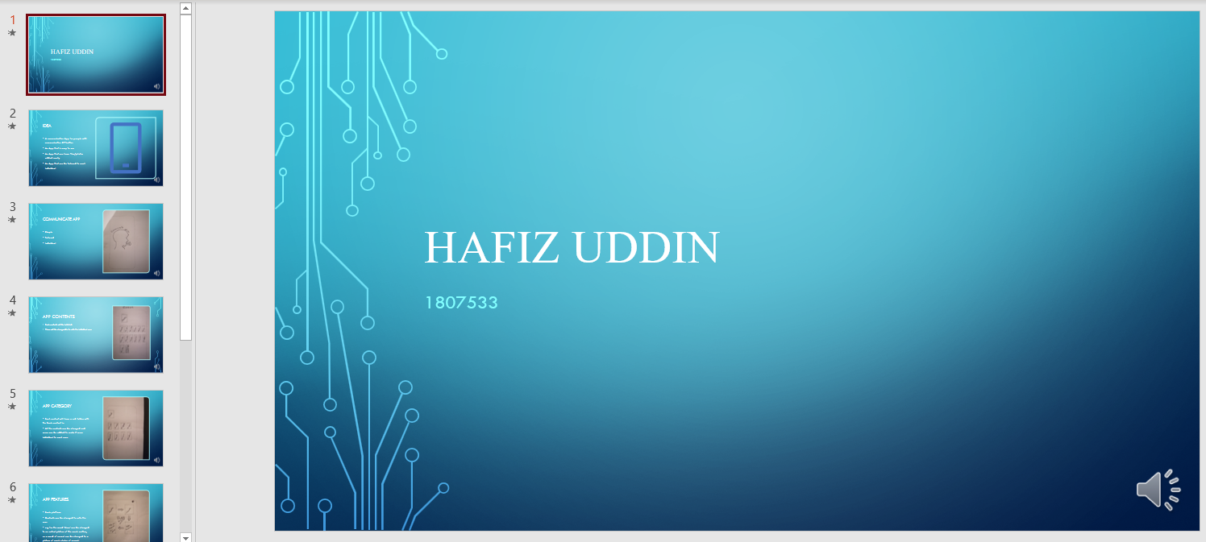

Conclusion
Throughout these two assignments I have learnt new skills and I have gained knowledge in the following areas –
- I have learnt how to create a mind map using the Mindmeister App.
- Creating a road map
- Creating PowerPoint with voice over and then converting it to video.
- Creating a academic poster
- Creating an e-portfolio website
- The steps involved in creating an App
Even though I have learnt these skills I know that I would have to practice these a lot more to get better at them and to be able to present them in the future.

