

PRODUCT AND FURNITURE DESIGN – BA|BSc
ADDA5017 DESIGN SIMULATION
TEACHING, LEARNING & ASSESSMENT: SEMESTER 2 | 2025-26

COURSEWORK TASKS 3 & 4

CW TASK 3: ASSEMBLY ANIMATION OF HIGH CHAIR
You are to animate in Autodesk Fusion 360 High Chair assembly, simulating the assembly and dis-assembly process. Each component should be positioned and moved in the correct orientation. The aim is to show how the product is assembled as it would be in the real world. Think about the timings of each component and camera angles to achieve the best result.

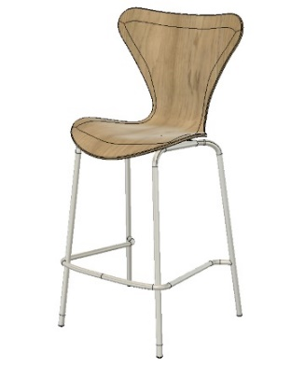

CW TASK 4: GENERATIVE DESIGN SIMULATION
You will set up a design study to generate outcomes for review for the High Chair seat.The objective is to minimise mass of the component by creating a structural frame work for the seat and back. A load of 100 newtons should be applied to the back section of the seat to simulate use with appropriate constraints and modelling geometry in order to produce the criteria to enable generative design solutions. An additive manufacturing outcome using an appropriate polymer material should be applied with a minimum safety factor of 2. Then explore, select and process the most appropriate design solution and bring it back within the Design work space.

COURSEWORK TASK 1&2 SUBMISSION DEADLINE:
Digital Submission: 12.00pm 18.05.26 – Upload all elements to One Drive/Fusion 360

Standard Digital File Name: 2025_26_ADDA5017_CW_SURNAME_FIRST INITIAL_1, 2, 3, etc.
Standard Digital File Format: PDF
Standard Video Formats: MP4/MOV/AVI/MPEG
Artwork File Format: PDF (Print friendly)
Artwork File Format: JPEG (Web friendly)
Standard File Format: Fusion F3D

COURSEWORK TASK 3&4 DELIVERABLES & ASSESSMENT:
The specified deliverables and following common assessment & marking criteria will be used in assessing this coursework task elements 2&3 in relation to LO1 & LO2:

Submission Deliverables:
- Task 3: 1 x AVI/MPEG file of the Animation configuration video;

- Task 4: 1 x Fusion 360 file of generative design outcome of the High chair seat section plus the chosen outcome within the design work space

Note: All 4 coursework task submissions are equally weighted.

Common Assessment & Marking Criteria:
- Cognitive and Intellectual Skills (Marks Available: 70 out of 100)
- Practical Skills (Marks Available: 30 out of 100)

