

Module Name: Managing Marketing Change
Module Code: BMMB7026
Assignment Title: Future Developments in the Field of Marketing

Student Name: Mohammad Sajadul Haque
Student ID: 2511320
Word Count: 3788
Date of Submission: 08.05.2026

Executive Summary
The nature of this report is a critical evaluation of marketing activities by YouTube in the fast growing and changing digital media sector. The discussion explores the external and internal elements that impact marketing performance and strategic choices of YouTube. PESTLE and Porters Five Forces reveal significant opportunities and threats to the competitiveness of organisations. The report further reviews segmentation, targeting, positioning, and marketing mix, strategies in a holistic manner. The digital marketing habit shows great customer involvement by way of creator relationships and suggestions. The effectiveness of marketing is supported by the audience analytics system, system of advertising performance and engagement measurement. Nevertheless, market dynamics are growing more competitive, privacy-related issues are raising serious concerns, and reliance on algorithms are becoming major marketing challenges in the future. These challenges demand ongoing innovations and strategic marketing choices on responsible fronts in international markets. A number of viable suggestions comfort the future organisational growth and competitive advantages in the long term. These guidelines encompass moral AI, enhanced collaborations with creators, sustainable advertising, and evinced analytics. Another advantage of the marketing channel diversification is the organisational resilience in the highly competitive digital landscapes. All in all, strategic marketing modification is a key to keeping customer confidence, viable expansion, and competitive lead.

Table of Contents
Executive Summary 2
1.0 Introduction 4
2.0 Critical Evaluation of YouTube's Marketing Activities 5
2.1 Importance of Marketing at YouTube 5
2.2 Macro Environment Analysis 6
2.3 Micro Environment Analysis 8
2.4 Segmentation, Targeting and Positioning (STP) 9
2.5 Marketing Mix Evaluation 11
2.6 Digital Marketing and Media Strategy 13
2.7 Measuring Marketing Effectiveness 14
3.0 Recommendations for Future Marketing Development 15
3.1 Develop Ethical Artificial Intelligence Personalisation 15
3.2 Strengthen Creator Partnership Programmes 15
3.3 Enhance Greener Digital Marketing 15
3.4 Enlarge Data Done Marketing Innovation 16
3.5 Become more diversified in marketing channels. 16
4.0 Conclusion. 16
References 18

1.0 Introduction



Figure 1: YouTube logo (YouTube,2024).

YouTube is among the biggest online video-sharing websites in the world that have a wide range of viewers worldwide. The site empowers consumers to post, distribute, find, and watch video content every day. YouTube integrates content creators, viewers, advertisers and businesses in a digital ecosystem. Marketing is a key factor in consolidations of this ecosystem and facilitating the growth of a sustainable platform (Agrawal and Mittal, 2025). Marketing effectively assists YouTube in capturing new users as well as maintaining old ones in the global markets. Businesses are also helped by the platform with the help of the targeted advertising approach and the personalised customer engagement strategies (Labib, 2024). The speed of technological alteration at the digital marketing practice and consumer demands in competitive online landscapes continues to change. Marketing decisions and customer experiences are becoming more and more affected by artificial intelligence, working with data analytics and recommendation systems (Oueslati and Ayari, 2024). These changes bring great opportunities as well as ethical, competitive, and regulatory challenges to digital platforms. Hence, YouTube has to keep on changing the marketing strategies to ensure a competitive edge and sustainability. In this report, a critical assessment of the recent marketing efforts of YouTube in the dynamic digital media industry is presented. This is analysed under the macro and micro environmental factors which influence the marketing performance of the organisation. Digital marketing strategies, marketing mix, marketing performance measurement strategies, and segmentation are also assessed in the report. Lastly, feasible recommendations are made that would solidify the future marketing approach and sustainable competitive advantage of YouTube (Abu Anzeh et al., 2024).

2.0 Critical Evaluation of YouTube's Marketing Activities

2.1 Importance of Marketing at YouTube
YouTube needs marketing since the online competition is ever growing worldwide on online platforms. Good marketing converts newly acquired users and enhances the long-term associations with already established audiences all over the world. YouTube is a value-generating operation that links customers, creators, advertisers, as well as companies via fresh digital services. Great marketing is also more effective in increasing brand awareness and helping to sustain competitive advantages of changes in digital markets (Rajendran, 2024). This is done in the platform where personalised recommendations are used to improve user satisfaction and promote longer viewing hours per day. Artificial intelligence assists in providing pertinent content that could relate to personal likes and the behavioural trends (Iyelolu et al., 2024). Creators are also motivated by marketing activities to create engaging content that appeals to a variety of audience groups. Effective creator collaborations can enhance the expansion of the platform and offer more advertising possibilities to business partners worldwide. Digital advertising continues to serve as a significant source of revenues that can sustain the financial stability and innovativeness of YouTube over the long term. Fruitful promotion strategy assists advertisers to access targeted audiences using quantifiable and data-driven marketing campaigns (Almestarihi et al., 2024). On-going marketing innovation facilitates the ability of YouTube to adapt fast to evolving consumer behaviour and demand in the market. Nonetheless, the growing competition means that it is under persistent pressure to continue enhancing customer experiences and platform differentiation. Transparency in algorithms and privacy issues also play a significant role in generating trust among people and the ultimate effectiveness of marketing. Thus, strategic marketing is critical in ensuring growth, customer retention, and organisational prosperity (Bakri, 2023).

2.2 Macro Environment Analysis

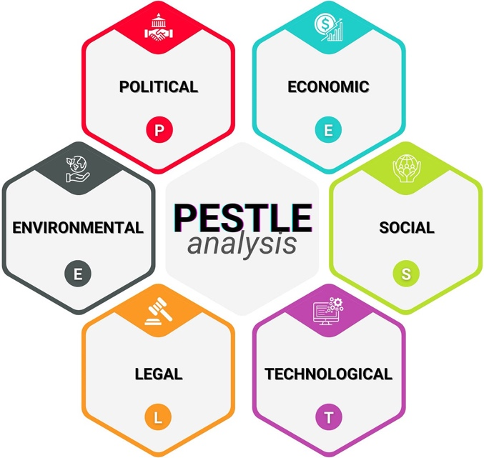
Figure 2: PESTLE Analysis (Rajendran, 2024).
YouTube has a dynamic external environment, which is influenced by some significant macro environmental factors. These are the external forces that directly affect marketing decisions, customer involvement and the business performance over the long term, worldwide. A PESTLE analysis gives an organized road map of how to place value on these significant environmental factors.
Political Factors
Government regulations have a big impact on the marketing operations of YouTube in the various international markets and areas. Most nations implement content control rules, advertising laws and accountability of platforms on a regular basis. YouTube has to adjust marketing strategies depending on the political environment to comply with the law and stay in businesses (Rajendran, 2024).
Economic Factors
Advertizing spending and consumer buying behaviour in the digital market of any economy is directly impacted by the economic condition. When there is fear in the economy, advertising budget and marketing is extended to a great extent. This also affects the advertisement income and future marketing planning decision of YouTube (Ramirez, 2024).
Social Factors
Tastes of consumers are still evolving as viewers increasingly desire customised and engaging digital content over the web. Authentic content, engagement with creators, and mobile-friendly entertainment are sought by younger audiences as well when using digital platforms. Such changing behaviours necessitate unending innovations in marketing, and enhanced customer relationship strategies (Shaheen, 2025).
Technological Factors
The fast growth in technology presents some good opportunities to enhance customer experience and the effectiveness of marketing process over and over again. Artificial intelligence aids in personalised suggestions, audience research and personalised advertisements throughout the digital ecosystem of YouTube. Efficiency of marketing is also enhanced using advanced technologies that enhance content discovery and engagement audience (Labib, 2024).
Legal Factors
There are legal aspects of privacy, copyright, and internet advertising which have a major impact on marketing operations of YouTube in the world. Consensus against the changing regulations safeguard organisational image and reinforce customer confidence as well as platform integrity. Operational risks also decrease via effective legal compliance in the digital environments that have become more controlled (Oueslati and Ayari, 2024).
Environmental Factors
Consumers, businesses, and governments are giving more and more concern to environmental sustainability in international digital markets. Digital platforms are under growing pressure to act responsibly during marketing and to clearly communicate about sustainability issues in organisations. Sustainable programs enhance corporate reputation and the sustainability of relationships with stakeholders, as well as competitive positioning over the long term (Alkhatib, Kecskes and Keller, 2023).
Critical Evaluation
The most influential factor currently on the development of the marketing strategy of YouTube is deemed to be technological and social. Nevertheless, worldwide strategic marketing choices are becoming more and more directed by legal, political, and sustainability pressures. Thus, YouTube ought to constantly adjust the marketing strategies that sustain organisational growth and competition (Abu Anzeh et al., 2024).

2.3 Micro Environment Analysis
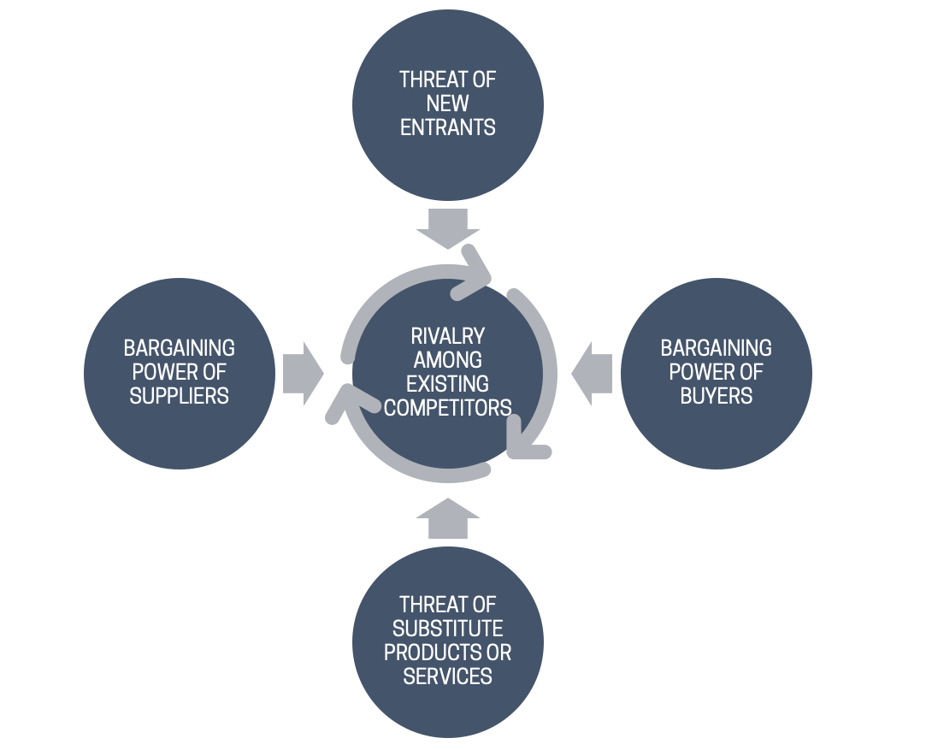
Figure 3: Porter’s Five Forces Analysis. Giankos, 2025).

YouTube is in a fiercely competitive digital media industry that is evolving fast. The Porters Five Forces could be used to analyze the level of competition that will impact marketing performance and strategic position of YouTube.
Competitive Rivalry
There is highly competitive rivalry in the market as there are a number of sites competing to get view points everyday. YouTube is the direct competitor to Tik Tok, Instagram Reels, Netflix, and other streaming media. These rivals are continually proposing new features to lure users and advertisers investment in the global arena. Existing intense competition translates into the constant enhancement of marketing business and customer experiences by YouTube (Giankos, Giannakopoulos and Sakas, 2025).
Threat of Substitutes
Substitute threats are also high with customers not having much trouble accessing other entertainment mediums. Interesting substitutes of video are turned to short-form videos, those of gaming, and those of podcasting and streaming services. Such replacements enhance customer switching behaviour and lower platform loyalty in the long term to a significant degree (Zajdel, Michalcewicz-Kaniowska and Mickiewicz, 2025).
Buyer Power
There is high buyer power since the viewers and advertisers have numerous digital platform options to choose. Without much financial expenditure and technical difficulties, users can switch among platforms. Another aspect that advertisers compare marketing performance is prior to choosing appropriate digital advertising channels selectively (Bakri, 2023).
Supplier Power
Creators of content are valuable suppliers since they generate quality videos which have continued to attract audiences all over the world. Media influencers are more likely to have a higher bargaining power since they attract large numbers of people to their platforms. YouTube as such offers monetisation and support programmes in order to ensure effective retention of successful creators (Babbar, Anand and Aggrawal, 2024).
Threat of New Entrants
There is a medium-level entry risk because technology innovation is an ongoing activity in the digital industries. Digital services can be introduced on new platforms via the modern technologies and reduce the costs of the development. Nevertheless, the long-term investment needed to establish global audiences, communities of creators, as well as advertiser trust is massive.
Critical Evaluation
The marketing strategy of YouTube is the most intensified by competitive rivalry and threat of substitutes today. Close relations with creators and robust technological abilities give valuable competitive edges in evolving digital markets. However, consistent innovation is the key to keeping the clients loyal and competitive performance at the necessary level (Kudapa, 2024).

2.4 Segmentation, Targeting and Positioning (STP)
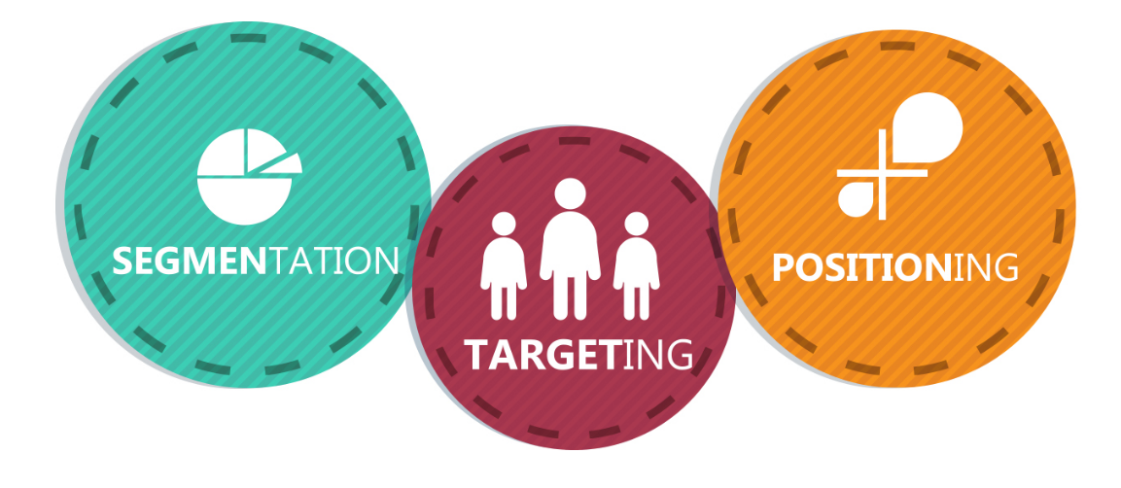
Figure 4: Segmentation, Targeting and Positioning.
YouTube uses strategies of segmentation, targeting and positioning in order to boost global marketing performance.
Segmentation Strategy
YouTube effectively divides markets based on customer characteristics of the demographic, geographic, behavioural and psychographic. Educational, entertainment, gaming, music and lifestyle content is regularly consumed by various groups of audiences. Viewing behaviours are also analysed by the platform to make personalised recommendation of content and advertisement (Musa et al., 2024). Artificial intelligence also enhances audience segmentation by constantly examining user preferences and engagements (Labib, 2024).
Targeting Strategy
YouTube has a wide range of audience audiences such as viewers, creators, advertisers, businesses and educational institutions around the world. Young adults would be a valuable target audience since they watch digital videos on a regular basis. It also offers advanced audience data and behavioural insights to help businesses with targeted advertising solutions (Kedi et al., 2024). The strategy enhances marketing and commercial partners gain a lot on the value of advertising.
Positioning Strategy
YouTube describes itself as the number one video sharing and discovery platform all over the world. The platform stands out with a variety of content, creator communities, personalised recommendations, and services accessible. The constant innovation empowers YouTube to compete effectively in the ever-changing digital media markets (Agrawal and Mittal, 2025).
Critical Evaluation
The STP strategy of YouTube will be effective in helping to serve the interests of customers and to expand the platform in the global markets in the long run. Data-based segmentation enhances relevance of content and boosts customer and advertising response in the long-term. Nevertheless, the rise of reliance on personal data prompts some significant questions about privacy and ethical marketing (Khamoushi, 2024). Thus, to build sustainable competitive advantage, YouTube needs to moderate personalised marketing with increased transparency and responsible data use (Zajdel, Michalcewicz-Kaniowska and Mickiewicz, 2025).

2.5 Marketing Mix Evaluation
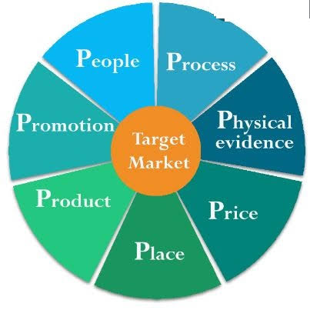
Figure 5: Marketing Mix-7Ps
YouTube deploys the marketing mix in a strategic manner to enhance the customer value and long term organisational performance at a global level.
Product
YouTube provides video hosting, Shorts, live streaming, Music, Premium and creator support. These services meet various customer demands in various global online markets at all times. Perpetual product innovation enhances customer experiences and competitive advantage and market differentiation (Agrawal and Mittal, 2025). Good-quality digital content also contributes to sustainable customer interaction and lasting development of the platform (Laila et al., 2024).
Price
The majority of YouTube platforms are free as advertisements are generating rigorous organisational incomes around the world. Premier subscriptions are given with no ads and special digital perks to subscribers who pay around the globe. Flexible pricing enhances accessibility and sustaining various preferences of consumers in international markets in a coherent way (Almestarihi et al., 2024). Effective pricing strategies also empower marketing outcomes due to enhanced customer satisfaction and value generation (Dimitrios et al., 2023).
Place
YouTube provides digital services on smartphone, tablets, computers, and smart televisions and gaming devices. Extensive digital coverage enhances convenience as well as the expansion of market coverage of various geographical areas. Good digital infrastructure will facilitate successful content delivery and similar customer experience across the world (Ng, 2024).
Promotion
YouTube advertises platform services by collaborating with creators, conducting social media campaigns, engaging in digital advertising, and branded events. Search engine optimisation not only helps enhance the visibility of the contents but also enhances a consistent growth of organic audience. The engagement of influencers enhances and solidifies customer interaction with the brand, as well as brand recognition among various consumer groups (Polat et al., 2024). Sustainable promotional practices also enhance organisational reputation and deepen the relationship with the stakeholders in the long term (Dash, Sharma and Sharma, 2023).
People
Utilizing creators of content, viewers, advertisers, and employees are contributing to the success that YouTube achieves on a global scale in its marketing. Close relationships with creators can enhance the quality of the platform and can promote the active communication with the audience and customer retention. Optimal collaboration between stakeholders enhances organisational performance via enhanced innovation and mutual value creation (Gigauri, Palazzo and Ferri, 2023).
Process
AI assists with personalised recommendations, serves adverts, newsfeed moderations, and enhances customer experience every day. Increased use of digital processes enhances operations and higher levels of customer satisfaction in competitive online markets. High-quality analytics enhance marketing choices with ongoing behavioural data insights and customer intelligence (Iyelolu et al., 2024).
Physical Evidence
International markets have the same branding, similar digital services, and up-to-date interface design at YouTube. Such stakeholders turn visible, and as a result, they lead to increased customer trust and enhanced organisational credibility and brand recognition. Digital experiences that are sustainable can also aid in retaining customers in the long term and loyalty to the platform (Băcilă et al., 2022).
Critical Evaluation
The marketing mix of YouTube manages the ability to reach its customers, innovate, and achieve sustainable competitive advantages all over the world. Nevertheless, these are the marketing challenges of today, privacy issues, and reliance on algorithms, challenging marketing prospects in the future persistently. Thus, YouTube ought to strike the balance between technological innovation and ethical marketing, as well as responsible customer interaction practices (Labib, 2024).

2.6 Digital Marketing and Media Strategy
YouTube is a company that depends on digital marketing to enhance customer interest and sustainable growth of its business all over the world. The digital technologies are constantly enhancing communication among creators, viewers, advertisers, and business partners around the globe. Recent trends in digital marketing promote increased personalisation and improved development of customer relationships (Laila et al., 2024).
AI and Personalised Marketing
The use of artificial intelligence enhances personalised suggestions with the continuous examination of user behaviours and preferences. Personalised content enhances satisfaction among the customers and leads to the subsequent desire to watch longer sessions based on various digital platforms. Behavioural insights also enhance the relevance of advertisements and campaign performance using advanced algorithms (Labib, 2024). Artificial intelligence enhances the rate of conversion by providing extremely relevant marketing messages at all times (Iyelolu et al., 2024).
Creator Marketing and Social Media
Creator partnerships are also crucial to the enhancement of brand awareness and customer engagement in all global markets. Veritable creator content is producing more and more audience confidence compared to most usual promotional endeavors these days. Credible digital communication and interaction with the audience also enhances the customer relationship in influencer marketing (Polat et al., 2024).
Video Visibility and Search Engine Optimisation
Video visibility will be enhanced through search engine optimisation, and the increase in the long-term growth in the organic traffic will be guaranteed. Good keywords can empower creators to reach a broader audience and attain greater levels of engagement. Video content that is optimised enhances competitive efforts in thoroughly saturated online platforms (Giankos, Giannakopoulos and Sakas, 2025). Video marketing is also beneficial at enhancing customer communication by using interactive experiences and engaging visual storytelling (Agrawal and Mittal, 2025).
Data Analytics and Performance of Campaigns
Advanced analytics assist marketers to gauge performance of campaign based on correct customer behaviour and engagement data. Ongoing performance tracking helps in improved marketing and resource generate around online promotions. Machine learning also enhances optimisation of the campaign based on predictive analysis of customer behaviour (Kedi et al., 2024).
Critical Evaluation
The digital marketing approach adopted on YouTube is effective in enhancement of innovation, communication with customers and competitive positioning over time. But as algorithms become more relied upon, there is a growing concern about ethical issues related to transparency and diversity of content all the time. Responsible innovation and open practices in communication with customers are therefore both necessary characteristics of sustainable digital marketing (Dash, Sharma and Sharma, 2023). Artificial intelligence that is taken responsibility of also enhances future sustainability of marketing and competitiveness of organisations in the long-term (Ediriweera, Fernando and Pramudika, 2024).

2.7 Measuring Marketing Effectiveness
YouTube effectively uses multiple key digital marketing performance metrics to continuously evaluate marketing performance. Increasing subscriber numbers are an indication of effective customer acquisition and growing popularity of the platform across the global markets (Shaheen, 2025). Watch time is an indicator of the customer engagement plus the level of content quality and the customer satisfaction. Viewer retention also measures the efficiency of videos in keeping viewers entertained during the entire viewing periods (Babbar, Anand and Aggrawal, 2024). The effectiveness of the advertisement and the customer reactions to the promotional marketing campaigns can be accurately measured in terms of click-through rates. The conversion rates are used to reflect the campaign performance to monitor valuable customers behaviors after the digital ads. Furthermore, YouTube also measures advertising income in order to determine the profitability and the sustainability of business in the long run (Almestarihi et al., 2024). High-order analytics ensure a valuable customer insight and promotes progressive strategic marketing enhancements excellently. The future planning is also being enhanced by evaluation of marketing performance by the use of evidence-based processes of managerial decision making (Ramirez, 2024). Nevertheless, customer trust and engagement cannot be completely described by the numerical performance indicators. Customer feedback is hence very necessary to know the satisfaction, loyalty and future behavioural intentions well (Mehran, Olya and Han, 2023). A combination of quantity and qualitative data leads to more powerful marketing analysis and improved strategic judgement. This moderating consensus can help organisations achieve sustainable expansion and competitive benefits in the long-term (Kudapa, 2024).

3.0 Recommendations for Future Marketing Development

3.1 Develop Ethical Artificial Intelligence Personalisation
YouTube needs to be more transparent and adopt responsible artificial intelligence behaviors in improving recommendation systems. Explain everything Telecommuters would feel more confident and less apprehensive about the personalised content choices. Sustainable customer relations and sustainable marketing are also enhanced through ethical artificial intelligence (Labib, 2024). Enhanced transparency in recommendation also leads to higher confidence as a user, creator and advertising partners globally. Capable artificial intelligence enhances the level of marketing and minimizes issues of algorithm bias by a large margin (Ediriweera, Fernando and Pramudika, 2024).

3.2 Strengthen Creator Partnership Programmes
YouTube needs to widen the creator development programmes by initiating more effective training and financial support programs. Good relationships with creators enhance the content quality and enhances audience interaction in the global markets. Higher collaboration enhances platform differentiation in the face of other digital players that are significantly emerging in the global scene (Babbar, Anand and Aggrawal, 2024). Greater support of creators fosters the innovations and enhances the loyalty of customers as well as platform sustainability. Creator development based on data is also effective in enhancing the effects of marketing by ensuring that the engagement with the audience is improved at all times (Agrawal and Mittal, 2025).

3.3 Enhance Greener Digital Marketing
YouTube ought to reinforce sustainable marketing by accountable communication and open environmental actions on a regular basis. Sustainable marketing enhances the organisational reputation as well as helps adjust the evolving customer demands in international markets. Accountable environmental communication helps avert the stakeholder trust and organisational credibility in the long term considerably (Durmuş Şenyapar, 2024). The enhanced competitiveness on a sustainable innovative approach, along with the responsible business approach and management of resource (Farooq et al., 2022), is also a factor that enhances the competitive positioning. Located sustainability communication is good, and brand value boosted, aiming to enhance long-term organisational reputation in the world (Pimonenko, Lyulyov and Us, 2025). The future strategic decision-making in all the marketing activities of an organisation should be guided by the principles of sustainable marketing (Gigauri, Palazzo and Ferri, 2023).

3.4 Enlarge Data Done Marketing Innovation
YouTube must continuously invest in technologies of advanced analytics and artificial intelligence marketing. Joining customer understanding enhances the effectiveness of campaigns and helps with personalised advertising and content administration. Advanced analytics help to make strategic decisions faster by being able to evaluate marketing performance processes more effectively (Iyelolu et al., 2024). The optimisation of the campaigns using machine learning also advances with the continuous analysis of the behavioural strategy and predictive marketing (Kedi et al., 2024). Constant innovation, strategic learning, development of technological competence are the main ways via which organisational resilience surrounds (Jjagwe et al., 2026). Constant innovation enhances sustainability and ensures better organisational competitiveness in the future both in digital markets.

3.5 Become more diversified in marketing channels.
YouTube needs to keep on varying the marketing channels via interactive technologies as well as emerging communication channels. The increased diversity of channels helps in cutting down marketing risks and also lowering the coverage of various markets. The new digital experience enhances customer interaction and improves the performance of the organisation in the long term (Rajendran, 2024). Inclusive marketing plans enhance stakeholder relationships and build more social and economic value (Gupta et al., 2024). It is also through digital transformation that innovative methods of engagement with customers and sustainable business development opportunities emerge (Koliouska and Andreopoulou, 2023). The marketing strategies used in the future must be fast to adapt to the evolving online landscapes and customer demands (Ng, 2024). Even the healthier digital communities are backed by responsible innovation due to better customer relations and trust. All the recommendations contribute to the enhancement of sustainable growth and elevate the competitive positioning in the future to high levels (Abu Anzeh et al., 2024). Continuous adaptation, responsible innovation, and customer-oriented strategic marketing choices are all the key to future success.

4.0 Conclusion.
YouTube has developed a very strong marketing presence in the very competitive digital media sector. Marketing strategies play a crucial role in increasing customer interest and enhancing sustainable organisational development in the global markets. Individualised suggestions, brand partnerships, and digital advertisement enhance comprehensive marketing effectiveness considerably. Nevertheless, emerging trends of competition, privacy issues and reliance on technology pose significant strategic marketing challenges. The key to retaining customer loyalty and long-term competitive advantages is the constant innovation. Responsible marketing and ethical artificial intelligence should get increased organisational focus always. Close coordination with creators also contributes to the business expansion and better experience to customers across the world. In general, strategic adaptation, responsible innovation, and constant customer value creation are all the keys to success in future marketing.

References
Abu Anzeh, A.Y., Abushaweesh, Q.B., Alfayez, M. and AlQudah, M.Z., 2024, ‘Mapping the future information systems and marketing strategy – a bibliometric analysis of emerging trends’, EDPACS, vol. 69(10), pp. 1–29. https://doi.org/10.1080/07366981.2024.2387332
Agrawal, S.R. and Mittal, D., 2025, ‘Optimizing marketing strategy: a video analysis approach’, Marketing Intelligence & Planning, vol. 43(1), pp. 73–95. https://doi.org/10.1108/mip-12-2023-0655
Alkhatib, S., Kecskés, P. and Keller, V., 2023, ‘Green marketing in the digital age: a systematic literature review’, Sustainability, vol. 15(16), p. 12369. https://doi.org/10.3390/su151612369
Almestarihi, R., Ahmad, A.Y., Frangieh, R.H., Abu-Alsondos, I.A., Nser, K.K. and Ziani, A., 2024, ‘Measuring the ROI of paid advertising campaigns in digital marketing and its effect on business profitability’, Uncertain Supply Chain Management, vol. 12(2), pp. 1275–1284. https://doi.org/10.5267/j.uscm.2023.11.009
Babbar, G., Anand, A. and Aggrawal, N., 2024, ‘Modelling & analyzing view growth pattern of YouTube videos inculcating the impact of subscribers, word of mouth and recommendation systems’, International Journal of Mathematical, Engineering and Management Sciences, vol. 9(3), pp. 435–450. https://doi.org/10.33889/IJMEMS.2024.9.3.023
Băcilă, M.F., Ciornea, R., Souca, L.M. and Drule, A.M., 2022, ‘Content analysis on sustainability dimensions in DMOs’ social media videos advertising the world’s most visited cities’, Sustainability, vol. 14(19), p. 12333. https://doi.org/10.3390/su141912333
Bakri, Z.F., 2023, ‘Analyzing the influence of digital marketing strategies on business performance in the beauty industry: a comprehensive analysis of social media engagement and influencer collaborations’, Journal on Economics, Management and Business Technology, vol. 2(1), pp. 37–48. https://doi.org/10.35335/jembut.v2i1.187
Dash, G., Sharma, C. and Sharma, S., 2023, ‘Sustainable marketing and the role of social media: an experimental study using natural language processing (NLP)’, Sustainability, vol. 15(6), p. 5443. https://doi.org/10.3390/su15065443
Dimitrios, B., Rossidis, I., Ntalakos, A. and Trihas, N., 2023, ‘Digital marketing: the case of digital marketing strategies on luxurious hotels’, Procedia Computer Science, vol. 219, pp. 688–696. https://doi.org/10.1016/j.procs.2023.01.340
Durmus Şenyapar, H.N., 2024, ‘Sustainability marketing strategies for the energy sector: trends, challenges, and future directions’, Environment and Social Psychology, vol. 9(5), p. 2573. https://doi.org/10.54517/esp.v9i5.2573
Ediriweera, C., Fernando, M.T. and Pramudika, H., 2023, ‘AI-driven sustainable video marketing strategies: harnessing deep learning algorithms to sustainable advertising campaigns with special reference to the education industry’, Asian Journal of Marketing Management, vol. 3(1), pp. 32–55. https://doi.org/10.31357/ajmm.v3i01.7304
Farooq, M., Cheng, J., Khan, N.U., Saufi, R.A., Kanwal, N. and Bazkiaei, H.A., 2022, ‘Sustainable waste management companies with innovative smart solutions: a systematic review and conceptual model’, Sustainability, vol. 14(20), p. 13146. https://doi.org/10.3390/su142013146
Giankos, E., Giannakopoulos, N.T. and Sakas, D.P., 2025, ‘Optimizing YouTube video visibility and engagement: the impact of keywords on fisheries’ product campaigns in the supply chain sector’, Information, vol. 16(5), p. 353. https://doi.org/10.3390/info16050353
Gigauri, I., Palazzo, M. and Ferri, M.A. (eds.), 2023, Handbook of Research on Achieving Sustainable Development Goals with Sustainable Marketing. IGI Global. https://doi.org/10.4018/978-1-6684-8681-8
Gupta, S., Wei, M., Tzempelikos, N. and Shin, M.M., 2024, ‘Women empowerment: challenges and opportunities for sustainable development goals’, Qualitative Market Research: An International Journal, vol. 27(4), pp. 608–630. https://doi.org/10.1108/QMR-11-2023-0160
Iyelolu, T.V., Agu, E.E., Idemudia, C. and Ijomah, T.I., 2024, ‘Leveraging artificial intelligence for personalized marketing campaigns to improve conversion rates’, International Journal of Engineering Research and Development, vol. 20(8), pp. 253–270. (No DOI; available from the journal’s website)
Jjagwe, R., Kirabira, J.B., Mukasa, N. and Okure, M., 2026, ‘National innovation system for resilience, transformation and sustainable development in Uganda: contextual analysis of the factors, actors and associated linkages’, International Journal of Innovation Science, vol. 18(2), pp. 386–416. https://doi.org/10.1108/IJIS-09-2023-0197
Kedi, W.E., Ejimuda, C., Idemudia, C. and Ijomah, T.I., 2024, ‘Machine learning software for optimizing SME social media marketing campaigns’, Computer Science & IT Research Journal, vol. 5(7), pp. 1634–1647. https://doi.org/10.51594/csitrj.v5i7.1349
Khamoushi, E., 2024, ‘AI in food marketing from personalized recommendations to predictive analytics: comparing traditional advertising techniques with AI-driven strategies’, arXiv preprint arXiv:2410.01815. https://arxiv.org/abs/2410.01815
Koliouska, C. and Andreopoulou, Z., 2023, ‘E-tourism for sustainable development through alternative tourism activities’, Sustainability, vol. 15(11), p. 8485. https://doi.org/10.3390/su15118485
Kudapa, S.P., 2024, ‘AI-enhanced data science approaches for optimizing user engagement in US digital marketing campaigns’, Journal of Sustainable Development and Policy, vol. 3(3), pp. 01–43. https://doi.org/10.63125/65ebsn47
Labib, E., 2024, ‘Artificial intelligence in marketing: exploring current and future trends’, Cogent Business & Management, vol. 11(1), p. 2348728. https://doi.org/10.1080/23311975.2024.2348728
Laila, N., Sukmaningrum, P.S., Wan Ngah, W.A., Rosyidi, L.N. and Rahmawati, I., 2024, ‘An in-depth analysis of digital marketing trends and prospects in small and medium-sized enterprises: utilizing bibliometric mapping’, Cogent Business & Management, vol. 11(1), p. 2336565. https://doi.org/10.1080/23311975.2024.2336565
Lanfranchi, G., Cioli, A., Amanti, A. and Marinelli, L., 2026, ‘Reconfiguring competitive advantage: a resource dynamic framework for generative AI adoption in digital content marketing’, European Journal of Innovation Management, vol. 29(3), pp. 770–798. https://doi.org/10.1108/EJIM-03-2024-0317
Mehran, J., Olya, H. and Han, H., 2023, ‘Psychology of space tourism marketing, technology, and sustainable development: from a literature review to an integrative framework’, Psychology & Marketing, vol. 40(6), pp. 1130–1151. https://doi.org/10.1002/mar.21795
Musa, H.G., Fatmawati, I., Nuryakin, N. and Suyanto, M., 2024, ‘Marketing research trends using technology acceptance model (TAM): a comprehensive review of researches (2002–2022)’, Cogent Business & Management, vol. 11(1), p. 2329375. https://doi.org/10.1080/23311975.2024.2329375
Ng, T., 2024, ‘The impact of digital transformation on tourism sustainable development: a case of SMEs in Vietnam’, International Journal of Entrepreneurship and Small Business (IJESB). (No DOI; available from Inderscience http://www.inderscience.com/jhome.php?jcode=ijesb)
Oueslati, K. and Ayari, S., 2024, ‘A bibliometric analysis on artificial intelligence in marketing: implications for scholars and managers’, Journal of Internet Commerce, vol. 23(3), pp. 233–261. https://doi.org/10.1080/15332861.2024.2350326
Pimonenko, T., Lyulyov, O. and Us, Y., 2025, ‘Country green brand promotion: a sentiment analysis’, Forum Scientiae Oeconomia, vol. 13(2), pp. 27–51. https://doi.org/10.23762/FSO_VOL13_NO2_2
Polat, E., Celik, F., Ibrahim, B. and Gursoy, D., 2024, ‘Past, present, and future scene of influencer marketing in hospitality and tourism management’, Journal of Travel & Tourism Marketing, vol. 41(3), pp. 322–343. https://doi.org/10.1080/10548408.2024.2317741
Rajendran, R.P., Punjabi, P., Aruna, V., Patil, S.S., Labhane, S. and Badhusha, M.H.N., 2024, ‘Navigating the new wave: unveiling the transformation effects of social media on digital marketing in the emerging era’, Journal of Informatics Education and Research, vol. 4(1), pp. 35–41. https://doi.org/10.52783/jier.v4i1.516
Ramirez, J.G.C., 2024, ‘The power of planning: how business plans drive effective management strategies’, Integrated Journal of Science and Technology, vol. 1(3), March. (No DOI; available from https://ijstindex.com/index.php/ijst)
Shaheen, H., 2025, ‘Social media marketing research: a bibliometric analysis from Scopus’, Future Business Journal, vol. 11(1), p. 41. https://doi.org/10.1186/s43093-025-00465-2
Zajdel, M., Michalcewicz-Kaniowska, M. and Mickiewicz, P., 2025, ‘The impact of the YouTube platform on consumer purchasing attitudes and behaviors in the context of video marketing content’, Scientific Papers of Silesian University of Technology. Organization & Management, no. 220, pp. 537–545. https://doi.org/10.29119/1641-3466.2025.220.34

